Additional File 1: Supplementary Methods, Figures S1-S10 and Tables S1-S12.
Supplementary information for the paper
“Disease and mortality trajectories of autistic individuals in mid- and later- adulthood”
Authors: Yiwei Pu^{1,†}, Feng Li^{1,†}, Tailin Zhu^{1,†}, Jiong Li^{1,2}, Wei Zhou¹, Lingli Zhang¹, Jingyu Chen¹, Qianlong Zhang¹, Tai Ren^{1,*}, Fei Li^{1,*}
Correspondence to: Dr. Fei Li, Department of Developmental and Behavioural Paediatric & Child Primary Care & Ministry of Education - Shanghai Key Laboratory of Children's Environmental Health, Xinhua Hospital Affiliated to Shanghai Jiao Tong University School of Medicine, Shanghai, China. Email: feili@shsmu.edu.cn; Dr. Tai Ren, Department of Developmental and Behavioural Paediatric & Child Primary Care & Ministry of Education - Shanghai Key Laboratory of Children's Environmental Health, Xinhua Hospital Affiliated to Shanghai Jiao Tong University School of Medicine, Shanghai, China. Email: rt@shsmu.edu.cn.
Table of Contents
Supplementary Methods Fluid intelligence test 3
Fig S1. Workflow. 5
Fig S2. Survival analysis. 6
Fig S3. Survival analysis, restricting on only inpatient diagnosis of autism spectrum disorder. 7
Fig S4. Odds ratios of medical conditions associated with autism spectrum disorder, restricting on only inpatient diagnosis of autism spectrum disorder. 8
Fig S5. Disease trajectories of ASD individuals, restricting on only inpatient diagnosis of autism spectrum disorder. 9
Fig S6. The multistate diagram depicting disease progression restricting on only inpatient diagnosis of autism spectrum disorder. 10
Fig S7. Estimated association between ASD and the rate of next disease transition, restricting on only inpatient diagnosis of autism spectrum disorder. 11
Fig S8. A multistate model to estimate association between ASD and the rate of morbidity progression excluding diagnoses from self-reported data. 12
Fig S9. Odds ratios of medical conditions associated with autism spectrum disorder in the UK Biobank study before covid. 13
Fig S10. A multistate model to estimate association between ASD and the rate of morbidity progression before covid. 14
Table S1 Details of data on diagnoses and deaths 15
Table S2 Codes for the three chronic conditions 16
Table S3 Prevalence of Malignant Neoplasm 17
Table S4. Comorbidities at recruitment of individual with or without diagnosis of autism spectrum disorder in hospital inpatient records. 18
Table S5 Cognitive Function Tests 19
Table S6 Survival analysis 20
Table S7 Medical conditions associated with autism spectrum disorder. 21
Table S8 Characteristics of individuals at recruitment with and without diagnosis of ASD, restricting on only inpatient diagnosis of autism spectrum disorder. 24
Table S9 Comorbidities at recruitment of individual with or without diagnosis of autism spectrum disorder in hospital inpatient records, restricting on only inpatient diagnosis of autism spectrum disorder. 25
Table S10 Survival analysis, restricting on only inpatient diagnosis of autism spectrum disorder 26
Table S11 Medical conditions associated with autism spectrum disorder restricted on only inpatient diagnosis of ASD. 27
Table S12 Distribution of diagnoses before and after the covid-19 pandemic 29

Supplementary Methods Fluid intelligence test
Fluid intelligence scores (data field 20016 for a touchscreen questionnaire & data field 20191 for online questionnaire) were derived from a set of 13 questions (eg. Identify largest number from a set of numbers. Please refer to Supplementary methods Table 1 for details). Participants were limited 2 minutes to respond to as many questions as possible and had the option to skip questions. Fluid intelligence scores were computed as the unweighted sum of correct responses to the 13 questions, yielding a possible range of 0 to 13. Questions left unanswered upon expiration of the 2-minute time limit were assigned a score of zero. (Table method S1). During the assessment of prospective memory, participants were allowed up to 2 attempts to correctly recall the colour/shape shown to them earlier in the touchscreen section. Responses are scored as follows: 0 for two incorrect attempts, 1 for a correct first attempt, and 2 for a correct second attempt. The field for reaction time is the mean duration to first press of snap-button summed over rounds in which both cards matched. It gives a crude measure of the raw processing and reaction speed of a participant.
Table method S1 Fluid intelligence test
No | Items | Questions
1 | Numeric addition test | Add the following numbers together: 1 2 3 4 5 - is the answer?  Asked to choose from 13, 14, 15, 16 or 17.
2 | Identify largest number | Which number is the largest?  Asked to choose from 642, 308, 987, 714 and 253.
3 | Word interpolation | Bud is to Flower as Child is to?  Offered choice from Grow, Develop, Improve, Adult and Old.
4 | Positional arithmetic | 11 12 13 14 15 16 17 18 Divide the sixth number to the right of twelve by three. Is the answer?  Offered choice from 5, 6, 7, or 8.
5 | Family relationship calculation | If Truda's mother's brother is Tim's sister's father, what relation is Truda to Tim?  Offered choice from Aunt, Sister, Niece, Cousin, No-relation.
6 | Conditional arithmetic | If sixty is more than half of seventy-five, multiply twenty-three by three. If not subtract 15 from eighty-five. Is the answer?  Offered choice from 68, 69, 70, 71, 72.
7 | Synonym | Stop means the same as?
8 | Chained arithmetic | Offered choice from Pause, Close, Cease, Break or Rest.
9 | Concept interpolation | Age is to Years as Height is to?  Offered choice from Long, Deep, Top, Metres or Tall.
10 | Arithmetic sequence recognition | 150 ... 137 ... 125 ... 114 ... 104 ... What comes next?  Offered choice from 92, 93, 94, 95 or 96.
11 | Antonym | Relaxed means the opposite of?  Offered choice from Calm, Anxious, Cool, Worried, Tense.
12 | Square sequence recognition | 100 ... 99 ... 95 ... 86 ... 70 ... What comes next?  Offered choice from 45, 46, 47, 48, 49, 50.
13 | Subset inclusion logic | If some flinks are plinks and some plinks are stinks then some flinks are definitely stinks?  Offered choice from True, False, Neither-true-nor-false.

Fig S1. Workflow.
This figure shows the study design, the inclusion and exclusion process of study population selection. ASD, autism spectrum disorder.

Fig S2. Survival analysis.
ASD, autism spectrum disorder.

Fig S3. Survival analysis, restricting on only inpatient diagnosis of autism spectrum disorder.
ASD, autism spectrum disorder.

Fig S4. Odds ratios of medical conditions associated with autism spectrum disorder, restricting on only inpatient diagnosis of autism spectrum disorder.
The X axis shows the disease categories according to the ICD-10 system. The Y axis shows the odds ratios. Only medical conditions that passed Bonferroni corrected P <0.05 were presented.

Fig S5. Disease trajectories of ASD individuals, restricting on only inpatient diagnosis of autism spectrum disorder.
This figure illustrates disease trajectories identified in our analysis, restricting on only inpatient diagnosis of autism spectrum disorder. The number above the arrow connecting two circles corresponds to the number of disease pairs among ASD individuals. The color of the arrows indicates the odds ratio of the sequential association between the two medical conditions. Red box indicates the external conditions. Yellow box indicates the infectious diseases. Green box indicates the cardiometabolic diseases. ASD, autism spectrum disorder.

Fig S6. The multistate diagram depicting disease progression restricting on only inpatient diagnosis of autism spectrum disorder.
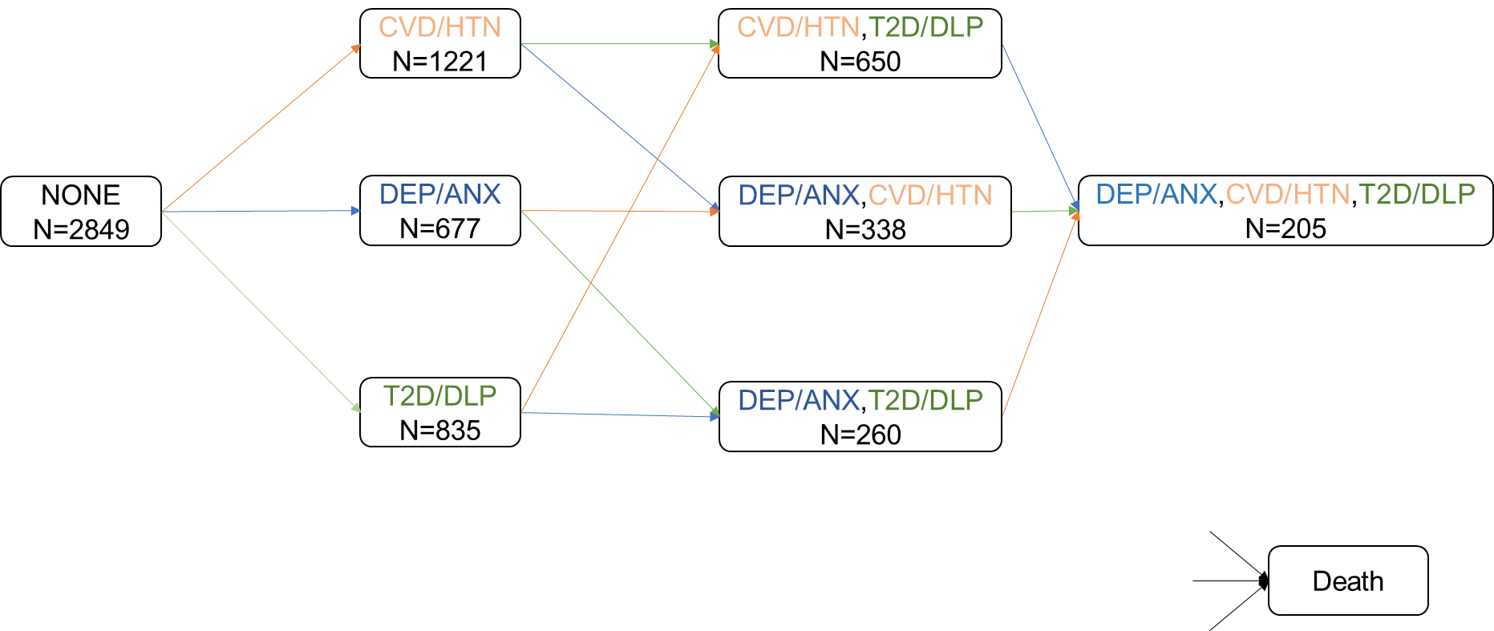

The initial condition, labelled “None”, represents participants with no comorbidities at baseline. Intermediate comorbidity states are color coded as follows: cardiovascular disease and hypertension (CVD/HTN, orange), type 2 diabetes and disorders of lipoprotein metabolism (T2D/DLP, green) and depression/ anxiety (DEP/ANX, blue). Each colored arrow indicates a transition, with the color corresponding to the condition diagnosed at the time of transition (e.g. blue arrows indicate transitions to a MH diagnosis). The final state “death” is directly accessible from all other states. The “N” below each comorbidity state indicates the total number of participants who entered that state during the follow-up period.

Fig S7. Estimated association between ASD and the rate of next disease transition, restricting on only inpatient diagnosis of autism spectrum disorder.
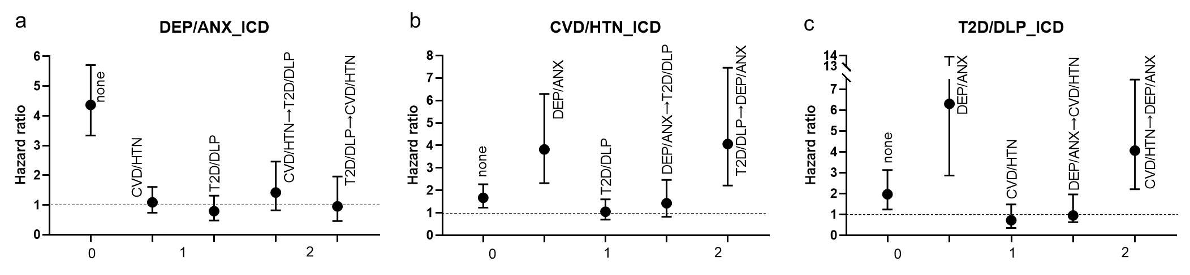

Figures (a) to (c) show the hazard ratios (HRs) of the association of ASD with an incident diagnosis of (a) DEP/ANX, (b) CVD/HTN, and (c) T2D/DLP, respectively. X axis shows the number of pre-existing comorbidities. HRs were estimated adjusted for age, sex, Townsend deprivation index and ethnicity.
ASD, Autism Spectrum Disorder; DEP/ANX, depression and anxiety; CVD/HTN, cardiovascular disease and hypertension; T2D/DLP, type 2 diabetes and disorders of lipoprotein metabolism; HR, hazard ratio; CI, confidence interval.

Fig S8. A multistate model to estimate association between ASD and the rate of morbidity progression excluding diagnoses from self-reported data.
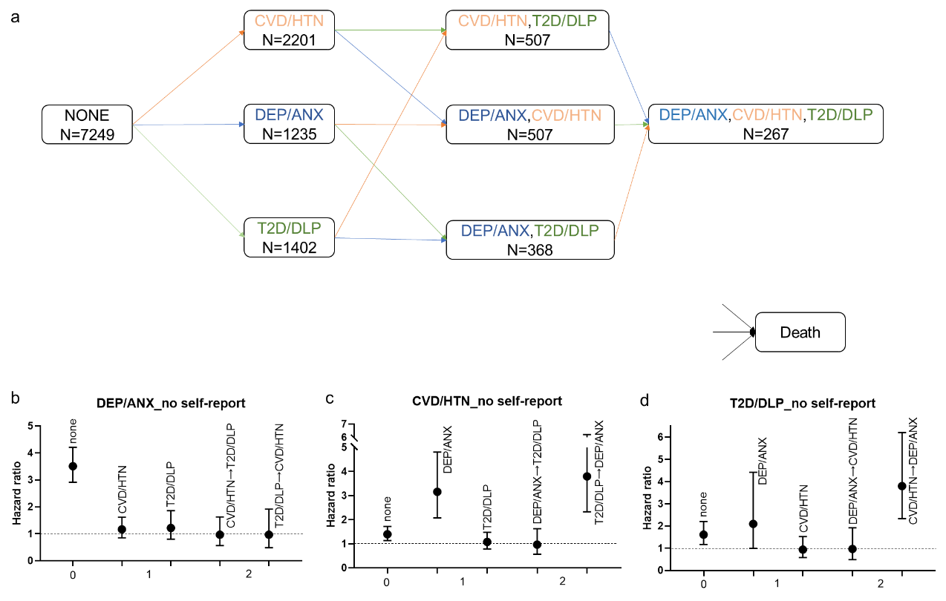

a) The initial condition, labelled “None”, represents participants with no comorbidities at baseline. Intermediate comorbidity states are color coded as follows: cardiovascular disease (CVD/HTN, orange), type 2 diabetes and disorders of lipoprotein metabolism (T2D/DLP, green) and depression/ anxiety (DEP/ANX, blue). Each colored arrow indicates a transition, with the color corresponding to the condition diagnosed at the time of transition (e.g. blue arrows indicate transitions to a MH diagnosis). The final state “death” is directly accessible from all other states. The “N” below each comorbidity state indicates the total number of participants who entered that state during the follow-up period.
Figures (b) to (d) show the hazard ratios (HRs) of the association of ASD with an incident diagnosis of (b) DEP/ANX, (c) CVD/HTN, and (d) T2D/DLP, respectively. X axis shows the number of pre-existing comorbidities. HRs were estimated adjusted for age, sex, Townsend deprivation index and ethnicity.
ASD, Autism Spectrum Disorder; DEP/ANX, depression and anxiety; CVD/HTN, cardiovascular disease and hypertension; T2D/DLP, type 2 diabetes and disorders of lipoprotein metabolism; HR, hazard ratio; CI, confidence interval.

Fig S9. Odds ratios of medical conditions associated with autism spectrum disorder in the UK Biobank study before covid.
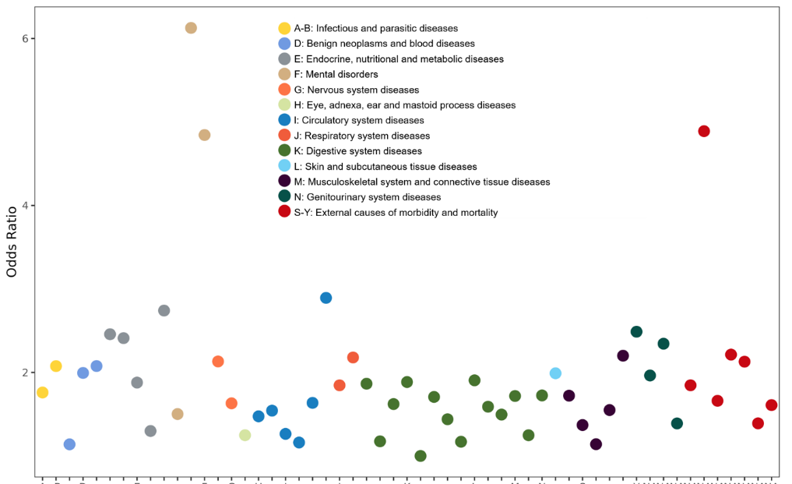
The X axis shows the disease categories according to the ICD-10 system. The Y axis shows the odds ratios of medical conditions associated with autism spectrum disorder in the UK Biobank study. Only medical conditions that passed Bonferroni corrected P <0.05 were presented.

Fig S10. A multistate model to estimate association between ASD and the rate of morbidity progression before covid.
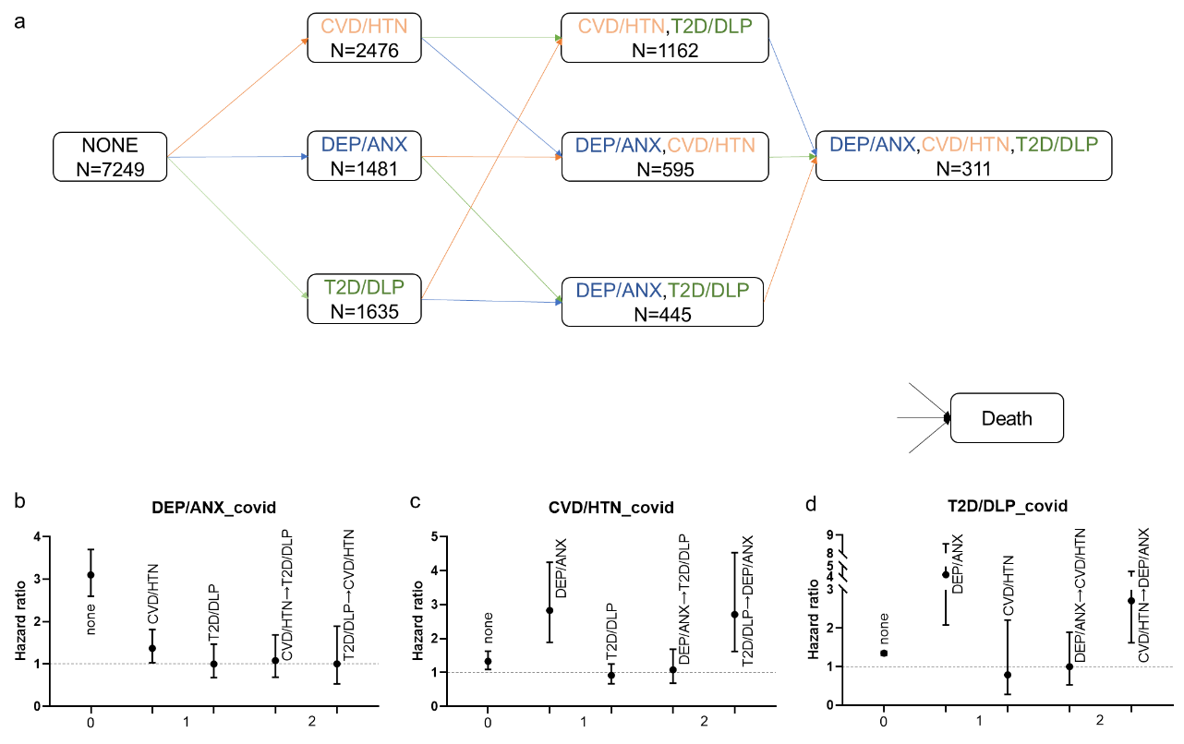

a) The initial condition, labelled “None”, represents participants with no comorbidities at baseline. Intermediate comorbidity states are color coded as follows: cardiovascular disease and hypertension (CVD/HTN, orange), type 2 diabetes and disorders of lipoprotein metabolism (T2D/DLP, green) and depression/ anxiety (DEP/ANX, blue). Each colored arrow indicates a transition, with the color corresponding to the condition diagnosed at the time of transition (e.g. blue arrows indicate transitions to a MH diagnosis). The final state “death” is directly accessible from all other states. The “N” below each comorbidity state indicates the total number of participants who entered that state during the follow-up period.
Figures (b) to (d) show the hazard ratios (HRs) of the association of ASD with an incident diagnosis of (b) DEP/ANX, (c) CVD/HTN, and (d) T2D/DLP, respectively. X axis shows the number of pre-existing comorbidities. HRs were estimated adjusted for age, sex, Townsend deprivation index and ethnicity.
ASD, Autism Spectrum Disorder; DEP/ANX, depression and anxiety; CVD/HTN, cardiovascular disease and hypertension; T2D/DLP, type 2 diabetes and disorders of lipoprotein metabolism; HR, hazard ratio; CI, confidence interval.

Table S1 Details of data on diagnoses and deaths
variable | source | starting time | Ending time
the Hospital Inpatient Data (Diagnoses - ICD10) | Hospital Episode Statistics (HES) Admitted Patient Care (APC), Patient Episode Database for Wales (PEDW),  Admitted Patient Care (APC), General Acute Inpatient and Day Case - Scottish Morbidity Record (SMR01) and the Mental Health Inpatient and Day Case - Scottish Morbidity Record (SMR04) | 1981 | 2022/10/31
First occurrence | Read code information in the Primary Care data (Category 3000), ICD-9 and ICD-10 codes in the Hospital inpatient data (Category 2000), ICD-10 codes in Death Register records (Field 40001, Field 40002), and Self-reported medical condition codes (Field 20002) reported at the baseline or subsequent UK Biobank assessment centre visit | 1959 | 2023/9/1
Death register | the NHS Central Register (NHSCR) and the National Records of Scotland | 2006/5/10 | 2022/12/30

Table S2 Codes for the three chronic conditions
Conditions | ICD-10 codes
DEP/ANX | F40, F41, F42, F43, F44, F45, F48, F32, F33, F34, 38, F39
CVD/HTN | I10, I20, I21, I22, I23, I24, I25, G45, I63
T2D/DLP | E11, E78
DEP/ANX, depression/anxiety; CVD/HTN, cardiovascular disease and hypertension; T2D/DLP, type 2 diabetes and disorders of lipoprotein metabolism

Table S3 Prevalence of Malignant Neoplasm
Variables | Individuals with no diagnosis of ASD  (N=6590) | Individuals diagnosed with ASD  (N=659) | P-value
Malignant neoplasms
0 | 5624 (85.3%) | 563 (85.4%) | 0.99
1 | 966 (14.7%) | 96 (14.6%)

Table S4. Comorbidities at recruitment of individual with or without diagnosis of autism spectrum disorder in hospital inpatient records.
Comorbidity | Individuals with no diagnosis of ASD  (N=6590) | Individuals diagnosed with ASD  (N=659) | P-value
AIDS HIV | 10 (0.2%) | 0 (0%) | 0.42
Any malignancy | 103 (1.6%) | 11 (1.7%) | 0.22
Cerebrovascular disease | 44 (0.7%) | 6 (0.9%) | 0.89
Chronic pulmonary disease | 186 (2.8%) | 35 (5.3%) | 0.3
Congestive heart failure | 28 (0.4%) | <5 | 0.39
Diabetes with chronic complication | 9 (0.1%) | <5 | 0.47
Diabetes without chronic complication | 108 (1.6%) | 31 (4.7%) | 0.001
Hemiplegia or paraplegia | 19 (0.3%) | <5 | 1
Metastatic solid tumor | 29 (0.4%) | <5 | 0.16
Mild liver disease | 35 (0.5%) | <5 | 1
Moderate or severe liver disease | 8 (0.1%) | 0 (0%) | 0.54
Myocardial Infarction | 74 (1.1%) | 6 (0.9%) | 0.13
Peptic ulcer disease | 49 (0.7%) | 6 (0.9%) | 0.68
Peripheral vascular disease | 27 (0.4%) | <5 | 0.42
Renal disease | 24 (0.4%) | <5 | 0.92
Rheumatic disease | 19 (0.3%) | <5 | 1
Numbers were expressed as frequency (percentage), unless otherwise indicated. In accordance with clinical research standards, privacy preservation measures are implemented for low-frequency data.
ASD, autism spectrum disorder.

Table S5 Cognitive Function Tests
 | Non-ASD  (N=6590) | ASD  (N=659) | P-value
Fluid Intelligence at baseline
Mean (SD) | 6.26 (2.24) | 6.62 (2.59) | 0.04
Missing | 4212 (63.9%) | 411 (62.4%)
Average Fluid Intelligence for allª
Mean (SD) | 5.82 (1.92) | 6.16 (2.16) | <0.001
Missing | 1370 (20.8%) | 126 (19.1%)
Reaction time at baseline
Mean (SD) | 537 (113) | 550 (124) | 0.01
Missing | 53 (0.8%) | 15 (2.3%)
Average Reaction time for all^{b}
Mean (SD) | 545 (111) | 559 (121) | 0.01
Missing | 51 (0.8%) | 14 (2.1%)
Prospective memory at baseline
Incorrect | 90 (1.4%) | 12 (1.8%) | 0.73
Correct at 1st | 1971 (29.9%) | 208 (31.6%)
Correct at 2nd | 373 (5.7%) | 38 (5.8%)
Missing | 4156 (63.1%) | 401 (60.8%)
Best Prospective memory for all^{c}
Incorrect | 171 (2.6%) | 21 (3.2%) | 0.51
Correct at 1st | 2956 (44.9%) | 293 (44.5%)
Correct at 2nd | 452 (6.9%) | 51 (7.7%)
Missing | 3011 (45.7%) | 294 (44.6%)
a, the average fluid intelligence for all was calculated using all available baseline and follow-up assessments, both online and in-center. b, the average reaction time for all was calculated using all available baseline and follow-up assessments in-center. c, the best prospective memory for all was computed using the best available scores from all in-center baseline and follow-up assessments. ASD, autism spectrum disorder.

Table S6 Survival analysis
 | HR（95%CI） | P- value
Model1ª | 1.90 (1.41, 2.55) | <0.001
Model2^{b} | 1.73 (1.28, 2.33) | <0.001
Model3^{c} | 1.56 (1.14, 2.14) | 0.005
Model4^{d} | 1.66 (1.22, 2.26) | 0.001
Model5e | 1.71 (1.06, 2.77) | 0.03
- Adjusting for sex, Townsend deprivation index, birth year and respondence status of the self-reported ASD question in 2016;
- Adjusting for sex, birth year, race, smoking status, alcohol consumption, respondence status of the self-reported ASD question in 2016, fluid intelligence, Townsend deprivation index, body mass index, level of physical exercise and age-adjusted Charlson comorbidity index;
- Adjusting for sex, birth year, race, smoking status, alcohol consumption, respondence status of the self-reported ASD question in 2016, intellectual disability, Townsend deprivation index, body mass index, level of physical exercise and age-adjusted Charlson comorbidity index;
- Adjusting for sex, birth year, race, smoking status, alcohol consumption, respondence status of the self-reported ASD question in 2016, reaction time, Townsend deprivation index, body mass index, level of physical exercise and age-adjusted Charlson comorbidity index;
- Adjusting for sex, birth year, race, smoking status, alcohol consumption, respondence status of the self-reported ASD question in 2016, prospective memory, Townsend deprivation index, body mass index, level of physical exercise and age-adjusted Charlson comorbidity index
HR, hazard ratio.

Table S7 Medical conditions associated with autism spectrum disorder.
ICD-10 | Description | Cases in autistic individuals (%) | Odds ratio (95% CI) | P-value | p.adjusted-value
A41 | Sepsis | 38 (5.8) | 2.44(1.69,3.51) | <0.001 | <0.001
B96 | Bacterial infectious agents | 57 (8.6) | 2.15(1.60,2.90) | <0.001 | <0.001
D50 | Iron deficiency anaemia | 47 (7.1) | 1.99(1.44,2.76) | <0.001 | 0.002
D51 | Other anaemias | 67 (10.2) | 1.99(1.51,2.62) | <0.001 | <0.001
E00 | Hypothyroid conditions | 50 (7.6) | 2.29(1.67,3.15) | <0.001 | <0.001
E10 | Diabetes | 109 (16.5) | 2.37(1.89,2.98) | <0.001 | <0.001
E40 | Malnutrition | 43 (6.5) | 4.19(2.91,6.02) | <0.001 | <0.001
E66 | Obesity | 81 (12.3) | 1.97(1.53,2.53) | <0.001 | <0.001
E78 | Disorders of lipoprotein metabolism and other lipidaemias | 115 (17.5) | 1.46(1.17,1.82) | <0.001 | 0.04
E86 | Volume depletion | 33 (5.8) | 2.72(1.83,4.03) | <0.001 | <0.001
E87 | Other disorders of fluid, electrolyte and acid-base balance | 56 (8.5) | 2.60(1.91,3.53) | <0.001 | <0.001
F10 | Alcohol abuse | 31 (4.7) | 2.01(1.35,2.98) | <0.001 | 0.04
F32 | Depression | 173 (26.3) | 6.08(4.96,7.46) | <0.001 | <0.001
F40 | Anxiety | 130 (19.7) | 4.92(3.93,6.15) | <0.001 | <0.001
G47 | Sleep disorder | 43 (6.5) | 2.36(1.68,3.32) | <0.001 | <0.001
G50 | Diseases in nerves, nerve roots and nerve plexa | 53 (8.4) | 1.70(1.26,2.31) | <0.001 | 0.04
H53 | Visual disturbances and blindness | 34 (5.2) | 2.77(1.88,4.08) | <0.001 | <0.001
I10 | Primary hypertension | 212 (32.2) | 1.52(1.27,1.82) | <0.001 | <0.001
I65 | Other cerebrovascular diseases | 32 (4.9) | 2.70(1.81,4.03) | <0.001 | <0.001
I83 | Varicose veins of lower extremities | 32 (4.9) | 2.06(1.39,3.04) | <0.001 | 0.02
I95 | Hypotension | 41 (6.2) | 2.56(1.80,3.65) | <0.001 | <0.001
J12 | Pneumonia | 64 (9.7) | 2.14(1.61,2.84) | <0.001 | <0.001
J45 | Asthma | 114 (17.3) | 2.28(1.83,2.85) | <0.001 | <0.001
J95 | Other diseases of the respiratory system | 31 (4.7) | 1.98(1.33,2.94) | <0.001 | 0.047
K20 | Oesophagitis | 35 (5.3) | 1.93(1.33,2.79) | <0.001 | 0.04
K29 | Gastritis and duodenitis | 98 (14.9) | 1.57(1.25,1.98) | <0.001 | 0.008
K30 | Functional dyspepsia | 38 (5.8) | 1.93(1.35,2.76) | <0.001 | 0.02
K31 | Disease of stomach and duodenum | 36 (5.5) | 2.09(1.45,3.02) | <0.001 | 0.005
K44 | Diaphragmatic hernia | 89 (13.5) | 1.65(1.30,2.10) | <0.001 | 0.003
K58 | Irritable bowel syndrome | 35 (5.3) | 2.80(1.91,4.11) | <0.001 | <0.001
K59 | Other functional intestinal disorders | 65 (9.9) | 2.11(1.59,2.79) | <0.001 | <0.001
K92 | Other disease of digestive system | 51 (7.7) | 1.90(1.39,2.59) | <0.001 | 0.003
L01 | Skin and subcutaneous infections | 51 (7.7) | 1.93(1.41,2.63) | <0.001 | 0.002
L20 | Dermatitis | 33 (5.8) | 2.64(1.78,3.90) | <0.001 | <0.001
M10 | Other inflammatory arthritis | 72 (10.9) | 1.81(1.38,2.36) | <0.001 | <0.001
M79 | Other soft tissue disorders, not elsewhere classified | 62 (9.4) | 2.12(1.59,2.83) | <0.001 | <0.001
N17 | Acute renal failure | 53 (8.4) | 2.42(1.76,3.32) | <0.001 | <0.001
N32 | Bladder disorder | 42 (6.4) | 2.16(1.53,3.05) | <0.001 | <0.001
N39 | Disorders of urinary system, possibly infection | 76 (11.5) | 2.39(1.83,3.11) | <0.001 | <0.001
S00 | Injuries due to external causes | 154 (23.4) | 1.95(1.60,2.36) | <0.001 | <0.001
T36 | Poisoning due to external causes | 34 (5.2) | 5(3.29,7.58) | <0.001 | <0.001
T80 | Complications due to medical treatment | 73 (11.8) | 1.65(1.27,2.14) | <0.001 | 0.013
V01 | Transport accidents | 36 (5.5) | 2.32(1.60,3.36) | <0.001 | <0.001
W00 | Falls | 84 (12.7) | 2.13(1.66,2.74) | <0.001 | <0.001
Y40 | External causes of morbidity related to medical treatment | 86 (13.5) | 1.55(1.22,1.98) | <0.001 | 0.03

Table S8 Characteristics of individuals at recruitment with and without diagnosis of ASD, restricting on only inpatient diagnosis of autism spectrum disorder.
Variables | Individuals with no diagnosis of ASD  (N=2590) | Individuals diagnosed with ASD  (N=259) | P-value
Age, y
Mean (SD) | 52.5(8.42) | 52.7 (8.47) | 0.81
Sex(male) | 1833 (70.8%) | 184 (71.0%) | 0.98
Birthyear
Mean (SD) | 1960 (8.50) | 1960 (853) | 0.80
Townsend deprivation index
Mean (SD) | 0.225 (3.38) | 0.361 (3.48) | 0.55
Missing | 4 (0.2%) | 0 (0%)
Body mass index, kg/m2
Mean (SD) | 27.8 (4.71) | 28.5 (6.41) | 0.01
Missing | 26 (1.0%) | 6 (2.3%)
White | 2279 (88.0%) | 245 (94.6%) | <0.001
Missing | 23 (0.9%) | 5 (1.9%)
Current drinker | 2330 (90.0%) | 204 (78.8%) | <0.001
Missing | 24 (0.9%) | 6 (2.3%)
Current smoker | 414 (16.0%) | 41 (15.8%) | 1
Missing | 30 (1.2%) | 4 (1.5%)
Number of days per week of moderate physical activity with 10+ minutes
Mean (SD) | 3.65 (2.34) | 3.36 (2.49) | 0.09
Missing | 159 (6.1%) | 24 (9.3%)
Deaths | 224 (8.6%) | 46 (17.8%) | <0.001
Fluid Intelligence
Mean (SD) | 5.68 (2.28) | 5.88 (2.76) | 0.50
Missing | 1671 (64.5%) | 166 (64.1%)
aCCI
0 | 2283 (88.1%) | 212 (81.9%) | 0.29
1 | 49 (1.9%) | 11 (4.2%)
≥2 | 258 (10.0%) | 36 (13.9%)

Table S9 Comorbidities at recruitment of individual with or without diagnosis of autism spectrum disorder in hospital inpatient records, restricting on only inpatient diagnosis of autism spectrum disorder.
Comorbidity | Individuals with no diagnosis of ASD  (N=2590) | Individuals diagnosed with ASD  (N=259) | P-value
AIDS HIV | <5 | 0 (0%) | 1
Any malignancy | 57 (2.2%) | 6 (2.3%) | 0.45
Cerebrovascular disease | 28 (1.1%) | <5 | 0.40
Chronic pulmonary disease | 88 (3.4%) | 14 (5.4%) | 1
Congestive heart failure | 20 (0.8%) | <5 | 0.79
Diabetes with chronic complication | <5 | <5 | 0.39
Diabetes without chronic complication | 66 (2.5%) | 20 (7.7%) | 0.003
Hemiplegia or paraplegia | 13 (0.5%) | <5 | 1
Metastatic solid tumor | 17 (0.7%) | <5 | 0.53
Mild liver disease | 23 (0.9%) | 5 (1.9%) | 0.65
Moderate or severe liver disease | 6 (0.2%) | 0 (0%) | 0.72
Myocardial Infarction | 45 (1.7%) | <5 | 0.08
Peptic ulcer disease | 36 (1.4%) | 5 (1.9%) | 1
Peripheral vascular disease | 20 (0.8%) | 0 (0%) | 0.14
Renal disease | 11 (0.4%) | <5 | 0.61
Rheumatic disease | 7 (0.3%) | <5 | 1
Numbers were expressed as frequency (percentage), unless otherwise indicated. In accordance with clinical research standards, privacy preservation measures are implemented for low-frequency data.
ASD, autism spectrum disorder.

Table S10 Survival analysis, restricting on only inpatient diagnosis of autism spectrum disorder
 | HR（95CI） | P- value
model1ª | 2.07 (1.51, 2.85) | <0.001
model2^{b} | 1.96 (1.42, 2.69) | <0.001
model3^{c} | 1.78 (1.32, 2.40) | <0.001
model4^{d} | 1.93 (1.40, 2.67) | <0.001
- Adjusting for sex, Townsend deprivation index, birth year and respondence status of the self-reported ASD question in 2016;
- Adjusting for sex, Townsend deprivation index, birth year, respondence status of the self-reported ASD question in 2016 and race;
- Adjusting for sex, Townsend deprivation index, birth year, respondence status of the self-reported ASD question in 2016, race, smoking status, alcohol consumption, fluid intelligence;
- Adjusting for sex, birth year, race, smoking status, alcohol consumption, respondence status of the self-reported ASD question in 2016, fluid intelligence, Townsend deprivation index, body mass index, level of physical exercise and age-adjusted Charlson comorbidity index;
HR, hazard ratio.

Table S11 Medical conditions associated with autism spectrum disorder restricted on only inpatient diagnosis of ASD.
ICD-10 | Description | Cases in autistic individuals (%) | Odds ratio (95% CI) | P-value | p.adjusted-value
A41 | Sepsis | 30 (30.9) | 3.38(2.20,5.22) | <0.001 | <0.001
B96 | Bacterial infectious agents | 38 (28.6) | 3.18(2.16,4.67) | <0.001 | <0.001
D50 | Iron deficiency anaemia | 32 (27.1) | 2.95(1.95,4.47) | <0.001 | <0.001
D51 | Other anaemias | 39 (21.2) | 2.33(1.61,3.39) | <0.001 | <0.001
E00 | Hypothyroid conditions | 31 (35.6) | 3.94(2.55,6.08) | <0.001 | <0.001
E10 | Diabetes | 73 (25.1) | 3.17(2.35,4.28) | <0.001 | <0.001
E66 | Obesity | 56 (27.9) | 3.28(2.36,4.56) | <0.001 | <0.001
E78 | Disorders of lipoprotein metabolism and other lipidaemias | 65 (15.9) | 1.85(1.35,2.52) | <0.001 | 0.004
E87 | Other disorders of fluid, electrolyte and acid-base balance | 44 (31.2) | 3.67(2.53,5.33) | <0.001 | <0.001
F32 | Depression | 109 (60.2) | 9.69(7.25,12.94) | <0.001 | <0.001
F40 | Anxiety | 91 (67.4) | 9.94(7.30,13.55) | <0.001 | <0.001
I10 | Primary hypertension | 115 (15.3) | 2.11(1.60,2.78) | <0.001 | <0.001
J12 | Pneumonia | 49 (26.9) | 3.15(2.22,4.46) | <0.001 | <0.001
J45 | Asthma | 55 (23.9) | 2.77(1.99,3.84) | <0.001 | <0.001
K29 | Gastritis and duodenitis | 63 (19.8) | 2.30(1.69,3.13) | <0.001 | <0.001
K44 | Diaphragmatic hernia | 47 (18.4) | 2.03(1.44,2.86) | <0.001 | 0.002
K59 | Other functional intestinal disorders | 43 (27.2) | 3.09(2.14,4.46) | <0.001 | <0.001
K92 | Other disease of digestive system | 33 (21.9) | 2.36(1.58,3.52) | <0.001 | 0.001
L01 | Skin and subcutaneous infections | 30 (24.4) | 2.63(1.72,4.00) | <0.001 | <0.001
M10 | Other inflammatory arthritis | 41 (18.6) | 2.04(1.42,2.94) | <0.001 | 0.004
M15 | Osteoarthritis | 64 (16.3) | 1.86(1.37,2.52) | <0.001 | 0.003
M54 | Dorsalgia | 37 (19.5) | 2.11(1.44,3.07) | <0.001 | 0.005
M79 | Other soft tissue disorders, not elsewhere classified | 41 (24.1) | 2.68(1.85,3.87) | <0.001 | <0.001
N17 | Acute renal failure | 40 (27.8) | 3.28(2.22,4.83) | <0.001 | <0.001
N39 | Disorders of urinary system, possibly infection | 55 (33.5) | 4.07(2.9,5.72) | <0.001 | <0.001
N40 | Hyperplasia of prostate | 32 (18) | 2.00(1.32,3.03) | 0.001 | 0.04
S00 | Injuries due to external causes | 93 (23.6) | 3.13(2.37,4.12) | <0.001 | <0.001
T80 | Complications due to medical treatment | 42 (19.3) | 2.11(1.48,3.03) | <0.001 | 0.002
W00 | Falls | 61 (29.8) | 3.60(2.61,4.97) | <0.001 | <0.001
W20 | Other external causes of accidental injury | 38 (23.5) | 2.58(1.76,3.77) | <0.001 | <0.001
Y40 | External causes of morbidity related to medical treatment | 54 (18.2) | 2.05(1.48,2.84) | <0.001 | <0.001

Table S12 Distribution of diagnoses before and after the covid-19 pandemic
 | ASD |  | Non-ASD
 | Before 2019-12-31 | After 2019-12-31 | Before 2019-12-31 | After 2019-12-31
Inpatient Diagnose | 479 (81.0%) | 112 (19.0%) | 4426 (82.6%) | 932 (17.4%)
DEP/ANX | 316 (92.9%) | 24 (7.1%) | 1165 (93.6%) | 80 (6.4%)
CVD/HTN | 270 (89.7%) | 31 (10.3%) | 2206 (91.2%) | 214 (8.8%)
T2D/DLP | 184 (87.2%) | 27 (12.8%) | 1451 (89.3%) | 174 (10.7%)
ASD, Autism Spectrum Disorder; DEP/ANX, depression and anxiety; CVD/HTN, cardiovascular disease and hypertension; T2D/DLP, type 2 diabetes and disorders of lipoprotein metabolism.

