Physical disability and psychological distress before and after a diagnosis of cancer: evidence on multiple cancer types from a large Australian cohort study, compared to people without a cancer diagnosis
Additional File 2. Supplementary Results
Contents

Table S2.1. Clinical characteristics of those with incident cancer during follow-up, by cancer type 2
Figure S2.1a. Changes in physical functioning stratified by time since diagnosis of cancer and type of cancer diagnosed 3
Figure S2.1b. Changes in physical functioning stratified by stage of cancer and type of cancer diagnosed 4
Figure S2.1c. Changes in physical functioning stratified by recent treatment of cancer and type of cancer diagnosed 5
Figure S2.2a. Changes in psychological distress stratified by time since diagnosis of cancer and type of cancer diagnosed 6
Figure S2.2b. Changes in psychological distress stratified by stage of cancer and type of cancer diagnosed 7
Figure S2.2c. Changes in psychological distress stratified by recent treatment of cancer and type of cancer diagnosed 8

 | Bladder | Breast | Colorectal | Kidney | Leukaemia | Lung | Melanoma | Multiple myeloma | NHL | Oesophagus | Prostate | Thyroid | Uterus | Other cancer | Any cancer
n | 205 | 1,440 | 979 | 156 | 160 | 191 | 1,365 | 84 | 323 | 36 | 2,656 | 157 | 180 | 1,381 | 9,313
Median time since diagnosis (years) | 2.4 | 2.5 | 2.6 | 2.3 | 2.1 | 1.6 | 2.6 | 2.3 | 2.5 | 1.4 | 2.7 | 2.7 | 2.6 | 2.3 | 2.5
Time since diagnosis (years)
<1 year | 19.0% | 17.6% | 19.2% | 25.6% | 23.8% | 34.0% | 21.0% | 15.5% | 19.8% | 44.4% | 18.2% | 15.9% | 25.6% | 23.8% | 20.3%
1–<2 years | 22.0% | 21.5% | 20.0% | 19.2% | 23.8% | 22.0% | 19.4% | 28.6% | 22.0% | 22.2% | 18.9% | 21.0% | 14.4% | 20.1% | 20.0%
2–<4 years | 30.2% | 33.5% | 35.3% | 27.6% | 28.8% | 30.9% | 32.0% | 44.0% | 37.5% | 25.0% | 33.8% | 31.8% | 36.7% | 29.1% | 32.8%
≥4 years | 28.8% | 27.4% | 25.4% | 27.6% | 23.8% | 13.1% | 27.5% | 11.9% | 20.7% | 8.3% | 29.1% | 31.2% | 23.3% | 27.0% | 26.9%
Stage
Localised to tissue | 26.8% | 54.3% | 39.3% | 72.4% |  | 50.8% | 80.4% |  |  | 44.4% | 55.1% | 66.9% | 66.1% | 22.3% | 48.8%
Regional spread | 15.1% | 36.6% | 43.9% | 14.1% |  | 24.1% | 5.7% |  | 0.3% | 19.4% | 13.5% | 19.7% | 23.9% | 15.6% | 19.2%
Distant metastases | 1.0% | 3.7% | 5.8% | 3.2% |  | 15.7% | 1.2% |  |  | 8.3% | 0.7% | 1.3% | 3.9% | 7.7% | 3.2%
Unknown (from CCR) | 13.7% | 2.4% | 7.4% | 7.1% | 99.4% | 8.9% | 3.2% | 100% | 97.8% | 22.2% | 29.3% | 10.2% | 6.1% | 19.3% | 19.8%
Missing (from APDC) | 43.4% | 3.1% | 3.6% | 3.2% | 0.6% | 0.5% | 9.5% |  | 1.9% | 5.6% | 1.4% | 1.9% |  | 35.1% | 9.0%
Recent treatment
No | 73.7% | 59.4% | 75.9% | 83.3% | 77.5% | 63.4% | 90.0% | 46.4% | 72.1% | 61.1% | 80.3% | 85.4% | 75.6% | 77.0% | 76.4%
Yes | 24.9% | 40.5% | 23.2% | 16.0% | 21.9% | 36.1% | 9.4% | 53.6% | 27.2% | 38.9% | 18.1% | 14.6% | 23.9% | 22.1% | 22.7%
Missing | 1.5% | 0.1% | 0.9% | 0.6% | 0.6% | 0.5% | 0.7% |  | 0.6% |  | 1.5% |  | 0.6% | 0.9% | 0.9%

Table S2.1. Clinical characteristics of those with incident cancer during follow-up, by cancer type
APDC: NSW Admitted Patient Data Collection, CCR: NSW Central Cancer Registry, NHL: non-Hodgkin’s lymphoma
Diagnosis codes grouped under “other cancer” and the corresponding numbers of participants are included in Additional File 1: Table S1.3.

Figure S2.1a. Changes in physical functioning stratified by time since diagnosis of cancer and type of cancer diagnosed

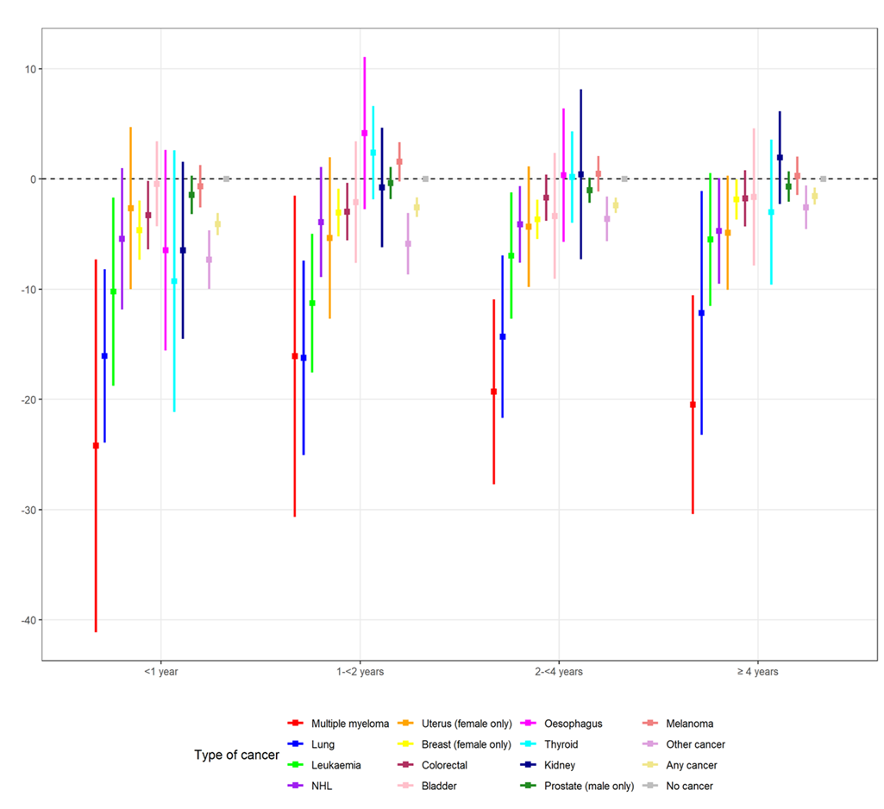
Difference between those diagnosed with cancer and those without cancer in change in Medical Outcomes Study Physical Functioning (MOS-PF) scores, adjusted for age at follow-up, sex, education, residence, country of birth, months of follow-up, and baseline score of physical functioning limitation.
NHL: non-Hodgkin’s Lymphoma
Diagnosis codes grouped under “other cancer” and the corresponding numbers of participants are included in Additional File 1: Table S1.3.

Figure S2.1b. Changes in physical functioning stratified by stage of cancer and type of cancer diagnosed
Difference between those diagnosed with cancer and those without cancer in change in Medical Outcomes Study Physical Functioning (MOS-PF) scores, adjusted for age at follow-up, sex, education, residence, country of birth, months of follow-up, and baseline score of physical functioning limitation.
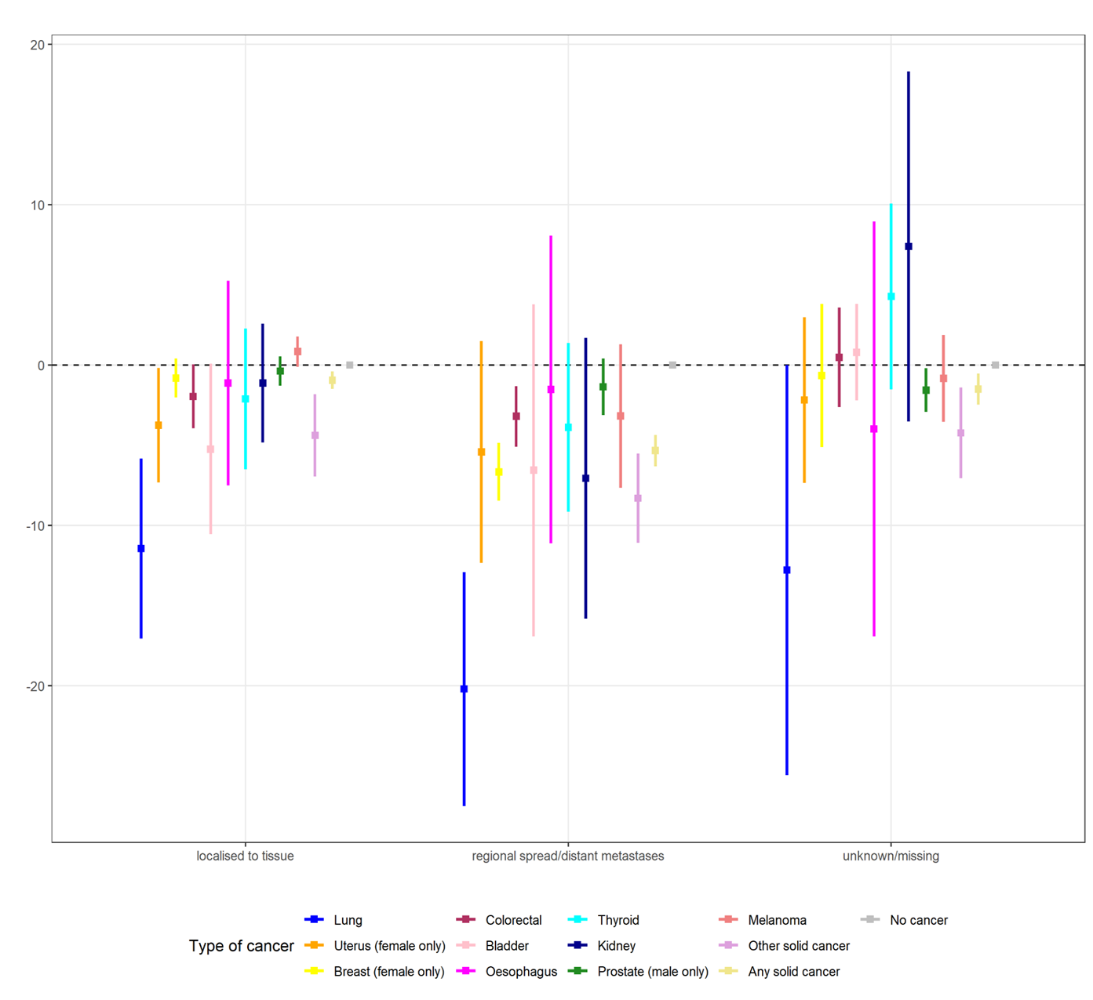
NHL: non-Hodgkin’s Lymphoma
Diagnosis codes grouped under “other cancer” and the corresponding numbers of participants are included in Additional File 1: Table S1.3.

Figure S2.1c. Changes in physical functioning stratified by recent treatment of cancer and type of cancer diagnosed
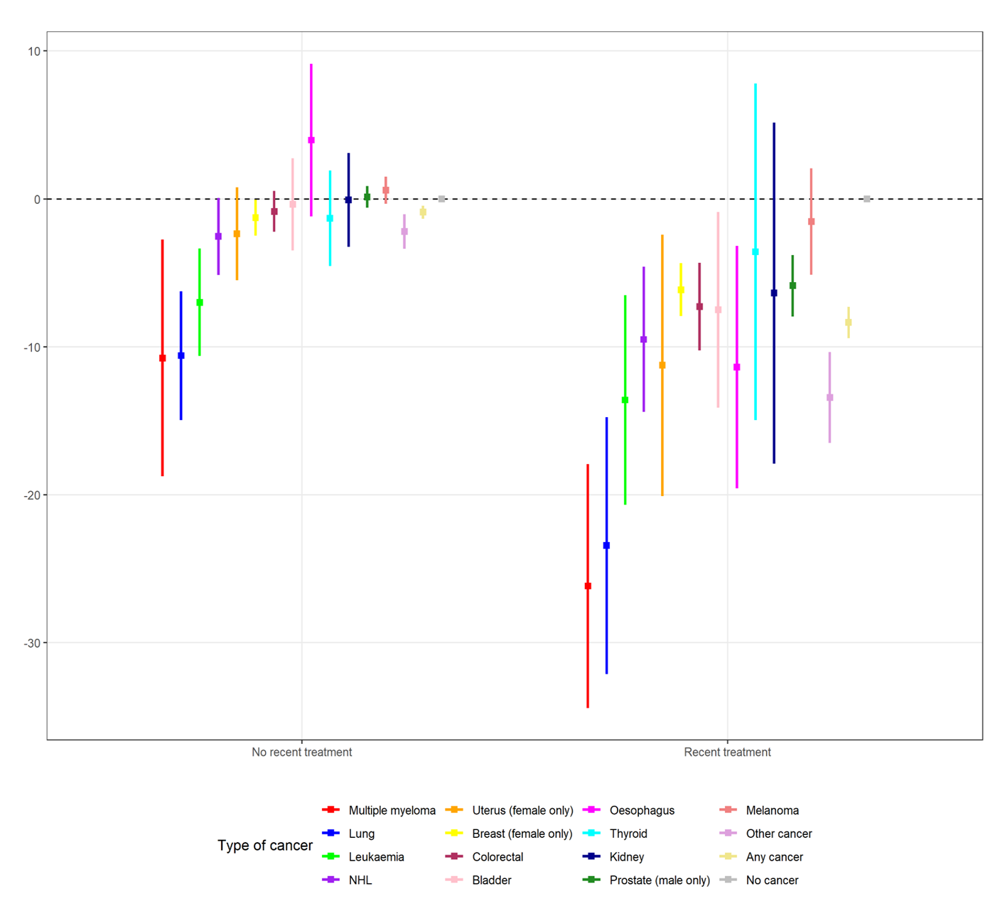
Difference between those diagnosed with cancer and those without cancer in change in Medical Outcomes Study Physical Functioning (MOS-PF) scores, adjusted for age at follow-up, sex, education, residence, country of birth, months of follow-up, and baseline score of physical functioning limitation.

NHL: non-Hodgkin’s Lymphoma
Diagnosis codes grouped under “other cancer” and the corresponding numbers of participants are included in Additional File 1: Table S1.3.

Figure S2.2a. Changes in psychological distress stratified by time since diagnosis of cancer and type of cancer diagnosed
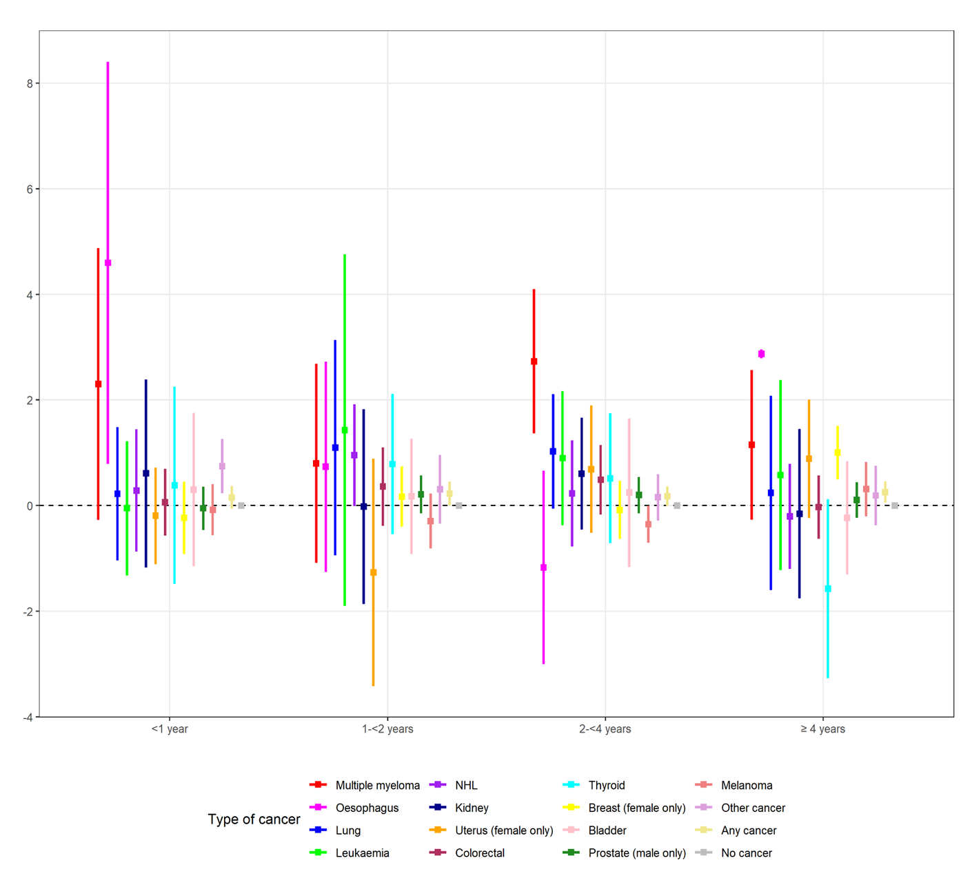
Difference between those diagnosed with cancer and those without cancer in change in Kessler-10 (K10) scores, adjusted for age at follow-up, sex, education, residence, country of birth, months of follow-up and baseline score of K10.
NHL: non-Hodgkin’s Lymphoma
Diagnosis codes grouped under “other cancer” and the corresponding numbers of participants are included in Additional File 1: Table S1.3.

Figure S2.2b. Changes in psychological distress stratified by stage of cancer and type of cancer diagnosed
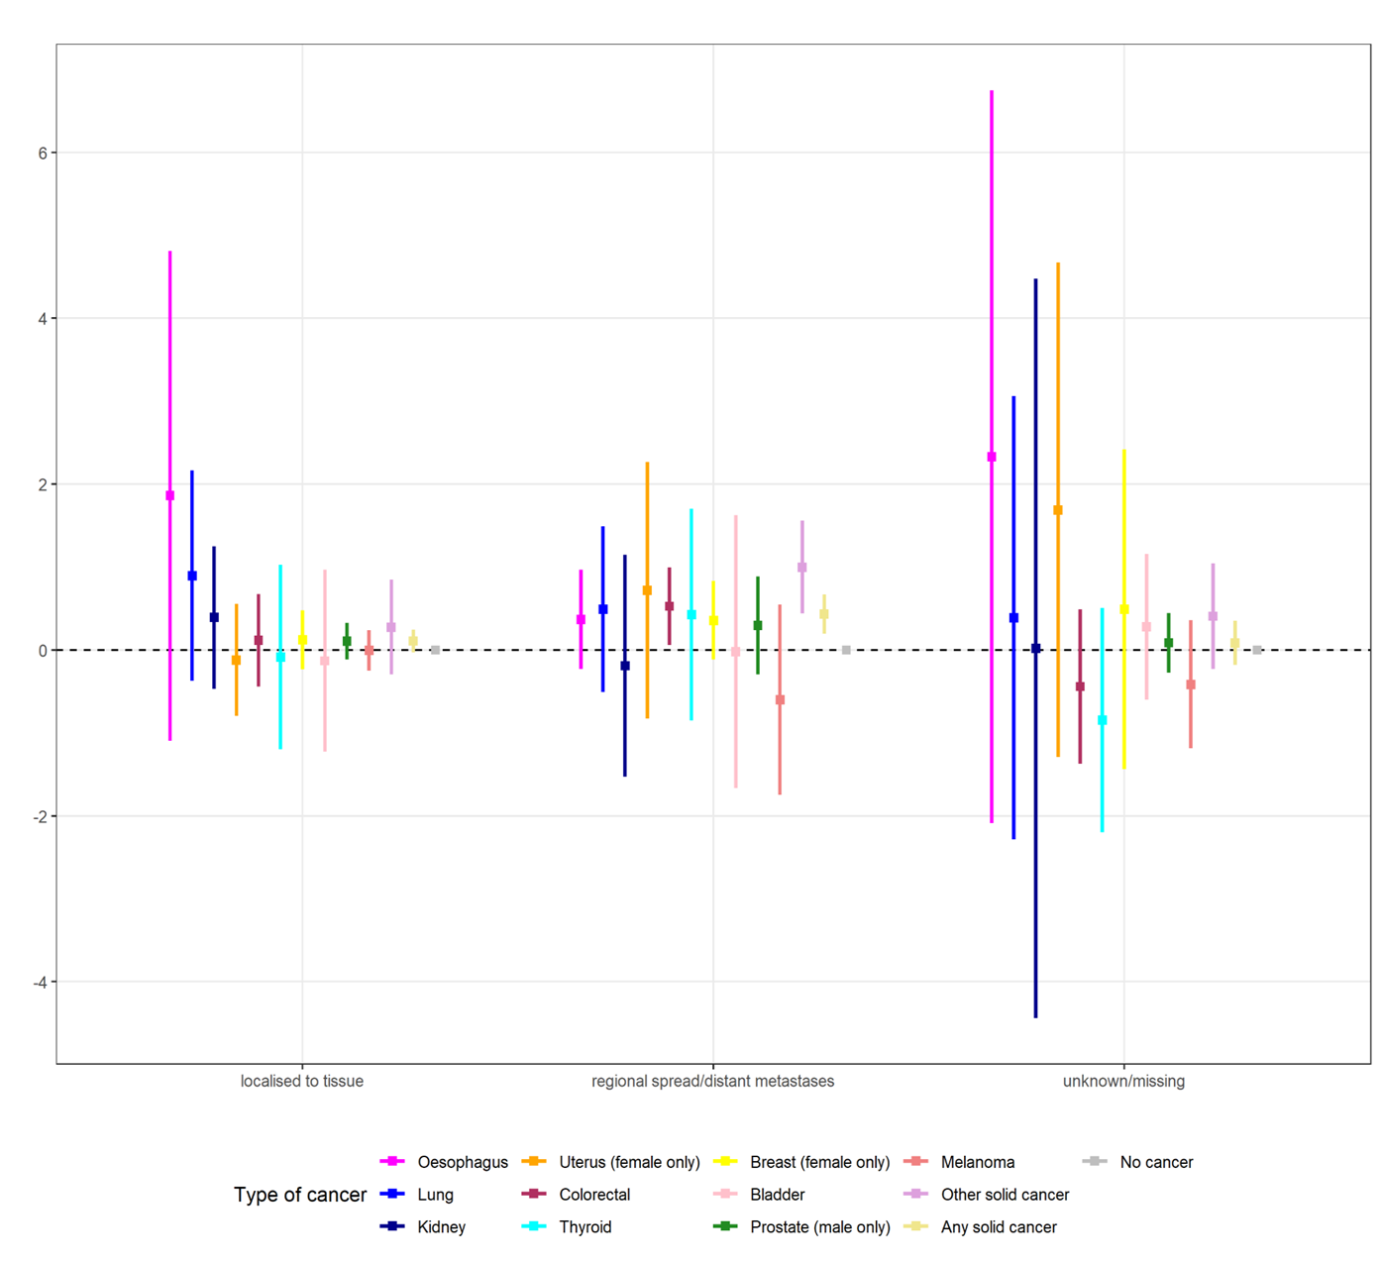
Difference between those diagnosed with cancer and those without cancer in change in Kessler-10 (K10) scores, adjusted for age at follow-up, sex, education, residence, country of birth, months of follow-up, and baseline score of K10.

NHL: non-Hodgkin’s Lymphoma
Diagnosis codes grouped under “other cancer” and the corresponding numbers of participants are included in Additional File 1: Table S1.3.

Figure S2.2c. Changes in psychological distress stratified by recent treatment of cancer and type of cancer diagnosed
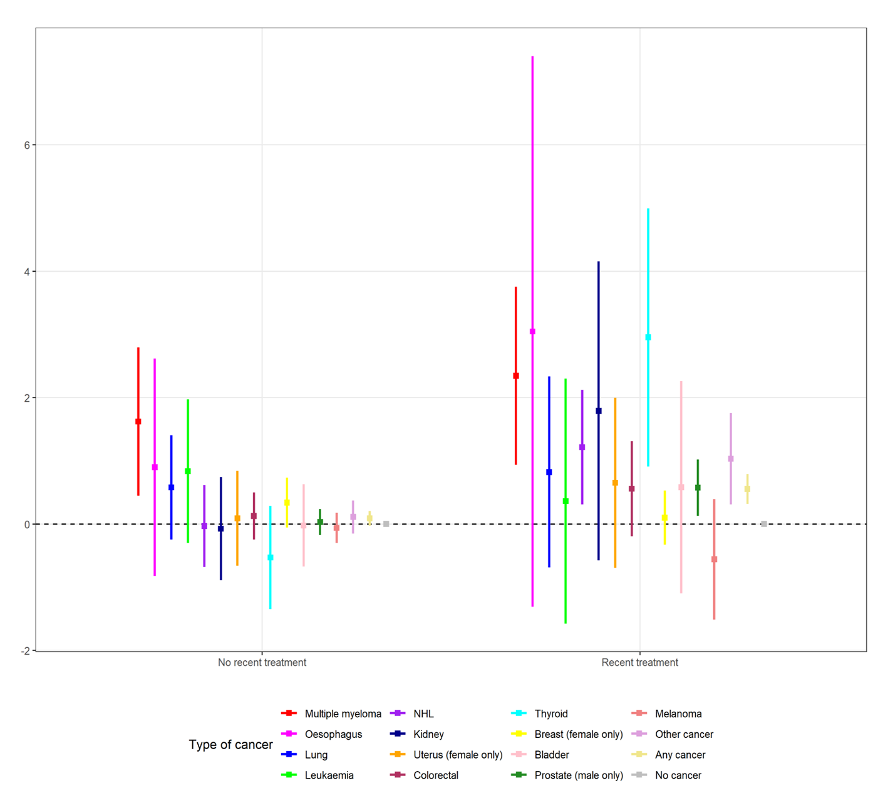
Difference between those diagnosed with cancer and those without cancer in change in Kessler-10 (K10) scores, adjusted for age at follow-up, sex, education, residence, country of birth, months of follow-up, and baseline score of K10.

NHL: non-Hodgkin’s Lymphoma
Diagnosis codes grouped under “other cancer” and the corresponding numbers of participants are included in Additional File 1: Table S1.3.

