Table S1. CT acquisition parameters
Parameters | Training cohort | External validation cohort
CT equipment | BrightSpeed RT 16 Elite; Aquilion ONE 640, TOSHIBA; LightSpeed CT750 HD, GE Healthcare; SOMATOM CT, Siemens Healthcare; Somatom Sensation Cardiac 64, Siemens Healthcare; Brilliance iCT, Philips Healthcare; | Discovery 750, GE Healthcare; Somatom Definition Flash, Siemens Healthcare; Aquilion ONE, TOSHIBA
Matrix size | 512 × 512 | 512 × 512
Pitch | 0.8 | 0.8
Tube voltage | 120 kV | 120 kV
Slice thickness | 5mm | 5mm
Detector collimation | 64×0.6mm  or 64×0.625mm | 64×0.6mm  or 64×0.625mm
Contrast agent | Ultravist 370 or Omnipaque 350 | Omnipaque 350
Injection rate | 3.0ml/s | 3.0ml/s
Contrast medium dose | 80~90ml | 80~90ml

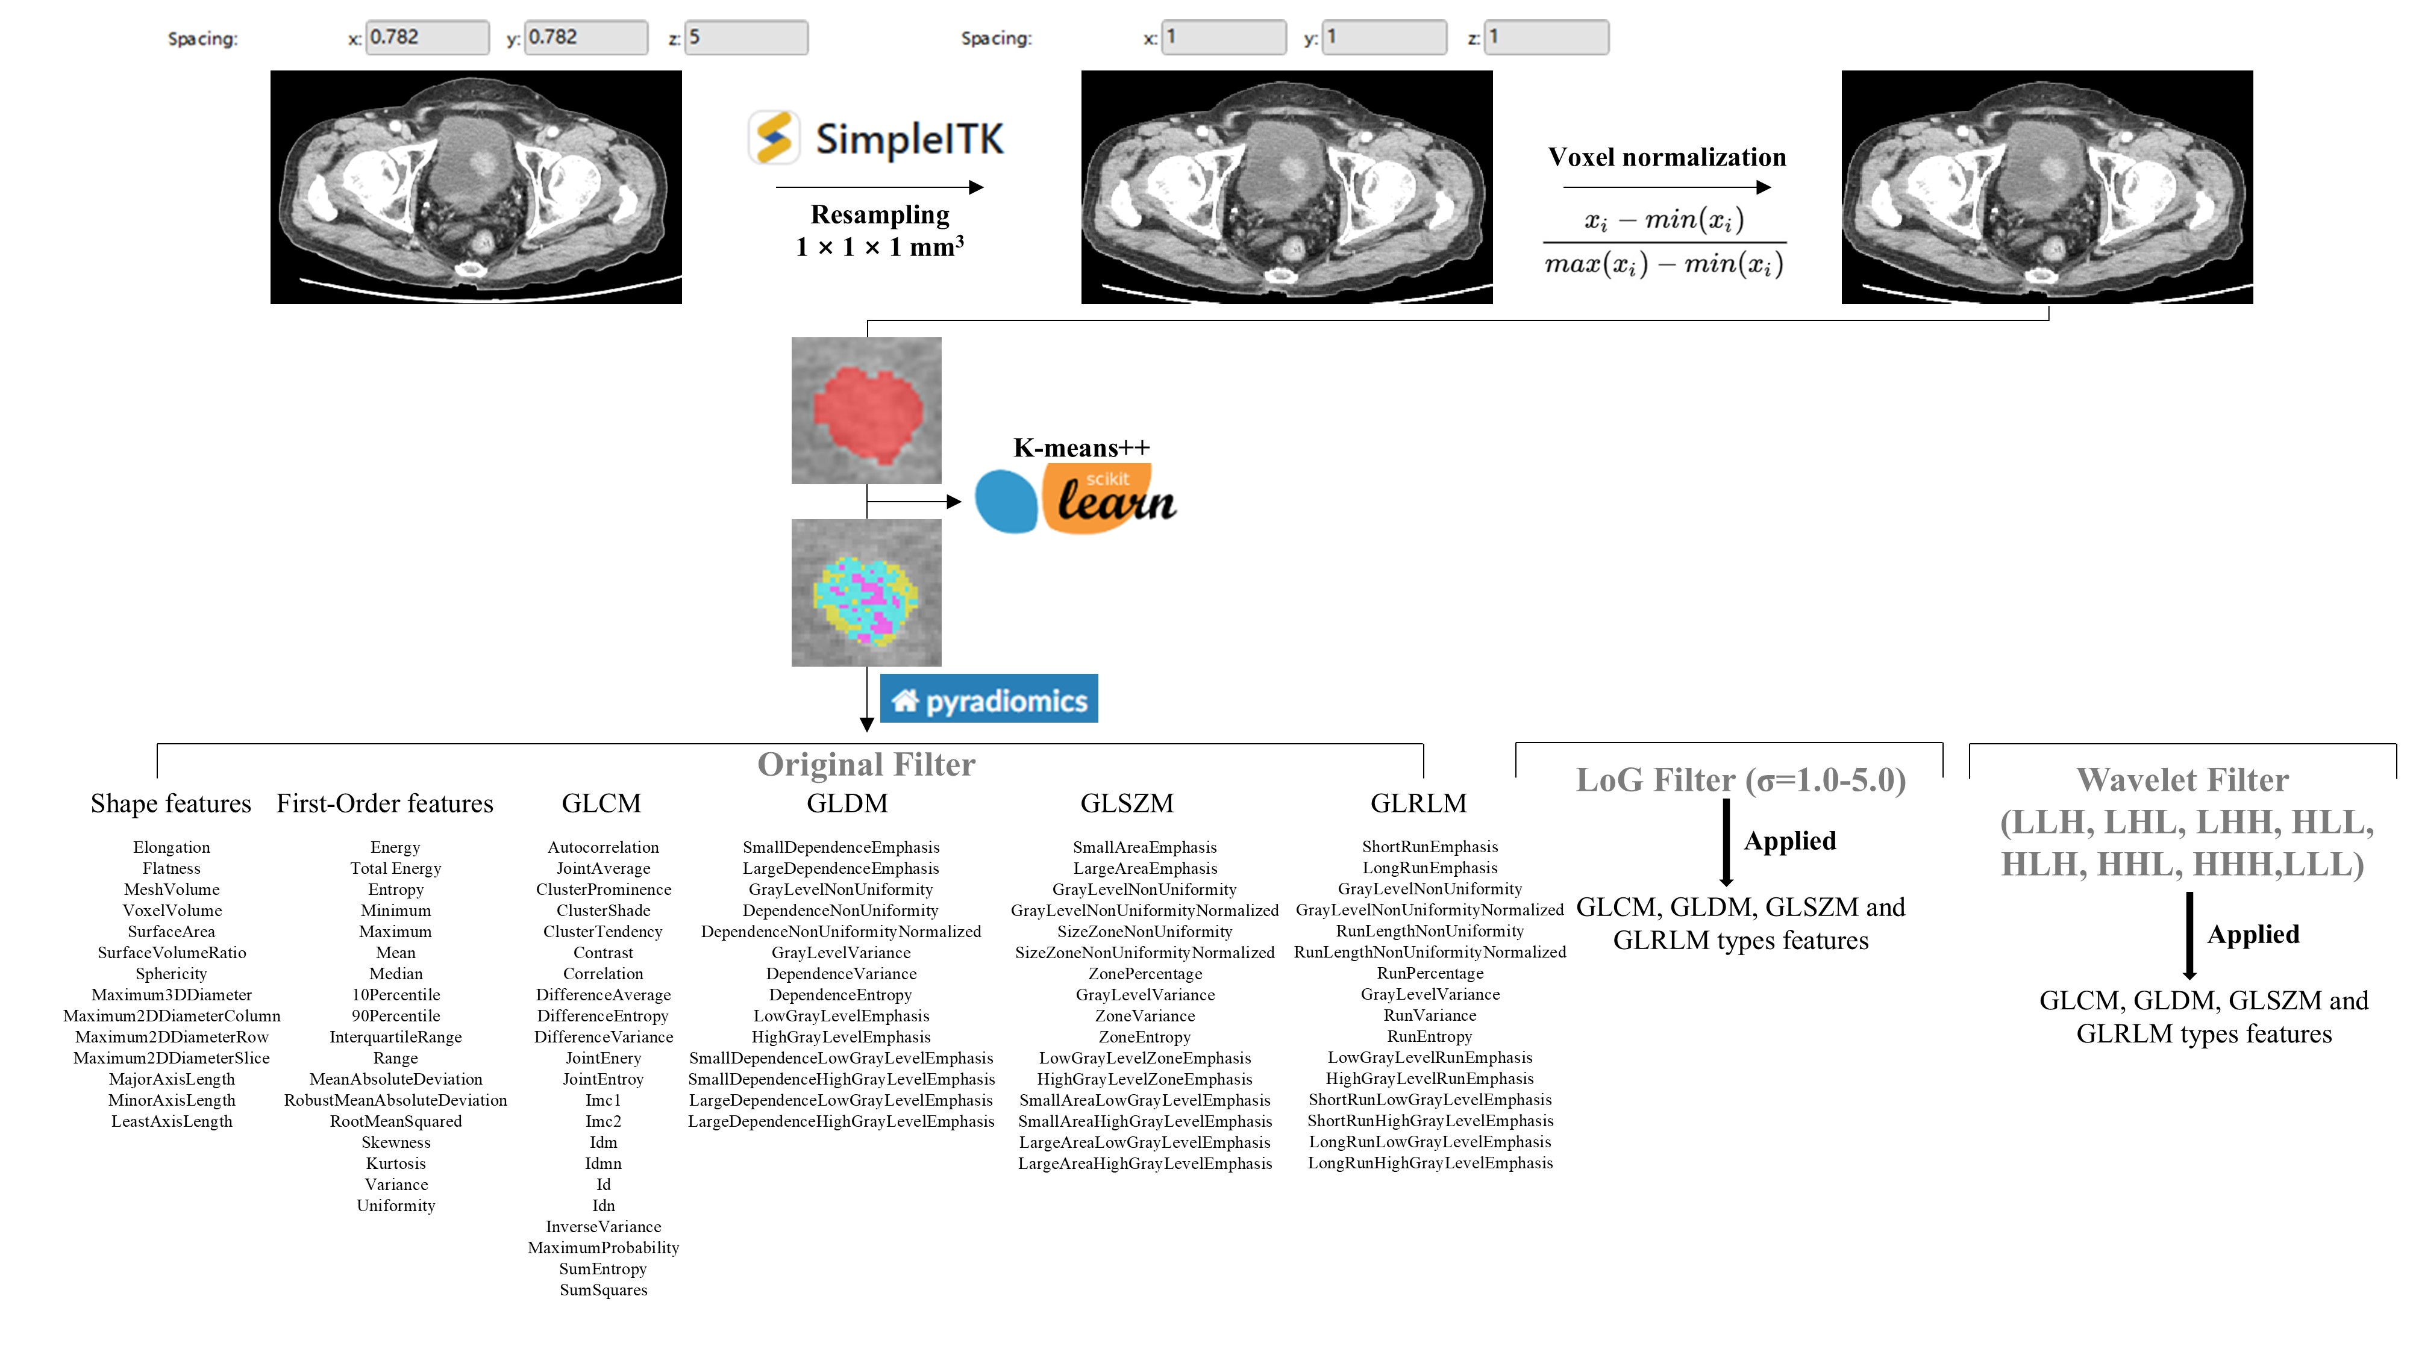
Figure S1. Schematic representation of the CT image preprocessing and radiomic feature extraction pipeline. The raw images were initially resampled using the SimpleITK open-source toolkit to standardize voxel dimensions. Tumor subregion segmentation was subsequently performed through clustering analysis implemented with the Scikit-learn library. Radiomic features were then extracted from each distinct subregion using the PyRadiomics package, employing three filter configurations: original (unfiltered) images, Laplacian of Gaussian (LoG) filters with σ values ranging from 1 to 5, and wavelet transforms incorporating eight scale combinations. The comprehensive feature set included 14 shape features, 18 first-order statistical features, 22 gray-level co-occurrence matrix (GLCM) features, 14 gray-level dependence matrix (GLDM) features, 16 gray-level size zone matrix (GLSZM) features, and 16 gray-level run length matrix (GLRLM) features.

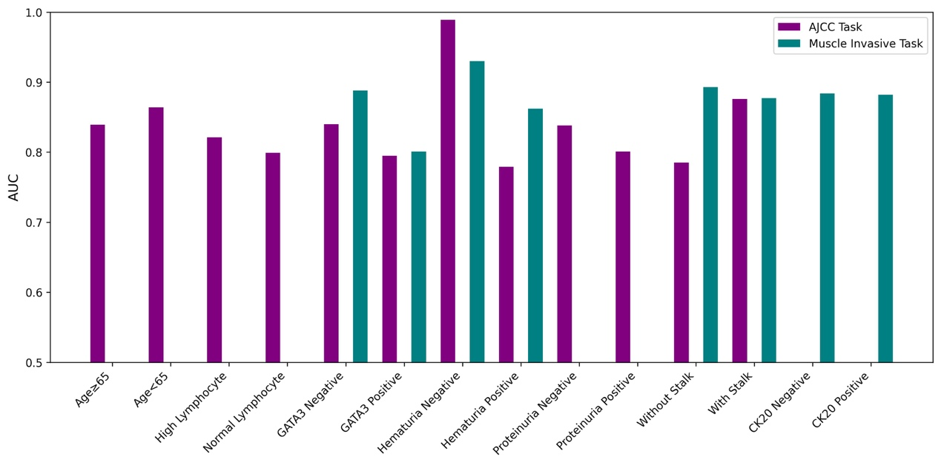
Figure S2. Subgroup analysis was performed based on optimal clinicopathologic characteristics to determine whether differences between the two cohorts could affect the validation process. For the muscle invasive task, the most relevant clinicopathologic variables were CK20, GATA3, hematuria, and stalk. For the AJCC task, the most relevant clinicopathologic variables were age, lymphocytes, GATA3, hematuria, proteinuria, and stalk.

