Fig. S1. Western blot analysis of synaptic proteins in the hippocampus of Aβ1–42-injected mice.
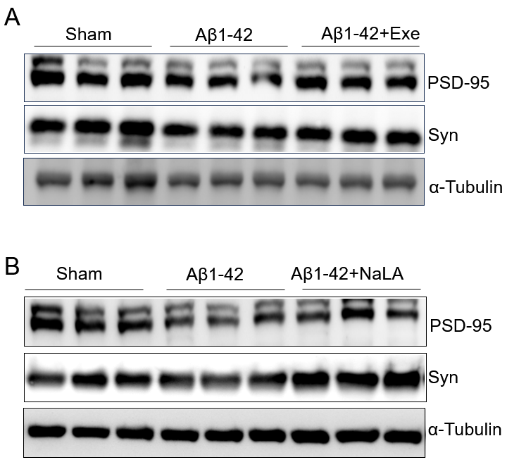
Fig. S1. Western blot analysis of synaptic proteins in the hippocampus of Aβ-injected mice.
A. Representative Western blot images of PSD-95 and Syn expression in hippocampal homogenates from Sham, Aβ1–42, and Aβ1–42+Exe groups.
B. Representative Western blot images of PSD-95 and Syn expression in hippocampal homogenates from Sham, Aβ1–42, and Aβ1–42+NaLA groups.

