Additional File 2: Figures S1 - S3.
Figure S1. Flow diagram of included studies
Figure S2. Overall analysis of weight change after drug withdrawal
Figure S3. Subgroup analysis of weight change after drug withdrawal

Figure S1. Flow diagram of included studies

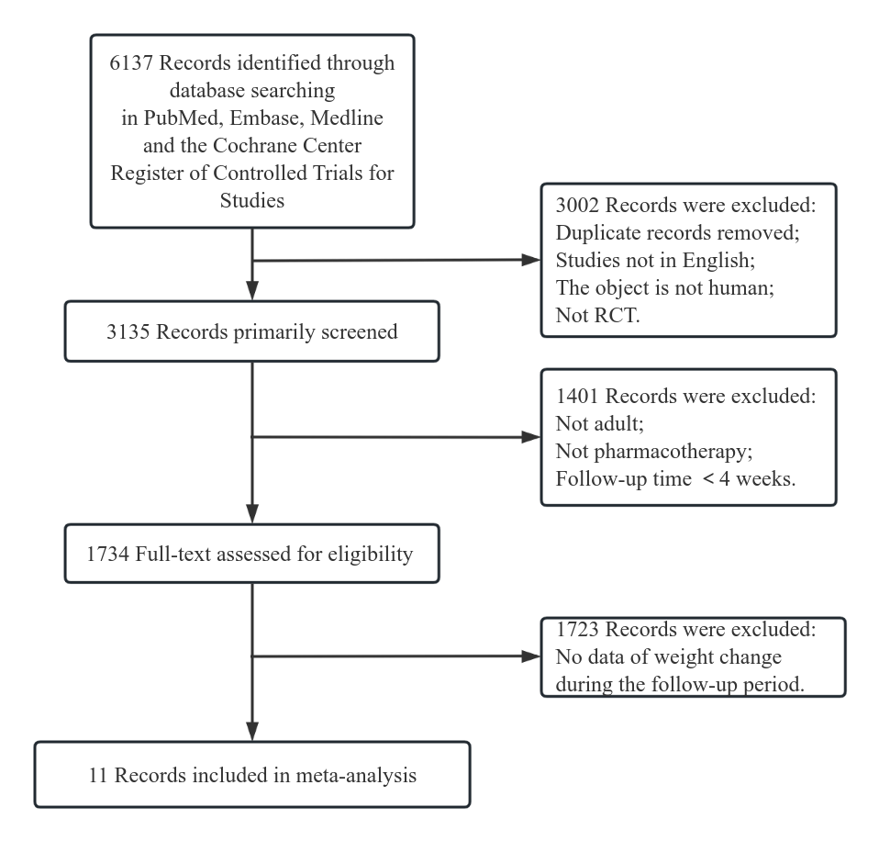

Figure S2. Overall analysis of weight change after discontinuation of AOMs
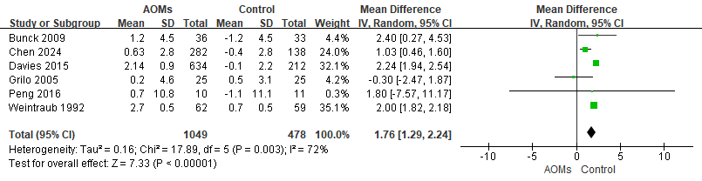

AOM:anti obesity medication

Figure S3. Subgroup analysis of weight change after discontinuation of AOMs
