Additional file 1

Section 1. Measurement of healthy lifestyle behaviours
Smoking
Participants were inquired about smoking status (never, former, or current smokers). Ever smokers were further asked about the frequency and type of cigarette smoking as well as the amount of tobacco consumed per day. Former smokers were additionally asked about the reasons for cessation. We defined both previous tobacco users and current users as smokers.
Alcohol consumption
For alcohol consumption, habitual drinking frequency (‘never’, ‘once or less per month’, ‘2-4 times per month’, ‘2-3 times per week’, ‘more than 4 times per week’) and the amount of alcohol consumption was asked in the questionnaire. The healthy group for alcohol use was defined as never drinkers, or drinkers who drank no more than 25g (for male) or 15g (for female) per day on average, according to the Chinese dietary guideline.
Leisure time physical activity (LTPA)
We measured habitual exercise by asking about typical type of activity at different intensity levels (vigorous or moderate), frequency, and exercise time per week. Participants who performed at least 150min of moderate-intensity aerobic activities or 75min of vigorous intensity aerobic activities per week were considered as having sufficient LTPA.
Typical type and intensity of LTPA
Type | Intensity
Tai-Chi/qigong/leisure walking | Moderate
Running/aerobic exercise | Vigorous
Ball games (e.g., basketball, table tennis, badminton) | Moderate
Brisk walking/gymnastics/folk dancing | Moderate
Swimming | Vigorous
Other exercise (e.g., mountain walking, home exercise and rope jumping) | Moderate
* LTPA: leisure time physical activity

Assessment of food intake
Habitual food intake frequency during the past year was asked in the questionnaire: ‘daily’, ‘4-6 days per week’, ‘1-3 days per week’, ‘1-3 days per month’, ‘never or almost never’. Based on the recommendations in the Chinese Dietary Guidelines, a healthy diet score was calculated by the weekly intake of 6 food groups, including the daily intake of fresh fruit, fresh vegetables, and whole grains, and eating fish and other seafood ≥1day per week, bean and bean food ≥4days per week, and red meat <7days per week. For each food group, the participant who met the criterion scored 1, otherwise, scored 0. The full mark of the healthy diet score was 6 and the healthy group was defined as those whose score≥4.
The definition of healthy diet score
Food groups | ‘Healthy’ (score=1)
Fresh fruit | every day per week
Fresh vegetables | every day per week
Whole grains | every day per week
Fish and other seafood | ≥ 1 day per week
Bean and bean products | ≥ 4 days per week
Red meat | <7 days per week

Section 2. Measurement of blood glucose and blood pressure
Blood glucose level was measured by a rapid blood glucose analyzer (BeneCheck BK6–20M Multi-Monitoring System, Suzhou Pu Chun Tang Biotechnology, China). Participants were considered in a fasting state if they had eaten their last meal at least eight hours before their visits.
Blood pressure was measured twice in the left upper arm after 5 min of rest in a seated position using a standardized electronic blood pressure monitor (Omron HEM-7430c, Omron Corporation, Kyoto, Japan), avoid exercise, eating or smoking before measuring blood pressure. The measurement process takes about 30 seconds, and the results are automatically displayed. If the difference between the two systolic blood pressure measurements was more significant than 10 mm Hg, a third measurement was obtained, and the average of the last two readings was used.

Figure S1. The Distribution of Estimated Sodium Intake over the Chinese mainland
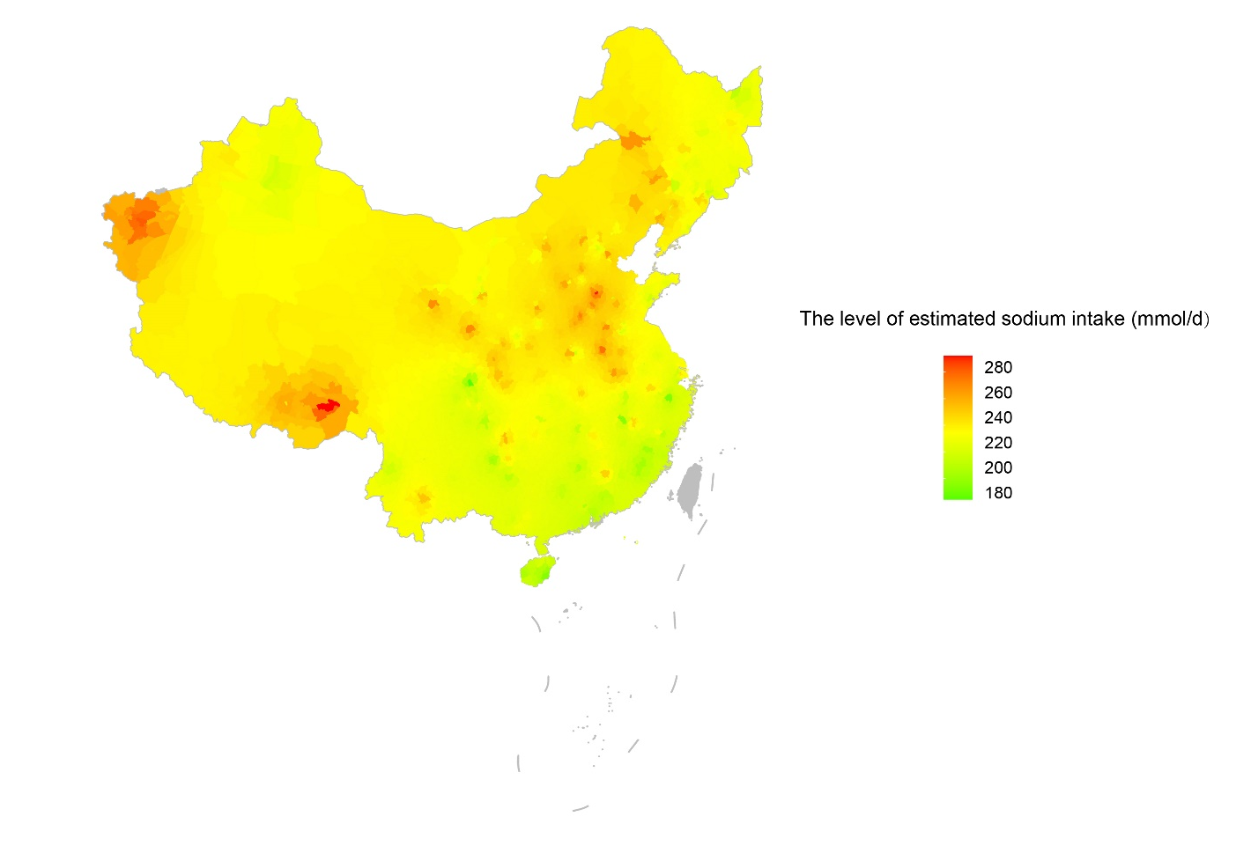

Figure S2. Flow diagram of study selection

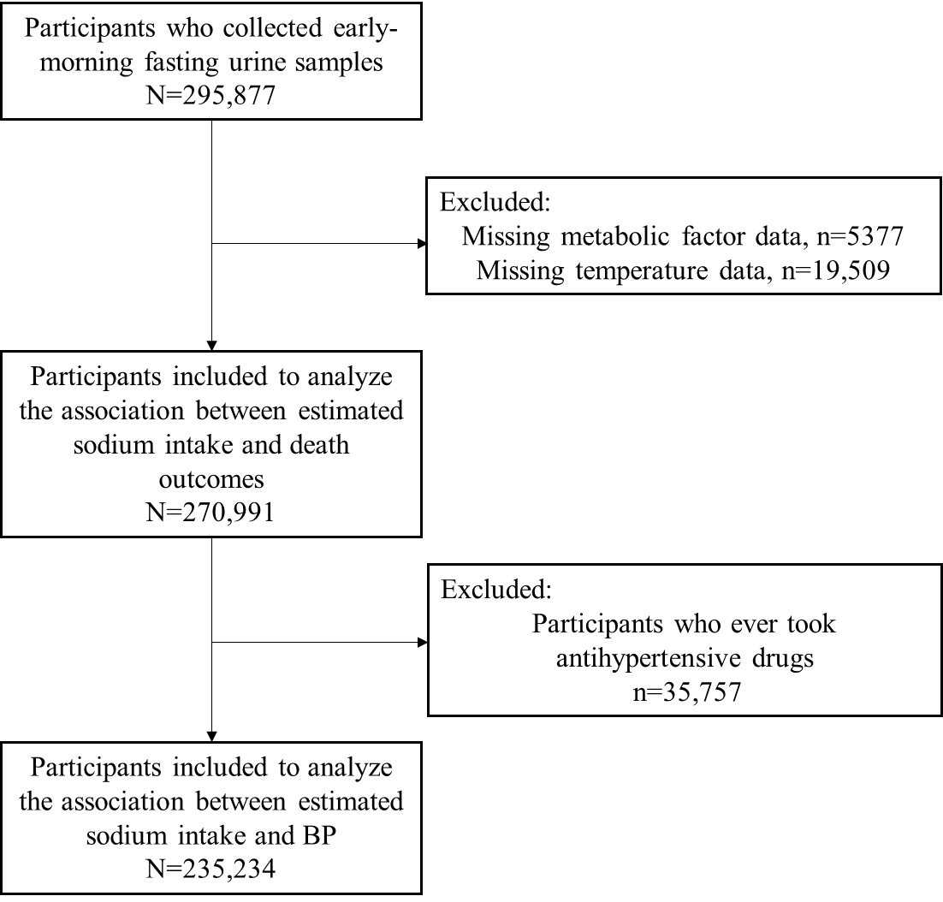

Figure S3. Association between estimated sodium intake and blood pressure stratified by sex, age, urbanity, body mass index, and self-reported history of hypertension
- Systolic blood pressure
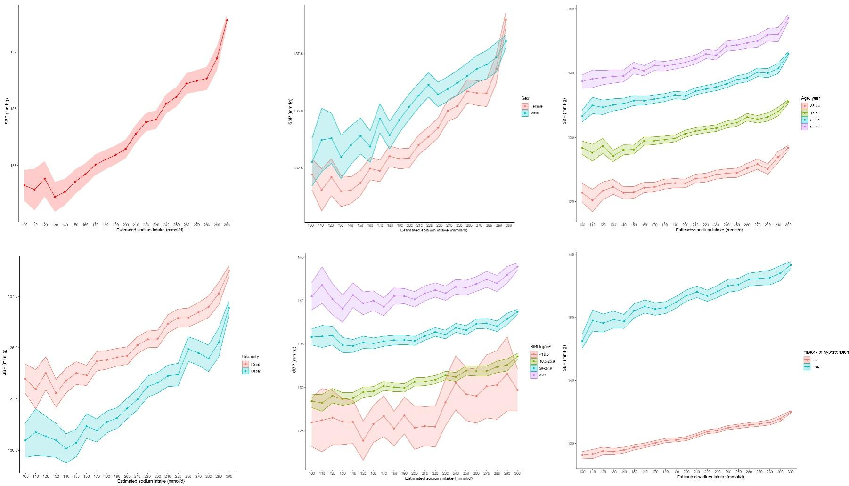
- Diastolic blood pressure
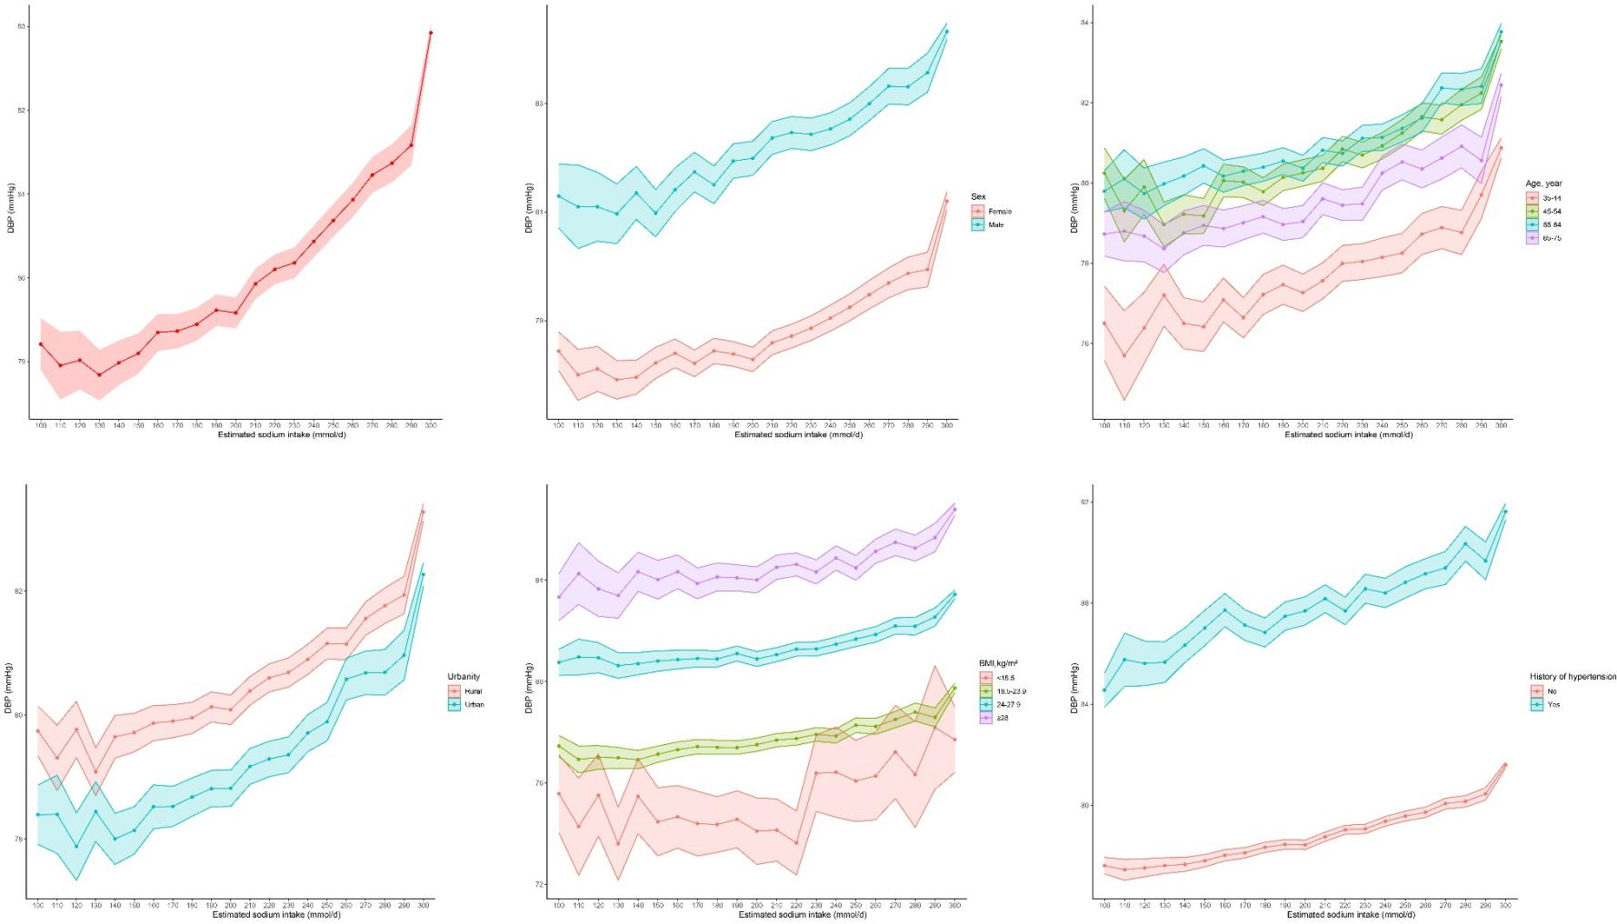
NOTE:
BMI=body mass index; DBP=diastolic blood pressure; SBP=systolic blood pressure

Figure S4. Tests for the proportion hazard (PH) of the Cox models.
We provided the plot of Schoenfeld test for each variable to test the PH assumption using R package. It was demonstrated that the PH assumption can be fully satisfied.
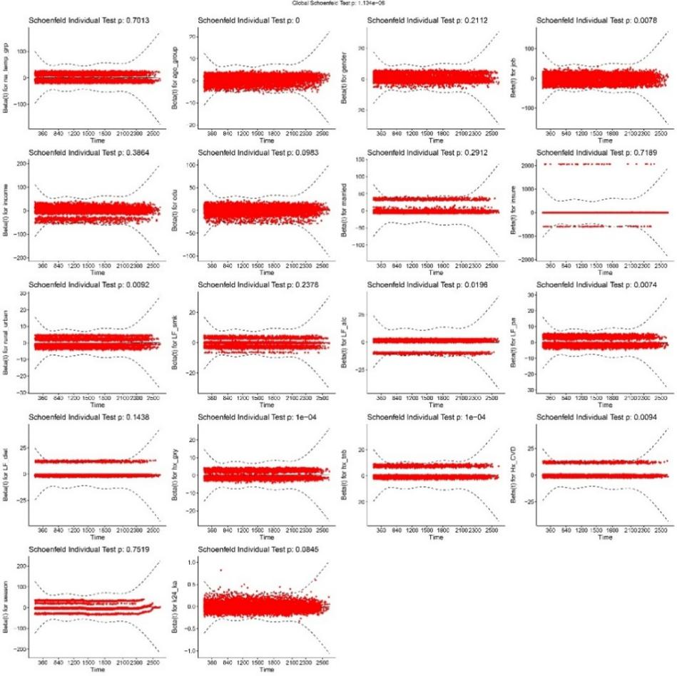

Figure S5. The association between estimated sodium intake and risk of CVD death among different subgroups.
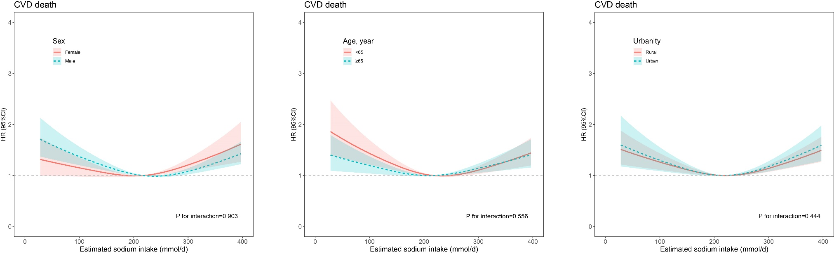

NOTE:
Models were adjusted for age, sex, annual household income, occupation, education level, marriage, medical insurance, urbanity, seasons, tobacco smoking, alcohol consumption, leisure time physical activity, diet patterns, history of hypertension, diabetes mellitus and CVD, and estimated urinary potassium excretion.
CVD=cardiovascular disease

Figure S6. The association between estimated sodium intake and risk of CVD death in the sensitivity analysis
(A) Participants without history of CVD, cancer, COPD, and CKD
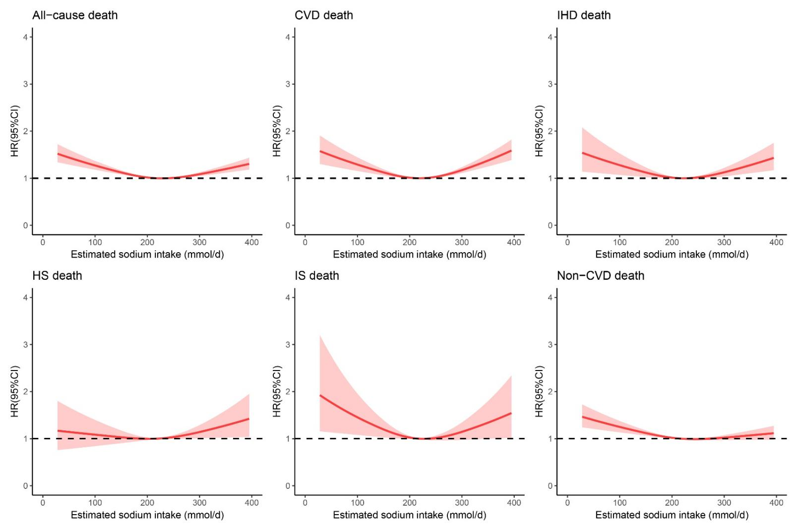

(B) Participants without those who died within the first year
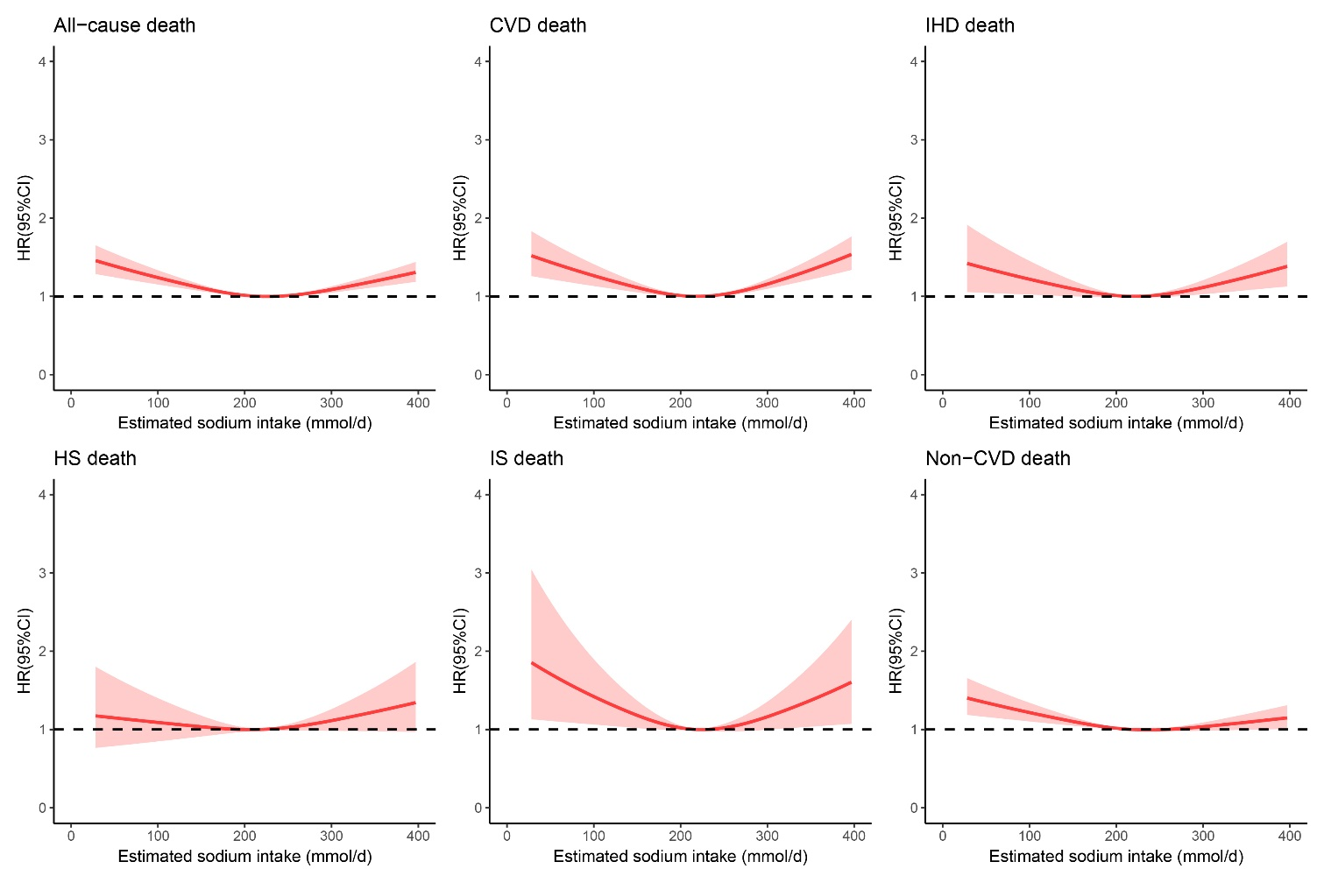
NOTE:
Models were adjusted for age, sex, annual household income, occupation, education level, marriage, medical insurance, urbanity, seasons, tobacco smoking, alcohol consumption, leisure time physical activity, diet patterns, history of hypertension and diabetes mellitus, and estimated urinary potassium excretion.
CKD=chronic kidney disease; COPD=chronic obstructive pulmonary disease; CVD=cardiovascular disease; HS=hemorrhagic stroke; IHD=ischemic heart disease; IS=ischemic stroke

Figure S7. Directed acyclic graph of key variables
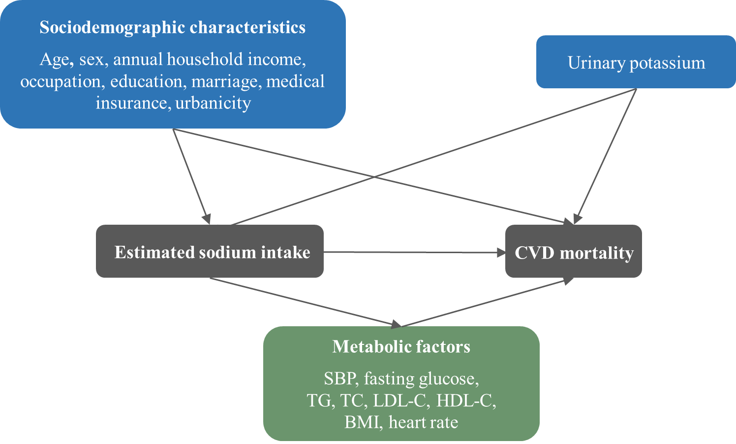

Table S1. Association between estimated sodium intake (per 100 mmol/d) and blood pressure by multiple linear regressions
 | SBP |  | DBP
 | β (95%CI) | P for interaction | β (95%CI) | P for interaction
All participants | 4.14 (4.02, 4.25)*** | - | 1.58 (1.51, 1.64)*** | -
Sex |  | <0.001 |  | 0.575
Female | 4.30 (4.14, 4.45)*** |  | 1.51 (1.42, 1.60)***
Male | 3.73 (3.57, 3.90)*** |  | 1.56 (1.46, 1.66)***
Age, year |  | <0.001 |  | 0.664
35-44 | 2.18 (1.94, 2.42)*** |  | 1.10 (0.94, 1.25)***
45-54 | 3.57 (3.38, 3.76)*** |  | 1.52 (1.41, 1.64)***
55-64 | 4.82 (4.61, 5.02)*** |  | 1.76 (1.64, 1.88)***
65-75 | 5.43 (5.15, 5.70)*** |  | 1.62 (1.46, 1.77)***
Urbanity |  | <0.001 |  | 0.098
Rural | 4.18 (4.04, 4.32)*** |  | 1.59 (1.51, 1.68)***
Urban | 4.12 (3.94, 4.30)*** |  | 1.56 (1.45, 1.67)***
BMI, kg/m² |  | 0.292 |  | 0.005
<18.5 | 4.35 (3.47, 5.23)*** |  | 1.47 (0.94, 2.01)***
18.5-23.9 | 3.82 (3.65, 4.00)*** |  | 1.25 (1.14, 1.35)***
24-27.9 | 3.62 (3.45, 3.80)*** |  | 1.30 (1.20, 1.40)***
≥28 | 3.70 (3.44, 3.97)*** |  | 1.28 (1.13, 1.44)***
Self-reported history of hypertension |  | <0.001 |  | <0.001
No | 3.89 (3.77, 4.01)*** |  | 1.52 (1.44, 1.59)***
Yes | 5.51 (5.19, 5.82)*** |  | 1.91 (1.72, 2.09)***

NOTE:
Models were adjusted for age, sex, annual household income, occupation, education level, marriage, medical insurance, urbanity, seasons, tobacco smoking, alcohol consumption, leisure time physical activity, diet patterns, history of hypertension, diabetes mellitus and CVD, and estimated urinary potassium excretion.
BMI=body mass index; CI=confidence interval; DBP= diastolic blood pressure; SBP=systolic blood pressure

Table S2. The results of the main analysis and sensitivity analysis on the association between estimated sodium intake and risk of death
 | Q1 | Q2 | Q3 | Q4 | Q5
Model 1
All-cause mortality | 1.15 (1.07, 1.23) *** | 0.99 (0.92, 1.06) | Reference | 0.96 (0.89, 1.03) | 1.08 (1.01, 1.16) *
CVD mortality | 1.17 (1.05, 1.30) ** | 1.03 (0.92, 1.15) | Reference | 0.99 (0.88, 1.11) | 1.18 (1.05, 1.32)
IHD mortality | 1.16 (0.97, 1.38) | 1.00 (0.84, 1.20) | Reference | 1.00 (0.83, 1.20) | 1.19 (0.99, 1.43)
HS mortality | 1.04 (0.82, 1.31) | 1.00 (0.79, 1.27) | Reference | 0.82 (0.64, 1.06) | 1.16 (0.91, 1.47)
IS mortality | 1.28 (0.96, 1.70) | 0.96 (0.71, 1.31) | Reference | 1.00 (0.73, 1.37) | 1.04 (0.76, 1.44)
Non-CVD mortality | 1.13 (1.04, 1.24) ** | 0.96 (0.88, 1.05) | Reference | 0.94 (0.85, 1.03) | 1.02 (0.92, 1.12)
Model 2
All-cause mortality | 1.16 (1.08, 1.24) *** | 0.97 (0.90, 1.04) | Reference | 0.96 (0.89, 1.04) | 1.10 (1.02, 1.19) *
CVD mortality | 1.18 (1.06, 1.33) ** | 1.01 (0.90, 1.14) | Reference | 0.99 (0.87, 1.12) | 1.22 (1.08, 1.38) **
IHD mortality | 1.24 (1.03, 1.49) * | 1.01 (0.83, 1.23) | Reference | 1.00 (0.82, 1.22) | 1.27 (1.04, 1.55) *
HS mortality | 1.03 (0.80, 1.31) | 0.95 (0.74, 1.23) | Reference | 0.82 (0.63, 1.08) | 1.16 (0.90, 1.48)
IS mortality | 1.31 (0.97, 1.78) | 0.93 (0.67, 1.30) | Reference | 0.99 (0.70, 1.39) | 1.11 (0.79, 1.56)
Non-CVD mortality | 1.14 (1.04, 1.25) ** | 0.94 (0.86, 1.04) | Reference | 0.95 (0.86, 1.04) | 1.02 (0.92, 1.13)
Model 3
All-cause mortality | 1.13 (1.05, 1.22) *** | 0.99 (0.92, 1.07) | Reference | 0.97 (0.90, 1.05) | 1.10 (1.02, 1.19) *
CVD mortality | 1.16 (1.03, 1.29) * | 1.02 (0.91, 1.15) | Reference | 0.99 (0.88, 1.12) | 1.18 (1.05, 1.33) **
IHD mortality | 1.13 (0.94, 1.35) | 1.00 (0.82, 1.20) | Reference | 1.00 (0.82, 1.21) | 1.18 (0.97, 1.43)
HS mortality | 1.08 (0.85, 1.37) | 0.97 (0.76, 1.25) | Reference | 0.83 (0.63, 1.08) | 1.16 (0.91, 1.50)
IS mortality | 1.23 (0.92, 1.65) | 0.95 (0.69, 1.31) | Reference | 0.99 (0.71, 1.37) | 1.04 (0.75, 1.46)
Non-CVD mortality | 1.11 (1.01, 1.22) * | 0.97 (0.88, 1.07) | Reference | 0.95 (0.86, 1.05) | 1.04 (0.94, 1.15)
Model 4
All-cause mortality | 1.16 (0.82, 1.64) | 1.14 (0.80, 1.62) | Reference | 1.09 (0.76, 1.56) | 0.99 (0.69, 1.43)
CVD mortality | 0.89 (0.51, 1.54) | 1.05 (0.62, 1.81) | Reference | 0.98 (0.56, 1.73) | 1.01 (0.57, 1.79)
IHD mortality | 0.72 (0.31, 1.70) | 0.77 (0.32, 1.87) | Reference | 0.78 (0.31, 2.00) | 0.80 (0.30, 2.11)
HS mortality | 0.54 (0.09, 3.40) | 1.36 (0.34, 5.42) | Reference | 0.53 (0.09, 3.17) | 1.38 (0.33, 5.67)
IS mortality | 2.63 (0.50, 13.8) | 4.73 (1.05, 21.3) * | Reference | 1.63 (0.29, 9.07) | 3.09 (0.64, 14.9)
Non-CVD mortality | 1.42 (0.90, 2.26) | 1.22 (0.76, 1.95) | Reference | 1.20 (0.75, 1.91) | 1.01 (0.62, 1.63)
Model 5
All-cause mortality | 1.09 (1.02, 1.17) | 0.97 (0.91, 1.04) | Reference | 0.98 (0.91, 1.05) | 1.12 (1.04, 1.21)
CVD mortality | 1.12 (1.00, 1.24) | 1.02 (0.91, 1.14) | Reference | 1.00 (0.89, 1.12) | 1.21 (1.08, 1.35)
IHD mortality | 1.10 (0.93, 1.31) | 0.99 (0.83, 1.19) | Reference | 1.01 (0.84, 1.22) | 1.21 (1.01, 1.46)
HS mortality | 0.99 (0.79, 1.26) | 0.98 (0.77, 1.25) | Reference | 0.83 (0.64, 1.07) | 1.19 (0.93, 1.51)
IS mortality | 1.22 (0.92, 1.62) | 0.95 (0.70, 1.29) | Reference | 1.02 (0.74, 1.39) | 1.07 (0.78, 1.48)
Non-CVD mortality | 1.07 (0.98, 1.17) | 0.94 (0.86, 1.03) | Reference | 0.96 (0.87, 1.05) | 1.06 (0.97, 1.17)
Model 6
All-cause mortality | 1.15 (1.07, 1.23) * | 0.99 (0.92, 1.06) | Reference | 0.96 (0.89, 1.03) | 1.09 (1.01, 1.17) *
CVD mortality | 1.17 (1.05, 1.30) * | 1.03 (0.92, 1.15) | Reference | 0.99 (0.88, 1.11) | 1.18 (1.05, 1.32)
IHD mortality | 1.16 (0.98, 1.38) | 1.01 (0.84, 1.21) | Reference | 1.00 (0.83, 1.20) | 1.18 (0.98, 1.42)
HS mortality | 1.04 (0.82, 1.31) | 1.00 (0.79, 1.27) | Reference | 0.82 (0.64, 1.06) | 1.16 (0.92, 1.48)
IS mortality | 1.28 (0.96, 1.70) | 0.96 (0.71, 1.31) | Reference | 1.01 (0.74, 1.38) | 1.05 (0.76, 1.45)
Non-CVD mortality | 1.13 (1.04, 1.24) | 0.96 (0.88, 1.05) | Reference | 0.94 (0.86, 1.03) | 1.02 (0.93, 1.13)
NOTE:
Model 1 was adjusted for age, sex, annual household income, occupation, education level, marriage, medical insurance, urbanity, seasons, tobacco smoking, alcohol consumption, leisure time physical activity, diet patterns, history of hypertension, diabetes mellitus and CVD, and estimated urinary potassium excretion.
Model 2 was adjusted for covariates in model 1 after excluding participants who had history of CVD, cancer, COPD, and CKD.
Model 3 was adjusted for covariates in model 1 after excluding participants who died within the first year.
Model 4 was adjusted for covariates in model 1 in the participants whose estimated sodium intake less than 100 mmol.
Model 5. Model 1 + TC, HDL-C, BMI, and heart rate.
Model 6. Model 1 + history of dyslipidemia and obesity.

CKD=chronic kidney disease; COPD=chronic obstructive pulmonary disease; CVD=cardiovascular disease; HS= hemorrhagic stroke; IHD= ischemic heart disease; IS=ischemic stroke
*P< 0.05; **P< 0.01; ***P< 0.001

Table S3. Association of Exposure with Mediator Variables, Association of Mediator Variables with Outcome, and the Interaction between Exposure and Mediator
 | Exposure-mediator |  | Mediator-outcome |  | P for interaction
 | β (95% CI) | P value | HR (95% CI) | P value | P for interaction
Below inflection point
SBP | 0.025 (0.024, 0.027) | <0.001 | 1.015 (1.013, 1.018) | <0.001 | 0.298
Fasting glucose | -0.003 (-0.003, -0.003) | <0.001 | 1.116 (1.097, 1.134) | <0.001 | 0.063
TG | -0.001 (-0.001, -0.0004) | <0.001 | 1.116 (1.062, 1.173) | <0.001 | 0.491
TC | -0.0001 (-0.0001, 0.00002) | 0.469 | 1.000 (0.956, 1.045) | 0.983 | 0.251
LDL-C | -0.009 (-0.011, -0.006) | 0.002 | 1.000 (1.000, 1.002) | 0.510 | 0.279
HDL-C | 0.0003 (0.0002, 0.0003) | <0.001 | 0.835 (0.747, 0.934) | 0.002 | 0.886
BMI | 0.001 (0.0002, 0.0008) | 0.055 | 1.018 (1.004, 1.033) | 0.010 | 0.957
Heart rate | -0.033 (-0.034, -0.032) | <0.001 | 1.019 (1.015, 1.023) | <0.001 | 0.110
Above inflection point
SBP | 0.045 (0.044, 0.046) | <0.001 | 1.016 (1.013, 1.018) | <0.001 | 0.724
Fasting glucose | -0.00001(-0.00020, -0.00003) | 0.165 | 1.130 (1.109, 1.152) | <0.001 | 0.088
TG | 0.0006 (0.0003, 0.0008) | <0.001 | 1.059 (1.003, 1.118) | 0.038 | 0.615
TC | -0.0001 (-0.0011, -0.0001) | 0.051 | 1.007 (0.958, 1.059) | 0.773 | 0.438
LDL-C | -0.0101 (-0.0119, -0.0081) | <0.001 | 1.001 (1.000, 1.002) | 0.185 | 0.706
HDL-C | 0.00005 (0.00003,0.00008) | 0.014 | 0.816 (0.719, 0.926) | 0.002 | 0.216
BMI | 0.0049 (0.0047, 0.0051) | <0.001 | 1.014 (0.999, 1.029) | 0.065 | 0.365
Heart rate | -0.0046 (-0.0051, -0.0040) | <0.001 | 1.016 (1.012, 1.021) | <0.001 | 0.302

Table S4. the Details of the Causes Corresponding to the Non-CVD Death
 | Cause of death | Number (%)
 | Neoplasms | 2812 (59.7%)
 | External causes of morbidity and mortality | 592 (12.6%)
 | Diseases of the respiratory system | 563 (12.0%)
 | Metabolic, nutritional and endocrine disorders | 257 (5.5%)
 | Diseases of the digestive system | 151 (3.2%)
 | Diseases of the genitourinary system | 94 (2.0%)
Diseases of the nervous system |  | 57 (1.2%)
 | Others | 183 (3.8%)

Table S5. Literature summary

Title | Type of study | Region | Methods for measuring sodium | Population | Main findings
Sodium intake, life expectancy, and all-cause mortality | Ecological research | 181 countries | Country-specific average sodium consumption | / | There is a positive correlation between sodium intake and healthy life expectancy at birth, as well as healthy life expectancy at age 60. Conversely, all-cause mortality is inversely correlated with sodium intake.
Sodium Intake and All-Cause Mortality Over 20 Years in the Trials of Hypertension Prevention | Randomized controlled trial | USA | Multiple 24-h urine samples | N=3 126;  Participants with high normal blood pressure | There was a direct linear association between average sodium intake and mortality
Salt intake, blood pressure and cardiovascular disease mortality in England, 2003–2018 | Cohort study | UK | 24-h urine samples | N=28 468;  General population | A decrease in salt intake was observed from 2003 to 2014, followed by an increase. Similar trends were also observed in cardiovascular disease mortality rates from 2003 to 2018. Additionally, a decline in stroke and ischaemic heart disease mortality rates was observed from 2003 to 2014, with a plateau thereafter.
Association Between Sodium Excretion and Cardiovascular Disease and Mortality in the Elderly: A Cohort Study | Cohort study | Italy | 24-h urine samples | N=920;  Participants were aged 65 years and older. | There was a bimodal association between sodium excretion and mortality. The risk increased only when sodium excretion was below 6.25 g/d. These findings were consistent among participants without cardiovascular diseases.
Joint association of urinary sodium and potassium excretion with cardiovascular events and mortality: prospective cohort study | Cohort study | 18 high, middle and low-income countries | Morning fasting spot urine sample | N=18 103;  General population | A J-shaped association was observed between sodium excretion and cardiovascular events.
Sodium and potassium intake and risk of cardiovascular events and all-cause mortality: the Rotterdam Study | Cohort study | Netherlands | Non-fasting spot urine sample | N=7 983;  Participants were aged 55 years and older. | There is a significant positive association between the urinary sodium/potassium ratio and all-cause mortality. but this association is only observed in overweight subjects who were initially free of cardiovascular disease and hypertension.
Dietary sodium intake and mortality: the National Health and Nutrition Examination Survey (NHANES I) | Cross-sectional study | USA | Single 24 h dietary recall | N=20 729;  General population | Sodium intake was inversely associated with all-cause and cardiovascular disease (CVD) mortality and sodium/calorie ratio was directly associated with all-cause and CVD mortality.
Urinary Sodium Excretion, Blood Pressure, and Risk of Future Cardiovascular Disease and Mortality in Subjects Without Prior Cardiovascular Disease | Cohort study | UK | Non-fasting spot urine sample | N=457 484;  General population | No pattern of increased cardiovascular disease, heart failure, or mortality risk was demonstrated with either high or low sodium intake
Estimated 24-Hour Urinary Sodium Excretion and Incident Cardiovascular Disease and Mortality Among 398 628 Individuals in UK Biobank | Cohort study | UK | Non-fasting spot urine sample | N=398 628;  General population | There is no support for a J-shaped association between sodium excretion and cardiovascular disease (CVD). However, this association was observed for mortality across various diseases.
Urinary sodium excretion, blood pressure, cardiovascular disease, and mortality: a community-level prospective epidemiological cohort study | Cohort study | 21 high, middle and low-income countries | Morning fasting spot urine sample | N=95 767;  General population | The association between mean sodium intake and major cardiovascular events showed significant deviations from linearity. A strong association was seen with stroke in China compared with other countries.
Urinary Sodium and Potassium Excretion, Mortality, and Cardiovascular Events | Cohort study | 17 high, middle and low-income countries | Morning fasting spot urine sample | N=101 945;  General population | This study defines death and major cardiovascular events as a composite outcome. Higher sodium excretion increases the risk of the composite outcome, as well as death and major cardiovascular events separately. Sodium excretion below 3.00 g per day also increases the risk of the composite outcome.
Urinary sodium excretion and cardiovascular mortality in Finland: a prospective study | Cohort study | Finland | 24-h urine samples | N=2 533;  General population | The frequency of heart attacks increased with higher sodium excretion, but not with strokes. When looking at men and women separately, the risk ratios were only significant for men. There was also a significant interaction between sodium excretion and body mass index for cardiovascular and overall mortality.
Urinary sodium excretion and risk of cardiovascular disease in the Chinese population: a prospective study | Cohort study | China | Overnight urine samples | N=954  General population | The risk of cardiovascular mortality increased as the levels of sodium excretion rose. However, no significant associations were found between sodium excretion and mortality due to all-causes, cancer, or other causes.
Salt reduction in England from 2003 to 2011: its relationship to blood pressure, stroke and ischaemic heart disease mortality | Cross-sectional study | UK | 24-h urine samples | N=31 672;  General population | The decrease in blood pressure is mainly due to the reduction in salt intake, rather than the use of antihypertensive medications.
Differential impacts of 24 hour urinary sodium excretion on cardiovascular diseases or cancer mortality in a general population | Cohort study | Japan | 24-h urine samples | N=1 291;  General population | 24-hour urinary sodium excretion was found to be inversely associated with cardiovascular mortality. However, there was no association between 24-hour urinary sodium excretion and cancer mortality.
Effect of Salt Substitution on Cardiovascular Events and Death | Cluster randomized trial | China | 24-h urine samples | N=20 995;  Participants had a history of stroke or were 60 years of age or older and had high blood pressure. | The rate of stroke was lower with the salt substitute than with regular salt, as were the rates of major cardiovascular events and death.

