Additional file 1: Table S1-S9 and Figures S1-S2
Association between vegetarian diet and risk of frailty in Chinese older adults: a prospective study
Yilun Huang
Table of Content
Table S1. Details of the simplified food frequency questionnaire (13 food group items).
Table S2. Scoring of frailty index.
Table S3. Time-varying covariates in each model.
Table S4. Baseline characteristics of omnivorous, pesco-vegetarian, ovo-lacto-vegetarian and vegan participants without frailty.
Table S5. Subgroup analyses of the association between vegetarian diet and the risk of incident frailty stratified by sex, years of education, household income, and financial support.
Table S6. Stratified analysis of the association between vegetarian diet and the risk of incident frailty by baseline frailty status (non-frail/prefrail).
Table S7. Potential mediation effect of BMI on the association between vegetarian diet and the risk of incident frailty.
Table S8. Baseline characteristics of participants aged ≥ 65 who were lost to follow-up and remained in the cohort.
Table S9. Baseline characteristics of participants in the analytic sample and all those who were recruited in the CLHLS.
Figure S1. Kaplan-Meier survival curve for incident frailty among vegetarians and omnivores.
Figure S2. Selection process of the study population for analysis of the association between diet trajectories and incident frailty.

Table S1. Details of the simplified food frequency questionnaire (13 food group items)
Food item | Intake frequency (before 2008) | Intake frequency (after 2008)
Fresh fruit | Almost every day | Almost every day
Fresh fruit | Except winter | Quite often
Fresh fruit | Occasionally | Occasionally
Fresh fruit | Rarely or never | Rarely or never
Vegetable | Almost every day | Almost every day
Vegetable | Except winter | Except winter
Vegetable | Occasionally | Occasionally
Vegetable | Rarely or never | Rarely or never
Meat | Almost every day | Almost every day
Meat | Occasionally | Not every day, but at least once per week
Meat | Rarely or never | Not every week, but at least once per month
Meat |  | Not every month, but occasionally
Meat |  | Rarely or never
Fish | Almost every day | Almost every day
Fish | Occasionally | Not every day, but at least once per week
Fish | Rarely or never | Not every week, but at least once per month
Fish |  | Not every month, but occasionally
Fish |  | Rarely or never
Egg | Almost every day | Almost every day
Egg | Occasionally | Not every day, but at least once per week
Egg | Rarely or never | Not every week, but at least once per month
Egg |  | Not every month, but occasionally
Egg |  | Rarely or never
Bean | Almost every day | Almost every day
Bean | Occasionally | Not every day, but at least once per week
Bean | Rarely or never | Not every week, but at least once per month
Bean |  | Not every month, but occasionally
Bean |  | Rarely or never
Salt-preserved vegetables | Almost every day | Almost every day
Salt-preserved vegetables | Occasionally | Not every day, but at least once per week
Salt-preserved vegetables | Rarely or never | Not every week, but at least once per month
Salt-preserved vegetables |  | Not every month, but occasionally
Salt-preserved vegetables |  | Rarely or never
Sugar | Almost every day | Almost every day
Sugar | Occasionally | Not every day, but at least once per week
Sugar | Rarely or never | Not every week, but at least once per month
Sugar |  | Not every month, but occasionally
Sugar |  | Rarely or never
Tea | Almost every day | Almost every day
Tea | Occasionally | Not every day, but at least once per week
Tea | Rarely or never | Not every week, but at least once per month
Tea |  | Not every month, but occasionally
Tea |  | Rarely or never
Garlic | Almost every day | Almost every day
Garlic | Occasionally | Not every day, but at least once per week
Garlic | Rarely or never | Not every week, but at least once per month
Garlic |  | Not every month, but occasionally
Garlic |  | Rarely or never
Milk or milk product | Not applicable | Almost every day
Milk or milk product |  | Not every day, but at least once per week
Milk or milk product |  | Not every week, but at least once per month
Milk or milk product |  | Not every month, but occasionally
Milk or milk product |  | Rarely or never
Nuts or nut product | Not applicable | Almost every day
Nuts or nut product |  | Not every day, but at least once per week
Nuts or nut product |  | Not every week, but at least once per month
Nuts or nut product |  | Not every month, but occasionally
Nuts or nut product |  | Rarely or never
Mushroom or algae | Not applicable | Almost every day
Mushroom or algae |  | Not every day, but at least once per week
Mushroom or algae |  | Not every week, but at least once per month
Mushroom or algae |  | Not every month, but occasionally
Mushroom or algae |  | Rarely or never

Table S2. Scoring of frailty index
Variables |  | Data Type | Cut‐off point
1 | Self‐reported health | Ordinal | Very good = 0; good = 0.25; okay= 0.5; bad = 0.75; very bad = 1
2 | Feel fearful or anxious | Ordinal | Always = 1; often = 0.75; sometimes = 0.5; seldom = 0.25; rarely or never = 0
3 | Feel useless with age | Ordinal | Always = 1; often = 0.75; sometimes = 0.5; seldom = 0.25; rarely or never = 0
4 | Bathing | Ordinal | Without assistance = 0; one part assistance = 0.5; more than one part assistance = 1
5 | Dressing | Ordinal | Without assistance = 0; one part assistance = 0.5; more than one part assistance = 1
6 | Toileting | Ordinal | Without assistance = 0; one part assistance = 0.5; more than one part assistance = 1
7 | Transferring | Ordinal | Without assistance = 0; one part assistance = 0.5; more than one part assistance = 1
8 | Continence | Ordinal | Without assistance = 0; one part assistance = 0.5; more than one part assistance = 1
9 | Feeding | Ordinal | Without assistance = 0; one part assistance = 0.5; more than one part assistance = 1
10 | Visual function | Binary | Can see and distinguish = 0; can see only = 0.5; can’t see = 1; blind = 1
11 | Rhythm of heart | Ordinal | ≥ 80bpm = 1; <80bpm = 0
12 | Hand behind neck | Ordinal | Both hands = 0; left hand = 0.5; right hand = 0.5; neither hand = 1
13 | Hand behind lower back | Ordinal | Both hands = 0; left hand = 0.5; right hand = 0.5; neither hand = 1
14 | Able to stand up from sitting | Ordinal | Yes, without using hands = 0; Yes, using hands = 0.5; no = 1
15 | Able to pick up a book from the floor | Ordinal | Yes, standing = 0; Yes, sitting = 0.5; no = 1
16 | Able to carry 5kg weight | Ordinal | Yes = 0; a little difficult = 0.5; no = 1
17 | Able to walk a distance of 1 kilometer | Ordinal | Yes = 0; a little difficult = 0.5; no = 1
18 | Number of times suffering from serious illness in the past two years | Binary | Yes = 1; no = 0
19 | Hypertension | Binary | Yes = 1; no = 0
20 | Diabetes | Binary | Yes = 1; no = 0
21 | Heart disease | Binary | Yes = 1; no = 0
22 | Stroke or CVD | Binary | Yes = 1; no = 0
23 | Bronchitis, emphysema,  pneumonia, or asthma | Binary | Yes = 1; no = 0
24 | Tuberculosis | Binary | Yes = 1; no = 0
25 | Cancer | Binary | Yes = 1; no = 0
26 | Gastric or duodenal ulcer | Binary | Yes = 1; no = 0
27 | Parkinson | Binary | Yes = 1; no = 0
28 | Bedsore | Binary | Yes = 1; no = 0
29 | Able to hear | Binary | Yes = 0; with or partly with hearing aid = 0.5;  no = 1
30 | Interviewer rated health | Ordinal | Surprisingly healthy = 0; relatively healthy = 0;  moderately ill = 0.5; very ill = 1
31 | Look on the bright side of things | Ordinal | Always = 0; often = 0.25; sometimes = 0.5;  seldom = 0.75; rarely or never = 1
32 | Keep my belongings neat and clean | Ordinal | Always = 0; often = 0.25; sometimes = 0.5;  seldom = 0.75; rarely or never = 1
33 | Make own decisions | Ordinal | Always = 0; often = 0.25; sometimes = 0.5;  seldom = 0.75; rarely or never = 1
34 | Housework at present | Ordinal | Almost every day = 0; not daily, but once for a week = 0.25; not weekly, but at least once for a month = 0.5; not monthly, but sometimes = 0.75;  never = 1
35 | Able to use chopsticks to eat | Binary | Yes = 0; no = 1
36 | Number of steps used to turn around a 360 degree turn without help | Binary | ≥ 6 steps = 1; <6 steps = 0
37 | Cataract | Binary | Yes = 1; no = 0
38 | Glaucoma | Binary | Yes = 1; no = 0
39 | Prostate Tumor | Binary | Yes = 1; no = 0
40 | Dementia | Binary | Yes = 1; no = 0

Table S3. Time-varying covariates in each model.
Model | Covariates that violated the proportional hazard assumption
Model 1 ¹ | Age
Model 2² | None
Model 3 ³ | Residence, living condition, household income, financial support, exercise status, BMI category
Model 4 ⁴ | Age, residence, living condition, household income, financial support, exercise status, BMI category
Abbreviation: BMI, body mass index; pTEE, predicted total energy expenditure.
¹ Adjusted for age (y).
² Adjusted for age (y) and sex (male or female).
³ Adjusted for age (y), sex (male or female), residence (rural or urban), years of education (0 y, 1 – 5 y, > 5 y, or missing), living arrangement (solitary, living with others, or missing), household income (< 2,300 CN¥, 2,300 – 10,000 CN¥, > 10,000 CN¥, or missing), financial support (sufficient, insufficient, or missing), marital status (married/partnered, not married, or missing), exercise status (current, former, never or missing), smoking status (current, former, never or missing), alcohol consumption (heavy, moderate, never/former), and BMI (underweight, normal weight, overweight, obese, or missing).
⁴ Based on Model 3 and further adjusted for pTEE (quartiles, or missing), which was calculated based on a validated predictive equation including age, sex, ethnicity, body weight, height, and elevation.

Table S4. Baseline characteristics of omnivorous, pesco-vegetarian, ovo-lacto-vegetarian and vegan participants without frailty ¹
Characteristics | Omnivorous  (N = 23,541) | Pesco-vegetarian  (N = 1,547) | Ovo-lacto-vegetarian  (N = 1,745) | Vegan  (N = 1,084) | P-value
Age, years | 86.8 (11.1) | 87.0 (10.7) | 87.7 (10.8) | 86.9 (10.4) | 0.013
Sex |  |  |  |  | <0.001
Female | 12646 (53.7) | 895 (57.9) | 1077 (61.7) | 678 (62.5)
Male | 10895 (46.3) | 652 (42.1) | 668 (38.3) | 406 (37.5)
Residence |  |  |  |  | <0.001
Rural | 11462 (48.7) | 574 (37.1) | 890 (51.0) | 499 (46.0)
Urban | 12079 (51.3) | 973 (62.9) | 855 (49.0) | 585 (54.0)
Years of education |  |  |  |  | <0.001
0 | 14448 (61.4) | 960 (62.1) | 1234 (70.7) | 810 (74.7)
1 – 5 | 5566 (23.6) | 335 (19.2) | 347 (22.4) | 196 (18.1)
>5 | 3392 (14.4) | 163 (9.3) | 237 (15.3) | 72 (6.6)
Missing | 135 (0.6) | 3 (0.2) | 13 (0.7) | 6 (0.6)
Household income, CN¥ |  |  |  |  | <0.001
< 2,300 | 7137 (30.3) | 765 (43.8) | 401 (25.9) | 526 (48.5)
2,300 – 10,000 | 9705 (41.2) | 627 (35.9) | 705 (45.6) | 366 (33.8)
> 10,000 | 5402 (22.9) | 235 (13.5) | 325 (21.0) | 106 (9.8)
Missing | 1297 (5.5) | 118 (6.8) | 116 (7.5) | 86 (7.9)
Financial support |  |  |  |  | <0.001
Sufficient | 18021 (76.6) | 1203 (68.9) | 1194 (77.2) | 644 (59.4)
Insufficient | 3653 (15.5) | 402 (23.0) | 214 (13.8) | 334 (30.8)
Missing | 1867 (7.9) | 140 (8.0) | 139 (9.0) | 106 (9.8)
Living condition |  |  |  |  | <0.001
Solitary | 3191 (13.6) | 218 (14.1) | 370 (21.2) | 267 (24.6)
Living with others | 20322 (86.3) | 1327 (85.8) | 1375 (78.8) | 817 (75.4)
Missing | 28 (0.1) | 2 (0.1) | 0 (0.0) | 0 (0.0)
Marital status |  |  |  |  | <0.001
Married or partnered | 7101 (30.2) | 441 (28.5) | 453 (26.0) | 282 (26.0)
Not married | 16415 (69.7) | 1106 (71.5) | 1292 (74.0) | 802 (74.0)
Missing | 25 (0.1) | 0 (0.0) | 0 (0.0) | 0 (0.0)
Smoking |  |  |  |  | 0.007
Current | 4876 (20.7) | 284 (18.4) | 337 (19.3) | 224 (20.7)
Former | 3280 (13.9) | 212 (13.7) | 202 (11.6) | 121 (11.2)
Never | 15361 (65.3) | 1050 (67.9) | 1204 (69.0) | 738 (68.1)
Missing | 24 (0.1) | 1 (0.1) | 2 (0.1) | 1 (0.1)
Alcohol consumption |  |  |  |  | <0.001
Heavy | 3804 (16.2) | 238 (13.6) | 239 (15.4) | 127 (11.7)
Moderate | 1509 (6.4) | 71 (4.1) | 77 (5.0) | 37 (3.4)
Never/former | 18041 (76.6) | 1425 (81.7) | 1218 (78.7) | 911 (84.0)
Missing | 187 (0.8) | 11 (0.6) | 13 (0.8) | 9 (0.8)
Exercise |  |  |  |  | <0.001
Current | 7368 (31.3) | 545 (35.2) | 505 (28.9) | 261 (24.1)
Former | 1236 (5.3) | 98 (6.3) | 62 (3.6) | 55 (5.1)
Never | 14867 (63.2) | 902 (58.3) | 1176 (67.4) | 766 (70.7)
Missing | 70 (0.3) | 2 (0.1) | 2 (0.1) | 2 (0.2)
BMI, kg/m² | 20.1 (4.60) | 20.5 (4.84) | 19.9 (4.39) | 19.5 (4.30) | <0.001
BMI category |  |  |  |  | <0.001
Underweight | 9104 (38.7) | 715 (41.0) | 570 (36.8) | 486 (44.8)
Normal weight | 10293 (43.7) | 734 (42.1) | 651 (42.1) | 446 (41.1)
Overweight | 2681 (11.4) | 213 (12.2) | 202 (13.1) | 89 (8.2)
Obese | 1139 (4.8) | 57 (3.3) | 96 (6.2) | 47 (4.3)
Missing | 324 (1.4) | 26 (1.5) | 28 (1.8) | 16 (1.5)
pTEE ², kcal/d | 1583 (416) | 1565 (384) | 1535 (395) | 1515 (374) | <0.001
pTEE, quartile |  |  |  |  | <0.001
Quartile 1 | 5230 (22.2) | 355 (22.9) | 436 (25.0) | 258 (23.8)
Quartile 2 | 5132 (21.8) | 424 (27.4) | 432 (24.8) | 290 (26.8)
Quartile 3 | 5260 (22.3) | 359 (23.2) | 401 (23.0) | 258 (23.8)
Quartile 4 | 5406 (23.0) | 345 (22.3) | 348 (19.9) | 180 (16.6)
Missing | 2513 (10.7) | 64 (4.1) | 128 (7.3) | 98 (9.0)
pSHE-I ³ | 7.94 (1.95) | 7.76 (2.10) | 7.16 (2.04) | 6.64 (2.00) | <0.001
Baseline FI | 0.126 (0.057) | 0.132 (0.057) | 0.136 (0.057) | 0.134 (0.054) | <0.001
Abbreviation: BMI, body mass index; pTEE: predicted total energy expenditure; pSHE-I: plant-based Simplified Healthy Eating Index; FI: frailty index.
¹ Baseline characteristics across the dietary preferences were compared using t-test for continuous variables and chi-square test for categorical variables. Data are presented as mean (SD) or n (%).
² pTEE was calculated based on a validated predictive equation including age, sex, ethnicity, body weight, height, and elevation.
³ pSHE-I was calculated based on the intake frequency of seven plant-based food groups (fruits, vegetables, bean products, tea, garlic, sugar, and salt-preserved vegetables) obtained from the food frequency questionnaire.

Table S5. Subgroup analyses of the association between vegetarian diet and the risk of incident frailty stratified by sex, years of education, household income, and financial support. ^{1,2}
 | Cases/person-year |  | HR [95% CI] | P-interaction
 | Omnivorous (Reference) | Vegetarian | HR [95% CI] | P-interaction
Sex ³ |  |  |  | 0.28
Male | 2,791/46,433 | 507/6,976 | 1.18 [1.07, 1.30]
Female | 4,302/48,130 | 955/9,823 | 1.09 [1.02, 1.17]
Years of education ⁴ |  |  |  | 0.63
0 | 4,579/46,433 | 1,017/6,976 | 1.12 [1.04, 1.20]
≥ 1 | 2,476/41,351 | 439/5,662 | 1.19 [1.08, 1.32]
Household income ⁵ |  |  |  | 0.11
< 2,300 | 2,248/30,262 | 564/6,864 | 1.12 [1.02, 1.23]
2,300 – 10,000 | 2,866/40,136 | 579/6,526 | 1.20 [1.10, 1.32]
> 10,000 | 1,676/20,636 | 235/2,575 | 1.01 [0.88, 1.16]
Financial support ⁶ |  |  |  | 0.35
Insufficient | 1,209/15,501 | 367/4,090 | 1.19 [1.05, 1.34]
Sufficient | 5,832/76,618 | 1,082/12,219 | 1.13 [1.06, 1.20]
Abbreviation: CI, confidence interval; HR, hazard ratio; BMI, body mass index; pTEE, predicted total energy expenditure.
¹ Multivariable Cox proportional hazard models were used to estimate the HRs and 95% CIs of incident frailty, adjusted for age (years), sex (male or female), residence (rural or urban), years of education (0 y, 1 – 5 y, > 5 y, or missing), living arrangement (solitary, living with others, or missing), household income (< 2,300 CN¥, 2,300 – 10,000 CN¥, > 10,000 CN¥, or missing), financial support (sufficient, insufficient, or missing), marital status (married/partnered, not married, or missing), exercise status (current, former, never or missing), smoking status (current, former, never, or missing), alcohol consumption (heavy, moderate, never/former), BMI (underweight, normal weight, overweight, obese, or missing), and pTEE (quartiles, or missing).
² Missing categories were not included in the stratification.
³ Not adjusted for sex (male or female).
⁴ Not adjusted for years of education (0 y, 1 – 5 y, > 5 y, or missing).
⁵ Not adjusted for household income (< 2,300 CN¥, 2,300 – 10,000 CN¥, > 10,000 CN¥, or missing).
⁶ Not adjusted for financial support (sufficient, insufficient, or missing)

Table S6. Stratified analysis of the association between vegetarian diet and the risk of incident frailty by baseline frailty status (non-frail/prefrail) ^{1,2}
 | Cases/person-years | HR [95% CI] | P-value
Nonfrail at baseline (N = 13,543)
Omnivorous | 3,358/58,939 | 1 [Reference]
Vegetarian | 630/9,284 | 1.14 [1.05, 1.24] | 0.003
Prefrail at baseline (N = 14,374)
Omnivorous | 3,735/35,624 | 1 [Reference]
Vegetarian | 832/7,515 | 1.07 [0.99, 1.16] | 0.08
Abbreviation: CI, confidence interval; HR, hazard ratio; BMI, body mass index; pTEE, predicted total energy expenditure.
¹ Multivariable Cox proportional hazard models with time-varying covariates were used to estimate the HRs and 95% CIs of incident frailty.
² Adjusted for age (y), sex (male or female), residence (rural or urban), years of education (0 y, 1 – 5 y, > 5 y, or missing), living arrangement (solitary, living with others, or missing), household income (< 2,300 CN¥, 2,300 – 10,000 CN¥, > 10,000 CN¥, or missing), financial support (sufficient, insufficient, or missing), marital status (married/partnered, not married, or missing), exercise status (current, former, never or missing), smoking status (current, former, never, or missing), alcohol consumption (heavy, moderate, never/former), BMI (underweight, normal weight, overweight, obese, or missing), and pTEE (quartiles, or missing).
Table S7. Potential mediation effect of BMI on the association between vegetarian diet and the risk of incident frailty ^{1,2,3}
 | HR [95% CI] | P-value | Proportion [95% CI] of mediation effect | P-value
Natural direct effect | 1.12 [1.06, 1.19] | <0.001 | 8.30% [4.93%, 20.1%] | <0.001
Natural indirect effect | 1.01 [1.01, 1.02] | <0.001
Total effect | 1.14 [1.08, 1.21] | <0.001
Abbreviation: CI, confidence interval; HR, hazard ratio; BMI, body mass index; pTEE, predicted total energy expenditure.
¹ Multivariable Cox proportional hazard models with time-varying covariates were used to estimate the HRs and 95% CIs of incident frailty.
² Using R package CMAverse, regression-based approaches were employed to estimate the total effect, natural indirect effect and natural direct effect. 95% CIs and P-values were bootstrapped with 1000 boots.
³ Adjusted for age (y), sex (male or female), residence (rural or urban), years of education (0 y, 1 – 5 y, > 5 y, or missing), living arrangement (solitary, living with others, or missing), household income (< 2,300 CN¥, 2,300 – 10,000 CN¥, > 10,000 CN¥, or missing), financial support (sufficient, insufficient, or missing), marital status (married/partnered, not married, or missing), exercise status (current, former, never or missing), smoking status (current, former, never, or missing), alcohol consumption (heavy, moderate, never/former), BMI (underweight, normal weight, overweight, obese, or missing), and pTEE (quartiles, or missing).
Table S8. Baseline characteristics of participants aged ≥ 65 who were lost to follow-up and remained in the cohort ¹
 | Lost to follow-up ²  (N = 6,713) | Remained in the cohort  (N = 38,052) | P-value
Diet preference |  |  | 0.90
Omnivorous | 5564 (82.9) | 31493 (82.8)
Vegetarian | 1124 (16.7) | 6404 (16.8)
Missing | 25 (0.4) | 155 (0.4)
Age, years | 87.8 (11.4) | 88.6 (11.1) | <0.001
Sex |  |  | 0.12
Female | 4018 (59.9) | 22390 (58.8)
Male | 2695 (40.1) | 15662 (41.2)
Residence |  |  | <0.001
Rural | 2532 (37.7) | 18068 (47.5)
Urban | 4181 (62.3) | 19984 (52.5)
Years of education |  |  | <0.001
0 | 2587 (38.5) | 12753 (33.5)
1 – 5 | 1347 (20.1) | 8029 (21.1)
> 5 | 1240 (18.5) | 4724 (12.4)
Missing | 63 (0.9) | 254 (0.7)
Household income, CN¥ |  |  | <0.001
< 2,300 | 810 (12.1) | 12034 (31.6)
2,300 – 10,000 | 1808 (26.9) | 15381 (40.4)
> 10,000 | 2092 (31.2) | 8378 (22.0)
Missing | 2003 (29.8) | 2259 (5.9)
Financial support
Sufficient | 4845 (72.2) | 27637 (72.6)
Insufficient | 952 (14.2) | 6789 (17.8)
Missing | 916 (13.6) | 3626 (9.5)
Living condition |  |  | 0.03
Solitary | 942 (14.0) | 4990 (13.1)
Living with others | 5768 (85.9) | 33017 (86.8)
Missing | 3 (0.0) | 45 (0.1)
Financial condition |  |  | <0.001
Dependent | 4275 (63.7) | 27495 (72.3)
Independent | 2436 (36.3) | 10541 (27.7)
Missing | 2 (0.0) | 16 (0.0)
Marital status |  |  | 0.68
Married or partnered | 1752 (26.1) | 9855 (25.9)
Not married | 4953 (73.8) | 28164 (74.0)
Missing | 8 (0.1) | 33 (0.1)
Smoking |  |  | <0.001
Current | 1042 (15.5) | 6851 (18.0)
Former | 948 (14.1) | 5177 (13.6)
Never | 4715 (70.2) | 25973 (68.3)
Missing | 8 (0.1) | 50 (0.1)
Alcohol consumption |  |  | <0.001
Heavy | 716 (10.7) | 5422 (14.2)
Moderate | 310 (4.6) | 2114 (5.6)
Never/former | 5648 (84.1) | 30242 (79.5)
Missing | 39 (0.6) | 274 (0.7)
Exercise |  |  | <0.001
Current | 2092 (31.2) | 10000 (26.3)
Former | 622 (9.3) | 2648 (7.0)
Never | 3976 (59.2) | 25293 (66.5)
Missing | 23 (0.3) | 108 (0.3)
BMI, kg/m² | 20.5 (5.04) | 19.8 (4.64) | <0.001
pTEE ³, kcal/d | 1553 (415) | 1520 (415) | <0.001
pSHE-I ⁴ | 8.12 (2.11) | 7.71 (2.02) | <0.001
Abbreviation: BMI, body mass index; pTEE: predicted total energy expenditure; pSHE-I: plant-based Simplified Healthy Eating Index.
¹ Baseline characteristics across the groups were compared using t-test for continuous variables and chi-square test for categorical variables. Data are presented as mean (SD) or n (%).
² “Loss to follow-up” denoted participants who only completed the baseline survey, in the selection process of the study population for baseline vegetarian diet analysis.
³ pTEE was calculated based on a validated predictive equation including age, sex, ethnicity, body weight, height, and elevation.
⁴ pSHE-I was calculated based on the intake frequency of seven plant-based food groups (fruits, vegetables, bean products, tea, garlic, sugar, and salt-preserved vegetables) obtained from the food frequency questionnaire.

Table S9. Baseline characteristics of participants in the analytic sample and all those recruited in the CLHLS.
 | Analytic sample  (N = 27,917) | All those recruited in the CLHLS  (N = 45,337)
Diet preference
Omnivorous | 23541 (84.3) | 37597 (82.9)
Vegetarian | 4376 (15.7) | 7559 (16.7)
Missing | 0 (0.0) | 181 (0.4)
Age, years | 86.9 (11.0) | 88.1 (11.5)
Sex
Female | 15296 (54.8) | 26602 (58.7)
Male | 12621 (45.2) | 18735 (41.3)
Residence
Rural | 13425 (48.1) | 21033 (46.4)
Urban | 14492 (51.9) | 24304 (53.6)
Education
0 | 17452 (62.5) | 29241 (64.5)
1 – 5 | 6444 (23.1) | 9511 (21.0)
> 5 | 3864 (13.8) | 6268 (13.8)
Missing | 157 (0.6) | 317 (0.7)
Household income, CN¥
< 2300 | 8829 (31.6) | 12899 (28.5)
2300 – 10000 | 11403 (40.8) | 17371 (38.3)
> 10000 | 6068 (21.7) | 10799 (23.8)
Missing | 1617 (5.8) | 4268 (9.4)
Financial support
Sufficient | 21062 (75.4) | 32965 (72.7)
Insufficient | 4603 (16.5) | 7827 (17.3)
Missing | 2252 (8.1) | 4545 (10.0)
Living condition
Solitary | 4046 (14.5) | 5955 (13.1)
Not living alone | 23841 (85.4) | 39333 (86.8)
Missing | 30 (0.1) | 49 (0.1)
Marital status
Married or partnered | 8277 (29.6) | 12085 (26.7)
Unmarried | 19615 (70.3) | 33209 (73.2)
Missing | 25 (0.1) | 43 (0.1)
Smoking
Current | 5721 (20.5) | 8091 (17.8)
Former | 3815 (13.7) | 6178 (13.6)
Never | 18353 (65.7) | 31007 (68.4)
Missing | 28 (0.1) | 60 (0.1)
Alcohol consumption
Heavy | 4408 (15.8) | 6295 (13.9)
Moderate | 1694 (6.1) | 2454 (5.4)
Never/former | 21595 (77.4) | 36269 (80.0)
Missing | 220 (0.8) | 319 (0.7)
Exercise
Current | 8679 (31.1) | 12232 (27.0)
Former | 1451 (5.2) | 3279 (7.2)
Never | 17711 (63.4) | 29690 (65.5)
Missing | 76 (0.3) | 135 (0.3)
BMI, kg/m² | 20.1 (4.59) | 19.9 (4.73)
pTEE ², kcal/d | 1576 (412) | 1536 (424)
pSHE-I ³ | 7.83 (2.00) | 7.78 (2.03)
Abbreviation: BMI, body mass index; pTEE: predicted total energy expenditure; pSHE-I: plant-based Simplified Healthy Eating Index.
¹ Baseline characteristics across the groups were compared using t-test for continuous variables and chi-square test for categorical variables. The differences were all statistically significant. Data are presented as mean (SD) or n (%).
² pTEE was calculated based on a validated predictive equation including age, sex, ethnicity, body weight, height, and elevation.
³ pSHE-I was calculated based on the intake frequency of seven plant-based food groups (fruits, vegetables, bean products, tea, garlic, sugar, and salt-preserved vegetables) obtained from the food frequency questionnaire.

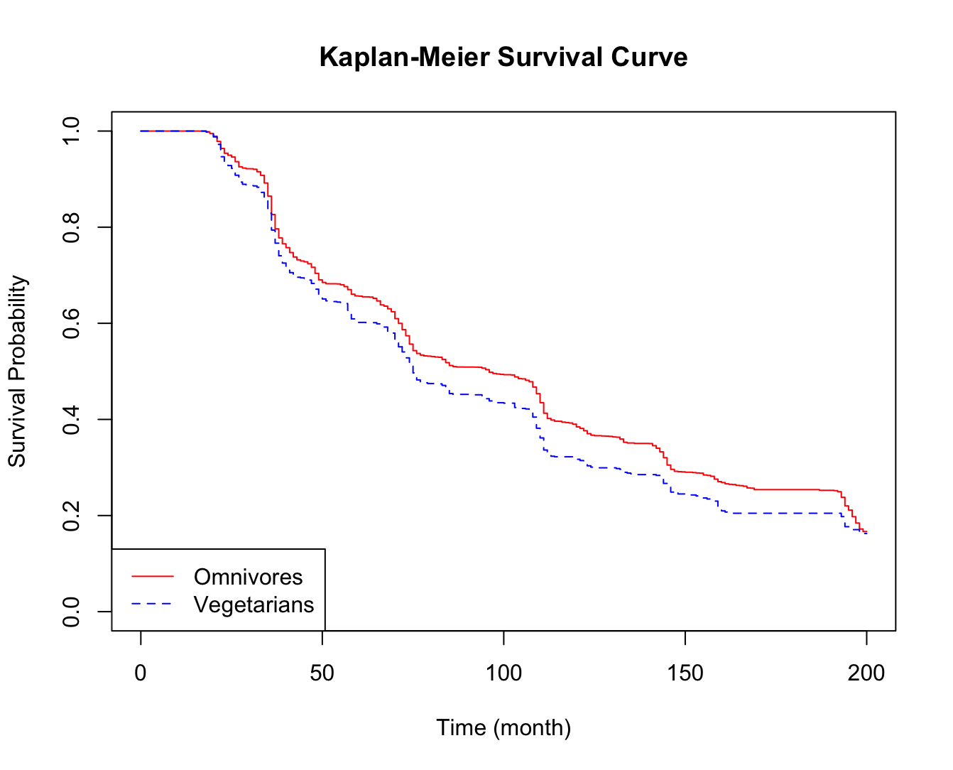
Figure S1. Kaplan-Meier survival curve for incident frailty among vegetarians and omnivores.

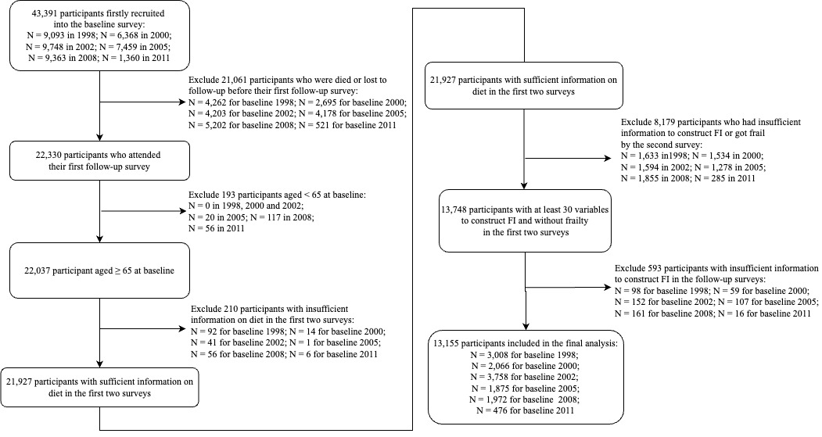
Figure S2. Selection process of the study population for analysis of the association between diet trajectories and incident frailty.

