Trajectories of Night Light Exposure and Associations with Overweight and Obesity: A 15-year Longitudinal Cohort Study of 218,239 Chinese Children

Additional file materials

Table of contents
- Additional file Figure S1. Distribution of included schools and corresponding light at night density during the study period in Zhongshan City, China.
- Additional file Figure S2. Weight status at baseline and endpoint for participants with distinct resident night light exposure trajectories.
- Additional file Figure S3. Cross-lagged panel model analysis on light at night exposure and overweight risk at baseline and endpoint.
- Additional file Table S1. Parameters of group-based trajectory modeling process.
- Additional file Table S2. Age and sex specific BMI and incident overweight and obesity by residential night light exposure groups
- Additional file Table S3. Cox regression model on risk of overweight and obesity during childhood among children from distinct resident nigh light exposure trajectory groups (children who were thinness at baseline were excluded).
- Additional file Table S4. Cox regression model on risk of obesity during childhood among children from distinct resident nigh light exposure trajectory groups.
- Additional file Table S5. Cox regression model on risk of overweight and obesity during childhood among children from distinct resident nigh light exposure trajectory groups (measurements with imputed body mass index were removed).
- Additional file Table S6. Cox regression model on risk of overweight and obesity during childhood among children from distinct resident nigh light exposure trajectory groups (district-fixed model).
- Additional file Table S7. Logistic regression model on risk of overweight and obesity at endpoint among children from distinct resident nigh light exposure trajectory groups (children who were overweight or obese at baseline were excluded).

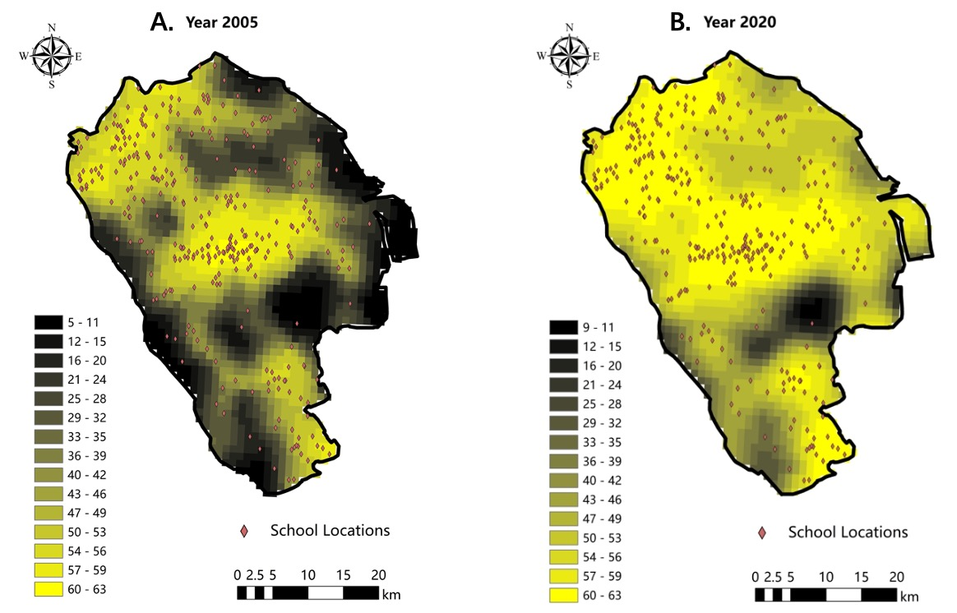
Additional file Figure S1. School locations and light at night (nW/cm²/sr) in 2005 and 2020 in Zhongshan City, China.

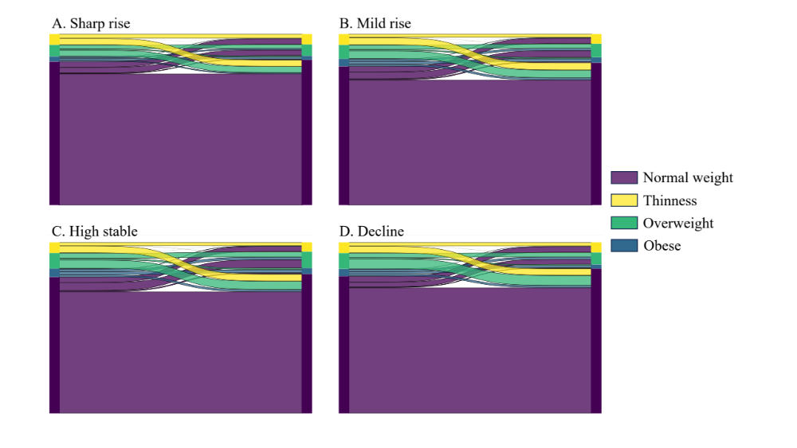
Additional file Figure S2. Weight status at baseline (left) and endpoint (right) for participants with distinct resident night light exposure trajectories.
A. Sharp rise; B. Mild rise; C. High stable; D. Decline

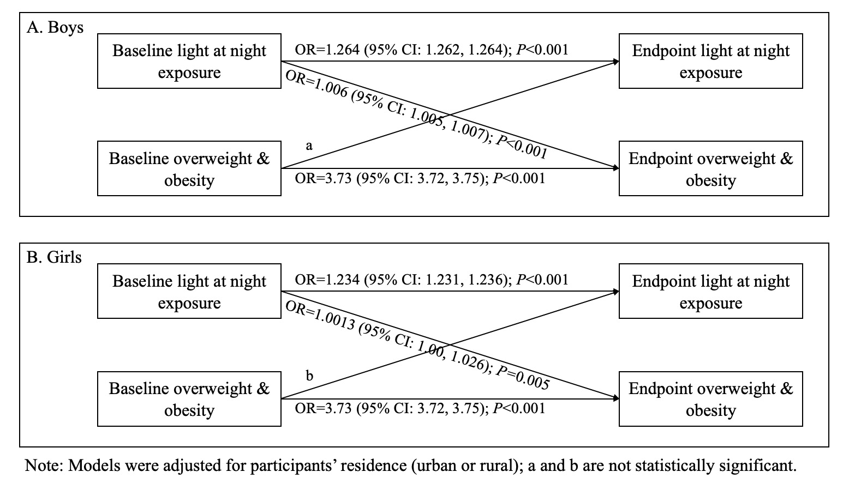
Additional file Figure 3. Cross-lagged panel model analysis on light at night exposure and overweight risk at baseline and endpoint.
Additional file Table S1. Parameters of group-based trajectory modeling process
Number of groups | Bayesian information criterion | Percentage of participants in each group (%) | Average posterior probability for each group
2 | -4301946.28 | 8.7612 | 0.9566537
 |  | 91.2388 | 0.9951344
3 | -4134952.15 | 7.66264 | 0.9533851
 |  | 15.14132 | 0.9439864
 |  | 77.19604 | 0.9826296
4 | -4060730.76 | 5.5316 | 0.9386073
 |  | 15.72033 | 0.889778
 |  | 67.59524 | 0.9490713
 |  | 11.15284 | 0.9165645
5 | -4040898.82 | 4.78696 | 0.9367068
 |  | 8.61301 | 0.8612454
 |  | 18.53799 | 0.781455
 |  | 58.07905 | 0.9021726
 |  | 9.983 | 0.9705279

Additional file Table S2 Age and sex specific BMI and incident overweight and obesity by residential night light exposure groups.
Age  (year) | BMI Z score (mean and 95% CI) |  |  |  |  | Incident overweight and obesity (/1000 person-year)
Age  (year) | Sharp rise | Mild rise | Stable high | Decline |  | Sharp rise | Mild rise | Stable high | Decline
6~ | -0.26 (-0.33, -0.2) | -0.28 (-0.31, -0.24) | -0.27 (-0.28, -0.26) | -0.27 (-0.31, -0.24) |  | 0.11 (0.03, 0.42) | 0.11 (0.04, 0.3) | 0.1 (0.06, 0.18) | -
7~ | -0.33 (-0.37, -0.29) | -0.35 (-0.37, -0.33) | -0.28 (-0.29, -0.28) | -0.31 (-0.34, -0.28) |  | 3.24 (2.52, 4.17) | 5.19 (4.5, 6) | 12.2 (11.58, 12.86) | 5.15 (4.19, 6.32)
8~ | -0.31 (-0.34, -0.27) | -0.33 (-0.35, -0.31) | -0.26 (-0.27, -0.25) | -0.27 (-0.29, -0.24) |  | 10.66 (9.28, 12.25) | 16.1 (14.83, 17.48) | 24.09 (23.2, 25) | 10.21 (8.82, 11.82)
9~ | -0.28 (-0.32, -0.24) | -0.32 (-0.34, -0.3) | -0.22 (-0.23, -0.21) | -0.24 (-0.26, -0.21) |  | 14.2 (12.58, 16.03) | 19.3 (17.89, 20.82) | 25.49 (24.57, 26.44) | 13.1 (11.5, 14.91)
10~ | -0.24 (-0.28, -0.21) | -0.31 (-0.33, -0.29) | -0.19 (-0.2, -0.18) | -0.19 (-0.21, -0.16) |  | 15.92 (14.19, 17.86) | 20.83 (19.34, 22.42) | 26.92 (25.96, 27.92) | 16.17 (14.37, 18.19)
11~ | -0.24 (-0.28, -0.21) | -0.28 (-0.3, -0.26) | -0.16 (-0.17, -0.15) | -0.19 (-0.21, -0.16) |  | 13.33 (11.73, 15.14) | 19.56 (18.11, 21.13) | 24.52 (23.58, 25.49) | 15.32 (13.55, 17.31)
12~ | -0.26 (-0.29, -0.23) | -0.23 (-0.24, -0.21) | -0.12 (-0.13, -0.11) | -0.13 (-0.15, -0.11) |  | 10.61 (9.17, 12.28) | 20.91 (19.37, 22.58) | 20.65 (19.75, 21.59) | 15.18 (13.39, 17.21)
13~ | -0.34 (-0.37, -0.32) | -0.22 (-0.24, -0.21) | -0.16 (-0.17, -0.15) | -0.16 (-0.18, -0.15) |  | 12.36 (10.76, 14.2) | 15.91 (14.52, 17.43) | 16.36 (15.51, 17.26) | 13.44 (11.73, 15.41)
14~ | -0.39 (-0.41, -0.37) | -0.27 (-0.28, -0.26) | -0.25 (-0.26, -0.24) | -0.24 (-0.26, -0.23) |  | 12.95 (11.24, 14.91) | 9.75 (8.62, 11.04) | 10.33 (9.6, 11.11) | 9.17 (7.74, 10.86)
15~ | -0.43 (-0.46, -0.41) | -0.36 (-0.38, -0.35) | -0.32 (-0.33, -0.32) | -0.33 (-0.35, -0.31) |  | 7.72 (6.35, 9.38) | 7 (5.96, 8.22) | 7.21 (6.54, 7.94) | 6.32 (5.12, 7.8)
16~ | -0.51 (-0.54, -0.49) | -0.46 (-0.48, -0.44) | -0.41 (-0.42, -0.4) | -0.49 (-0.51, -0.47) |  | 6.16 (4.88, 7.79) | 6.45 (5.35, 7.77) | 6.05 (5.36, 6.82) | 4.12 (3.11, 5.45)
17~ | -0.63 (-0.65, -0.61) | -0.55 (-0.57, -0.53) | -0.51 (-0.52, -0.5) | -0.6 (-0.62, -0.58) |  | 5.59 (4.16, 7.51) | 6.68 (5.27, 8.48) | 7.31 (6.34, 8.43) | 3.82 (2.62, 5.57)
Note: Age and sex specific BMI Z score, as defined according to the 2007 version of growth reference by World Health Organization, was calculated for all the participants, while incident overweight and obesity was calculated for those who were identified as normal weight.
BMI, body mass index; CI, confidence interval.

Additional file Table S3. Cox regression model on risk of overweight and obesity during childhood among children from distinct resident nigh light exposure trajectory groups
Nigh light trajectory | Boys |  |  |  | Girls
Nigh light trajectory | Hazard ratio (95% CI) | P value | PAR (min-max) |  | Hazard ratio (95% CI) | P value | PAR (min-max)
Sharp rise | 1 (Reference) |  |  |  | 1 (Reference)
Mild rise | 1.24 (1.13, 1.35) | <0.001 | 19.07 (11.55, 25.95) |  | 1.31 (1.17, 1.46) | <0.001 | 23.72 (14.88, 31.65)
Stable high | 1.68 (1.55, 1.82) | <0.001 | 40.47 (35.54, 45.02) |  | 1.55 (1.4, 1.71) | <0.001 | 35.41 (28.72, 41.48)
Decline | 1.24 (1.12, 1.36) | <0.001 | 19.04 (11.02, 26.34) |  | 1.09 (0.97, 1.23) | 0.141 | 8.55 (-3.02, 18.81)
Note: 13,491 participants who were thinness at baseline were excluded from this analysis. Model were adjusted for living residence (urban or rural) and baseline body mass index; level 1, individual; level 2, school district.

Additional file Table S4. Cox regression model on risk of obesity during childhood among children from distinct resident nigh light exposure trajectory groups
Nigh light trajectory | Boys |  |  |  | Girls
Nigh light trajectory | Hazard ratio (95% CI) | P value | PAR (min-max) |  | Hazard ratio (95% CI) | P value | PAR (min-max)
Sharp rise | 1 (Reference) |  |  |  | 1 (Reference)
Mild rise | 1.19 (1.03, 1.36) | 0.016 | 15.61 (3.11, 26.50) |  | 1.99 (1.29, 3.06) | 0.002 | 49.64 (22.48, 67.29)
Stable high | 1.63 (1.44, 1.85) | <0.001 | 38.81 (30.77, 45.92) |  | 2.00 (1.34, 2.99) | 0.001 | 50.09 (25.42, 66.60)
Decline | 1.19 (1.03, 1.38) | 0.019 | 16.06 (2.84, 27.49) |  | 1.00 (0.61, 1.64) | 0.999 | -0.01 (-64.51, 39.20)
Note: PAR, population attributable rate. Model were adjusted for living residence (urban or rural) and baseline body mass index; level 1, individual; level 2, school district.

Additional file Table S5. Cox regression model on risk of overweight and obesity during childhood among children from distinct resident nigh light exposure trajectory groups.
Nigh light trajectory | Boys |  |  |  | Girls
Nigh light trajectory | Hazard ratio (95% CI) | P value | PAR (min-max) |  | Hazard ratio (95% CI) | P value | PAR (min-max)
Sharp rise | 1 (Reference) |  |  |  | 1 (Reference)
Mild rise | 1.23 (1.13, 1.35) | <0.001 | 19.02 (11.53, 25.87) |  | 1.3 (1.17, 1.46) | <0.001 | 23.32 (14.44, 31.28)
Stable high | 1.68 (1.55, 1.82) | <0.001 | 40.59 (35.69, 45.11) |  | 1.54 (1.4, 1.7) | <0.001 | 35.23 (28.53, 41.31)
Decline | 1.23 (1.12, 1.36) | <0.001 | 18.98 (10.99, 26.25) |  | 1.09 (0.97, 1.23) | 0.145 | 8.46 (-3.09, 18.72)
Note: Measurements with imputed body mass index were removed; PAR, population attributable rate. Model were adjusted for living residence (urban or rural) and baseline body mass index; level 1, individual; level 2, district of school.

Additional file Table S6. Cox regression model on risk of overweight and obesity during childhood among children from distinct resident nigh light exposure trajectory groups.
Nigh light trajectory | Boys |  |  |  | Girls
Nigh light trajectory | Hazard ratio (95% CI) | P value | PAR (min-max) |  | Hazard ratio (95% CI) | P value | PAR (min-max)
Sharp rise | 1 (Reference) |  |  |  | 1 (Reference)
Mild rise | 1.29 (0.91, 1.84) | 0.157 | 22.6 (-10.4, 45.73) |  | 1.3 (0.89, 1.88) | 0.175 | 22.79 (-12.19, 46.87)
Stable high | 1.67 (1.21, 2.31) | 0.002 | 40.24 (17.45, 56.74) |  | 1.56 (1.16, 2.12) | 0.004 | 36.09 (13.48, 52.79)
Decline | 1.02 (0.72, 1.46) | 0.895 | 2.37 (-39.32, 31.59) |  | 0.94 (0.66, 1.34) | 0.737 | -6.21 (-50.9, 25.25)
Note: Measurements with imputed body mass index were removed; PAR, population attributable rate. Model were adjusted for living residence (urban or rural) and baseline body mass index; level 1, individual; level 2, school district. District corresponding to each school address was applied for fixed-effect model.

Additional file Table S7. Logistic regression model on risk of overweight and obesity at endpoint among children from distinct resident nigh light exposure trajectory groups.
Nigh light trajectory | Boys |  |  | Girls
Nigh light trajectory | Hazard ratio (95% CI) | P value |  | Hazard ratio (95% CI) | P value
Sharp rise | 1 (Reference) |  |  | 1 (Reference)
Mild rise | 1.16 (1.02, 1.33) | 0.029 |  | 1.43 (1.20, 1.71) | <0.001
Stable high | 1.50 (1.33, 1.69) | <0.001 |  | 1.56 (1.33, 1.83) | <0.001
Decline | 0.93 (0.80, 1.08) | 0.340 |  | 0.85 (0.69, 1.04) | 0.112
Note: Children who were overweight or obese at baseline were excluded in this analysis. Model were adjusted for living residence (urban or rural) and baseline body mass index; level 1, individual; level 2, school district.

