Additional Files for:
Age-targeted vaccination for reducing Clostridioides difficile infection in England:
a coupled mathematical-economic modelling analysis
Laith Yakob, Kasim Allel, Aiman Elragig, Tim Planche, Jennifer Moïsi, Tendai Mugwagwa, Holly Yu

Contents
Additional Files for: 1
Additional File 1: Setting the epidemiological proportions of new hospital admissions 2
Figure S1. Setting the epidemiological proportions of new hospital admissions 2
Additional File 2: Global sensitivity analysis 3
Figure S2. Global sensitivity analysis 3
Additional File 3: Vaccine efficacy sensitivity analysis (health outcomes) 4
Figure S3. Simulated impacts of different vaccine (60% efficacy) coverage levels 4
Figure S4. Simulated impacts of different vaccine (100% efficacy) coverage levels 4
Additional File 4: Vaccine efficacy sensitivity analysis (economic outcomes) 5
Figure S5. Economic analysis for 60% vaccine efficacy 5
Figure S6. Economic analysis for 100% vaccine efficacy 5
Additional File 5: Vaccination schedules under alternative waning scenarios 6
Figure S7. Alternative scenarios for vaccine waning 6
Additional File 6: Economic analysis 7
Table S1. Total bed costs per patient and day 7
Table S2. Treatment costs per patient and by severity levels 8
Table S3. Utilities scores per patient with CDI 8
Hospitalisation cost for general ward bed-days 9
Table S4. Derivation of hospitalisation. 10
Table S5. Derivation of hospitalisation costs. 10
Table S6. Summary of the total hospital costs per day 11
Table S7. Summary of the costs associated with years lost due to premature mortality 11

Additional File 1: Setting the epidemiological proportions of new hospital admissions
At endemic equilibrium, approximately 0.05% of new admissions have CDI ¹ and 5% of new admissions are colonized (all colonized-but-not-diseased categories sum to 5-0.05=4.95%). 10% of those discharged are re-admitted within 30 days ². This means that 10% of the newly admitted patients have been exposed to a healthcare setting within past 30 days (because new admissions and discharges are balanced). Among those with CDI, approximately one-third experience first recurrence ^{3,4}, and, among those who have recovered from their first recurrence, recurrence rates double ⁵.
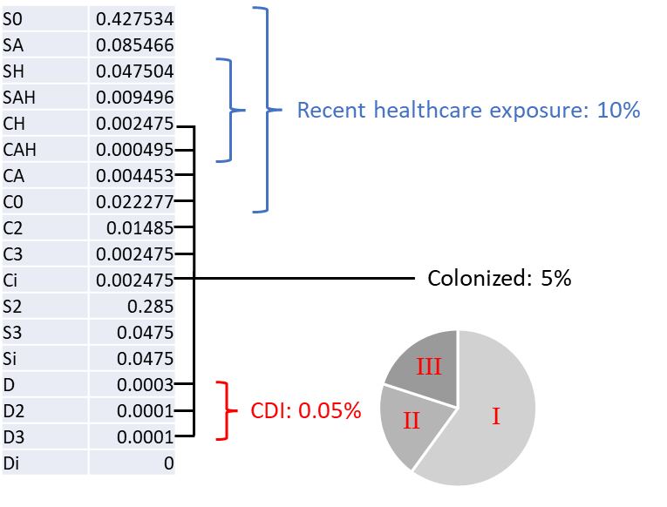
Figure S1. Setting the epidemiological proportions of new hospital admissions.

An equivalent calibration process was undertaken to ensure a stable ICU population whereby the rate of ICU admissions⁶ and the rate of ICU discharge⁷ were known and the remaining (non-CDI related) ICU admissions could be inferred.

