Additional File 5: Vaccination schedules under alternative waning scenarios
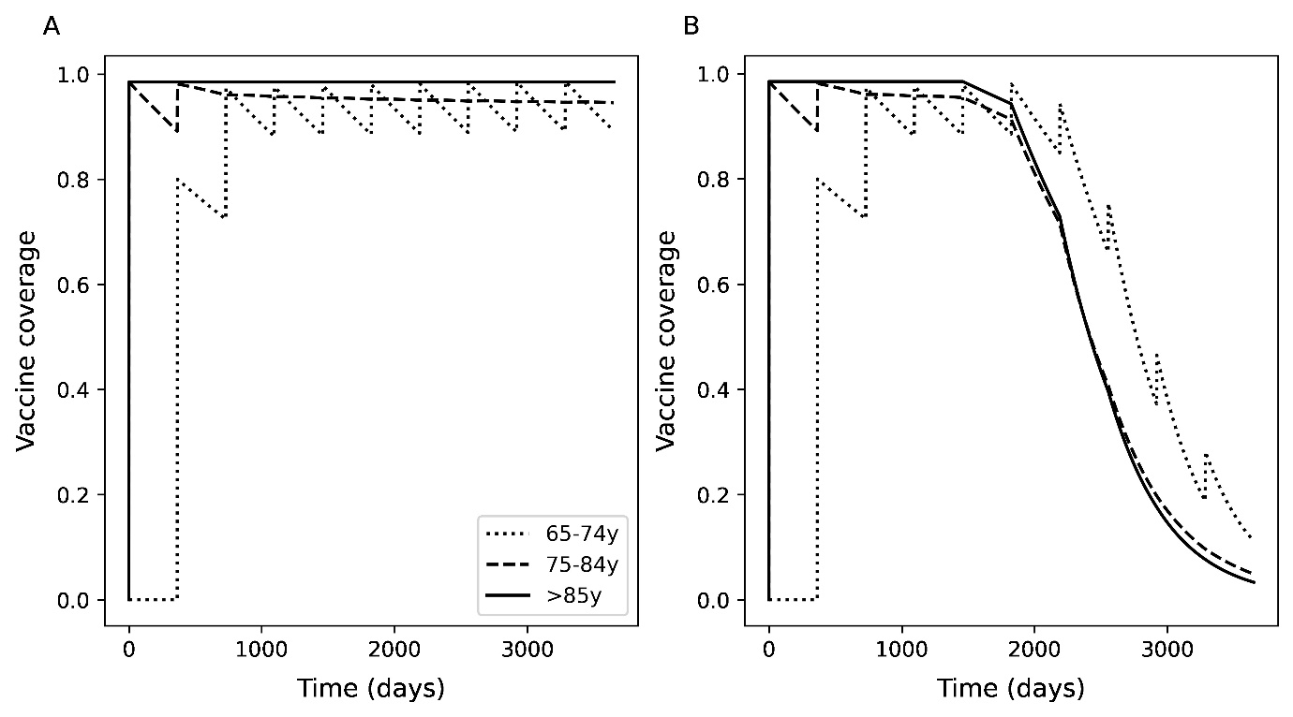
Figure S7. Alternative scenarios for vaccine waning. A) The vaccine is assumed to not wane over the 10-year time horizon, or, B) the vaccine wanes according to a Weibull function. The figure also demonstrates the gradual rolling out of vaccines, at first prioritizing to those >74 years old, then >64 year olds, ultimately switching to a top-up strategy for those newly turning 65 years old each year. Strictly, waning does not occur in the number of people who have received vaccine over time, so the wane in ‘vaccine coverage’ refers to the combined impact of people moving age groups and how vaccine efficacy is assumed to decrease over time.

