Table S1. Guidelines for Accurate and Transparent Health Estimates Reporting (GATHER) checklist of information for reports of global health estimates.
Item # | Checklist item | Reported on page #
Objectives and funding
1 | Define the indicator(s), populations (including age, sex, and geographic entities), and time period(s) for which estimates were made. | Pages 6, Methods section, paragraph 1
2 | List the funding sources for the work. | Page 26, Funding section
Data Inputs
For all data inputs from multiple sources that are synthesized as part of the study:
3 | Describe how the data were identified and how the data were accessed. | Page 6, Methods section, paragraphs 2
4 | Specify the inclusion and exclusion criteria. Identify all ad‐hoc exclusions.
5 | Provide information on all included data sources and their main characteristics. For each data source used, report reference information or contact name/institution, population represented, data collection method, year(s) of data collection, sex and age range, diagnostic criteria or measurement method, and sample size, as relevant. | Page 6, Methods section, paragraphs 2
6 | Identify and describe any categories of input data that have potentially important biases (e.g., based on characteristics listed in item 5). | Pages 23-24, Discussion section, last paragraph
For data inputs that contribute to the analysis but were not synthesized as part of the study:
7 | Describe and give sources for any other data inputs. | Page 7, Methods section, paragraph 3
For all data inputs:
8 | Provide all data inputs in a file format from which data can be efficiently extracted (e.g., a spreadsheet rather than a PDF), including all relevant meta‐data listed in item 5. For any data inputs that cannot be shared because of ethical or legal reasons, such as third‐party ownership, provide a contact name or the name of the institution that retains the right to the data. | Page 6, Methods section, paragraphs 2
Data analysis
9 | Provide a conceptual overview of the data analysis method. A diagram may be helpful. | Pages 7-8, Methods section, paragraph 5
10 | Provide a detailed description of all steps of the analysis, including mathematical formulae. This description should cover, as relevant, data cleaning, data pre‐processing, data adjustments and weighting of data sources, and mathematical or statistical model(s). | Pages 7-8, Methods section, paragraph 5
11 | Describe how candidate models were evaluated and how the final model(s) were selected. | Page 7, Methods section, paragraph 4
12 | Provide the results of an evaluation of model performance, if done, as well as the results of any relevant sensitivity analysis. | Page 7, Methods section, paragraph 4
13 | Describe methods for calculating uncertainty of the estimates. State which sources of uncertainty were, and were not, accounted for in the uncertainty analysis. | Page 6, Methods section, paragraph 2
14 | State how analytic or statistical source code used to generate estimates can be accessed. | Pages 7-8, Methods section, paragraph 5
Results and Discussion
15 | Provide published estimates in a file format from which data can be efficiently extracted. | Page 6, Methods section, paragraph 2
16 | Report a quantitative measure of the uncertainty of the estimates (e.g. uncertainty intervals). | Page 6, Methods section, paragraph 2
17 | Interpret results in light of existing evidence. If updating a previous set of estimates, describe the reasons for changes in estimates. | Pages 18-19, Discussion section, paragraphs 1-2
18 | Discuss limitations of the estimates. Include a discussion of any modelling assumptions or data limitations that affect interpretation of the estimates. | Pages 23-24, Discussion section, last paragraph

Table S2. Number, ASR and EAPC of DALYs attributable to suboptimal fruit and vegetable intake at global and regional levels in 1990 and 2021.
 | Suboptimal fruit intake (95% UI) |  |  |  | EAPC (95% CI) | Suboptimal vegetable intake (95% UI) |  |  |  | EAPC (95% CI)
 | No of people in 1990 (per 1000) | ASR in 1990 (per 100 000) | No of people in 2021 (per 1000) | ASR in 2021 (per 100 000) | EAPC (95% CI) | No of people in 1990 (per 1000) | ASR in 1990 (per 100 000) | No of people in 2021 (per 1000) | ASR in 2021 (per 100 000) | EAPC (95% CI)
Global | 31960.8 (11570.7 to 48758.3) | 780.3 (292.2 to 1186.8) | 43766.7 (17669.8 to 65157.8) | 510.1 (207.7 to 758.2) | -1.53 (-1.59 to -1.47) | 17756.2 (9735.7 to 25084.2) | 442.8 (249 to 625.2) | 20655.7 (12448.9 to 28673.8) | 241.7 (146.3 to 335.4) | -2.06 (-2.21 to -1.91)
High SDI | 4052 (1474.6 to 6329.8) | 379.8 (137.6 to 591.9) | 4112.8 (2141.7 to 5857.1) | 216.4 (110.7 to 309.9) | -1.71 (-1.84 to -1.58) | 2028.2 (1085.6 to 3059.6) | 187.8 (100.5 to 283.6) | 2404.7 (1533 to 3375) | 121 (77.3 to 170.6) | -1.1 (-1.25 to -0.95)
High-middle SDI | 6853.5 (2259.9 to 10684.7) | 691.2 (233.6 to 1073.4) | 6016.2 (2403.4 to 9512.2) | 317.3 (126.4 to 499.8) | -3.01 (-3.3 to -2.71) | 2825.1 (1443.9 to 4214.3) | 291.6 (152.2 to 432.1) | 1718.1 (1018.3 to 2574.6) | 90.2 (53.8 to 134.4) | -4.01 (-4.14 to -3.88)
Middle SDI | 10385.9 (4039.4 to 15437.9) | 957.7 (401 to 1418.4) | 14292.1 (5896.6 to 21497.3) | 531.2 (227.3 to 790.7) | -2.03 (-2.1 to -1.96) | 6121.7 (3558.2 to 8535.4) | 594.8 (357.2 to 821) | 5870 (3693.4 to 8170.4) | 222 (140.6 to 309.5) | -3.38 (-3.62 to -3.14)
Low-middle SDI | 7743.7 (2672.8 to 11833.8) | 1154 (425.4 to 1753.3) | 14040.4 (5033.4 to 21074.5) | 922.3 (343.5 to 1377) | -0.71 (-0.77 to -0.65) | 4233.7 (2215.9 to 5921) | 660.5 (358.9 to 924.5) | 6456.2 (3824.9 to 8970.5) | 441 (266.9 to 612.1) | -1.36 (-1.43 to -1.28)
Low SDI | 2893.8 (1226.7 to 4306.6) | 1195.6 (543.3 to 1754.2) | 5271.6 (2218.9 to 7763.7) | 962.8 (431.3 to 1395.5) | -0.8 (-0.88 to -0.72) | 2528.3 (1294.4 to 3569.8) | 1075.3 (579.2 to 1502) | 4183 (2224.7 to 5920.7) | 784 (435.4 to 1093.8) | -1.21 (-1.3 to -1.11)
Andean Latin America | 87.1 (39.5 to 126.1) | 399.8 (194.3 to 569.9) | 136.3 (74.5 to 200.6) | 225.4 (126.9 to 331.4) | -1.92 (-2.06 to -1.78) | 99.8 (60.5 to 136.2) | 475.5 (300.8 to 642.1) | 175.6 (109.9 to 250.1) | 297.8 (187.8 to 423.1) | -1.48 (-1.62 to -1.33)
Australasia | 74.1 (22.6 to 120.8) | 323.2 (99 to 526.1) | 61.9 (26 to 94.9) | 120.9 (49.3 to 184.9) | -3.17 (-3.34 to -2.99) | 42.4 (21 to 63.9) | 184.2 (91 to 277.3) | 40.6 (20.4 to 62.3) | 76 (37.6 to 117) | -2.77 (-2.93 to -2.62)
Caribbean | 136.7 (58.8 to 201.7) | 515.4 (227.5 to 760.1) | 203.4 (104.6 to 293.5) | 382.2 (196.3 to 551.1) | -0.97 (-1.13 to -0.8) | 175 (90 to 247.1) | 667.5 (349.5 to 941.3) | 286.4 (156.7 to 416.7) | 536.1 (292.9 to 781.1) | -0.68 (-0.83 to -0.52)
Central Asia | 504.5 (163.5 to 786.7) | 1044.8 (340.1 to 1639.9) | 485.5 (182.9 to 749.8) | 584.4 (223.9 to 898.7) | -2.7 (-3.2 to -2.19) | 154.3 (72.9 to 245.3) | 328.3 (155.6 to 522.2) | 66.3 (36.6 to 107.3) | 90.6 (51.1 to 143.7) | -5.61 (-6.45 to -4.77)
Central Europe | 1050.9 (371 to 1632.3) | 727.2 (258 to 1131.4) | 788 (404.2 to 1132.2) | 373.4 (187.6 to 539.3) | -2.37 (-2.5 to -2.24) | 377.4 (217.4 to 568.1) | 263 (152.6 to 393.5) | 246 (147 to 361.5) | 110.7 (65.7 to 163.1) | -3.19 (-3.32 to -3.06)
Central Latin America | 330.4 (152.5 to 478.6) | 372.6 (182.8 to 534.1) | 703.9 (339.2 to 1023.7) | 276.2 (134.6 to 401.3) | -1.01 (-1.16 to -0.87) | 333.8 (209.9 to 453.3) | 396.9 (253.2 to 535.2) | 702 (460 to 981) | 278.9 (183.8 to 389.2) | -1.16 (-1.31 to -1.01)
Central Sub-Saharan Africa | 254.9 (126.1 to 379.9) | 1087.5 (560.7 to 1593.3) | 639.1 (308.2 to 947.1) | 1115.4 (589.9 to 1604.5) | -0.09 (-0.22 to 0.05) | 387.5 (178.4 to 585.3) | 1666.1 (812.4 to 2466.1) | 778.6 (355.3 to 1165.5) | 1381.3 (670.1 to 2023.5) | -0.79 (-0.87 to -0.7)
East Asia | 8403.6 (3340.2 to 12496.4) | 984.6 (430.3 to 1448.2) | 7146 (2890.5 to 11366.2) | 351.2 (144.9 to 553.2) | -3.48 (-3.57 to -3.39) | 4320.5 (2244 to 6454) | 536.3 (296.3 to 768.9) | 837.6 (346 to 1597.5) | 43.8 (18.4 to 82.3) | -8.66 (-8.99 to -8.32)
Eastern Europe | 2431.3 (683 to 3924.3) | 900.4 (251.8 to 1453.1) | 1929.5 (605.9 to 3130.3) | 583.3 (182.5 to 947.4) | -2.29 (-2.88 to -1.71) | 678.3 (338.1 to 1050.4) | 252.6 (124.7 to 391.2) | 678.5 (350.2 to 1052.8) | 200.1 (103.7 to 308.8) | -1.07 (-1.41 to -0.73)
Eastern Sub-Saharan Africa | 1030.4 (525.1 to 1442.5) | 1312.9 (713.1 to 1811) | 1551.5 (746.1 to 2211.5) | 857.6 (451.1 to 1203.6) | -1.62 (-1.71 to -1.53) | 1152.3 (557.9 to 1642.1) | 1489.3 (782.9 to 2082.9) | 1611.8 (810.8 to 2314.9) | 915.9 (492.9 to 1302.1) | -1.92 (-2.04 to -1.8)
High-income Asia Pacific | 640.1 (228 to 991.1) | 326.1 (119.9 to 500.4) | 648.9 (294.7 to 979) | 157.4 (62.3 to 244) | -2.13 (-2.28 to -1.98) | 172.8 (88.5 to 272.1) | 90.3 (47.7 to 140.7) | 178.7 (96.7 to 279.1) | 35.4 (17.3 to 57.1) | -2.49 (-2.89 to -2.09)
High-income North America | 1241.4 (492.4 to 1926.8) | 371.8 (148.1 to 574.2) | 1679 (961.2 to 2316.3) | 288.6 (165.8 to 398.3) | -0.55 (-0.75 to -0.34) | 622.5 (345.4 to 932.1) | 184.2 (102.7 to 275.7) | 1153.2 (779.7 to 1570.1) | 192.7 (132.8 to 260.5) | 0.65 (0.53 to 0.78)
North Africa and Middle East | 1423.9 (684.2 to 1973.5) | 806.1 (414.2 to 1105.3) | 1973.7 (1106.9 to 2816.5) | 404.5 (242.1 to 560.7) | -2.46 (-2.58 to -2.34) | 903.6 (567.3 to 1248.3) | 541 (351.2 to 749.9) | 1244.6 (789.2 to 1759.5) | 268.5 (172.8 to 376.5) | -2.51 (-2.64 to -2.38)
Oceania | 50.1 (15.3 to 78.4) | 1460.1 (483.8 to 2272.9) | 104 (31.5 to 167) | 1167.6 (382.4 to 1862.1) | -0.72 (-0.74 to -0.69) | 30.8 (13.7 to 44.6) | 948.4 (436.7 to 1359.6) | 63.7 (30.5 to 94.1) | 743.7 (363.1 to 1094) | -0.72 (-0.77 to -0.66)
South Asia | 7949.3 (2502.8 to 12290.7) | 1229.4 (408.5 to 1913.1) | 17187.8 (5530.5 to 26388.5) | 1102 (367.6 to 1681.3) | -0.33 (-0.38 to -0.28) | 3529.7 (1790.4 to 5042.1) | 574.3 (301.2 to 820.3) | 6269.7 (3586.2 to 8741.4) | 416.7 (242.9 to 580.7) | -1.04 (-1.08 to -1)
Southeast Asia | 3104.3 (1033.9 to 4725.7) | 1088.7 (387.7 to 1657.6) | 4549.4 (1701.8 to 6894.9) | 655.9 (254.9 to 983.9) | -1.7 (-1.73 to -1.67) | 2222.6 (1073.1 to 3183.7) | 802.7 (409.3 to 1143.8) | 2933.5 (1885 to 3998.9) | 435.5 (281.4 to 591.9) | -2.03 (-2.18 to -1.88)
Southern Latin America | 214.8 (92.1 to 319.4) | 470.1 (205 to 697.6) | 148.7 (90 to 207.1) | 172.7 (101.8 to 241.9) | -3.21 (-3.44 to -2.97) | 169.7 (105.9 to 230.4) | 375.1 (235.1 to 509) | 155.6 (106.5 to 212.4) | 177.1 (120.1 to 243) | -2.23 (-2.34 to -2.12)
Southern Sub-Saharan Africa | 289.7 (132.3 to 416.7) | 979.6 (460.8 to 1410) | 665.1 (325.8 to 960.8) | 1105.6 (560.9 to 1584.6) | 0.51 (0.09 to 0.93) | 200.6 (113.8 to 280.1) | 698.2 (400.8 to 973) | 444.6 (260.2 to 630.7) | 750.3 (448.4 to 1051.4) | 0.23 (-0.18 to 0.63)
Tropical Latin America | 521.7 (226.6 to 764) | 518.2 (241.9 to 750.8) | 515.1 (277.5 to 750.4) | 199.5 (108.6 to 288.2) | -3.29 (-3.42 to -3.15) | 603.8 (339 to 840.2) | 626.4 (362.6 to 866.1) | 723.1 (453.6 to 980) | 280.4 (177.5 to 379.5) | -2.59 (-2.76 to -2.43)
Western Europe | 1418.9 (528.5 to 2232.6) | 259.9 (94.4 to 406.3) | 1165.4 (653.1 to 1648.9) | 125 (62.4 to 180.7) | -2.29 (-2.4 to -2.18) | 939.8 (491.8 to 1419.6) | 167.9 (86.9 to 254.3) | 943.3 (579.3 to 1342.6) | 93.6 (53.5 to 133.8) | -1.63 (-1.71 to -1.55)
Western Sub-Saharan Africa | 802.7 (388.3 to 1161.2) | 870.1 (439.2 to 1254.2) | 1484.4 (716.7 to 2117.1) | 681.8 (335.6 to 971) | -0.98 (-1.09 to -0.86) | 638.8 (400.7 to 868.4) | 709.4 (455.7 to 961.2) | 1122.4 (674.7 to 1556.4) | 531.4 (333.7 to 732.9) | -1.11 (-1.23 to -1)
*DALY=disability-adjusted life year; ASR=age standardized rate; EAPC=estimated annual percentage change; UI=uncertainty interval; CI=confidence interval, SDI=sociodemographic index.

Table S3. Number, ASR and EAPC of deaths attributable to suboptimal fruit and vegetable intake at national level in 1990 and 2021.
 | Suboptimal fruit intake (95% UI) |  |  |  | EAPC (95% CI) | Suboptimal vegetable intake (95% UI) |  |  |  | EAPC (95% CI)
 | No of people in 1990 (per 1000) | ASR in 1990 (per 100 000) | No of people in 2021 (per 1000) | ASR in 2021 (per 100 000) | EAPC (95% CI) | No of people in 1990 (per 1000) | ASR in 1990 (per 100 000) | No of people in 2021 (per 1000) | ASR in 2021 (per 100 000) | EAPC (95% CI)
Afghanistan | 6.8 (3.3 to 9.7) | 110.3 (58.5 to 157.7) | 7.2 (3.6 to 10.6) | 81.1 (45.4 to 117.3) | -1.24 (-1.48 to -1) | 7.7 (4.1 to 11.1) | 124.6 (69.9 to 180.2) | 8.3 (4.5 to 12) | 95.4 (55.7 to 136.3) | -1.06 (-1.25 to -0.87)
Albania | 0.4 (0.1 to 0.7) | 22.5 (7.2 to 36.9) | 0.3 (0.1 to 0.5) | 6.6 (2.6 to 11.6) | -4.29 (-4.68 to -3.91) | 0.2 (0.1 to 0.3) | 10.1 (6 to 14.5) | 0.1 (0 to 0.1) | 1.9 (0.6 to 3.8) | -6.19 (-6.69 to -5.69)
Algeria | 4.5 (2.3 to 6.2) | 51 (27.7 to 70.4) | 6.2 (3.8 to 8.8) | 25 (15.4 to 35.5) | -2.36 (-2.52 to -2.2) | 3.2 (2.1 to 4.4) | 39.3 (27 to 53.2) | 6 (3.9 to 8.6) | 23.9 (15.5 to 34.8) | -1.37 (-1.5 to -1.24)
American Samoa | 0 (0 to 0) | 26.3 (10.6 to 40.4) | 0 (0 to 0) | 26.5 (9 to 43) | -0.05 (-0.15 to 0.04) | 0 (0 to 0) | 24.6 (13.6 to 35) | 0 (0 to 0) | 22 (10.8 to 33.4) | -0.42 (-0.55 to -0.29)
Andorra | 0 (0 to 0) | 7.4 (3.8 to 11.4) | 0 (0 to 0) | 4.1 (2.2 to 6.4) | -1.62 (-1.89 to -1.35) | 0 (0 to 0) | 6.1 (3.4 to 9.7) | 0 (0 to 0) | 3.6 (2.2 to 5.9) | -1.39 (-1.66 to -1.12)
Angola | 2.1 (1.1 to 3) | 65.6 (37.7 to 92.5) | 3.7 (2 to 5.5) | 41.3 (24.5 to 58.8) | -2.05 (-2.24 to -1.86) | 2.5 (1.2 to 3.6) | 76.9 (42.9 to 108.6) | 3.2 (2 to 4.6) | 38.4 (24.9 to 53.5) | -2.97 (-3.25 to -2.7)
Antigua and Barbuda | 0 (0 to 0) | 20.9 (13.1 to 28) | 0 (0 to 0) | 21.4 (15.5 to 27.4) | 0.49 (0.16 to 0.83) | 0 (0 to 0) | 28.3 (21.3 to 36.1) | 0 (0 to 0) | 30.4 (23.3 to 38.3) | 0.47 (0.16 to 0.79)
Argentina | 6.4 (3.5 to 9) | 21.2 (11.8 to 29.7) | 4.7 (3.2 to 6.5) | 8.2 (5.6 to 11.2) | -3.02 (-3.31 to -2.73) | 6.2 (4.2 to 8.2) | 20.7 (14 to 27.4) | 6.6 (4.8 to 8.8) | 11.4 (8.2 to 15.1) | -1.68 (-1.8 to -1.55)
Armenia | 0.6 (0.3 to 0.9) | 25.4 (11 to 39.5) | 0.4 (0.2 to 0.6) | 9.5 (5.1 to 14.2) | -4.29 (-4.77 to -3.8) | 0.2 (0.1 to 0.3) | 7.1 (3.5 to 11.8) | 0 (0 to 0.1) | 0.7 (0.1 to 1.9) | -10.58 (-11.77 to -9.37)
Australia | 2.9 (0.9 to 4.9) | 15.5 (5 to 25.9) | 2.8 (1.3 to 4.2) | 5.5 (2.5 to 8.2) | -3.35 (-3.52 to -3.18) | 1.7 (0.8 to 2.6) | 9 (4.2 to 13.6) | 2 (1 to 3) | 3.8 (1.9 to 5.8) | -2.65 (-2.81 to -2.48)
Austria | 1.2 (0.5 to 1.8) | 9.7 (4.4 to 15) | 1.3 (0.8 to 1.8) | 5.4 (3.3 to 7.8) | -1.56 (-1.74 to -1.37) | 1.3 (0.8 to 1.9) | 11.1 (6.5 to 15.8) | 1.6 (1 to 2.2) | 6.8 (4.4 to 9.4) | -1.2 (-1.39 to -1)
Azerbaijan | 1.5 (0.6 to 2.3) | 33.4 (14.5 to 51.6) | 1.4 (0.7 to 2.2) | 16.9 (8 to 26.3) | -2.83 (-3.33 to -2.32) | 0.8 (0.4 to 1.2) | 17.9 (10 to 27.5) | 0.3 (0.1 to 0.5) | 3.7 (1.3 to 7.5) | -6.67 (-7.7 to -5.64)
Bahamas | 0.1 (0 to 0.1) | 34.9 (24.2 to 45.1) | 0.1 (0.1 to 0.2) | 31.3 (22.4 to 41.3) | -0.48 (-0.69 to -0.27) | 0 (0 to 0) | 23.5 (16.8 to 31.8) | 0.1 (0.1 to 0.2) | 29.8 (21.8 to 41.3) | 0.85 (0.61 to 1.1)
Bahrain | 0 (0 to 0) | 20.5 (11.5 to 30.6) | 0.1 (0 to 0.1) | 9.8 (5.6 to 14.5) | -2.87 (-3.13 to -2.6) | 0 (0 to 0) | 19.5 (11.7 to 29.9) | 0 (0 to 0.1) | 8.3 (4.2 to 13.5) | -3.08 (-3.32 to -2.83)
Bangladesh | 27.3 (8.8 to 42.1) | 60.3 (22 to 91.4) | 47.3 (17 to 74.7) | 38.5 (15.3 to 59.9) | -1.49 (-1.8 to -1.18) | 24.2 (9.6 to 37) | 54.4 (23.2 to 83.2) | 34.2 (15.3 to 53.9) | 29.2 (13.6 to 45.7) | -2.29 (-2.68 to -1.89)
Barbados | 0.1 (0 to 0.1) | 34 (16.2 to 50.6) | 0.1 (0.1 to 0.2) | 21.5 (11.3 to 32.4) | -1.37 (-1.59 to -1.14) | 0.1 (0 to 0.1) | 19.3 (13.1 to 25.7) | 0.1 (0 to 0.1) | 14.1 (9.5 to 19.8) | -0.77 (-0.97 to -0.58)
Belarus | 4.3 (1.1 to 7.1) | 34.5 (8.8 to 57.6) | 3.7 (0.9 to 6.4) | 23.2 (5.4 to 39.7) | -2.28 (-2.8 to -1.75) | 1.6 (0.7 to 2.4) | 12.7 (5.9 to 19.8) | 1 (0.4 to 1.8) | 5.9 (2.3 to 10.7) | -3.8 (-4.51 to -3.1)
Belgium | 2.1 (0.7 to 3.4) | 13.6 (4.6 to 21.9) | 1.2 (0.6 to 1.8) | 4.2 (2 to 6.5) | -3.79 (-3.9 to -3.68) | 1.1 (0.5 to 1.6) | 6.9 (3.2 to 10.7) | 0.7 (0.4 to 1.2) | 2.6 (1.1 to 4.2) | -3.12 (-3.2 to -3.04)
Belize | 0 (0 to 0) | 5.3 (3.6 to 7.2) | 0 (0 to 0) | 5.9 (3.9 to 8.3) | 0.95 (0.62 to 1.28) | 0 (0 to 0) | 21.9 (14.3 to 29.5) | 0.1 (0 to 0.1) | 22.9 (17 to 29.7) | 0.54 (0.31 to 0.77)
Benin | 0.7 (0.3 to 1.1) | 38.8 (18.8 to 57.2) | 1.5 (0.8 to 2.2) | 32.5 (17.4 to 48) | -0.73 (-0.87 to -0.59) | 0.4 (0.3 to 0.6) | 22.9 (15.2 to 31.9) | 0.9 (0.6 to 1.2) | 19.7 (13.2 to 27.3) | -0.41 (-0.48 to -0.34)
Bermuda | 0 (0 to 0) | 11.7 (5.8 to 17.7) | 0 (0 to 0) | 9.9 (5.6 to 14.2) | -0.33 (-0.42 to -0.24) | 0 (0 to 0) | 12.8 (6.9 to 19.5) | 0 (0 to 0) | 7.9 (5 to 11) | -1.4 (-1.69 to -1.12)
Bhutan | 0.1 (0 to 0.1) | 37 (16.3 to 56.4) | 0.1 (0.1 to 0.2) | 25.5 (11.9 to 38.8) | -1.24 (-1.31 to -1.16) | 0.1 (0 to 0.1) | 28.7 (15.1 to 42.9) | 0.1 (0.1 to 0.1) | 17.4 (10.9 to 24.7) | -1.68 (-1.84 to -1.53)
Bolivia (Plurinational State of) | 0.8 (0.4 to 1.1) | 26.9 (14.7 to 39) | 1.6 (0.9 to 2.3) | 19.6 (11.6 to 28.6) | -0.79 (-0.88 to -0.71) | 0.8 (0.5 to 1.1) | 29.7 (19 to 40.8) | 1.8 (1.1 to 2.6) | 23.3 (14.6 to 33.3) | -0.63 (-0.69 to -0.58)
Bosnia and Herzegovina | 1.2 (0.4 to 1.8) | 31.4 (11.3 to 49) | 0.7 (0.4 to 1.1) | 12 (6.1 to 18.4) | -3.78 (-4.18 to -3.39) | 0.4 (0.2 to 0.6) | 11.9 (7 to 17.1) | 0.4 (0.2 to 0.6) | 5.6 (2.9 to 8.8) | -2.95 (-3.34 to -2.56)
Botswana | 0.3 (0.1 to 0.5) | 68 (34.7 to 102.7) | 0.6 (0.3 to 0.8) | 47.4 (27.1 to 68.3) | -1 (-1.24 to -0.75) | 0.2 (0.1 to 0.4) | 54.7 (30.3 to 80.5) | 0.4 (0.2 to 0.5) | 33.2 (22.1 to 46) | -1.41 (-1.62 to -1.2)
Brazil | 17 (8.4 to 24.5) | 20.5 (10.9 to 29.2) | 19.6 (11.7 to 27.4) | 8 (4.8 to 11.1) | -3.08 (-3.2 to -2.97) | 21.3 (12.6 to 29.4) | 26.5 (16.5 to 36.2) | 29.6 (19.6 to 39.5) | 12.1 (8.1 to 16.1) | -2.43 (-2.57 to -2.29)
Brunei Darussalam | 0 (0 to 0.1) | 34.6 (16 to 52.1) | 0.1 (0 to 0.1) | 24.8 (12.8 to 35.6) | -0.6 (-0.83 to -0.37) | 0 (0 to 0) | 21.3 (14.5 to 28.9) | 0 (0 to 0) | 14.5 (10.1 to 19.4) | -0.69 (-0.97 to -0.4)
Bulgaria | 3.3 (1.4 to 5) | 36.6 (15.4 to 56.5) | 7.4 (5.2 to 9.7) | 53.6 (36.9 to 70.3) | 1.25 (0.65 to 1.85) | 1.4 (0.9 to 2.2) | 15 (8.7 to 23) | 2.2 (1.1 to 3.5) | 16 (8.8 to 25.6) | -0.1 (-0.64 to 0.44)
Burkina Faso | 2.1 (1 to 3) | 53.6 (26.8 to 77.6) | 4.6 (2.2 to 6.6) | 56.5 (28.5 to 81) | 0.39 (0.31 to 0.48) | 1.5 (0.8 to 2.1) | 39.9 (23.3 to 57) | 3.5 (2 to 5.1) | 43.3 (24.8 to 62.1) | 0.63 (0.51 to 0.74)
Burundi | 0.7 (0.3 to 1) | 32.3 (15.5 to 47.5) | 0.7 (0.4 to 1) | 17.8 (9.4 to 25.8) | -2.58 (-2.96 to -2.2) | 1.5 (0.6 to 2.2) | 70.4 (32.6 to 103.9) | 1.7 (0.8 to 2.5) | 42.2 (20.2 to 62.5) | -2.28 (-2.52 to -2.03)
Cabo Verde | 0.1 (0 to 0.1) | 27.6 (14.3 to 40) | 0.1 (0.1 to 0.2) | 27.1 (13.3 to 40.4) | -0.48 (-0.79 to -0.17) | 0.1 (0 to 0.1) | 22.1 (13.5 to 31.7) | 0.1 (0 to 0.1) | 16.1 (9.1 to 23.9) | -1.62 (-2.12 to -1.12)
Cambodia | 2.8 (1.2 to 4.2) | 67.7 (30.7 to 100.5) | 5.5 (2.7 to 8.3) | 50.6 (26.1 to 75.1) | -0.95 (-1.02 to -0.88) | 2.1 (1.1 to 3.1) | 53 (29.6 to 78.2) | 4.4 (2.5 to 6.5) | 41.5 (24.4 to 59.9) | -0.91 (-0.99 to -0.83)
Cameroon | 0.9 (0.6 to 1.3) | 25 (15.6 to 33.9) | 2.5 (1.3 to 3.9) | 22.2 (12.6 to 33.7) | -0.85 (-1.14 to -0.56) | 1.3 (0.8 to 1.7) | 33.7 (21.8 to 45.1) | 2.3 (1.3 to 3.5) | 21.9 (13.2 to 33) | -1.83 (-2.05 to -1.61)
Canada | 3.1 (1 to 5.1) | 9.9 (3.3 to 16) | 3.9 (2.1 to 5.8) | 5 (2.6 to 7.4) | -2.52 (-2.71 to -2.33) | 2.1 (1 to 3.4) | 6.7 (3.2 to 10.6) | 3.1 (1.7 to 4.6) | 4 (2.1 to 5.9) | -1.54 (-1.71 to -1.37)
Central African Republic | 0.7 (0.3 to 1) | 69.3 (36.7 to 101.6) | 1.2 (0.6 to 1.8) | 64.5 (32.1 to 96.7) | -0.23 (-0.27 to -0.2) | 0.9 (0.4 to 1.4) | 94.8 (45.7 to 138.8) | 1.5 (0.7 to 2.4) | 84.5 (41.7 to 130.2) | -0.42 (-0.47 to -0.37)
Chad | 1.3 (0.6 to 1.9) | 48.4 (22.5 to 72) | 2.9 (1.3 to 4.4) | 54.9 (26.6 to 83.8) | 0.3 (0.03 to 0.57) | 1.2 (0.6 to 1.8) | 46.9 (25 to 69.5) | 2.7 (1.3 to 4.2) | 52.8 (25.8 to 80) | 0.31 (0.07 to 0.55)
Chile | 1.7 (0.7 to 2.6) | 18.6 (7.8 to 28.4) | 2.2 (1.4 to 3) | 8.4 (5.2 to 11.5) | -2.2 (-2.31 to -2.09) | 1 (0.6 to 1.5) | 11.3 (6.6 to 16.3) | 1.5 (1 to 2.1) | 5.7 (3.8 to 8) | -1.74 (-1.87 to -1.6)
China | 302.6 (137.6 to 449.5) | 46.7 (24.1 to 66.8) | 314.1 (140.3 to 487) | 17.3 (8.1 to 26.4) | -3.3 (-3.38 to -3.22) | 173.6 (95.1 to 251.2) | 27.9 (17.4 to 38.5) | 42.3 (16.3 to 84.5) | 2.6 (1 to 5) | -8.15 (-8.38 to -7.91)
Colombia | 3.2 (1.8 to 4.4) | 20.4 (12.3 to 27.7) | 3.4 (1.8 to 5) | 5.9 (3.1 to 8.8) | -4.34 (-4.52 to -4.15) | 3.4 (2.4 to 4.4) | 22 (15.6 to 28.5) | 4.5 (2.9 to 6.2) | 8 (5.1 to 11) | -3.63 (-3.79 to -3.46)
Comoros | 0 (0 to 0.1) | 31.5 (19.1 to 45) | 0.1 (0.1 to 0.1) | 24.6 (13.3 to 35.9) | -0.87 (-1.02 to -0.71) | 0.1 (0.1 to 0.2) | 72.2 (35.4 to 106) | 0.2 (0.1 to 0.3) | 51.2 (23.9 to 77.9) | -1.36 (-1.55 to -1.17)
Congo | 0.6 (0.3 to 0.9) | 70.3 (38.6 to 100.5) | 1.1 (0.6 to 1.6) | 49.8 (29.1 to 71.8) | -1.33 (-1.44 to -1.21) | 0.8 (0.4 to 1.3) | 95 (49.1 to 138.2) | 1.5 (0.8 to 2.3) | 70.4 (38.9 to 102.1) | -1.21 (-1.33 to -1.08)
Cook Islands | 0 (0 to 0) | 80.2 (57.2 to 104) | 0 (0 to 0) | 31.7 (21.2 to 43.3) | -2.94 (-3.06 to -2.81) | 0 (0 to 0) | 85 (64.3 to 108) | 0 (0 to 0) | 35.9 (26.4 to 46.4) | -2.76 (-2.9 to -2.62)
Costa Rica | 0.1 (0.1 to 0.2) | 7.9 (4.2 to 11.2) | 0.3 (0.2 to 0.4) | 5.6 (3.5 to 7.7) | -1.21 (-1.36 to -1.07) | 0.3 (0.2 to 0.4) | 17.8 (9.9 to 25.1) | 0.6 (0.4 to 0.8) | 10.1 (6.8 to 13.8) | -2.25 (-2.4 to -2.09)
Côte d’Ivoire | 0.9 (0.4 to 1.3) | 25 (13.5 to 35.1) | 2.6 (1.4 to 3.9) | 25.6 (14.7 to 38.7) | 0.18 (-0.07 to 0.43) | 0.9 (0.6 to 1.3) | 28.1 (18.1 to 38.5) | 2.6 (1.6 to 3.7) | 26.8 (17.5 to 37.9) | -0.15 (-0.34 to 0.05)
Croatia | 1.5 (0.6 to 2.2) | 27.2 (12.2 to 41) | 0.9 (0.5 to 1.4) | 9.8 (5.2 to 14.9) | -3.35 (-3.49 to -3.22) | 0.9 (0.6 to 1.3) | 17.9 (11.2 to 25.5) | 0.9 (0.5 to 1.2) | 8.8 (5.5 to 12.9) | -1.99 (-2.16 to -1.83)
Cuba | 1.4 (0.5 to 2.2) | 13.9 (5.1 to 22) | 2 (1.3 to 2.8) | 10 (6.3 to 13.6) | -1.13 (-1.49 to -0.77) | 1.3 (0.7 to 1.9) | 13.1 (7.3 to 19) | 2.2 (1.4 to 3.1) | 10.7 (6.8 to 14.8) | -0.77 (-1.08 to -0.46)
Cyprus | 0.1 (0 to 0.1) | 18.3 (9.5 to 27.5) | 0.1 (0.1 to 0.2) | 9.1 (5.3 to 12.9) | -2.43 (-2.72 to -2.13) | 0.1 (0.1 to 0.2) | 23.4 (14.4 to 33.7) | 0.2 (0.1 to 0.2) | 10.4 (7.2 to 14.4) | -2.69 (-3.02 to -2.37)
Czechia | 3.3 (0.9 to 5.5) | 24.5 (6.7 to 41.3) | 3 (1.4 to 4.6) | 13 (5.9 to 20.2) | -1.75 (-1.89 to -1.6) | 1.9 (0.9 to 2.9) | 14.4 (7 to 21.8) | 2 (1.2 to 2.9) | 8.8 (5.3 to 12.5) | -1.6 (-1.76 to -1.43)
Democratic People's Republic of Korea | 4.2 (1.7 to 6.7) | 31.6 (15.1 to 49.5) | 9.3 (3.9 to 14.3) | 30.9 (13.7 to 47.4) | 0.08 (-0.08 to 0.24) | 1.7 (0.9 to 2.6) | 14.6 (8.4 to 22.2) | 4.9 (2.8 to 7.3) | 17 (9.9 to 25.3) | 0.67 (0.43 to 0.92)
Democratic Republic of the Congo | 5 (2.5 to 7.6) | 40.3 (21.5 to 59.6) | 15.7 (7.8 to 23.1) | 54 (28 to 77.1) | 0.88 (0.71 to 1.04) | 8.5 (3.9 to 13.2) | 66.6 (34 to 99.2) | 19.9 (9.3 to 29.6) | 68.6 (34.3 to 99) | 0.08 (0.01 to 0.14)
Denmark | 1.5 (0.4 to 2.6) | 18.2 (5 to 31) | 0.5 (0.2 to 0.7) | 3.6 (1.8 to 5.6) | -5.52 (-6.16 to -4.87) | 0.8 (0.4 to 1.3) | 10.1 (4.7 to 15.7) | 0.5 (0.2 to 0.7) | 3.6 (1.7 to 5.6) | -3.57 (-3.81 to -3.32)
Djibouti | 0.1 (0 to 0.1) | 69 (37.7 to 98.9) | 0.3 (0.1 to 0.4) | 52.8 (27.3 to 81.4) | -1.03 (-1.09 to -0.97) | 0 (0 to 0.1) | 49.3 (29.7 to 68.4) | 0.1 (0.1 to 0.2) | 31.2 (19.4 to 47.5) | -1.89 (-2.04 to -1.74)
Dominica | 0 (0 to 0) | 7.7 (4.6 to 11.5) | 0 (0 to 0) | 5.3 (2.9 to 8.6) | -1.11 (-1.38 to -0.84) | 0 (0 to 0) | 35.9 (27.1 to 45.9) | 0 (0 to 0) | 30.3 (21.7 to 39.6) | -0.46 (-0.66 to -0.26)
Dominican Republic | 0.3 (0.2 to 0.5) | 10.6 (6.6 to 15) | 0.5 (0.3 to 0.8) | 5 (3 to 7.8) | -2.3 (-2.6 to -2) | 0.7 (0.5 to 1) | 23.3 (15.9 to 31.3) | 1.7 (1.2 to 2.4) | 17.7 (11.9 to 24.9) | -0.32 (-0.54 to -0.11)
Ecuador | 0.5 (0.3 to 0.6) | 9.9 (6.7 to 13.3) | 1.1 (0.7 to 1.5) | 7.3 (4.7 to 10.4) | -0.22 (-0.97 to 0.54) | 1.6 (1.1 to 2.1) | 34.7 (23.4 to 45.1) | 3.4 (2.2 to 4.8) | 23.2 (14.9 to 32.2) | -0.62 (-1.08 to -0.16)
Egypt | 12.4 (7.7 to 16.8) | 63 (41.7 to 85.6) | 9.8 (6.4 to 13.8) | 22.3 (14.5 to 31.3) | -3.15 (-3.4 to -2.89) | 3.6 (1.8 to 6.3) | 23.9 (12.4 to 41.1) | 0.6 (0.1 to 1.8) | 2.7 (0.4 to 6.9) | -7.2 (-8.26 to -6.14)
El Salvador | 0.5 (0.2 to 0.8) | 17.8 (7.1 to 27.2) | 1 (0.6 to 1.6) | 16.1 (8.8 to 25) | -0.32 (-0.48 to -0.17) | 0.5 (0.3 to 0.7) | 17.6 (8.9 to 25.4) | 0.9 (0.6 to 1.3) | 13.5 (8.5 to 19.8) | -0.83 (-1.08 to -0.57)
Equatorial Guinea | 0.1 (0.1 to 0.2) | 66.2 (36.4 to 96.5) | 0.1 (0.1 to 0.2) | 23.5 (13.6 to 37.9) | -4.44 (-5.16 to -3.71) | 0.1 (0.1 to 0.2) | 89.3 (45.4 to 131.4) | 0.2 (0.1 to 0.3) | 42.6 (24.9 to 66.5) | -2.94 (-3.41 to -2.47)
Eritrea | 0.7 (0.4 to 1) | 79.9 (47.5 to 112.2) | 1.2 (0.6 to 1.8) | 54.8 (31.3 to 77.8) | -1.24 (-1.33 to -1.16) | 0.8 (0.4 to 1.2) | 93.7 (51.7 to 132.4) | 1.4 (0.7 to 2.1) | 64 (34.7 to 94.9) | -1.3 (-1.37 to -1.23)
Estonia | 0.8 (0.2 to 1.3) | 40.3 (12.3 to 65.1) | 1.1 (0.8 to 1.4) | 32.5 (23.1 to 42) | -0.35 (-0.65 to -0.04) | 0.4 (0.2 to 0.6) | 19.8 (10.9 to 28.9) | 0.8 (0.5 to 1.1) | 23.4 (16.3 to 32.3) | 1.17 (0.79 to 1.56)
Eswatini | 0.1 (0.1 to 0.2) | 60.4 (35.1 to 84.1) | 0.3 (0.1 to 0.4) | 54.6 (30.6 to 79.8) | 0.06 (-0.48 to 0.6) | 0.2 (0.1 to 0.2) | 63.7 (34.5 to 94.2) | 0.3 (0.1 to 0.5) | 66.1 (33.1 to 101.4) | 0.66 (0.1 to 1.22)
Ethiopia | 16.3 (8.8 to 22.9) | 96.1 (57.3 to 131.4) | 17.5 (9.4 to 24.6) | 47 (27 to 64.9) | -2.79 (-2.96 to -2.62) | 14.1 (7.7 to 20.1) | 85.4 (51 to 117.4) | 13.6 (8 to 19.1) | 37.6 (22.8 to 52) | -3.21 (-3.41 to -3.01)
Fiji | 0.3 (0.1 to 0.5) | 91.8 (30.4 to 146.5) | 0.5 (0.1 to 0.9) | 75.2 (22.1 to 125.2) | -0.82 (-0.93 to -0.71) | 0.2 (0.1 to 0.3) | 53.8 (24.3 to 82.6) | 0.2 (0.1 to 0.3) | 29.8 (16 to 44.4) | -1.99 (-2.18 to -1.8)
Finland | 1.4 (0.4 to 2.3) | 19.5 (5.6 to 32.3) | 1.5 (0.8 to 2.2) | 9.9 (5.2 to 14.4) | -2.13 (-2.47 to -1.8) | 0.9 (0.4 to 1.3) | 12 (6.1 to 17.9) | 1.2 (0.8 to 1.6) | 7.3 (4.7 to 10) | -1.31 (-1.62 to -0.99)
France | 8.8 (4.1 to 13.3) | 10.3 (4.7 to 15.7) | 10 (5.9 to 14.2) | 5.5 (2.9 to 7.9) | -1.9 (-2.03 to -1.78) | 6.3 (3.2 to 9.5) | 7.4 (3.7 to 11.1) | 7.5 (4.8 to 10.6) | 4 (2.3 to 5.7) | -1.87 (-1.94 to -1.81)
Gabon | 0.1 (0.1 to 0.1) | 17.9 (11.5 to 26.5) | 0.2 (0.1 to 0.2) | 19.6 (12.1 to 28.8) | 0.2 (-0.13 to 0.53) | 0.3 (0.2 to 0.5) | 64.3 (38.6 to 91.7) | 0.4 (0.3 to 0.6) | 51.5 (33 to 73.1) | -0.82 (-0.94 to -0.69)
Gambia | 0.2 (0.1 to 0.3) | 56.5 (24.9 to 85.6) | 0.6 (0.3 to 0.9) | 65.9 (28.5 to 99.8) | 0.4 (0.28 to 0.53) | 0.1 (0.1 to 0.2) | 41.7 (22.4 to 60.6) | 0.4 (0.2 to 0.6) | 44.3 (24.1 to 66.2) | 0.09 (-0.03 to 0.22)
Georgia | 1.7 (0.4 to 2.9) | 29.2 (7.5 to 49.2) | 1.9 (1.1 to 2.7) | 30.5 (17.4 to 42.9) | 0.41 (-0.25 to 1.06) | 0.7 (0.4 to 1.1) | 12.2 (6.5 to 18.7) | 1.1 (0.8 to 1.5) | 16.6 (11.7 to 22.5) | 1.65 (0.91 to 2.4)
Germany | 16 (7.3 to 24.2) | 12.5 (5.6 to 19) | 20 (12.5 to 27.8) | 8.5 (5.1 to 11.7) | -0.96 (-1.16 to -0.77) | 16.1 (9.4 to 23) | 12.4 (7.2 to 17.7) | 18.1 (11.8 to 24.8) | 7.5 (4.7 to 10.2) | -1.21 (-1.36 to -1.05)
Ghana | 1.8 (0.9 to 2.5) | 30.2 (15.6 to 42.9) | 2 (1 to 2.9) | 13.1 (7.2 to 19.1) | -3.13 (-3.34 to -2.91) | 1.8 (1.1 to 2.5) | 33.6 (20.7 to 46.2) | 3.7 (2.3 to 5.3) | 25.5 (16.4 to 36.1) | -0.95 (-1.13 to -0.77)
Greece | 0.6 (0.3 to 0.9) | 4.3 (2.1 to 6.6) | 1.3 (0.8 to 2) | 4.1 (2.5 to 6) | 0.07 (-0.15 to 0.3) | 0.1 (0 to 0.2) | 0.5 (0.1 to 1.4) | 0.8 (0.3 to 1.5) | 2.2 (0.9 to 4.1) | 6.29 (5.81 to 6.77)
Greenland | 0 (0 to 0) | 21.9 (8.3 to 34.1) | 0 (0 to 0) | 9 (4.3 to 13.7) | -2.91 (-3 to -2.83) | 0 (0 to 0) | 14.1 (6.4 to 22.5) | 0 (0 to 0) | 6.5 (2.9 to 10.5) | -2.46 (-2.54 to -2.39)
Grenada | 0 (0 to 0) | 18.2 (11.3 to 24.9) | 0 (0 to 0) | 18 (11.4 to 24.8) | 0.32 (0.17 to 0.47) | 0 (0 to 0.1) | 47 (23.1 to 67.8) | 0 (0 to 0) | 35.4 (23.5 to 47.9) | -0.82 (-0.96 to -0.68)
Guam | 0 (0 to 0) | 31.8 (19.5 to 42.5) | 0 (0 to 0) | 10.9 (5.3 to 16.6) | -3.15 (-3.66 to -2.63) | 0 (0 to 0) | 39 (26.6 to 50) | 0 (0 to 0) | 13 (8.5 to 17.8) | -3.16 (-3.71 to -2.6)
Guatemala | 0.6 (0.2 to 1) | 22.6 (9.8 to 33.7) | 1.6 (0.7 to 2.4) | 15.7 (7.6 to 23.4) | -0.97 (-1.28 to -0.66) | 0.5 (0.3 to 0.6) | 17.6 (11.2 to 23.7) | 1.2 (0.7 to 1.7) | 12.2 (7.7 to 17.3) | -0.95 (-1.27 to -0.63)
Guinea | 0.6 (0.4 to 0.9) | 20.9 (12.2 to 30.9) | 1.3 (0.7 to 1.9) | 24.2 (13.7 to 36.1) | 0.69 (0.43 to 0.95) | 0.8 (0.5 to 1.1) | 26.3 (18 to 37.3) | 1.5 (1 to 2.2) | 30.1 (19.5 to 43.1) | 0.55 (0.31 to 0.8)
Guinea-Bissau | 0.2 (0.1 to 0.3) | 56.2 (25.8 to 81.9) | 0.3 (0.1 to 0.5) | 51 (23.6 to 74.8) | -0.19 (-0.3 to -0.08) | 0.3 (0.1 to 0.4) | 77.8 (37.4 to 112.7) | 0.5 (0.2 to 0.7) | 70.4 (31.9 to 106) | -0.28 (-0.4 to -0.16)
Guyana | 0.3 (0.1 to 0.4) | 76.3 (43.5 to 104.3) | 0.3 (0.2 to 0.4) | 53.4 (33.1 to 75) | -0.49 (-0.68 to -0.3) | 0.3 (0.2 to 0.4) | 85.8 (53.2 to 115.4) | 0.2 (0.2 to 0.3) | 43 (30.2 to 57.7) | -1.66 (-2.08 to -1.24)
Haiti | 1.1 (0.5 to 1.7) | 38.4 (18.4 to 58.4) | 2.4 (1 to 4) | 37.6 (17 to 61.1) | -0.11 (-0.23 to 0) | 2 (0.9 to 3) | 70.7 (33.6 to 105.9) | 4 (1.6 to 6.4) | 61.8 (28 to 97.8) | -0.38 (-0.45 to -0.31)
Honduras | 0.4 (0.2 to 0.6) | 20.7 (11 to 30.1) | 1.4 (0.7 to 2.1) | 25.9 (14 to 37.3) | 0.9 (0.66 to 1.15) | 0.5 (0.3 to 0.6) | 25.1 (15.9 to 35.5) | 1.3 (0.9 to 1.7) | 24.5 (17.1 to 33.1) | 0.05 (-0.11 to 0.21)
Hungary | 3.5 (1.4 to 5.4) | 26.2 (10.5 to 40.3) | 3.9 (2.1 to 5.6) | 19 (10.2 to 27.1) | -0.87 (-1.03 to -0.72) | 2.3 (1.4 to 3.2) | 16.4 (9.9 to 23.4) | 1.8 (1.1 to 2.7) | 8.6 (5.2 to 12.9) | -1.96 (-2.21 to -1.71)
Iceland | 0 (0 to 0.1) | 16.4 (5.2 to 26.5) | 0 (0 to 0.1) | 5.7 (2.6 to 8.7) | -3.39 (-3.5 to -3.28) | 0 (0 to 0) | 10.4 (5 to 15.6) | 0 (0 to 0) | 4.8 (2.5 to 7.2) | -2.38 (-2.47 to -2.29)
India | 201.9 (65.4 to 317.2) | 45.6 (16.5 to 72.7) | 487.2 (165.6 to 749.4) | 43.2 (15.5 to 66.1) | -0.09 (-0.25 to 0.06) | 75.3 (45 to 109.2) | 18.4 (11.5 to 26.6) | 165.3 (106.6 to 230.4) | 15.4 (10.1 to 21.3) | -0.44 (-0.62 to -0.27)
Indonesia | 42.2 (13.9 to 66.8) | 43.7 (15.6 to 68.5) | 69.4 (26.5 to 108.6) | 32 (13.2 to 49.2) | -0.99 (-1.03 to -0.94) | 29.9 (14.3 to 44.3) | 32.1 (16.4 to 48) | 46.8 (28.5 to 64.8) | 22.8 (14 to 31.8) | -1.03 (-1.1 to -0.95)
Iran (Islamic Republic of) | 3.1 (2 to 4.1) | 16.6 (11.4 to 22.6) | 5.3 (3.8 to 7.2) | 7.9 (5.6 to 10.9) | -2.23 (-2.66 to -1.81) | 5 (3.4 to 6.7) | 26.5 (18.5 to 36) | 5.4 (3.2 to 8.4) | 8.5 (5.1 to 13) | -3.85 (-4.17 to -3.52)
Iraq | 2.1 (1 to 3) | 27 (13.8 to 39) | 6.3 (2.9 to 9.9) | 30.7 (15.6 to 46.5) | -0.42 (-0.79 to -0.04) | 1.1 (0.6 to 1.6) | 14.3 (8.6 to 22) | 2.1 (1.1 to 3.3) | 12 (7 to 18.6) | -2.11 (-2.54 to -1.68)
Ireland | 1 (0.3 to 1.6) | 24.4 (6.9 to 39.8) | 0.4 (0.2 to 0.6) | 4.5 (1.9 to 6.9) | -5.41 (-5.72 to -5.11) | 0.5 (0.2 to 0.7) | 12.1 (5.5 to 18.8) | 0.3 (0.1 to 0.5) | 3.7 (1.5 to 6) | -3.68 (-3.81 to -3.54)
Israel | 0.1 (0.1 to 0.2) | 3.6 (1.8 to 5.8) | 0.3 (0.1 to 0.4) | 1.8 (1 to 2.8) | -2.06 (-2.22 to -1.91) | 0.1 (0.1 to 0.2) | 3.1 (1.4 to 5.4) | 0.1 (0 to 0.2) | 0.6 (0.2 to 1.2) | -4.74 (-5.71 to -3.76)
Italy | 5.4 (2.9 to 7.7) | 6.4 (3.5 to 9.1) | 12.5 (7.8 to 17) | 6 (3.9 to 8.1) | 0.31 (0.1 to 0.52) | 4 (2.2 to 6.2) | 4.8 (2.7 to 7.3) | 14 (9.1 to 19.8) | 6.7 (4.5 to 9.3) | 1.86 (1.62 to 2.09)
Jamaica | 0.4 (0.3 to 0.6) | 24.5 (17.6 to 31.1) | 0.7 (0.4 to 0.9) | 19.7 (12.2 to 27.4) | 0.23 (-0.4 to 0.87) | 0.5 (0.4 to 0.7) | 29.6 (23.5 to 36.5) | 0.7 (0.5 to 0.9) | 20.5 (14.2 to 27.9) | -0.55 (-1.12 to 0.03)
Japan | 19.7 (8.6 to 30) | 12.8 (5.8 to 19.3) | 26.7 (14.3 to 38.5) | 5.9 (2.7 to 8.8) | -2.12 (-2.38 to -1.86) | 7.2 (3.9 to 11.2) | 4.7 (2.6 to 7) | 8.6 (4.3 to 14.1) | 1.6 (0.7 to 2.6) | -2.91 (-3.44 to -2.37)
Jordan | 0.4 (0.2 to 0.5) | 35.5 (22 to 49) | 1.3 (0.8 to 1.8) | 22.7 (14.8 to 30.8) | -1.77 (-2.04 to -1.5) | 0.3 (0.2 to 0.4) | 29 (20.8 to 39) | 0.9 (0.6 to 1.2) | 16.4 (10.6 to 23.1) | -2.19 (-2.39 to -2)
Kazakhstan | 5.9 (1.7 to 9.5) | 49 (14.2 to 80) | 3.4 (1 to 5.6) | 23.1 (7 to 38) | -3.8 (-4.55 to -3.05) | 1.9 (0.7 to 3.1) | 16.2 (6 to 26.1) | 0.5 (0.2 to 0.9) | 3.7 (1.5 to 7.1) | -6.76 (-7.88 to -5.63)
Kenya | 1.9 (1.2 to 2.7) | 27.5 (17.3 to 38.1) | 5.2 (3 to 7.3) | 28.8 (18.1 to 39.9) | 0.47 (0.35 to 0.59) | 1.7 (1.1 to 2.4) | 25.7 (16.5 to 35.8) | 4.4 (2.8 to 6.3) | 25.9 (17.3 to 36.4) | 0.42 (0.26 to 0.57)
Kiribati | 0 (0 to 0) | 47 (15.2 to 75.1) | 0 (0 to 0.1) | 43.4 (13.3 to 71.8) | -0.35 (-0.43 to -0.27) | 0 (0 to 0) | 36.8 (14.3 to 57.2) | 0 (0 to 0) | 33.8 (13.6 to 52.6) | -0.31 (-0.35 to -0.28)
Kuwait | 0.1 (0.1 to 0.1) | 20.3 (14 to 26.3) | 0.3 (0.2 to 0.5) | 10.8 (5.9 to 15.8) | -2.02 (-2.29 to -1.76) | 0.1 (0 to 0.1) | 12.4 (7.5 to 18.3) | 0.1 (0 to 0.1) | 3.2 (1.5 to 5.7) | -4.28 (-5.47 to -3.08)
Kyrgyzstan | 1.3 (0.4 to 2.1) | 44.9 (14.1 to 74.4) | 1.5 (0.6 to 2.2) | 35.3 (13.8 to 54.2) | -1.13 (-1.44 to -0.82) | 0.3 (0.2 to 0.5) | 11.3 (6 to 17.9) | 0.3 (0.2 to 0.5) | 8.2 (4.2 to 13) | -1.9 (-2.33 to -1.47)
Lao People's Democratic Republic | 1.7 (0.7 to 2.5) | 84.7 (36.7 to 127.2) | 1.4 (0.7 to 2.1) | 34.5 (17 to 51) | -3.24 (-3.39 to -3.1) | 1.7 (0.8 to 2.5) | 87.1 (42 to 128.8) | 1.1 (0.7 to 1.5) | 28.7 (19 to 39.7) | -3.97 (-4.34 to -3.6)
Latvia | 1.3 (0.3 to 2.2) | 37.2 (8.9 to 62.3) | 1 (0.5 to 1.6) | 23.9 (10.7 to 36.6) | -1.79 (-2.08 to -1.51) | 0.4 (0.2 to 0.7) | 12.1 (5.6 to 19.2) | 0.5 (0.3 to 0.7) | 10 (6.2 to 14.5) | -0.89 (-1.23 to -0.54)
Lebanon | 0.1 (0.1 to 0.2) | 6.9 (3.3 to 11.4) | 0.3 (0.2 to 0.5) | 4.9 (2.8 to 7.1) | -1.04 (-1.13 to -0.96) | 0 (0 to 0.1) | 2.2 (0.4 to 5) | 0.1 (0 to 0.2) | 1.5 (0.4 to 3.1) | 0.04 (-0.54 to 0.62)
Lesotho | 0.4 (0.2 to 0.6) | 57.9 (33.4 to 81.8) | 0.8 (0.4 to 1.2) | 87.9 (46.7 to 126.4) | 2.22 (1.72 to 2.73) | 0.4 (0.2 to 0.5) | 49.5 (29 to 69.6) | 0.7 (0.3 to 1) | 74 (39.3 to 106.4) | 2.31 (1.8 to 2.82)
Liberia | 0.4 (0.2 to 0.5) | 36.5 (20.1 to 51.4) | 0.8 (0.4 to 1.2) | 40.8 (22.2 to 59.7) | 0.26 (0.12 to 0.41) | 0.4 (0.2 to 0.6) | 40.7 (22.7 to 57.1) | 0.9 (0.4 to 1.3) | 45.2 (23.6 to 69.2) | 0.11 (-0.07 to 0.3)
Libya | 0.3 (0.1 to 0.4) | 14 (8.2 to 20.3) | 1 (0.6 to 1.4) | 20.7 (12.3 to 29.8) | 1.51 (1.21 to 1.8) | 0.2 (0.1 to 0.3) | 11.9 (7.2 to 18.6) | 0.8 (0.5 to 1.3) | 18.2 (10.9 to 28.3) | 1.93 (1.67 to 2.19)
Lithuania | 1.4 (0.3 to 2.3) | 30.9 (7.7 to 51.5) | 1.1 (0.4 to 1.8) | 17.3 (6.5 to 28.1) | -2 (-2.23 to -1.77) | 0.6 (0.3 to 1) | 14.2 (6.8 to 22.4) | 0.6 (0.3 to 0.8) | 8.5 (4.6 to 13.1) | -1.85 (-2.05 to -1.64)
Luxembourg | 0.1 (0 to 0.1) | 12.3 (4.6 to 19.4) | 0.1 (0 to 0.1) | 5.2 (2.9 to 7.4) | -2.46 (-2.62 to -2.31) | 0.1 (0 to 0.1) | 9.9 (5.3 to 14.9) | 0.1 (0 to 0.1) | 4.6 (2.8 to 6.7) | -2.37 (-2.49 to -2.25)
Madagascar | 3 (1.8 to 4.2) | 68.6 (42.4 to 95.4) | 5.6 (2.9 to 8.1) | 59.3 (34.6 to 84.6) | -0.62 (-0.69 to -0.54) | 3.7 (2 to 5.2) | 84.1 (46.7 to 115.5) | 6.8 (3.3 to 10.2) | 72.9 (38 to 106.5) | -0.59 (-0.65 to -0.53)
Malawi | 1.3 (0.6 to 1.8) | 39.6 (21.3 to 56.7) | 2.2 (1.1 to 3.3) | 35 (19.6 to 50.7) | -0.73 (-0.88 to -0.57) | 1.5 (0.7 to 2.3) | 48.1 (23.6 to 69.6) | 3 (1.3 to 4.7) | 47.6 (23 to 72.1) | -0.33 (-0.55 to -0.12)
Malaysia | 2.9 (0.8 to 4.6) | 31.4 (9.6 to 50.9) | 3.8 (1.4 to 6.1) | 14.6 (5.4 to 23.3) | -2.82 (-3.03 to -2.61) | 2.2 (1 to 3.2) | 24.4 (11.4 to 36.3) | 3.2 (2 to 4.6) | 12.5 (7.6 to 17.9) | -2.22 (-2.38 to -2.05)
Maldives | 0 (0 to 0.1) | 44.9 (17.3 to 68.9) | 0 (0 to 0.1) | 14.9 (7 to 22.4) | -3.88 (-4.07 to -3.7) | 0 (0 to 0) | 26.3 (15.9 to 36.4) | 0 (0 to 0) | 9.2 (6 to 13) | -3.84 (-4.07 to -3.61)
Mali | 1.5 (0.7 to 2.1) | 41.1 (21 to 60) | 2.5 (1.2 to 3.6) | 31.6 (15.6 to 45.5) | -0.77 (-0.84 to -0.71) | 1.3 (0.7 to 1.9) | 38 (20.5 to 54.4) | 2.2 (1.2 to 3.3) | 28.8 (15.8 to 40.8) | -0.82 (-0.91 to -0.74)
Malta | 0.1 (0 to 0.1) | 15.1 (5.2 to 23.8) | 0.1 (0 to 0.1) | 6.2 (3 to 9.3) | -2.17 (-2.42 to -1.92) | 0 (0 to 0.1) | 9.2 (5 to 13.8) | 0 (0 to 0.1) | 3 (1.6 to 4.8) | -3.26 (-3.43 to -3.08)
Marshall Islands | 0 (0 to 0) | 75.1 (29.5 to 113.5) | 0 (0 to 0) | 68.2 (27.6 to 106.2) | -0.29 (-0.4 to -0.17) | 0 (0 to 0) | 74.8 (33 to 109.5) | 0 (0 to 0) | 62.5 (25.8 to 98) | -0.57 (-0.68 to -0.46)
Mauritania | 0.6 (0.3 to 0.9) | 68.4 (32.3 to 100.3) | 1 (0.5 to 1.5) | 51.4 (25.9 to 79) | -1.11 (-1.22 to -0.99) | 0.6 (0.3 to 0.8) | 63 (31.8 to 92) | 0.7 (0.4 to 1.1) | 39.2 (21.3 to 59.7) | -1.91 (-2.08 to -1.75)
Mauritius | 0.5 (0.2 to 0.8) | 78.3 (35.5 to 114.2) | 0.7 (0.4 to 1) | 42.1 (22.1 to 59.7) | -1.95 (-2.11 to -1.78) | 0.2 (0.2 to 0.3) | 38 (27.2 to 48.7) | 0.4 (0.3 to 0.5) | 21 (15.1 to 28.3) | -1.6 (-1.93 to -1.27)
Mexico | 5.2 (2.9 to 7.3) | 14.6 (8.5 to 20) | 12.6 (6.9 to 18.2) | 10.6 (5.9 to 15.2) | -0.85 (-1.02 to -0.67) | 5.6 (3.8 to 7.5) | 16.5 (11.4 to 21.7) | 15.1 (9.9 to 21.2) | 12.9 (8.5 to 18) | -0.54 (-0.68 to -0.39)
Micronesia (Federated States of) | 0 (0 to 0.1) | 77.3 (30.3 to 113) | 0 (0 to 0.1) | 65.8 (28.5 to 105.4) | -0.51 (-0.54 to -0.49) | 0 (0 to 0.1) | 77.2 (35.6 to 114.8) | 0 (0 to 0.1) | 61.7 (28.6 to 95.5) | -0.72 (-0.75 to -0.68)
Monaco | 0 (0 to 0) | 3.7 (1.8 to 6.2) | 0 (0 to 0) | 2.3 (1.2 to 3.5) | -1.45 (-1.68 to -1.21) | 0 (0 to 0) | 2.4 (0.9 to 4.8) | 0 (0 to 0) | 1.2 (0.4 to 2.6) | -1.79 (-2.15 to -1.42)
Mongolia | 0.8 (0.2 to 1.3) | 84.9 (20 to 140.9) | 1 (0.3 to 1.7) | 51.2 (13.4 to 83.1) | -2.07 (-2.38 to -1.76) | 0.6 (0.2 to 0.9) | 58.3 (17.4 to 93.1) | 0.4 (0.1 to 0.6) | 19.8 (7.4 to 31.1) | -4.42 (-4.75 to -4.09)
Montenegro | 0.1 (0 to 0.1) | 11.7 (3.5 to 20) | 0.1 (0 to 0.1) | 8.5 (3 to 15.1) | -1.76 (-2.22 to -1.31) | 0 (0 to 0) | 2.7 (1.1 to 4.9) | 0 (0 to 0) | 2.5 (1 to 4.9) | -2.35 (-3.3 to -1.38)
Morocco | 5 (2.4 to 7.4) | 37.6 (18.8 to 55) | 4.1 (2.4 to 6) | 14.5 (8.5 to 20.5) | -3.18 (-3.66 to -2.69) | 3.8 (2.5 to 5.1) | 29.4 (19.7 to 40.1) | 4.6 (2.7 to 7.1) | 16.3 (9.6 to 25.4) | -1.88 (-2.22 to -1.55)
Mozambique | 3 (1.5 to 4.3) | 62.5 (36.4 to 88.3) | 5.5 (2.5 to 8.3) | 60.6 (31.2 to 88.4) | 0.32 (0.16 to 0.47) | 3.2 (1.4 to 4.6) | 66.6 (35 to 94.6) | 5.4 (2.5 to 8.2) | 61.5 (30.3 to 92) | 0.07 (-0.04 to 0.18)
Myanmar | 18.9 (6.6 to 30.7) | 85.6 (32.2 to 137.1) | 19.3 (7.1 to 30.2) | 42.9 (16.8 to 66.8) | -2.59 (-2.71 to -2.47) | 11.2 (5.5 to 17.1) | 52.7 (27.2 to 78.7) | 8.6 (5.4 to 12.6) | 20.3 (12.7 to 29.5) | -3.64 (-3.89 to -3.38)
Namibia | 0.4 (0.2 to 0.5) | 65.2 (36.2 to 94.7) | 0.7 (0.4 to 1) | 59.2 (33.2 to 86.5) | -0.58 (-0.92 to -0.24) | 0.4 (0.2 to 0.5) | 65.5 (35.7 to 95.6) | 0.5 (0.3 to 0.7) | 43.9 (27.8 to 61) | -1.74 (-2.01 to -1.47)
Nauru | 0 (0 to 0) | 57.7 (20.1 to 90.4) | 0 (0 to 0) | 61.7 (20.8 to 100.6) | 0.12 (-0.46 to 0.71) | 0 (0 to 0) | 56.1 (29.6 to 82.8) | 0 (0 to 0) | 54.8 (27.2 to 84) | -0.14 (-0.74 to 0.47)
Nepal | 3.5 (1.3 to 5.4) | 41.7 (18 to 63) | 6.4 (3 to 9.6) | 32.3 (16.7 to 46.9) | -0.6 (-0.94 to -0.26) | 2.5 (1.2 to 3.7) | 32 (16.8 to 46.6) | 4.2 (2.8 to 5.8) | 22.3 (15.2 to 31.3) | -1.08 (-1.59 to -0.56)
Netherlands | 2.1 (0.7 to 3.4) | 10.6 (3.5 to 17) | 1.7 (0.9 to 2.5) | 4.3 (2.3 to 6.4) | -3.04 (-3.16 to -2.92) | 1.6 (0.8 to 2.5) | 8.2 (3.8 to 12.6) | 1.9 (0.9 to 2.9) | 4.8 (2.3 to 7.4) | -1.69 (-1.76 to -1.62)
New Zealand | 0.4 (0.1 to 0.6) | 10.5 (3.8 to 17) | 0.4 (0.2 to 0.6) | 4.6 (2.1 to 7) | -2.74 (-2.81 to -2.68) | 0.3 (0.2 to 0.5) | 8.8 (4.1 to 13.6) | 0.4 (0.2 to 0.6) | 4.2 (2.2 to 6.4) | -2.44 (-2.51 to -2.37)
Nicaragua | 0.3 (0.2 to 0.5) | 23.1 (11.2 to 33.3) | 1.1 (0.6 to 1.7) | 24.7 (13.8 to 36.2) | 0.44 (0.14 to 0.74) | 0.4 (0.2 to 0.6) | 27.6 (13.7 to 39.7) | 1.1 (0.6 to 1.6) | 24.2 (12.9 to 35.4) | -0.31 (-0.53 to -0.09)
Niger | 1.1 (0.4 to 1.7) | 46.8 (20.8 to 70.2) | 2.6 (1.1 to 4) | 36.6 (16.3 to 56) | -0.92 (-1.06 to -0.78) | 0.5 (0.3 to 0.7) | 22.5 (13.6 to 32) | 1.2 (0.7 to 1.7) | 17.3 (10.6 to 25.5) | -0.89 (-1.1 to -0.67)
Nigeria | 13.5 (7.4 to 20) | 35.1 (19.8 to 51.1) | 18.2 (9.3 to 26.5) | 23.2 (12.3 to 33.1) | -1.82 (-2.04 to -1.6) | 10.6 (7.3 to 14.6) | 28.5 (19.8 to 39.1) | 12.3 (7.8 to 16.9) | 16.4 (10.6 to 22.2) | -2.35 (-2.63 to -2.08)
Niue | 0 (0 to 0) | 43.8 (16.8 to 70.4) | 0 (0 to 0) | 34.1 (12 to 55.5) | -1.12 (-1.23 to -1) | 0 (0 to 0) | 41.7 (19.5 to 61.7) | 0 (0 to 0) | 30.9 (15 to 46.9) | -1.23 (-1.32 to -1.15)
North Macedonia | 0.4 (0.2 to 0.6) | 23.8 (13.2 to 35.2) | 0.5 (0.2 to 0.7) | 19 (10.7 to 28.7) | -0.97 (-1.41 to -0.53) | 0.1 (0 to 0.2) | 6.8 (3.4 to 11.5) | 0.1 (0 to 0.2) | 5.4 (2.1 to 10.2) | -1.7 (-2.54 to -0.84)
Northern Mariana Islands | 0 (0 to 0) | 16.2 (5.5 to 26.3) | 0 (0 to 0) | 14.7 (4.8 to 23.7) | 0.08 (-0.18 to 0.35) | 0 (0 to 0) | 15.2 (7.7 to 22.6) | 0 (0 to 0) | 14.2 (7.2 to 20.9) | 0.02 (-0.19 to 0.22)
Norway | 0.8 (0.3 to 1.4) | 12 (3.6 to 19.9) | 0.4 (0.2 to 0.6) | 3.3 (1.6 to 5) | -4.5 (-4.72 to -4.28) | 0.7 (0.3 to 1) | 9.5 (4.6 to 14.3) | 0.4 (0.2 to 0.6) | 3.7 (1.9 to 5.5) | -3.17 (-3.28 to -3.05)
Oman | 0.1 (0.1 to 0.2) | 26.1 (17.1 to 37.1) | 0.2 (0.1 to 0.2) | 11.4 (7.3 to 16.2) | -2.7 (-3.51 to -1.9) | 0.2 (0.1 to 0.3) | 33.4 (22 to 48.6) | 0.3 (0.2 to 0.4) | 18.8 (12 to 26.6) | -1.64 (-2.11 to -1.16)
Pakistan | 17.7 (6.9 to 27.6) | 34.1 (14.5 to 52.6) | 44.2 (16.5 to 71.1) | 39.5 (16 to 62.3) | 0.37 (0.14 to 0.59) | 16.6 (8.2 to 25.1) | 32.5 (17 to 48.8) | 31.4 (16.8 to 48.9) | 29.9 (17 to 45.4) | -0.39 (-0.51 to -0.27)
Palau | 0 (0 to 0) | 36.2 (11.7 to 59.6) | 0 (0 to 0) | 28 (8 to 47.3) | -0.62 (-0.71 to -0.53) | 0 (0 to 0) | 32.5 (13.3 to 51.3) | 0 (0 to 0) | 24.6 (11 to 39) | -0.69 (-0.78 to -0.6)
Palestine | 0.4 (0.2 to 0.6) | 56.3 (32 to 79.4) | 0.6 (0.4 to 0.8) | 32.7 (20.9 to 44.1) | -1.7 (-1.93 to -1.46) | 0.5 (0.3 to 0.7) | 69.7 (44.1 to 96) | 0.4 (0.3 to 0.6) | 25.9 (17.9 to 34.7) | -3.28 (-3.48 to -3.08)
Panama | 0.2 (0.1 to 0.3) | 13 (4.9 to 20.6) | 0.5 (0.2 to 0.7) | 10.4 (5.4 to 15.6) | -0.68 (-0.8 to -0.57) | 0.2 (0.1 to 0.3) | 13.5 (6.5 to 19.9) | 0.5 (0.3 to 0.7) | 10.9 (6.4 to 15.7) | -0.89 (-1.03 to -0.74)
Papua New Guinea | 0.8 (0.3 to 1.3) | 48.2 (17.7 to 76) | 1.9 (0.6 to 3.1) | 39.6 (14.5 to 62.7) | -0.59 (-0.64 to -0.53) | 0.4 (0.2 to 0.6) | 27.1 (14.3 to 40.4) | 1.1 (0.6 to 1.7) | 24.9 (13.2 to 36.6) | -0.16 (-0.24 to -0.08)
Paraguay | 0.2 (0.1 to 0.3) | 10.3 (6.1 to 14.6) | 0.7 (0.4 to 1) | 11.6 (6.6 to 17.1) | 0.57 (0.23 to 0.91) | 0.4 (0.3 to 0.6) | 19.6 (12.3 to 26.8) | 1 (0.6 to 1.4) | 17.8 (11.5 to 24.8) | 0 (-0.12 to 0.13)
Peru | 2.1 (1.1 to 3.1) | 18.8 (10.2 to 26.4) | 3 (1.6 to 4.4) | 8.7 (4.8 to 12.9) | -3.11 (-3.46 to -2.75) | 1.7 (1.1 to 2.3) | 15.4 (10.5 to 20.8) | 2.9 (1.9 to 4.3) | 8.7 (5.6 to 12.8) | -2.41 (-2.76 to -2.07)
Philippines | 7.8 (4.3 to 10.9) | 31.3 (18 to 43.1) | 20.6 (12 to 28.9) | 27.2 (16.4 to 37.8) | -0.16 (-0.34 to 0.02) | 8.2 (5.7 to 11) | 34.2 (24.5 to 45.3) | 20.7 (15 to 27.1) | 28.5 (20.9 to 37) | -0.32 (-0.42 to -0.23)
Poland | 15.5 (5.5 to 24.6) | 37.4 (13.5 to 59.2) | 12 (6.5 to 17.8) | 15.9 (8.4 to 23.5) | -3.06 (-3.21 to -2.91) | 4.4 (2.4 to 6.8) | 10.7 (5.8 to 16.4) | 3.5 (1.9 to 5.5) | 4.5 (2.5 to 7) | -3.14 (-3.32 to -2.96)
Portugal | 1.6 (0.6 to 2.5) | 12.7 (5.3 to 20) | 1.6 (1 to 2.4) | 5.4 (3.1 to 7.7) | -2.63 (-2.74 to -2.51) | 0.7 (0.4 to 1.2) | 6.2 (3.3 to 9.9) | 1 (0.6 to 1.6) | 3.1 (1.7 to 4.9) | -1.8 (-1.95 to -1.65)
Puerto Rico | 0.7 (0.3 to 1) | 20.3 (9.9 to 29.9) | 0.7 (0.4 to 1) | 8.1 (5.2 to 11.4) | -3.31 (-3.69 to -2.92) | 1.1 (0.5 to 1.6) | 31.8 (14.5 to 47.1) | 1.2 (0.7 to 1.8) | 14.5 (8.5 to 20.7) | -2.81 (-3.04 to -2.58)
Qatar | 0 (0 to 0) | 11.1 (5.9 to 17.9) | 0 (0 to 0) | 3 (1.6 to 4.9) | -5.6 (-6.13 to -5.06) | 0 (0 to 0) | 8.4 (3.5 to 15.7) | 0 (0 to 0) | 1.1 (0.2 to 2.7) | -8.36 (-8.99 to -7.73)
Republic of Korea | 5.5 (2 to 8.6) | 24 (10.8 to 35.8) | 6.2 (3.5 to 8.9) | 7.1 (4 to 10.1) | -3.76 (-3.91 to -3.61) | 0.9 (0.5 to 1.5) | 6.3 (3.7 to 9.5) | 3.4 (2.1 to 5.4) | 3.9 (2.4 to 6.1) | -0.72 (-1.16 to -0.27)
Republic of Moldova | 1.1 (0.2 to 1.9) | 30 (6.1 to 52.2) | 1.7 (0.8 to 2.5) | 28.1 (13 to 41.6) | -0.81 (-1.23 to -0.39) | 0.4 (0.2 to 0.6) | 11.4 (5.2 to 18.4) | 1 (0.6 to 1.3) | 15.9 (10.6 to 21.8) | 0.55 (0.17 to 0.92)
Romania | 8.1 (3.4 to 12) | 33.5 (14.7 to 50.1) | 7 (4 to 9.9) | 17.9 (10.1 to 25.5) | -2.29 (-2.51 to -2.08) | 2.2 (1.3 to 3.5) | 9.9 (5.5 to 15.5) | 0.5 (0.1 to 1.2) | 1.2 (0.2 to 2.9) | -7.97 (-8.58 to -7.35)
Russian Federation | 63 (17.1 to 103.7) | 37.7 (10.2 to 62.7) | 48.4 (15.3 to 79.5) | 20.6 (6.5 to 33.9) | -2.73 (-3.29 to -2.16) | 18.5 (8.4 to 29.2) | 11.4 (5.1 to 18) | 22.5 (11.6 to 34.2) | 9.4 (4.9 to 14.2) | -0.43 (-0.78 to -0.08)
Rwanda | 0 (0 to 0.1) | 2.1 (0.4 to 5.8) | 0.1 (0 to 0.1) | 1.5 (0.5 to 3.4) | -2.33 (-3.21 to -1.44) | 2.5 (1.1 to 3.6) | 103.6 (52 to 146.9) | 1.8 (1 to 2.7) | 39.3 (21.2 to 58.1) | -4.4 (-4.88 to -3.91)
Saint Kitts and Nevis | 0 (0 to 0) | 65.1 (28.1 to 97.7) | 0 (0 to 0) | 38.9 (22.9 to 53.9) | -1.19 (-1.52 to -0.87) | 0 (0 to 0) | 38 (24 to 51.5) | 0 (0 to 0) | 27.2 (20.3 to 35.7) | -0.33 (-0.75 to 0.1)
Saint Lucia | 0 (0 to 0) | 18.9 (12.4 to 25.7) | 0 (0 to 0.1) | 17.9 (11.9 to 24.3) | -0.16 (-0.26 to -0.06) | 0 (0 to 0.1) | 51.5 (29.9 to 72.6) | 0.1 (0 to 0.1) | 26.7 (18.3 to 36.5) | -2.2 (-2.67 to -1.73)
Saint Vincent and the Grenadines | 0 (0 to 0) | 44.5 (26.8 to 61.2) | 0 (0 to 0) | 27.8 (19.6 to 35.5) | -1.91 (-2.46 to -1.35) | 0 (0 to 0.1) | 56.4 (32.6 to 78.5) | 0.1 (0 to 0.1) | 41.5 (31.8 to 52.1) | -1.07 (-1.65 to -0.49)
Samoa | 0 (0 to 0.1) | 52.1 (22.1 to 79.9) | 0.1 (0 to 0.1) | 43.7 (18.1 to 67.5) | -0.6 (-0.71 to -0.48) | 0.1 (0 to 0.1) | 74.7 (28.2 to 113.8) | 0.1 (0 to 0.1) | 61.8 (24.1 to 96.2) | -0.74 (-0.84 to -0.63)
San Marino | 0 (0 to 0) | 6.6 (3.3 to 10) | 0 (0 to 0) | 2.9 (1.5 to 4.6) | -1.82 (-2.31 to -1.34) | 0 (0 to 0) | 5.1 (3 to 7.4) | 0 (0 to 0) | 2.3 (1.3 to 3.7) | -1.56 (-2.06 to -1.05)
Sao Tome and Principe | 0 (0 to 0) | 19.6 (11.2 to 27.1) | 0 (0 to 0) | 12.2 (7 to 18.1) | -1.8 (-1.99 to -1.61) | 0 (0 to 0) | 31.7 (17.3 to 45.5) | 0 (0 to 0) | 28.9 (17.4 to 41.7) | -0.32 (-0.38 to -0.26)
Saudi Arabia | 1.5 (0.9 to 2.1) | 30.1 (18.6 to 42.3) | 5.7 (3.1 to 8.4) | 32.2 (20.2 to 44.4) | 0.22 (-0.08 to 0.51) | 1.5 (1 to 2.2) | 32.8 (21.1 to 47.9) | 4.3 (2.7 to 6.5) | 27.6 (17.9 to 39.8) | -0.57 (-0.76 to -0.39)
Senegal | 1.5 (0.6 to 2.2) | 48.9 (21.1 to 74.2) | 3 (1.4 to 4.7) | 43.3 (20.6 to 66.8) | -0.42 (-0.51 to -0.33) | 0.9 (0.5 to 1.2) | 30.7 (18.5 to 43.2) | 1.7 (1.1 to 2.5) | 25 (16.4 to 36.7) | -0.55 (-0.87 to -0.23)
Serbia | 2.3 (1 to 3.5) | 26.4 (12.9 to 39.5) | 1.9 (1.1 to 2.8) | 11.4 (6.3 to 16.7) | -3.64 (-4.05 to -3.24) | 1.7 (1.1 to 2.5) | 20.8 (13.8 to 29.6) | 2.2 (1.4 to 3.1) | 12.7 (8 to 18.4) | -2.35 (-2.66 to -2.04)
Seychelles | 0 (0 to 0) | 52.8 (35.6 to 67.4) | 0 (0 to 0) | 31 (21.3 to 40.2) | -1.58 (-1.69 to -1.47) | 0 (0 to 0) | 56 (41.5 to 73.6) | 0 (0 to 0) | 35.5 (26.1 to 45.6) | -1.37 (-1.48 to -1.25)
Sierra Leone | 0.7 (0.3 to 1.1) | 36 (14.6 to 55) | 1.3 (0.5 to 1.9) | 35.6 (14.6 to 54.7) | 0.15 (-0.06 to 0.36) | 0.5 (0.3 to 0.8) | 27.6 (15.8 to 40.4) | 0.9 (0.5 to 1.3) | 26 (14.7 to 38.1) | -0.08 (-0.37 to 0.21)
Singapore | 0.4 (0.2 to 0.5) | 17.6 (9.3 to 26) | 0.4 (0.2 to 0.5) | 4.4 (2.9 to 5.8) | -4.15 (-4.37 to -3.94) | 0.2 (0.1 to 0.3) | 12.4 (8.1 to 17.5) | 0.3 (0.2 to 0.4) | 3.8 (2.5 to 5.3) | -3.48 (-3.67 to -3.29)
Slovakia | 2.1 (0.6 to 3.3) | 35.7 (10.7 to 57.6) | 1.7 (0.7 to 2.7) | 18.1 (7.3 to 28.2) | -2.23 (-2.3 to -2.16) | 0.9 (0.5 to 1.4) | 16.1 (8.8 to 23.9) | 0.9 (0.5 to 1.3) | 9.2 (5.2 to 13.6) | -1.65 (-1.78 to -1.52)
Slovenia | 0.3 (0.1 to 0.4) | 10.5 (5.5 to 15.3) | 0.3 (0.2 to 0.5) | 5.8 (3.7 to 8.1) | -1.7 (-1.93 to -1.46) | 0.3 (0.2 to 0.4) | 11.2 (7.2 to 15.7) | 0.4 (0.3 to 0.5) | 7.2 (4.7 to 9.8) | -1.26 (-1.39 to -1.12)
Solomon Islands | 0.1 (0 to 0.1) | 70.3 (20.8 to 113.2) | 0.2 (0.1 to 0.3) | 59 (19.8 to 96.4) | -0.64 (-0.71 to -0.58) | 0.1 (0 to 0.2) | 88.8 (28.5 to 143.5) | 0.3 (0.1 to 0.5) | 84.7 (25.5 to 139.7) | -0.12 (-0.2 to -0.04)
Somalia | 1.5 (0.7 to 2.3) | 77.1 (42.6 to 109.3) | 3.1 (1.5 to 4.7) | 61.6 (31.5 to 91.3) | -0.67 (-0.71 to -0.63) | 1.8 (0.8 to 2.8) | 91.7 (43.2 to 135.5) | 3.4 (1.4 to 5.3) | 67.7 (30.9 to 103.9) | -0.98 (-1.04 to -0.92)
South Africa | 7 (3.6 to 9.9) | 35.2 (19.2 to 49.5) | 17.6 (9.8 to 24.9) | 43.1 (25.5 to 59.7) | 0.65 (0.22 to 1.09) | 4.6 (2.9 to 6.2) | 23.9 (15.4 to 32.3) | 11.1 (7.4 to 14.6) | 28 (19.4 to 36.7) | 0.32 (-0.1 to 0.75)
South Sudan | 1 (0.5 to 1.4) | 44.9 (25.6 to 65.9) | 1.3 (0.7 to 2) | 39 (21.7 to 58.9) | -0.76 (-1.13 to -0.38) | 1.2 (0.6 to 1.8) | 54.2 (30 to 80.4) | 1.3 (0.7 to 2) | 39.9 (22.5 to 61.3) | -1.26 (-1.55 to -0.97)
Spain | 2.3 (1.1 to 3.6) | 4.6 (2.3 to 7.1) | 4.2 (2.6 to 6.3) | 3.1 (2 to 4.6) | -1.02 (-1.18 to -0.86) | 1.7 (0.8 to 2.8) | 3.3 (1.6 to 5.5) | 5 (3.1 to 7.2) | 3.7 (2.3 to 5.3) | 0.81 (0.58 to 1.04)
Sri Lanka | 3.9 (1.9 to 5.6) | 41.9 (21.5 to 59.8) | 6.2 (2.5 to 10.1) | 24.8 (10.1 to 40.4) | -1.48 (-1.67 to -1.29) | 3.4 (2 to 4.6) | 36.9 (21.8 to 50.9) | 3.7 (2.1 to 5.7) | 15.1 (8.7 to 23.1) | -2.91 (-3.04 to -2.78)
Sudan | 4.8 (2.2 to 7) | 56.3 (28.2 to 81.7) | 6 (3 to 9.4) | 33.6 (18.4 to 52.3) | -1.99 (-2.11 to -1.87) | 3.4 (2.3 to 4.7) | 42.8 (28.7 to 58.5) | 4.8 (2.9 to 7.2) | 28.6 (17.8 to 42.6) | -1.47 (-1.59 to -1.35)
Suriname | 0.1 (0 to 0.1) | 33.1 (17.8 to 46.5) | 0.1 (0.1 to 0.2) | 23.4 (14.1 to 34.6) | -0.9 (-1.09 to -0.71) | 0.1 (0.1 to 0.1) | 29.8 (21.3 to 38.7) | 0.1 (0.1 to 0.2) | 22.8 (15.5 to 32.2) | -0.58 (-0.77 to -0.39)
Sweden | 2.1 (0.6 to 3.5) | 13 (3.6 to 21.6) | 1.5 (0.9 to 2.2) | 5.5 (3.1 to 8.1) | -2.6 (-2.78 to -2.41) | 1.5 (0.7 to 2.2) | 9 (4.3 to 13.7) | 1.5 (0.9 to 2) | 5.2 (3.3 to 7.3) | -1.37 (-1.53 to -1.21)
Switzerland | 1.2 (0.6 to 1.8) | 10.7 (5.3 to 16.3) | 1.5 (1 to 2.1) | 6.2 (3.9 to 8.5) | -1.63 (-1.83 to -1.43) | 1.1 (0.7 to 1.6) | 10.2 (6.1 to 14.6) | 1.6 (1.1 to 2.2) | 6.3 (4.1 to 8.6) | -1.18 (-1.38 to -0.98)
Syrian Arab Republic | 1.2 (0.7 to 1.8) | 26.7 (15.7 to 37.6) | 2.5 (1.4 to 3.9) | 25 (14.8 to 36.8) | -0.76 (-1.05 to -0.46) | 1.1 (0.7 to 1.6) | 26.1 (17.2 to 36.8) | 2.9 (1.8 to 4.2) | 29.2 (19.2 to 42.1) | -0.21 (-0.45 to 0.02)
Taiwan (Province of China) | 2.3 (1.1 to 3.4) | 18.3 (9.9 to 26.1) | 2.7 (1.8 to 3.7) | 6.1 (4 to 8.3) | -2.97 (-3.48 to -2.45) | 1.8 (1.1 to 2.4) | 14.4 (9.7 to 19.3) | 2.6 (1.6 to 3.8) | 5.8 (3.4 to 8.6) | -2.35 (-2.78 to -1.92)
Tajikistan | 1.4 (0.6 to 2.1) | 55.7 (25.4 to 82) | 1.8 (0.8 to 2.8) | 40 (17.9 to 60.7) | -1.53 (-2 to -1.06) | 0.5 (0.2 to 0.7) | 18.8 (9.9 to 29) | 0.4 (0.2 to 0.7) | 10.9 (5.8 to 17.5) | -2.97 (-3.8 to -2.13)
Thailand | 4.9 (1.6 to 7.9) | 15.1 (5.3 to 24.1) | 6.6 (3.1 to 10.1) | 6.2 (2.9 to 9.6) | -3.51 (-3.75 to -3.27) | 5.1 (2.1 to 8.1) | 16.3 (7.3 to 25.1) | 9.7 (5.2 to 14.6) | 9 (4.9 to 13.6) | -2.4 (-2.61 to -2.19)
Timor-Leste | 0.1 (0.1 to 0.2) | 56.8 (24.9 to 86.6) | 0.4 (0.2 to 0.7) | 55.6 (23.1 to 86.6) | 0.04 (-0.12 to 0.2) | 0.1 (0.1 to 0.2) | 48.9 (26.4 to 73) | 0.3 (0.2 to 0.5) | 41.4 (21.1 to 62) | -0.51 (-0.66 to -0.37)
Togo | 0.6 (0.2 to 0.9) | 54.2 (23 to 81.3) | 1.9 (0.8 to 3.1) | 56.4 (25.6 to 88.3) | 0.07 (-0.09 to 0.23) | 0.4 (0.2 to 0.6) | 39 (20.7 to 55.7) | 1.5 (0.7 to 2.3) | 43.8 (22.2 to 67) | 0.41 (0.22 to 0.6)
Tokelau | 0 (0 to 0) | 57.5 (23.6 to 87.1) | 0 (0 to 0) | 37.3 (13 to 59.2) | -1.48 (-1.52 to -1.44) | 0 (0 to 0) | 58.7 (27.4 to 88.5) | 0 (0 to 0) | 32.2 (15.7 to 48.3) | -2.04 (-2.09 to -1.99)
Tonga | 0 (0 to 0) | 27.6 (8.9 to 45.5) | 0 (0 to 0) | 23.8 (7.5 to 40.7) | -0.36 (-0.47 to -0.26) | 0 (0 to 0) | 27.1 (8.2 to 44.5) | 0 (0 to 0) | 21.7 (6.5 to 35.6) | -0.62 (-0.72 to -0.52)
Trinidad and Tobago | 0.4 (0.2 to 0.6) | 55.7 (28.3 to 80.2) | 0.5 (0.3 to 0.8) | 27.5 (14.1 to 42.3) | -2.69 (-2.93 to -2.45) | 0.3 (0.2 to 0.4) | 43.4 (27.7 to 58.2) | 0.4 (0.2 to 0.6) | 21.2 (13.4 to 30.7) | -2.84 (-3.14 to -2.54)
Tunisia | 1.2 (0.7 to 1.6) | 30.1 (19 to 42.3) | 2.1 (1.2 to 3.2) | 18 (10.7 to 27.6) | -1.72 (-1.87 to -1.57) | 0.9 (0.6 to 1.3) | 24.6 (17.1 to 34.4) | 1.3 (0.6 to 2.2) | 11.5 (5.8 to 19.7) | -2.91 (-3.07 to -2.75)
Türkiye | 4 (2.4 to 5.6) | 13.7 (8.6 to 19.6) | 4 (2.4 to 5.9) | 5 (3 to 7.5) | -3.13 (-3.66 to -2.6) | 0.6 (0.1 to 1.4) | 2.4 (0.6 to 5.8) | 0.4 (0 to 1.3) | 0.5 (0 to 1.8) | -3.28 (-3.93 to -2.63)
Turkmenistan | 0.7 (0.2 to 1.1) | 39.2 (13.4 to 62.3) | 0.9 (0.3 to 1.4) | 23.2 (9.1 to 37.7) | -2.79 (-3.28 to -2.29) | 0.3 (0.1 to 0.5) | 19.2 (7.8 to 32) | 0.1 (0 to 0.2) | 3.1 (1 to 6.3) | -7.73 (-8.78 to -6.66)
Tuvalu | 0 (0 to 0) | 80.9 (32.7 to 120.6) | 0 (0 to 0) | 55.1 (19.6 to 86) | -1.1 (-1.18 to -1.03) | 0 (0 to 0) | 81.2 (36.1 to 118) | 0 (0 to 0) | 51.3 (23.1 to 77.2) | -1.35 (-1.44 to -1.26)
Uganda | 0.4 (0.2 to 0.6) | 8 (4.1 to 12.6) | 1.1 (0.5 to 1.7) | 8.5 (4.4 to 13.5) | 0.28 (0.22 to 0.33) | 2.7 (1 to 4.2) | 47.9 (19.6 to 73.6) | 4.4 (1.9 to 7) | 36.1 (16.4 to 56.3) | -1.46 (-1.66 to -1.26)
Ukraine | 23.8 (6.3 to 39.5) | 36.1 (9.4 to 60) | 28.7 (7.8 to 50.4) | 37.1 (10.1 to 64.9) | -0.74 (-1.39 to -0.09) | 6.6 (3.1 to 10.5) | 10 (4.8 to 16) | 5.9 (2.5 to 10.4) | 7.5 (3.2 to 13.2) | -2.51 (-3.26 to -1.76)
United Arab Emirates | 0 (0 to 0) | 7.2 (4.1 to 10.7) | 0.3 (0.2 to 0.4) | 13.8 (8.6 to 19.3) | 3.98 (3.18 to 4.79) | 0 (0 to 0) | 3 (1 to 6) | 0.3 (0.2 to 0.4) | 16.2 (10.4 to 23.4) | 8.53 (6.97 to 10.1)
United Kingdom | 19.4 (6 to 31.7) | 21.4 (6.6 to 35) | 9.9 (4.5 to 15.2) | 7.1 (3.2 to 10.8) | -3.64 (-3.87 to -3.41) | 9.6 (4.2 to 14.8) | 10.5 (4.5 to 16.1) | 6.9 (3 to 10.7) | 4.8 (2 to 7.6) | -2.49 (-2.65 to -2.32)
United Republic of Tanzania | 4 (2.3 to 5.6) | 45.5 (27.3 to 61.9) | 5.9 (3.1 to 8.8) | 28.3 (16 to 42) | -1.88 (-2.01 to -1.75) | 4.2 (2.3 to 5.8) | 47.9 (28.8 to 65.5) | 7 (3.9 to 10.3) | 34 (19.4 to 50.3) | -1.49 (-1.64 to -1.34)
United States of America | 50.2 (20.1 to 78.9) | 15.8 (6.3 to 24.6) | 69.6 (42.1 to 94.6) | 11.8 (7.2 to 15.9) | -0.69 (-0.94 to -0.44) | 27 (14.8 to 40.7) | 8.4 (4.6 to 12.6) | 53.4 (36 to 72.6) | 8.9 (6 to 12) | 0.58 (0.48 to 0.69)
United States Virgin Islands | 0 (0 to 0) | 18.7 (11.3 to 26) | 0 (0 to 0) | 7.6 (4.6 to 10.9) | -2.57 (-2.9 to -2.25) | 0 (0 to 0) | 27.1 (19.2 to 35.4) | 0 (0 to 0) | 13.6 (9.3 to 19) | -1.9 (-2.06 to -1.74)
Uruguay | 0.7 (0.3 to 1.1) | 19.3 (7.7 to 29.7) | 0.6 (0.4 to 0.9) | 10.2 (6.2 to 14) | -2.03 (-2.2 to -1.86) | 0.7 (0.3 to 1) | 18.2 (8.8 to 26.9) | 0.7 (0.5 to 1) | 11.2 (7.4 to 15.1) | -1.52 (-1.7 to -1.34)
Uzbekistan | 4.5 (1.4 to 7.1) | 40.6 (13.4 to 64.4) | 5.7 (2.3 to 8.9) | 26.1 (10.7 to 40.3) | -1.81 (-2.2 to -1.42) | 1 (0.4 to 1.7) | 9.3 (3.9 to 16.2) | 0.2 (0 to 0.5) | 1.5 (0.3 to 3.4) | -7.99 (-9.06 to -6.92)
Vanuatu | 0 (0 to 0) | 33.3 (9.9 to 54.6) | 0.1 (0 to 0.1) | 37.3 (11.6 to 61.5) | 0.53 (0.45 to 0.61) | 0 (0 to 0) | 41.8 (17.3 to 64.5) | 0.1 (0 to 0.1) | 39.2 (17.1 to 60.3) | -0.26 (-0.31 to -0.21)
Venezuela (Bolivarian Republic of) | 1.4 (0.8 to 2) | 15.5 (9 to 21.3) | 4.9 (2.5 to 7.3) | 17.1 (8.9 to 25.4) | -0.17 (-0.48 to 0.14) | 2.2 (1.5 to 3) | 25.1 (16.8 to 33.9) | 5.2 (3.4 to 7.5) | 18.2 (12 to 26) | -1.37 (-1.73 to -1.01)
Viet Nam | 14.2 (6.5 to 21.4) | 37.8 (17.9 to 56.7) | 21.1 (8.9 to 33.2) | 23.4 (10.5 to 36) | -1.46 (-1.52 to -1.4) | 10.5 (5.7 to 15.3) | 28.6 (16.3 to 41.4) | 9.9 (6.3 to 14.2) | 11.8 (7.6 to 16.9) | -2.91 (-3.44 to -2.37)
Yemen | 3.7 (1.7 to 5.5) | 87.2 (44.1 to 125.3) | 8 (3.9 to 12.2) | 66.9 (34.2 to 101.4) | -1.24 (-1.44 to -1.05) | 2.6 (1.6 to 3.6) | 65.2 (41.3 to 91.8) | 6.2 (3.5 to 9.3) | 54.1 (31.9 to 82) | -0.87 (-1.02 to -0.72)
Zambia | 2.1 (1.2 to 2.9) | 88.8 (54.3 to 122) | 4.4 (2.3 to 6.8) | 79.1 (44.3 to 114.3) | -0.66 (-0.81 to -0.51) | 1.7 (1 to 2.4) | 74.6 (48.6 to 102.6) | 3.5 (1.9 to 5.2) | 65.4 (38.1 to 92.4) | -0.77 (-0.97 to -0.58)
Zimbabwe | 1.6 (0.8 to 2.3) | 47.5 (24 to 68.5) | 3.9 (1.7 to 6) | 64.1 (29.7 to 97.5) | 1.58 (1.08 to 2.08) | 1.5 (0.7 to 2.3) | 46.3 (21.3 to 69.1) | 3.8 (1.5 to 6) | 63.6 (26.5 to 98.9) | 1.62 (1.13 to 2.11)
*ASR=age standardized rate; EAPC=estimated annual percentage change; UI=uncertainty interval; CI=confidence interval, SDI=sociodemographic index.

Table S4. Number, ASR and EAPC of DALYs attributable to suboptimal fruit and vegetable intake at national level in 1990 and 2021.
 | Suboptimal fruit intake (95% UI) |  |  |  | EAPC (95% CI) | Suboptimal vegetable intake (95% UI) |  |  |  | EAPC (95% CI)
 | No of people in 1990 (per 1000) | ASR in 1990 (per 100 000) | No of people in 2021 (per 1000) | ASR in 2021 (per 100 000) | EAPC (95% CI) | No of people in 1990 (per 1000) | ASR in 1990 (per 100 000) | No of people in 2021 (per 1000) | ASR in 2021 (per 100 000) | EAPC (95% CI)
Afghanistan | 184.4 (79.4 to 272.8) | 2669.9 (1204.1 to 3891.5) | 228.8 (103 to 349.4) | 1943.1 (939.1 to 2880.8) | -1.34 (-1.59 to -1.09) | 209.4 (104.5 to 303.5) | 3017.9 (1550.9 to 4366.4) | 266.1 (123.8 to 395.3) | 2319.1 (1153 to 3385.8) | -1.1 (-1.3 to -0.9)
Albania | 10 (2.9 to 16.2) | 482.3 (144.3 to 783) | 4.5 (1.8 to 7.6) | 114.9 (44.9 to 195.9) | -5.14 (-5.55 to -4.71) | 4 (2.4 to 5.7) | 200.1 (120.6 to 286.1) | 1 (0.3 to 2) | 24.8 (8.1 to 51.3) | -8.06 (-8.75 to -7.37)
Algeria | 123.9 (56.7 to 176.2) | 1049.5 (512.4 to 1470.3) | 142.1 (84.5 to 200) | 435.8 (266.7 to 609.1) | -3.21 (-3.41 to -3.02) | 78.9 (53.2 to 108.8) | 723.8 (490.9 to 990.6) | 127.3 (83.1 to 180.9) | 400.3 (262.6 to 565.1) | -1.89 (-1.98 to -1.8)
American Samoa | 0.2 (0.1 to 0.3) | 698.1 (251.7 to 1113.2) | 0.4 (0.1 to 0.6) | 754.4 (226 to 1224) | 0.16 (0.07 to 0.25) | 0.2 (0.1 to 0.2) | 607.3 (314.1 to 885.3) | 0.3 (0.1 to 0.4) | 568.5 (264.7 to 894.3) | -0.28 (-0.42 to -0.15)
Andorra | 0.1 (0 to 0.1) | 152 (73.6 to 240.4) | 0.1 (0.1 to 0.2) | 83.8 (43 to 129.5) | -1.75 (-2.01 to -1.49) | 0.1 (0 to 0.1) | 109.9 (60.7 to 178.2) | 0.1 (0.1 to 0.2) | 63.2 (36.7 to 98.7) | -1.58 (-1.85 to -1.31)
Angola | 64.2 (33.3 to 92.2) | 1541.4 (832.6 to 2205.4) | 110.7 (55.8 to 162.2) | 896.9 (490 to 1299.6) | -2.33 (-2.53 to -2.13) | 74.8 (35.1 to 110.2) | 1814.1 (915 to 2634.1) | 88.2 (54.4 to 129.1) | 769.6 (492.7 to 1091.9) | -3.6 (-3.91 to -3.28)
Antigua and Barbuda | 0.3 (0.2 to 0.3) | 472.9 (284.9 to 634.1) | 0.5 (0.3 to 0.6) | 440.6 (312.5 to 572.8) | 0.24 (-0.08 to 0.56) | 0.3 (0.2 to 0.4) | 596.6 (455.5 to 761.7) | 0.6 (0.5 to 0.7) | 581 (448.5 to 732.7) | 0.17 (-0.14 to 0.47)
Argentina | 154.6 (69.8 to 226.9) | 488.5 (225.3 to 712.4) | 88.5 (55.5 to 123.5) | 159.4 (99 to 223.7) | -3.74 (-4.08 to -3.41) | 132.1 (85.2 to 177.8) | 419.4 (270.7 to 563.8) | 116.3 (80.7 to 158.2) | 206.4 (142.3 to 281.2) | -2.13 (-2.26 to -2.01)
Armenia | 15.4 (5.8 to 23.8) | 567.6 (222.4 to 876) | 8.1 (4.2 to 11.9) | 195.6 (98.3 to 287.4) | -4.63 (-5.09 to -4.17) | 3.1 (1.4 to 5.4) | 124.3 (57.7 to 213.4) | 0.3 (0 to 0.9) | 7.4 (0.7 to 20.3) | -12.6 (-14.01 to -11.17)
Australia | 64.8 (19.6 to 106) | 338.3 (102.4 to 553.5) | 53.5 (22.3 to 82.1) | 123.5 (49.4 to 187) | -3.23 (-3.43 to -3.04) | 35.1 (17.3 to 52.7) | 183 (90 to 274.4) | 33.8 (16.9 to 51.9) | 75 (36.8 to 115.6) | -2.77 (-2.95 to -2.59)
Austria | 23.4 (9.8 to 35.7) | 209 (84.7 to 320.1) | 18.4 (11.1 to 26) | 93.3 (53.4 to 132.9) | -2.53 (-2.73 to -2.33) | 25.7 (15.2 to 36.6) | 223.7 (130.7 to 316.9) | 22.5 (14.7 to 31.6) | 111.1 (70.4 to 157.5) | -2.06 (-2.3 to -1.83)
Azerbaijan | 40.6 (15.2 to 61.5) | 792 (308.9 to 1198.7) | 37.6 (17 to 58.1) | 372 (172.5 to 573.1) | -3.35 (-3.91 to -2.8) | 18.6 (10.3 to 28.8) | 378.3 (212.9 to 576.1) | 5.2 (1.6 to 11.2) | 61.3 (20.8 to 128) | -8.03 (-9.28 to -6.76)
Bahamas | 1.5 (1 to 1.9) | 884.4 (582.7 to 1142) | 3.1 (2.2 to 4.1) | 745.6 (524.5 to 991.8) | -0.7 (-0.85 to -0.54) | 0.9 (0.6 to 1.2) | 532.9 (380 to 713.8) | 2.7 (1.9 to 3.8) | 658 (475 to 912.2) | 0.8 (0.61 to 0.98)
Bahrain | 0.8 (0.4 to 1.3) | 411.5 (211.9 to 619.5) | 1.7 (0.9 to 2.6) | 182.8 (104.6 to 276.2) | -3.26 (-3.49 to -3.03) | 0.6 (0.3 to 0.9) | 352 (206.6 to 540.3) | 0.9 (0.5 to 1.6) | 131.8 (66.2 to 209.9) | -3.61 (-3.79 to -3.43)
Bangladesh | 821.7 (228.4 to 1281.5) | 1571.8 (479.3 to 2442.1) | 1302.2 (385.2 to 2103.6) | 926.5 (292.3 to 1478) | -1.66 (-1.84 to -1.48) | 717.4 (248.7 to 1082.7) | 1391.1 (513.3 to 2117.1) | 855.1 (342.1 to 1355.4) | 629.3 (257.2 to 975.2) | -2.82 (-3.1 to -2.53)
Barbados | 2.2 (0.9 to 3.3) | 788.3 (334.5 to 1185.8) | 2.5 (1.2 to 3.8) | 511.1 (246.2 to 782) | -1.32 (-1.55 to -1.1) | 1.1 (0.8 to 1.5) | 400 (266.1 to 542.2) | 1.4 (0.9 to 2.1) | 290.9 (189.7 to 416.2) | -0.78 (-0.98 to -0.57)
Belarus | 104.4 (27.7 to 167.7) | 835.1 (220.6 to 1341.3) | 82.2 (20 to 139.1) | 542.4 (131.7 to 912.1) | -2.5 (-3.09 to -1.92) | 36.6 (18.7 to 55) | 290.4 (149 to 435.1) | 17.5 (6.8 to 31.8) | 111.6 (42.5 to 203.9) | -4.74 (-5.59 to -3.88)
Belgium | 45.5 (14.8 to 73.8) | 315.7 (100.2 to 509.6) | 22.5 (10 to 34.7) | 100.4 (40.7 to 156.8) | -3.81 (-3.98 to -3.63) | 21.3 (10.2 to 33.3) | 144.5 (69.6 to 226.5) | 12.2 (5.2 to 20.5) | 50.6 (20.4 to 86.7) | -3.35 (-3.44 to -3.26)
Belize | 0.1 (0.1 to 0.2) | 124.7 (80.1 to 170.3) | 0.5 (0.3 to 0.6) | 140.6 (93.9 to 190.4) | 0.94 (0.62 to 1.26) | 0.5 (0.3 to 0.7) | 508.9 (324.2 to 691) | 1.6 (1.2 to 2.2) | 519.4 (372.8 to 687.1) | 0.46 (0.25 to 0.67)
Benin | 19.7 (8.8 to 29.6) | 946.7 (423.8 to 1414) | 44.1 (20.6 to 65.2) | 776.4 (371.4 to 1153.9) | -0.85 (-0.99 to -0.7) | 10.5 (6.9 to 14.8) | 516.5 (338.7 to 726.8) | 23.5 (15.3 to 32.8) | 429 (281 to 595.8) | -0.52 (-0.62 to -0.43)
Bermuda | 0.2 (0.1 to 0.2) | 256.7 (118.5 to 381.3) | 0.3 (0.2 to 0.5) | 240.4 (117.2 to 357.4) | 0.06 (-0.04 to 0.16) | 0.2 (0.1 to 0.2) | 259.1 (137.8 to 398) | 0.2 (0.1 to 0.3) | 158.4 (95 to 227.5) | -1.39 (-1.66 to -1.12)
Bhutan | 2.5 (0.9 to 3.8) | 915.8 (362.7 to 1394) | 3.7 (1.5 to 5.8) | 585.9 (246.5 to 914.7) | -1.53 (-1.6 to -1.46) | 1.7 (0.8 to 2.6) | 667.5 (324.4 to 1029.8) | 2.2 (1.3 to 3.1) | 357.2 (214.4 to 513.7) | -2.13 (-2.28 to -1.97)
Bolivia (Plurinational State of) | 20.4 (8.8 to 31.2) | 607.6 (283.2 to 913.9) | 39.8 (21.3 to 59.7) | 432.9 (238.8 to 639.6) | -0.9 (-0.98 to -0.82) | 20.1 (11.9 to 28.8) | 627.2 (382 to 879.2) | 42.6 (24.9 to 62.6) | 477.5 (283.2 to 699.4) | -0.76 (-0.82 to -0.69)
Bosnia and Herzegovina | 32.3 (10.8 to 49.8) | 766 (263.5 to 1181.3) | 15.1 (7.4 to 23.5) | 255.6 (121.7 to 394.5) | -4.29 (-4.65 to -3.92) | 10.5 (6.1 to 15.3) | 260.6 (151.7 to 375.6) | 6.2 (3.2 to 10) | 100.7 (51.5 to 161) | -3.68 (-4.06 to -3.29)
Botswana | 8.9 (4 to 13.8) | 1554.2 (740.7 to 2374.1) | 16.1 (7.5 to 24.1) | 1060.5 (532.1 to 1559.5) | -1.17 (-1.41 to -0.92) | 6.7 (3.3 to 10) | 1201.5 (612.9 to 1803.1) | 10 (6 to 14.4) | 684.8 (425.8 to 965.3) | -1.7 (-1.89 to -1.51)
Brazil | 515.9 (223.7 to 755.7) | 525 (244.9 to 761.1) | 498.5 (269.8 to 724.9) | 197.8 (107.8 to 286) | -3.37 (-3.51 to -3.23) | 593.8 (333.1 to 825.9) | 631 (365.1 to 872.6) | 700.7 (438.8 to 953.3) | 278.1 (175.8 to 377.5) | -2.65 (-2.82 to -2.48)
Brunei Darussalam | 1 (0.4 to 1.6) | 804 (315.1 to 1237.2) | 2.3 (0.9 to 3.7) | 608 (245.3 to 925.2) | -0.65 (-0.87 to -0.44) | 0.5 (0.3 to 0.7) | 434.7 (289 to 587) | 1 (0.6 to 1.4) | 284.9 (193.9 to 391) | -1.04 (-1.29 to -0.79)
Bulgaria | 80.3 (32.1 to 121.5) | 755.6 (303.7 to 1141.1) | 143.4 (93.7 to 190.8) | 1102.3 (685.8 to 1487.7) | 1.06 (0.45 to 1.67) | 32 (18.9 to 48.8) | 291.5 (175.8 to 450.8) | 30.8 (15.6 to 50.1) | 228.1 (117.1 to 380.3) | -1.57 (-2.07 to -1.07)
Burkina Faso | 58 (26.3 to 84.4) | 1297.3 (608 to 1875.3) | 129.1 (57.3 to 186.2) | 1320.6 (611.2 to 1887.9) | 0.24 (0.17 to 0.31) | 41 (22 to 58.7) | 931.5 (512.4 to 1325.3) | 96.4 (50.2 to 143.2) | 994.2 (532.8 to 1464.7) | 0.56 (0.47 to 0.66)
Burundi | 18.9 (7.7 to 28.2) | 761.6 (335.6 to 1117.2) | 21.7 (10.4 to 31.9) | 394.7 (197.6 to 570.6) | -2.82 (-3.24 to -2.39) | 40.9 (15.8 to 62.3) | 1679.7 (694.2 to 2530) | 49.8 (21.6 to 75.9) | 950.6 (426.6 to 1421.5) | -2.5 (-2.76 to -2.24)
Cabo Verde | 1.6 (0.8 to 2.3) | 715.3 (350.5 to 1052.5) | 2.9 (1.3 to 4.5) | 627.8 (272.2 to 956) | -0.76 (-0.98 to -0.53) | 1.2 (0.7 to 1.7) | 542.5 (317.1 to 770.3) | 1.5 (0.8 to 2.3) | 332.3 (176 to 504.4) | -2.17 (-2.64 to -1.69)
Cambodia | 84.2 (33 to 126.6) | 1714.7 (707.5 to 2573.3) | 155.9 (68.7 to 234) | 1210 (556.9 to 1803.5) | -1.17 (-1.23 to -1.11) | 61.6 (30 to 90.2) | 1288.8 (673 to 1896.2) | 121.4 (62.4 to 181.7) | 960 (519.1 to 1434.9) | -1.12 (-1.23 to -1.01)
Cameroon | 27.1 (15.7 to 37.7) | 576.2 (342.7 to 785.3) | 79 (41.1 to 121.4) | 533.5 (287.8 to 819.7) | -0.74 (-1.1 to -0.37) | 33.9 (21.6 to 45.6) | 748.1 (485.4 to 1002.1) | 65.8 (36.7 to 100.7) | 481.8 (281.7 to 729.7) | -1.89 (-2.11 to -1.67)
Canada | 70.9 (23.6 to 113.5) | 223.2 (74.2 to 357) | 80.2 (39.5 to 122.1) | 121.8 (58.6 to 184.3) | -2.29 (-2.46 to -2.11) | 44.6 (21.8 to 69.6) | 139.7 (68.4 to 217.8) | 59.8 (31.4 to 89.7) | 88.5 (47.5 to 132) | -1.24 (-1.43 to -1.05)
Central African Republic | 20.1 (9 to 30.1) | 1650.7 (808 to 2459.1) | 37.9 (16.2 to 58.3) | 1535.3 (742 to 2337.6) | -0.25 (-0.29 to -0.21) | 27.8 (11.2 to 42.7) | 2290 (1011.2 to 3471.2) | 50.2 (19.1 to 81.3) | 2052.4 (862.9 to 3242.4) | -0.43 (-0.49 to -0.37)
Chad | 34.5 (14.9 to 51.8) | 1191.2 (525.3 to 1784.8) | 87.5 (37.6 to 135.6) | 1364.6 (611.6 to 2108.4) | 0.32 (0.04 to 0.61) | 33.3 (15.8 to 49.6) | 1153.8 (558.4 to 1713.3) | 83.4 (34.1 to 129) | 1312.9 (572.1 to 2010) | 0.34 (0.09 to 0.58)
Chile | 43 (16.2 to 66.5) | 422.7 (164.8 to 651.9) | 48.3 (25.5 to 68.3) | 192.3 (99.8 to 272.8) | -2.25 (-2.33 to -2.16) | 22.2 (12.8 to 31.9) | 225.7 (130.5 to 325.6) | 27.1 (17.6 to 38.8) | 105.9 (68.4 to 151.6) | -2.03 (-2.15 to -1.91)
China | 8227.2 (3276.9 to 12251) | 1002.6 (439.9 to 1475.4) | 6851.1 (2743.1 to 10948.9) | 349.7 (143 to 553.8) | -3.56 (-3.65 to -3.47) | 4239.6 (2194.4 to 6337.1) | 547 (302 to 783.1) | 678.6 (235 to 1367) | 37.4 (14.3 to 73.1) | -9.29 (-9.61 to -8.97)
Colombia | 85.9 (43.9 to 122.2) | 462.5 (246 to 646.6) | 78.6 (35.4 to 118.1) | 141.8 (63.5 to 214.1) | -4.18 (-4.38 to -3.98) | 79.7 (54.3 to 104.8) | 455.4 (318.6 to 596.8) | 94.5 (57.6 to 131) | 169.7 (103.4 to 235.2) | -3.55 (-3.72 to -3.38)
Comoros | 1.4 (0.7 to 2) | 695.1 (383.6 to 1000.2) | 2.7 (1.4 to 3.9) | 537.6 (272.3 to 769.9) | -0.93 (-1.13 to -0.74) | 3.4 (1.4 to 5.3) | 1686.8 (757 to 2553.2) | 5.9 (2.3 to 9.1) | 1174.3 (471 to 1813.9) | -1.45 (-1.67 to -1.24)
Congo | 18 (8.7 to 26.2) | 1637.8 (838.8 to 2377.8) | 33 (16.5 to 50.6) | 1123 (603.6 to 1678.2) | -1.47 (-1.6 to -1.33) | 24.4 (10.7 to 36.3) | 2226.8 (1034.9 to 3286.3) | 46.2 (21.4 to 72) | 1603.4 (796.8 to 2405.7) | -1.34 (-1.49 to -1.2)
Cook Islands | 0.2 (0.2 to 0.3) | 1813.5 (1214.9 to 2396.2) | 0.2 (0.1 to 0.3) | 766.4 (485.5 to 1079.7) | -2.65 (-2.8 to -2.49) | 0.2 (0.2 to 0.3) | 1852.5 (1369.2 to 2382.1) | 0.2 (0.1 to 0.3) | 801.2 (577.3 to 1057) | -2.61 (-2.78 to -2.45)
Costa Rica | 3.5 (1.6 to 5.1) | 184.2 (88.6 to 268.1) | 7.7 (4.4 to 10.9) | 140.1 (79.8 to 198.1) | -0.86 (-0.98 to -0.74) | 7.5 (3.7 to 11.1) | 414 (206.3 to 608.9) | 12.3 (8.1 to 17.2) | 222.2 (147.3 to 310.4) | -2.43 (-2.63 to -2.23)
Côte d’Ivoire | 28.2 (12.8 to 41.4) | 601.8 (292.8 to 866.6) | 82.9 (43.6 to 126.1) | 622.2 (338.2 to 944) | 0.21 (-0.03 to 0.45) | 28.7 (17.7 to 40) | 648.4 (403.6 to 895) | 77.9 (46.1 to 114.1) | 616.7 (385.3 to 894.6) | -0.13 (-0.32 to 0.05)
Croatia | 32.7 (12.5 to 50.6) | 563.7 (224 to 873.8) | 16.3 (7.8 to 24.5) | 191.6 (90.6 to 287.5) | -3.72 (-3.86 to -3.57) | 18.3 (10.8 to 26.3) | 324.3 (197 to 465.3) | 14.3 (8.7 to 20.8) | 161.7 (97.9 to 235.6) | -2.06 (-2.21 to -1.91)
Cuba | 35.6 (12.5 to 55.9) | 347.3 (122.2 to 544.2) | 41.7 (25 to 57.4) | 221.7 (129.3 to 306) | -1.55 (-1.92 to -1.18) | 29.7 (17.3 to 42.5) | 292.5 (170.2 to 419.4) | 42.6 (26.6 to 59.4) | 218.6 (136 to 306.3) | -1.13 (-1.45 to -0.82)
Cyprus | 1.6 (0.8 to 2.3) | 270.8 (142.3 to 395.1) | 2.7 (1.4 to 4) | 152.1 (81.6 to 217.9) | -2.03 (-2.24 to -1.83) | 2.1 (1.3 to 2.9) | 342.7 (212.2 to 485.4) | 2.7 (1.8 to 3.6) | 152.1 (103.3 to 209.6) | -2.68 (-2.94 to -2.43)
Czechia | 79.3 (21.9 to 129.6) | 597 (166.1 to 972) | 58 (24.9 to 88.8) | 280.7 (116.9 to 431.7) | -2.12 (-2.23 to -2) | 43.9 (22.9 to 65.2) | 327.1 (171 to 485.4) | 35.6 (21.2 to 51) | 167.7 (98.1 to 241.8) | -2.15 (-2.27 to -2.03)
Democratic People's Republic of Korea | 115 (40.6 to 188.3) | 709.3 (283.8 to 1149.4) | 239.4 (87.3 to 376) | 736.1 (280.8 to 1142.4) | 0.21 (0.07 to 0.35) | 39 (20.2 to 62.5) | 270.4 (149.3 to 420.1) | 111.5 (61.2 to 166.6) | 349.9 (193.3 to 520.9) | 0.95 (0.68 to 1.22)
Democratic Republic of the Congo | 147.4 (69.6 to 224.5) | 918 (466.9 to 1382.5) | 450.2 (215.1 to 681.6) | 1188.8 (591.5 to 1747.6) | 0.74 (0.55 to 0.94) | 248.6 (108.3 to 388.3) | 1547.6 (721.8 to 2377.1) | 578.2 (235.6 to 875.8) | 1536.1 (687.2 to 2288.1) | -0.07 (-0.13 to -0.01)
Denmark | 32.2 (9 to 53.3) | 423.2 (118.4 to 699.4) | 8.4 (4.1 to 13.1) | 74 (33.5 to 114) | -5.94 (-6.64 to -5.24) | 17 (8.1 to 25.9) | 218.2 (103.3 to 333.1) | 8.3 (3.7 to 13.3) | 70.2 (29.8 to 112.9) | -3.87 (-4.14 to -3.6)
Djibouti | 2.4 (1.1 to 3.5) | 1566.9 (824.9 to 2285.2) | 8.4 (3.6 to 13.6) | 1198.9 (571 to 1892) | -1.04 (-1.11 to -0.96) | 1.5 (0.8 to 2.2) | 1037.4 (570.3 to 1470.5) | 4.1 (2.4 to 6.5) | 638.7 (381.6 to 992.6) | -2.04 (-2.22 to -1.87)
Dominica | 0.1 (0.1 to 0.1) | 139.7 (93.9 to 188.8) | 0.1 (0.1 to 0.1) | 104.3 (65.2 to 150.7) | -0.75 (-1.12 to -0.38) | 0.4 (0.3 to 0.5) | 678.7 (518.2 to 858.8) | 0.5 (0.3 to 0.6) | 592.9 (425.4 to 785.6) | -0.29 (-0.53 to -0.04)
Dominican Republic | 10 (5.5 to 14) | 244.7 (145.8 to 343.3) | 13.3 (7.5 to 19.6) | 126.1 (72.6 to 186.4) | -2.18 (-2.42 to -1.94) | 19.8 (12.8 to 27.3) | 513.4 (339.6 to 698.5) | 41.9 (28.2 to 58.8) | 409.9 (275 to 575.2) | -0.25 (-0.45 to -0.04)
Ecuador | 10.4 (6.3 to 13.8) | 189.3 (125.9 to 248.8) | 24.2 (14.2 to 34.5) | 149.2 (89.7 to 211.7) | -0.18 (-0.92 to 0.56) | 39.2 (22.3 to 53.4) | 723.3 (433 to 972.4) | 69.2 (39.2 to 99.9) | 439 (255.4 to 631.9) | -1.2 (-1.61 to -0.8)
Egypt | 343.3 (197.5 to 474.4) | 1267.4 (786.2 to 1725.2) | 276 (177.8 to 391.4) | 445.1 (293.5 to 620.1) | -3.33 (-3.6 to -3.07) | 81.9 (38.4 to 147.1) | 379.7 (192.1 to 652.5) | 10.9 (1.4 to 28.7) | 33.3 (5 to 87.6) | -8.43 (-9.69 to -7.14)
El Salvador | 15 (5.3 to 23) | 469.2 (170.5 to 724.1) | 26.1 (13.7 to 41) | 420.9 (219.9 to 659.4) | -0.34 (-0.53 to -0.16) | 13.9 (6.4 to 20.2) | 442.1 (209.2 to 646.4) | 19.5 (12.1 to 28.8) | 312 (192.7 to 461.5) | -1.09 (-1.41 to -0.77)
Equatorial Guinea | 3.1 (1.5 to 4.8) | 1561.2 (761.8 to 2336.7) | 3 (1.6 to 4.9) | 516.6 (287.4 to 831) | -4.7 (-5.45 to -3.94) | 4.3 (1.8 to 6.5) | 2127.1 (957.5 to 3189.9) | 4.9 (2.6 to 8) | 911 (507.4 to 1431.7) | -3.37 (-3.89 to -2.86)
Eritrea | 23.1 (11 to 33.8) | 1852.8 (1003.5 to 2653.4) | 36.3 (18 to 55.6) | 1209 (651.5 to 1786.5) | -1.38 (-1.49 to -1.27) | 27 (11.6 to 40.8) | 2186.8 (1085.8 to 3151.3) | 40.8 (18 to 64.7) | 1400.1 (706.3 to 2122.6) | -1.49 (-1.58 to -1.4)
Estonia | 18.6 (6.1 to 29.2) | 940.9 (312.4 to 1482.3) | 16.2 (11.6 to 21) | 566.9 (399.2 to 730) | -1.61 (-1.85 to -1.38) | 8.9 (5.1 to 12.9) | 451 (258.7 to 651) | 10.9 (7.7 to 15.1) | 361.9 (257.6 to 497.7) | -0.5 (-0.81 to -0.19)
Eswatini | 4 (2.1 to 5.7) | 1354.8 (740.7 to 1886.6) | 7.9 (4.1 to 12.3) | 1301.6 (693.9 to 1978.1) | 0.17 (-0.44 to 0.78) | 4.1 (2.1 to 6.1) | 1411.5 (723.6 to 2074.9) | 9.4 (4.2 to 15.2) | 1574.2 (719.4 to 2508.7) | 0.84 (0.21 to 1.48)
Ethiopia | 476 (237.7 to 680.6) | 2286.1 (1223 to 3201.4) | 472.5 (231.6 to 682.2) | 1040.6 (541.9 to 1476.6) | -3.05 (-3.23 to -2.87) | 407.8 (200.1 to 590.4) | 1992.3 (1070.7 to 2827.8) | 348.3 (185.7 to 495.5) | 791.2 (445.4 to 1120.5) | -3.6 (-3.81 to -3.39)
Fiji | 10.9 (3.1 to 17.5) | 2496.3 (747.8 to 4007.4) | 16.2 (4 to 27.2) | 1971.9 (515 to 3311.4) | -0.86 (-0.95 to -0.78) | 5.8 (2.4 to 8.9) | 1375.7 (576.5 to 2131.6) | 5.5 (3 to 8.2) | 699.3 (375.2 to 1043.5) | -2.17 (-2.41 to -1.93)
Finland | 32.1 (9 to 52.2) | 470.8 (130.9 to 765.4) | 25.6 (13.1 to 37.9) | 210.4 (97.2 to 314.8) | -2.52 (-2.86 to -2.19) | 18.6 (9.9 to 27.3) | 269.5 (142.8 to 394.4) | 17.5 (11.2 to 24.1) | 131.8 (82.7 to 183.5) | -2.03 (-2.3 to -1.75)
France | 173.5 (71.2 to 265.8) | 219 (87.6 to 338.6) | 175.4 (92.8 to 255) | 127.4 (59.8 to 186.8) | -1.63 (-1.76 to -1.5) | 119.2 (52.1 to 184.9) | 148.9 (60.4 to 231.9) | 119.4 (66.6 to 172) | 79.3 (40.8 to 118) | -1.95 (-2.02 to -1.88)
Gabon | 2.1 (1.2 to 3.1) | 383.2 (231.4 to 541.6) | 4.4 (2.6 to 6.4) | 414.4 (255.4 to 597.4) | 0.12 (-0.24 to 0.48) | 7.7 (4.4 to 11.1) | 1388.1 (810.3 to 1965.1) | 10.9 (6.4 to 16.2) | 1061.4 (658.4 to 1528.6) | -0.99 (-1.13 to -0.85)
Gambia | 5.5 (2.2 to 8.4) | 1410.3 (578.5 to 2149) | 17.4 (7.1 to 26.7) | 1610.7 (674.2 to 2469.2) | 0.29 (0.14 to 0.45) | 3.9 (1.8 to 5.8) | 1016.9 (492.7 to 1500.7) | 11.2 (5.8 to 16.7) | 1045.5 (549.7 to 1570.5) | -0.06 (-0.23 to 0.1)
Georgia | 43.6 (11.1 to 71.5) | 720.3 (184.4 to 1176.8) | 40 (19.9 to 57.6) | 703.5 (331.3 to 1021.3) | -0.27 (-0.94 to 0.41) | 15.9 (8.7 to 24.4) | 265.3 (146.1 to 407.4) | 19.8 (13.7 to 26.5) | 334.4 (232.2 to 447.9) | 0.78 (0.04 to 1.54)
Germany | 320.3 (137.8 to 485.1) | 266 (111.2 to 403.1) | 325.3 (187.1 to 456.9) | 167.2 (89.2 to 239.5) | -1.36 (-1.47 to -1.25) | 312.4 (181.1 to 448.2) | 252.1 (146.6 to 362.1) | 268 (169.2 to 373.3) | 129.1 (75.3 to 181.8) | -1.84 (-1.93 to -1.75)
Ghana | 56 (25.6 to 81.2) | 773.5 (374.9 to 1115) | 63.9 (31.7 to 94.9) | 320.2 (164.4 to 471.2) | -3.26 (-3.47 to -3.06) | 56 (32.3 to 77.3) | 811.6 (478.1 to 1115.4) | 109.3 (67.6 to 155.2) | 593.9 (373.8 to 837.5) | -1.01 (-1.18 to -0.84)
Greece | 10.9 (4.6 to 16.6) | 81.4 (33.9 to 123.3) | 19.1 (11.2 to 28.2) | 77.2 (42.2 to 113.3) | -0.09 (-0.3 to 0.13) | 0.7 (0.1 to 1.9) | 5.5 (0.7 to 14.9) | 9.7 (4.1 to 18.2) | 32.1 (13.6 to 61.2) | 7.61 (7.11 to 8.11)
Greenland | 0.2 (0.1 to 0.4) | 565.7 (215.2 to 883.6) | 0.2 (0.1 to 0.3) | 234.9 (109.2 to 353.9) | -2.91 (-3 to -2.82) | 0.1 (0.1 to 0.2) | 331.7 (148 to 521.9) | 0.1 (0 to 0.2) | 149.2 (66.8 to 242.3) | -2.53 (-2.62 to -2.44)
Grenada | 0.3 (0.2 to 0.4) | 465.2 (260.5 to 639) | 0.5 (0.3 to 0.7) | 416.9 (259 to 577.4) | 0.05 (-0.11 to 0.2) | 0.8 (0.4 to 1.2) | 1189.8 (536.4 to 1744.5) | 0.9 (0.5 to 1.2) | 777.8 (487.3 to 1068.9) | -1.24 (-1.42 to -1.05)
Guam | 0.6 (0.3 to 0.8) | 690.6 (408.8 to 935.9) | 0.7 (0.3 to 1.1) | 360.3 (162.8 to 549.6) | -1.89 (-2.29 to -1.48) | 0.6 (0.4 to 0.8) | 808.2 (553.6 to 1018.9) | 0.8 (0.5 to 1.1) | 393.8 (255.2 to 538.4) | -2.05 (-2.51 to -1.58)
Guatemala | 20 (7 to 30.8) | 530.1 (203.4 to 807) | 45.2 (19.1 to 69.9) | 392.5 (170.9 to 602.8) | -0.87 (-1.24 to -0.5) | 13.1 (7.5 to 18.4) | 373.3 (226.9 to 514.2) | 28.9 (17.7 to 41.8) | 260.8 (159.1 to 376.4) | -1.02 (-1.43 to -0.61)
Guinea | 17.2 (9.1 to 25.6) | 503.1 (273.3 to 747.7) | 36.2 (18.4 to 56) | 580.1 (307 to 881.8) | 0.64 (0.4 to 0.88) | 20 (13.5 to 28.4) | 598.6 (401.3 to 844.8) | 41.5 (25.5 to 61.5) | 689.8 (435.7 to 1012.3) | 0.57 (0.33 to 0.82)
Guinea-Bissau | 6.5 (2.6 to 9.6) | 1456.2 (607.9 to 2138.3) | 11.3 (4.8 to 17.3) | 1279.4 (548.7 to 1911.9) | -0.3 (-0.4 to -0.19) | 8.9 (3.7 to 13.4) | 2035 (875.1 to 3018.3) | 15.3 (6.2 to 23.6) | 1778.8 (749.5 to 2740.6) | -0.41 (-0.52 to -0.29)
Guyana | 7.6 (3.7 to 10.9) | 1861.6 (955.1 to 2621.9) | 9.1 (5.2 to 13.4) | 1356.5 (792.7 to 1962.4) | -0.34 (-0.54 to -0.14) | 8.3 (4.6 to 11.6) | 2065.1 (1187.9 to 2862.8) | 6.3 (4.4 to 8.7) | 970 (681.6 to 1324.2) | -1.83 (-2.32 to -1.34)
Haiti | 33.2 (12.5 to 51.8) | 945.2 (393.4 to 1453.7) | 77.2 (30.4 to 125) | 942.8 (396.1 to 1530.2) | -0.03 (-0.14 to 0.08) | 58.9 (23.8 to 90.7) | 1718.1 (728.6 to 2625.1) | 124.6 (42.6 to 202) | 1563.5 (569 to 2536.9) | -0.23 (-0.31 to -0.16)
Honduras | 11.3 (4.8 to 16.7) | 505.1 (236.8 to 738.9) | 37.5 (17.9 to 56.8) | 579.3 (288.8 to 860.6) | 0.58 (0.38 to 0.78) | 12.9 (7.1 to 18.3) | 592.2 (338.7 to 835.3) | 30.1 (20.8 to 40.7) | 490.8 (344.4 to 660.4) | -0.5 (-0.67 to -0.33)
Hungary | 86.8 (32.3 to 134.2) | 636.7 (235.3 to 982.2) | 77.7 (39.2 to 111) | 422.4 (207.3 to 611.4) | -1.35 (-1.52 to -1.19) | 52.4 (30.9 to 75.8) | 375.9 (221.2 to 540.9) | 31.1 (18.1 to 47) | 161.1 (93.8 to 245.2) | -2.87 (-3.14 to -2.59)
Iceland | 1 (0.3 to 1.7) | 372.7 (111.2 to 597.3) | 0.7 (0.3 to 1.1) | 126.5 (51 to 195) | -3.6 (-3.76 to -3.44) | 0.6 (0.3 to 0.9) | 223.6 (104.6 to 335) | 0.5 (0.3 to 0.8) | 92.1 (42.8 to 141.1) | -2.86 (-3 to -2.72)
India | 6508.3 (2033.1 to 10152) | 1238.8 (403.9 to 1945.7) | 14300.3 (4547.7 to 21954.5) | 1139.3 (373 to 1746.3) | -0.24 (-0.35 to -0.13) | 2275.9 (1279.2 to 3271.9) | 456.3 (272.9 to 656.6) | 4387.3 (2730.4 to 6131.3) | 361.3 (228.2 to 502.2) | -0.68 (-0.79 to -0.58)
Indonesia | 1400.2 (432.4 to 2199.8) | 1217.6 (399.7 to 1921.2) | 2142.2 (763 to 3332.1) | 815.4 (306.7 to 1257.8) | -1.28 (-1.32 to -1.25) | 961.3 (413.4 to 1412.6) | 860.1 (398.4 to 1270.8) | 1352.2 (817.9 to 1900.9) | 537.3 (332.1 to 739.5) | -1.44 (-1.53 to -1.34)
Iran (Islamic Republic of) | 83.8 (50 to 113.5) | 334.2 (215.2 to 445.5) | 121.4 (83.3 to 163.6) | 154.4 (110 to 207) | -2.27 (-2.77 to -1.78) | 126.3 (85.2 to 174.7) | 519.3 (360.4 to 706.5) | 93.6 (53.9 to 150.6) | 131.5 (76.2 to 209.8) | -4.84 (-5.24 to -4.43)
Iraq | 58.3 (24.4 to 87.4) | 663.9 (293.3 to 991.5) | 185.8 (74.1 to 303.1) | 719.5 (312.1 to 1135.6) | -0.48 (-0.89 to -0.06) | 24.9 (14.4 to 39) | 303 (177.6 to 472.7) | 47.8 (25.3 to 79.2) | 216.1 (119 to 346.6) | -2.66 (-3.11 to -2.2)
Ireland | 21.8 (6.3 to 35.4) | 556.1 (159.6 to 900.2) | 7.8 (3.4 to 12.1) | 102.5 (43.1 to 159.6) | -5.57 (-5.89 to -5.25) | 10.3 (4.7 to 15.6) | 260.8 (118.3 to 395) | 5.8 (2.3 to 9.6) | 74.4 (29 to 121.6) | -3.97 (-4.09 to -3.85)
Israel | 3.1 (1.3 to 4.9) | 69.6 (30.2 to 110.6) | 4.7 (2.6 to 7) | 37.9 (20.3 to 56.5) | -1.86 (-2.01 to -1.72) | 2.3 (1 to 4.3) | 49.6 (21.4 to 91.9) | 1.1 (0.3 to 2.4) | 7.8 (2.3 to 16.9) | -5.24 (-6.49 to -3.98)
Italy | 107.4 (52.5 to 157.6) | 130.4 (62.2 to 190.6) | 161.1 (104 to 214.7) | 94.6 (59.1 to 126.7) | -0.75 (-0.96 to -0.54) | 66.3 (36.1 to 103.2) | 78.3 (42.6 to 121.3) | 175.4 (119.9 to 243.9) | 98 (66.8 to 135.6) | 1.4 (1.19 to 1.62)
Jamaica | 9.1 (6.1 to 11.7) | 514.8 (344.3 to 662.1) | 14.5 (8.9 to 20) | 462.7 (280.9 to 640.3) | 0.44 (-0.16 to 1.04) | 10.4 (8.1 to 12.8) | 581.1 (456.7 to 718.2) | 13.9 (9.7 to 18.9) | 436.6 (304 to 593.5) | -0.44 (-0.98 to 0.11)
Japan | 467.4 (174.4 to 712.8) | 287.5 (109.2 to 436.8) | 518.5 (230.9 to 792.6) | 176.9 (66.2 to 275.2) | -1.26 (-1.42 to -1.1) | 148.9 (76.4 to 235.1) | 91.5 (47.4 to 143.9) | 123.8 (62.9 to 204.9) | 32.8 (15.8 to 54.9) | -2.84 (-3.27 to -2.4)
Jordan | 11.1 (6.1 to 15.7) | 773.1 (456.5 to 1068.7) | 37 (20.8 to 52.1) | 483.2 (279.7 to 663.8) | -1.9 (-2.19 to -1.6) | 7.6 (5.3 to 10.3) | 573.7 (406.3 to 785.3) | 21.1 (13.9 to 29.9) | 301.7 (201 to 420.9) | -2.51 (-2.75 to -2.28)
Kazakhstan | 170.4 (55.2 to 268.8) | 1287.9 (411.6 to 2035.2) | 91.5 (28.5 to 147.1) | 520.9 (163.5 to 849.4) | -4.4 (-5.2 to -3.59) | 52 (21.6 to 81.4) | 400.4 (164.9 to 631) | 9.4 (3.4 to 19.1) | 62.2 (24.5 to 123.2) | -8.42 (-9.73 to -7.09)
Kenya | 51.2 (27.7 to 72.7) | 604.4 (350.4 to 851.2) | 145 (76.8 to 208.4) | 613.8 (348.4 to 864.2) | 0.32 (0.19 to 0.46) | 44.6 (27.1 to 62.5) | 542.4 (338.3 to 751.6) | 113.9 (69.4 to 162) | 513 (330.3 to 723.4) | 0.18 (0.04 to 0.32)
Kiribati | 0.6 (0.2 to 1) | 1366.5 (384.5 to 2205.9) | 1.1 (0.3 to 1.8) | 1256.1 (335.3 to 2096) | -0.38 (-0.47 to -0.29) | 0.4 (0.1 to 0.7) | 1007.9 (361.3 to 1583.2) | 0.8 (0.3 to 1.3) | 918.5 (340.9 to 1488.1) | -0.35 (-0.39 to -0.3)
Kuwait | 3.8 (2.1 to 5.1) | 459.5 (290.8 to 602) | 10.7 (4.7 to 16.6) | 268.5 (132.1 to 404.5) | -1.71 (-1.98 to -1.44) | 1.6 (1 to 2.5) | 239.7 (140.6 to 360.9) | 1.9 (0.8 to 3.5) | 59.8 (26.2 to 108.7) | -4.35 (-5.69 to -2.99)
Kyrgyzstan | 35.6 (11.2 to 56.9) | 1166.8 (366.7 to 1872.9) | 39.6 (15.3 to 60) | 798.6 (311.8 to 1216.8) | -1.82 (-2.19 to -1.45) | 7.8 (4.1 to 12.4) | 262.3 (138.1 to 413.8) | 7.1 (3.5 to 11.9) | 156.3 (78.8 to 256.1) | -2.85 (-3.38 to -2.31)
Lao People's Democratic Republic | 51 (17.7 to 78.1) | 2234.7 (854.9 to 3388.8) | 42.1 (18.8 to 65.1) | 825.1 (381.3 to 1242.9) | -3.58 (-3.73 to -3.43) | 51.2 (22.4 to 77.3) | 2271 (1023.5 to 3413.8) | 29.6 (18.9 to 41.5) | 619.7 (402.6 to 865.5) | -4.62 (-5.04 to -4.2)
Latvia | 30.9 (7.7 to 50.7) | 895.8 (222.1 to 1465.2) | 20.3 (8.8 to 31.2) | 551.4 (230.9 to 845.8) | -2.17 (-2.51 to -1.83) | 9.6 (4.6 to 14.8) | 275.3 (134.9 to 426.2) | 7.9 (4.9 to 11.5) | 202.6 (123.9 to 294.4) | -1.58 (-2 to -1.17)
Lebanon | 2.7 (1.3 to 4.1) | 131.2 (64.8 to 203.6) | 6.5 (3.8 to 9.5) | 103.4 (59 to 151.1) | -0.46 (-0.63 to -0.28) | 0.3 (0.1 to 0.8) | 23.4 (4.2 to 54.9) | 1.3 (0.4 to 2.9) | 19.7 (5.2 to 41.8) | 0.97 (0.28 to 1.66)
Lesotho | 10.6 (5.5 to 15.2) | 1267 (687.1 to 1814.3) | 23.1 (11.4 to 34.1) | 2072.6 (1046.1 to 3038.7) | 2.4 (1.88 to 2.93) | 8.7 (4.5 to 12.6) | 1049.1 (573.3 to 1515.2) | 18.5 (8.4 to 27.7) | 1692.7 (825.2 to 2501.2) | 2.53 (1.99 to 3.07)
Liberia | 10.4 (5.3 to 15) | 869.7 (449.4 to 1242.5) | 25.1 (12.5 to 38.7) | 987 (511.8 to 1491.6) | 0.31 (0.16 to 0.46) | 11.4 (6.2 to 16.3) | 955.6 (515 to 1365.8) | 26.7 (12.3 to 41.6) | 1081 (509.4 to 1658.7) | 0.14 (-0.06 to 0.34)
Libya | 7 (3.7 to 9.8) | 327.4 (182.3 to 458.1) | 27.8 (15.5 to 41.1) | 469.6 (269 to 693.8) | 1.17 (0.86 to 1.49) | 4.8 (2.8 to 7.6) | 244.6 (146.7 to 382.4) | 20.4 (12.2 to 32.6) | 372.8 (226.8 to 591.2) | 1.72 (1.45 to 1.99)
Lithuania | 31.4 (8.2 to 51) | 719.6 (189.1 to 1168.7) | 20.9 (7.8 to 34.2) | 392.8 (143.7 to 631.5) | -2.1 (-2.38 to -1.81) | 14 (7.2 to 21.1) | 316.7 (164.5 to 478) | 9.7 (5.3 to 14.8) | 172.6 (92.7 to 263.3) | -2.24 (-2.51 to -1.96)
Luxembourg | 1.4 (0.5 to 2.2) | 272.6 (91.9 to 431.3) | 1.2 (0.6 to 1.8) | 111 (54.5 to 167.8) | -2.68 (-2.84 to -2.52) | 1.1 (0.5 to 1.6) | 200.9 (101.3 to 299.1) | 0.9 (0.5 to 1.4) | 80.8 (43.8 to 120.8) | -2.96 (-3.07 to -2.84)
Madagascar | 86.1 (47.8 to 120.5) | 1595.9 (931.8 to 2240) | 178.4 (83.6 to 265.9) | 1378.7 (743.8 to 2007.3) | -0.61 (-0.69 to -0.54) | 105.1 (52.9 to 147.7) | 1964.8 (1025.7 to 2730.5) | 216.6 (97.9 to 329) | 1703.5 (826.4 to 2536.5) | -0.58 (-0.64 to -0.51)
Malawi | 36.3 (16.6 to 53.3) | 903.3 (439.9 to 1303.7) | 64.5 (29.6 to 97.5) | 793.7 (405.3 to 1176.1) | -0.8 (-0.98 to -0.62) | 43.2 (18.3 to 65.2) | 1090.7 (494.6 to 1620.4) | 86.4 (34.8 to 134.7) | 1086.3 (474.2 to 1679.1) | -0.37 (-0.61 to -0.12)
Malaysia | 85.2 (23.8 to 135.5) | 830.6 (237.2 to 1331.8) | 112.9 (39.1 to 181.9) | 379.9 (134.8 to 614) | -2.83 (-3.13 to -2.53) | 63.5 (27.3 to 94.8) | 630.6 (276.1 to 943.8) | 86.7 (51.3 to 122.8) | 298.1 (178.9 to 423.2) | -2.41 (-2.67 to -2.15)
Maldives | 1.2 (0.4 to 1.9) | 1186.9 (390.5 to 1848.6) | 1.5 (0.5 to 2.3) | 355.2 (145.6 to 532) | -4.26 (-4.49 to -4.02) | 0.6 (0.4 to 0.9) | 631.5 (378.7 to 881.9) | 0.7 (0.4 to 1) | 182.6 (115.2 to 258.4) | -4.5 (-4.79 to -4.22)
Mali | 44.6 (21.3 to 65.7) | 1042 (508.7 to 1529.3) | 79 (35.3 to 118.5) | 805.3 (373 to 1195.4) | -0.77 (-0.84 to -0.7) | 39.4 (20.2 to 57.5) | 938.1 (494.3 to 1367.4) | 68.4 (35.5 to 101.3) | 709.7 (371.6 to 1032.6) | -0.85 (-0.94 to -0.75)
Malta | 1.3 (0.4 to 2.1) | 318.4 (103.8 to 503.6) | 1.3 (0.6 to 1.9) | 144.2 (62.9 to 220.5) | -1.87 (-2.16 to -1.58) | 0.7 (0.4 to 1.1) | 179.6 (94.6 to 272) | 0.5 (0.3 to 0.8) | 48.5 (24.2 to 79.3) | -3.99 (-4.17 to -3.81)
Marshall Islands | 0.4 (0.1 to 0.6) | 1984.2 (717.2 to 3027.5) | 0.8 (0.3 to 1.3) | 1923.7 (700.7 to 3037) | -0.08 (-0.21 to 0.05) | 0.3 (0.1 to 0.5) | 1924.4 (759 to 2868.3) | 0.7 (0.2 to 1.1) | 1683.5 (611.8 to 2695.9) | -0.42 (-0.54 to -0.3)
Mauritania | 17.2 (7.5 to 25.7) | 1659 (738.5 to 2462.9) | 26.8 (13.2 to 41.4) | 1191.4 (586.5 to 1839.8) | -1.24 (-1.35 to -1.13) | 15.8 (7.1 to 23) | 1521.3 (708.3 to 2239.6) | 19.3 (10.5 to 29.5) | 871.8 (479.7 to 1333.4) | -2.21 (-2.38 to -2.04)
Mauritius | 15.9 (6.2 to 23.3) | 2026.3 (820.1 to 2959.9) | 19.2 (8.9 to 27.7) | 1083.3 (499.4 to 1556.3) | -1.96 (-2.14 to -1.79) | 6.7 (4.6 to 8.8) | 886.9 (620.6 to 1153.8) | 8.3 (5.8 to 11.3) | 470 (332.4 to 634.3) | -1.73 (-2.06 to -1.4)
Mexico | 139.7 (65.2 to 202.6) | 315.8 (159.9 to 449.3) | 338.7 (167.9 to 501) | 262.3 (132.1 to 386.9) | -0.45 (-0.63 to -0.28) | 131.2 (87.4 to 178.2) | 317.4 (215.3 to 427.2) | 355 (228.6 to 504.7) | 280.3 (182 to 398.1) | -0.16 (-0.29 to -0.03)
Micronesia (Federated States of) | 1.1 (0.4 to 1.7) | 2087.2 (729.5 to 3110.5) | 1.5 (0.5 to 2.5) | 1809 (681.2 to 2961) | -0.44 (-0.47 to -0.41) | 1.1 (0.4 to 1.6) | 2032.1 (842.6 to 3070.5) | 1.3 (0.6 to 2.2) | 1632.5 (698 to 2608.3) | -0.68 (-0.72 to -0.64)
Monaco | 0.1 (0 to 0.1) | 88.9 (37.6 to 147.1) | 0 (0 to 0.1) | 50 (25.1 to 79.5) | -1.72 (-1.9 to -1.54) | 0 (0 to 0.1) | 44.7 (17.4 to 88.7) | 0 (0 to 0) | 20.4 (6.4 to 43.1) | -2.14 (-2.48 to -1.8)
Mongolia | 22.5 (5.3 to 36.1) | 2071.1 (489.2 to 3330.6) | 31.9 (8.4 to 50.4) | 1251.1 (335.7 to 2001.5) | -2.03 (-2.36 to -1.7) | 15.4 (4.2 to 24.7) | 1422.8 (396.5 to 2277.6) | 10.3 (4.2 to 16.2) | 435.5 (174.4 to 683.2) | -4.79 (-5.14 to -4.44)
Montenegro | 1.8 (0.5 to 2.9) | 280 (79.2 to 463.5) | 1.3 (0.4 to 2.3) | 155.4 (52.9 to 266.2) | -2.74 (-3.23 to -2.25) | 0.3 (0.1 to 0.6) | 49.4 (19.3 to 93.8) | 0.2 (0.1 to 0.5) | 31.4 (11.6 to 62.3) | -4.32 (-5.5 to -3.12)
Morocco | 138.5 (61.9 to 204.3) | 911.7 (418.1 to 1334.4) | 97.9 (55.6 to 144.1) | 293.4 (170.6 to 423.4) | -3.91 (-4.42 to -3.41) | 93.6 (61.4 to 127.7) | 642.2 (421 to 877.7) | 100.4 (56.3 to 160.5) | 307.2 (176.3 to 476.9) | -2.46 (-2.82 to -2.11)
Mozambique | 81.2 (35.3 to 120.5) | 1354.2 (672.8 to 1964.7) | 163.4 (63.9 to 246.1) | 1362.9 (606.9 to 2021.8) | 0.45 (0.28 to 0.61) | 86.5 (35.7 to 129.4) | 1448.1 (652.7 to 2119) | 156.5 (66.5 to 244.9) | 1344.5 (614.4 to 2035.9) | 0.06 (-0.06 to 0.18)
Myanmar | 589.2 (192.8 to 955.2) | 2307.5 (789.7 to 3717.7) | 552.4 (186.5 to 871) | 1088.3 (381.6 to 1710.9) | -2.79 (-2.92 to -2.67) | 336.4 (159.9 to 517.8) | 1350.5 (660.6 to 2066.2) | 218.1 (134.7 to 315.5) | 447.1 (282.2 to 650.2) | -4.16 (-4.43 to -3.89)
Namibia | 9.6 (4.7 to 14.4) | 1479.3 (744.9 to 2174.4) | 18 (8.7 to 27.5) | 1292 (658.6 to 1931.8) | -0.78 (-1.15 to -0.4) | 9.6 (4.5 to 14.1) | 1479.8 (738.1 to 2188.7) | 11.6 (7 to 17.1) | 875.3 (536.8 to 1257.1) | -2.29 (-2.6 to -1.98)
Nauru | 0.1 (0 to 0.2) | 1677.5 (518.6 to 2655.6) | 0.1 (0 to 0.2) | 1821.1 (547 to 2994.8) | 0.16 (-0.44 to 0.77) | 0.1 (0 to 0.1) | 1525 (754.5 to 2246.5) | 0.1 (0 to 0.2) | 1512.9 (708 to 2407.8) | -0.1 (-0.75 to 0.56)
Nepal | 107.9 (36.9 to 167.2) | 1053.5 (392.5 to 1620.9) | 170.8 (72.5 to 264.5) | 735.6 (329.2 to 1116.5) | -0.99 (-1.29 to -0.69) | 74.5 (32.5 to 109.6) | 758.8 (354.4 to 1108.3) | 99 (63.5 to 139.2) | 446.4 (294 to 617.8) | -1.71 (-2.2 to -1.22)
Netherlands | 48.2 (15.4 to 77) | 251.3 (79.3 to 403.8) | 30.4 (15.4 to 46) | 90.7 (42.9 to 136.9) | -3.51 (-3.64 to -3.39) | 35 (16.5 to 52.9) | 180.3 (84.8 to 272.2) | 31.9 (13.9 to 50) | 90.7 (38 to 142.5) | -2.25 (-2.32 to -2.18)
New Zealand | 9.4 (3.1 to 14.8) | 248.2 (83.2 to 389.3) | 8.4 (3.7 to 13.1) | 107 (45 to 165.2) | -2.79 (-2.87 to -2.71) | 7.3 (3.6 to 11.2) | 190.4 (94.7 to 292) | 6.8 (3.4 to 10.4) | 81.4 (41.1 to 124.3) | -2.78 (-2.87 to -2.69)
Nicaragua | 9.5 (4 to 14) | 566.6 (250.9 to 839.2) | 33.2 (16.6 to 49.9) | 646.1 (329.5 to 964.9) | 0.58 (0.32 to 0.84) | 11.5 (4.7 to 17.2) | 691.9 (293.8 to 1036.3) | 32.1 (13.4 to 50) | 630.5 (264.4 to 974.4) | -0.29 (-0.46 to -0.11)
Niger | 35.4 (13.7 to 53.2) | 1159.8 (463.2 to 1749.5) | 78.4 (32.2 to 122.7) | 887.9 (372.7 to 1365.5) | -1 (-1.15 to -0.85) | 14.7 (9.1 to 21.3) | 507.1 (309 to 720.5) | 32 (19.3 to 46.8) | 380 (233.7 to 559.7) | -0.95 (-1.18 to -0.71)
Nigeria | 359 (185.8 to 535.6) | 794.1 (416.3 to 1172) | 533.4 (262.3 to 783.6) | 533.4 (271 to 774.7) | -1.72 (-1.93 to -1.5) | 267.4 (181.5 to 368.1) | 609 (415.4 to 837.2) | 332.1 (203.7 to 461.5) | 348.3 (222.5 to 477.7) | -2.36 (-2.63 to -2.09)
Niue | 0 (0 to 0) | 1159.5 (391.8 to 1891.7) | 0 (0 to 0) | 921.4 (290 to 1506.1) | -1.09 (-1.21 to -0.97) | 0 (0 to 0) | 1054.7 (455 to 1609.5) | 0 (0 to 0) | 774.4 (353.1 to 1205.8) | -1.3 (-1.4 to -1.2)
North Macedonia | 9.9 (4.1 to 14.9) | 532.5 (233.2 to 794.1) | 9.7 (4.7 to 14.6) | 338.9 (176.8 to 507.9) | -1.72 (-2.04 to -1.41) | 1.8 (0.8 to 3.2) | 111.6 (51.5 to 192.2) | 1.7 (0.6 to 3.4) | 71.7 (28 to 138.3) | -2.48 (-3.31 to -1.64)
Northern Mariana Islands | 0.1 (0 to 0.2) | 438.1 (128.6 to 723.6) | 0.2 (0.1 to 0.4) | 396.7 (112.3 to 654.1) | 0.09 (-0.17 to 0.34) | 0.1 (0 to 0.1) | 378.4 (188.3 to 568.1) | 0.2 (0.1 to 0.3) | 350.7 (171.8 to 516.1) | 0.03 (-0.17 to 0.23)
Norway | 18 (5.4 to 29.3) | 286.6 (84.1 to 467.8) | 7.1 (3.1 to 10.9) | 72.1 (30.1 to 111.4) | -4.82 (-5.08 to -4.56) | 13.7 (6.9 to 20.5) | 211.7 (108 to 314.9) | 7.4 (3.7 to 11.2) | 71.9 (34.7 to 109.5) | -3.57 (-3.7 to -3.44)
Oman | 4.1 (2.2 to 6) | 543.3 (326.6 to 778.4) | 5.2 (3.3 to 7.3) | 217 (144.4 to 302.6) | -2.97 (-3.64 to -2.3) | 4.5 (2.8 to 6.5) | 656.7 (425.2 to 954) | 6.9 (4.6 to 10) | 343.7 (225.8 to 485.8) | -1.89 (-2.21 to -1.56)
Pakistan | 508.8 (182.1 to 808.5) | 854.7 (320.2 to 1344.4) | 1410.8 (467.5 to 2301.6) | 1005 (361.1 to 1614.9) | 0.42 (0.18 to 0.65) | 460.1 (206.9 to 697.3) | 787.9 (368 to 1197.1) | 926.3 (465 to 1438) | 697 (363.2 to 1078.9) | -0.53 (-0.64 to -0.42)
Palau | 0.1 (0 to 0.2) | 1012.3 (285.7 to 1651.2) | 0.2 (0 to 0.3) | 814.2 (216 to 1399.2) | -0.53 (-0.62 to -0.45) | 0.1 (0 to 0.1) | 860.9 (323.4 to 1336.5) | 0.2 (0.1 to 0.2) | 655.5 (271.8 to 1044.4) | -0.7 (-0.78 to -0.63)
Palestine | 9.3 (4.6 to 13.6) | 1102.4 (567 to 1589) | 15.3 (8.2 to 22.5) | 621.7 (359.9 to 893) | -1.83 (-2.01 to -1.64) | 11.5 (6.7 to 16.3) | 1368.1 (815 to 1937.5) | 8.9 (6.1 to 12.1) | 414.2 (283.5 to 542.4) | -4.08 (-4.45 to -3.72)
Panama | 5 (1.7 to 7.9) | 319.8 (113.5 to 506.1) | 12 (5.4 to 18) | 269.3 (122.6 to 405.9) | -0.52 (-0.63 to -0.4) | 4.8 (2.3 to 7.2) | 312.6 (147.6 to 468.1) | 10.9 (6.2 to 16.2) | 245.7 (137.7 to 362.2) | -1.03 (-1.16 to -0.9)
Papua New Guinea | 27.2 (8.5 to 43.9) | 1287.5 (438.1 to 2070) | 66.4 (21.6 to 107.3) | 1071.2 (367.6 to 1722.1) | -0.56 (-0.61 to -0.5) | 13.2 (6.6 to 19.6) | 665.5 (347.8 to 983.9) | 36 (18.4 to 53.4) | 615.1 (320.9 to 912.1) | -0.14 (-0.22 to -0.07)
Paraguay | 5.8 (2.8 to 8.4) | 243.2 (123.2 to 345.6) | 16.6 (8.6 to 25.2) | 274.7 (144.1 to 415) | 0.44 (0.05 to 0.83) | 9.9 (5.8 to 13.6) | 434.2 (258.1 to 594.2) | 22.4 (13.9 to 31.9) | 381.3 (235.9 to 538.3) | -0.22 (-0.32 to -0.12)
Peru | 56.2 (24.3 to 84.5) | 439.5 (203.8 to 646.2) | 72.4 (36.4 to 108.7) | 207.8 (106.1 to 311.6) | -2.96 (-3.31 to -2.61) | 40.5 (25.5 to 55.6) | 329.1 (211.7 to 448.8) | 63.8 (40.5 to 93.8) | 186.3 (118 to 272.6) | -2.31 (-2.65 to -1.96)
Philippines | 238.4 (120.3 to 339.1) | 723 (388.8 to 1019.7) | 606.8 (321.6 to 868.7) | 680.4 (384.5 to 959) | 0 (-0.2 to 0.19) | 233.7 (159.1 to 316.7) | 747.7 (516.5 to 1011) | 557.9 (405.6 to 744.4) | 652.3 (474.7 to 861.2) | -0.27 (-0.36 to -0.18)
Poland | 399.3 (135.5 to 626.4) | 936.1 (317.7 to 1467.9) | 240.2 (117.3 to 363.7) | 348.2 (166 to 525.1) | -3.43 (-3.57 to -3.3) | 101.7 (55.7 to 156.3) | 238.8 (130.7 to 367.1) | 56.8 (31.2 to 89.1) | 78.2 (43.1 to 121.9) | -3.9 (-4.08 to -3.72)
Portugal | 34.5 (11.4 to 55.9) | 270.2 (91.3 to 434) | 26.6 (14.6 to 37.7) | 109.8 (51.4 to 161.5) | -2.74 (-2.86 to -2.62) | 13.8 (6.5 to 22.5) | 108.2 (52.7 to 174.7) | 13.7 (7.6 to 22.1) | 49.4 (25.9 to 82) | -1.99 (-2.17 to -1.81)
Puerto Rico | 16.9 (8 to 25.2) | 476.1 (226 to 711.4) | 13 (8.1 to 18.3) | 197.1 (121.3 to 276.7) | -3.37 (-3.75 to -2.98) | 25.9 (10.7 to 39.4) | 730.7 (302.5 to 1108.6) | 23.3 (12.3 to 33.9) | 340.6 (183.8 to 492) | -2.95 (-3.19 to -2.7)
Qatar | 0.4 (0.1 to 0.6) | 214.9 (112.5 to 342.7) | 0.9 (0.4 to 1.6) | 58.6 (30.6 to 95.1) | -5.42 (-5.87 to -4.98) | 0.1 (0.1 to 0.3) | 138 (53.3 to 265.2) | 0.1 (0 to 0.4) | 16.7 (3.5 to 41.6) | -8.5 (-9.09 to -7.91)
Republic of Korea | 161.7 (48.8 to 258.4) | 527.9 (187.4 to 819.3) | 119.1 (58.5 to 180.8) | 136.3 (66.4 to 207.1) | -4.35 (-4.52 to -4.19) | 17.5 (7.9 to 31.5) | 85.6 (47.8 to 136.9) | 47.3 (27 to 74.7) | 53.6 (31.3 to 84.9) | -0.73 (-1.14 to -0.31)
Republic of Moldova | 28.2 (6.2 to 47.2) | 665.8 (147.7 to 1126.1) | 37.2 (16.2 to 55.4) | 642 (275.7 to 956.3) | -0.65 (-1.15 to -0.15) | 8.9 (4.5 to 14.1) | 221.4 (109.5 to 353.4) | 19.2 (12.9 to 26.6) | 325.8 (217.5 to 451.3) | 0.71 (0.2 to 1.23)
Romania | 191.1 (75.5 to 289.6) | 725.8 (288.6 to 1092.5) | 134.8 (69.9 to 195.6) | 384.4 (188 to 557.8) | -2.48 (-2.74 to -2.22) | 43.8 (24.1 to 69.9) | 174.8 (98.9 to 274.5) | 6.3 (1.1 to 15.2) | 15.4 (2.9 to 37) | -9.6 (-10.49 to -8.71)
Russian Federation | 1662.2 (474.9 to 2667.4) | 945.6 (269.6 to 1515.9) | 1142.5 (358.4 to 1871.2) | 508.6 (158.8 to 828.2) | -2.92 (-3.53 to -2.31) | 455.7 (225.9 to 705.1) | 262.2 (127.5 to 404.4) | 507.1 (266.1 to 765.5) | 220.3 (117.9 to 331.2) | -0.38 (-0.74 to -0.01)
Rwanda | 0.9 (0.3 to 1.8) | 31.1 (11.1 to 72.7) | 2.3 (1.1 to 4.1) | 30.9 (13.7 to 58.9) | -1.65 (-2.71 to -0.58) | 73.4 (29.1 to 107.9) | 2453.1 (1096 to 3545) | 47 (24.1 to 70) | 774.7 (416.4 to 1127) | -5.17 (-5.71 to -4.63)
Saint Kitts and Nevis | 0.6 (0.2 to 0.8) | 1591.1 (618.7 to 2390.5) | 0.6 (0.3 to 0.9) | 876.4 (450.8 to 1268.4) | -1.63 (-2 to -1.26) | 0.3 (0.2 to 0.4) | 855.1 (512.6 to 1168.9) | 0.4 (0.2 to 0.5) | 535.6 (382.4 to 715.6) | -0.86 (-1.37 to -0.35)
Saint Lucia | 0.3 (0.2 to 0.4) | 385.2 (237.7 to 527.8) | 1 (0.6 to 1.4) | 420.2 (267.6 to 574.4) | 0.52 (0.41 to 0.62) | 0.9 (0.5 to 1.4) | 1101.9 (565.3 to 1614.2) | 1.3 (0.9 to 1.9) | 564 (367.6 to 784.5) | -2.04 (-2.51 to -1.57)
Saint Vincent and the Grenadines | 0.7 (0.4 to 1) | 989 (549 to 1370.5) | 0.7 (0.5 to 1) | 556.1 (395.2 to 714.2) | -2.35 (-2.89 to -1.81) | 0.9 (0.5 to 1.2) | 1232.2 (667.5 to 1734.1) | 1.1 (0.8 to 1.4) | 818.3 (621.1 to 1040.3) | -1.43 (-2.02 to -0.83)
Samoa | 1.2 (0.4 to 1.9) | 1319 (478.8 to 2087.2) | 1.8 (0.6 to 2.9) | 1171 (431.1 to 1847.3) | -0.39 (-0.52 to -0.26) | 1.7 (0.5 to 2.8) | 1928.6 (600 to 3026.9) | 2.5 (0.8 to 4.1) | 1659.8 (531.3 to 2680.3) | -0.62 (-0.74 to -0.5)
San Marino | 0 (0 to 0.1) | 135.9 (60.8 to 206.5) | 0.1 (0 to 0.1) | 67 (34.4 to 107.6) | -1.64 (-2.04 to -1.24) | 0 (0 to 0) | 91 (53.5 to 132.5) | 0 (0 to 0.1) | 45.3 (26.2 to 70.6) | -1.48 (-1.92 to -1.04)
Sao Tome and Principe | 0.3 (0.1 to 0.4) | 473.8 (231.5 to 677.8) | 0.4 (0.2 to 0.6) | 283.6 (149.8 to 423.5) | -2.09 (-2.3 to -1.88) | 0.5 (0.3 to 0.7) | 777.7 (391.2 to 1139.2) | 0.8 (0.4 to 1.2) | 672 (381.6 to 983.8) | -0.62 (-0.72 to -0.51)
Saudi Arabia | 41.6 (22.8 to 60.4) | 627.5 (372.1 to 892.6) | 207.5 (107.4 to 310.4) | 750.1 (429.8 to 1053.7) | 0.74 (0.41 to 1.06) | 38.2 (23.7 to 56.6) | 639.8 (405.7 to 943.3) | 141.1 (86.2 to 213.3) | 583.5 (374.3 to 845.4) | -0.17 (-0.4 to 0.05)
Senegal | 42.8 (16.9 to 65.5) | 1233.8 (497.3 to 1890) | 87.6 (38.4 to 136.2) | 1054.2 (471.7 to 1643.8) | -0.49 (-0.59 to -0.38) | 24.9 (14.3 to 35.1) | 730.1 (423.5 to 1023.4) | 45.3 (29.5 to 66) | 558.1 (364.3 to 814.2) | -0.63 (-1.03 to -0.23)
Serbia | 54 (21.1 to 83.9) | 533 (222.8 to 819.5) | 34.5 (18.2 to 51.1) | 219.4 (111.4 to 327.4) | -3.74 (-4.12 to -3.37) | 35.5 (22.5 to 50.8) | 366.4 (241.4 to 518.6) | 36.2 (22.4 to 53.2) | 220.7 (135.3 to 319.8) | -2.34 (-2.64 to -2.05)
Seychelles | 0.7 (0.4 to 0.9) | 1236.8 (757.2 to 1626.6) | 0.8 (0.5 to 1.1) | 706.5 (462.5 to 938.4) | -1.68 (-1.78 to -1.59) | 0.7 (0.5 to 0.9) | 1269.8 (877 to 1653.3) | 0.9 (0.6 to 1.2) | 758.1 (535.6 to 1009.4) | -1.57 (-1.67 to -1.46)
Sierra Leone | 19.5 (7.3 to 29.9) | 898.8 (339.6 to 1379.7) | 38.6 (13.8 to 60.9) | 896.6 (335.3 to 1401.9) | 0.2 (0 to 0.39) | 14.2 (7.6 to 21) | 662.9 (358.3 to 972.4) | 25.9 (13.7 to 38.1) | 618.2 (334.1 to 915) | -0.1 (-0.4 to 0.2)
Singapore | 10 (4.3 to 15.3) | 417.5 (191.2 to 638.5) | 8.8 (5.5 to 11.8) | 104.3 (64.5 to 139.4) | -4.16 (-4.38 to -3.94) | 5.9 (3.6 to 8.2) | 261.3 (162.4 to 366) | 6.6 (4.3 to 9.4) | 78 (50.5 to 110.2) | -3.54 (-3.72 to -3.35)
Slovakia | 50.6 (15.2 to 79.3) | 865.6 (260 to 1359.4) | 36 (14.2 to 56.2) | 394.1 (154.5 to 615.9) | -2.64 (-2.73 to -2.55) | 21.4 (11.6 to 31.8) | 365.8 (197.9 to 542.7) | 16.5 (9 to 24.3) | 178.8 (98 to 263) | -2.26 (-2.42 to -2.11)
Slovenia | 6 (2.7 to 8.7) | 246.3 (112 to 360.9) | 4.9 (3.1 to 6.8) | 105.5 (65.6 to 144.4) | -2.73 (-2.98 to -2.47) | 5.8 (3.6 to 8.2) | 236.8 (147.9 to 334.3) | 5.8 (3.7 to 8) | 120 (76.5 to 165.6) | -2.24 (-2.34 to -2.14)
Solomon Islands | 2.9 (0.8 to 4.8) | 1845.5 (504.2 to 3022.6) | 6.6 (2 to 10.9) | 1587.5 (497.9 to 2593.2) | -0.57 (-0.65 to -0.49) | 3.6 (1 to 5.9) | 2333.4 (700.4 to 3764.1) | 9.5 (2.5 to 15.9) | 2307.9 (623.6 to 3874.4) | 0.01 (-0.09 to 0.1)
Somalia | 48.2 (21.2 to 73) | 1782.3 (888.2 to 2576.9) | 99.4 (42.4 to 155.6) | 1442.1 (695 to 2168.1) | -0.68 (-0.73 to -0.64) | 58.1 (21.8 to 89.9) | 2162 (913.2 to 3268.8) | 108.2 (41.1 to 174.6) | 1592.7 (656.6 to 2489.2) | -1.05 (-1.11 to -0.98)
South Africa | 213.8 (99.2 to 311.6) | 921 (441 to 1341.6) | 481.9 (241.9 to 694) | 1007.8 (529.2 to 1449.1) | 0.31 (-0.09 to 0.72) | 130 (81 to 176.5) | 575.1 (364.1 to 778) | 279.1 (184.1 to 375.6) | 597.8 (394.2 to 797.5) | -0.08 (-0.49 to 0.33)
South Sudan | 25.6 (12.5 to 38.5) | 992.1 (512.2 to 1472.6) | 37.5 (17.9 to 60) | 894.8 (459.9 to 1380.4) | -0.65 (-1.05 to -0.25) | 30.4 (14.4 to 46.3) | 1190.5 (595.2 to 1792.2) | 36 (18 to 57.9) | 888.8 (467.2 to 1385.6) | -1.24 (-1.55 to -0.93)
Spain | 48.5 (19.9 to 73.9) | 98.6 (39.2 to 150.5) | 62.9 (38.5 to 91.6) | 59.7 (33.5 to 86.2) | -1.47 (-1.63 to -1.31) | 29 (12.5 to 51.2) | 56.6 (24.2 to 100.2) | 70.4 (43.8 to 103.9) | 63.1 (37.2 to 96.1) | 0.79 (0.5 to 1.08)
Sri Lanka | 110.8 (49.1 to 160.5) | 979.6 (454.7 to 1421.2) | 171 (59.5 to 281.5) | 643.8 (225 to 1056.9) | -1.28 (-1.49 to -1.06) | 91 (50.9 to 126.2) | 825.1 (468.5 to 1141.4) | 87.4 (48.5 to 133.5) | 333 (186.2 to 510.3) | -3.12 (-3.29 to -2.95)
Sudan | 138.7 (58.3 to 207.8) | 1377 (621.4 to 2025.9) | 179.6 (79.2 to 289.6) | 791.5 (377.9 to 1249.9) | -2.1 (-2.21 to -1.99) | 91.9 (59.1 to 127.2) | 958.4 (626.3 to 1323.9) | 128.1 (77.1 to 191.7) | 609.3 (366.9 to 907.5) | -1.62 (-1.72 to -1.52)
Suriname | 2.2 (1.1 to 3.2) | 822 (406.3 to 1171.1) | 3.9 (2.2 to 5.9) | 607.4 (344.7 to 916.4) | -0.86 (-1.06 to -0.67) | 1.8 (1.2 to 2.4) | 684.5 (474.1 to 897.9) | 3.4 (2.3 to 4.7) | 531.6 (361.4 to 740.8) | -0.62 (-0.82 to -0.42)
Sweden | 40.8 (11.2 to 67.5) | 287.2 (78.1 to 468.7) | 24 (13 to 35.3) | 106 (53.2 to 158.1) | -3.16 (-3.34 to -2.97) | 27.4 (13.4 to 41.2) | 186 (91.8 to 279) | 21.5 (13.4 to 30.3) | 90.5 (53.4 to 130.8) | -2 (-2.13 to -1.87)
Switzerland | 22 (9.6 to 33.7) | 216.2 (90.7 to 332.5) | 22.5 (14.1 to 31) | 112.3 (66.1 to 158) | -2.15 (-2.27 to -2.03) | 19.8 (11.5 to 28.8) | 190.9 (108 to 278.3) | 21.1 (13.8 to 28.9) | 98.8 (63 to 138.3) | -1.87 (-2 to -1.73)
Syrian Arab Republic | 34.5 (15.7 to 50.8) | 588.8 (302.5 to 849.3) | 65.6 (33.4 to 106.3) | 523.8 (284.1 to 824.4) | -0.92 (-1.26 to -0.58) | 26.6 (16.4 to 39) | 502.8 (318.4 to 726.9) | 67.5 (41.4 to 101.7) | 552.8 (349.9 to 816.9) | -0.37 (-0.64 to -0.1)
Taiwan (Province of China) | 61.4 (25.2 to 91) | 395.8 (181.9 to 578.6) | 55.5 (33.8 to 76) | 137.6 (79.9 to 187.6) | -2.85 (-3.3 to -2.39) | 41.9 (25.3 to 58) | 283.9 (177.4 to 388.8) | 47.5 (24.9 to 74.2) | 113.4 (59.9 to 176.9) | -2.37 (-2.71 to -2.02)
Tajikistan | 35.7 (15.4 to 53.5) | 1272.5 (559.7 to 1900.2) | 51.4 (20.8 to 78.3) | 864.8 (357 to 1310.2) | -1.78 (-2.21 to -1.35) | 9.6 (5.3 to 14.9) | 361.6 (195.2 to 554.4) | 9.5 (4.6 to 15.9) | 187.9 (95.1 to 306.3) | -3.57 (-4.49 to -2.64)
Thailand | 150.1 (44.8 to 240.3) | 383 (122.7 to 614.5) | 171.9 (67.7 to 272.6) | 173.2 (64.8 to 275) | -3.24 (-3.49 to -2.98) | 148.7 (57.7 to 231.2) | 393.6 (161 to 610.7) | 234.3 (118.2 to 356.5) | 224.5 (113.1 to 341.2) | -2.28 (-2.5 to -2.07)
Timor-Leste | 4.6 (1.6 to 7.2) | 1387.8 (552.7 to 2141.2) | 12.1 (4.3 to 18.8) | 1373.4 (509.5 to 2153.5) | 0.06 (-0.13 to 0.24) | 3.8 (1.6 to 5.7) | 1166.1 (565.7 to 1776.1) | 8.4 (3.9 to 12.9) | 972.5 (461.9 to 1483.4) | -0.61 (-0.77 to -0.45)
Togo | 19.1 (7 to 29.5) | 1364.6 (531.9 to 2088.3) | 60.8 (25.4 to 95.6) | 1399 (605.3 to 2201.3) | 0.04 (-0.13 to 0.21) | 13.1 (6.5 to 19.4) | 952.3 (490.4 to 1377.9) | 46.2 (21 to 72.3) | 1074.6 (502.2 to 1652.2) | 0.47 (0.25 to 0.68)
Tokelau | 0 (0 to 0) | 1463 (537.6 to 2291.6) | 0 (0 to 0) | 1021.7 (325.7 to 1639.7) | -1.27 (-1.32 to -1.23) | 0 (0 to 0) | 1452.9 (618.3 to 2248) | 0 (0 to 0) | 825.7 (360.5 to 1258.7) | -1.96 (-2.02 to -1.91)
Tonga | 0.4 (0.1 to 0.7) | 747 (216.7 to 1220.9) | 0.5 (0.2 to 1) | 661.8 (190.7 to 1147.6) | -0.31 (-0.39 to -0.22) | 0.4 (0.1 to 0.7) | 709.3 (194.9 to 1165.4) | 0.5 (0.1 to 0.8) | 568.3 (147.4 to 941.2) | -0.65 (-0.72 to -0.57)
Trinidad and Tobago | 10.9 (4.6 to 16.2) | 1295.4 (572 to 1914.8) | 13.8 (6.4 to 21.8) | 738.7 (344.4 to 1152.6) | -2.31 (-2.55 to -2.06) | 7.6 (4.6 to 10.4) | 924.4 (563.5 to 1264) | 9.5 (5.9 to 13.9) | 506.7 (314.4 to 741.4) | -2.66 (-2.99 to -2.32)
Tunisia | 28.6 (16.6 to 39.8) | 599.6 (373.5 to 834.4) | 43.7 (25.2 to 65.2) | 345.1 (201 to 515.3) | -1.86 (-2.03 to -1.68) | 20.5 (14.1 to 28.8) | 451.6 (314.9 to 627.5) | 21.4 (9.9 to 38.2) | 179.1 (85.8 to 313.5) | -3.61 (-3.83 to -3.38)
Türkiye | 100.3 (51.8 to 144.7) | 283.7 (159.8 to 409.6) | 79.2 (49.2 to 110.1) | 90.3 (57 to 126.3) | -3.88 (-4.26 to -3.49) | 10.1 (2.3 to 24.6) | 35.3 (8.5 to 83.8) | 4.7 (0.4 to 14.5) | 6.2 (0.5 to 19.8) | -4.04 (-4.81 to -3.26)
Turkmenistan | 19.6 (6.7 to 30.7) | 970.5 (332.5 to 1529) | 25.4 (9.8 to 41.2) | 587.4 (230.6 to 951) | -2.66 (-3.15 to -2.16) | 8.4 (3.3 to 14.1) | 434.6 (174.9 to 729.1) | 1.9 (0.5 to 4.5) | 53.7 (15.6 to 117.7) | -8.74 (-9.95 to -7.51)
Tuvalu | 0.2 (0.1 to 0.2) | 2127.7 (779.7 to 3232.5) | 0.2 (0.1 to 0.3) | 1509.4 (497.4 to 2360.2) | -0.96 (-1.04 to -0.88) | 0.1 (0.1 to 0.2) | 2089.1 (854.9 to 3100.1) | 0.1 (0.1 to 0.2) | 1344 (551.8 to 2064.1) | -1.27 (-1.38 to -1.17)
Uganda | 11.7 (5.3 to 18.8) | 172.1 (85.3 to 270) | 33.2 (15.9 to 51.9) | 193.7 (95.6 to 296.1) | 0.39 (0.28 to 0.5) | 73.8 (25.1 to 118.1) | 1112.4 (400.5 to 1739.8) | 124.4 (49.5 to 197.9) | 800.3 (335.4 to 1265.1) | -1.72 (-1.95 to -1.48)
Ukraine | 555.7 (152.3 to 905.1) | 813.1 (220.7 to 1322.6) | 610.2 (171.7 to 1052.8) | 830.2 (232.1 to 1412.3) | -0.8 (-1.44 to -0.15) | 144.7 (70.2 to 230.3) | 210.1 (102.7 to 332.7) | 106.1 (43.8 to 189.1) | 140.2 (58.8 to 250.4) | -3.09 (-3.86 to -2.31)
United Arab Emirates | 1.3 (0.6 to 1.8) | 156 (88.7 to 228.5) | 12 (6.1 to 17.4) | 260.7 (158.5 to 364.5) | 2.98 (2.33 to 3.63) | 0.1 (0 to 0.3) | 37.3 (11.4 to 80.3) | 10.4 (6.4 to 15.3) | 288.8 (186.8 to 414.7) | 9.39 (7.65 to 11.16)
United Kingdom | 430.1 (134.2 to 691.9) | 513.6 (158.9 to 818.1) | 216.3 (92.2 to 333.7) | 184.1 (75.2 to 284.3) | -3.41 (-3.66 to -3.17) | 202.1 (91 to 307.4) | 235.6 (106 to 356.4) | 131.8 (56.4 to 205.4) | 106.2 (45.4 to 165) | -2.57 (-2.72 to -2.41)
United Republic of Tanzania | 109.3 (57.8 to 155.3) | 999.2 (570.5 to 1389.6) | 155.6 (77 to 231.9) | 588 (296.4 to 866.3) | -2.13 (-2.28 to -1.98) | 110.5 (58.4 to 156.7) | 1028.6 (562.7 to 1430.6) | 174.2 (92.1 to 257) | 683.9 (375.5 to 1003.8) | -1.79 (-1.99 to -1.6)
United States of America | 1170.3 (468.7 to 1810.8) | 387.8 (156 to 596.8) | 1598.6 (920.6 to 2194.3) | 308.6 (178.4 to 424.9) | -0.43 (-0.65 to -0.21) | 577.8 (323.6 to 860) | 189 (106.2 to 281.2) | 1093.3 (744 to 1485.9) | 205.4 (143 to 277.3) | 0.79 (0.67 to 0.91)
United States Virgin Islands | 0.4 (0.2 to 0.5) | 427.7 (238 to 597.4) | 0.3 (0.2 to 0.4) | 188.5 (108.7 to 279.2) | -2.32 (-2.69 to -1.96) | 0.5 (0.3 to 0.7) | 573.8 (400.3 to 769.1) | 0.5 (0.3 to 0.6) | 298.4 (204.5 to 411.2) | -1.81 (-1.98 to -1.63)
Uruguay | 17.2 (6 to 27.1) | 466.7 (157.4 to 734.2) | 11.9 (6.5 to 17) | 223.3 (112.5 to 324.5) | -2.37 (-2.54 to -2.2) | 15.4 (7.1 to 22.7) | 408.9 (184.4 to 602.8) | 12.2 (7.8 to 16.6) | 217.1 (134.6 to 298.3) | -1.99 (-2.19 to -1.79)
Uzbekistan | 121.1 (39.1 to 189.7) | 1011.7 (331.9 to 1588.9) | 159.9 (64.6 to 247.1) | 591.9 (239.7 to 909.3) | -2.21 (-2.61 to -1.82) | 23.5 (9.7 to 41.3) | 202.8 (82.8 to 356) | 2.8 (0.5 to 7.1) | 17 (3.4 to 40) | -10.72 (-12.1 to -9.32)
Vanuatu | 0.7 (0.2 to 1.2) | 942.3 (244.6 to 1555.6) | 2.3 (0.6 to 3.8) | 1093.8 (311.1 to 1794) | 0.62 (0.54 to 0.69) | 0.8 (0.3 to 1.3) | 1107 (445 to 1738.5) | 2.2 (0.9 to 3.3) | 1066.3 (441.8 to 1631.5) | -0.21 (-0.27 to -0.15)
Venezuela (Bolivarian Republic of) | 40.6 (20 to 57.1) | 374.4 (197.2 to 521.3) | 124.9 (59.9 to 189.2) | 415.1 (202.4 to 627.6) | -0.2 (-0.5 to 0.1) | 59.2 (37 to 81.2) | 577.7 (366.5 to 792.4) | 118.7 (75.4 to 170.5) | 396.9 (253.6 to 570) | -1.61 (-1.99 to -1.23)
Viet Nam | 368.3 (153.5 to 561.4) | 903.4 (389.7 to 1374.8) | 554.2 (214.7 to 878.9) | 546.1 (223.1 to 851) | -1.5 (-1.58 to -1.42) | 260.1 (133.3 to 380.1) | 647.4 (340.4 to 943.5) | 223.5 (136.9 to 322.6) | 232.9 (145.5 to 335.3) | -3.31 (-3.94 to -2.67)
Yemen | 106.7 (44.1 to 162.5) | 2039.3 (910.4 to 3040.2) | 227.1 (100.4 to 352.2) | 1485.5 (709.4 to 2241.7) | -1.45 (-1.65 to -1.24) | 69.7 (40 to 101.6) | 1411.2 (864.7 to 1994.4) | 162.5 (88.4 to 245.2) | 1122 (638.5 to 1661.9) | -1.03 (-1.19 to -0.88)
Zambia | 57.4 (30 to 82.2) | 1974.3 (1111.2 to 2784.8) | 129.3 (60 to 199.1) | 1743.3 (890.9 to 2635.5) | -0.74 (-0.9 to -0.58) | 45.1 (24.5 to 65) | 1593.1 (949 to 2258.5) | 98.1 (49 to 148.2) | 1372.5 (738.6 to 2000.5) | -0.91 (-1.15 to -0.67)
Zimbabwe | 42.8 (19.7 to 62.4) | 1057.5 (504 to 1547.8) | 118.1 (49.4 to 182.4) | 1567.2 (676.8 to 2400.7) | 1.85 (1.28 to 2.42) | 41.5 (16.1 to 63.6) | 1030.2 (428.3 to 1575) | 116 (41.8 to 184) | 1554.8 (574.4 to 2463.8) | 1.89 (1.34 to 2.44)
*DALY=disability-adjusted life year; ASR=age standardized rate; EAPC=estimated annual percentage change; UI=uncertainty interval; CI=confidence interval, SDI=sociodemographic index.

Table S5. GBD level 2 causes for ASR and EAPC of DALYs attributable to suboptimal fruit and vegetable intake globally and by SDI in 1990 and 2021.
Causes by SDI | Suboptimal fruit intake (95% UI) |  | EAPC (95% CI) | Suboptimal vegetable intake (95% UI) |  | EAPC (95% CI)
Causes by SDI | ASR in 1990 (per 100 000) | ASR in 2021 (per 100 000) | EAPC (95% CI) | ASR in 1990 (per 100 000) | ASR in 2021 (per 100 000) | EAPC (95% CI)
Cardiovascular diseases
Global | 671.49 (234.81 to 1023.16) | 411.91 (155.37 to 613.7) | -1.73 (-1.8 to -1.67) | 353.29 (228.59 to 473.07) | 187.47 (122.49 to 247.6) | -2.12 (-2.27 to -1.97)
High SDI | 308.48 (95.61 to 487.26) | 154.45 (73.06 to 218.79) | -2.11 (-2.26 to -1.96) | 148.48 (90.1 to 212.26) | 86.43 (61.89 to 113.91) | -1.39 (-1.57 to -1.21)
High-middle SDI | 604.99 (184.69 to 946.49) | 266.94 (99.42 to 422.04) | -3.14 (-3.46 to -2.81) | 217.48 (142.72 to 295.61) | 73.3 (46.99 to 105.48) | -3.66 (-3.75 to -3.57)
Middle SDI | 832.93 (338.23 to 1233.68) | 431.49 (168.29 to 644.89) | -2.24 (-2.32 to -2.16) | 468.49 (324.05 to 602.36) | 169.16 (112.9 to 225.99) | -3.44 (-3.7 to -3.17)
Low-middle SDI | 996.93 (358.07 to 1519.26) | 750.07 (260.34 to 1134.38) | -0.89 (-0.95 to -0.84) | 559.07 (332.44 to 765.45) | 353.4 (226.3 to 470.83) | -1.52 (-1.6 to -1.44)
Low SDI | 1019.24 (457.48 to 1488.88) | 783.56 (352.04 to 1126.77) | -0.95 (-1.03 to -0.86) | 878.68 (537.56 to 1179.61) | 613.84 (384.86 to 820.92) | -1.34 (-1.43 to -1.24)
Diabetes and kidney diseases
Global | 70.03 (35.91 to 104.89) | 77.82 (38.69 to 117.97) | 0.25 (0.21 to 0.29) | 39.36 (18.63 to 61.25) | 37.71 (19.35 to 59.47) | -0.16 (-0.21 to -0.1)
High SDI | 39.79 (20.18 to 60.39) | 45.66 (23.59 to 68.52) | 0.56 (0.47 to 0.65) | 16.12 (8.18 to 26.45) | 19.93 (10.13 to 32.62) | 1.12 (0.97 to 1.27)
High-middle SDI | 41.82 (20.99 to 64.29) | 32.88 (16.43 to 49.88) | -1.13 (-1.29 to -0.96) | 14.84 (7.37 to 24.64) | 9.25 (4.57 to 15.54) | -1.48 (-1.62 to -1.33)
Middle SDI | 82.71 (41.95 to 123.82) | 79.52 (41.08 to 119.33) | -0.25 (-0.32 to -0.19) | 46.32 (24.25 to 71.74) | 37.41 (19.51 to 60.25) | -0.68 (-0.72 to -0.64)
Low-middle SDI | 118.71 (60.34 to 179.23) | 145.11 (65.19 to 222.69) | 0.62 (0.57 to 0.67) | 71.4 (30.31 to 113.15) | 64.4 (32.14 to 99.77) | -0.45 (-0.52 to -0.38)
Low SDI | 145.65 (74.1 to 216.28) | 158.17 (76.73 to 242.5) | 0.18 (0.12 to 0.24) | 144.44 (40.1 to 235.03) | 130.63 (42.15 to 209.58) | -0.55 (-0.63 to -0.46)
Neoplasms
Global | 34.39 (17.24 to 50.7) | 18.46 (9.49 to 26.9) | -2.23 (-2.31 to -2.14) | 49.01 (-10.74 to 96.93) | 16.02 (-3.37 to 33.09) | -4.09 (-4.33 to -3.85)
High SDI | 31.18 (15.77 to 45.16) | 16.18 (8.21 to 24.09) | -2.03 (-2.11 to -1.95) | 23.12 (-4.97 to 46.44) | 14.61 (-3.11 to 29.63) | -1.46 (-1.51 to -1.4)
High-middle SDI | 43.32 (21.63 to 64.65) | 17.17 (8.48 to 25.96) | -3.46 (-3.64 to -3.27) | 59.05 (-12.82 to 117.94) | 7.56 (-1.46 to 17.54) | -7.48 (-7.86 to -7.1)
Middle SDI | 37.98 (18.93 to 56.7) | 18.97 (9.76 to 27.83) | -2.53 (-2.65 to -2.41) | 78.94 (-17.05 to 156.03) | 15.18 (-3.34 to 33.25) | -6.13 (-6.43 to -5.82)
Low-middle SDI | 25.21 (13.29 to 37.46) | 21.96 (11.38 to 30.93) | -0.47 (-0.59 to -0.36) | 26.53 (-6.29 to 51.78) | 21.86 (-4.63 to 44.45) | -0.73 (-0.78 to -0.67)
Low SDI | 16.45 (8.68 to 25.52) | 14.28 (7.06 to 20.35) | -0.57 (-0.68 to -0.47) | 47.54 (-11.14 to 90.97) | 37.33 (-7.59 to 72.77) | -0.99 (-1.07 to -0.9)
Respiratory infections and tuberculosis
Global | 4.4 (0.61 to 8.23) | 1.9 (0.25 to 3.67) | -2.86 (-3.01 to -2.71) | 1.19 (-0.28 to 2.59) | 0.49 (-0.12 to 1.06) | -2.94 (-3.05 to -2.84)
High SDI | 0.35 (0.04 to 0.66) | 0.09 (0.01 to 0.16) | -4.85 (-5.07 to -4.63) | 0.06 (-0.01 to 0.13) | 0.02 (0 to 0.04) | -4.49 (-4.76 to -4.22)
High-middle SDI | 1.03 (0.13 to 2.03) | 0.27 (0.04 to 0.51) | -4.65 (-5.06 to -4.23) | 0.21 (-0.05 to 0.49) | 0.04 (-0.01 to 0.08) | -5.49 (-5.58 to -5.39)
Middle SDI | 4.04 (0.55 to 7.64) | 1.25 (0.17 to 2.41) | -3.95 (-4.1 to -3.8) | 1.08 (-0.26 to 2.34) | 0.3 (-0.07 to 0.65) | -4.23 (-4.31 to -4.15)
Low-middle SDI | 13.19 (1.83 to 24.99) | 5.2 (0.68 to 9.98) | -3.07 (-3.23 to -2.91) | 3.49 (-0.81 to 7.7) | 1.31 (-0.33 to 2.79) | -3.22 (-3.37 to -3.06)
Low SDI | 14.28 (1.99 to 26.85) | 6.78 (0.89 to 12.83) | -2.66 (-2.9 to -2.43) | 4.61 (-1.09 to 10.25) | 2.15 (-0.49 to 4.68) | -2.72 (-2.92 to -2.52)
* DALY=disability-adjusted life year; ASR=age standardized rate; EAPC=estimated annual percentage change; UI=uncertainty interval; CI=confidence interval; SDI=sociodemographic index.
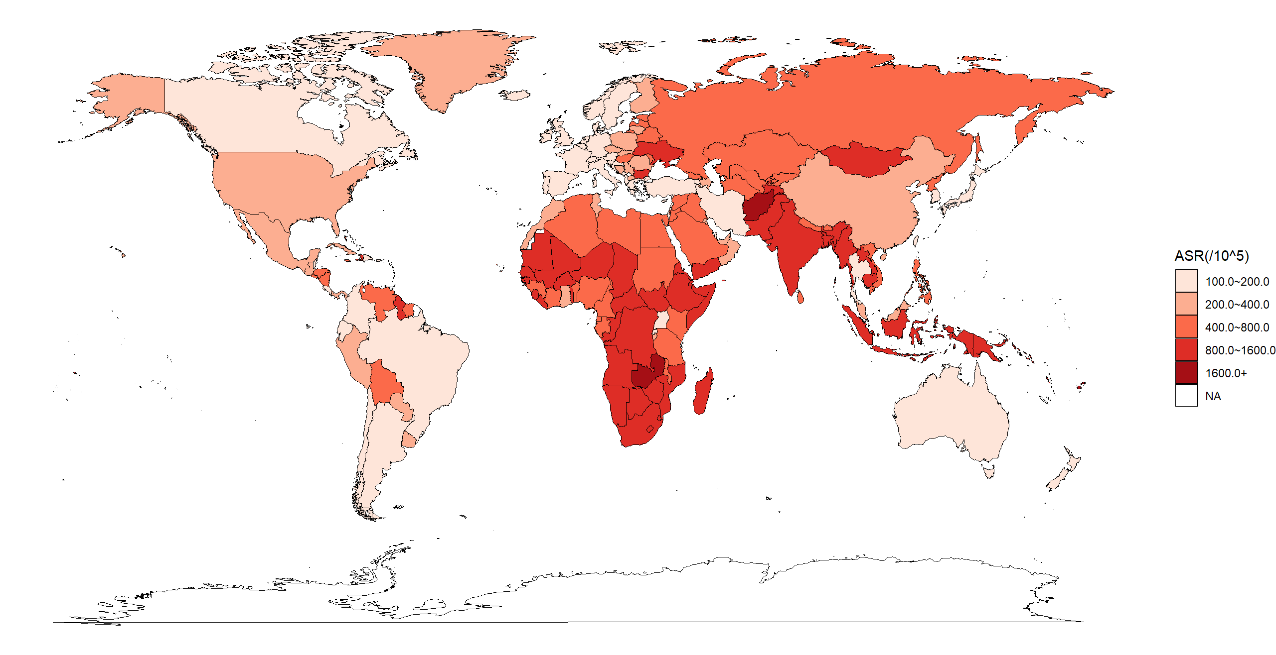

Fig S1. Age standardized rate (ASR) of disability-adjusted life years attributable to suboptimal fruit intake per 100 000 population in 2021.

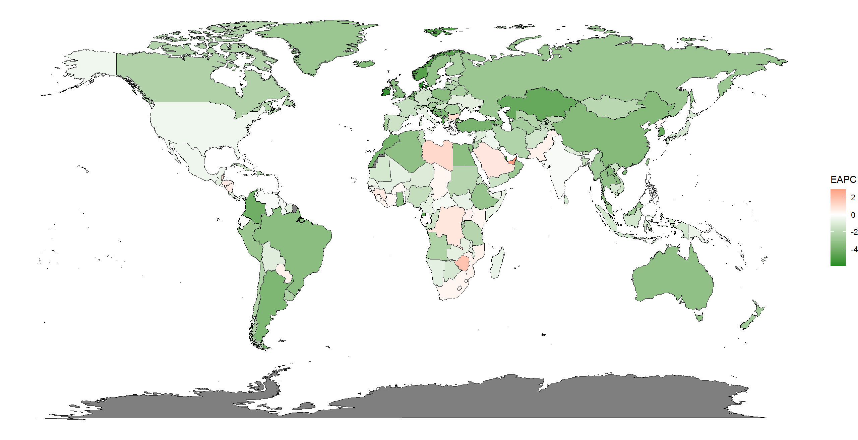

Fig S2. Estimated annual percentage change (EAPC) on age standardized rate of disability-adjusted life years attributable to suboptimal fruit intake from 1990 to 2021.

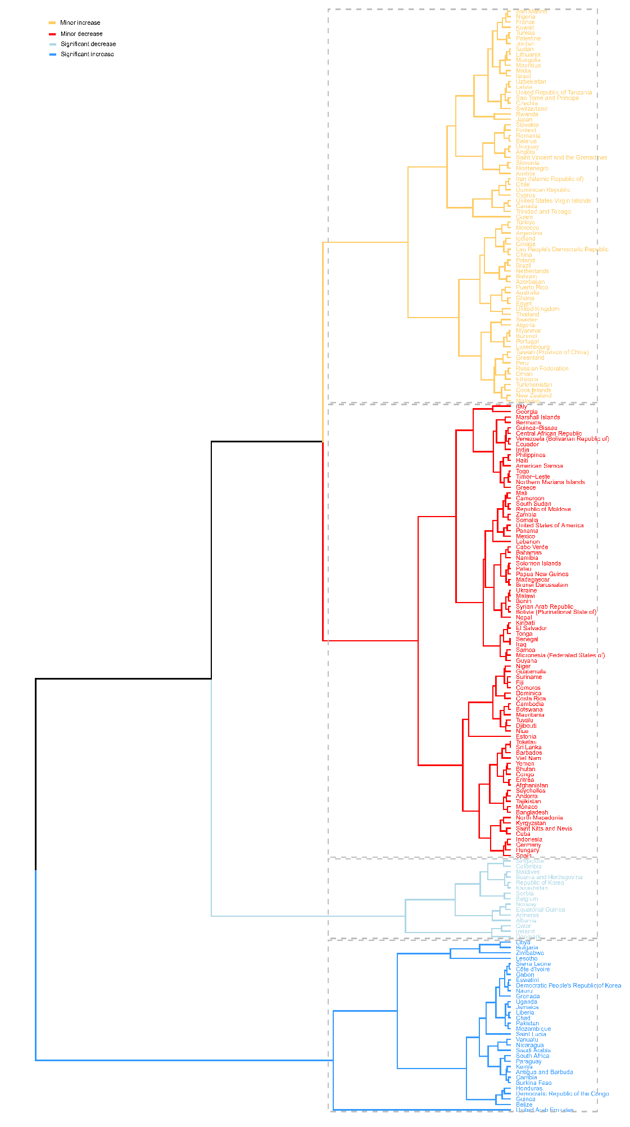

Fig S3. Hierarchical cluster analysis based on estimated annual percentage change on age standardized rate of deaths and disability-adjusted life years attributable to suboptimal intake of fruit in 2021.

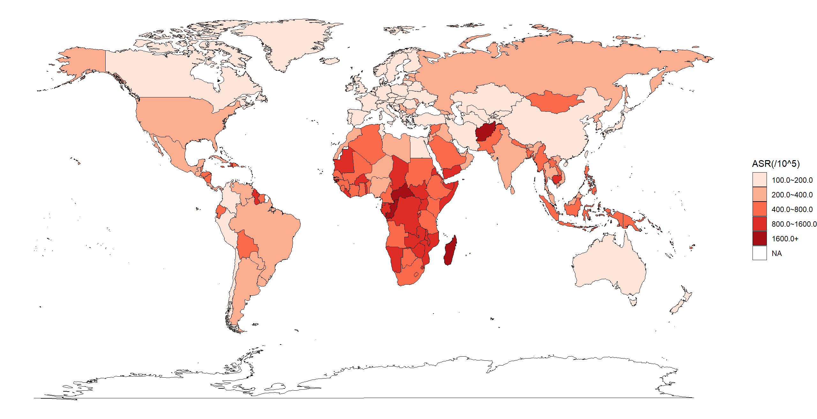

Fig S4. Age standardized rate (ASR) of disability-adjusted life years attributable to suboptimal vegetable intake per 100 000 population in 2021.

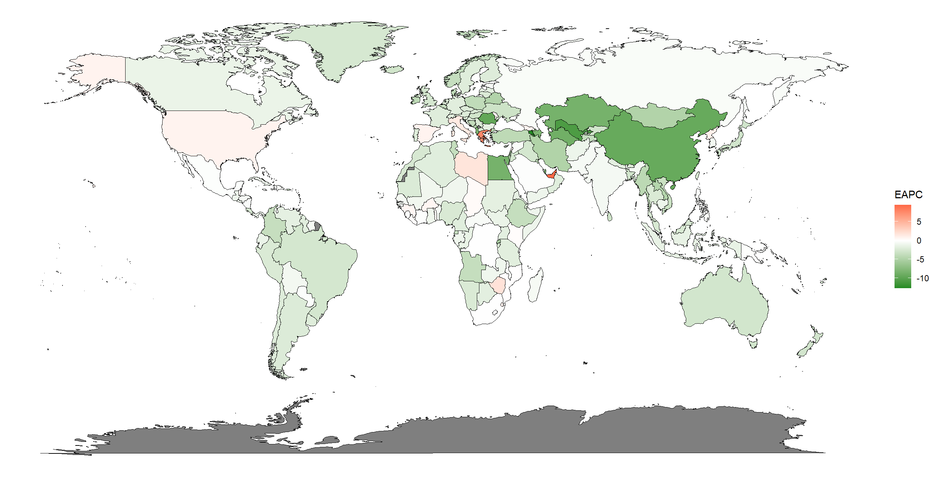

Fig S5. Estimated annual percentage change (EAPC) on age standardized rate of disability-adjusted life years attributable to suboptimal vegetable intake from 1990 to 2021.

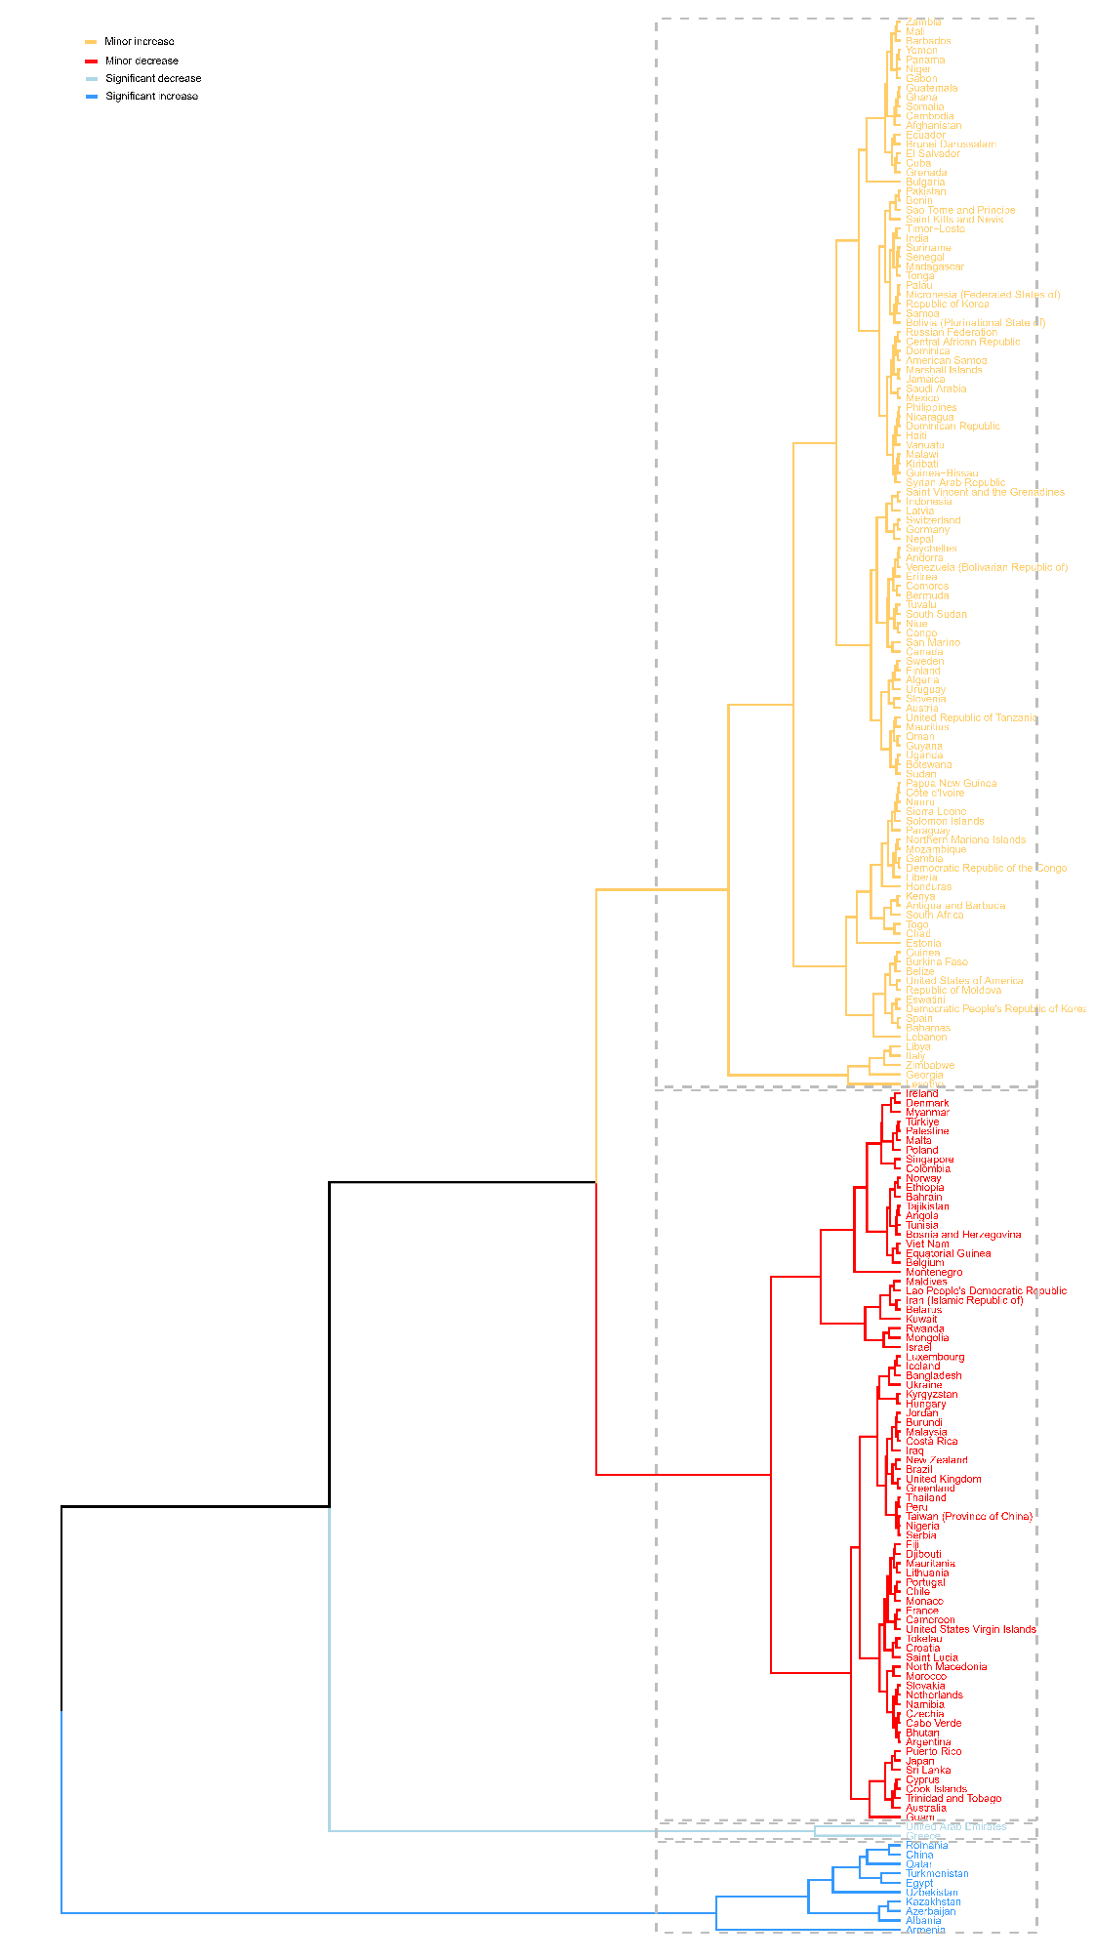

Fig S6. Hierarchical cluster analysis based on the estimated annual percentage change in deaths and disability-adjusted life years attributable to suboptimal vegetable intake in 2021.

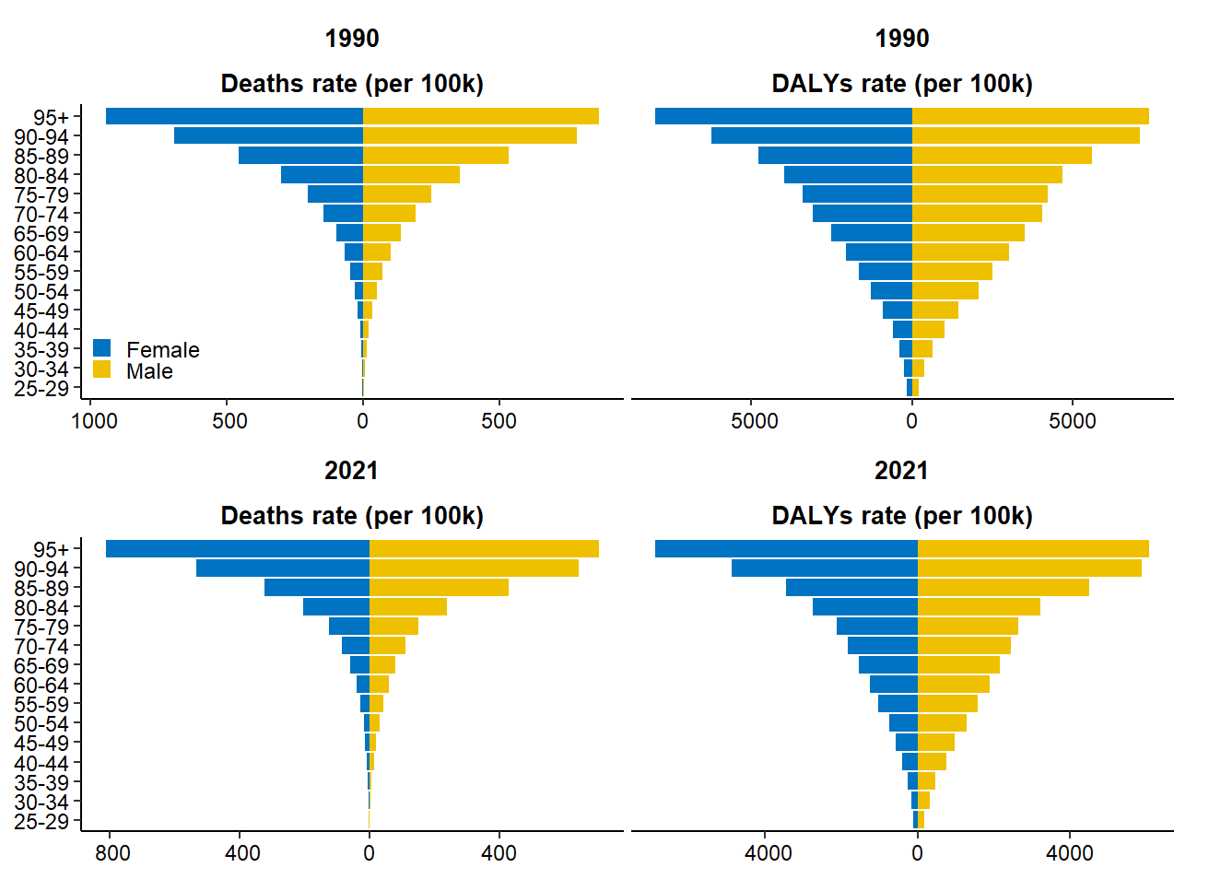

Fig S7. Number of global age-specific deaths and disability-adjusted life years (DALYs) attributable to suboptimal fruit intake per 100 000 population in females and males, in 1990 and 2021.

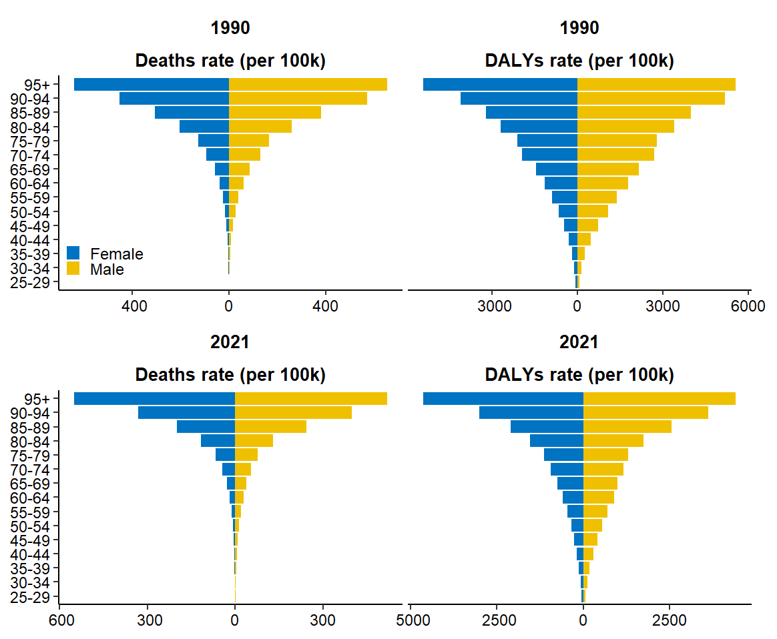

Fig S8. Number of global age-specific deaths and disability-adjusted life years (DALYs) attributable to suboptimal vegetable intake per 100 000 population in females and males, in 1990 and 2021.

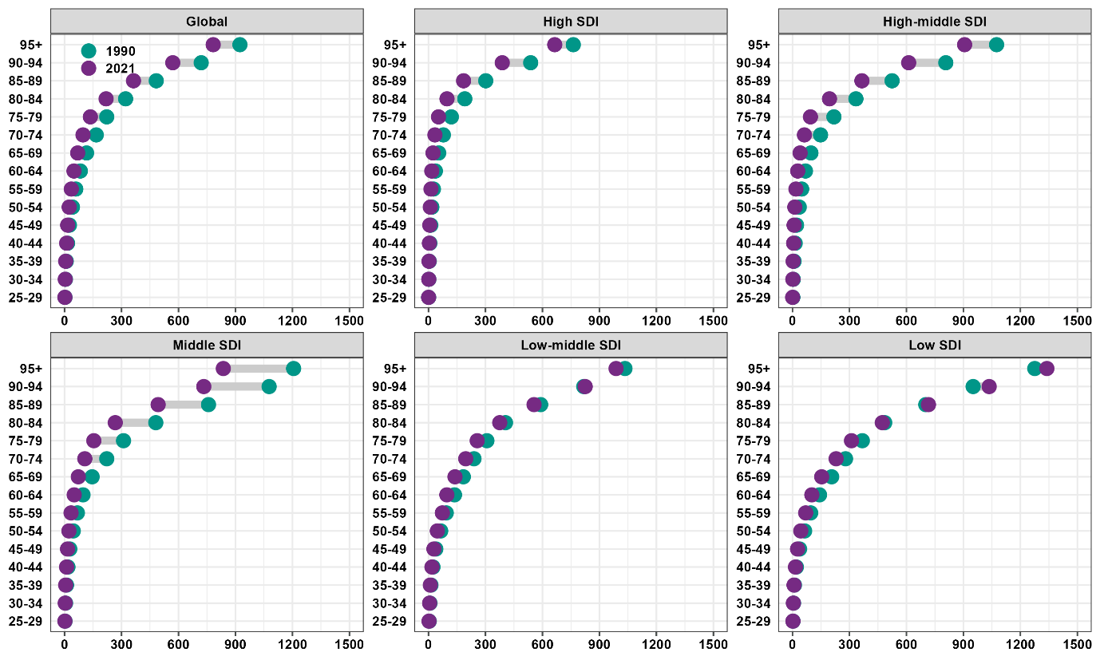

Fig S9. Age-specific number of deaths attributable to suboptimal fruit intake per 100 000 population globally and by sociodemographic index (SDI) in 1990 and 2021.

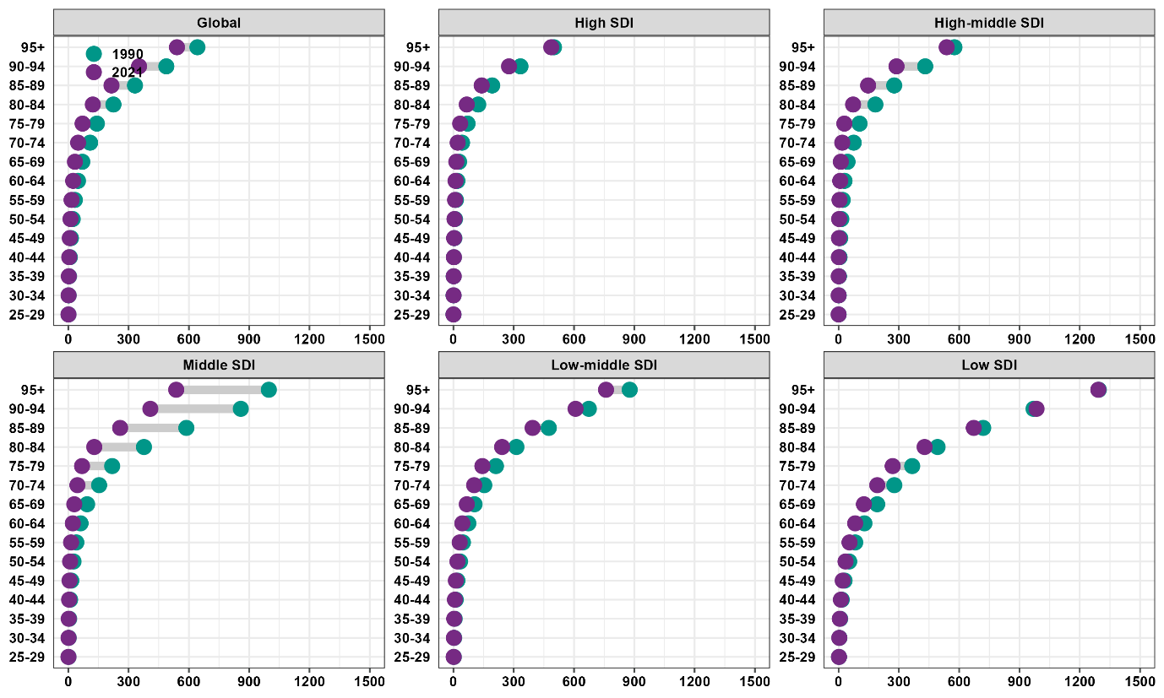

Fig S10. Age-specific number of deaths attributable to suboptimal vegetable intake per 100 000 population globally and by sociodemographic index (SDI) in 1990 and 2021.

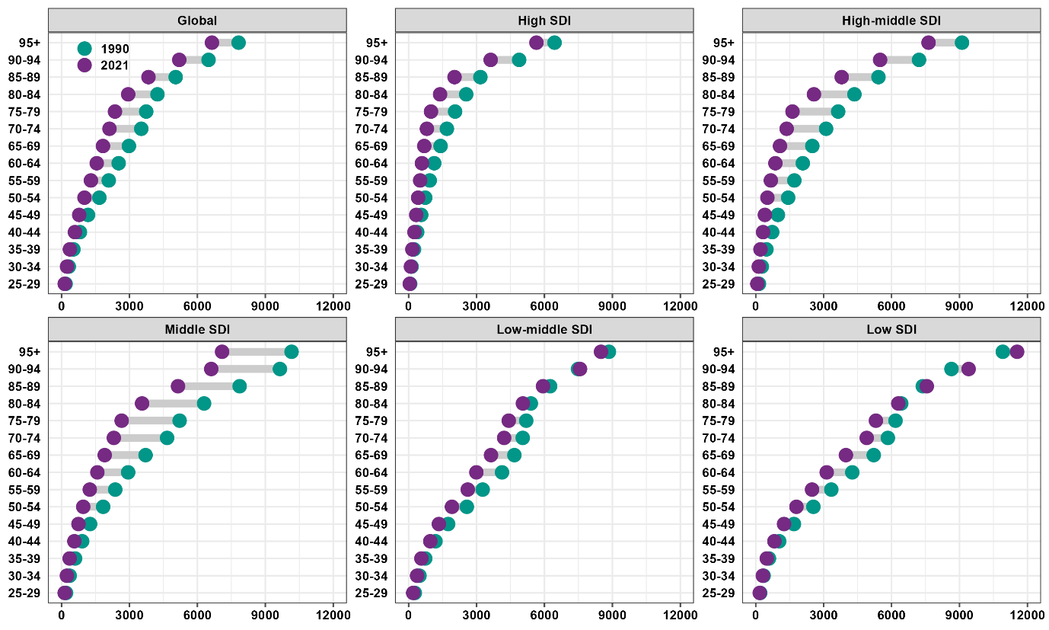

Fig S11. Age-specific number of disability-adjusted life years (DALYs) attributable to suboptimal fruit intake per 100 000 population globally and by sociodemographic index (SDI) in 1990 and 2021.

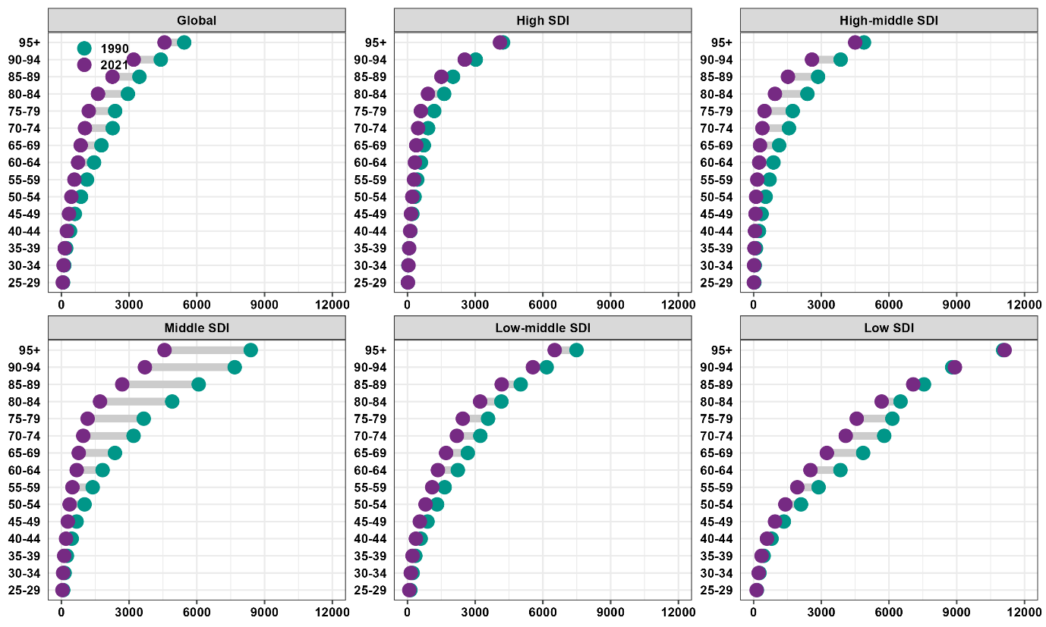

Fig S12. Age-specific number of disability-adjusted life years (DALYs) attributable to suboptimal vegetable intake per 100 000 population globally and by sociodemographic index (SDI) in 1990 and 2021.

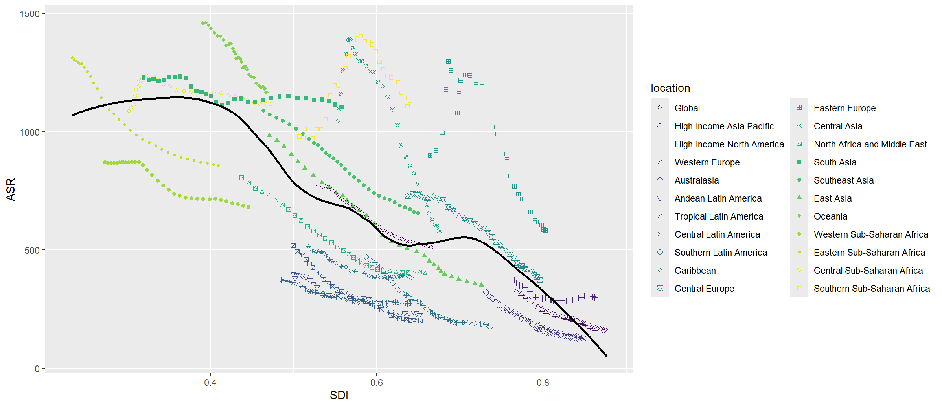

Fig S13. Age standardized rate (ASR) of disability-adjusted life years (DALYs) attributable to suboptimal fruit intake per 100 000 population at regional levels by sociodemographic index (SDI) from 1990 to 2021. The dark line represents the expected ASR of DALYs, estimated by SDI using smoothing splines models.

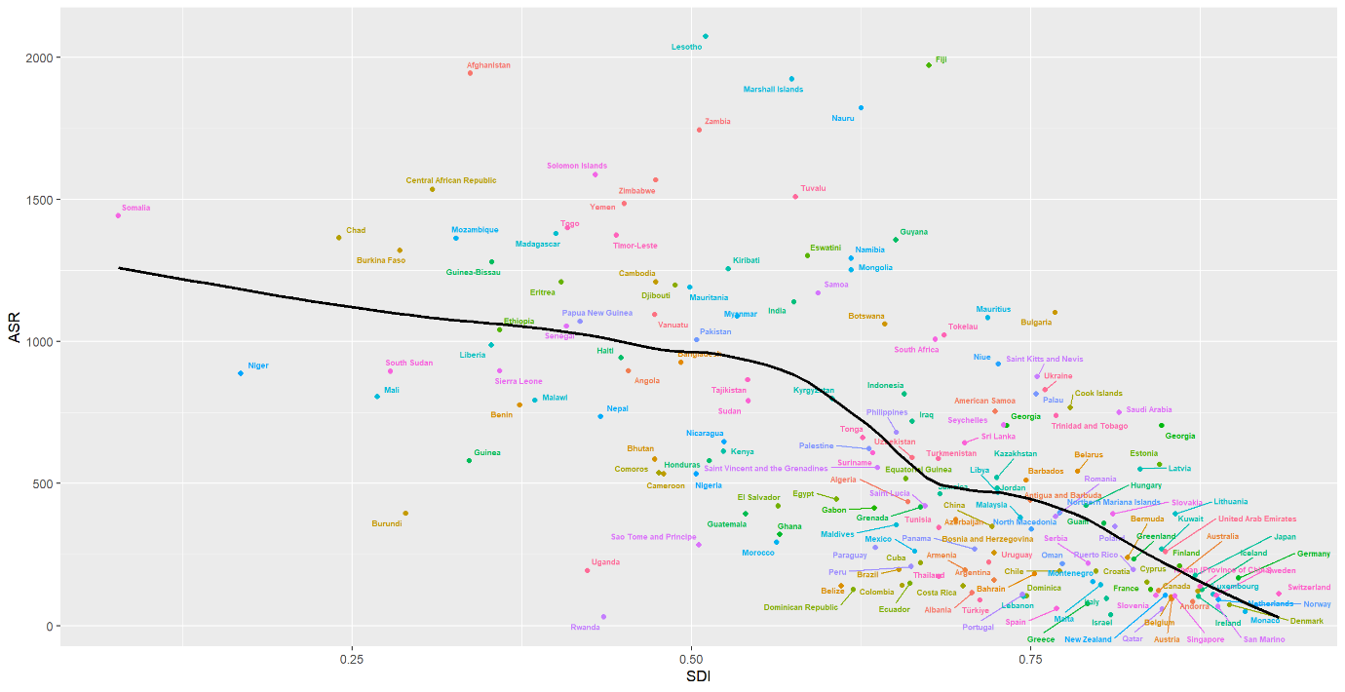

Fig S14. Age standardized rate (ASR) of disability-adjusted life years (DALYs) attributable to suboptimal fruit intake per 100 000 population at national levels by sociodemographic index (SDI) in 2021. The dark line represents the expected ASR of DALYs, estimated by SDI using smoothing splines models.

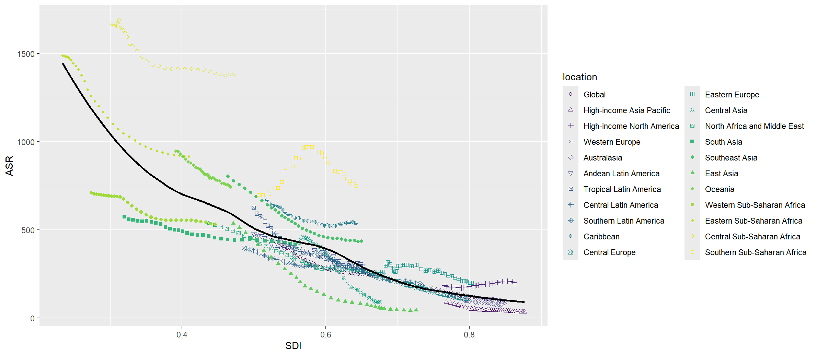

Fig S15. Age standardized rate (ASR) of disability-adjusted life years (DALYs) attributable to suboptimal vegetable intake per 100 000 population at regional levels by sociodemographic index (SDI) from 1990 to 2021. The dark line represents the expected ASR of DALYs, estimated by SDI using smoothing splines models.

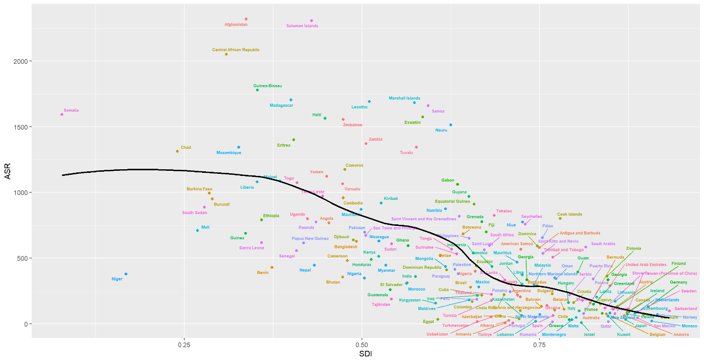

Fig S16. Age standardized rate (ASR) of disability-adjusted life years (DALYs) attributable to suboptimal vegetable intake per 100 000 population at national levels by sociodemographic index (SDI) in 2021. The dark line represents the expected ASR of DALYs, estimated by SDI using smoothing splines models.

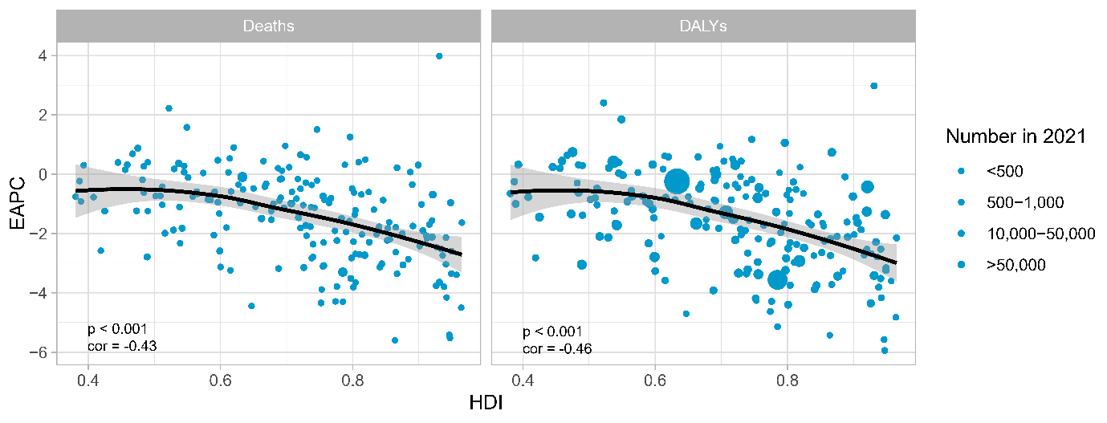

Fig S17. Relationship between national human development index (HDI) and estimated annual percentage change (EAPC) of age standardized rate (ASR) of deaths and disability-adjusted life years (DALYs) attributable to suboptimal intake of fruit in 2021. The dot size represents the number of deaths or DALYs in a certain country.

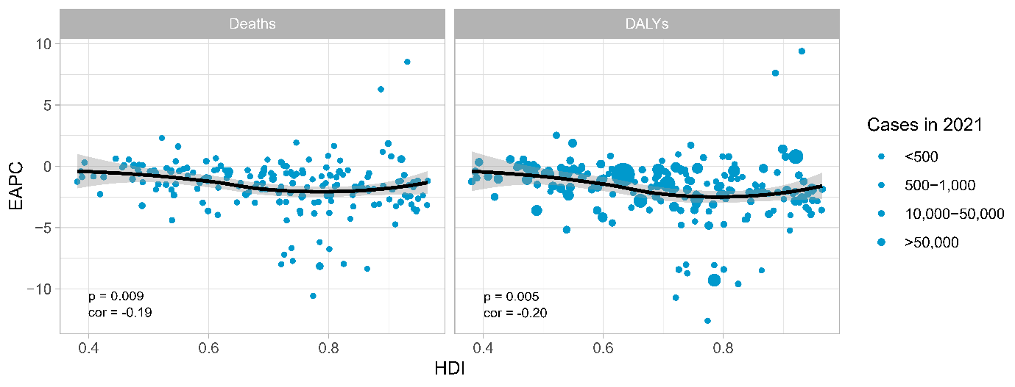

Fig S18. Relationship between national human development index (HDI) and estimated annual percentage change (EAPC) of age standardized rate (ASR) of deaths and disability-adjusted life years (DALYs) attributable to suboptimal vegetable intake in 2021. The dot size represents the number of deaths or DALYs in a certain country.

