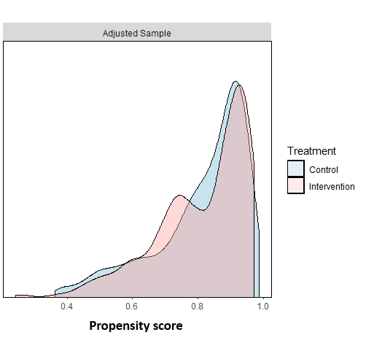

Additional File 20 : Figure 9 – Sensitivity analysis: distribution of propensity scores by study arm in unweighted population

