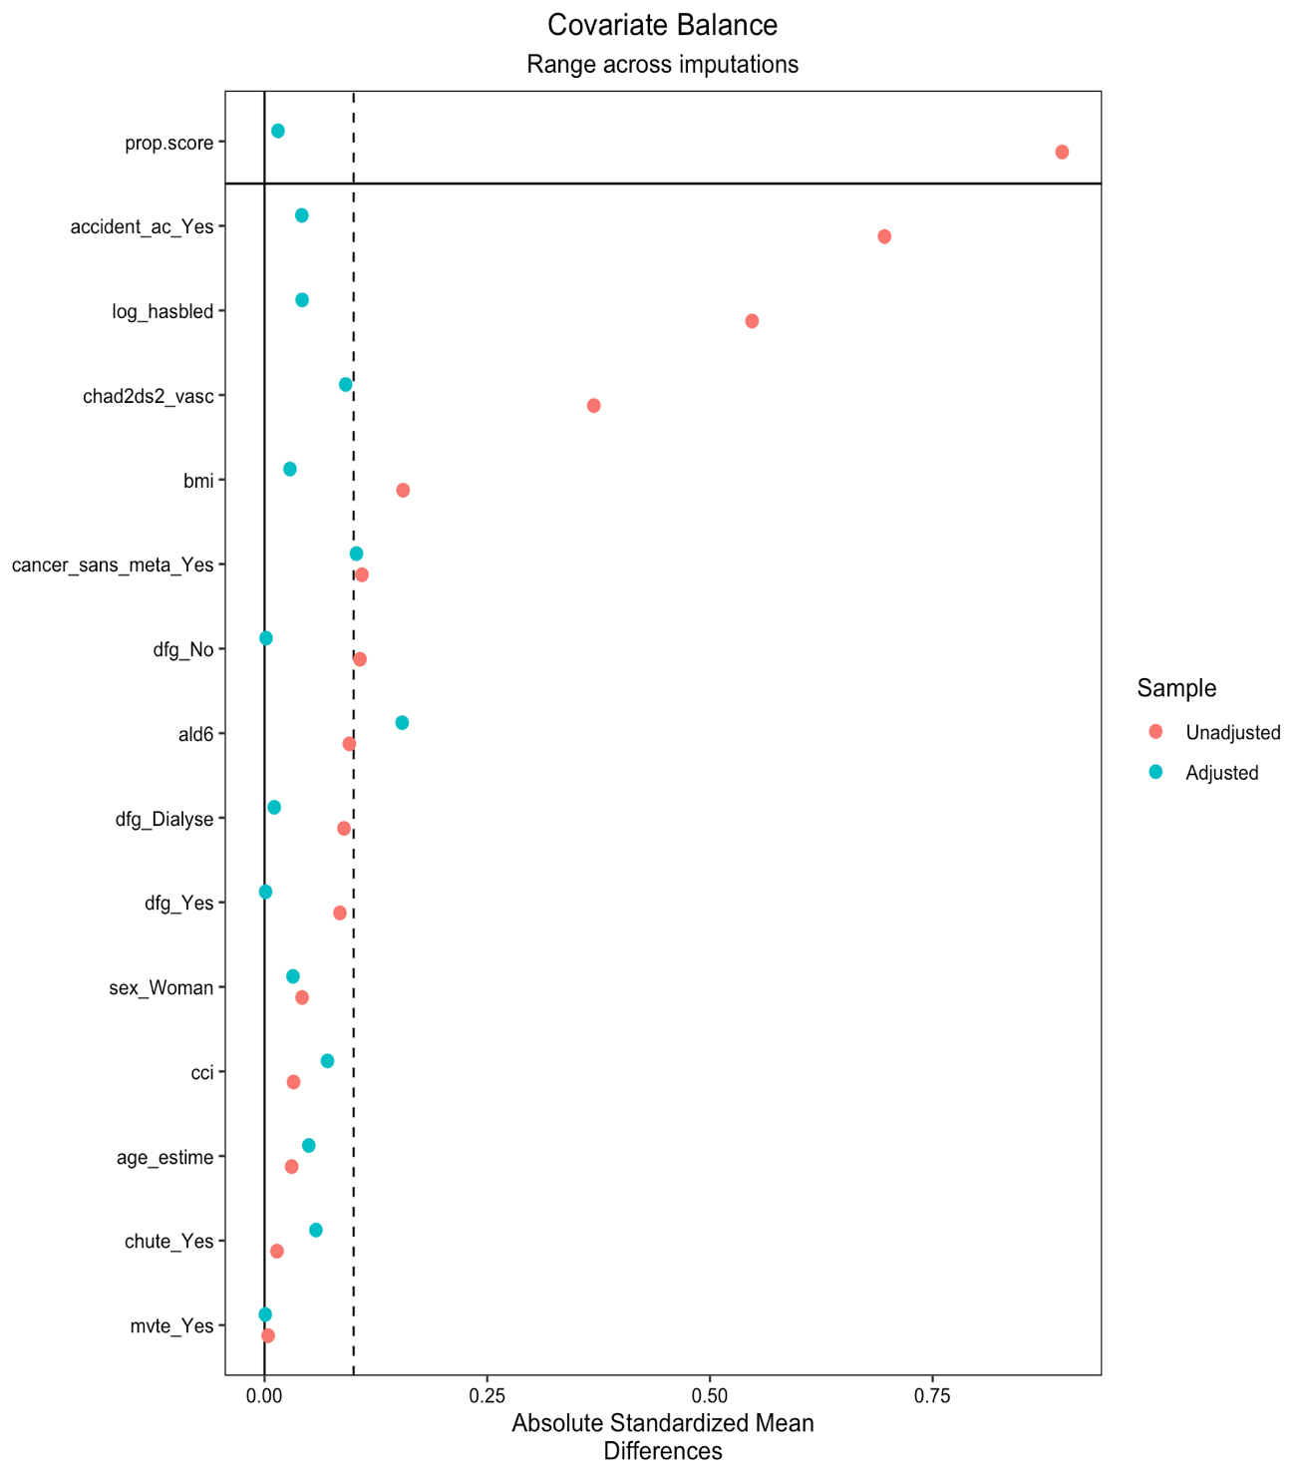
Additional File 21 : Figure 10 – Sensitivity analysis: mean baseline balance with standardized mean differences in unweighted vs weighted populations using propensity score across all imputed datasets

