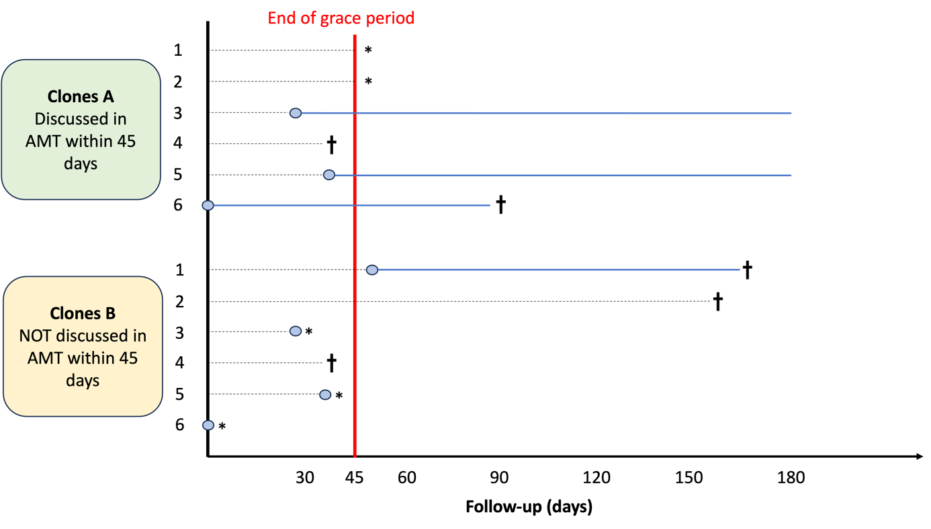
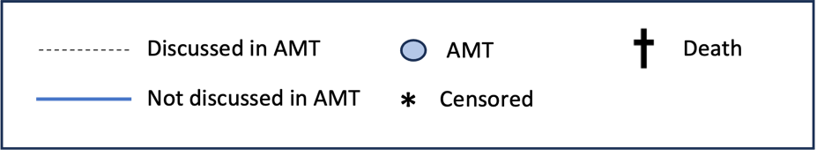

Additional File 5: Figure 1 – Representation of the cloning, censoring and weighting procedure
Inspired by Fu et al.
Each individual was duplicated and assigned to 1 of 2 intervention strategies. In this example, clones 1a–6a follow the strategy “discussed in AMT within 45 days”, whereas clones 1b–6b follow the strategy “not discussed in AMT within 45 days”. Clones 1a and 1b represent the same individual. Because clone 1a was assigned to initiation within 45 days, it is censored after day 45 because the corresponding patient had not been discussed in AMT. The censoring is likely informative, and inverse probability weighting is required to adjust for this. ATM, antithrombotics multidisciplinary team
Fu EL, van Diepen M, Xu Y, et al. Pharmacoepidemiology for nephrologists (part 2): potential biases and how to overcome them. Clin Kidney J. 2021;14(5):1317-1326. doi:10.1093/ckj/sfaa242

