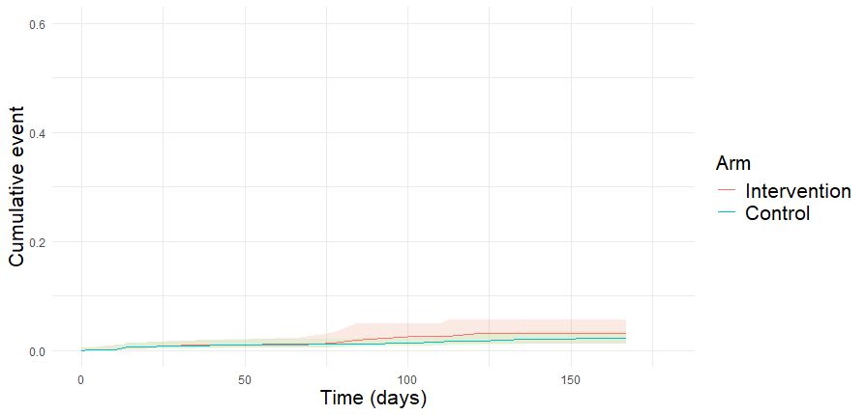
Additional File 10 : Figure 3 – Weighted cumulative incidence curves for major thromboembolic events by study arm

