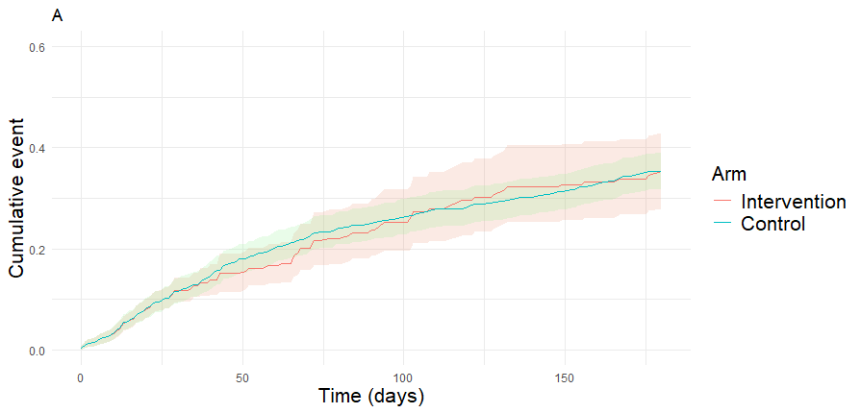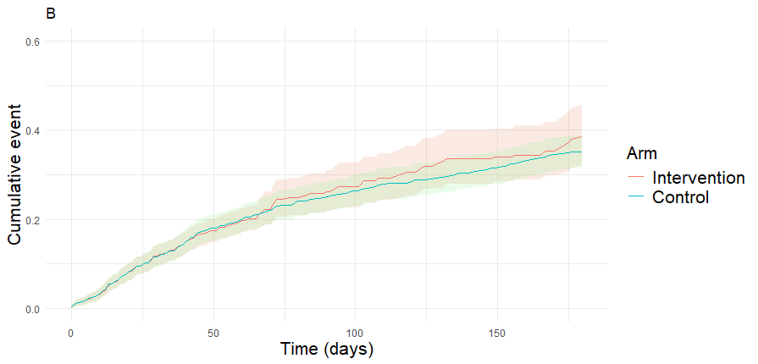
Additional File 18 : Figure 7– Sensitivity analysis: weighted cumulative incidence curves for primary outcome by arm, grace period of 30 days (A) and 60 days (B)

