Additional file 7: Fig. S2. Evolution of mpox publications over time

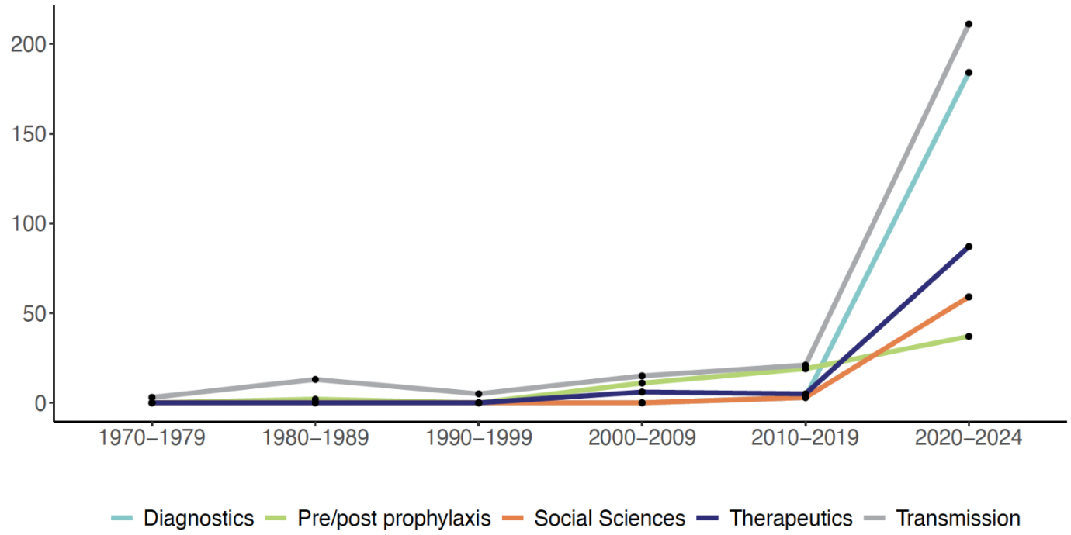
The figure presents the number of primary publications from systematic reviews in domains 2 to 7 by year of publication.

