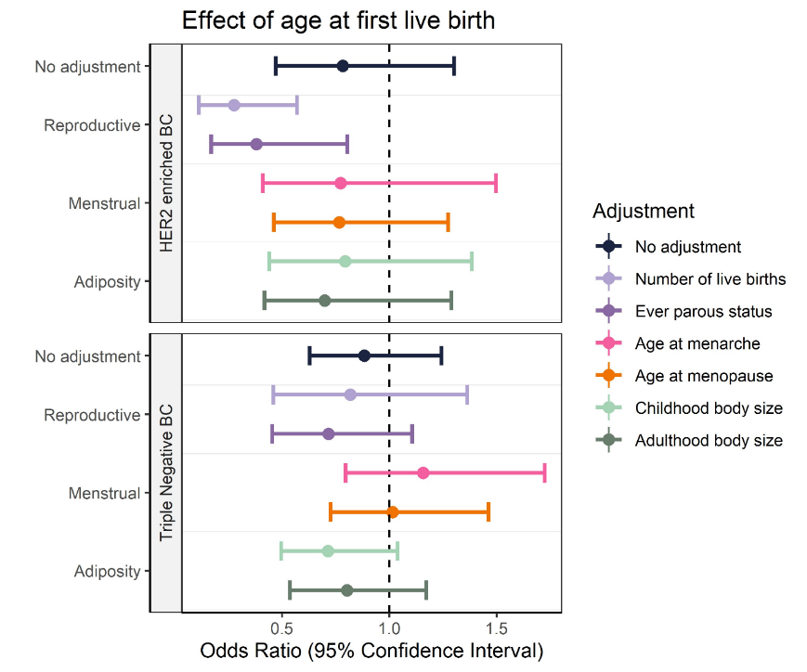
Figure S1 Univariable and multivariable mendelian randomization assessing the effects of age at first birth, on HER2 enriched and triple negative breast cancer risk.
No adjustment indicated findings from the univariable analysis.

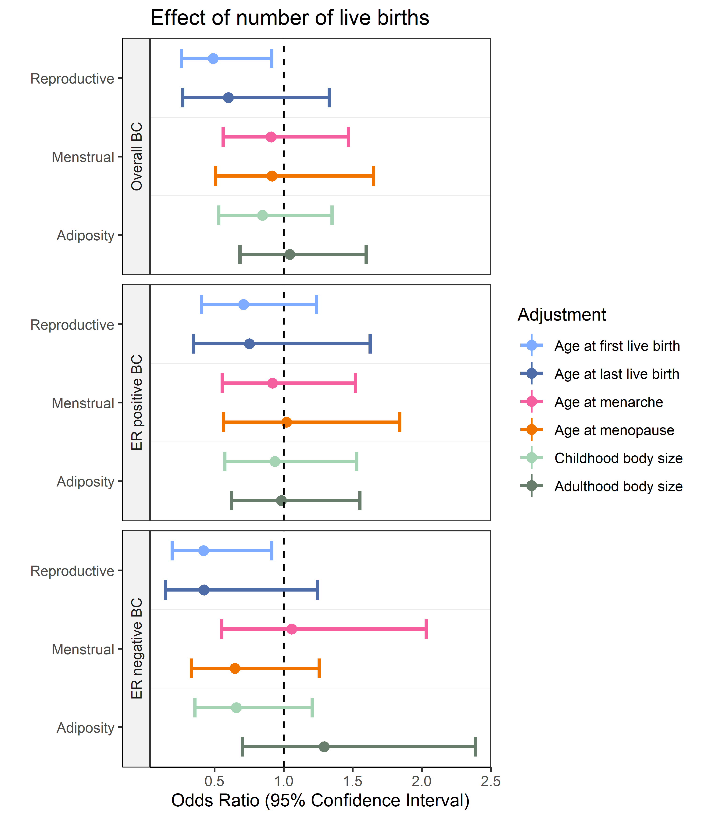
Figure S2 Multivariable mendelian randomization using MR Egger assessing the effects of number of births on overall, ER positive and ER negative breast cancer risk.

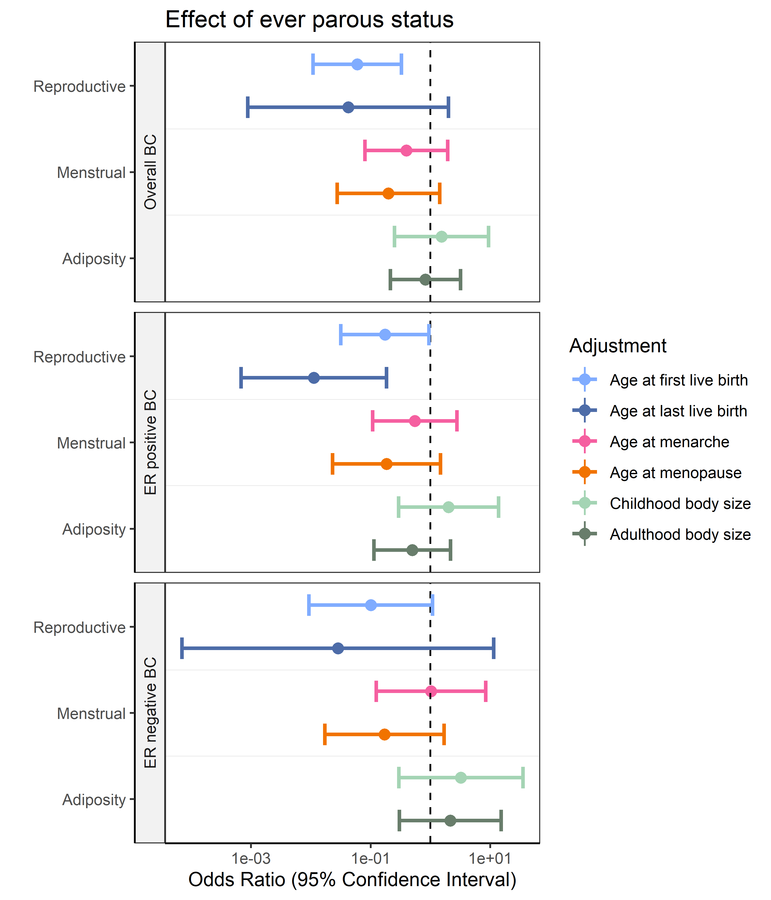
Figure S3 Multivariable mendelian randomization using MR Egger assessing the effects of ever parous status on overall, ER positive and ER negative breast cancer risk.

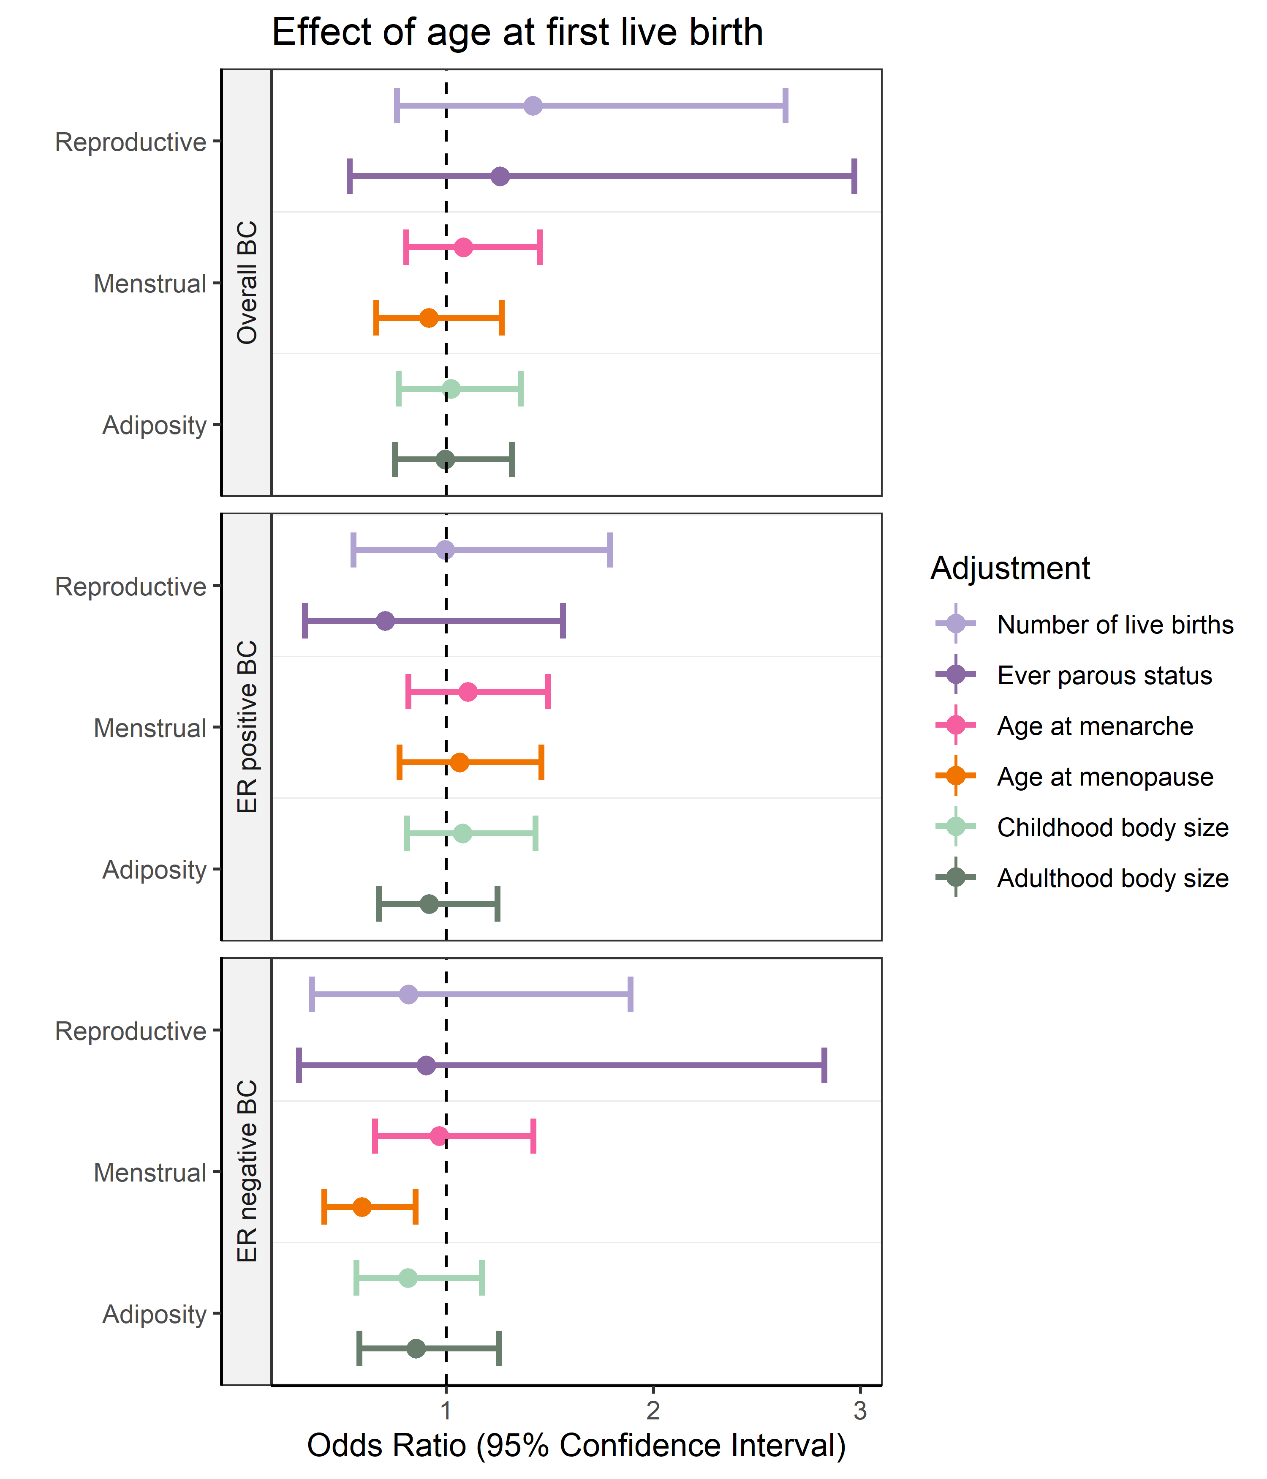
Figure S4 Multivariable mendelian randomization using MR Egger assessing the effects of age at first birth on overall, ER positive and ER negative breast cancer risk.

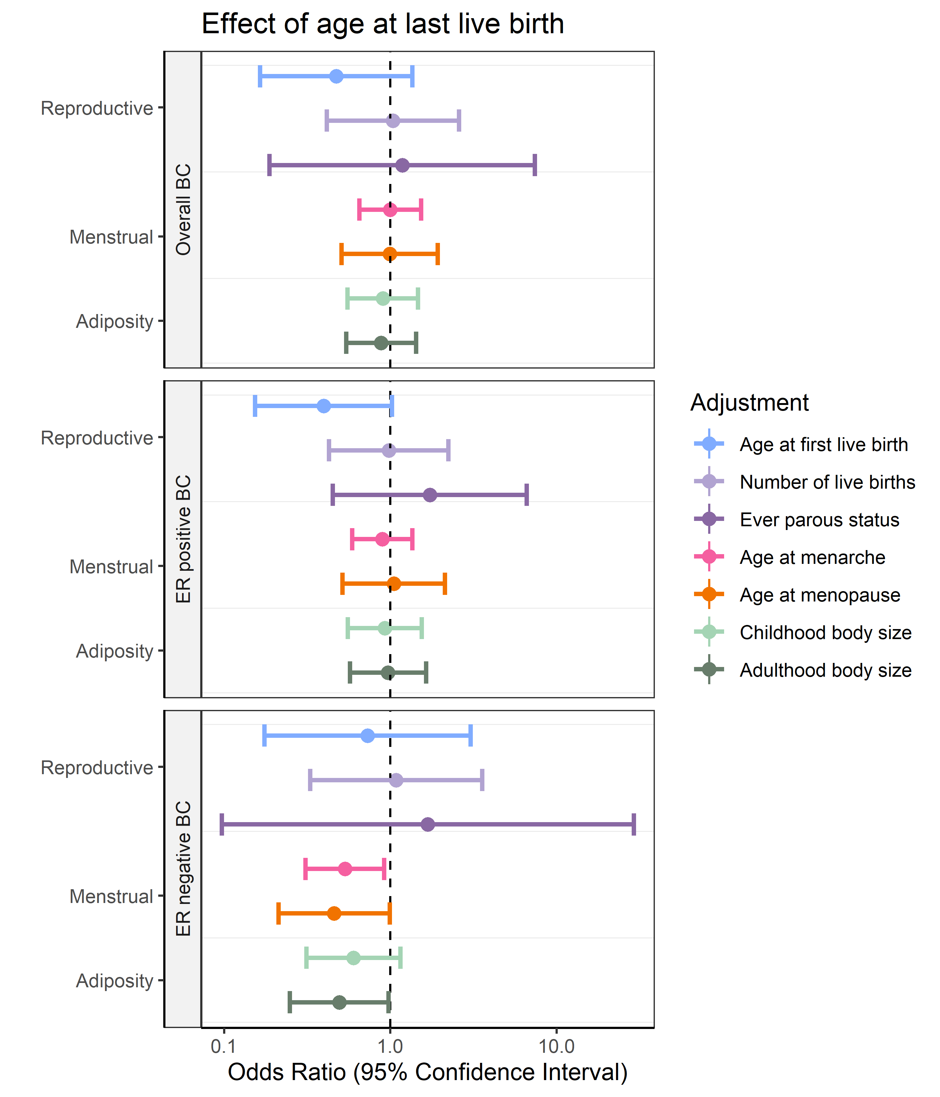
Figure S5 Multivariable mendelian randomization using MR Egger assessing the effects of age at last live births on overall, ER positive and ER negative breast cancer risk. `

