Figure S1. Vaccine effectiveness among those aged ≥65 years against (a) influenza A(H1N1)pdm09 and (b) A(H3N2), by individual season and pooled (1- and 2-stage analysis) over six seasons, 2015/16–2023/24, I-MOVE and VEBIS multicentre hospital studies, Europeª

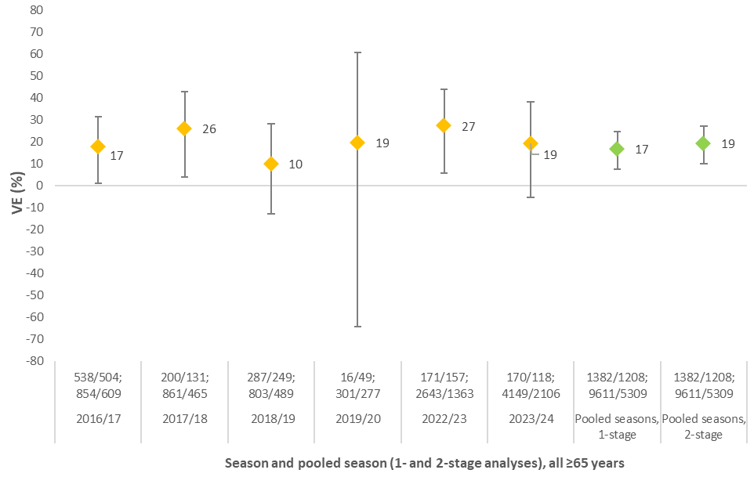
ab
a
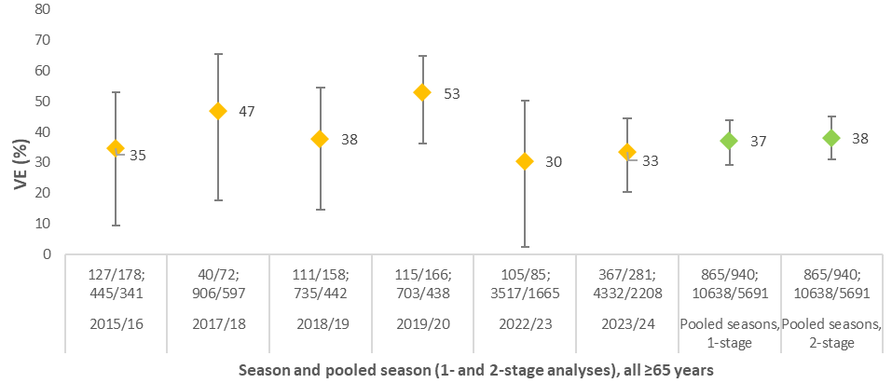
bb

vacc/unvacc cases;
vacc/unvacc controls

vacc/unvacc cases;
vacc/unvacc controls

I-MOVE: Influenza – Monitoring Vaccine Effectiveness in Europe; VEBIS: Vaccine effectiveness, Burden and Impact Studies.
ªNote: we adjusted the odds ratios for each individual season using the same variables used in the final pooled-season analysis, to have better comparison between the 1- and 2-stage pooled VE results. Some minor differences between these and previously published data for any individual season may therefore exist, due to differences in adjustment variables and analytic approaches. For each subtype, heterogeneity I²=0 for the 2-stage analysis.

Figure S2. Vaccine effectiveness among those aged ≥65 years against influenza A(H1N1)pdm09 by presence and absence of (a) heart disease, lung disease/asthma, diabetes, and kidney disease; (b) cancer, obesity, immunosuppression and liver disease, pooled over six seasons, 2015/16–2023/24, I-MOVE and VEBIS multicentre hospital studies, Europe
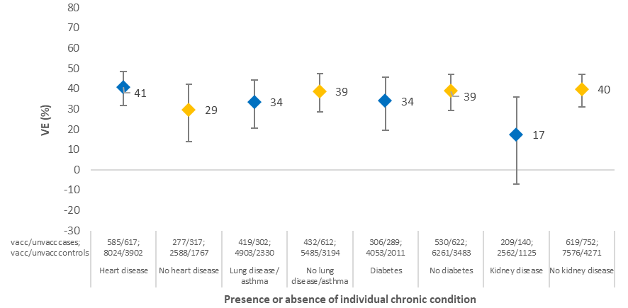
ab

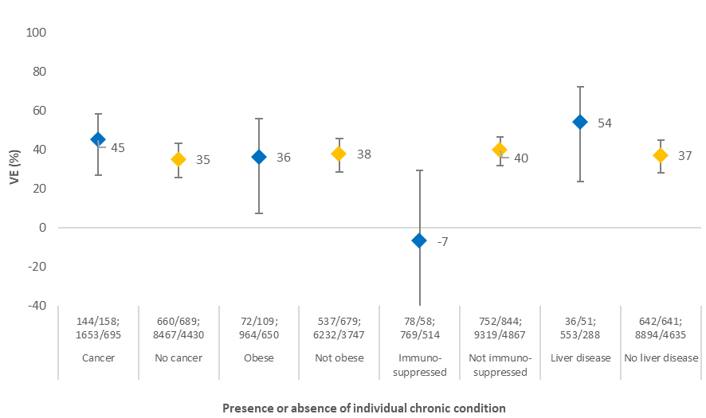
bb

vacc/unvacc cases;
vacc/unvacc controls

I-MOVE: Influenza – Monitoring Vaccine Effectiveness in Europe; VEBIS: Vaccine effectiveness, Burden and Impact Studies.

Figure S3. Vaccine effectiveness among those aged ≥65 years against influenza A(H3N2) by presence and absence of (a) heart disease, lung disease/asthma, diabetes, and kidney disease; (b) cancer, obesity, immunosuppression and liver disease, pooled over six seasons, 2015/16–2023/24, I-MOVE and VEBIS multicentre hospital studies, Europe

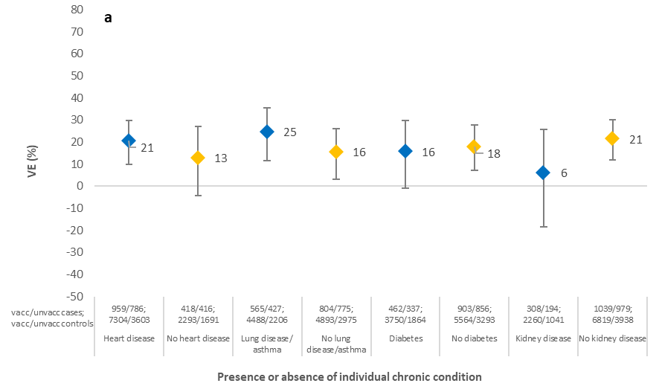

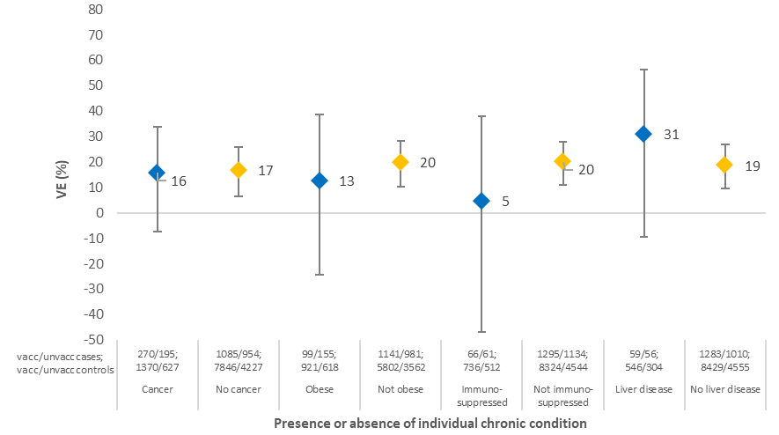
bb

I-MOVE: Influenza – Monitoring Vaccine Effectiveness in Europe; VEBIS: Vaccine effectiveness, Burden and Impact Studies.

Figure S4. Sensitivity analysis 1. Vaccine effectiveness among those aged ≥65 years and among those with at least two chronic conditions against (a) influenza A(H1N1)pdm09 and (b) A(H3N2) by SARI case definition, 2022/23 and 2023/24, I-MOVE and VEBIS multicentre hospital studies, Europe.
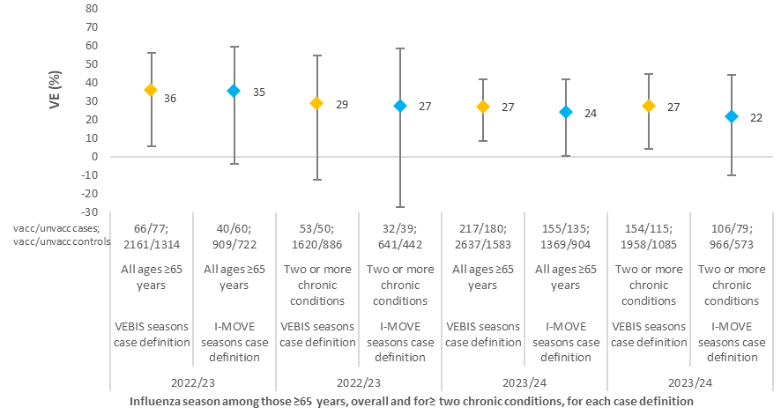
ab

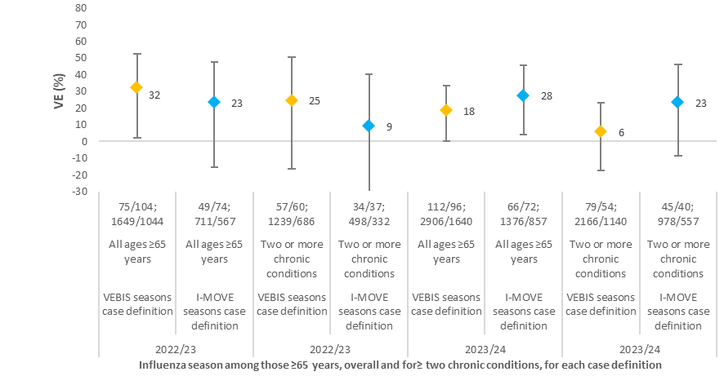
vacc/unvacc cases;
vacc/unvacc controls
bb
I-MOVE: Influenza – Monitoring Vaccine Effectiveness in Europe; VEBIS: Vaccine effectiveness, Burden and Impact Studies.

Figure S5. Sensitivity analysis 2. Vaccine effectiveness among those aged ≥65 years and among those with at least two chronic conditions against influenza (a) A(H1N1)pdm09 and (b) A(H3N2) overall and excluding SARS-CoV-2-positive controls, 2022/23 and 2023/24, I-MOVE and VEBIS multicentre hospital studies, Europe.
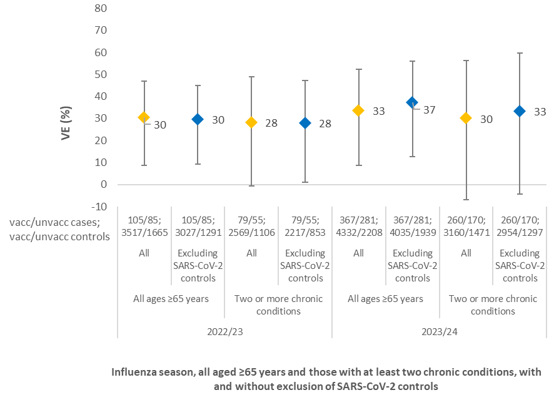
ab

b
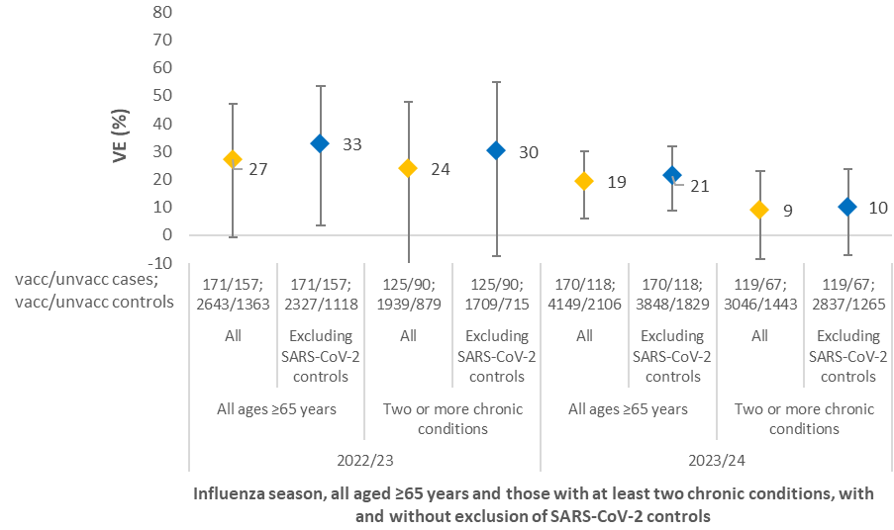

I-MOVE: Influenza – Monitoring Vaccine Effectiveness in Europe; VEBIS: Vaccine effectiveness, Burden and Impact Studies.
Table S1. Proportion of each chronic condition among test-negative controls, by site/country, among hospitalised SARI patients aged ≥65 years, pooled seasons 2015/16–2023/24, I-MOVE and VEBIS multicentre hospital studies, Europe.
Chronic condition | Yes |  | No |  | Missing data
Site/country | N | % | N | % | N | %
Diabetes
Albania | 13 | 25.5 | 38 | 74.5 | 0 | 0
Belgium | 237 | 21.2 | 879 | 78.7 | 1 | 0.1
Germany | 38 | 22.6 | 10 | 6 | 120 | 71.4
Spain (except Navarre Region) | 4434 | 43.8 | 5151 | 50.9 | 539 | 5.3
France | 225 | 26.4 | 628 | 73.6 | 0 | 0
Croatia | 92 | 32.5 | 191 | 67.5 | 0 | 0
Hungary | 7 | 26.9 | 19 | 73.1 | 0 | 0
Ireland | 28 | 19.7 | 114 | 80.3 | 0 | 0
Italy | 144 | 29.1 | 351 | 70.9 | 0 | 0
Lithuania | 57 | 18.7 | 248 | 81.3 | 0 | 0
Malta | 162 | 34.7 | 305 | 65.3 | 0 | 0
Navarre Region, Spain | 1933 | 32.7 | 3974 | 67.3 | 0 | 0
Netherlands | 61 | 27.7 | 159 | 72.3 | 0 | 0
Poland | 6 | 42.9 | 8 | 57.1 | 0 | 0
Portugal | 277 | 38.8 | 436 | 61.2 | 0 | 0
Romania | 141 | 26.3 | 368 | 68.5 | 28 | 5.2
Heart disease
Albania | 46 | 90.2 | 5 | 9.8 | 0 | 0
Belgium | 502 | 44.9 | 613 | 54.9 | 2 | 0.2
Germany | 114 | 67.9 | 10 | 6 | 44 | 26.2
Spain (except Navarre Region) | 8100 | 80 | 1998 | 19.7 | 26 | 0.3
France | 468 | 54.9 | 385 | 45.1 | 0 | 0
Croatia | 214 | 75.6 | 69 | 24.4 | 0 | 0
Hungary | 21 | 80.8 | 5 | 19.2 | 0 | 0
Ireland | 91 | 64.1 | 51 | 35.9 | 0 | 0
Italy | 338 | 68.3 | 157 | 31.7 | 0 | 0
Lithuania | 255 | 83.6 | 50 | 16.4 | 0 | 0
Malta | 309 | 66.2 | 158 | 33.8 | 0 | 0
Navarre Region, Spain | 3975 | 67.3 | 1932 | 32.7 | 0 | 0
Netherlands | 97 | 44.1 | 123 | 55.9 | 0 | 0
Poland | 14 | 100 | 0 | 0 | 0 | 0
Portugal | 556 | 78 | 156 | 21.9 | 1 | 0.1
Romania | 445 | 82.9 | 91 | 16.9 | 1 | 0.2
Lung disease/asthma
Albania | 23 | 45.1 | 28 | 54.9 | 0 | 0
Belgium | 384 | 34.4 | 732 | 65.5 | 1 | 0.1
Germany | 96 | 57.1 | 10 | 6 | 62 | 36.9
Spain (except Navarre Region) | 5051 | 49.9 | 4634 | 45.8 | 439 | 4.3
France | 394 | 46.2 | 458 | 53.7 | 1 | 0.1
Croatia | 68 | 24 | 215 | 76 | 0 | 0
Hungary | 6 | 23.1 | 20 | 76.9 | 0 | 0
Ireland | 63 | 44.4 | 79 | 55.6 | 0 | 0
Italy | 224 | 45.3 | 271 | 54.7 | 0 | 0
Lithuania | 83 | 27.2 | 222 | 72.8 | 0 | 0
Malta | 124 | 26.6 | 343 | 73.4 | 0 | 0
Navarre Region, Spain | 2336 | 39.5 | 3571 | 60.5 | 0 | 0
Netherlands | 128 | 58.2 | 92 | 41.8 | 0 | 0
Poland | 3 | 21.4 | 11 | 78.6 | 0 | 0
Portugal | 365 | 51.2 | 345 | 48.4 | 3 | 0.4
Romania | 114 | 21.2 | 386 | 71.9 | 37 | 6.9
Immunosuppression
Albania | 1 | 2 | 50 | 98 | 0 | 0
Belgium | 276 | 24.7 | 841 | 75.3 | 0 | 0
Germany | 6 | 3.6 | 10 | 6 | 152 | 90.5
Spain (except Navarre Region) | 1147 | 11.3 | 8041 | 79.4 | 936 | 9.2
France | 63 | 7.4 | 790 | 92.6 | 0 | 0
Croatia | 4 | 1.4 | 279 | 98.6 | 0 | 0
Hungary | 0 | 0 | 26 | 100 | 0 | 0
Ireland | 2 | 1.4 | 140 | 98.6 | 0 | 0
Italy | 6 | 1.2 | 489 | 98.8 | 0 | 0
Lithuania | 2 | 0.7 | 303 | 99.3 | 0 | 0
Malta | 7 | 1.5 | 460 | 98.5 | 0 | 0
Navarre Region, Spain | 199 | 3.4 | 5708 | 96.6 | 0 | 0
Netherlands | 24 | 10.9 | 195 | 88.6 | 1 | 0.5
Poland | 0 | 0 | 14 | 100 | 0 | 0
Portugal | 24 | 3.4 | 668 | 93.7 | 21 | 2.9
Romania | 14 | 2.6 | 481 | 89.6 | 42 | 7.8
Liver diseaseª
Albania | 0 | 0 | 51 | 100 | 0 | 0
Belgium | 48 | 4.3 | 1068 | 95.6 | 1 | 0.1
Spain (except Navarre Region) | 622 | 6.1 | 8324 | 82.2 | 1178 | 11.6
France | 23 | 2.7 | 577 | 67.6 | 253 | 29.7
Croatia | 2 | 0.7 | 238 | 84.1 | 43 | 15.2
Hungary | 0 | 0 | 26 | 100 | 0 | 0
Ireland | 1 | 0.7 | 141 | 99.3 | 0 | 0
Italy | 27 | 5.5 | 468 | 94.5 | 0 | 0
Lithuania | 3 | 1 | 261 | 85.6 | 41 | 13.4
Malta | 2 | 0.4 | 202 | 43.3 | 263 | 56.3
Navarre Region, Spain | 316 | 5.3 | 5339 | 90.4 | 252 | 4.3
Netherlands | 2 | 0.9 | 218 | 99.1 | 0 | 0
Portugal | 3 | 0.4 | 154 | 21.6 | 556 | 78
Romania | 19 | 3.5 | 206 | 38.4 | 312 | 58.1
Renal disease^{b}
Albania | 2 | 3.9 | 49 | 96.1 | 0 | 0
Belgium | 263 | 23.5 | 854 | 76.5 | 0 | 0
Spain (except Navarre Region) | 2220 | 21.9 | 7056 | 69.7 | 848 | 8.4
France | 128 | 15 | 596 | 69.9 | 129 | 15.1
Croatia | 44 | 15.5 | 238 | 84.1 | 1 | 0.4
Hungary | 5 | 19.2 | 20 | 76.9 | 1 | 3.8
Ireland | 11 | 7.7 | 131 | 92.3 | 0 | 0
Italy | 88 | 17.8 | 407 | 82.2 | 0 | 0
Lithuania | 54 | 17.7 | 251 | 82.3 | 0 | 0
Malta | 12 | 2.6 | 192 | 41.1 | 263 | 56.3
Navarre Region, Spain | 1502 | 25.4 | 4405 | 74.6 | 0 | 0
Netherlands | 10 | 4.5 | 210 | 95.5 | 0 | 0
Poland | 3 | 21.4 | 11 | 78.6 | 0 | 0
Portugal | 178 | 25 | 531 | 74.5 | 4 | 0.6
Romania | 74 | 13.8 | 427 | 79.5 | 36 | 6.7
Cancer^{c}
Albania | 1 | 2 | 49 | 96.1 | 1 | 2
Spain (except Navarre Region) | 538 | 5.3 | 9564 | 94.5 | 22 | 0.2
France | 173 | 20.3 | 680 | 79.7 | 0 | 0
Croatia | 78 | 27.6 | 205 | 72.4 | 0 | 0
Hungary | 2 | 7.7 | 24 | 92.3 | 0 | 0
Ireland | 27 | 19 | 115 | 81 | 0 | 0
Italy | 121 | 24.4 | 374 | 75.6 | 0 | 0
Lithuania | 60 | 19.7 | 245 | 80.3 | 0 | 0
Malta | 94 | 20.1 | 373 | 79.9 | 0 | 0
Navarre Region, Spain | 1748 | 29.6 | 4159 | 70.4 | 0 | 0
Netherlands | 38 | 17.3 | 182 | 82.7 | 0 | 0
Poland | 2 | 14.3 | 12 | 85.7 | 0 | 0
Portugal | 63 | 8.8 | 646 | 90.6 | 4 | 0.6
Romania | 50 | 9.3 | 448 | 83.4 | 39 | 7.3
Obesity^{b}
Albania | 4 | 7.8 | 47 | 92.2 | 0 | 0
Belgium | 125 | 11.2 | 967 | 86.6 | 25 | 2.2
Spain (except Navarre Region) | 1326 | 13.1 | 5888 | 58.2 | 2910 | 28.7
France | 91 | 10.7 | 762 | 89.3 | 0 | 0
Croatia | 16 | 5.7 | 266 | 94 | 1 | 0.4
Hungary | 1 | 3.8 | 25 | 96.2 | 0 | 0
Ireland | 3 | 2.1 | 139 | 97.9 | 0 | 0
Italy | 47 | 9.5 | 448 | 90.5 | 0 | 0
Lithuania | 98 | 32.1 | 206 | 67.5 | 1 | 0.3
Malta | 4 | 0.9 | 463 | 99.1 | 0 | 0
Navarre Region, Spain | 173 | 2.9 | 3522 | 59.6 | 2212 | 37.4
Netherlands | 46 | 20.9 | 168 | 76.4 | 6 | 2.7
Poland | 2 | 14.3 | 12 | 85.7 | 0 | 0
Portugal | 162 | 22.7 | 498 | 69.8 | 53 | 7.4
Romania | 138 | 25.7 | 398 | 74.1 | 1 | 0.2

I-MOVE: Influenza – Monitoring Vaccine Effectiveness in Europe; SARI: Severe acute respiratory infection; VEBIS: Vaccine effectiveness, Burden and Impact Studies.

ª Two sites did not provide information on liver disease.
b
^{b} One site did not provide information on renal disease.
b
^{c} Two sites did not provide information on cancer.
b

