Additional file 2
Fig. S1- (A) Variables selected by the LASSO regression, (B) Forest plots for multivariate analyses of risk factors concerning HCC development. LASSO, least absolute shrinkage and selection operator. HCC, hepatocellular carcinoma.
Fig. S2- Applying the thresholds established by X-tile on the nomogram, the derivation cohort was divided into three risk categories. ALB, albumin; PLT, platelet; HR, hazard ratio; CI, confidence interval; LSM, liver stiffness measurement.
Fig. S3- Kaplan–Meier curves for the external validation cohort 1, after dichotomizing the cohort using the risk-stratification cut-off value rounded to the nearest integer (low risk<160 points, intermediate risk 160-193 points, high-risk>193 points). HCC, hepatocellular carcinoma.
Fig. S4- Kaplan–Meier curves for the external validation cohort 2, after dichotomizing the cohort using the risk-stratification cut-off value rounded to the nearest integer (low risk<160 points, intermediate risk 160-193 points, high-risk>193 points). HCC, hepatocellular carcinoma.
Graphical Abstract-This graphical abstract illustrates the overall workflow for developing and validating a hepatocellular carcinoma prediction model. The process begins with a baseline study of a chronic hepatitis B cohort, followed by the construction of a statistical model, and concludes with successful validation across multiple independent external cohorts.

Fig. S1 (A) Variables selected by the LASSO regression, (B) Forest plots for multivariate analyses of risk factors concerning HCC development. LASSO, least absolute shrinkage and selection operator. HCC, hepatocellular carcinoma.

Fig. S2 Applying the thresholds established by X-tile on the nomogram, the derivation cohort was divided into three risk categories. ALB, albumin; PLT, platelet; HR, hazard ratio; CI, confidence interval; LSM, liver stiffness measurement.

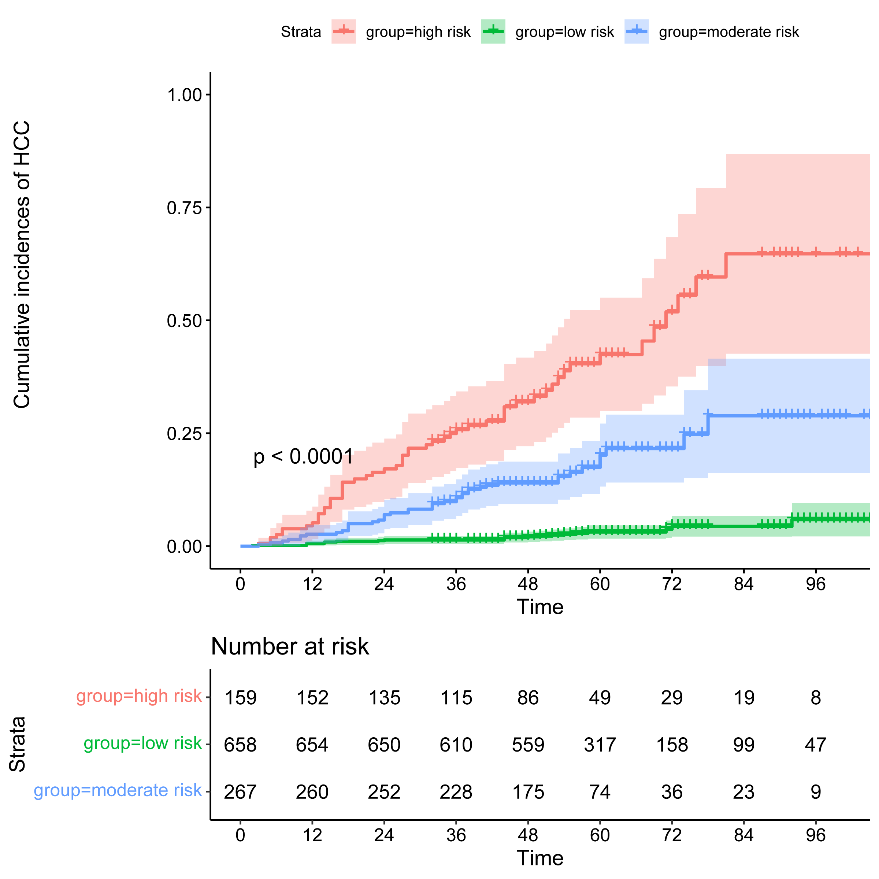
Fig. S3 Kaplan–Meier curves for the external validation cohort 1, after dichotomizing the cohort using the risk-stratification cut-off value rounded to the nearest integer (low risk<160 points, intermediate risk 160-193 points, high-risk>193 points). HCC, hepatocellular carcinoma.
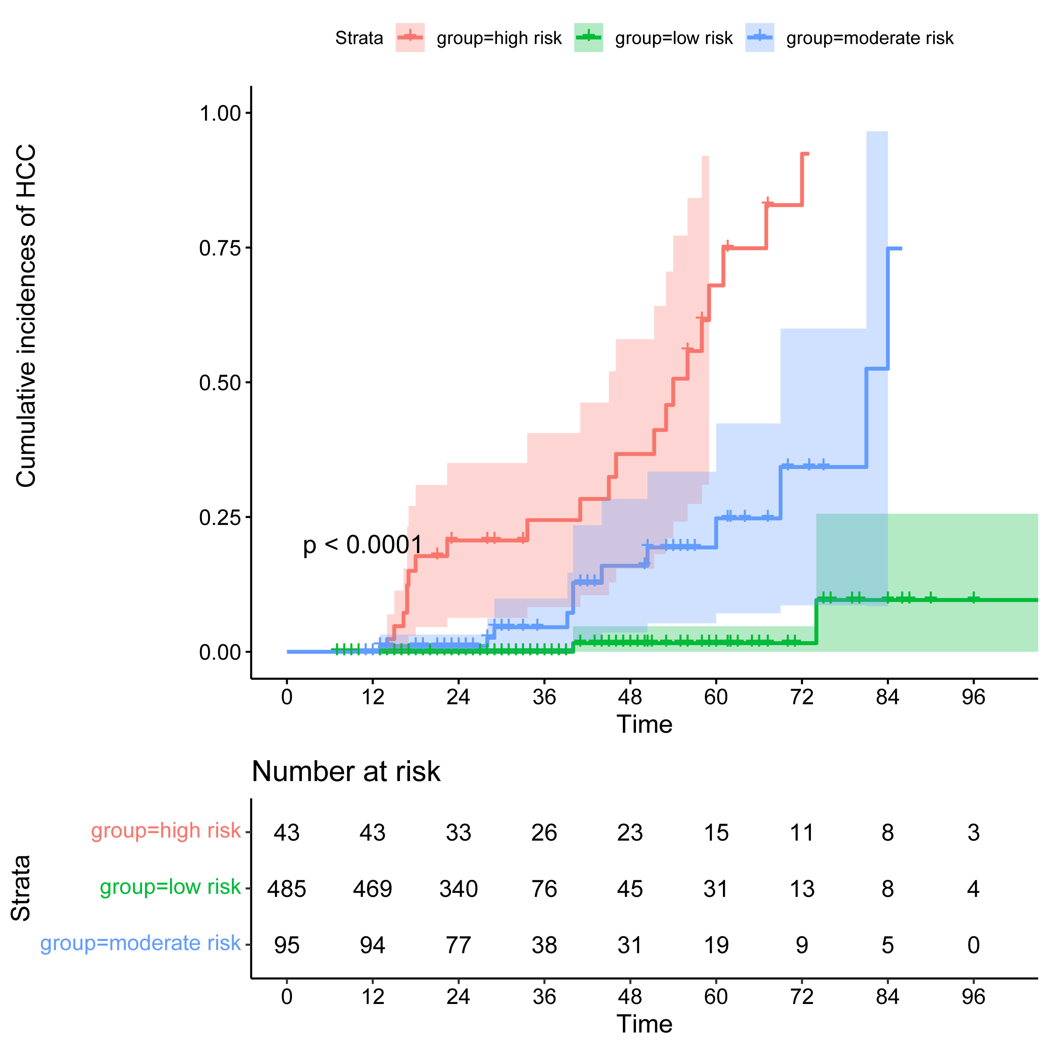

Fig. S4 Kaplan–Meier curves for the external validation cohort 2, after dichotomizing the cohort using the risk-stratification cut-off value rounded to the nearest integer (low risk<160 points, intermediate risk 160-193 points, high-risk>193 points). HCC, hepatocellular carcinoma.

Graphical Abstract
This graphical abstract illustrates the overall workflow for developing and validating a hepatocellular carcinoma prediction model. The process begins with a baseline study of a chronic hepatitis B cohort, followed by the construction of a statistical model, and concludes with successful validation across multiple independent external cohorts.

