Statistical report (SR)

Full study title | Efficacy and safety of esketamine for “treatment resistant depression”: registered report for a Systematic Review with an Individual Participant Data Meta-analysis of Randomized, Double-Blind, Placebo-Controlled Trials
Acronym | ESK-T-DEP
Prospero registry number | CRD42021290721
OSF registration | https://osf.io/xetvn
Study protocol version | V1.0
SR version | V2

Roles and responsibility

Author | Estelle Le Pabic
Coordinator | Florian NAUDET

SR revision history

Date | Document | Version | Description of and reason for change
08.08.2024 | Statistical_report_240808_V1 | V1 | Creation of the document
21.03.2024 | Statistical_report_250321_V1 | V2 | Additional analysis

Table des matières
1 Methods 3
1.1 Outcomes 3
1.2 Study participants 3
1.3 Availability of data and materials 4
1.4 Selected studies 4
1.5 Analysis strategy 4
2 Study description 5
3 Results 8
3.1 Initiation studies 8
3.1.1 Efficacy outcomes 8
3.1.2 Safety outcomes 24
3.1.3 Moderators of esketamine efficacy 37
3.2 Continuation studies 49
3.2.1 Efficacy outcomes assessed at the end of the study 49
3.2.2 Safety outcomes assessed at the end of the study 51
3.2.3 Moderators of esketamine efficacy 53

Methods

The main objective is to independently reappraise the efficacy of esketamine in “treatment resistant depression” (TRD) using an individual participant data meta-analysis methodology. The secondary objectives are to reappraise the safety of esketamine in the treatment of TRD and to explore moderating factors of esketamine efficacy and safety, including level of treatment resistance, patient age, site-specific effects, among others.

Outcomes

The primary outcome will be the MADRS score (continuous outcome) assessed after at least 4 weeks (the end of treatment in the pivotal initiation trials / it is expected to be 4 weeks but may be longer depending on the studies selected for the meta-analysis). To take into account the possible rapid effect of esketamine, we will also study the MADRS score at week 1 as a secondary outcome.
All of the following secondary outcomes will be assessed at end of treatment as well as at the last follow-up visit post-treatment (expected to be 24 weeks) in initiation trials. These will be assessed at the end of the study in continuation trial (this is expected to be over 500 days).
Secondary outcomes will include efficacy outcomes, namely (a) suicide/suicide attempt (binary outcome); b) suicidal ideations, e.g. Beck Scale for Suicidal Ideation (BSS, continuous outcome); c) MADRS (continuous outcome, similar to the primary outcome but, here using the last follow-up visit post-treatment); d) remission (binary outcome); e) Sheehan Disability Scale (continuous outcome); f) PHQ-9 (continuous outcome); g) relapse (censored outcome) for continuation trials, and safety outcomes, namely a) serious adverse events (count outcome, i.e. number of events per patient); b) dropout for any cause (binary outcome); c) dropout due to adverse events (binary outcome); d) Adverse events (count outcome i.e. number of events per patient); e) Blood pressure (continuous repeatedly measured outcome); f) Dissociation (binary outcome) g) Sedation (binary outcome).

Study participants

We were consider studies that include all patients with TRD meeting the inclusion criteria of esketamine’s development program for this indication. Following the definition used in this program, TRD refers to a depressive episode with inadequate response to at least two antidepressant trials of adequate doses and duration). This definition includes “higher” level of “resistance” according to Thase and Rush staging method of treatment resistant depression [20]. There was no age limit. In terms of strategy the systematic review search criteria was include all studies of esketamine for the primary treatment of depression. The IPD analysis was then be restricted to participants/patients with TRD within the included studies (i.e., have failed > 2 adequate antidepressant trials).
Included studies were studies that compare the use of intranasal esketamine (with the following approved doses: 56 mg or 84 mg or “flexible” doses) to a placebo. In the trials, placebo is described as a solution with a bittering agent added to simulate the taste of the esketamine solution. All randomised controlled trials (initiation and continuation trials) will be considered.

Availability of data and materials

The datasets that analyzed during the current study are available in the YODA repository (https://yoda.yale.edu/). All prespecified analysis plans and the code to reproduce our analyses were shared on the Open Science Framework.

This study, carried out under YODA Project 2021-4851, used data obtained from the Yale University Open Data Access Project, which has an agreement with JANSSEN RESEARCH & DEVELOPMENT, L.L.C.. The interpretation and reporting of research using this data are solely the responsibility of the authors and does not necessarily represent the official views of the Yale University Open Data Access Project or JANSSEN RESEARCH & DEVELOPMENT, L.L.C..

Selected studies

Thirteen studies were selected. After applying the inclusion criteria, 6 initiation studies (NCT01998958, NCT02918318, NCT02417064, NCT02418585, NCT02422186 and NCT03434041) and 1 continuation study (NCT02493868). For study NCT01998958, only data at 1 week were selected, because patients were randomized after 1 week of treatment. The study were divided in two panel, A and B.

Analysis strategy

For efficacy and safety outcomes a two-step approach will be adopted, the one-stage approach will be used to explore moderators of esketamine efficacy. All the analyses will be performed with R (R core Team, 2021).

A fixed effect meta-analysis, or a random effect meta-analysis (in case of heterogeneity defined as an I² index > 25 % and/or detection of significant heterogeneity (p<0.10) detected using Cochran's Q test statistic), has been used to pool the different efficacy indexes (mean differences or relative risks or odds ratio or hazard ratios) that will be derived from these re-analyses. Initiation and continuation designs were analyzed separately. For the primary outcome, mean differences in MADRS scores observed (point estimates and confidence intervals were compared with 0 (absence of difference) and 6.5 points (the threshold defined a priori in initiation studies).

Sensitivity analyses were performed to deal with missing data. The multiple imputation by chained equations (MICE) method implemented in the mice package in R was used under the assumption of missing at random data and m=10 imputation were generated.

For the analysis of blood pressure, the one-satge approach was used with the realsiation of a linear mixed-effect model with treatment and measurement interaction (predose and at 40 minutes, 1 hour and 1.5 hours postdose) and treatment group and day effect as random effect and stratified by trial the intercept.

To explore moderators of esketamine efficay in one-stage approach, a mixed model or was specified with one intercept for each study (random effects), one treatment effect for each study, the separation of within-study and across-study interaction, one within-study interaction effect for each study (random effects) and one residual variance for each study (stratification).

Study description

Table 1: Studies included

Study | Initiation or continuation study | Reanalysis OSF link
NCT01998958 (2003, panel A) | Initiation study | OSF_ ReAnalysis_2003.docx
NCT01998958 (2003, panel B) | Initiation study | OSF_ReAnalysis_2003.docx
NCT02918318 (2005) | Initiation study | OSF_ReAnalysis_2005.docx
NCT02417064 (3001) | Initiation study | OSF_ReAnalysis_3001.docx
NCT02418585 (3002) | Initiation study | OSF_ReAnalysis_3002xpt.docx
NCT02422186 (3005) | Initiation study | OSF_ReAnalysis_3005.docx
NCT03434041 (3006) | Initiation study | OSF_ReAnalysis_3006.docx
NCT02493868 (3003) | Continuation study | OSF_ReAnalysis3003.docx

Table 2: Studies assessed at the end of treatment

Study | Total | Esketamine | Placebo
NCT02918318 (2005) | 161 | 81 | 80
NCT02417064 (3001) | 342 | 229 | 113
NCT02418585 (3002) | 232 | 118 | 114
NCT02422186 (3005) | 138 | 72 | 66
NCT03434041 (3006) | 250 | 124 | 126
Overall population | 1123 | 624 | 499

Table 3: Studies assessed at 1 week

Study | Total | Esketamine | Placebo
NCT01998958 (2003, panel A) | 55 | 23 | 32
NCT01998958 (2003, panel B) | 30 | 9 | 21
NCT02918318 (2005) | 161 | 81 | 80
NCT02417064 (3001) | 342 | 229 | 113
NCT02418585 (3002) | 232 | 118 | 114
NCT02422186 (3005) | 138 | 72 | 66
NCT03434041 (3006) | 250 | 124 | 126
Overall population | 1208 | 656 | 552

Table 4: Studies assessed at the follow-up visit

Study | Total | Esketamine | Placebo
NCT02918318 (2005) | 161 | 81 | 80
NCT03434041 (3006) | 250 | 124 | 126
Overall population | 411 | 205 | 206

Table 5: Treatment during follow-up phase

Study | Total
NCT02918318 (2005) | No intranasal study medication were administered during follow-up phase. The oral antidepressant medication were to be continued in this phase unless determined as not clinically appropriate
NCT03434041 (3006) | No intranasal study medication were administered during follow-up phase. The decision to continue the oral antidepressant in this phase were at the discretion of the investigator.

The total duration of a posttreatment follow-up (FU) phase in study NCT03434041 (3006) was 8-week. For study NCT02918318 (2005), responders (subject who have ≥50% reduction from baseline in MADRS total score) at the end of the double-blind (DB) induction phase were eligible to proceed to the posttreatment phase; thode who do bot (ie, nonresponders) were proceed to the 4-week follow-up phase, the 8-week posttreatment were selected for to match 4-week follow-up (4-week DB + 4-week posttreatment).

Table 6: Continuation study
Study | Total | Esketamine | Placebo
NCT02493868 (3003) | 297 | 152 | 145

Table 7: Esketamine dose and study duration (double-blinded)

Study | Esketamine dose* | Study duration (blinded)
NCT01998958 (2003, panel A) | 28, 56 and 84 mg | 8 days
NCT01998958 (2003, panel B) | 14, 56 mg | 8 days
NCT02918318 (2005) | 28, 56 and 84 mg | 28 days
NCT02417064 (3001) | 56 and 84 mg | 28 days
NCT02418585 (3002) | Flexible (56 or 84 mg) | 28 days
NCT02422186 (3005) | Flexible (28, 56 or 84 mg) | 28 days
NCT03434041 (3006) | Flexible (56 or 84 mg) | 28 days
NCT02493868 (3003 : continuation study) | Flexible (56 or 84 mg) | Time to event
* For the re-analyses, all doses were considered; however, for the meta-analyses, only doses of 56 mg, 84 mg, or flexible dosing were included.

Table 8: Description patient (mean age and sex) and major deviations in double-blinded phase

Study | Mean age ± standard deviation | Sex, n (%)
NCT01998958 (2003, panel A) | 42.9 ± 10.1 | M: 29 (43.3) ; W: 38 (56.7)
NCT01998958 (2003, panel B) | 42.2 ± 8.0 | M: 24 (58.5) ; W: 17 (41.5)
NCT02918318 (2005) | 43.4 ± 10.4 | M: 106 (52.5) ; W: 96 (47.5)
NCT02417064 (3001) | 46.7 ± 11.2 | M: 101 (29.5) ; W: 241 (70.5)
NCT02418585 (3002) | 46.2 ± 11.8 | M: 90 (38.8) ; W: 142 (61.2)
NCT02422186 (3005) | 70.3 ± 4.5 | M: 52 (37.7) ; W: 86 (62.3
NCT03434041 (3006) | 36.4 ± 12.4 | M: 137 (54.8) ; W: 113 (45.2)
NCT02493868 (3003 : continuation study) : Responders | 47.9 ± 10.5 | M: 42 (34.7) ; W: 79 (65.3)
NCT02493868 (3003 : continuation study) : Remiters | 46.9 ± 11.6 | M: 58 (33) ; W: 118 (67)
M: Male; W: Women

Table 9: Major deviations

Study | Details of observed major deviations
NCT01998958 (2003, panel A) | There were 5 major deviations: 1 patient entered but did not satisfy criteria and 4 patients had major deviations categorized as 'other,' with no further details provided.
NCT01998958 (2003, panel B) | There were 2 major deviations: 2 patients had major deviations categorized as 'other,' with no further details provided.
NCT02918318 (2005) | There were 25 major deviations: 5 patients received disallowed concomitant treatments, 10 patients received the wrong treatment or an incorrect dose, and 9 patients had deviations categorized as 'other' (including 1 patient with 2 deviations). No further details were provided.
NCT02417064 (3001) | There were 62 major deviations: 28 patients entered but did not satisfy criteria (of those, one had 2 deviations), 9 patients received disallowed concomitant treatments, 1 patient received wrong treatment or incorrect dose, 2 patients developed withdrawal criteria but not withdrawn, and 21 patients had deviations categorized as 'other'. No further details were provided.
NCT02418585 (3002) | There were 14 major deviations: 3 patients received disallowed concomitant treatments, 3 patients received the wrong treatment or an incorrect dose and 8 patients had deviations categorized as 'other'. No further details were provided.
NCT02422186 (3005) | There were 22 major deviations: 6 patients received the wrong treatment or an incorrect dose, 6 entered but did not satisfy criteria and 10 had deviations categorized as 'other'. No further details were provided.
NCT03434041 (3006) | There were 21 major deviations: 10 patients received disallowed concomitant treatments, 2 patients received the wrong treatment or an incorrect dose, 2 patients entered but did not satisfy criteria and 7 patients had deviations categorized as 'other'. No further details were provided.
NCT02493868 (3003 : continuation study) | There were 5 major deviations: 2 patients developed withdrawal criteria but not withdrawn, 1 patient received the wrong treatment or an incorrect dose, 1 patient received disallowed concomitant treatments and 1 patient had deviations categorized as 'other'. No further details were provided.

Results

Initiation studies

Efficacy outcomes

Meta-analysis of primary outcome

Table 10: Missing data per study for primary outcome

Study | Total | Esketamine | Placebo
NCT02918318 (2005) | 16* | 8 | 8
NCT02417064 (3001) | 24 | 19 | 5
NCT02418585 (3002) | 21 | 13 | 8
NCT02422186 (3005) | 15 | 9 | 6
NCT03434041 (3006) | 35 | 15 | 19
*The 41 patients in the esketamine 28mg group were not included in the analysis and are not included in the calculation of the number of missing data.

MADRS (Montgomery-Asberg Depression Rating Scale) after at least 4 weeks

Figure 1: Forest plot, MADRS after at least 4 weeks outcome

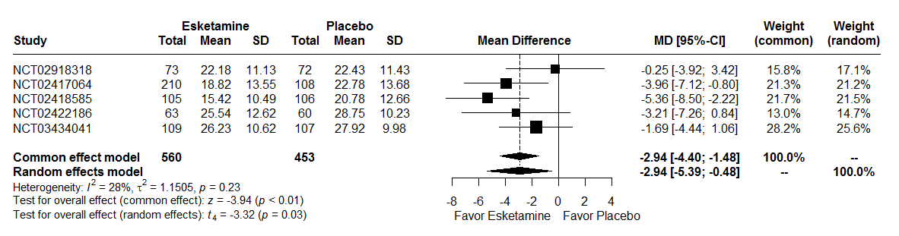

MD : Mean Difference
CI : Confidence Interval

A random effects model were used because there are heterogeneity between studies (I² = 28%, t² = 1.15, p = 0.23). The two-stage meta-analysis indicates a significant effect between MADRS at 4 weeks and treatment group with a mean difference of -2.94 [-4.40; -1.48], p < 0.01 in common effect model and a mean difference of -2.94 [-5.39; -0.48], p = 0.03 in a random effects model.

Figure 2: Forest plot, MADRS after at least 4 weeks outcome and line reference at -6.5 (6.5 points is the threshold defined a priori in initiation studies)

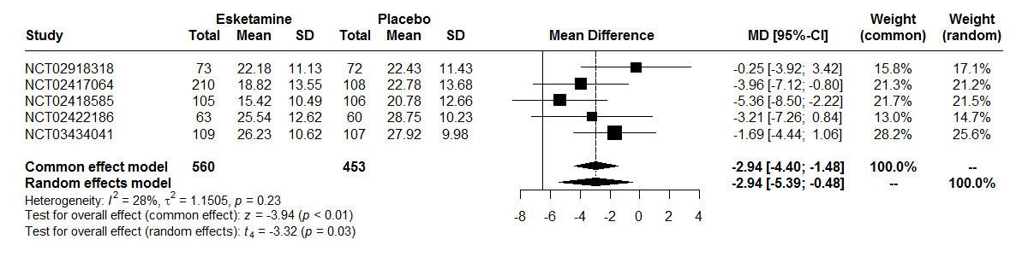

MD : Mean Difference
CI : Confidence Interval

MADRS after at least 4 weeks with imputation missing data

Figure 3: Forest plot, MADRS after at least 4 weeks outcome with imputation missing data

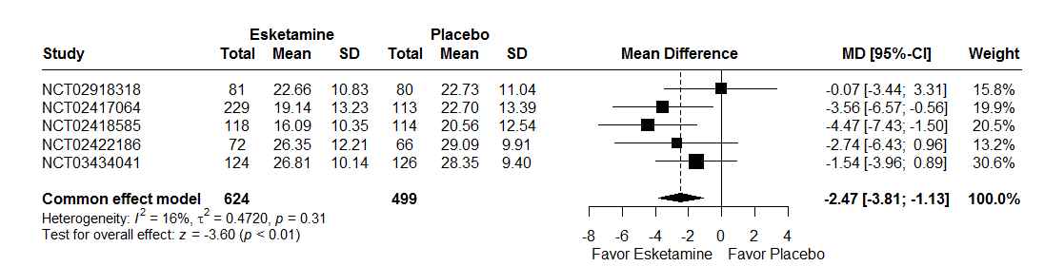

MD : Mean Difference
CI : Confidence Interval

A random effects model were not used because there are no heterogeneity between studies (I² = 16%, t² = 0.47, p = 0.31). The two-stage meta-analysis indicates a significant effect between MADRS at 4 weeks with imputation data and treatment group with a beta of -2.47 [-3.81; -1.13], p < 0.01 in common effect model.

Figure 4: Forest plot, MADRS after at least 4 weeks outcome with imputation missing data and line reference at -6.5 (6.5 points is the threshold defined a priori in initiation studies)

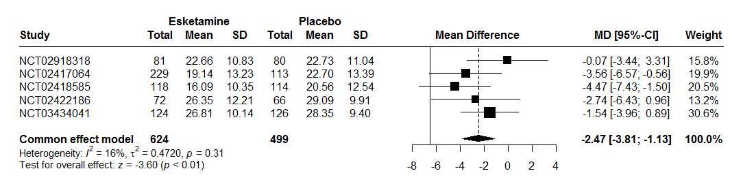

MD : Mean Difference
CI : Confidence Interval

Meta-analysis of secondary outcomes

Outcome assessed at week 1

MADRS after at least 1 week

Figure 5: Forest plot, MADRS after at least 1 week outcome

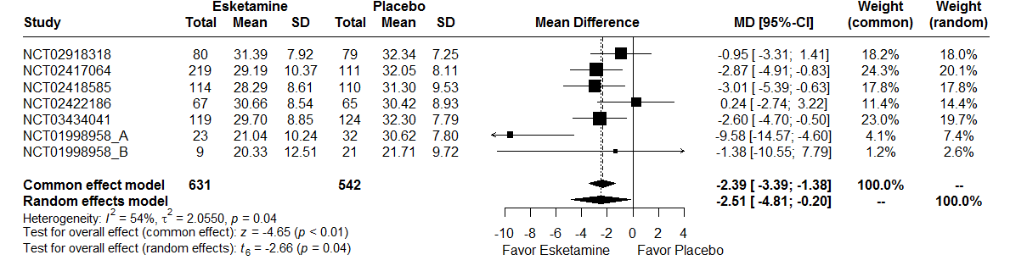
MD : Mean Difference
CI : Confidence Interval

A random effects model were used because there are heterogeneity between studies (I² = 54%, t² = 2.06, p = 0.04). The two-stage meta-analysis indicates a significant effect between MADRS at 1 week and treatment group with a beta of –2.39 [-3.39; -1.38], p < 0.01 in common effect model and a beta of -2.51 [-4.81; -0.20], p = 0.04 in a random effects model.

For studies NCT01998958, panel A and NCT01998958, panel B, the number of patients in the esketamine group is lower because patients randomized in the esketamine 28 mg group for panel A and esketamine 14 mg for panel B were excluded from the analysis (see section 1.2).

MADRS after at least 1 weeks with imputation missing data

Figure 6: Forest plot, MADRS after at least 1 week outcome with imputation missing data

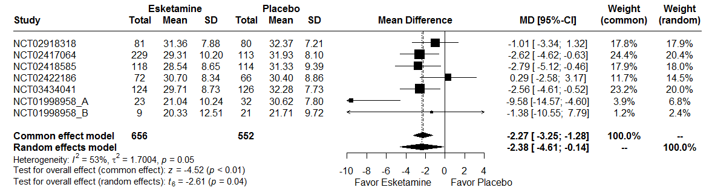
MD : Mean Difference
CI : Confidence Interval

A random effects model were used because there are heterogeneity between studies (I² = 53%, t² = 1.70, p = 0.05). The two-stage meta-analysis indicates a significant effect between MADRS at 1 week with imputation missing data and treatment group with a beta of –2.27 [-3.25; -1.28], p < 0.01 in common effect model and a beta of -2.38 [-4.61; -0.15], p =0.04 in a random effects model.

Outcomes assessed at the end of treatment

Suicide/suicide attempt

To identify suicide attempts or suicides, the "Actual Attempt" and "Suicide" items of the Columbia-Suicide Severity Rating Scale (C-SSRS) part Suicidal behavior were selected, along with adverse events reported as "Suicide attempt", "Suicide", “Attempted suicide”, “Suicidal behavior”, “Completed suicide”. The Peto method was used to take account of rare events.

Figure 7: Forest plot, suicide/suicide attempt outcome

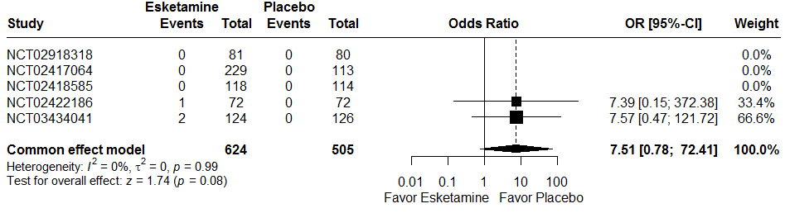

RR : Relative Risk
CI : Confidence Interval

A random effects model were not used because there not are heterogeneity between studies (I² = 0%, t² = 0, p = 0.99). The two-stage meta-analysis indicates a no significant effect between suicide/suicide attempt and treatment group with a RR of 7.51 [0.78; 72.41], p = 0.08 in common effects.

Table 11: Description Suicide/Suicide attempt

NCT02422186 | Suicidal and self-injurious behaviour | 14 days after randomization | No serious event, the patient continue the treatment Esketamine until the end of the double blind phase (day 28)
NCT03434041 | Completed suicide | 4 days after randomization | Patient treated with Esketamine. He has died. More details in table 12
NCT03434041 | Suicide attempt | 2 day after randomization | Patient treated with Esketamine. The double-blind phase and treatment is discountinued

Table 12: Death

Study | Cause of death | Time of study | Arm | On esketamine treatment at time of death | Time since last treatment | Treatment-related death
3002 | Road traffic accident and multiple injuries | Treatment (serious adverse event on day 16) | Esketamine | No | Clinical study report : Died 55 days after study start (40 days after last dose of treatment) | Clinical study report : according to the investigator, death unrelated to treatment
3006 | Completed suicide | Treatment | Esketamine | Yes | Clinical study report : On study day 4 | Clinical study report : The investigator assessed the event of completed suicide as possibly to blinded study medication. In the subsequent evaluation, the sponsor took into account such factors as underlying severe depressive condition with worsening symptoms since the start of a major depressive episode several pharmacological treatments, the prior, and medication plan changes in the last month; based on the totality of evidence, the sponsor assessed the event as not related to esketamine treatment

Suicidal ideations

To identify suicidal ideations, the Columbia-Suicide Severity Rating Scale (C-SSRS) part Suicidal ideation were selected, along with adverse events reported as "Suicide ideation", “Passive suicidal ideation”, “Suicidal intention”, “Depression suicidal”.
For C-SSRS, the suicidal ideation was defined if the sum of 5 items is greater than 3. The answer to questions 3, 4, 5 were available if answer question 2 was “yes”. The Peto method was used to take account of rare events.

Figure 8: Forest plot, suicidal ideations outcome

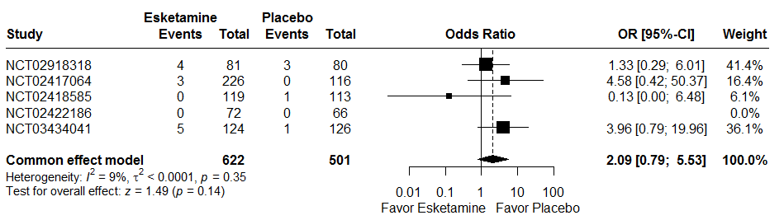
RR : Relative Risk
CI : Confidence Interval

Two studies don’t have events in two groups.
A random effects model were not used because there not are heterogeneity between studies (I² = 9%, t² <0.01, p = 0.35). The two-stage meta-analysis indicates a no significant effect between suicidal ideation and treatment group with a RR of 2.09 [0.79; 5.53], p = 0.14l in common effects.

Remission

For all studies, remission is defined as MADRS score ≤ 12.

Figure 9: Forest plot, remission outcome

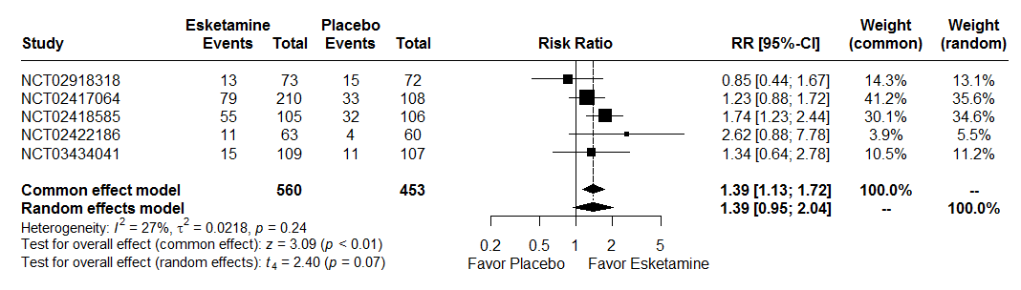
RR : Relative Risk
CI : Confidence Interval

A random effects model were used because there are heterogeneity between studies (I² = 27%, t² = 0.02, p = 0.24). The two-stage meta-analysis indicates a significant effect between remission and treatment group with a RR of 1.39 [1.13; 1.72], p < 0.01 in common effect model and a RR of 1.39 [0.95; 2.04], p = 0.07 in a random effects model.

Remission with imputation missing data

For all studies, remission is defined as MADRS score ≤ 12.

Figure 10: Forest plot, remission outcome with imputation missing data.

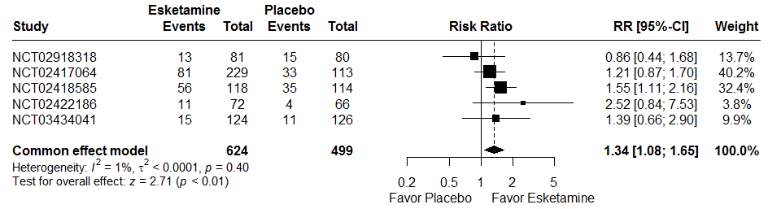
RR : Relative Risk
CI : Confidence Interval

A random effects model were not used because there are heterogeneity between studies (I² = 1%, t² = <0.01, p = 0.40). The two-stage meta-analysis indicates a significant effect between remission and treatment group with a RR of 1.34 [1.08; 1.65], p < 0.01 in common effect model.

Sheehan Disability Scale

The Sheehan Disability Scale (SDS) is a self-rated, 3-item questionnaire that uses from 0 (not at all) to 10 (extremely) to assess impairment in the family life/home responsibilities, social life, work/school domains. The three items are summed to obtain a total score (range: 0–30), with higher scores indicating greater functional impairment. If “I have not worked / studied” checked and/or work/school missing, first analysis the average of the family life/home responsibilities and social life items was imputed to work/school for calculated total score and second analysis the total score was considered missing.

First analysis:

Figure 11: Forest plot, Sheehan Disability Scale outcome

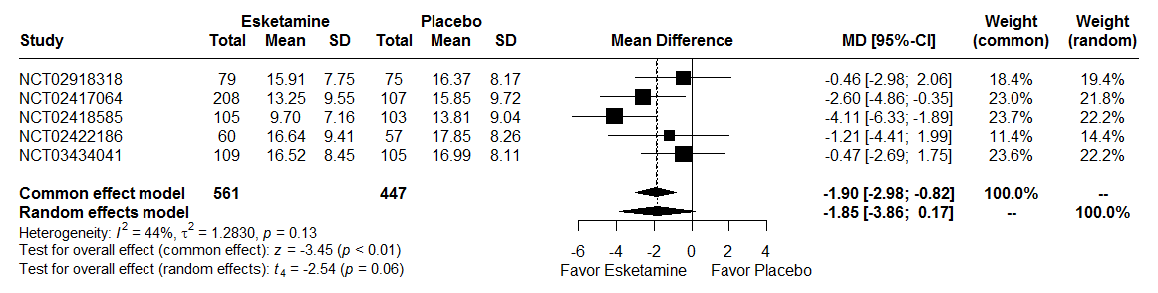
MD : Mean Difference
CI : Confidence Interval

A random effects model were used because there are heterogeneity between studies (I² = 44%, t² = 1.28, p = 0.13). The two-stage meta-analysis indicates a significant effect between SDS and treatment group with a beta of –1.90 [-2.98; -0.82], p < 0.01 in common effect model and a beta of -1.85 [-3.86; 0.17], p = 0.06 in a random effects model.

Second analysis:

Figure 12: Forest plot, Sheehan Disability Scale outcome

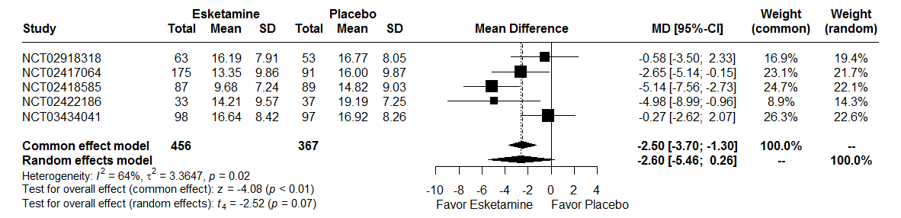
MD : Mean Difference
CI : Confidence Interval

A random effects model were used because there are heterogeneity between studies (I² = 64%, t² = 3.36, p = 0.02). The two-stage meta-analysis indicates a significant effect between SDS and treatment group with a beta of –2.50 [-3.70; -1.30], p < 0.01 in common effect model and no significant effect with a beta of -2.60 [-5.46; 0.26], p = 0.07 in a random effects model.

Sheehan Disability Scale with imputation missing data

First analysis:

Figure 13: Forest plot, Sheehan Disability Scale outcome with imputation missing data

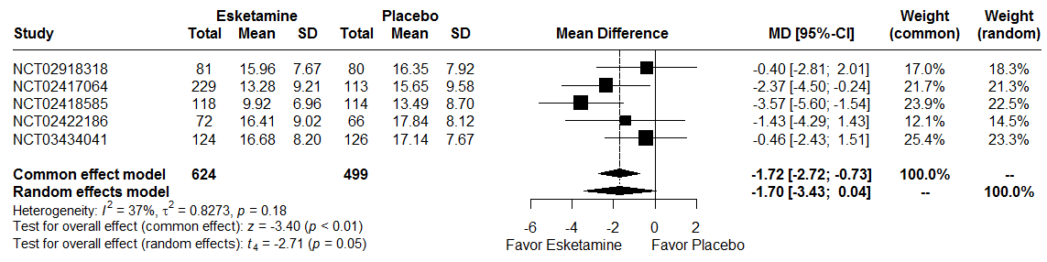
MD : Mean Difference
CI : Confidence Interval

A random effects model were used because there are heterogeneity between studies (I² = 37%, t² = 0.83, p = 0.18). The two-stage meta-analysis indicates a significant effect between SDS and treatment group with a beta of –1.72 [-2.72; -0.73], p < 0.01 in common effect model and no significant effect with a beta of -1.70 [-3.43; -0.04], p = 0.05 in a random effect model.

Second analysis:

Figure 14: Forest plot, Sheehan Disability Scale outcome with imputation missing data

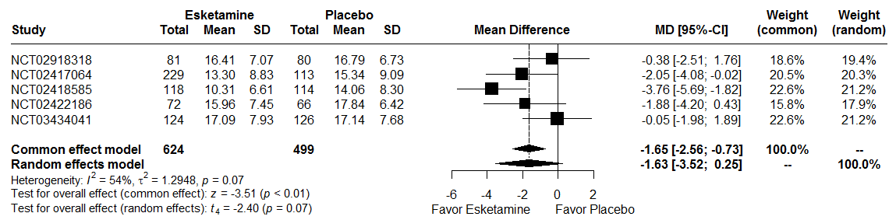
MD : Mean Difference
CI : Confidence Interval

A random effects model were used because there are heterogeneity between studies (I² = 54%, t² = 1.29, p = 0.07). The two-stage meta-analysis indicates a significant effect between SDS and treatment group with a beta of –1.65 [-2.56; -0.73], p < 0.01 in common effect model and no significant effect with a beta of -1.63 [-3.52; 0.25], p = 0.07 in a random effect model.

PHQ-9

The Patient Health Questionnaire – 9-item (PHQ-9), I a 9-item, subject-reported outcome measure that was used to assess depressive symptoms. The scale scores each of the 9 symptom domains of the DSM-5 MDD criteria, and it has been used both as a screening tool and a measure of response to treatment for depression. Each item is rated on a 4 point scale (0=not at all, 1=several days, 2=more than half the days and 3=nearly every day). The subject’s item responses are summed to provide a total score (range of 0 to 27) with higher scores indicating greater severity of depressive symptoms.

Figure 15: Forest plot, PHQ-9 outcome

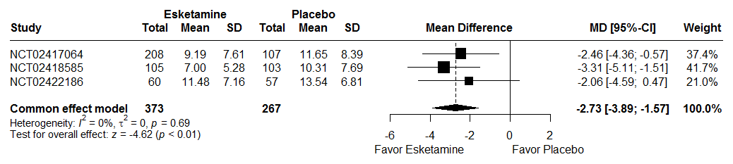
MD : Mean Difference
CI : Confidence Interval

Three studies were realized PHQ-9. A random effects model were 4 used because there are 4 heterogeneity between studies (I² = 0%, t² = 0, p = 0.69). The two-stage meta-analysis indicates a no significant effect between PHQ-9 and treatment group with a beta of –2.73 [-3.89; -1.57], p < 0.01 in common effect model.

PHQ-9 with imputation missing data

Figure 16: Forest plot, PHQ-9 outcome with imputation missing data

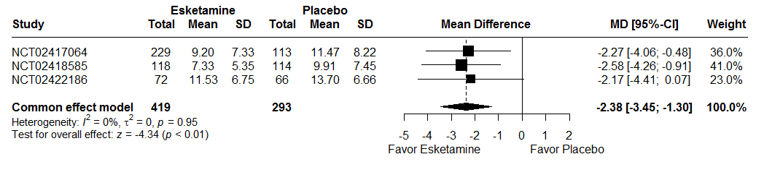

Three studies were realized PHQ-9. A random effects model were not used because there are not heterogeneity between studies (I² = 0%, t² = 0, p = 0.95). The two-stage meta-analysis indicates a significant effect between PHQ-9 and treatment group with a beta of –2.38 [-3.45; -1.30], p < 0.01 in common effect model.

Outcomes assessed at the last follow-up visit post-treatment

For analysis at the last follow-up visit post-treatment, two studies were analysed.
Reasons for no analysis other studies:
- NCT02422186 (3005) : follow-up phase included patient with received at least 1 dose of intranasal study medication in the double-blind phase and either withdrew early before the end of the double-blind induction phase, or chose not to participate in the other (ESKETINTRD3004) safety study
- NCT02418585 (3002): follow-up phase included all subjects who were not eligible or who chose to not participate in the maintenance of effect study NCT02493868 (3003).
- NCT02417064 (3001): follow-up included subjects who receive at least 1 dose of intranasal study medication in the double-blind induction phase, but do not enter the subsequent maintenance clinical study NCT02493868 (3003).

Suicide/suicide attempt

To identify suicide attempts or suicides, the "Actual Attempt" and "Suicide" items of the Columbia-Suicide Severity Rating Scale (C-SSRS) part Suicidal behavior were selected, along with adverse events reported as "Suicide attempt", "Suicide", “Attempted suicide”, “Suicidal behavior”, “Completed suicide”. The Peto method was used to take account of rare events.

Figure 17: Forest plot, suicide/suicide attempt outcome during the follow-up period.

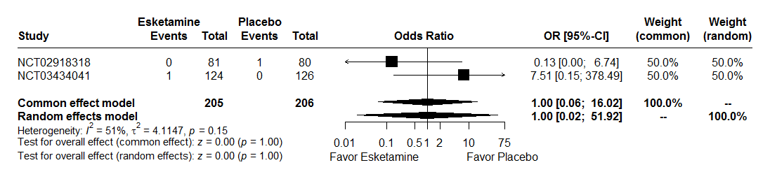
RR : Relative Risk
CI : Confidence Interval

A random effects model were not used because there are heterogeneity between studies (I² = 51%, t² = 4.11, p = 0.15). The two-stage meta-analysis indicates a no significant effect between Suicide/suicide attempt and treatment group with a RR of 1.00 [0.06; 16.02], p = 1.00 in common effect model and a beta of 1.00 [0.02; 51.92], p = 1.00 in a random effects model.

Table 13: Description suicide attempt at the last follow-up visit post-treatment

Study | Description | Treatment during event
NCT02918318 | Two episodes the same day | No treatment
NCT03434041 | The same subject who attempted suicide in the double-blind phase | Oral antidepressant (Setraline)

Suicidal ideations

To identify suicidal ideations, the Columbia-Suicide Severity Rating Scale (C-SSRS) part Suicidal ideation were selected, along with adverse events reported as "Suicide ideation", “Passive suicidal ideation”, “Suicidal intention”, “Depression suicidal”.
For C-SSRS, the suicidal ideation was defined if the sum of 5 items is greater than 3. The answer to questions 3, 4, 5 were available if answer question 2 was “yes”. The Peto method was used to take account of rare events.

Figure 18: Forest plot, suicidal ideations outcome during the follow-up period

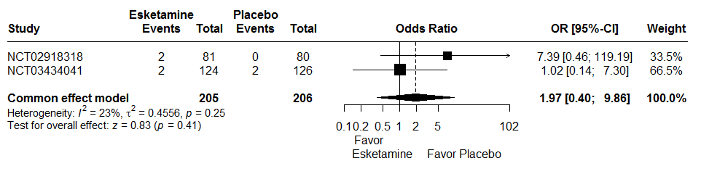
RR : Relative Risk
CI : Confidence Interval

A random effects model were not used because there not are heterogeneity between studies (I² = 23%, t² = 0.46, p = 0.25). The two-stage meta-analysis indicates a no significant effect between suicidal ideation and treatment group with a RR of 1.97 [0.40; 9.86], p = 0.41 in common effects.

Table 14: Description suicide attempt at the last follow-up visit post-treatment

Study | Study medication in double-blind phase | Description | Study medication during event
NCT02918318 | Esketamine | C-SSR > 3 | No study medication
NCT02918318 | Esketamine | C-SSR > 3 | No study medication
NCT03434041 | Esketamine | C-SSR > 3 | No study medication
NCT03434041 | Placebo | C-SSR > 3 | No study medication
NCT03434041 | Placebo | Adverse event | No study medication
NCT03434041 | Esketamine | Adverse event | No study medication

MADRS

The total duration of a posttreatment follow-up (FU) phase in study NCT03434041 (3006) was 8-week. For study NCT02918318 (2005), responders (subject who have ≥50% reduction from baseline in MADRS total score) at the end of the double-blind (DB) induction phase were eligible to proceed to the posttreatment phase; thode who do bot (ie, nonresponders) were proceed to the 4-week follow-up phase, the 8-week posttreatment were selected for to match 4-week follow-up (4-week DB + 4-week posttreatment).
MADRS score was selected if patient was realized the last visit of follow-up provided in the protocol.

Figure 19: Forest plot, MADRS outcome at the last follow-up visit post-treatment

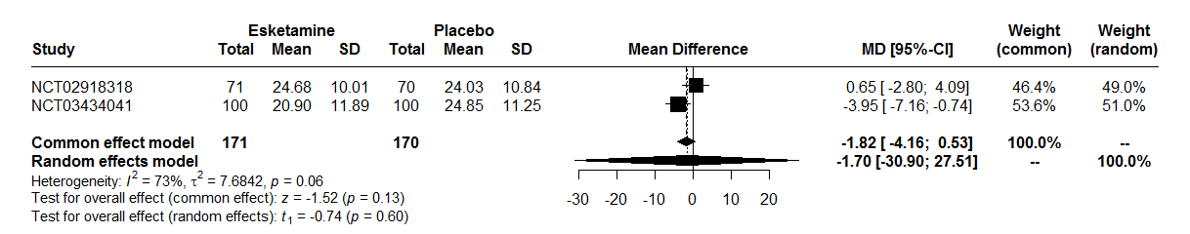
MD : Mean Difference
CI : Confidence Interval

A random effects model were used because there are heterogeneity between studies (I² = 73%, t² = 7.68, p = 0.06). The two-stage meta-analysis indicates a no significant effect between MADRS at follow-up phase and treatment group with a beta of -1.82 [-4.16; 0.53], p = 0.13 in common effect model and a beta of -1.70 [-30.90; 27.51], p = 0.60 in a random effects model.

MADRS with imputation missing data

Figure 20: Forest plot, MADRS outcome with imputation missing data at the last follow-up visit post-treatment

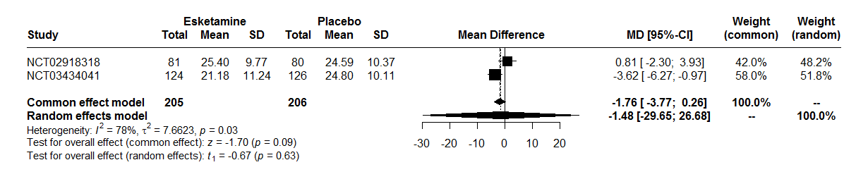

MD : Mean Difference
CI : Confidence Interval

A random effects model were used because there are heterogeneity between studies (I² = 78%, t² = 7.66, p = 0.03). The two-stage meta-analysis indicates a no significant effect between MADRS at follow-up phase and treatment group with a beta of -1.76 [-3.77; 0.26], p = 0.09 in common effect model and a beta of -1.48 [-29.65; 26.68], p = 0.63 in a random effects model.

Remission

For all studies, remission is defined as MADRS score ≤ 12.

Figure 21: Forest plot, remission outcome at the last follow-up visit post-treatment

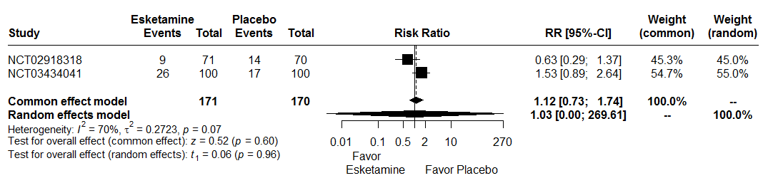
RR : Relative Risk
CI : Confidence Interval

A random effects model were used because there are heterogeneity between studies (I² = 70%, t² = 0.27, p = 0.07). The two-stage meta-analysis indicates a no significant effect between remission and treatment group with a RR of 1.12 [0.73; 1.74], p = 0.60 in common effect model and a RR of 1.03 [0.00; 269.61], p = 0.96 in a random effects model.

Remission with imputation missing data

For all studies, remission is defined as MADRS score ≤ 12.

Figure 22: Forest plot, remission with imputation missing data outcome at the last follow-up visit post-treatment

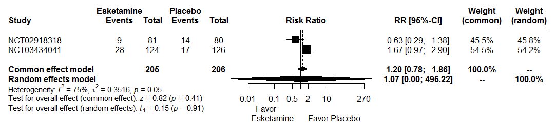
Interpretation:
A random effects model were used because there are heterogeneity between studies (I² = 75%, t² = 0.35, p=0.05). The two-stage meta-analysis indicates a no significant effect between remission and treatment group with a RR of 1.20 [0.78; 1.86], p=0.41 in common effect model and a RR of 1.07 [0.00; 496.22], p=0.91 in a random effects model.

Sheehan Disability Scale
The Sheehan Disability Scale (SDS) is a self-rated, 3-item questionnaire that uses from 0 (not at all) to 10 (extremely) to assess impairment in the family life/home responsibilities, social life, work/school domains. The three items are summed to obtain a total score (range: 0–30), with higher scores indicating greater functional impairment. If “I have not worked / studied” checked and/or work/school missing, first analysis the average of the family life/home responsibilities and social life items was imputed to work/school for calculated total score and second analysis the total score was considered missing.

Only study NCT03434041 (3006) have a data to SDS at follow-up phase. No forest-plot performed.

First analysis:

 | Esketamine | Placebo
n | 95 | 95
Mean | 13.01 | 14.58
Standard deviation | 8.73 | 8.63

Result of ANOVA:
 | Estimate [Confidence Interval 95%] | P-value
Esketamine vs. Placebo | -1.57 [-4.05 ; 0.92] | 0.2146

Second analysis:

 | Esketamine | Placebo
n | 91 | 85
Mean | 13.55 | 14.89
Standard deviation | 8.82 | 8.61

Result of ANOVA:
 | Estimate [Confidence Interval 95%] | P-value
Esketamine vs. Placebo | -1.34 [-3.93 ; 1.26] | 0.3103

Sheehan Disability Scale with imputation missing data

Only study NCT03434041 (3006) have a data to SDS at follow-up phase. No forest-plot performed.

First analysis:

 | Esketamine | Placebo
n | 124 | 126
Mean | 13.16 | 14.74
Standard deviation | 8.43 | 7.96

Result of ANOVA:
 | Estimate [Confidence Interval 95%] | P-value
Esketamine vs. Placebo | -1.58 [-3.62 ; 0.46] | 0.1288

Second analysis:

 | Esketamine | Placebo
n | 124 | 126
Mean | 13.61 | 15.13
Standard deviation | 8.15 | 7.94

Result of ANOVA:
 | Estimate [Confidence Interval 95%] | P-value
Esketamine vs. Placebo | -1.52 [-3.52 ; 0.49] | 0.1371

PHQ-9

No study has PHQ-9 data at the follow-up phase.

Safety outcomes

Outcomes assessed at the end of treatment

Serious adverse events

Figure 23: Forest plot, serious adverse events outcome

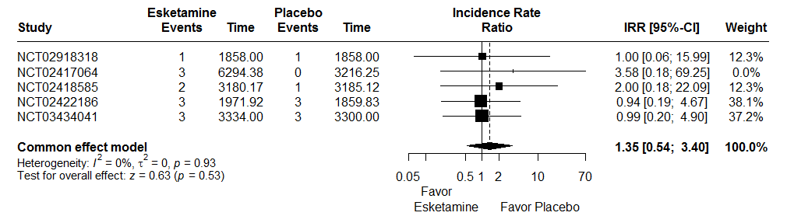
IRR : Incidence Rate Ratio
CI : Confidence Interval

A random effects model were not used because there are not heterogeneity between studies (I² = 0%, t² = 0, p = 0.93). The two-stage meta-analysis indicates a no significant effect between serious adverse events and treatment group with an IRR of 1.35 [0.54; 3.40], p = 0.53 in common effect model.

Table 15: Description serious adverse events

Study | AELLT | Group
3006 | Recurrent depressive disorder | PLACEBO
3006 | Recurrent depressive disorder | ESKETAMINE
3006 | Recurrent depressive disorder | PLACEBO
3006 | Completed suicide | ESKETAMINE
3006 | Suicide attempt | ESKETAMINE
3006 | Recurrent depressive disorder | PLACEBO
3005 | Feeling of despair | PLACEBO
3005 | Gait disturbance | PLACEBO
3005 | Broken hip | ESKETAMINE
3005 | Blood pressure increased | ESKETAMINE
3005 | Anxiety disorder | ESKETAMINE
3005 | Dizziness | PLACEBO
3002 | Benign paroxysmal positional vertigo | PLACEBO
3002 | Multiple injuries | ESKETAMINE
3002 | Road traffic accident | ESKETAMINE
3001 | Depression worsened | ESKETAMINE
3001 | Depression aggravated | ESKETAMINE
3001 | Headache | ESKETAMINE
2005 | Suicidal ideation | PLACEBO
2005 | Suicidal ideation | ESKETAMINE

Dropout for any cause

Dropout for any cause is considered if patient checked at least one of the following criteria:
- Adverse event
- Death
- Lack of efficacy
- Lost to follow-up
- Non-compliance with switched oral antidepressant therapy
- Other
- Withdrawal by subject
- Investigator decision
- Protocol violation

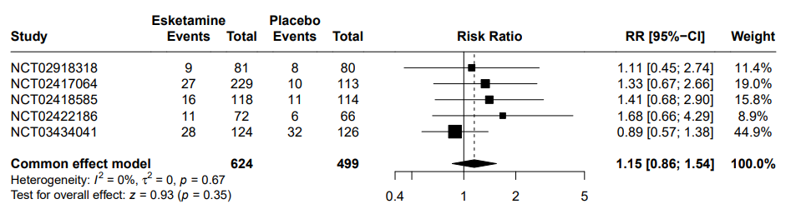
Figure 24: Forest plot, dropout due to any cause outcome
RR : Relative Risk
CI : Confidence Interval

A random effects model were not used because there are not heterogeneity between studies (I² = 0%, t² = 0, p = 0.67). The two-stage meta-analysis indicates a no significant effect between dropout for any cause and treatment group with an RR of 1.15 [0.86; 1.54], p = 0.35 in common effect model.

Dropout due to adverse events

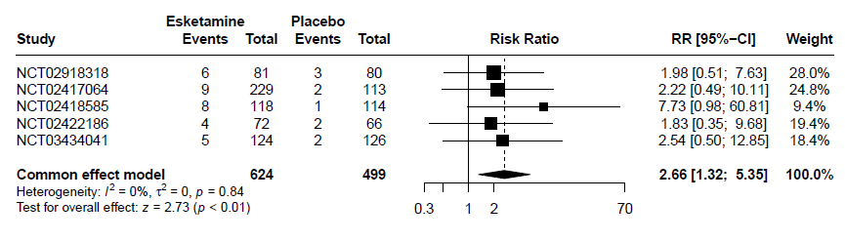
Figure 25: Forest plot, dropout due to adverse events outcome
RR : Relative Risk
CI : Confidence Interval

A random effects model were not used because there are not heterogeneity between studies (I² = 0%, t² = 0, p = 0.84). The two-stage meta-analysis indicates a significant effect between dropout due to adverse events and treatment group with an RR of 2.66 [1.32; 5.35], p < 0.01 in common effect model.

Adverse events

Figure 26: Forest plot, adverse events outcome

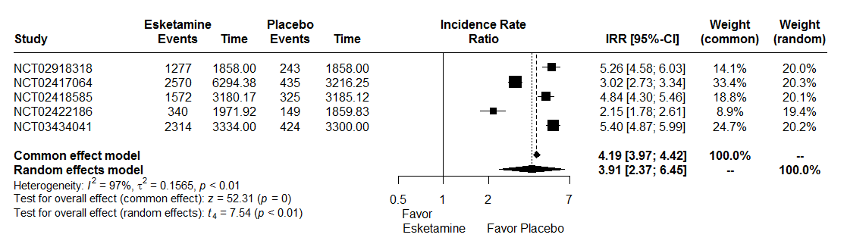
IRR : Incidence Rate Ratio
CI : Confidence Interval

A random effects model were used because there are heterogeneity between studies (I² = 97%, t² = 0.15, p < 0.01). The two-stage meta-analysis indicates a significant effect between adverse events and treatment group with an IRR of 3.91 [2.37; 6.45], p < 0.01 in random effects model.

Blood pressure

The analysis of blood pressure was realized with one-stage individual participant’s data meta-analysis. The blood pressure was measured at predose and at 40 minutes, 1 hour and 1.5 hours postdose and repeated during the double-blind induction phase.
A linear mixed model was realized with blood pressure as response variable, treatment and measurement interaction (predose and at 40 minutes, 1 hour and 1.5 hours postdose) and treatment group and day effect as random effect and stratified by trial the intercept.

Diastolic blood pressure per day and per time

Figure 27: Evolution of diastolic blood pressure by measurement time and per day according to group

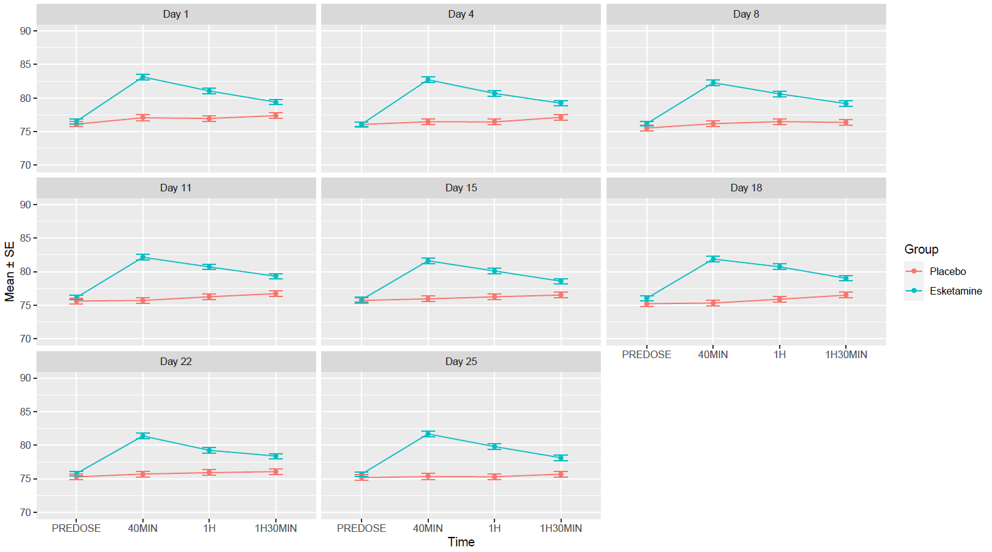

Table 16 : Evolution of diastolic blood pressure by measurement time and per day according to group, mean difference [Confidence Interval(CI) 95%]

Day | Time | Mean difference [CI95%]
Day 1
 | PREDOSE | 0.41 [-0.61 ; 1.45]
 | 40 minutes | 6.09 [4.92 ; 7.26]
 | 1 hour | 4.10 [2.94 ; 5.27]
 | 1 hour and 30 minutes | 2.02 [0.95 ; 3.09]
Day 4
 | PREDOSE | 0.04 [-1.00 ; 1.08]
 | 40 minutes | 6.26 [5.06 ; 7.47]
 | 1 hour | 4.25 [3.08 ; 5.43]
 | 1 hour and 30 minutes | 2.11 [0.98 ; 3.24]
Day 8
 | PREDOSE | 0.66 [-0.44 ; -1.76]
 | 40 minutes | 6.11 [4.89 ; 7.33]
 | 1 hour | 4.12 [2.96 ; 5.29]
 | 1 hour and 30 minutes | 2.81 [1.68 ; 3.94]
Day 11
 | PREDOSE | 0.52 [-0.54 ; 1.58]
 | 40 minutes | 6.44 [5.26 ; 7.62]
 | 1 hour | 4.45 [3.28 ; 5.61]
 | 1 hour and 30 minutes | 2.60 [1.47 ; 3.74]
Day 15
 | PREDOSE | 0.12 [-0.97 ; 1.20]
 | 40 minutes | 5.67 [4.50 ; 6.84]
 | 1 hour | 3.86 [2.67 ; 5.03]
 | 1 hour and 30 minutes | 2.06 [0.95 ; 3.18]
Day 18
 | PREDOSE | 0.80 [-0.29 ; 1.89]
 | 40 minutes | 6.56 [5.39 ; 7.73]
 | 1 hour | 4.83 [3.66 ; 6.00]
 | 1 hour and 30 minutes | 2.50 [1.38 ; 3.63]
Day 22
 | PREDOSE | 0.49 [-0.56 ; 1.55]
 | 40 minutes | 5.68 [4.51 ; 6.84]
 | 1 hour | 3.33 [2.18 ; 4.48]
 | 1 hour and 30 minutes | 2.32 [1.22 ; 3.43]
Day 25
 | PREDOSE | 0.51 [-0.57 ; 1.59]
 | 40 minutes | 6.36 [5.16 ; 7.56]
 | 1 hour | 4.50 [3.34 ; 5.67]
 | 1 hour and 30 minutes | 2.45 [1.34 ; 3.55]

 | Pvalue
Interaction treatment*measure | < 0.0001

The interaction between treatment and measurement was significant at the 5% level. The effect of measurement time on diastolic blood pressure differed between groups.

Diastolic blood pressure per time

For each patient, the mean of D4 to D25 was taken for each time.

Figure 28: Evolution of diastolic blood pressure by measurement time and per day according to group

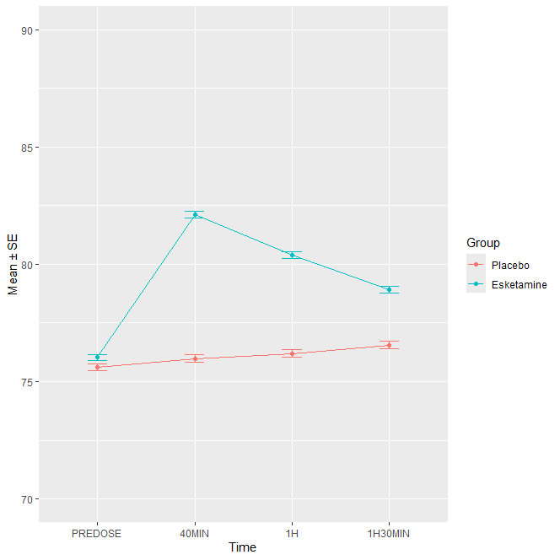
 | Pvalue
Interaction treatment*time | < 0.0001

The interaction between treatment and measurement was significant at the 5% level. The effect of measurement time on diastolic blood pressure differed between groups.

Least-squares means were computed using the lsmeans function, with Tukey adjustment for multiple comparisons.

 | Comparison | Estimate | Standard error | Pvalue
Time : Predose | Esketamine vs Placebo | 0.52 | 0.57 | 0.3644
Time : 40 minutes | Esketamine vs Placebo | 6.14 | 0.57 | < 0.0001
Time : 1 hour | Esketamine vs Placebo | 4.22 | 0.57 | < 0.0001
Time : 1 hour 30 | Esketamine vs Placebo | 2.41 | 0.57 | < 0.0001

Systolic blood pressure per day and per time

Figure 29: Evolution of systolic blood pressure by measurement time and per day according to group

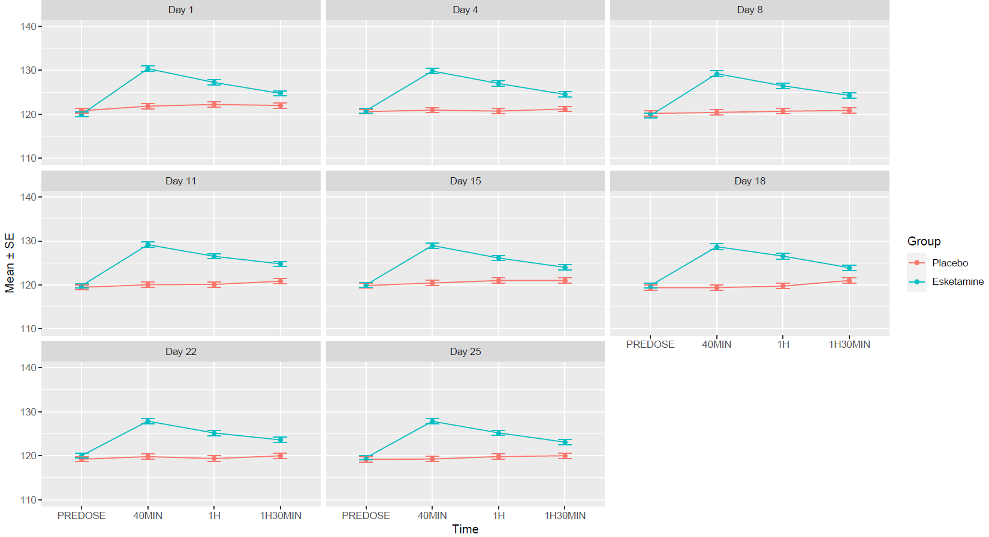

Table 17: Evolution of systolic blood pressure by measurement time and per day according to group, mean difference [Confidence Interval (CI) 95%]

Day | Time | Mean difference [CI95%]
Day 1
 | PREDOSE | -0.83 [-2.31 ; 0.64]
 | 40 minutes | 8.54 [6.78 ; 10.30]
 | 1 hour | 5.01 [3.29 ; 6.74]
 | 1 hour and 30 minutes | 2.74 [1.14 ; 4.33]
Day 4
 | PREDOSE | 0.22 [-1.25 ; 1.68]
 | 40 minutes | 8.88 [7.15 ; 10.60]
 | 1 hour | 6.28 [4.59 ; 7.96]
 | 1 hour and 30 minutes | 3.32 [1.69 ; 4.95]
Day 8
 | PREDOSE | -0.46 [-2.04 ; 1.11]
 | 40 minutes | 8.80 [7.00 ; 10.59]
 | 1 hour | 5.78 [4.09 ; 7.47]
 | 1 hour and 30 minutes | 3.41 [1.75 ; 5.07]
Day 11
 | PREDOSE | 0.34 [-1.13 ; 1.82]
 | 40 minutes | 9.10 [7.39 ; 10.82]
 | 1 hour | 6.40 [4.72 ; 8.07]
 | 1 hour and 30 minutes | 3.94 [2.30 ; 5.60]
Day 15
 | PREDOSE | 0.14 [-1.38 ; 1.67]
 | 40 minutes | 8.53 [6.81 ; 10.26]
 | 1 hour | 5.12 [3.37 ; 6.86]
 | 1 hour and 30 minutes | 3.00 [1.34 ; 4.66]
Day 18
 | PREDOSE | 0.46 [-1.03 ; 1.95]
 | 40 minutes | 9.30 [7.59 ; 11.02]
 | 1 hour | 6.82 [5.06 ; 8.58]
 | 1 hour and 30 minutes | 2.91 [1.22 ; 4.60]
Day 22
 | PREDOSE | 0.80 [-0.70 ; 2.29]
 | 40 minutes | 8.07 [6.35 ; 9.80]
 | 1 hour | 5.81 [4.11 ; 7.51]
 | 1 hour and 30 minutes | 3.62 [1.97 ; 5.27]
Day 25
 | PREDOSE | 0.38 [-1.11 ; 1.87]
 | 40 minutes | 8.58 [6.89 ; 10.27]
 | 1 hour | 5.38 [3.72 ; 7.05]
 | 1 hour and 30 minutes | 3.10 [1.51 ; 4.69]

 | Pvalue
Interaction treatment*measure | < 0.0001

The interaction between treatment and measurement was significant at the 5% level. The effect of measurement time on systolic blood pressure differed between groups.

Systolic blood pressure per time

For each patient, the mean of D4 to D25 was taken for each time.

Figure 30: Evolution of diastolic blood pressure by measurement time and per day according to group

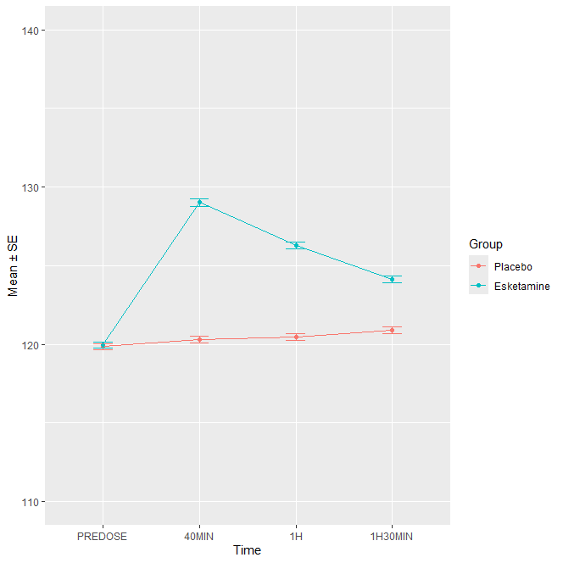

 | Pvalue
Interaction treatment*time | < 0.0001

The interaction between treatment and measurement was significant at the 5% level. The effect of measurement time on systolic blood pressure differed between groups.

Least-squares means were computed using the lsmeans function, with Tukey adjustment for multiple comparisons.

 | Comparison | Estimate | Standard error | Pvalue
Time : Predose | Esketamine vs Placebo | 0.39 | 0.72 | 0.5881
Time : 40 minutes | Esketamine vs Placebo | 8.96 | 0.72 | < 0.0001
Time : 1 hour | Esketamine vs Placebo | 6.09 | 0.72 | < 0.0001
Time : 1 hour 30 | Esketamine vs Placebo | 3.58 | 0.72 | < 0.0001

Dissociation

The dissociation criteria was analyzed using the Clinician-Administered Dissociative States Scale (CADSS). The CADSS consists of 23 subjective items. Participant’s responses are coded on a 5-point scale (0=not at all through to 4=extremely). To obtain the total CADSS score you need to sums all the items. The score vary from 0 to 92.
The CADSS was performed predose and at 40 minutes and 1.5 hours postdose. Predose no select. The maximum of the two values (40 minutes and 1.5 hours postdose) was selected for each day of double-blind induction phase, then the maximum value of phase was selected. Dissociation was defined if the CADSS value was ≥ 1.

Figure 31: Forest plot, dissociation outcome

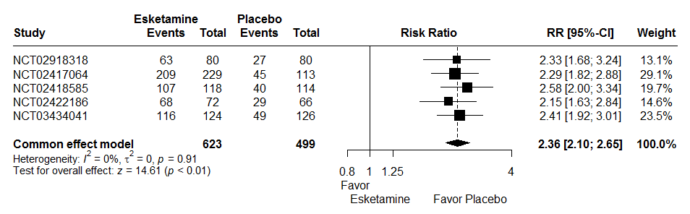
RR : Relative Risk
CI : Confidence Interval

A random effects model were not used because there are not heterogeneity between studies (I² = 0%, t² = 0, p = 0.91). The two-stage meta-analysis indicates a significant effect between dissociation and treatment group with an RR of 2.36 [2.10; 2.65], p < 0.01 in common effect model.

Sedation

The sedation criteria was analyzed using the Modified Observer’s Assessment of Alertness/Sedation (MOAA/S). The MOAA/S scores range from 0=no response to painful stimulus to 5=readily responds to name spoken in normal tone.
On each intranasal doing day, the MOAA/S was performed at every 15 minutes from predose to t=+1.5 hours postdose. Predose no select. The minimum of the values was selected for each day, then the minimal value for the treatment period was selected. Sedation was defined if the MOAA/S value was < 5.

Figure 32: Forest plot, sedation outcome

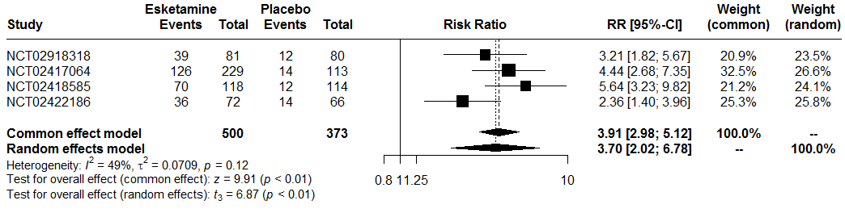RR : Relative Risk
CI : Confidence Interval

A random effects model were used because there are heterogeneity between studies (I² = 49%, t² = 0.07, p = 0.12). The two-stage meta-analysis indicates a significant effect between dissociation and treatment group with an RR of 3.91 [2.98; 5.12], p < 0.01 in common effect model and an RR of 3.70 [2.02; 6.78], p < 0.01 in random effects model.

Outcomes assessed at the last follow-up visit post-treatment

Serious adverse events

Figure 33: Forest plot, serious adverse events outcome at the follow-up visit

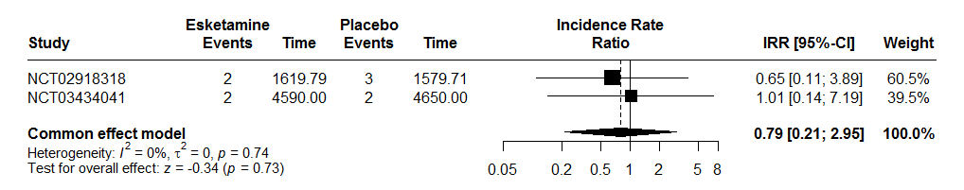

IRR : Incidence Rate Ratio
CI : Confidence Interval

A random effects model were not used because there are not heterogeneity between studies (I² = 0%, t² = 0, p = 0.74). The two-stage meta-analysis indicates a no significant effect between serious adverse events and treatment group with an IRR of 0.79 [0.21; 2.95], p = 0.73 in common effect model.

Dropout for any cause

Dropout for any cause is considered if patient checked at least one of the following criteria:
- Adverse event
- Death
- Lack of efficacy
- Lost to follow-up
- Non-compliance with switched oral antidepressant therapy
- Other
- Withdrawal by subject
- Investigator decision
- Protocol violation

Figure 34: Forest plot, dropout for any cause outcome during the follow-up period
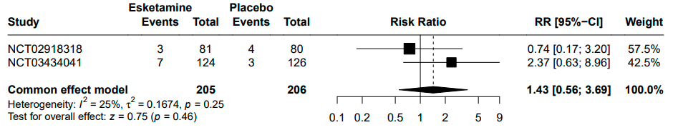
RR : Relative Risk
CI : Confidence Interval

A random effects model were not used because there are not heterogeneity between studies (I² = 25%, t² = 0.17, p = 0.25). The two-stage meta-analysis indicates a no significant effect between dropout for any cause and treatment group with an RR of 1.43 [0.56; 3.69], p = 0.46 in common effect model.

Dropout due to adverse events

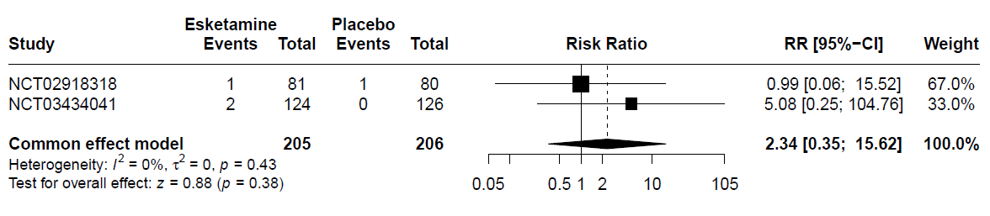
Figure 35: Forest plot, dropout due to adverse events outcome during the follow-up period
RR : Relative Risk
CI : Confidence Interval

A random effects model were not used because there are not heterogeneity between studies (I² = 0%, t² = 0, p = 0.43). The two-stage meta-analysis indicates a no significant effect between dropout due to adverse events and treatment group with an RR of 2.34 [0.35; 15.62], p = 0.38 in common effect model.

Adverse events

Figure 36: Forest plot, adverse events outcome at the follow-up visit

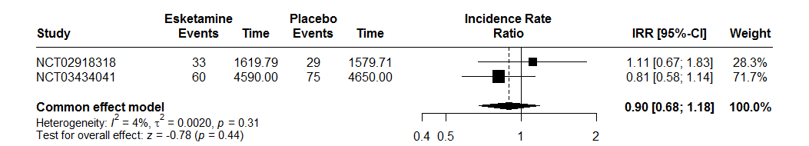IRR : Incidence Rate Ratio
CI : Confidence Interval

A random effects model were not used because there are no heterogeneity between studies (I² = 4%, t² < 0.01, p = 0.31). The two-stage meta-analysis indicates a no significant effect between adverse events and treatment group with an IRR of 0.90 [0.68; 1.18], p = 0.44 in common effects.

Blood pressure

Only study NCT03434041 (3006) had available follow-up data for blood pressure.

Diastolic blood pressure

Figure 37: Evolution of diastolic blood pressure by week 2, 5 and 8 at the follow-up visit

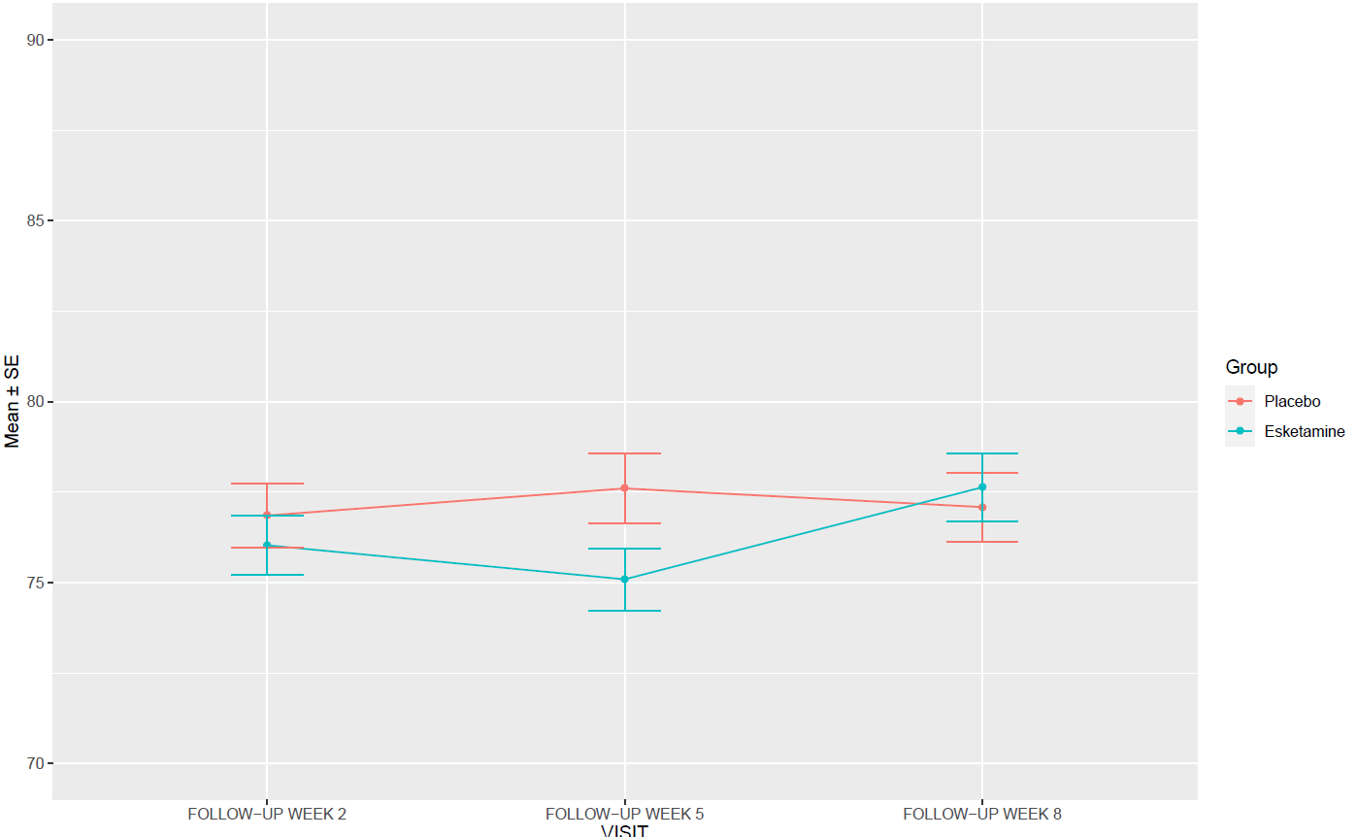

Table 18: Evolution of diastolic blood pressure by measurement time and per day according to group, mean difference [Confidence Interval(CI) 95%]

Day | Mean difference [CI95%]
Follow-up week 2 | -0.82 [-3.20 ; 1.56]
Follow-up week 5 | -2.51 [-5.06 ; 0.04]
Follow-up week 8 | 0.55 [-2.06 ; 3.16]

 | Pvalue
Interaction treatment*follow-up visit | 0.2454

The interaction between treatment and follow-up visit was no significant at the 5% level.

Systolic blood pressure

Figure 38: Evolution of systolic blood pressure by week 2, 5 and 8 at the follow-up visit

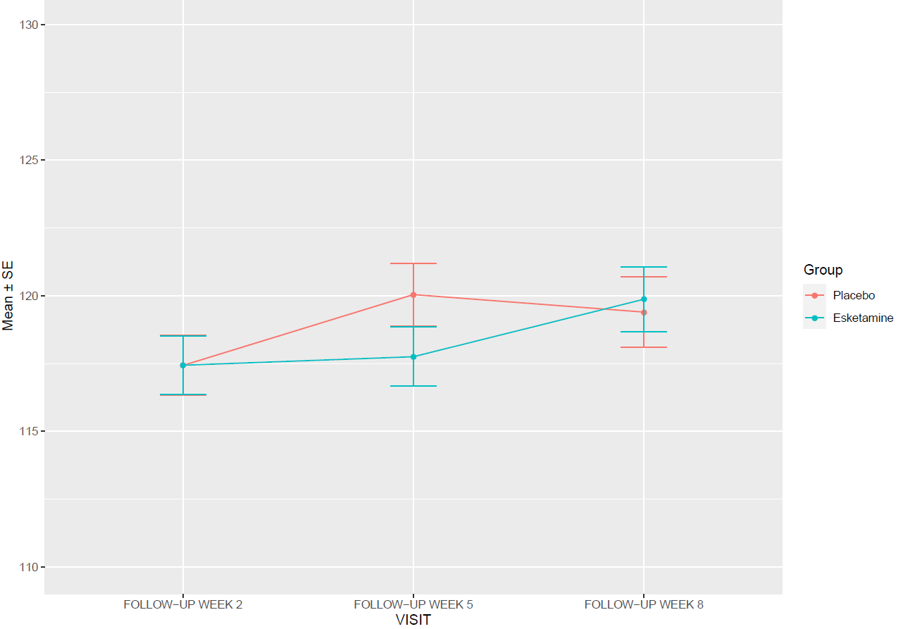

Table 19: Evolution of systolic blood pressure by measurement time and per day according to group, mean difference [Confidence Intervals (CI) 95%]

Day | Mean difference [CI95%]
Follow-up week 2 | 0.01 [-3.02 ; 3.04]
Follow-up week 5 | -2.29 [-5.41 ; 0.83]
Follow-up week 8 | 0.47 [-2.98 ; 3.92]

 | Pvalue
Interaction treatment*visit | 0.4471

The interaction between treatment and visit was no significant at the 5% level.

Moderators of esketamine efficacy

Impact of resistance stage

Each participant was to be classified into the Thase and Rush resistance stages according to their basic characteristics (Table 7). However, some of patients have received treatments that do not fit neatly into the established categories of classification. A modified classification was applied (Table 8) to better capture these nuances. We used classification, but the pure number of attempts, irrespective of class was used (one class: stage I, two classes: stage II, three classes: stage III, four or more: stage IV.

Table 20: Definition classification Thase and Rush

Stage | Definition
Stage I | Failure of 1 adequate trial of 1 major class of antidepressants
Stage II | Failure of 2 adequate trial of 2 major class of antidepressants
Stage III | Stage II resistance + failure of an adequate trial of a tricyclic agent
Stage IV | Stage III resistance + failure of an adequate trial of a monoamine oxidase inhibitor
Stage V | Stage IV resistance + a course of bilateral electroconvulsive therapy

Table 21: Coding of classification Thase and Rush with the combined treatments

Traitement | STAGES
MAOI | Stage 1
MAOI + TRICYCLIC | Stage 2
OTHER | Stage 1
OTHER + MAOIS | Stage 2
OTHER + TRICYCLIC | Stage 2
SNRIS | Stage 1
SNRIS + MAOI | Stage 2
SNRIS + OTHER | Stage 2
SNRIS + OTHER + MAOI + TRICYCLIC | Stage 4
SNRIS + OTHER + MAOI | Stage 3
SNRIS + OTHER + TRICYCLIC | Stage 3
SNRIS + SSRIS | Stage 2
SNRIS + SSRIS + MAOI | Stage 3
SNRIS + SSRIS + OTHER | Stage 2
SNRIS + SSRIS + OTHER + MAOI | Stage 4
SNRIS + SSRIS + OTHER + MAOI + TRICYCLIC | Stage 4
SNRIS + SSRIS + OTHER + TRICYCLIC | Stage 3
SNRIS + SSRIS + TRICYCLIC | Stage 3
SNRIS + TRICYCLIC | Stage 2
SSRIS | Stage 1
SSRIS + MAOI | Stage 2
SSRIS + MAOI + TRICYCLIC | Stage 3
SSRIS + OTHER | Stage 2
SSRIS + OTHER + MAOI + TRICYCLIC | Stage 4
SSRIS + OTHER + MAOI | Stage 3
SSRIS + OTHER + TRICYCLIC | Stage 3
SSRIS + TRICYCLIC | Stage 2
TRICYCLIC | Stage 1

Two-stage

MADRS after at least 4 weeks

Table 22: Distribution of the number of patients in each stage by study
 | Number patients : Stage 1 | Number patients : Stage 2 | Number patients : Stage 3 | Number patients : Stage 4
NCT02918318 (2005) | 90 | 69 | 2 | 0
NCT02417064 (3001) | 81 | 245 | 15 | 1
NCT02418585 (3002) | 55 | 169 | 7 | 1
NCT02422186 (3005) | 39 | 92 | 6 | 1
NCT03434041 (3006) | 105 | 143 | 2 | 0
All studies | 370 | 718 | 32 | 3

Figure 39: Forest plot, impact of resistance stage

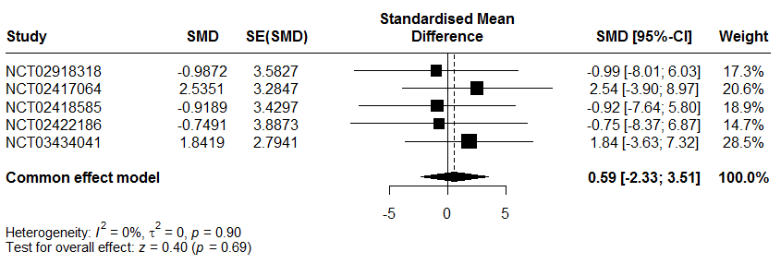
SMD : The effect size estimates
SE(SMD) : Standard errors of the treatment effect estimates

A random effects model were not used because there are no heterogeneity between studies (I2 = 0%, t² = 0, p = 0.90). The two-stage meta-analysis indicates a no significant effect with MARDS at 4 weeks and interaction of Impact of resistance stage and treatment group with an SMD of 0.59 [-2.33; 3.51], p = 0.69 in common effects.

MADRS after at least 4 weeks with imputation missing data

Figure 40: Forest plot, impact of resistance stage with imputation missing data

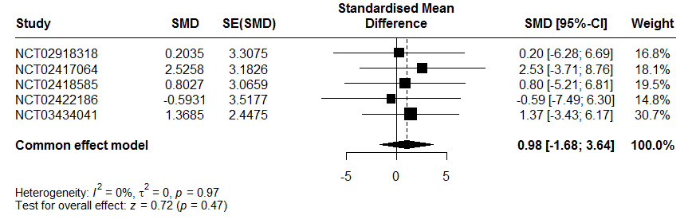
SMD : The effect size estimates
SE(SMD) : Standard errors of the treatment effect estimates.

A random effects model were not used because there are no heterogeneity between studies (I2 = 0%, t² = 0, p = 0.97). The two-stage meta-analysis indicates a no significant effect with MARDS at 4 weeks with imputation data and interaction of Impact of resistance stage and treatment group with an SMD of 0.98 [-1.68; 3.64], p = 0.47 in common effects.

One-stage

MADRS after at least 4 weeks

Table 23: Description MARDRS at 4 weeks by impact of resistance stage and group

Stage | Group | N | Mean ± standard deviation
Stage 1
 | Placebo | 147 | 23.38 ± 12.00
 | Esketamine | 187 | 20.96 ± 12.87
Stage 2
 | Placebo | 296 | 24.72 ± 12.33
 | Esketamine | 352 | 20.41 ± 12.43
Stage 3
 | Placebo | 9 | 22.44 ± 11.89
 | Esketamine | 20 | 25.90 ± 13.62
Stage 4
 | Placebo | 1 | 33.00
 | Esketamine | 1 | 38.00

 | Pvalue
Interaction impact of resistance stage and treatment group | 0.8014

The one-stage meta-analysis indicates a no significant effect with MARDS at 4 weeks and interaction of Impact of resistance stage and treatment group at the 5% level.

MADRS after at least 4 weeks with imputation missing data

Table 24: Description MARDRS at 4 weeks with imputation missing data by impact of resistance stage and group

Stage | Group | N | Mean ± standard deviation
Stage 1
 | Placebo | 162 | 23.64 ± 11.68
 | Esketamine | 208 | 21.41 ± 12.55
Stage 2
 | Placebo | 324 | 24.91 ± 12.06
 | Esketamine | 394 | 21.04 ± 12.14
Stage 3
 | Placebo | 11 | 24.15 ± 11.48
 | Esketamine | 21 | 26.50 ± 13.55
Stage 4
 | Placebo | 2 | 26.55 ± 9.12
 | Esketamine | 1 | 38.00

 | Pvalue
Interaction impact of resistance stage and treatment group | 0.5956

The one-stage meta-analysis indicates a no significant effect with MARDS at 4 weeks and interaction of Impact of resistance stage and treatment group at the 5% level.

Sensitivity analysis impact of resistance stage

A sensitivity analysis was performed excluding patients with MAOI.

Two-stage

MADRS after at least 4 weeks

Table 25: Distribution of the number of patients in each stage by study
 | Number patients : Stage 1 | Number patients : Stage 2 | Number patients : Stage 3
NCT02918318 (2005) | 90 | 69 | 2
NCT02417064 (3001) | 81 | 243 | 11
NCT02418585 (3002) | 54 | 168 | 5
NCT02422186 (3005) | 39 | 92 | 4
NCT03434041 (3006) | 105 | 143 | 1
All studies | 369 | 715 | 23

Figure 41: Forest plot, impact of resistance stage
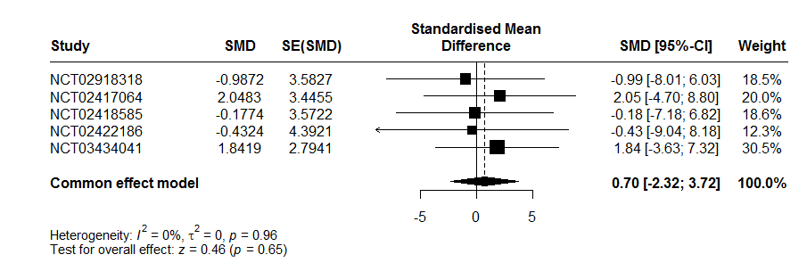
SMD : The effect size estimates
SE(SMD) : Standard errors of the treatment effect estimates

A random effects model were not used because there are no heterogeneity between studies (I2 = 0%, t² = 0, p = 0.96). The two-stage meta-analysis indicates a no significant effect with MARDS at 4 weeks and interaction of impact of resistance stage and treatment group with an SMD of 0.70 [-2.32; 3.72], p = 0.65 in common effects.

MADRS after at least 4 weeks with imputation missing data

Figure 42: Forest plot, impact of resistance stage with imputation missing data

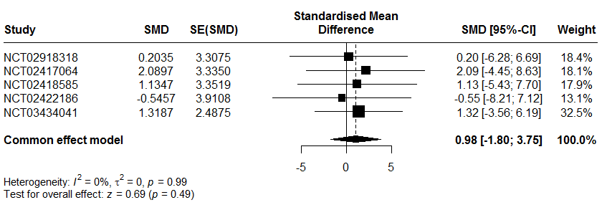
SMD : The effect size estimates
SE(SMD) : Standard errors of the treatment effect estimates.

A random effects model were not used because there are no heterogeneity between studies (I2 = 0%, t² = 0, p = 0.99). The two-stage meta-analysis indicates a no significant effect with MARDS at 4 weeks with imputation data and interaction of Impact of resistance stage and treatment group with an SMD of 0.98 [-1.80; 3.75], p = 0.49 in common effects.

One-stage

MADRS after at least 4 weeks

Table 26: Description MARDRS at 4 weeks by impact of resistance stage and group

Stage | Group | N | Mean ± standard deviation
Stage 1
 | Placebo | 146 | 23.40 ± 12.04
 | Esketamine | 187 | 20.96 ± 12.87
Stage 2
 | Placebo | 296 | 24.72 ± 12.33
 | Esketamine | 350 | 20.38 ± 12.44
Stage 3
 | Placebo | 7 | 19.71 ± 11.31
 | Esketamine | 14 | 28.07 ± 12.98

 | Pvalue
Interaction impact of resistance stage and treatment group | 0.8576

The one-stage meta-analysis indicates a no significant effect with MARDS at 4 weeks and interaction of Impact of resistance stage and treatment group at the 5% level.

MADRS after at least 4 weeks with imputation missing data

Table 27: Description MARDRS at 4 weeks with imputation missing data by impact of resistance stage and group

Stage | Group | N | Mean ± standard deviation
Stage 1
 | Placebo | 161 | 23.66 ± 11.71
 | Esketamine | 208 | 21.41 ± 12.55
Stage 2
 | Placebo | 324 | 24.91 ± 12.06
 | Esketamine | 391 | 21.02 ± 12.17
Stage 3
 | Placebo | 8 | 21.81 ± 12.04
 | Esketamine | 15 | 28.76 ± 12.79

 | Pvalue
Interaction impact of resistance stage and treatment group | 0.6958

The one-stage meta-analysis indicates a no significant effect with MARDS at 4 weeks and interaction of Impact of resistance stage and treatment group at the 5% level.

Impact of age

Two-stage

MADRS after at least 4 weeks

Table 28: Number subject per trial per group

Number NCT trial | Group | N
NCT02918318 | Placebo | 72
 | Esketamine | 73
NCT02417064 | Placebo | 108
 | Esketamine | 210
NCT02418585 | Placebo | 106
 | Esketamine | 105
NCT02422186 | Placebo | 60
 | Esketamine | 63
NCT03434041 | Placebo | 107
 | Esketamine | 109

Figure 43: Forest plot, impact of age
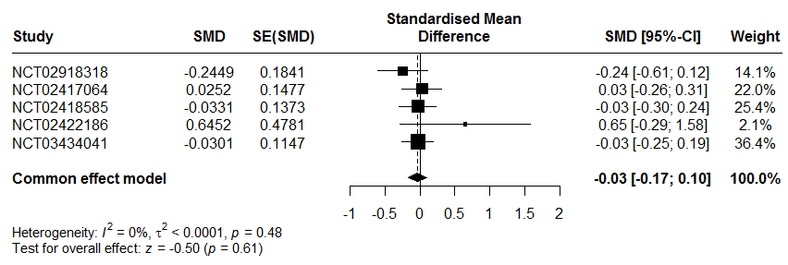SMD : The effect size estimates
SE(SMD) : Standard errors of the treatment effect estimates.

A random effects model were not used because there are no heterogeneity between studies (I² = 0%, t² < 0.01, p = 0.48). The two-stage meta-analysis indicates a no significant effect with MARDS at 4 weeks and interaction of impact of age and treatment group with an SMD of -0.03 [-0.17; 0.10], p = 0.61 in common effects.

MADRS after at least 4 weeks with imputation missing data

Table 29: Number subject per trial per group

Number NCT trial | Group | N
NCT02918318 (2005) | Placebo | 80
 | Esketamine | 81
NCT02417064 (3001) | Placebo | 113
 | Esketamine | 229
NCT02418585 (3002) | Placebo | 114
 | Esketamine | 118
NCT02422186 (3005) | Placebo | 66
 | Esketamine | 72
NCT03434041 (3006) | Placebo | 126
 | Esketamine | 124

Figure 44: Forest plot, impact of age with imputation missing data for MADRS

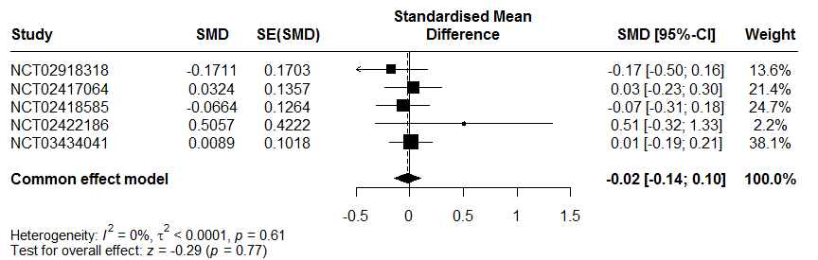
SMD : The effect size estimates
SE(SMD) : Standard errors of the treatment effect estimates.

A random effects model were not used because there are no heterogeneity between studies (I² = 0%, t² <0.01, 0, p = 0.61). The two-stage meta-analysis indicates a no significant effect with MARDS at 4 weeks with imputation data and interaction of impact of age and treatment group with an SMD of -0.02 [-0.14; 0.10], p = 0.77 in common effects.

One-stage

MADRS after at least 4 weeks

 | Pvalue
Interaction impact of age and treatment group | 0.4456

The one-stage meta-analysis indicates a no significant effect with MARDS at 4 weeks and interaction of Impact of age and treatment group at the 5% level.

Table 30: Description MARDRS at 4 weeks by age and group

Stage | Group | N | Mean ± standard deviation
<40
 | Placebo | 137 | 24.50 ± 11.34
 | Esketamine | 202 | 21.65 ± 12.28
[40-50]
 | Placebo | 122 | 22.04 ± 12.78
 | Esketamine | 132 | 19.52 ± 12.40
]50-60]
 | Placebo | 100 | 24.13 ± 13.27
 | Esketamine | 128 | 18.75 ± 12.41
]60-70]
 | Placebo | 77 | 26.42 ± 10.70
 | Esketamine | 69 | 21.20 ± 13.50
>70
 | Placebo | 17 | 29.29 ± 12.49
 | Esketamine | 29 | 29.21 ± 11.99

MADRS after at least 4 weeks with imputation missing data

 | Pvalue
Interaction impact of age and treatment group | 0.6052

The one-stage meta-analysis indicates a no significant effect with MARDS at 4 weeks and interaction of Impact of age and treatment group at the 5% level.

Table 31: Description MARDRS at 4 weeks with imputation missing data by age and group

Stage | Group | N | Mean ± standard deviation
<40
 | Placebo | 163 | 24.98 ± 10.92
 | Esketamine | 224 | 21.98 ± 11.93
[40-50]
 | Placebo | 129 | 22.01 ± 12.61
 | Esketamine | 146 | 20.14 ± 12.30
]50-60]
 | Placebo | 104 | 24.12 ± 13.07
 | Esketamine | 141 | 19.37 ± 12.12
]60-70]
 | Placebo | 83 | 26.45 ± 10.37
 | Esketamine | 78 | 21.85 ± 13.06
>70
 | Placebo | 20 | 30.21 ± 11.73
 | Esketamine | 35 | 29.71 ± 11.40

Impact of per capita gross national income

Table 32: Country classification

 | High income country | Low, lower middle, and upper middle income country
China |  | X
USA | X
Africa |  | X
Europe | X
North America | X
South America |  | X
Czech Republic | X
Germany | X
Spain | X
Poland | X
Belgium | X
Brazil |  | X
Canada | X
Estonia | X
France | X
Hungary | X
Ital | X
Mexico |  | X
Slovakia | X
Sweden | X
Turkey |  | X
Japan | X

Table 33: Description of the per capita gross national income in each initiation study
Study | High income country | Low, lower middle, and upper middle income country
NCT02918318 (2005) | 161 | 0
NCT02417064 (3001) | 240 | 102
NCT02418585 (3002) | 232 | 0
NCT02422186 (3005) | 130 | 8
NCT03434041 (3006) | 28 | 222

Two-stage

Three country were evaluated to two-stage analysis because two studies had no low, lower middle or upper middle income countries.

MADRS after at least 4 weeks

Figure 45: Forest plot, impact of per capita gross national income
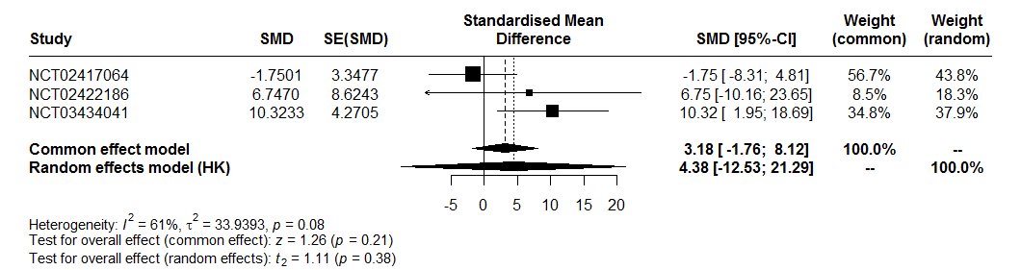SMD : The effect size estimates
SE(SMD) : Standard errors of the treatment effect estimates

Interpretation:
A random effects model were used because there are heterogeneity between studies (I² = 61%, t² = 33.94, p = 0.08). The two-stage meta-analysis indicates a no significant effect with MARDS at 4 weeks and interaction of impact of per capital gross national income and treatment group with an SMD of 3.218 [-1.76; 8.12], p = 0.21 in common effect and an SMD of 4.39 [-12.53; 21.29], p = 0.38 in random effects.

MADRS after at least 4 weeks with imputation missing data

Figure 46: Forest plot, impact of per capita gross national income with imputation missing data for MADRS
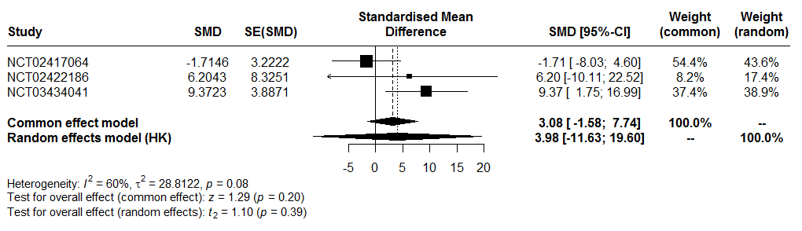SMD : The effect size estimates
SE(SMD) : Standard errors of the treatment effect estimates.

A random effects model were used because there are heterogeneity between studies (I² = 60%, t²=28.81, p = 0.08). The two-stage meta-analysis indicates a no significant effect with MARDS at 4 weeks with imputation data and interaction of impact of per capital gross national income and treatment group with an SMD of 3.08 [-1.58; 7.74], p=0.08 in common effect and an SMD of 3.98 [-11.63; 19.60], p=0.39 in random effects.

One-stage

MADRS after at least 4 weeks

Table 34: Description MARDRS at 4 weeks by impact of capita gross national income

Stage | Group | N | Mean ± standard deviation
High income country
 | Placebo | 321 | 24.08 ± 12.22
 | Esketamine | 395 | 20.68 ± 12.67
Low, lower middle, and upper middle income country
 | Placebo | 132 | 24.70 ± 12.19
 | Esketamine | 165 | 21.16 ± 12.62

 | Pvalue
Interaction impact of capita gross national income and treatment group | 0.3079

The one-stage meta-analysis indicates a no significant effect with MARDS at 4 weeks and interaction of impact of per capital gross national income and treatment group at the 5% level.

MADRS after at least 4 weeks with imputation missing data

Table 35: Description MARDRS at 4 weeks with imputation missing data by impact of capita gross national income

Stage | Group | N | Mean ± standard deviation
High income country
 | Placebo | 349 | 24.07 ± 11.97
 | Esketamine | 442 | 21.14 ± 12.36
Low, lower middle, and upper middle income country
 | Placebo | 150 | 25.46 ± 11.71
 | Esketamine | 182 | 21.94 ± 12.35

 | Pvalue
Interaction impact of capita gross national income and treatment group | 0.3557

The one-stage meta-analysis indicates a no significant effect with MARDS at 4 weeks with imputation missing data and interaction of impact of per capital gross national income and treatment group at the 5% level.

Continuation studies

Efficacy outcomes assessed at the end of the study

Only one continuation study.

Patients randomized in the maintenance phase were included in the meta-analysis. A total of 303 patients were randomized, but 6 were excluded due to sponsor audit results. The analysis was carried out on 297 patients (176 in a stable remission and 121 in a stable response).
The end of study corresponds to the end of maintenance phase.
For all outcome, the definitions were the same that initiations studies.

Relapse

Treatment | HR [95%CI] | Standard error
Placebo | 1
Esketamine | 0.38 [0.26, 0.57] | 0.20

Relapse for patient in stable remission:

Treatment | HR [95%CI] | Standard error
Placebo | 1
Esketamine | 0.46 [0.28, 0.77] | 0.26

Relapse for patient in stable response:

Treatment | HR [95%CI] | Standard error
Placebo | 1
Esketamine | 0.30 [0.16, 0.55] | 0.31

Suicide/suicide attempt

Treatment | Number event | Number total of subjects
Placebo | 0 | 145
Esketamine | 2 | 152

Table 36: Describe Suicide/Suice attempt

Patient 1 | Stable response | Esketamine group | C-SSRS part Suicidal behavior were selected. Time relapse = 48 days
Patient 2 | Stable response | Esketamine group | C-SSRS part Suicidal behavior were selected. Time relapse = 262.96 days

Suicidal ideations

Treatment | Number event | Number total of subjects
Placebo | 0 | 145
Esketamine | 1 | 152

MADRS

Selection of last MADRS available in maintenance phase by patient.

 | ESKETAMINE | Placebo
n | 151 | 145
Mean | 12.89 | 19.07
Standard deviation | 11.66 | 12.61

Remission

Treatment | Number of event | Number total of subjects
Placebo | 51 | 145
Esketamine | 86 | 151

Sheehan Disability Scale

 | ESKETAMINE | Placebo
n | 150 | 144
Mean | 7.32 | 11.04
Standard deviation | 7.28 | 8.58

PHQ-9

 | ESKETAMINE | Placebo
n | 150 | 144
Mean | 5.73 | 8.12
Standard deviation | 5.47 | 6.52

Safety outcomes assessed at the end of the study

Serious adverse events

 | ESKETAMINE | Placebo
Number of events | 5 | 1
Person time at risk (days) | 24145.58 | 16123.33
Incidence rate [CI95%] per 1000/person day | 0.2071 [0.2013 ; 0.2128] | 0.0620 [0.0562 ; 0.0677]

Result poisson regression. An overdispersion was observed, and a quasi-Poisson model was performed.

Estimate (reference = Placebo) | Standard error | P-value
1.206 | 2.06 | 0.5590

Incidence Risk Ratio and 95% Confidence interval = 3.34 [0.42; 26.21]

Dropout for any cause

 | ESKETAMINE | Placebo
Number of events | 12 | 11
Number total of subjects | 152 | 145

Odds ratio and 95% confidence interval (reference: Placebo) = 1.04 [0.44; 2.48]
Relative risk and 95% confidence interval (reference: Placebo) = 1.04 [0.47; 2.28]

Dropout due to adverse events

 | ESKETAMINE | Placebo
Number of events | 1 | 2
Number total of subjects | 152 | 145

Odds ratio and 95% confidence interval (reference: Placebo) = 0.47 [0.02; 4.99]
Relative risk and 95% confidence interval (reference: Placebo) = 0.48 [0.04; 5.20]

Adverse events

 | ESKETAMINE | Placebo
Number of events | 3263 | 400
Person time at risk (days) | 24145.58 | 16123.33
Incidence rate [CI95%] per 1000/person day | 135.14 [134.99 ; 135.29] | 24.81 [24.73 ; 24.89]

Result poisson regression. An overdispersion was observed, and a quasi-Poisson model was performed.

Estimate (reference = Placebo) | Standard error | P-value
1.695 | 0.26 | < 0.0001

Incidence Risk Ratio and 95% Confidence interval = 5.45 [4.20; 7.06]

Blood pressure

The blood pressure was measured at predose and at 40 minutes, 1 hour and 1.5 hours postdose and repeated during the maintenance phase.
A linear mixed model was realized with blood pressure as response variable, treatment and measurement interaction (predose and at 40 minutes, 1 hour and 1.5 hours postdose) and day as random effect.

Diastolic blood pressure

 | Pvalue
Interaction treatment*measure | < 0.0001

The interaction between treatment and measurement was significant at the 5% level. The effect of measurement time on diastolic blood pressure differed between groups.

Systolic blood pressure

 | Pvalue
Interaction treatment*measure | < 0.0001

The interaction between treatment and measurement was significant at the 5% level. The effect of measurement time on systolic blood pressure differed between groups.

Dissociation

 | ESKETAMINE | Placebo
Number of events | 118 | 27
Number total of subjects | 151 | 143
Odds ratio and 95% confidence interval (reference: Placebo) = 15.36 [8.83; 27.63]
Relative risk and 95% confidence interval (reference: Placebo) = 4.14 [2.92; 5.87]

Sedation

 | ESKETAMINE | Placebo
Number of events | 66 | 22
Number total of subjects | 152 | 145

Odds ratio and 95% confidence interval (reference: Placebo) = 4.29 [2.49; 7.61]
Relative risk and 95% confidence interval (reference: Placebo) = 2.86 [1.87; 4.38]

3.2.3 Moderators of esketamine efficacy

Impact of resistance stage

 | Interaction term between treatment group and Thase and Rush classification
Estimate | -4.12
Standard error | 3.52
pvalue | 0.211
Number of subjects | 181

Impact of age

 | Interaction term between treatment group and age
Estimate | 0.33
Standard error | 0.13
pvalue | 0.0079
Number of subjects | 296

Impact of country

 | Interaction term between treatment group and country
Estimate | 5.01
Standard error | 3.49
pvalue | 0.151
Number of subjects | 296

Analysis primary outcome with one country removed

Global population, forest plot:

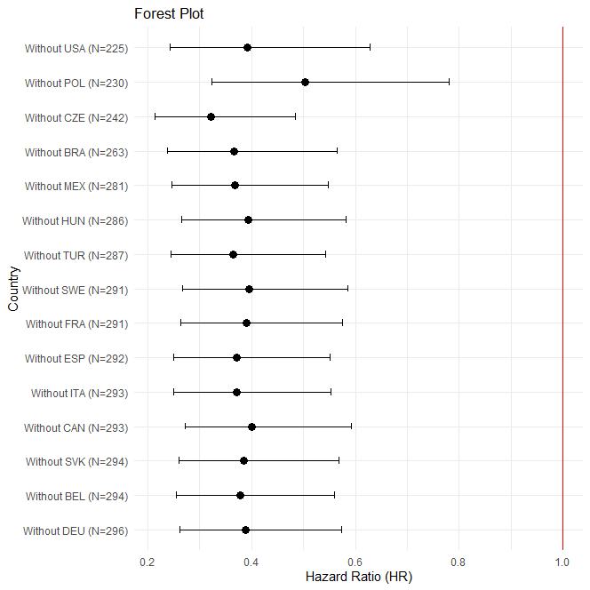

Stable remission population, forest plot:

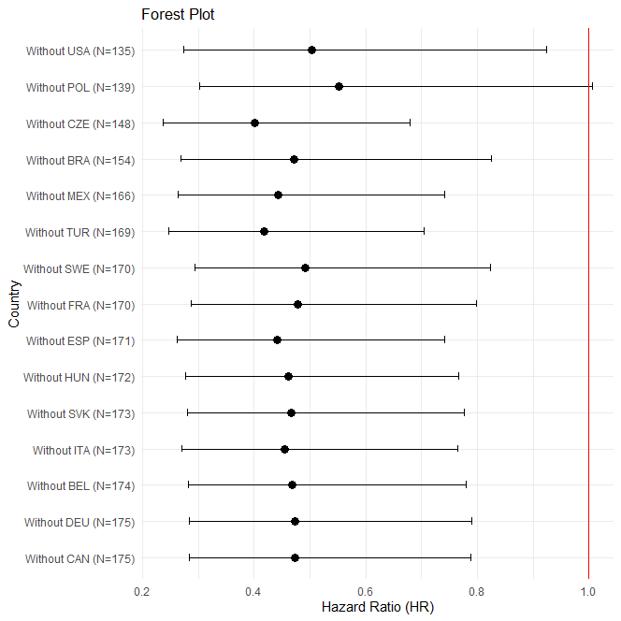

Stable response population:

