Modifying effects of compensatory sleep on elevated blood pressure related to school-day sleep patterns
Jieyu Liu¹, Xinli Song¹, Manman Chen², Yi Zhang¹, Jianuo Jiang¹, Ruolin Wang¹, Ziqi Dong¹, Li Chen¹, Yang Qin¹, Tongjun Guo¹, Zhiying Song¹, Wen Yuan³, Xinxin Wang⁴, Jun Ma¹, Yanhui Dong^{1, *}, Yi Song^{1, *}
Affiliations:
1 Institute of Child and Adolescent Health, School of Public Health, Peking University, National Health Commission Key Laboratory of Reproductive Health, Beijing, China
2. School of Population Medicine and Public Health, Chinese Academy of Medical Sciences and Peking Union Medical College, Beijing, China
3. School of Psychology, Central China Normal University, Wuhan, China
4. Linyi University, Linyi, China
*Corresponding author (Yanhui Dong, Email: dongyanhui@bjmu.edu.cn; Yi Song, Email: songyi@bjmu.edu.cn)

Additional File
Table S1. The Akaike Information Criterion (AIC) and Bayesian Information Criterion (BIC), and likelihood ratio test (LRT) for RCS models.
RCS vs. linear model | Number of Knots in RCS Model | Exact knot locations* | Degrees of freedom (df) | Akaike Information Criterion (AIC) | Bayesian Information Criterion (BIC) | Likelihood ratio chi-square (χ²) | P value for non-linear
Schoolday's wake-up times | 3 | 6, 6.5, 7 | 2 vs. 1 | 22644.87 | 22675.49 | 19.85 | <0.001
Schoolday's wake-up times | 4 | 6, 6.3, 6.8, 7.2 | 3 vs. 1 | 22645.77 | 22684.05 | 21.64 | 0.0001
Schoolday's wake-up times | 5 | 5.7, 6.2, 6.5, 7, 8 | 4 vs. 1 | 22647.70 | 22693.63 | 21.78 | 0.0002
Schoolday's wake-up times | 6 | 5.7, 6, 6.5, 6.7, 7, 8 | 5 vs. 1 | 22649.34 | 22702.93 | 22.25 | 0.001
Schoolday's wake-up times | 7 | 5.7, 6, 6.5, 6.5, 6.8, 7, 8 | 6 vs. 1 | 22649.93 | 22703.52 | 23.39 | 0.001
Schoolday's bedtimes | 3 | 8.5, 9.5, 10.3 | 2 vs. 1 | 22660.78 | 22691.40 | 14.82 | 0.001
Schoolday's bedtimes | 4 | 8.3, 9, 9.8, 10.5 | 3 vs. 1 | 22661.77 | 22700.05 | 16.15 | 0.001
Schoolday's bedtimes | 5 | 8, 9, 9.5, 10, 11 | 4 vs. 1 | 22662.97 | 22708.91 | 16.44 | 0.003
Schoolday's bedtimes | 6 | 8, 9, 9, 9.5, 10, 11 | 5 vs. 1 | 22662.97 | 22708.91 | 16.73 | 0.005
Schoolday's bedtimes | 7 | 8, 8.7, 9, 9.5, 9.5, 10, 11 | 6 vs. 1 | 22664.41 | 22718.00 | 19.10 | 0.004
Sleep midpoint | 3 | 1.6, 2.2, 2.8 | 2 vs. 1 | 22662.49 | 22693.12 | 11.67 | 0.003
Sleep midpoint | 4 | 1.5, 2, 2.5, 3 | 3 vs. 1 | 22663.65 | 22701.93 | 11.95 | 0.008
Sleep midpoint | 5 | 1.3, 2, 2.2, 2.5, 3.2 | 4 vs. 1 | 22664.69 | 22710.63 | 16.38 | 0.003
Sleep midpoint | 6 | 1.3, 1.8, 2, 2.2, 2.6, 3.2 | 5 vs. 1 | 22655.76 | 22709.35 | 20.45 | 0.001
Sleep midpoint | 7 | 1.3, 1.8, 2, 2.2, 2.4, 2.7, 3.2 | 6 vs. 1 | 22658.02 | 22719.27 | 19.71 | 0.003
Sleep duration | 3 | 7.7, 8.8, 9.9 | 2 vs. 1 | 22640.34 | 22670.96 | 17.24 | 0.0002
Sleep duration | 4 | 7.4, 8.2, 9.3, 10 | 3 vs. 1 | 22642.32 | 22680.60 | 17.47 | 0.001
Sleep duration | 5 | 7, 8, 8.8, 9.5, 10.5 | 4 vs. 1 | 22644.29 | 22690.22 | 19.51 | 0.001
Sleep duration | 6 | 7, 8, 8.5, 9, 9.5, 10.5 | 5 vs. 1 | 22644.98 | 22698.57 | 20.71 | 0.001
Sleep duration | 7 | 7, 8, 8.5, 8.8, 9.1, 9.7, 10.5 | 6 vs. 1 | 22644.72 | 22705.97 | 24.07 | 0.001
*Exact knot locations and percentiles: K=3: 15th, 50th, 85th; K=4: 10th, 30th, 70th, 90th; K=5: 5th, 27.5th, 50th, 72.5th, 95th; K=6: 5th, 23th, 41th, 59th, 77th, 95th; K=7: 5th, 20th, 35th, 50th, 65th, 80th, 95th.
Sleep midpoint of 2:30 AM is recorded as 2.50, therefore 2.33 corresponds to approximately 2:20 AM.

Table S2. the “beneficial” range of sleep timing derived from the RCS curve.
Sleep timing | Minimum OR point | Non-significant range | The “beneficial” range based on public health relevance and clinical practicality
Schoolday’s wake-up times (AM.) | 6.99 | 6.40~12.57 | 6.40~8.00
Schoolday’s bedtimes (PM.) | 9.35 | 8.14~10.09 | 9.00~10.00
Sleep midpoint | 2.33 | 1.81~3.37 | 2.00~2.50[28]
Sleep duration | 9.14 | 8.37~14.83 | 9.00~11.00[29]
Sleep midpoint of 2:30 AM is recorded as 2.50, therefore 2.33 corresponds to approximately 2:20 AM.
- Wang J, et al., 2022.
- Hirshkowitz M et al., 2015.

Table S3. Collinearity diagnostics for included confounders and the sleep parameters.
X | VIF | Numbers | Eigenvalues | Condition Index
School-day sleep patterns | 1.09515 | 1 | 8.9147 | 1
Compensatory sleep | 1.03688 | 2 | 0.97125 | 3.02962
Age | 1.03594 | 3 | 0.74737 | 3.45372
Sex | 1.03759 | 4 | 0.60765 | 3.83026
Obesity status | 1.04632 | 5 | 0.42871 | 4.56008
Province | 1.07566 | 6 | 0.41449 | 4.63764
Frequency of egg consumption | 1.09169 | 7 | 0.28857 | 5.55809
Frequency of milk consumption | 1.21392 | 8 | 0.21386 | 6.4564
Frequency of breakfast consumption | 1.2022 | 9 | 0.14845 | 7.74938
Frequency of SSB consumption | 1.02596 | 10 | 0.13724 | 8.05958
Sunrise/sunset times | 1.0345 | 11 | 0.08534 | 10.22051
Social jet lag | 1.11971 | 12 | 0.03713 | 15.49451
Physical activity | 1.01061 | 13 | 0.00524 | 41.23499

Table S4. Detailed sleep characteristics in the total study samples.
Sleep parameters | School days |  | Non-school days |  | Compensatory sleep (hours)
Sleep parameters | sleep midpoint | sleep duration (hours) | sleep midpoint | sleep duration (hours)
Mean±SD | 2.26±0.70 | 8.76±1.13 | 3.10±0.91 | 9.48±1.30 | 0.71±1.35
Median±IQR | 2.25±0.63 | 8.83±1.50 | 3.00±1.00 | 9.50±1.50 | 0.50±1.50
Minimum | 0.05 | 4.00 | -0.13 | 4.00 | -7.00
Maximum | 6.50 | 14.83 | 6.88 | 15.00 | 9.00
Sleep midpoint of 2:30 AM is recorded as 2.5, therefore 2.26 corresponds to approximately 2:16 AM.

Table S5. The effect estimates at specified 10th and 90th percentiles (versus the minimum) of each sleep parameter for EBP in children.
Sleep parameters | 10th percentiles |  | 90th percentiles
Sleep parameters | Values | OR versus the minimum | Values | OR versus the minimum
Schoolday’s wake-up times (AM.) | 6.00 | 1.20 (1.12, 1.27) | 7.25 | 1.00 (0.93, 1.07)
Schoolday’s bedtimes (PM.) | 8.33 | 1.04 (0.98, 1.10) | 10.50 | 1.05 (0.97, 1.13)
Sleep midpoint | 1.50 | 1.11 (1.05, 1.18) | 3.00 | 1.09 (1.02, 1.17)
Sleep duration | 7.40 | 1.17 (1.00, 1.25) | 10.00 | 1.02 (0.96, 1.09)
Sleep midpoint of 2:30 AM is recorded as 2.50, therefore 2.33 corresponds to approximately 2:20 AM.
Adjusted for age, sex, province, obesity status, and the frequency of egg, milk, breakfast, and SSB consumption, sunrise/sunset times, social jet lag and physical activity.
Bold values referred to P<0.05.

Table S6. Associations between sleep parameters and EBP among children.
 | EBP
 | N (%) | OR (95%CI)
Phenotype on schooldays
Morning-type | 3227 (50.67) | 1.10 (1.02, 1.18)
Intermediate-type | 2684 (48.44) | 1 (ref.)
Evening-type | 1895 (51.19) | 1.11 (1.02, 1.21)
Sleep duration
Inadequate | 4056 (51.21) | 1.11 (1.04, 1.19)
Moderate | 3486 (48.65) | 1 (ref.)
Excessive | 264 (50.19) | 1.04 (0.87, 1.25)
Adjusted for age, sex, province, obesity status, and the frequency of egg, milk, breakfast, and SSB consumption, sunrise/sunset times, social jet lag and physical activity.
Bold values referred to P<0.05.
Table S7. Sensitivity analysis for the sleep duration and EBP among children.
 | EBP
 | N (%) | OR (95%CI)
Sleep duration
Inadequate (<9 hours) | 4056 (51.21) | 1.11 (1.04, 1.19)
Moderate (9~11 hours) | 3486 (48.65) | 1 (ref.)
Excessive (≥ 11 hours) | 264 (50.19) | 1.04 (0.87, 1.25)
Sleep duration*
Inadequate (<8.5 hours) | 2726 (52.07) | 1.13 (1.06, 1.22)
Moderate (8.5~11.5 hours) | 5026 (48.99) | 1 (ref.)
Excessive (≥ 11.5 hours) | 54 (45.76) | 0.88 (0.61, 1.26)
*sensitivity of the reasonable alternative sleep duration of 8.5~11.5 hours.
Adjusted for age, sex, province, obesity status, and the frequency of egg, milk, breakfast, and SSB consumption, sunrise/sunset times, social jet lag and physical activity.
Bold values referred to P<0.05.

Table S8. Prevalence of the sleep patterns combining sleep phenotype with sleep duration in children.
Group | Phenotype | Sleep duration | Schooldays (%) | Non-schooldays (%)
A | Morning-type | Inadequate | 13.66 | 2.64
B | Morning-type | Moderate | 26.15 | 7.84
C | Morning-type | Excessive | 0.99 | 1.55
D | Intermediate-type | Inadequate | 19.47 | 3.60
E | Intermediate-type | Moderate | 15.81 | 15.96
F | Intermediate-type | Excessive | 0.20 | 0.17
G | Evening-type | Inadequate | 17.60 | 21.10
H | Evening-type | Moderate | 3.93 | 36.50
I | Evening-type | Excessive | 2.18 | 10.63
A. Morning-type+inadequate duration; B. Morning-type+moderate duration; C. Morning-type+excessive duration; D. Intermediate-type+inadequate duration; E. Intermediate-type+moderate duration; F. Intermediate-type+excessive duration; G. Evening-type+inadequate duration; H. Evening-type+moderate duration; I. Evening-type+excessive duration.

Table S9. Prevalence of EBP in groups of school-day sleep patterns among children.
Sleep phenotype | Sleep duration | SBP (mmHg) | DBP (mmHg) | EBP (%)
Morning-type | Inadequate | 112.51±13.34 | 72.14±10.22 | 1126 (52.81%)
Morning-type | Middle | 111.62±12.72 | 71.78±10.67 | 2025 (49.60%)
Morning-type | Excessive | 110.99±13.04 | 70.50±11.19 | 76 (49.35%)
intermediate-type | Inadequate | 112.37±13.29 | 71.63±10.41 | 1512 (49.74%)
intermediate-type | Middle | 110.19±13.05 | 71.33±10.94 | 1155 (46.78%)
intermediate-type | Excessive | 113.06±11.38 | 73.00±9.87 | 17 (53.13%)
Evening-type | Inadequate | 112.54±13.61 | 71.58±10.77 | 1418 (51.60%)
Evening-type | Middle | 111.29±11.84 | 72.69±9.62 | 306 (49.84%)
Evening-type | Excessive | 112.51±13.34 | 71.48±11.23 | 171 (50.29%)

Table S10. Associations between sleep duration on schooldays and non-schooldays, and the compensatory sleep with EBP.
Sleep duration and compensatory sleep |  | SBP, β (95% CI) | DBP, β (95% CI) | EBP, OR (95% CI)
Sleep duration on schooldays | Inadequate | 0.47 (0.05, 0.89) | -0.49 (-0.84, -0.14) | 1.10 (1.03, 1.18)
Sleep duration on schooldays | Middle | 0 (ref.) | 0 (ref.) | 1 (ref.)
Sleep duration on schooldays | Excessive | 0.69 (-0.46, 1.83) | -0.64 (-1.60, 0.31) | 1.02 (0.85, 1.22)
Sleep duration on non-schooldays | Inadequate | 0.08 (-0.39, 0.54) | 0.06 (-0.32, 0.45) | 1.06 (0.99, 1.15)
Sleep duration on non-schooldays | Middle | 0 (ref.) | 0 (ref.) | 1 (ref.)
Sleep duration on non-schooldays | Excessive | 0.51 (-0.07, 1.10) | 0.48 (0.00, 0.97) | 1.07 (0.98, 1.18)
Compensatory sleep | < median | 0 (ref.) | 0 (ref.) | 1 (ref.)
Compensatory sleep | ≥ median | 0.38 (-0.02, 0.79) | -0.20 (-0.54, 0.14) | 1.04 (0.98, 1.11)
Compensatory sleep# | < median | 0 (ref.) | 0 (ref.) | 1 (ref.)
Compensatory sleep# | ≥ median | 0.39 (-0.04, 0.81) | -0.06 (-0.42, 0.29) | 1.03 (0.96, 1.10)
Adjusted for age, sex, province, obesity status, and the frequency of egg, milk, breakfast, and SSB consumption, sunrise/sunset times, social jet lag and physical activity.
#Additionally adjusted for sleep duration on schooldays.
Bold values referred to P<0.05.

Table S11. Moderating effects of compensatory sleep in subgroup analysis for the associations between school-day sleep patterns and EBP.
EBP (%) |  | Boys |  | Girls |  | Obesity |  | Non-obesity
 |  | Compensatory sleep< median | Compensatory sleep≥ median | Compensatory sleep< median | Compensatory sleep≥ median | Compensatory sleep< median | Compensatory sleep≥ median | Compensatory sleep< median | Compensatory sleep≥ median
Morning-type | Inadequate | 1.19 (0.92, 1.54) | 1.24 (0.98, 1.59) | 1.54 (1.19, 2.01) | 1.28 (1.02, 1.62) | 1.45 (1.09, 1.93) | 1.39 (1.05, 1.83) | 1.31 (1.03, 1.66) | 1.19 (0.97, 1.47)
Morning-type | Middle | 0.99 (0.82, 1.20) | 1.06 (0.85, 1.33) | 1.37 (1.12, 1.66) | 1.14 (0.91, 1.42) | 1.24 (0.99, 1.55) | 1.02 (0.78, 1.34) | 1.13 (0.95, 1.33) | 1.13 (0.93, 1.38)
Morning-type | Excessive | 1.17 (0.71, 1.92) | 1.30 (0.48, 3.57) | 1.04 (0.60, 1.82) | 1.21 (0.41, 3.50) | 0.71 (0.37, 1.35) | 1.14 (0.39, 3.33) | 1.42 (0.89, 2.26) | 1.43 (0.52, 3.91)
intermediate-type | Inadequate | 0.89 (0.70, 1.14) | 1.03 (0.83, 1.27) | 1.29 (1.00, 1.66) | 1.23 (0.99, 1.52) | 1.21 (0.91, 1.61) | 1.11 (0.86, 1.42) | 0.99 (0.79, 1.24) | 1.14 (0.95, 1.38)
intermediate-type | Middle | 1 (ref.) | 1 (ref.) | 1 (ref.) | 1 (ref.)
intermediate-type | Excessive | 1.73 (0.62, 4.84) | 0.90 (0.49, 1.67) | 0.50 (0.15, 1.66) | - | 0.85 (0.27, 2.72) | 0.77 (0.41, 1.47) | 1.20 (0.46, 3.14) | 1.29 (0.74, 2.25)
Evening-type | Inadequate | 1.36 (1.03, 1.80) | 1.12 (0.90, 1.39) | 1.13 (0.86, 1.49) | 1.22 (0.98, 1.51) | 1.64 (1.21, 2.22) | 1.29 (1.01, 1.67) | 0.99 (0.77, 1.27) | 1.10 (0.90, 1.33)
Evening-type | Middle | 1.01 (0.73, 1.40) | 0.93 (0.61, 1.43) | 1.40 (1.01, 1.96) | 1.08 (0.74, 1.57) | 1.32 (0.92, 1.89) | 1.14 (0.72, 1.79) | 1.11 (0.82, 1.51) | 0.97 (0.68, 1.38)
Evening-type | Excessive | 0.86 (0.61, 1.21) | 0.78 (0.17, 3.54) | 1.49 (0.98, 2.25) | 2.91 (0.56, 15.19) | 1.11 (0.74, 1.66) | 2.30 (0.21, 25.64) | 1.09 (0.78, 1.54) | 1.32 (0.40, 4.38)
EBP (%) |  | High physical activity |  | Low physical activity |  | Low social jet lag |  | High social jet lag
 |  | Compensatory sleep< median | Compensatory sleep≥ median | Compensatory sleep< median | Compensatory sleep≥ median | Compensatory sleep< median | Compensatory sleep≥ median | Compensatory sleep< median | Compensatory sleep≥ median
Morning-type | Inadequate | 1.34 (0.80, 2.23) | 1.23 (0.76, 1.99) | 1.34 (1.10, 1.63) | 1.27 (1.06, 1.52) | 1.21 (0.77, 1.91) | 1.03 (0.61, 1.73) | 1.31 (0.28, 6.04) | 2.99 (0.84, 10.61)
Morning-type | Middle | 1.28 (0.86, 1.90) | 1.19 (0.76, 1.85) | 1.14 (0.99, 1.32) | 1.09 (0.92, 1.29) | 1.15 (0.81, 1.63) | 1.11 (0.92, 1.33) | 1.90 (0.56, 6.48) | 1.84 (0.59, 5.68)
Morning-type | Excessive | 0.11 (0.01, 0.85) | 1.97 (0.31, 12.50) | 1.33 (0.90, 1.98) | 1.14 (0.51, 2.53) | 0.73 (0.20, 2.59) | 1.22 (0.92, 1.62) | 0.69 (0.08, 6.04) | 1.09 (0.88, 1.36)
intermediate-type | Inadequate | 1.25 (0.74, 2.12) | 1.22 (0.79, 1.89) | 1.04 (0.87, 1.26) | 1.12 (0.95, 1.31) | 1.38 (0.83, 2.30) | 1.29 (1.00, 1.66) | 12.62 (0.92, 173.76) | 1.43 (0.44, 4.69)
intermediate-type | Middle | 1 (ref.) | 1 (ref.)
intermediate-type | Excessive | 0.43 (0.04, 4.29) | - | 1.16 (0.53, 2.57) | 1.02 (0.65, 1.58) | 1.27 (0.72, 2.25) | 0.94 (0.53, 1.67) | 1.17 (0.64, 2.15) | 1.14 (0.62, 2.09)
Evening-type | Inadequate | 1.10 (0.62, 1.95) | 1.28 (0.82, 1.99) | 1.24 (1.01, 1.52) | 1.15 (0.98, 1.36) | 1.17 (0.60, 2.27) | 1.02 (0.84, 1.24) | 1.22 (0.05, 29.60) | 1.50 (0.41, 5.45)
Evening-type | Middle | 1.03 (0.52, 2.02) | 1.05 (0.48, 2.31) | 1.20 (0.94, 1.54) | 1.01 (0.75, 1.36) | 1.75 (0.68, 4.50) | 1.07 (0.86, 1.34) | - | 3.57 (0.39, 32.80)
Evening-type | Excessive | 2.24 (0.81, 6.16) | 1.28 (0.17, 9.43) | 1.03 (0.79, 1.35) | 1.57 (0.44, 5.59) | 1.54 (0.49, 4.83) | 0.86 (0.59, 1.25) | 1.10 (0.49, 2.47) | 1.27 (0.78, 2.07)
Adjusted for age, sex, province, obesity status, and the frequency of egg, milk, breakfast, and SSB consumption, sunrise/sunset times, social jet lag and physical activity.
*Bold values referred to P<0.05.

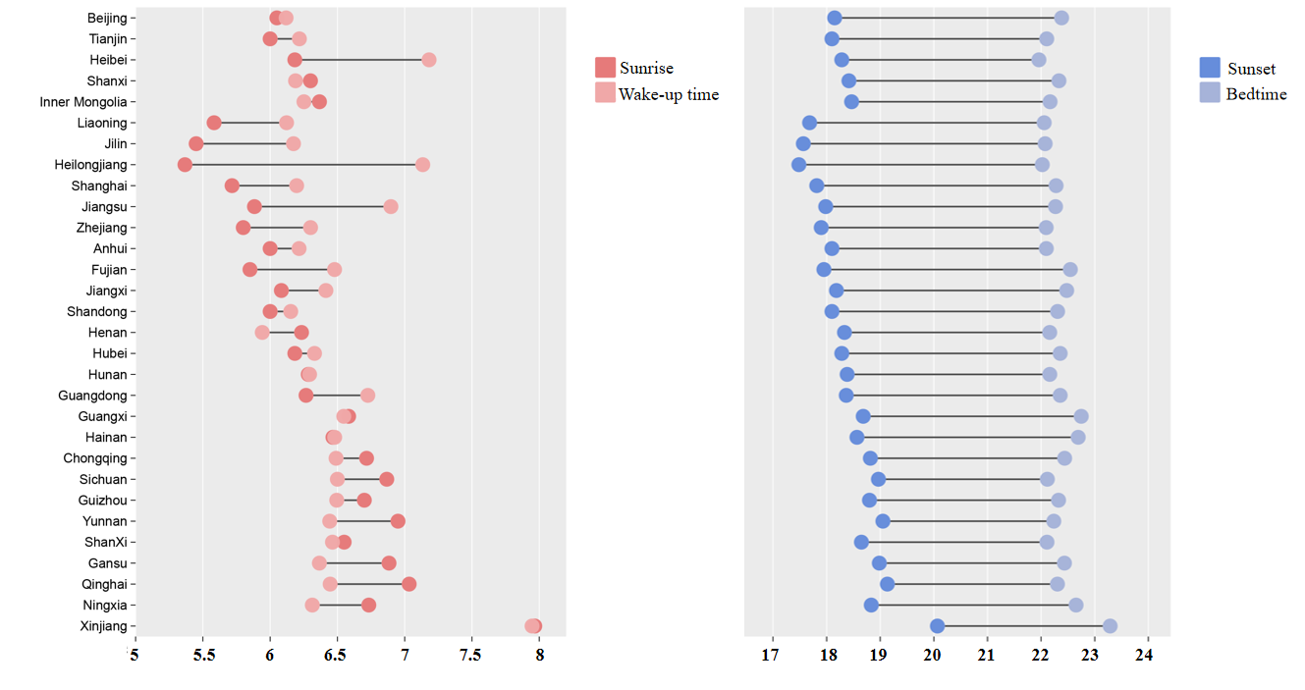
Fig. S1. The average sunrise and sunset time, wake-up times and bedtimes at all school stages in each province.

Fig. S2. Province-level associations between sleep midpoint, duration with SBP/DBP nationwide (P-values for non-linear was derived from a generalized additive model with a smooth term, using a likelihood ratio test for the non-linear component).

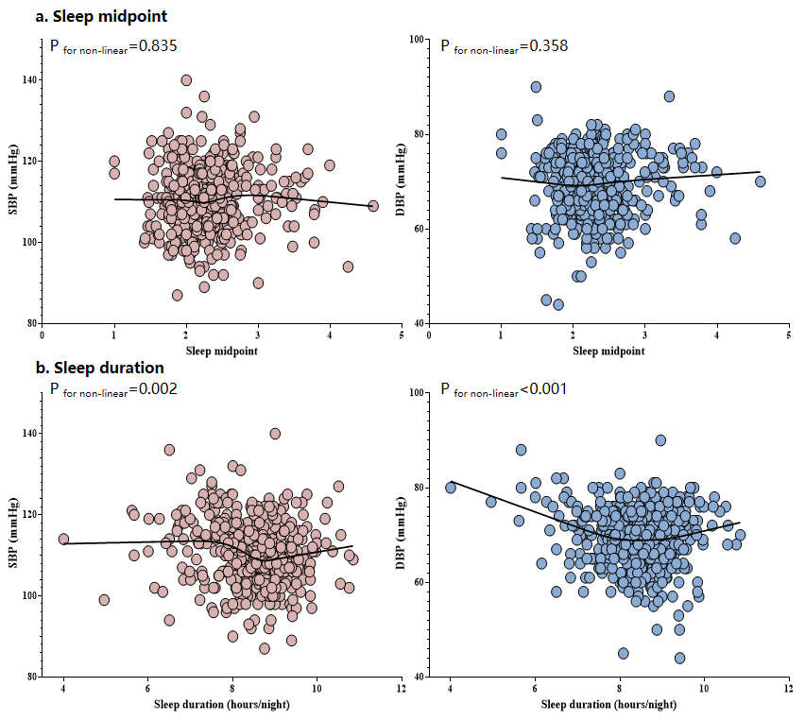
Fig. S3. School-level associations between sleep midpoint, duration with SBP/DBP at the level of 504 schools nationwide (P-values for non-linear was derived from a generalized additive model with a smooth term, using a likelihood ratio test for the non-linear component).

Fig. S4. School-level associations between sleep midpoint, duration with SBP/DBP at the level of 493 schools excluding schools from Xinjiang (P-values for non-linear was derived from a generalized additive model with a smooth term, using a likelihood ratio test for the non-linear component).

Fig. S5. School-level associations between sleep midpoint, duration with SBP/DBP at the level of schools nationwide excluding the potential influence of outliers, such as sleep midpoint>3.00, sleep duration< 7 hours/night, SBP>140 mmHg or SBP< 90 mmHg, or DBP> 80 mmHg or DBP< 45 mmHg (P-values for non-linear was derived from a generalized additive model with a smooth term, using a likelihood ratio test for the non-linear component).

Fig. S6. Quadratic linear associations between sleep midpoint, duration and SBP/DBP at the population level (statistical significance defined as the P-value for the quadratic term <0.05 for non-linear associations).

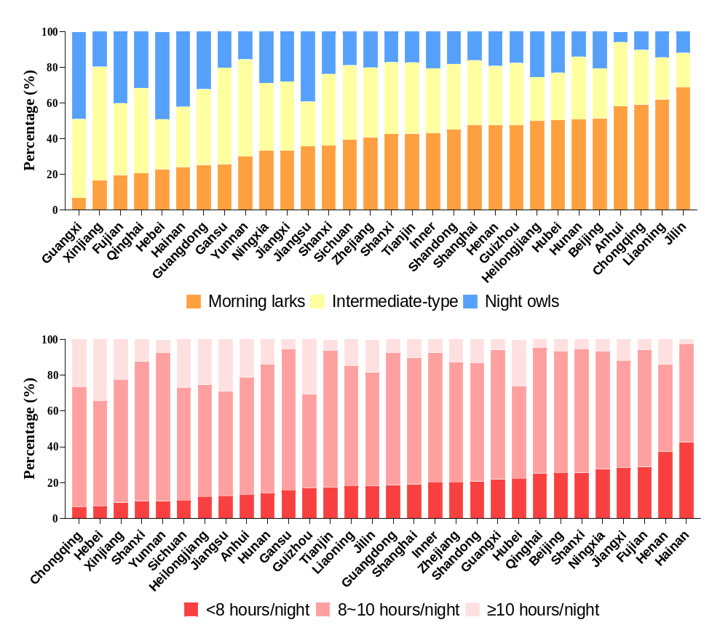Fig. S7. The distribution of sleep phenotype, sleep duration across China’s 30 provinces.

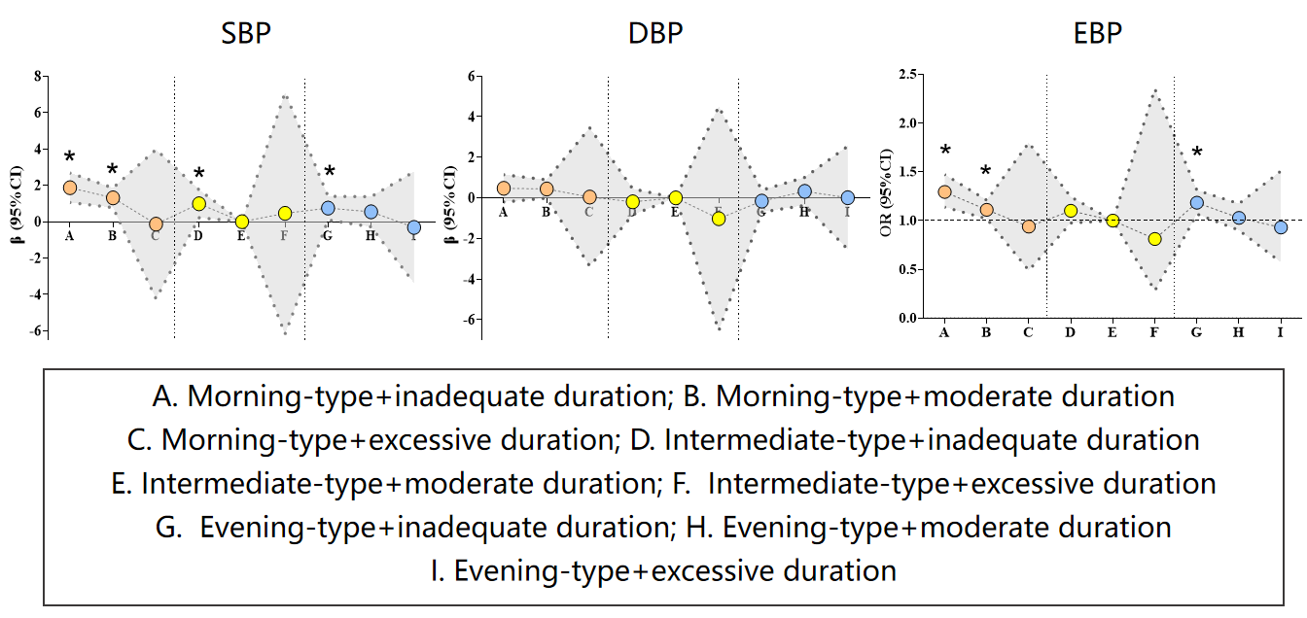
Fig. S8. Sensitivity ssociations of school-day sleep patterns with SBP/DBP levels using multivariable linear regression (β, 95% CI) and EBP using multivariable logistic regression (ORs, 95% CI) (Sleep duration of 8.5~11.5 hours/night ; *P<0.05).

