Table S1. Population demographics of Sabon Gari (intervention) and Doro (control) camps.
Camp  (Arm) | Type of HH | No. of HH | No. of individuals | Pregnant | Male  (<5 years) | Female (<5 years) | Male  (5-18 years) | Female  (5 -18 years) | Male  (>19 years) | Female (>19 years) |  | Data Source
Sabon Gari (Intervention) | Enrolled HH | 130 | 804 | 9 | 108 | 134 | 147 | 153 | 118 | 144 |  | MENTOR Initiative data
Sabon Gari (Intervention) | Overall HH | 172 | 1064 | 12 | 143 | 177 | 194 | 202 | 156 | 191 |  | *
Doro Camp (Control) | Enrolled HH | 130 | 700 | 17 | 82 | 100 | 101 | 123 | 132 | 162 |  | MENTOR Initiative data
Doro Camp (Control) | Overall HH | 398 | 2225 | 53 | 260 | 318 | 320 | 392 | 421 | 514 |  | DTM round 49 data
*In Sabon Gari 172 HH were available, which all received ATSB. According to DTM round 49, there are 95 shelters; however, most shelters are split into 2 families separated by a partition under 1 ceiling and are therefore considered to be separate households.

Material S1. Demographic, bioclimatic and ecological environmental variables, model selection and evaluation.

To explore environmental drivers of vector occurrence, we initially assembled 60 demographic, bioclimatic and ecological variables, derived from remote sensing data from Google Earth Engine, for Maiduguri, Borno State, Nigeria, in 2023 – 2024 (Supplementary Table 2). To avoid the inclusion of highly correlated predictor variables and introduction of multicollinearity into the models, pairwise Pearson’s correlation coefficients and variance inflation factors (VIF) were calculated; variables were excluded when Pearson’s correlation coefficients exceeded 0.90 and VIF exceeded 10, as these provided redundant information (Supplementary Figure 1). Next, several variables which were highly correlated were combined to form a final list of composite indices (Supplementary Table 3). The dataset was partitioned into training and test subsets using an 80/20 split stratified by An. gambiae s.l. count distribution. An. gambiae s.l. data were derived from this study in 2024 and a previous malaria clinical trial conducted by the MENTOR Initiative in Maiduguri during 2023.

To evaluate the suitability of different modelling approaches for predicting An. gambiae s.l. abundance, we implemented a comprehensive set of statistical and machine learning models, including traditional generalized linear models (GLMs; Poisson and Negative Binomial), tree-based ensemble methods (Random Forest and XGBoost), and hybrid ensemble models that combined predictions from XGBoost with those from GLM and Random Forest (Supplementary Table 4). Poisson regression was performed using statsmodel library v0.14.4 and the negative binomial model estimated the overdispersion parameter α via method-of-moments using the residuals from the Poisson model. We implemented a Random Forest Regressor using scikit-learn v1.6.1 and XGBoost model using xgboost v3.0.0. We then tuned the Random Forest model using RandomizedSearchCV with a wide grid covering n_estimators (100-300), max_depth (=20), min_samples_split (=5), min_samples_leaf, and different max_features strategies (including 0.5 and ‘log2’). The most promising model was the tuned XGBoost regressor. Following a comprehensive hyperparameter search (n_iter=30, 5-fold CV), the best model was selected with the following parameters: n_estimators=200, max_depth=7, learning_rate=0.005, subsample=0.7, colsample_bytree=0.9, gamma=1, reg_alpha=0.1, reg_lambda=1, and min_child_weight=10. Hybrid models combining XGBoost predictions with Poisson and Random Forest regressors in weighted ensembles (60% XGBoost, 40% other) were also tested.

Model performance was evaluated using a multi-metric framework. Predictive accuracy was assessed using mean absolute error (MAE) and root mean squared error (RMSE). Model fit was measured using Akaike Information Criterion (AIC) and Bayesian Information Criterion (BIC). To assess generalizability, we computed cross-validation RMSE (CV_RMSE) using 5-fold validation for tuned machine learning models. In addition, we measured classification performance using area under the receiver operating characteristic curve (ROC AUC) and the area under the precision-recall curve (PRC AUC), both of which were calculated using a binary threshold for vector presence. All analytical methods were run in an environment using Python v.3.11.11.

Table S2. Sixty demographic, bioclimatic and ecological remote sensing variables for initial multicollinearity analysis.
Variable Label | Variable Definition | Google Earth Engine Dataset
altitude | Elevation above sea level | SRTM / Copernicus DEM
dewpoint_temperature_2m | Average daily dewpoint at 2 meters | ERA5-Land
dewpoint_temperature_2m_max | Max daily dewpoint at 2 meters | ERA5-Land
dewpoint_temperature_2m_min | Min daily dewpoint at 2 meters | ERA5-Land
evaporation_from_bare_soil_sum | Daily evaporation from bare soil | ERA5-Land
leaf_area_index_high_vegetation | Leaf area index of tall vegetation | ERA5-Land
leaf_area_index_low_vegetation | Leaf area index of low vegetation | ERA5-Land
runoff_sum | Total daily surface runoff | ERA5-Land
skin_temperature | Temperature of the land surface | ERA5-Land
surface_sensible_heat_flux_sum | Sensible heat flux from land to air | ERA5-Land
surface_solar_radiation_downwards_sum | Total incoming solar radiation | ERA5-Land
temperature_2m | Average air temperature at 2 meters | ERA5-Land
temperature_2m_max | Max air temperature at 2 meters | ERA5-Land
temperature_2m_min | Min air temperature at 2 meters | ERA5-Land
total_precipitation_sum | Total daily precipitation | ERA5-Land
u_component_of_wind_10m | East-west wind at 10m | ERA5-Land
v_component_of_wind_10m | North-south wind at 10m | ERA5-Land
volumetric_soil_water_layer_1 | Top layer soil moisture content | ERA5-Land
pr | Daily precipitation rate | NEX-GDDP
tasmax | Daily maximum air temperature | NEX-GDDP
tasmin | Daily minimum air temperature | NEX-GDDP
EVI | Enhanced Vegetation Index | MODIS MOD13Q1
NDVI | Normalized Difference Vegetation Index | MODIS MOD13Q1
sur_refl_b01 | MODIS red band reflectance | MODIS MOD13Q1
sur_refl_b02 | MODIS near-infrared reflectance | MODIS MOD13Q1
sur_refl_b03 | MODIS blue reflectance | MODIS MOD13Q1
sur_refl_b07 | MODIS mid-infrared reflectance | MODIS MOD13Q1
veg_ratio | Ratio of vegetative cover | Derived from MODIS
NDVI_scaled | Normalized NDVI after scaling | Derived from MODIS
EVI_scaled | Normalized EVI after scaling | Derived from MODIS
NDVI_anomaly | Anomaly from mean NDVI | Derived from MODIS
NDVI_ma7 | 7-day moving average of NDVI | Derived from MODIS
sm_mean | Mean soil moisture (daily avg) | SMAP
veg_wc_avg | Mean vegetation water content | SMAP
sm_best | Best estimate of soil moisture | SMAP
veg_wc_best | Best estimate of vegetation water | SMAP
wet_soil_day | Presence of wet soil | Derived binary from SMAP/ERA5
moist_canopy_day | Presence of moist canopy | Derived binary from SMAP/ERA5
MODIS_FireMask | Daily fire detection mask | MODIS Fire (MCD14DL/VNP14A1)
MODIS_Fire_QA | MODIS fire quality assessment | MODIS Fire
modis_fire_detected | Binary flag for fire presence | Derived from MODIS Fire
DW_water | Probability of open water cover | Dynamic World
DW_flooded_vegetation | Probability of flooded vegetation | Dynamic World
DW_crops | Probability of cropland | Dynamic World
DW_shrub_and_scrub | Probability of shrub/scrub | Dynamic World
DW_grass | Probability of grassland | Dynamic World
DW_bare | Probability of bare soil | Dynamic World
DW_built | Probability of built-up area | Dynamic World
DW_trees | Probability of tree cover | Dynamic World
DW_label | Dominant land cover class | Dynamic World
ghsl_built_volume_total | Total built-up volume | GHSL P2023A
ghsl_built_volume_nres | Non-residential built volume | GHSL P2023A
GHSL_age_diff | Age difference in buildings | Derived from GHSL
landscan_pop_2023 | Population per km² | LandScan
HMI | Human Modification Index | Global Human Modification
temp_range | Difference between daily max and min temp | Derived from ERA5/NEX-GDDP
humidity_index | Composite index of moisture stress | Derived from ERA5
NDVI_EVI_interaction | Interaction term of NDVI and EVI | Derived from MODIS
NDVI_anomaly_sq | Squared NDVI anomaly | Derived from MODIS
flood_count_2000_2018 | Number of historical flood events | Global Flood Database
DSM: Digital Surface Model; ERA5-Land: European Centre for Medium-Range Weather Forecasts (ECMWF) Reanalysis v5-Land; GHSL: Global Human Settlement Layer; MODIS: The Terra Moderate Resolution Imaging Spectroradiometer; NEX-GDDP: NASA Earth Exchange Global Daily Downscaled Projections; SMAP: Soil Moisture Active Passive; SRTM: Shuttle Radar Topography Mission.

Fig. S1. Heatmap presenting pairwise Pearson’s correlation coefficients between remote sensing variables and Anopheles gambiae s.l. (both sexes, indoor and outdoor collections) count data.

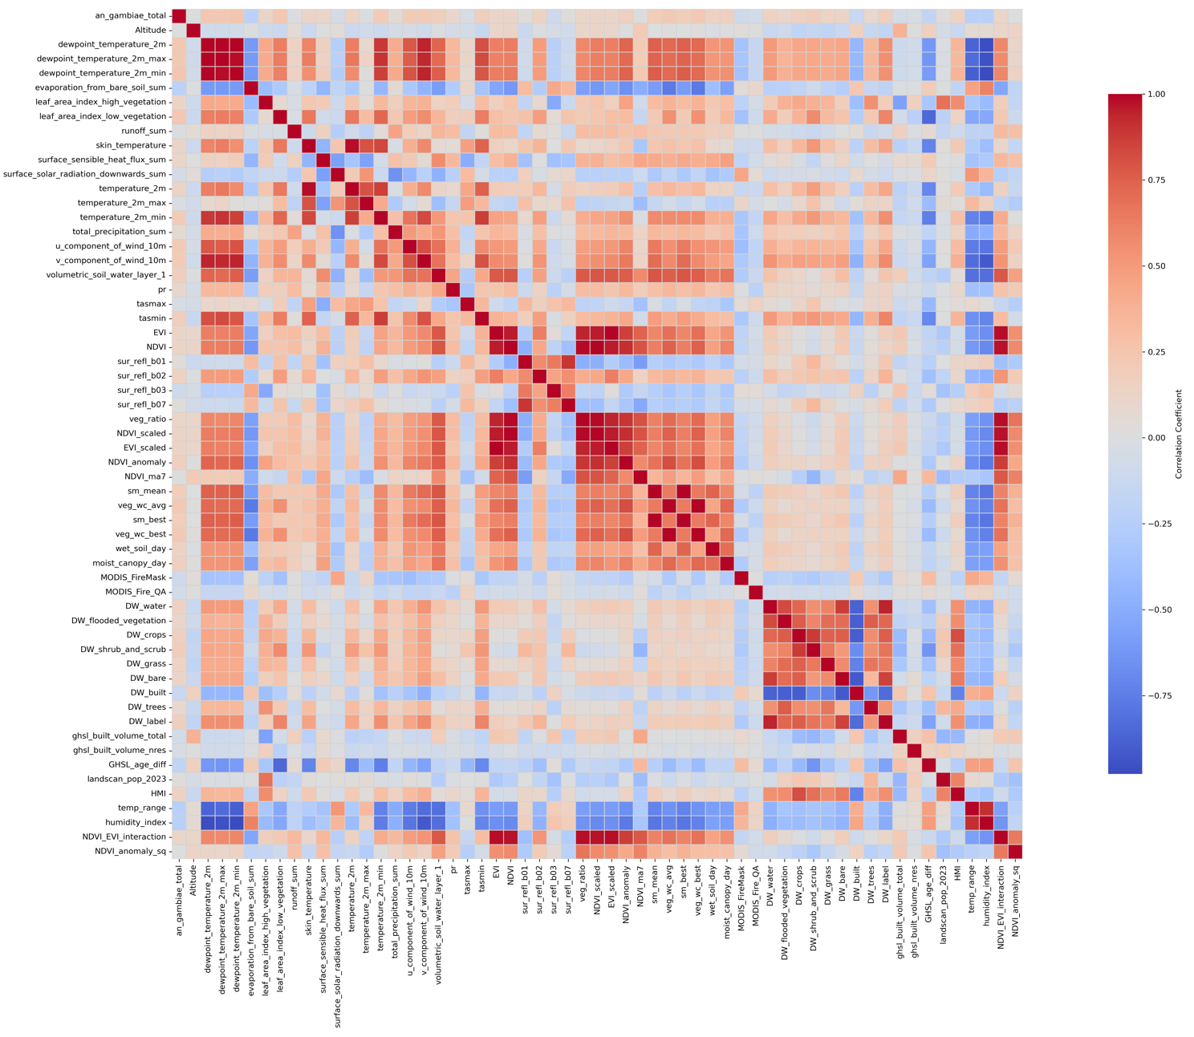

Table S3. Final list of composite remote sensing variables for supervised machine learning analysis.
Final Composite Variable | Type | Variables Used | Construction Method | VIF
NDVI_anomaly | Index | NDVI time series | Deviation from climatological baseline | 3.363
NDVI_interaction_resid | Residualized Index | NDVI × EVI interaction, residualized against NDVI | Linear residualization (NDVI regressed out) | 1.381
radiation_heat_index | Composite Index | Skin temperature, sensible heat flux, solar radiation | Standardized mean composite | 7.077
wind_stress_index | Combined Variable | u-component and v-component of wind | Euclidean norm (√(u² + v²)) | 8.364
landcover_diversity_index | Index | Land cover class proportions | Shannon Diversity Index or normalized entropy | 8.285
urbanization_index | Composite Index | Human Modification Index, population density, built volume | Standardized mean composite | 1.316
modis_reflectance_index | Spectral Composite Index | MODIS bands B01 (red), B02 (NIR), B03 (blue), B07 (MIR) | Standardized mean composite | 1.19
eco_component_1 | PCA Component | veg_wc_avg, sm_mean, veg_wc_best, sm_best, moist_canopy_day | PCA – 1st principal component | 3.917
eco_component_2 | PCA Component | veg_wc_avg, sm_mean, veg_wc_best, sm_best, moist_canopy_day | PCA – 2nd principal component | 1.132
dewpoint_residual | Residualized Variable | Dewpoint temperature residualized against surface temperature | Linear residualization (dewpoint regressed out) | 5.867
EVI: Enhanced Vegetation Index; MIR: Mid-Infrared; MODIS: The Terra Moderate Resolution Imaging Spectroradiometer; NDVI: Normalized Difference Vegetation Index; NIR: Near-Infrared; PCA: Principal Component Analysis; VIF: variance inflation factor.

Fig. S2. Heatmap presenting pairwise Pearson’s correlation coefficients between final composite remote sensing variables and Anopheles gambiae s.l. (both sexes, indoor and outdoor collections) count data.
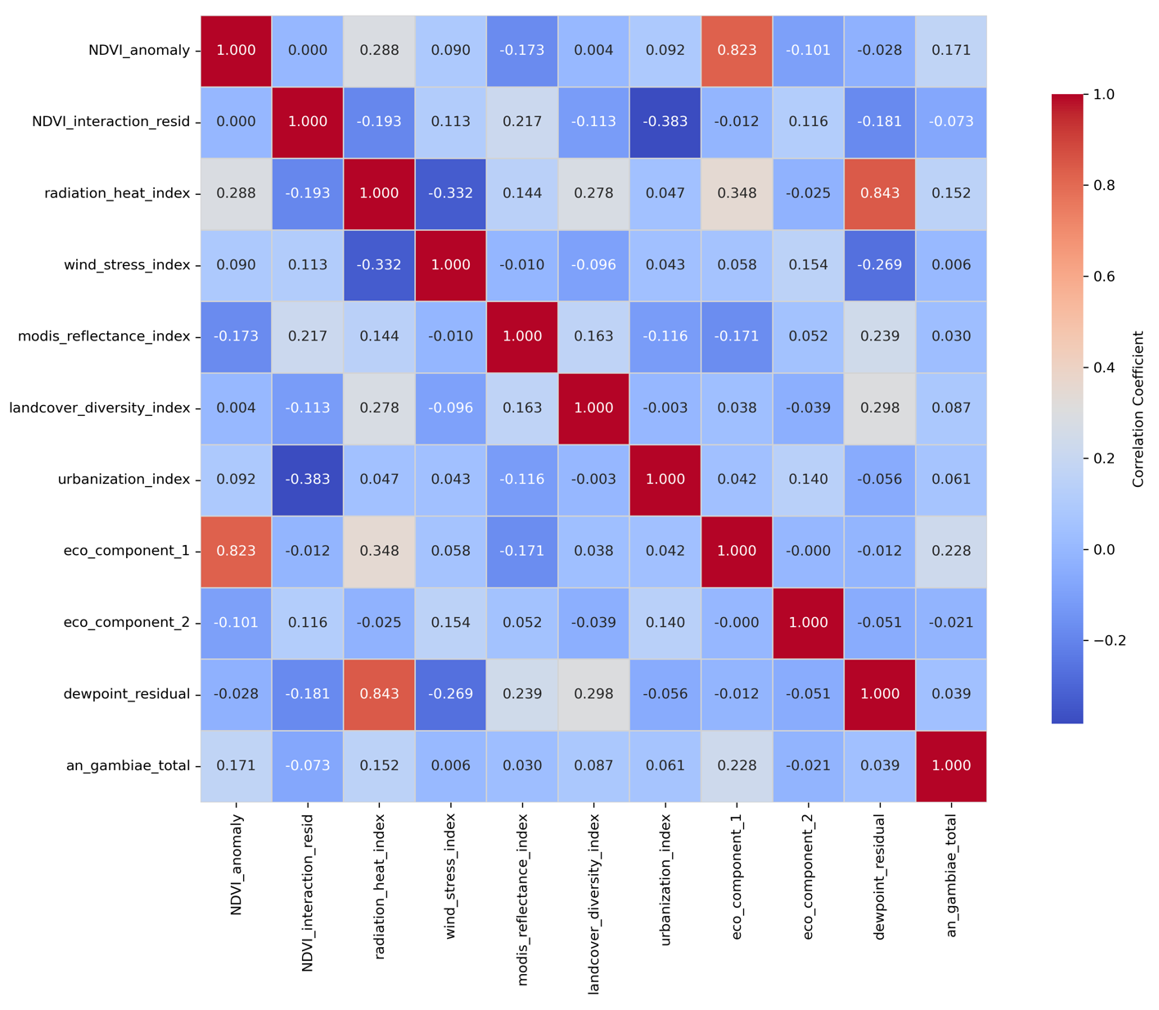

Table S4. Comparative machine learning performance of different regression models.
Model | MAE | RMSE | AIC | BIC | CV_RMSE | ROC AUC | PR AUC
Poisson | 29.892018 | 75.851523 | 6164.86445 | 6205.95183 | – | 0.794108 | 0.768864
Negative Binomial | 45.94237 | 251.000502 | 7864.14601 | 7905.2334 | – | – | –
Hybrid: XGB + NB | 38.43553 | 126.501279 | 6913.15844 | 7004.46374 | – | – | –
XGBoost | 35.706917 | 98.319061 | 6715.26944 | 7171.79593 | – | 0.821508 | 0.781239
Random Forest | 35.321383 | 96.091095 | 6682.72124 | 7139.24773 | – | 0.83783 | 0.789188
Hybrid: XGB + Poisson | 32.01133 | 81.459984 | 6288.15891 | 6379.46421 | – | 0.815533 | 0.772563
Hybrid: XGB + RF | 35.350918 | 96.885535 | 6534.41292 | 6625.71822 | – | 0.833291 | 0.787631
XGBoost (Tuned) | 31.78944 | 70.835148 | 6649.70455 | 8019.28404 | 86.011898 | 0.830181 | 0.784378
Random Forest (Tuned) | 32.667888 | 82.534886 | 6466.77391 | 6923.3004 | 83.81533 | 0.835783 | 0.77873
AIC: Akaike Information Criterion; AUC: Area Under the Curve; BIC: Bayesian Information Criterion; CV_RMSE: 5-Fold Cross-Validation Root Mean Squared Error; MAE: Mean Absolute Error; NB: Negative Binomial; PRC: Precision-Recall; RMSE: Root Mean Squared Error; RF: Random Forest; ROC: Receiver Operating Characteristic; XGB: XGBoost.

Fig. S3. Proportional contribution of composite remote sensing variables to the final selected model (XGBoost Tuned).

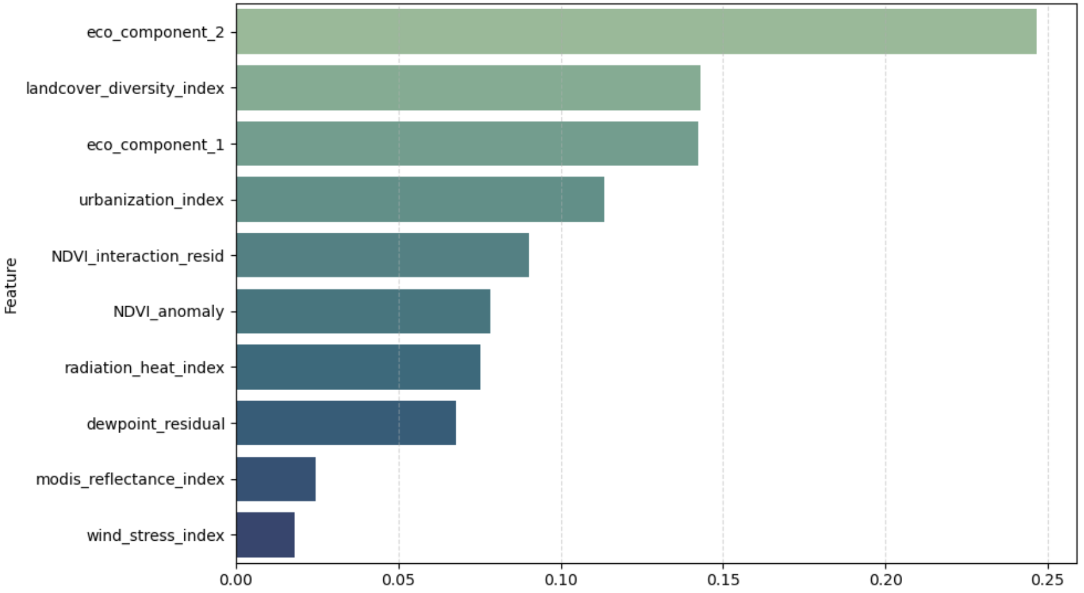

Fig. S4. Actual versus predicted Anopheles gambiae s.l. occurrence modelled using XGBoost (Tuned).
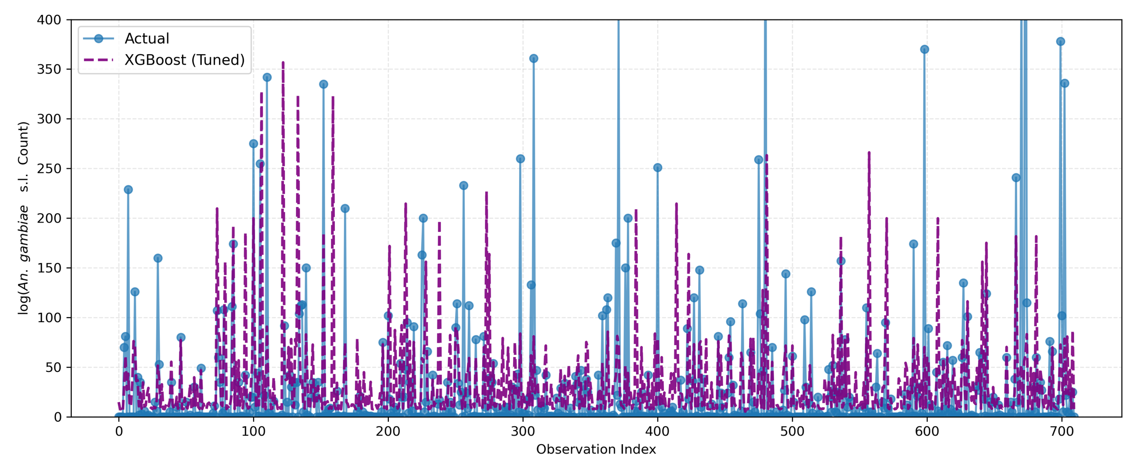

Table S5. Cross-validation of estimated protective efficacy of ATSB using Frequentist and Bayesian approaches across 6-months of follow-up in Northern Nigeria.
Vector Population | IRR [95% confidence intervals]^{c} | p-value | IRR [95% credible intervals]^{d,e}
Indoorª female An. gambiae s.l. (all physiological status) | 0.140 [0.093 – 0.212] | <0.0001 | 0.200 [0.145 – 0.278]
Indoorª An. gambiae s.l. (both sexes) | 0.141 [0.094 – 0.210] | <0.0001 | 0.195 [0.137 – 0.278]
All^{b} household An. gambiae s.l. | 0.140 [0.0949 – 0.206] | <0.0001 | 0.192 [0.127 – 0.290]
Indoorª female Culex (all physiological status) | 0.844 [0.627 – 1.136] | 0.263 | 0.856 [0.694 – 1.190]
Indoorª Culex (both sexes) | 0.873 [0.659 – 1.156] | 0.343 | 0.951 [0.746 – 1.198]
All^{b} household Culex | 0.884 [0.677 – 1.156] | 0.368 | 0.960 [0.772 – 1.158]
ªIndoor vector populations refer to individuals collected in both CDC-LTs and by indoor Prokopack aspirators. ^{b}All household vector populations refer to An. gambiae s.l. collected in CDC-LTs and by both indoor and outdoor Prokopack aspirators. ^{c}IRR reported from mixed effects negative binomial regression, with a fixed interaction between study arm and timepoint, a random intercept for household to account for repeated measures and robust standard errors to accommodate clustering. ^{d}IRR reported from Bayesian negative binomial regression models, with a fixed interaction between study arm and timepoint, a random intercept for household to account for repeated measures. ^{e}Credible intervals which do not include 1 are considered statistically significant.

Table S6. Household entomological indices for larval surveys in Northern Nigeria.
Time Point | Intervention Camp |  |  | Control Camp
Time Point | CI | HI | BI | CI | HI | BI
Baseline | 1.8 | 2.3 | 2.3 | 1.1 | 1.5 | 1.5
Month 1 | 11.9 | 14.6 | 15.4 | 5.5 | 6.2 | 7.7
Month 2 | 10.1 | 11.5 | 13.1 | 26.9 | 33.1 | 37.7
Month 3 | 12.4 | 15.4 | 16.2 | 11.0 | 15.4 | 15.4
Month 4 | 16.7 | 20.8 | 21.5 | 20.6 | 26.2 | 28.5
Month 5 | 8.3 | 10.0 | 10.8 | 26.2 | 29.2 | 33.1
Month 6 | 4.8 | 5.4 | 6.2 | 23.3 | 23.1 | 23.8
CI: Container Index; HI: Household Index; BI: Breteau Index. CI = containers positive for larvae*100 / containers inspected; HI = houses positive for larvae*100 / houses inspected; and BI = containers positive for larvae*100 / houses inspected.

Table S7. Household entomological indices for pupal surveys in Northern Nigeria.
Time Point | Intervention Camp |  |  | Control Camp
Time Point | CI | HI | BI | CI | HI | BI
Baseline | 0.6 | 0.8 | 0.8 | 1 | 1.5 | 1.5
Month 1 | 1.2 | 1.5 | 1.5 | 4 | 4.6 | 6.2
Month 2 | 4.1 | 5.4 | 5.4 | 12 | 16.2 | 16.2
Month 3 | 7.1 | 9.2 | 9.2 | 5 | 6.9 | 6.9
Month 4 | 7.1 | 9.2 | 9.2 | 4.4 | 6.2 | 6.2
Month 5 | 3.6 | 4.6 | 4.6 | 7 | 7.7 | 8.5
Month 6 | 3.6 | 4.6 | 4.6 | 9 | 9.2 | 9.2
CI: Container Index; HI: Household Index; BI: Breteau Index. CI = containers positive for pupae*100 / containers inspected; HI = houses positive for pupae*100 / houses inspected; and BI = containers positive for pupae*100 / houses inspected.

Table S8. Baseline household characteristics of Sabon Gari (intervention) and Doro (control) camps.
 | Variable | Intervention Camp | Control Camp | Overall Frequency | χ² | p-valueª
Household | Number of HH Surveyed | 134 (42.40%) | 182 (57.60%) | 316 (100.00%)
Age | Mean age of respondent (SD) | 39.9 (± 13.50) | 38.3 (±14.17) | 39.0 (±13.89) | 54.06 | 0.10
Sex | Proportion of female respondents | 97.80% | 91.20% | 94.0% | 5.86 | 0.015
House Wall Construction | Plastic sheeting (tent / tarpaulin) | 114 (36.08%) | 137 (43.35%) | 251 (79.43%) | 4.54 | 0.033
House Wall Construction | Bricks | 19 (14.18%) | 2 (1.10%) | 21 (6.65%) | 21.24 | <0.0001
House Wall Construction | Concrete | 0 | 1 (0.55%) | 1 (0.32%) | - | -
House Wall Construction | Metal | 0 | 3 (1.65%) | 3 (0.95%) | - | -
House Wall Construction | Mud | 0 | 33 (18.13%) | 33 (10.44%) | 27.13 | <0.0001
House Wall Construction | Thatch | 0 | 3 (1.65%) | 3 (0.95%) | - | -
House Wall Construction | Wood | 1 (0.75%) | 3 (1.65%) | 3 (0.95%) | - | -
House Windows | Number of windows
House Windows | 0 | 5 (3.73%) | 34 (18.68%) | 39 (12.34%) | 15.94 | <0.0001
House Windows | 1 | 49 (36.57%) | 58 (31.87%) | 107 (33.86%) | 0.76 | 0.383
House Windows | 2 | 41 (30.60%) | 81 (44.51%) | 122 (38.61%) | 6.30 | 0.012
House Windows | 3 | 30 (22.39%) | 9 (4.95%) | 39 (12.34%) | 21.71 | <0.0001
House Windows | 4 | 9 (6.72%) | 0 | 9 (2.85%) | 12.58 | <0.0001
House Windows | Net covered windows | 36 (26.87%) | 60 (32.97%) | 96 (30.38%) | 1.36 | 0.244
House Windows | Open windows | 93 (69.40%) | 88 (48.35%) | 181 (57.28%) | 13.98 | <0.0001
Fuel | Charcoal | 65 (48.51%) | 121 (66.48%) | 186 (58.86%) | 10.299 | 0.001
Fuel | Firewood | 69 (51.49%) | 61 (33.52%) | 130 (41.14%) | 10.299 | 0.001
Floor Condition | Proportion with damp | 123 (91.79%) | 139 (76.37%) | 262 (82.91%) | 12.95 | <0.0001
Water Storage | Proportion with water storage containers in sleeping room | 57 (42.54%) | 73 (40.11%) | 130 (41.14%) | 0.19 | 0.665
Toilets | Proportion with indoor toilet | 26 (19.40%) | 91 (50.00%) | 117 (37.03%) | 30.99 | <0.0001
Toilets | Proportion using temporary outdoor toilet | 130 (97.01%) | 136 (74.73%) | 266 (84.18%) | 28.79 | <0.0001
Toilets | Proportion practicing open defecation | 0 | 34 (18.68%) | 34 (10.76%) | 28.05 | <0.0001
Waste Disposal | Waste collection available | 132 (98.51%) | 78 (42.86%) | 210 (66.46%) | 107.22 | <0.0001
Waste Disposal | Store outside the household | 0 | 67 (36.81%) | 67 (21.20%) | 62.60 | <0.0001
Waste Disposal | Throw in hole | 0 | 17 (9.34%) | 17 (5.38%) | 13.23 | <0.0001
Waste Disposal | Burning | 2 (1.49%) | 13 (7.14%) | 15 (4.75%) | 5.45 | 0.020
Waste Disposal | Keep inside the household | 0 | 7 (3.85%) | 7 (2.22%) | - | 0.020
Animal Husbandry | None | 130 (97.01%) | 105 (57.69%) | 235 (74.37%) | 62.60 | <0.0001
Animal Husbandry | Poultry | 0 | 33 (18.13%) | 33 (10.44%) | 31.80 | <0.0001
Animal Husbandry | Goats | 1 (0.75%) | 9 (4.95%) | 10 (3.16%) | 8.24 | 0.004
Animal Husbandry | Sheep | 2 (1.49%) | 0 | 2 (0.63%) | - | -
Animal Husbandry | Cows | 0 | 2 (1.10%) | 2 (0.63%) | - | -
Animal Husbandry | Dogs / Cats | 1 (0.75%) | 18 (9.89%) | 19 (6.01%) | 11.42 | 0.001
Animal Husbandry | Rodents (mice / rats / rabbits) | 0 | 10 (5.49%) | 10 (3.16%) | 7.60 | 0.006
Animal Husbandry | Poultry + Goats | 0 | 3 (1.65%) | 3 (0.95%) | - | -
Animal Husbandry | Poultry + Goats + Sheep | 0 | 1 (0.55%) | 1 (0.32%) | - | -
Animal Husbandry | Donkeys / Horses /Mules | 0 | 0 | 0 | - | -
Drinking Water Access | Borehole | 134 (100%) | 182 (100%) | 316 (100%) | - | -
Drinking Water Access | How long does it take to fetch water?
Drinking Water Access | Minute(s) | 133 (99.25%) | 119 (65.38%) | 252 (79.75%) | 57.55 | <0.0001
Drinking Water Access | Hour(s) | 0 | 63 (34.62%) | 63 (19.94%) | 57.55 | <0.0001
Drinking Water Access | How often do you fetch water?
Drinking Water Access | Several time a day | 32 (23.88%) | 91 (50.00%) | 123 (38.92%) | 22.15 | <0.0001
Drinking Water Access | Once everyday | 41 (30.60%) | 71 (39.01%) | 112 (35.44%) | 2.39 | 0.122
Drinking Water Access | Every 4 + days | 39 (29.10%) | 7 (3.85%) | 46 (14.56%) | 39.59 | <0.0001
Drinking Water Access | Every 2 days | 12 (8.96%) | 9 (4.95%) | 21 (6.65%) | 2.00 | 0.157
Drinking Water Access | Every 3 days | 10 (7.46%) | 4 (2.20%) | 14 (4.43%) | 5.05 | 0.025
Vector Control | Insecticide-treated nets | 99 (73.88%) | 124 (68.13%) | 223 (70.57%) | 11.57 | 0.001
Vector Control | Mosquito coil | 17 (12.69%) | 12 (6.59%) | 29 (9.18%) | 15.93 | <0.0001
Vector Control | Insecticide-treated nets + Mosquito coil | 17 (12.69%) | 4 (2.20%) | 21 (6.65%) | 32.74 | <0.0001
Vector Control | IRS | 0 | 11 (6.04%) | 11 (3.48%) | 8.39 | 0.004
Vector Control | Topical repellent | 1 (0.75%) | 0 | 4 (1.27%) | - | -
Vector Control | No vector control | 1 (0.75%) | 27 (14.84%) | 28 (8.86%) | 18.97 | <0.0001
Insecticide-treated nets | Proportion with insecticide-treated nets | 102 (76.12%) | 153 (84.07%) | 255 (80.70%) | 3.13 | 0.077
Insecticide-treated nets | Insecticide-treated net age
Insecticide-treated nets | Week(s) | 2 (1.49%) | 3 (1.65%) | 5 (1.58%) | 0.012 | 0.913
Insecticide-treated nets | Month(s) | 8 (5.97%) | 45 (24.73%) | 53 (16.77%) | 19.45 | <0.0001
Insecticide-treated nets | Year(s) | 92 (68.66%) | 105 (57.69%) | 197 (62.34%) | 3.95 | 0.047
Insecticide-treated nets | Proportion currently using an insecticide-treated net | 101 (75.37%) | 153 (84.07%) | 254 (80.38%) | 1.51 | 0.220
Insecticide-treated nets | Slept under an ITN last night
Insecticide-treated nets | All household members | 93 (69.40%) | 124 (68.13%) | 217 (68.67%) | 0.058 | 0.810
Insecticide-treated nets | Only the adults (>18 years) | 1 (0.75%) | 10 (5.49%) | 11 (3.48%) | 1.97 | 0.160
Insecticide-treated nets | Only the children (>18 years) | 8 (5.97%) | 19 (10.44%) | 27 (8.54%) | 5.18 | 0.023
Insecticide-treated nets | Insecticide-treated net source
Insecticide-treated nets | Mass distribution (e.g. National Malaria Control Program, NGO) | 49 (36.57%) | 52 (28.57%) | 101 (31.96%) | 5.05 | 0.025
Insecticide-treated nets | Antenatal clinic visit | 11 (8.21%) | 15 (8.24%) | 26 (8.23%) | 0.064 | 0.80
Insecticide-treated nets | Bought it myself in the pharmacy | 0 | 4 (2.20%) | 4 (1.27%) | - | 0.152
Insecticide-treated nets | Bought it myself in the shop / market | 36 (26.87%) | 64 (35.16%) | 100 (31.65%) | 1.10 | 0.295
Insecticide-treated nets | Healthcare facility | 6 (4.48%) | 16 (8.79%) | 22 (6.96%) | 1.63 | 0.202
Insecticide-treated nets | Immunization visit | 0 | 4 (2.20%) | 4 (1.27%) | - | 0.152
Insecticide-treated nets | Mass distribution (e.g. National Malaria Control Program, NGO) + Bought it myself in the shop / market | 0 | 2 (1.10%) | 2 (0.63%) | - | -
Insecticide-treated nets | Alternative uses for insecticide-treated net
Insecticide-treated nets | Only sleeping under | 100 (74.63%) | 126 (69.23%) | 226 (71.52%) | 14.94 | <0.0001
Insecticide-treated nets | Fence | 2 (1.49%) | 10 (5.49%) | 12 (3.80%) | 2.86 | 0.091
Insecticide-treated nets | Construction material | 0 | 3 (1.65%) | 3 (0.95%) | - | -
Insecticide-treated nets | Constructing bed / chairs | 0 | 10 (5.49%) | 10 (3.16%) | 6.94 | 0.008
Insecticide-treated nets | Bathing sponge | 0 | 2 (1.10%) | 2 (0.63%) | - | -
Insecticide-treated nets | Clothing | 0 | 1 (0.55%) | 1 (0.32%) | - | -
Insecticide-treated nets | Rope | 0 | 1 (0.55%) | 1 (0.32%) | - | -
ªTo account for multiple testing, p-values were adjusted using Bonferroni correction by dividing the alpha level (0.05) by the number of comparisons per variable. Statistically significant comparisons are shown in bold.

Table S9. Total Anopheles gambiae s.l. collected in the intervention arm, disaggregated by location, sampling method, sex and physiological status.
Timepoint | CDC LT |  |  |  |  |  | Indoor Aspiration |  |  |  |  |  | Outdoor Aspiration |  |  |  |  |  | Total  Indoors | Total Outdoors
Timepoint | M | Total F | UF | BF | G | M+F Total | M | TotalF | UF | BF | G | M+F Total | M | Total F | UF | BF | G | M+F Total | Total  Indoors | Total Outdoors
Baseline | 73 | 3395 | 1815 | 1523 | 57 | 3468 | 55 | 130 | 25 | 104 | 1 | 185 | 22 | 31 | 9 | 22 | 0 | 53 | 3653 | 53
Round 1 | 62 | 5548 | 5405 | 142 | 1 | 5610 | 97 | 165 | 98 | 67 | 0 | 262 | 27 | 37 | 24 | 12 | 1 | 64 | 5872 | 64
Round 2 | 17 | 425 | 399 | 25 | 1 | 442 | 25 | 77 | 64 | 13 | 0 | 102 | 15 | 15 | 10 | 5 | 0 | 30 | 544 | 30
Round 3 | 0 | 8 | 8 | 0 | 0 | 8 | 1 | 0 | 0 | 0 | 0 | 1 | 1 | 0 | 0 | 0 | 0 | 1 | 9 | 1
Round 4 | 0 | 7 | 7 | 0 | 0 | 7 | 0 | 0 | 0 | 0 | 0 | 0 | 0 | 0 | 0 | 0 | 0 | 0 | 7 | 0
Round 5 | 0 | 11 | 11 | 0 | 0 | 11 | 1 | 1 | 1 | 0 | 0 | 2 | 0 | 0 | 0 | 0 | 0 | 0 | 13 | 0
Round 6 | 1 | 11 | 11 | 0 | 0 | 12 | 0 | 0 | 0 | 0 | 0 | 0 | 0 | 1 | 1 | 0 | 0 | 1 | 12 | 1
Total |  |  |  |  |  |  |  |  |  |  |  |  |  |  |  |  |  |  | 10110 | 149

Table S10. Total Anopheles gambiae s.l. collected in the control arm, disaggregated by location, sampling method, sex and physiological status.
Timepoint | CDC LT |  |  |  |  |  | Indoor Aspiration |  |  |  |  |  | Outdoor Aspiration |  |  |  |  |  | Total  Indoors | Total Outdoors
Timepoint | M | Total F | UF | BF | G | M+F Total | M | TotalF | UF | BF | G | M+F Total | M | Total F | UF | BF | G | M+F Total | Total  Indoors | Total Outdoors
Baseline | 41 | 1621 | 894 | 712 | 15 | 1662 | 13 | 58 | 6 | 52 | 0 | 71 | 11 | 30 | 11 | 19 | 0 | 41 | 1733 | 41
Round 1 | 327 | 4137 | 237 | 3674 | 226 | 4464 | 42 | 532 | 3 | 517 | 12 | 574 | 18 | 82 | 21 | 61 | 0 | 100 | 5038 | 100
Round 2 | 21 | 996 | 74 | 922 | 0 | 1017 | 9 | 95 | 13 | 82 | 0 | 104 | 6 | 44 | 11 | 33 | 0 | 50 | 1121 | 50
Round 3 | 6 | 28 | 0 | 28 | 0 | 34 | 0 | 4 | 0 | 4 | 0 | 4 | 4 | 4 | 0 | 4 | 0 | 8 | 38 | 8
Round 4 | 0 | 24 | 6 | 18 | 0 | 24 | 0 | 1 | 0 | 1 | 0 | 1 | 0 | 0 | 0 | 0 | 0 | 0 | 25 | 0
Round 5 | 0 | 52 | 26 | 26 | 0 | 52 | 2 | 1 | 0 | 1 | 0 | 3 | 0 | 3 | 0 | 3 | 0 | 3 | 55 | 3
Round 6 | 6 | 122 | 41 | 80 | 1 | 128 | 5 | 11 | 5 | 6 | 0 | 16 | 1 | 4 | 0 | 4 | 0 | 5 | 144 | 5
Total |  |  |  |  |  |  |  |  |  |  |  |  |  |  |  |  |  |  | 8154 | 207

Table S11. Total Aedes spp. collected in the intervention arm, disaggregated by location, sampling method, sex and physiological status.
Timepoint | CDC LT |  |  |  |  |  | Indoor Aspiration |  |  |  |  |  | Outdoor Aspiration |  |  |  |  |  | Total  Indoors | Total Outdoors
Timepoint | M | Total F | UF | BF | G | M+F Total | M | TotalF | UF | BF | G | M+F Total | M | Total F | UF | BF | G | M+F Total | Total  Indoors | Total Outdoors
Baseline | 0 | 10 | 6 | 3 | 1 | 10 | 1 | 2 | 0 | 2 | 0 | 3 | 3 | 1 | 0 | 1 | 0 | 4 | 13 | 4
Round 1 | 4 | 8 | 6 | 2 | 0 | 12 | 10 | 6 | 6 | 0 | 0 | 16 | 5 | 4 | 4 | 0 | 0 | 9 | 28 | 9
Round 2 | 3 | 10 | 10 | 0 | 0 | 13 | 5 | 12 | 11 | 1 | 0 | 17 | 5 | 8 | 8 | 0 | 0 | 13 | 30 | 13
Round 3 | 0 | 2 | 2 | 0 | 0 | 2 | 0 | 3 | 3 | 0 | 0 | 3 | 0 | 0 | 0 | 0 | 0 | 0 | 5 | 0
Round 4 | 0 | 0 | 0 | 0 | 0 | 0 | 1 | 6 | 6 | 0 | 0 | 7 | 0 | 0 | 0 | 0 | 0 | 0 | 7 | 0
Round 5 | 0 | 1 | 1 | 0 | 0 | 1 | 3 | 5 | 5 | 0 | 0 | 8 | 2 | 2 | 2 | 0 | 0 | 4 | 9 | 4
Round 6 | 0 | 1 | 1 | 0 | 0 | 1 | 0 | 3 | 3 | 0 | 0 | 3 | 0 | 1 | 1 | 0 | 0 | 1 | 4 | 1
Total |  |  |  |  |  |  |  |  |  |  |  |  |  |  |  |  |  |  | 96 | 31

Table S12. Total Aedes spp. collected in the control arm, disaggregated by location, sampling method, sex and physiological status.
Timepoint | CDC LT |  |  |  |  |  | Indoor Aspiration |  |  |  |  |  | Outdoor Aspiration |  |  |  |  |  | Total  Indoors | Total Outdoors
Timepoint | M | Total F | UF | BF | G | M+F Total | M | TotalF | UF | BF | G | M+F Total | M | Total F | UF | BF | G | M+F Total | Total  Indoors | Total Outdoors
Baseline | 1 | 29 | 9 | 20 | 0 | 30 | 25 | 45 | 18 | 27 | 0 | 70 | 46 | 27 | 22 | 5 | 0 | 73 | 100 | 73
Round 1 | 26 | 46 | 4 | 42 | 0 | 72 | 25 | 52 | 0 | 52 | 0 | 77 | 21 | 10 | 2 | 8 | 0 | 31 | 149 | 31
Round 2 | 1 | 38 | 4 | 34 | 0 | 39 | 26 | 183 | 0 | 183 | 0 | 209 | 20 | 157 | 1 | 156 | 0 | 177 | 248 | 177
Round 3 | 1 | 68 | 0 | 68 | 0 | 69 | 6 | 4 | 0 | 4 | 0 | 10 | 7 | 16 | 0 | 16 | 0 | 23 | 79 | 23
Round 4 | 0 | 31 | 0 | 31 | 0 | 31 | 1 | 2 | 0 | 2 | 0 | 3 | 0 | 6 | 0 | 6 | 0 | 6 | 34 | 6
Round 5 | 8 | 55 | 36 | 16 | 3 | 63 | 0 | 2 | 1 | 0 | 1 | 2 | 0 | 9 | 3 | 3 | 3 | 9 | 65 | 9
Round 6 | 2 | 61 | 18 | 43 | 0 | 63 | 0 | 0 | 0 | 0 | 0 | 0 | 0 | 5 | 0 | 5 | 0 | 5 | 63 | 5
Total |  |  |  |  |  |  |  |  |  |  |  |  |  |  |  |  |  |  | 738 | 324

Table S13. Total Aedes aegypti collected in the intervention arm, disaggregated by location, sampling method, sex and physiological status.
Timepoint | CDC LT |  |  |  |  |  | Indoor Aspiration |  |  |  |  |  | Outdoor Aspiration |  |  |  |  |  | Total  Indoors | Total Outdoors
Timepoint | M | Total F | UF | BF | G | M+F Total | M | TotalF | UF | BF | G | M+F Total | M | Total F | UF | BF | G | M+F Total | Total  Indoors | Total Outdoors
Baseline | 0 | 10 | 6 | 3 | 1 | 10 | 1 | 2 | 0 | 2 | 0 | 3 | 3 | 1 | 0 | 1 | 0 | 4 | 13 | 4
Round 1 | 4 | 8 | 6 | 2 | 0 | 12 | 10 | 6 | 6 | 0 | 0 | 16 | 5 | 4 | 4 | 0 | 0 | 9 | 28 | 9
Round 2 | 3 | 10 | 10 | 0 | 0 | 13 | 5 | 12 | 11 | 1 | 0 | 17 | 5 | 8 | 8 | 0 | 0 | 13 | 30 | 13
Round 3 | 0 | 0 | 0 | 0 | 0 | 0 | 0 | 3 | 3 | 0 | 0 | 3 | 0 | 0 | 0 | 0 | 0 | 0 | 3 | 0
Round 4 | 0 | 0 | 0 | 0 | 0 | 0 | 1 | 6 | 6 | 0 | 0 | 7 | 0 | 0 | 0 | 0 | 0 | 0 | 7 | 0
Round 5 | 0 | 0 | 0 | 0 | 0 | 0 | 3 | 4 | 4 | 0 | 0 | 7 | 2 | 2 | 2 | 0 | 0 | 4 | 7 | 4
Round 6 | 0 | 1 | 1 | 0 | 0 | 1 | 0 | 3 | 3 | 0 | 0 | 3 | 0 | 1 | 1 | 0 | 0 | 1 | 4 | 1
Total |  |  |  |  |  |  |  |  |  |  |  |  |  |  |  |  |  |  | 92 | 31

Table S14. Total Aedes aegypti collected in the control arm, disaggregated by location, sampling method, sex and physiological status.
Timepoint | CDC LT |  |  |  |  |  | Indoor Aspiration |  |  |  |  |  | Outdoor Aspiration |  |  |  |  |  | Total  Indoors | Total Outdoors
Timepoint | M | Total F | UF | BF | G | M+F Total | M | TotalF | UF | BF | G | M+F Total | M | Total F | UF | BF | G | M+F Total | Total  Indoors | Total Outdoors
Baseline | 1 | 29 | 9 | 20 | 0 | 30 | 25 | 45 | 18 | 27 | 0 | 70 | 46 | 27 | 22 | 5 | 0 | 73 | 100 | 73
Round 1 | 26 | 46 | 4 | 42 | 0 | 72 | 25 | 52 | 0 | 52 | 0 | 77 | 21 | 10 | 2 | 8 | 0 | 31 | 149 | 31
Round 2 | 1 | 38 | 4 | 34 | 0 | 39 | 26 | 183 | 0 | 183 | 0 | 209 | 20 | 157 | 1 | 156 | 0 | 177 | 248 | 177
Round 3 | 0 | 2 | 0 | 2 | 0 | 2 | 6 | 2 | 0 | 2 | 0 | 8 | 5 | 4 | 0 | 4 | 0 | 9 | 10 | 9
Round 4 | 0 | 0 | 0 | 0 | 0 | 0 | 1 | 1 | 0 | 1 | 0 | 2 | 0 | 1 | 0 | 1 | 0 | 1 | 2 | 1
Round 5 | 0 | 0 | 0 | 0 | 0 | 0 | 0 | 0 | 0 | 0 | 0 | 0 | 0 | 0 | 0 | 0 | 0 | 0 | 0 | 0
Round 6 | 0 | 0 | 0 | 0 | 0 | 0 | 0 | 0 | 0 | 0 | 0 | 0 | 0 | 0 | 0 | 0 | 0 | 0 | 0 | 0
Total |  |  |  |  |  |  |  |  |  |  |  |  |  |  |  |  |  |  | 509 | 291

Table S15. Total Culex spp. collected in the intervention arm, disaggregated by location, sampling method, sex and physiological status.
Timepoint | CDC LT |  |  |  |  |  | Indoor Aspiration |  |  |  |  |  | Outdoor Aspiration |  |  |  |  |  | Total  Indoors | Total Outdoors
Timepoint | M | Total F | UF | BF | G | M+F Total | M | TotalF | UF | BF | G | M+F Total | M | Total F | UF | BF | G | M+F Total | Total  Indoors | Total Outdoors
Baseline | 1336 | 24087 | 23330 | 529 | 228 | 25423 | 867 | 1240 | 436 | 683 | 121 | 2107 | 379 | 317 | 141 | 137 | 39 | 696 | 27530 | 696
Round 1 | 741 | 16202 | 15638 | 378 | 186 | 16943 | 507 | 976 | 766 | 138 | 72 | 1438 | 272 | 2922 | 2795 | 75 | 52 | 3194 | 18381 | 3194
Round 2 | 714 | 22764 | 22224 | 434 | 106 | 23478 | 446 | 1494 | 952 | 339 | 203 | 1940 | 424 | 858 | 490 | 287 | 81 | 1282 | 25418 | 1282
Round 3 | 699 | 6619 | 6455 | 141 | 23 | 7318 | 778 | 828 | 420 | 314 | 94 | 1606 | 359 | 480 | 236 | 200 | 44 | 839 | 8924 | 839
Round 4 | 468 | 9152 | 8818 | 270 | 64 | 9620 | 439 | 765 | 460 | 249 | 56 | 1204 | 206 | 359 | 194 | 143 | 22 | 565 | 10824 | 565
Round 5 | 585 | 11772 | 11136 | 530 | 106 | 12357 | 564 | 906 | 481 | 332 | 93 | 1470 | 266 | 481 | 226 | 212 | 43 | 747 | 13827 | 747
Round 6 | 245 | 5808 | 5549 | 214 | 45 | 6053 | 455 | 753 | 405 | 278 | 70 | 1208 | 204 | 523 | 240 | 241 | 42 | 727 | 7261 | 727
Total |  |  |  |  |  |  |  |  |  |  |  |  |  |  |  |  |  |  | 112165 | 8050

Table S16. Total Culex spp. collected in the control arm, disaggregated by location, sampling method, sex and physiological status.
Timepoint | CDC LT |  |  |  |  |  | Indoor Aspiration |  |  |  |  |  | Outdoor Aspiration |  |  |  |  |  | Total  Indoors | Total Outdoors
Timepoint | M | Total F | UF | BF | G | M+F Total | M | TotalF | UF | BF | G | M+F Total | M | Total F | UF | BF | G | M+F Total | Total  Indoors | Total Outdoors
Baseline | 1850 | 18775 | 18023 | 587 | 165 | 20625 | 698 | 807 | 448 | 315 | 44 | 1505 | 643 | 527 | 402 | 104 | 21 | 1170 | 22130 | 1170
Round 1 | 470 | 22720 | 22176 | 290 | 254 | 23190 | 352 | 664 | 402 | 243 | 19 | 1016 | 191 | 634 | 506 | 108 | 20 | 825 | 24206 | 825
Round 2 | 478 | 10553 | 10270 | 193 | 90 | 11031 | 676 | 1132 | 755 | 292 | 85 | 1808 | 707 | 1547 | 1288 | 122 | 137 | 2254 | 12839 | 2254
Round 3 | 165 | 4587 | 4461 | 120 | 6 | 4752 | 317 | 542 | 296 | 180 | 66 | 859 | 175 | 317 | 207 | 75 | 35 | 492 | 5611 | 492
Round 4 | 584 | 6539 | 6390 | 136 | 13 | 7123 | 367 | 569 | 318 | 227 | 24 | 936 | 595 | 540 | 416 | 77 | 47 | 1135 | 8059 | 1135
Round 5 | 1176 | 9834 | 9600 | 209 | 25 | 11010 | 1286 | 1096 | 463 | 512 | 121 | 2382 | 582 | 460 | 255 | 158 | 47 | 1042 | 13392 | 1042
Round 6 | 496 | 8765 | 8587 | 157 | 21 | 9261 | 939 | 896 | 409 | 363 | 124 | 1835 | 511 | 416 | 165 | 206 | 45 | 927 | 11096 | 927
Total |  |  |  |  |  |  |  |  |  |  |  |  |  |  |  |  |  |  | 97333 | 7845

Material S2. Vector molecular species identification.

A total of 138 female Anopheles samples were assayed; 81 and 57 from control and intervention arms, respectively. The dominant species was An. coluzzii, representing 77% (n=106) of the total collection, with similar relative frequencies in each study arm. Other samples identified morphologically as An. gambiae s.l. included An. arabiensis (n=2), An. funestus s.s. (n=1), An. pharoensis (n=1). No samples identified morphologically as An. funestus were verified by molecular identification, with all identified to species as An. coluzzii (n=19). Five samples, three morphologically identified as An. gambiae and two as An. funestus did not produce robust genotyping results but were successfully sequenced and identified as An. gambiae s.l. (the sequenced fragments did not allow discrimination to species with the complex).

All of the samples suspected to be An. kingi were identified by sequencing as An. coustani (n=18) or An. squamosus (n=1). Whilst there are no NCBI GenBank entries available for An. kingi, high percentage identity (>99%) to the two species identified provided confident results. It should be noted that neither COI nor ITS2 sequences provide resolution within the An. coustani group (Ciubotariu et al. 2020), therefore, An. coustani here could be one of the alternative species with the group (An. paludis, An. ziemanni, An. tenebrosus). Four of the 138 samples gave no genotyping result or PCR amplicon, and thus their identity could not be verified.

Table S17. Summary of vector molecular species identification disaggregated by field trial arm.
Species Identity | Control | % of Total | Intervention | % of Total
Anopheles coluzzii | 63 | 77.8 | 43 | 75.4
Anopheles arabiensis | 0 | 0.0 | 2 | 3.5
Anopheles gambiae s.s. | 2 | 2.5 | 3 | 5.3
Anopheles funestus s.s. | 0 | 0.0 | 1 | 1.8
Anopheles coustani | 14 | 17.3 | 4 | 7.0
Anopheles squamosus | 1 | 1.2 | 0 | 0.0
Anopheles pharoensis | 0 | 0.0 | 1 | 1.8
unidentified | 1 | 1.2 | 3 | 5.3
Total | 81 |  | 57

Table S18. Protective efficacy of ATSB against wild Aedes spp. populations in Northern Nigeria across 6-months of follow-up.
Vector Population | IRR [95% CI] | Protective Efficacy [95% CI]^{i} | p-value
Indoorª female Aedes^{b} (all physiological status) | 0.621 [0.257 – 1.502]^{f} | 37.9% [-50.2% – 74.3%] | 0.291
Indoorª Aedes^{b} (both sexes) | 0.870 [0.386 – 1.963]^{f} | 13.0% [-96.3% – 61.4%] | 0.737
Indoorª blood-fed Ae. aegypti^{c} | 0.0746 [0.00884 – 0.502]^{g,h} | 92.54% [49.80% – 99.12%] | –
Outdoor Aedes^{d} | 0.0041 [0.0012 – 0.014]^{f} | 99.59% [98.6% – 99.88%] | <0.0001
All^{e} household Aedes^{b} | 1.091 [0.521 – 2.284]^{f} | -9.1% [-128.4% – 47.9%] | 0.818
ªIndoor vector populations refer to Aedes collected in both CDC-LTs and by indoor Prokopack aspirators. ^{b}Due to sparse / zero Ae. aegypti counts during later field trial months, these analyses included an additional 266 adult Aedes which were unable to be identified to species-level (233 indoors and 33 outdoors). ^{c}Due to sparse / zero Ae. aegypti counts during later field trial months, this analysis was restricted to the baseline and the first 2 months post-intervention, after which almost complete population suppression was achieved. ^{d}Due to sparse / zero Aedes spp. counts during later field trial months, this analysis was restricted to the baseline and the first 2 months post-intervention, after which almost complete population suppression was achieved. ^{e}All household vector populations refer to Aedes collected in CDC-LTs and by both indoor and outdoor Prokopack aspirators.^{f}IRR reported from mixed effects negative binomial regression, with a fixed interaction between study arm and timepoint, a random intercept for household to account for repeated measures and robust standard errors to accommodate clustering. ^{g}IRR reported from Bayesian negative binomial regression models, with a fixed interaction between study arm and timepoint, a random intercept for household to account for repeated measures. ^{h}Credible intervals which do not include 1 are considered statistically significant. ^{i}PE = protective efficacy ((1-IRR)*100).

Table S19. Protective efficacy of ATSB against wild Culex spp. populations in Northern Nigeria across 6-months of follow-up.
Vector Population | IRR [95% CI]^{c} | Protective Efficacy [95% CI]^{d} | p-value
Indoorª female Culex (all physiological status) | 0.844 [0.627 – 1.136] | 15.59% [-13.56% – 37.26%] | 0.263
Indoorª Culex (both sexes) | 0.873 [0.659 – 1.156] | 12.72% [-15.61% – 34.11%] | 0.343
Indoorª blood-fed Culex | 0.923 [0.675 – 1.262] | 7.68% [-26.19% – 32.46%] | 0.616
Outdoor female Culex (all physiological status) | 1.500 [0.878 – 2.563] | -49.98% [-156.27% – 12.22%] | 0.138
Outdoor Culex (both sexes) | 1.452 [0.837 – 2.521] | -45.22% [-152.08% – 16.34%] | 0.185
Outdoor blood-fed Culex | 0.870 [0.510 – 1.486] | 12.97% [-48.65% – 49.05%] | 0.611
All^{b} household Culex | 0.884 [0.677 – 1.156] | 11.60% [-56.0% – 32.30%] | 0.368
ªIndoor vector populations refer to Culex spp. collected in both CDC-LTs and by indoor Prokopack aspirators. ^{b}All household vector populations refer to Culex spp. collected in CDC-LTs and by both indoor and outdoor Prokopack aspirators. ^{c}IRR reported from mixed effects negative binomial regression, with a fixed interaction between study arm and timepoint, a random intercept for household to account for repeated measures and robust standard errors. ^{d}PE = protective efficacy ((1-IRR)*100).

Table S20. Changes in vector density pre-post-intervention in Northern Nigeria in the intervention arm.
Vector Population | IRR [95% CI] | p-value
Indoorª female An. gambiae s.l. (all physiological status) | 0.0150 [0.0108 – 0.0208]^{h} | <0.0001
Indoorª An. gambiae s.l. (both sexes) | 0.0155 [0.0112 – 0.0213]^{h} | <0.0001
Indoorª blood-fed An. gambiae s.l. | 0.0257 [0.0146 – 0.0403]^{h} | -
Outdoor An. gambiae s.l. | 0.0000594 [0.0000313 – 0.000113]^{i} | <0.0001
All^{b} household An. gambiae s.l. | 0.0160 [0.0117 – 0.0218]^{h} | <0.0001
Indoor^{c} female Aedes^{d} (all physiological status) | 0.541 [0.285 – 1.028]^{h} | 0.061
Indoor^{c} Aedes^{d} (both sexes) | 0.751 [0.388 – 1.451]^{h} | 0.393
Indoor^{c} blood-fed Ae. aegypti | 0.364 [0.462 – 1.270]^{h} | -
Outdoor Aedes | 0.00179 [0.000587 – 0.00547]^{i} | <0.0001
All^{e} household Aedes | 0.712 [0.390 – 1.298]^{h} | 0.268
Indoor^{f} female Culex (all physiological status) | 0.463 [0.392 – 0.548]^{h} | <0.0001
Indoor^{f} Culex (both sexes) | 0.471 [0.401 – 0.552]^{h} | <0.0001
Indoor^{f} blood-fed Culex | 0.493 [0.402 – 0.604]^{h} | <0.0001
Outdoor female Culex (all physiological status) | 1.813 [1.268 – 2.592]^{h} | 0.001
Outdoor Culex (both sexes) | 1.372 [0.955 – 1.973]^{h} | 0.088
Outdoor blood-fed Culex | 0.808 [0.593 – 1.101]^{h} | 0.177
All^{g} household Culex | 0.498 [0.425 – 0.584]^{h} | <0.0001
ªIndoor vector populations refer to An. gambiae s.l. collected in both CDC-LTs and by indoor Prokopack aspirators. ^{b}All household vector populations refer to An. gambiae s.l. collected in CDC-LTs and by both indoor and outdoor Prokopack aspirators. ^{c}Indoor vector populations refer to Aedes collected in both CDC-LTs and by indoor Prokopack aspirators. ^{d}Due to sparse / zero Ae. aegypti counts during later field trial months, these analyses included an additional 266 adult Aedes which were unable to be identified to species-level (233 indoors and 33 outdoors). ^{e}All household vector populations refer to Aedes collected in CDC-LTs and by both indoor and outdoor Prokopack aspirators. ^{f}Indoor vector populations refer to Culex spp. collected in both CDC-LTs and by indoor Prokopack aspirators. ^{g}All household vector populations refer to Culex spp. collected in CDC-LTs and by both indoor and outdoor Prokopack aspirators. ^{h}Within-arm pre-post effects were estimated for the intervention arm as IRR_{t}=exp(γ_{t}+δ_{t}) (time main effect plus the armxtime interaction at time t). Summary pre-post effect per arm was calculated as the geometric mean IRR and CIs were derived via the delta method using linear combinations of coefficients. ^{i}Credible intervals which do not include 1 are considered statistically significant.

Table S21. Changes in vector density pre-post-intervention in Northern Nigeria in the control arm.
Vector Population | IRR [95% CI] | p-value
Indoorª female An. gambiae s.l. (all physiological status) | 0.107 [0.0808 – 0.141]^{h} | <0.0001
Indoorª An. gambiae s.l. (both sexes) | 0.110 [0.0833 – 0.146]^{h} | <0.0001
Indoorª blood-fed An. gambiae s.l. | 1.186 [0.717 – 1.874]^{h} | -
Outdoor An. gambiae s.l. | 0.00676 [0.00369 – 0.0124]^{i} | <0.0001
All^{b} household An. gambiae s.l. | 0.114 [0.0869 – 0.150]^{h} | <0.0001
Indoor^{c} female Aedes^{d} (all physiological status) | 0.000286 [0.000113 – 0.000723]^{i} | <0.0001
Indoor^{c} Aedes^{d} (both sexes) | 0.863 [0.554 – 1.344]^{h} | 0.514
Indoor^{c} blood-fed Ae. aegypti | 3.657 [2.024 – 6.141]^{h} | -
Outdoor Aedes | 0.295 [0.161 – 0.540]^{h} | <0.0001
All^{e} household Aedes | 0.652 [0.421 – 1.011]^{h} | 0.056
Indoor^{f} female Culex (all physiological status) | 0.549 [0.429 – 0.702]^{h} | <0.0001
Indoor^{f} Culex (both sexes) | 0.539 [0.428 – 0.679]^{h} | <0.0001
Indoor^{f} blood-fed Culex | 0.528 [0.421 – 0.662]^{h} | <0.0001
Outdoor female Culex (all physiological status) | 1.209 [0.835 – 1.749]^{h} | 0.314
Outdoor Culex (both sexes) | 0.945 [0.644 – 1.387]^{h} | 0.772
Outdoor blood-fed Culex | 0.928 [0.621 – 1.388]^{h} | 0.717
All^{g} household Culex | 0.563 [0.452 – 0.702]^{h} | <0.0001
ªIndoor vector populations refer to An. gambiae s.l. collected in both CDC-LTs and by indoor Prokopack aspirators. ^{b}All household vector populations refer to An. gambiae s.l. collected in CDC-LTs and by both indoor and outdoor Prokopack aspirators. ^{c}Indoor vector populations refer to Aedes collected in both CDC-LTs and by indoor Prokopack aspirators. ^{d}Due to sparse / zero Ae. aegypti counts during later field trial months, these analyses included an additional 266 adult Aedes which were unable to be identified to species-level (233 indoors and 33 outdoors). ^{e}All household vector populations refer to Aedes collected in CDC-LTs and by both indoor and outdoor Prokopack aspirators. ^{f}Indoor vector populations refer to Culex spp. collected in both CDC-LTs and by indoor Prokopack aspirators. ^{g}All household vector populations refer to Culex spp. collected in CDC-LTs and by both indoor and outdoor Prokopack aspirators. ^{h}Within-arm pre-post effects were estimated for the control arm, as IRR_{t}=exp(γ_{t}) (the time main effect at time t). Summary pre-post effect per arm was calculated as the geometric mean IRR and CIs were derived via the delta method using linear combinations of coefficients. ^{i}Credible intervals which do not include 1 are considered statistically significant.

Table S22. Protective efficacy of ATSB against wild immature vector populations in Northern Nigeria across 6-months of follow-up.
Follow-Up | Vector Population
Follow-Up | Larvae | Pupae | Pooled
Follow-Up | aOR [95% credible intervals]^{a,b} | aOR [95% credible intervals] ^{a,b} | aOR [95% credible intervals] ^{a,b}
Month 1 | 0.618 [0.561 – 5.739] | 0.539 [0.183 – 1.485] | 1.772 [0.270 – 4.052]
Month 2 | 0.154 [0.076 – 0.315] | 0.472 [0.296 – 0.720] | 0.196 [0.117 – 0.334]
Month 3 | 0.708 [0.336 – 1.497] | 2.330 [0.951 – 5.844] | 0.425 [0.155 – 2.233]
Month 4 | 0.570 [0.250 – 1.424] | 2.541 [0.782 – 5.351] | 0.570 [0.273 – 3.140]
Month 5 | 0.193 [0.069 – 0.588] | 1.856 [0.864 – 4.113] | 0.209 [0.086 – 0.487]
Month 6 | 0.116 [0.037 – 0.391] | 0.810 [0.277 – 2.254] | 0.133 [0.084 – 0.205]
ªaOR reported from Bayesian multilevel logistic regression models, with a fixed interaction between study arm and timepoint, a random intercept for household to account for repeated measures. ^{b}Credible intervals which do not include 1 are considered statistically significant.

Table S23. Focus Group Discussion (FGD) quotations regrading aspects of ATSB acceptability and feasibility at 6-months post-intervention.
Theme | Quotation | FGD Participant
Perceived Entomological Impact | “We were at first not comfortable with it, but after some time, we noticed a drastic decrease in diseases that were caused by mosquitoes. It really helped us.” | R1 Female, Sabon Gari, March 2025
Perceived Entomological Impact | “Most of our children are having malaria before the devices were placed, but there is a significant decrease in rate now. We are glad to have this device placed in our household, we are really happy about it.” | R2 Female, Sabon Gari, March 2025
Perceived Entomological Impact | “The first time it was stationed, we couldn't see the effect immediately, and we thought it was not effective, but as time goes on, we began to notice the effects of this device, the effectiveness of the device then became visible to us, we really appreciate that.” | R2 Male, Sabon Gari, March 2025
Perceived Entomological Impact | “Yes, we really appreciate the effect of this devices, before the devices were placed, there are high chances you would acquire a disease after mosquito bites, but what I have noticed now is, even after mosquito bites, we tend not to come up with diseases, unlike before.” | R1 Male, Sabon Gari, March 2025
Perceived Entomological Impact | “We are glad to have it. This has significantly reduced mosquitoes, and we are grateful for that.” | R1 Female, Sabon Gari, March 2025
Perceived Entomological Impact | “Before the devices were placed, everyone knows the high level of mosquitoes that are present in this area, but now, there is a drastic drop in the level of mosquitoes and their bites, this is more than enough reason why we should want these devices to remain in our houses.” | R1 Male, Sabon Gari, March 2025
Perceived Entomological Impact | “The difference is crystal clear, before the devices were placed, we encounter many issues, from bites to diseases, you can't even sit down in this place if it was before, you need to get a hand fan that you will be using to drive the mosquitoes away, otherwise, they will bite you.” | R1 Male, Sabon Gari, March 2025
ATSB Installation | “No, we were all present when they were placing the devices all over, no one encountered any problem, had it been there were complaints, we will definitely know about them, so basically, no complaints.” | R1 Male, Sabon Gari, March 2025
ATSB Installation | “No comments, everything is rightly placed, but we would want it to be two placed inside the room and two on the outside.” | R1 Female, Sabon Gari, March 2025
Perceived Side Effects | “I: Did you face any reaction as a result of the presence of this device, like itchy eyes, skin irritation, and so on? R1: No, because to date, no one has experienced anything like this. We have no problem with it.” | R1 Male, Sabon Gari, March 2025
Intervention Acceptability | “We can only rate it to be excellent because the device is extremely good.” | R1 Male, Sabon Gari, March 2025
Intervention Acceptability | “It is very strong and effective, it's very effective.” | R1 Male, Sabon Gari, March 2025
Willingness To Use and Pay | “Since you are about to leave, we will be glad if you could tell us where we can purchase these devices.” | R3 Female, Sabon Gari, March 2025
Willingness To Use and Pay | “The effectiveness of this devices significantly supersedes that of the other means, I use to buy mosquito coils every day, but since these devices were placed, I no longer buy mosquito coils, mosquito coils can cause sneezing, but this device has no smoke, so it won't cause sneezing.” | R1 Male, Sabon Gari, March 2025
Willingness To Use and Pay | “Yes, we will make good use of it, the only reason we had issues accepting it at first was because we don't know its usefulness, now we know it uses, we make use of the device instead of buying mosquito coils, which could even make we and our children to have cough. We now know it's uses, I will never stop by to purchase this device if it was before, but now, I would stop to get it where ever I see it, we really appreciate this device, there is a decrease in malaria, if it was last year this time, people would have been on their way to hospital, some hospitalised, some will even be fainting before they get to hospital, but this year, we thank God, people are not hospitalised, we are really grateful.” | R1 Female, Sabon Gari, March 2025
Willingness To Use and Pay | “Its effectiveness, we have seen the level of effectiveness of this device, we will even purchase it with our money. There is a very low incidence of malaria, too.” | R2 Male, Sabon Gari, March 2025
Willingness To Use and Pay | “You know, this thing is just like when fertilizers were first introduced to us, many of us rejected it, but as time goes on, we began to accept it gradually, and now, we are using our own money to purchase it, so this is how the acceptability of this device is going to evolve.” | R2 Male, Sabon Gari, March 2025
Willingness To Use and Pay | “Of course, yes, once it is affordable to us, we will definitely purchase it.” | R1 Female, Sabon Gari, March 2025

Table S24. ATSB acceptability at 6-months post-intervention.
Variable | Response (%)
Still using the ATSB | 169 (100.00)
How many ATSB are present in the shelter?  3 | 169 (100.00)
Are ATSB stations placed correctly (1 indoor, 2 outdoors)?  Yes  No | 168 (99.40)  1 (0.59)
How easy did you find ATSB to use?  Very easy, absolutely no problems  Easy, one or two problems | 168 (99.41)  1 (0.59)
What would make ATSB easier to use?  Fine as is  Clearer instructions | 130 (76.92)  39 (23.08)
What is the purpose of ATSB?  It is a mosquito killer  It is a mosquito repellent | 168 (99.41)  1 (0.59
How happy are you with ATSB?  Very happy  Happy  Okay | 83 (49.11)  81 (47.93)  5 (2.96)
What did you like about ATSB?  Protects me and my family from disease  Decreases the number of mosquitoes and other insects  Protects me and my family + decreases the number of mosquitoes and other insects  Protects me and my family + decreases the number of mosquitoes and other insects + Easy to use  Decreases the number of mosquitoes and other insects + Easy to use  Decreases the number of mosquitoes and other insects + Pleasant smell | 60 (35.50)  50 (29.6)  50 (29.6)  5 (2.96)  3 (1.78)  1 (0.59)
What did you not like about ATSB?  I like it as is  Was not effective at keeping mosquitoes out of the house | 130 (76.92)  39 (23.08)
How did you feel about the number of ATSB stations placed in your home?  The right amount  Too few  Too many | 149 (88.17)  18 (10.65)  2 (1.18)
How did you like the appearance of ATSB in your home?  It was okay  I did not like it  I liked it very much | 161 (95.27)  5 (2.96)  3 (1.78)
What would be your preferred colour for the ATSB?  The colour is okay as is  Brown  Yellow | 167 (98.82)  1 (0.59)  1 (0.59)
Did you or anyone living in this household feel any discomfort since the ATSB was installed?  No, no issues | 169 (100.00)
Did the ATSB retain its effectiveness (killed mosquitoes) since it was first installed?  Yes, it seemed effective since it was first installed  Yes, but effectiveness decreased with time | 100 (59.17)  69 (40.83)
What effect did ATSB have on the number of insects in the room with ATSB?  ATSB decreased the number of insects  ATSB increased the number of insects | 168 (99.41)  1 (0.59)
What effect did ATSB have on the number of insect bites you or your family had?  ATSB decreased the number of insect bites  ATSB increased the number of insect bites | 164 (97.04)  5 (2.96)
Is ATSB more effective against mosquitoes than bed nets?  ATSB is better  ATSB is worse  Same  Don’t know | 120 (71.01)  31 (18.34)  17 (10.06)  1 (0.59)
Is ATSB more effective against mosquitoes than burning incense?  ATSB is better  ATSB is worse  Same  Don’t know | 152 (89.94)  4 (2.37)  11 (6.51)  2 (1.18)
Is ATSB more effective against mosquitoes than room sprays like Pif Paf?  ATSB is better  ATSB is worse  Same  Don’t know | 131 (77.51)  9 (5.33)  17 (10.06)  12 (7.10)
Is ATSB more effective against mosquitoes than topical repellents?  ATSB is better  ATSB is worse  Same  Don’t know | 125 (73.96)  3 (1.78)  10 (5.92)  31 (18.34)
Is ATSB more effective against mosquitoes than no vector control?  ATSB is better  ATSB is worse | 168 (99.41)  1 (0.59)
Since you have had ATSB in your house, how often do you use other products to protect yourself and your family from insect bites?  Less often than before we had ATSB installed  More often than before we had ATSB installed  No difference | 134 (79.29)  27 (15.98)  8 (4.73)
If you have been using the same or more products – which other products have you used?  Bed nets  Bed nets + Topical repellent  Topical Repellent | 27 (77.14)  7 (20.00)  1 (2.86)
Have you changed the location of the ATSB from the place where it was first installed?  No, it is in the same place | 169 (100.00)
Would you be willing to use ATSB again?  Yes  No | 168 (99.41)  1 (0.59)
If yes, why?  Protects me and my family from insects / disease  Decreases the number of mosquitoes  Protects me and my family from insects / disease + Decreases the number of mosquitoes  Decreases the number of mosquitoes + Easy to use  Protects me and my family from insects / diseases + Decreases the number of mosquitoes + Easy to use  Protects me and my family from insects / disease + Easy to use | 48 (28.57)  46 (27.38)  42 (25.00)  18 (10.71)  13 (7.74)  1 (0.60)
If no, why?  Other – bed net is more preferable | 1 (100.00)
What would make you more likely to use ATSB in the future?  ATSB for a longer duration (e.g. efficacy)  More numbers of ATSB outdoors and indoors  ATSB for a longer duration (e.g. efficacy) + More numbers of ATSB outdoors and indoors  More numbers of ATSB outdoors and indoors + Provision of installation material  More numbers of ATSB outdoors and indoors + Design with different installation options + Provision of installation material  Less numbers of ATSB outdoors and indoors  Changing the appearance of ATSB (e.g. colour, size)  Other | 102 (60.36)  29 (17.16)  22 (13.02)  3 (1.78)  3 (1.78)  2 (1.18)  2 (1.18)  6 (3.55)
Would you recommend ATSB to friends and family?  Yes | 169 (100.00)
Would you be willing to purchase ATSB for your home if available in the local market?  Yes | 169 (100.00)
Where would be the easiest outlet to get ATSB?  Local shop / provision shop  Healthcare facility  Healthcare facility + Local shop / provision shop  Local shop / provision shop + Local government area  Pharmacy + Healthcare facility + Local shop / provision shop  Local shop / provision shop + Pharmacy  Local shop / provision shop + Local government area + Pharmacy  Local shop / provision shop + Supermarket  Supermarket  Supermarket + Pharmacy  Pharmacy | 122 (72.19)  25 (14.79)  9 (5.33)  4 (2.37)  2 (1.18)  2 (1.18)  1 (0.59)  1 (0.59)  1 (0.59)  1 (0.59)  1 (0.59)
How much would you be willing to pay for one ATSB unit (in Naira)?  30  100  200  300  400  500  600  700  800  900  1,000  1,500  2,000  2,500  2,800  3,000  3,500  4,000  5,000  10,000 | 1 (0.59)  3 (1.78)  6 (3.55)  9 (5.33  4 (2.37)  29 (17.16)  6 (3.55)  2 (1.18)  3 (1.78)  1 (0.59)  32 (18.93)  15 (8.88)  28 (16.57)  1 (0.59)  1 (0.59)  9 (5.33)  1 (0.59)  5 (2.96)  10 (5.92)  3 (1.78)
If you were purchasing ATSB yourself on the market and nobody could help you in answering your questions during the installation, would you have difficulties using the product?  Yes  No | 99 (58.58)  70 (41.42)
If you were purchasing ATSB yourself on the market and nobody could help you in answering your questions during the installation, what would you find difficult to understand?  Duration of ATSB  Number of ATSB to be put into each room + How to hang up the ATSB  How to hang up the ATSB  How to make the ATSB work  Number of ATSB to be put into each room  Purpose of the product  Number of ATSB to be put into each room + How to hang up the ATSB + What material needs to be used to hang up the ATSB + How to place the ATSB in the room + Duration of ATSB  Others | 35 (20.71)  18 (10.65)  16 (9.47)  14 (8.28)  13 (7.69)  10 (5.92)  6 (3.55)  51 (30.18)
If you were purchasing ATSB yourself, how many would you buy for your household?  1  2  3  4  5  6  8  10 | 1 (0.59)  8 (4.73)  89 (52.66)  38 (22.49)  15 (8.88)  13 (7.69)  2 (1.18)  3 (1.78)

