Additional File 1: model structure and functions

Table S1a. Tests and modifications to model structure during iterative development of the system dynamics model.
# | Component | Assumption | Finding | Modification to model structure
1 | HD supply | Insufficient HD supply causes:  - expansion of HD supply  - increased HD death rates | - Private HD centres open when capacity is around 60-70%.  - Removing HD supply stocks had negligible impact on model output. | - Stocks for number of HD centres and HD centre capacity removed.  - Change in HD supply is proportional to rate of change in HD patients.
2 | HD nurses | Insufficient HD nurses increases death rate | - Number of registered HD nurses is sufficient to cope with continued increase in patients beyond the 2022 policy change.  - Removing HD nurse stocks had negligible impact on model output. | - Stocks for HD nurses removed.  - Burden on nurses is proportional to changes in HD supply (i.e. from turnover between HD centres).  - A stress factor introduced for sudden peaks in number of HD patients.
3 | PD nurses | Rate of peritonitis is influenced by:  - ratio of PD patients per nurse  - rate of PD nurse turnover to HD | - Renal registry and TRT data show that ratio of PD patients/nurse was above the recommended threshold before and after the 2022 policy change.  - Changing functional form to linear relationship between PD nurse ratio and peritonitis showed poor fit.  - Removing nurse threshold showed good fit whereas switching off PD nurse “turnover” factor changed shape of model and led to worse fit. | - Stocks for PD nurses removed (absolute nurse number not influential).  - Experienced PD nurses transitioning to HD has been kept and is modelled as proportional to changes in HD supply.
4 | Vascular access | Death rates from increased temporary vascular access can be modelled as a stressor | - Total number of dialysis patients is strongly correlated with proportion of patients with temporary access.  - Model stressor for vascular access did not accurately predict proportion of patients with vascular access. | - New stock introduced for HD patients with temporary access.  - Functional form iteratively defined through model calibration (depends on rate of change).
5 | PD to HD transitions | Only affected by peritonitis risk after 2022 policy | Negligible influence of relaxing this assumption. | None
6 | PD death rate | PD death rates are independent of rate of change in number of PD patients | Introducing a change in death rate (immediate or delayed) proportional to rate of change in number of PD patients (relative or absolute) and calibrating for the best fit parameters led to a pre-2022 shape that was “bent” in the wrong direction. | None
7 | Policy relaxation | PD-first policy was implemented until 01 February 2022 | From the renal registry:  - Number of new PD cases is lower in 2022 than other years. However, new HD cases is also lower.  - There is a drop in new PD cases and increase in new HD cases in December 2021. This aligns with NHSO Board policy approval.  From changing model structure:  - Relaxing the PD-first policy in 2021 showed poor fit.  - Phased change in PD eligible choice from December 2021 showed a better fit, but phased change of other HD patients did not. | Gradual phasing in of 2022 policy for PD-eligible patients from December 2021. All other 2022 policy changes implemented in February 2022.
HD – haemodialysis; PD – peritoneal dialysis

Table S1b. Structural analysis of functional forms in the base model. The analysis informed base model structure and alternative structures for model calibration in the structural uncertainty analysis.
# | Component | Function | Alternative functions tested | Structural analysis for policy projections
1 | Patient choice | S-shaped curve between 0 and 1 to scale importance of doctor fee (and peritonitis for PD)  e.g. (1/(exp(-sDF*aDF_PD_k)) - 1) where sDF is the doctor fee and aDF_PD_k is a scaling factor | Linear, exponential, plateau, switching off:  - Value of k (parameter scaling rate of change) had greater influence than function for PD-eligible and CCC-suitable choice  - For premature DF initiation, S-shaped showed the closest fit to the data (even when varying other parameters)  - Switching off doctor fee with extreme values of other parameters could represent shape for premature HD initiation | - No change to functional form.  - Conduct structural uncertainty analysis to “switch off” the doctor fee for premature HD initiation.  - Conduct structural uncertainty analysis to “switch off” risk of peritonitis in PD-eligible patient choice.
2 | Temporary VA | VA required is sum of new HD patients, PD to HD transitions, and HD patients with temporary access divided by average lifespan of catheter | Time lag for number of patients, with or without adjustment for death rate (no improvement in fit) | No change in functional form.
3 | Proportion temporary VA | - A baseline proportion of patients will require temporary access (e.g. urgent start HD)  - Rate of change in new temporary access patients scales the proportion of patients with temporary access, with a power term and multiplicative term  - Above a threshold rate of change, a maximum proportion is applied | - Fixed capacity (absolute or percentage) for VA  - Setting the baseline constant, power and multiplicative terms to zero  - Proportional to new HD cases or rate of change in total HD cases  - No maximum threshold rate of change | No change in functional form (no parameter sets in calibration showed a good fit to any of the other functions).
CCC – comprehensive conservative care; DF – doctor fee; HD – haemodialysis; PD – peritoneal dialysis; VA – vascular access

Table S1c. Functions in the base model.
Component | Type | Function | Description
HD supply
aHD_ref1 | Aux | ifelse(time < aHDsupply_lag, 1, lagvalue(time - aHDsupply_lag, 1)) | Number of HD patients when the decision to increase HD supply was taken
aHD_ref2 | Aux | ifelse(time < (aHDsupply_lag + aHDinfo_lag), 1, lagvalue(time - (aHDsupply_lag + aHDinfo_lag), 1)) | Number of HD patients at the point in the past used to inform decisions to increase HD supply
aHDsupply | Aux | max((aHD_ref1 - aHD_ref2)/aHD_ref1, 0) | Increase in HD supply depends on the rate of increase in HD patients in the past (due to the delay in constructing and registering new centres)
CCC-suitable choice
aRRTbase | Aux | aRRT_t * time + aRRT_i | Base rate of dialysis incidence (according to the 2008 policy), which increases over time due to increasing chronic kidney disease burden
aCCC_i | Aux | aCCCmax * aRRTbase/(1 - aCCCmax) | Incidence of CCC-suitable patients (based on proportion of kidney failure patients suitable for CCC)
aCCC_DF | Aux | min((1/(exp(-sDF*aDF_CCC_k)) - 1), 1) | Scales between 0 (when doctor fee is zero) to 1 (high values of the doctor fee) according to an S-shaped curve
aCCC_DF_influence | Aux | max(1 - aCCCpref - aCCCprefHD, 0) | Proportion of CCC-suitable patients whose choice is modified by the doctor fee
aHD_CCC_new | Aux | aCCC_i * (aCCCprefHD + aCCC_DF_influence * aCCC_DF) | CCC-suitable patients selecting HD depends on inherent preference for HD and the amount of the doctor fee
fHD_CCC_new | Flow | aPolicy_2022 * aHD_CCC_new | Number of new CCC-suitable patients per month – CCC-suitable patients can only choose HD after the 2022 policy change (aPolicy_2022 is a function of time with value 0 prior to the policy change and 1 after)
PD to HD transitions
aRRperitonitis | Aux | 1 + aRRnurse_scaler * aHDsupply | Relative risk of peritonitis, which increases above baseline proportional to rate of increase in HD supply
aPDtoHD_DF | Aux | min((1/(exp(-sDF * aDF_PDtoHD_k))), 3) | S-shaped curve from 0 (no doctor fee) to 3 (high doctor fee)
aPDtoHD_peritonitis | Aux | max(aRRperitonitis * aPDtoHD_peritonitis_k, 1) | Influence of relative risk of peritonitis on rate of switch from PD to HD
aPDtoHD | Aux | aPDtoHD_base * (aPDtoHD_DF * aPDtoHD_peritonitis * aPD_2022 + 1 - aPD_2022) | Base rate of PD to HD transitions increases after the 2022 policy change relative to risk of peritonitis and amount of the doctor fee
fPDtoHD | Flow | aPDtoHD * sPD | Number of patients transitioning from PD to HD (rate multiplied by number of PD patients)
PD-eligible choice
aPD_i | Aux | aRRTbase * aPDmax | Incidence of PD-eligible patients
aHD_always_i | Aux | aRRTbase * (1 - aPDmax) | Incidence of dialysis patients who are not PD-eligible (HD always)
aPD_DF | Aux | min((1/(exp(-sDF*aDF_PD_k)) - 1), 1) | S shaped curve from 0 (no doctor fee) to 1 (high doctor fee)
aPD_peritonitis | Aux | min((1/(exp(-aRRperitonitis * aPD_peritonitis_k)) - 1), 1) | S shaped curve from 0 (low relative risk of peritonitis) to 1 (high risk of peritonitis)
aPD_changeable | Aux | max(1 - aPDpref - aPDprefHD, 0) | Proportion of PD patients whose choice is modified by relative risk of peritonitis and the doctor fee
aPD_chooseHD | Aux | aPDprefHD + aPD_changeable * min((aPD_DF + aPD_peritonitis), 1) | Proportion of PD-eligible patients selecting HD, which depends on inherent HD preference and the scale of peritonitis risk and the doctor fee (additive)
aPD_choosePD | Aux | 1 - aPD_chooseHD | Proportion of PD-eligible patients selecting PD
aHD_PD_new | Aux | aPD_i * aPD_chooseHD | Number of incident PD-eligible patients selecting HD
aPD_new | Aux | aPD_i * aPD_choosePD | Number of incident PD-eligible patients selecting PD
fHD_PD_new | Flow | aHD_PD_new * aPD_2022 | PD-eligible patients can only select HD after the 2022 policy change
fPDnew | Flow | aPD_2022 * aPD_new + (1 - aPD_2022) * aPD_i | Prior to the 2022 policy change, all PD-eligible patients select PD
Premature HD initiation
aHDprem_i | Aux | min((1/(exp(-sDF * aDF_prem_k)) - 1), 1) * aRRTbase | Premature HD initiation is scaled between 0 and 1 as a proportion of dialysis incidence, dependent on the average amount of the doctor fee
fHDprem_i | Flow | aHDprem_i * aPolicy_2022 | Only premature HD initiation after the 2022 policy change
Other HD incidence
aSSO_i | Aux | SSO_PDrefuse * aRRTbase | Number of new HD cases that would not have been registered under NHSO prior to the 2022 policy change (fixed proportion of base dialysis incidence)
fSSO_i | Flow | aSSO_i * aPolicy_2022 | Only applicable after the 2022 policy change
Temporary vascular access
aVA_ref1 | Aux | ifelse(time < aVAlag1, sHD_temp, lagvalue(time - aVAlag1, 3)) | Number of HD patients with temporary access at a reference point in the past
aVA_ref2 | Aux | ifelse(time < aVAlag2, sHD_temp, lagvalue(time - aVAlag2, 3)) | Number of HD patients with temporary access at a reference point in the past
aVArate1 | Aux | (sHD_temp - aVA_ref1)/ max(sHD_temp,1) | Rate of change in number of HD patients at the current point in time
aVArate2 | Aux | (aVA_ref1 - aVA_ref2)/max(aVA_ref1,1) | Rate of change in number of HD patients with temporary access in the past
aVAreq | Aux | fHDnew + fPDtoHD + sHD_temp / aVAtemp_redo | Number of vascular access operations required per month depends on number of new HD patients, number of PD to HD transitions, and number of HD patients with temporary access requiring another vascular access operation
aVAtemp_p | Aux | aVAconstant + max(aVArate1 - aVArate2, 0) ^ aVA_k1 * aVA_k2 | Proportion of patients receiving temporary vascular access depends on a constant rate and the rate of change of number of temporary access patients
aVAtemp_new | Aux | ifelse(aVArate1 > aVA_max_rate, aVAreq * aVA_p_max, aVAtemp_p * aVAreq) | Above a certain rate of change, a maximum proportion of HD patients receiving temporary access is applied
fVAtemp_new | Flow | aVAtemp_new | Number of HD patients receiving temporary vascular access per month
PD death rate
aPD_death | Aux | aPDdeath_base * (1 + (aRRperitonitis-1) * aRRdeath_peritonitis) | PD death rates increase as peritonitis increases
fPD_death | Flow | aPD_death * sPD | Number of PD patients dying per month
HD death rate
aHDdeath_nurse | Aux | 1 + min(aHDsupply * aHDnurse_death_k, 2) | Relative risk of HD death from higher rate of HD nurse turnover as HD supply increases
aHDpatient_ref3 | Aux | ifelse(time < aHDstrain_lag, 1, lagvalue(time - aHDstrain_lag, 1)) | Reference number of HD patients at a point in the past
aHDchange | Aux | max((sHD - aHDpatient_ref3)/sHD, 0) | Percentage change in number of new HD patients compared to reference time point in the past
aHDstrain | Aux | max(aHDchange - aHDsupply, 0) | Increase in rate of change of number of HD patients compared to in the past
aHDdeath_strain | Aux | 1 + min(aHDstrain * aHDstrain_death_k, 2) | Additional risk of death due to strain on the HD system due to above-average increase in number of patients
aHD_adjust | Aux | aHDdeath_base * aHDdeath_nurse * aHDdeath_strain | HD death rate, adjusted for strain on the HD system from increases in patients and increases in HD supply
pHDtemp | Aux | sHD_temp/sHD | Proportion of HD patients with temporary access
pCCC | Aux | sHD_CCC/sHD | Proportion of HD patients who are CCC-suitable
aHD_CCC_death | Aux | aHD_adjust * aRRdeath_CCC * (1 - pHDtemp + pHDtemp * aRR_VAtemp) | Death rate among CCC-suitable HD patients
aVAtemp_death | Aux | aHD_adjust * aRR_VAtemp * (1 - pCCC + pCCC * aRRdeath_CCC) | Death rate among HD patients with vascular access
fHD_CCC_death | Flow | aHD_CCC_death * sHD_CCC | Number of CCC-suitable HD patients dying per month
fVAtemp_death | Flow | aVAtemp_death * sHD_temp | Number of HD patients with temporary vascular access dying per month
Doctor fee
aDFsupply | Aux | aDFsupply_factor * aHDsupply | Increase in the average doctor fee due to increased competition from changes in HD supply
aDFdeath | Aux | (aHDdeath - aHDdeath_base) * aDFdeath_factor | Increase in average doctor fee due to increased competition from increased HD death rates
fDF | Flow | aDFsupply + aDFdeath | Overall change per month of average doctor fee per patient per session

FigS1a. Structure of the preliminary model developed from the causal loop diagram.
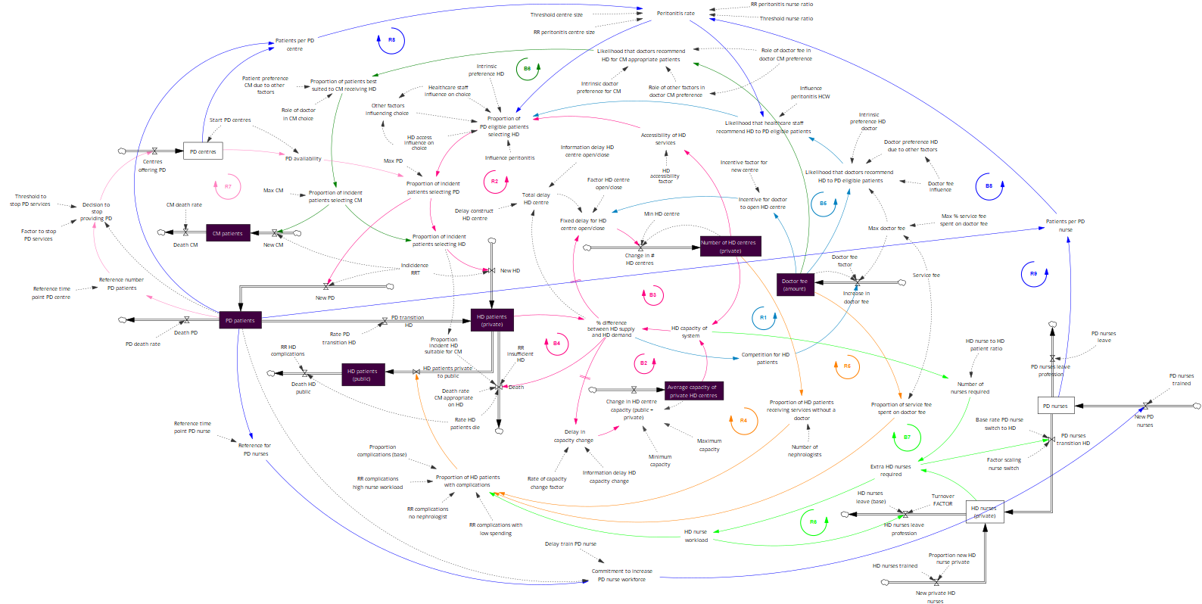

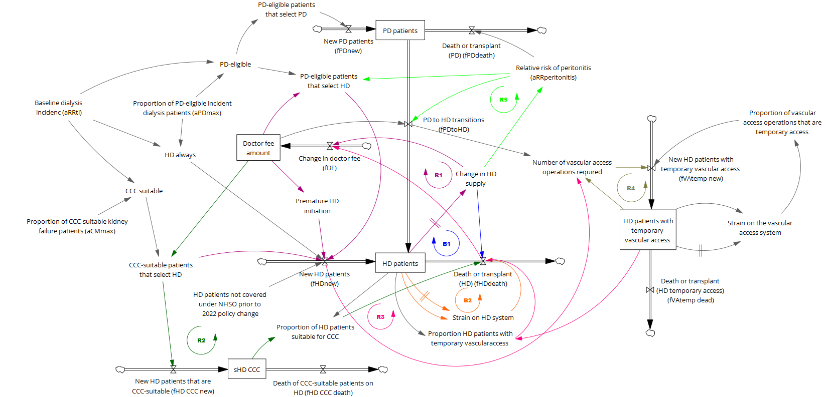
FigS1b. Revised model structure, after the iterative process of model testing, showing the main reinforcing and balancing feedback loops.

CCC- comprehensive conservative care; HD – haemodialysis; PD – peritoneal dialysis

