Additional File 3: policy analysis

Table S3. List of policies proposed for consideration and rationale for their inclusion/exclusion from the system dynamics model projections. Policies were either identified directly from other research informing the policy process or proposed by policy working group members to address specific challenges associated with the 2022 policy change in Thailand. Further details are available in other publications describing policies identified from the causal loop diagram (CLD) [36], literature review [15, 58], or National Health Security Office (NHSO) policy working group (WG) [21].
# | Policy | Description | Source | SD model | Rationale
1 | Pre-authorisation | HD patients require pre-authorisation prior to initiating dialysis, to ensure that: (1) timing of HD initiation is appropriate,  (2) patient quality of life is best on HD, and  (3) there is available HD supply. | WG + CLD | Yes | Prevents premature HD initiation
2 | KPI for regulatory capacity | Key performance indicator that measures quality assurance staff for regulation of dialysis services relative to supply. | CLD | No | Impact relates to HD death rate only
3 | Quality-based payment for HD | HD service provider payments are provided per patient, contingent upon performance against a set of quality indicators. | CLD | Yes | Potential to reduce the doctor fee (and therefore PD-eligible, CCC-suitable, and premature HD)
4 | KPI for HD nurse to patient ratio | Key performance indicator that measures number of registered HD nurses in service relative to registered number of HD patients. | CLD | No | Affects loops removed from model structure (as there are sufficient HD nurses according to the data)
5 | HD nurse regulations | Enforceable regulations determining maximum number and length of shifts for HD nurses. | CLD | No | Impact relates to HD death rate only
6 | PD investment planning | Demand projections for PD determine investment in PD nurse training and PD centres. | CLD | No | Only modified PD-eligible patients selecting HD
7 | Doctor fee restrictions | Regulation to allow payment of the doctor fee only when the nephrologist attends the full dialysis session of the patient. | WG | Yes | Decreases the doctor fee (and therefore PD-eligible, CCC-suitable, and premature HD)
8 | Education by multi-disciplinary team | Patients with stage 4 chronic kidney disease are provided with multiple education sessions from multi-disciplinary teams of healthcare professionals prior to making a choice between HD, PD, and CCC. | Literature review | Yes | Potential to reduce HD initiation among PD-eligible, CCC-suitable, and premature initiation
9 | CCC protocols | Prior to dialysis initiation, doctors are provided with prompting questions and/or protocols to identify patients with short life expectancy who may have better quality of life on CCC. | Literature review | No | Only changes CCC-suitable HD incident patients
10 | CQI for dialysis services | Establishment of a working group to monitor and resolve issues with dialysis quality of care. | WG | No | Only changes HD and PD complications and death rates
11 | Global budget for dialysis | Service provider payments are allocated according to a fixed budget per year (therefore payments per patient are lower with more patients). | Literature review | Yes | Changes across all categories of HD incident patients
12 | Bundle payments for dialysis | Service provider payments are provided per kidney failure patient, with adjustment to make CCC, PD, and HD equally profitable, with adjustment for case mix of patients. | Literature review | No | Changes only affect CCC-suitable and PD-eligible patients
CCC – comprehensive conservative care; CLD – causal loop diagram; HD – haemodialysis; KPI – key performance indicator; PD – peritoneal dialysis; SD – system dynamics; WG – ad-hoc working group on kidney replacement therapy under the National Health Security Office (NHSO) Board

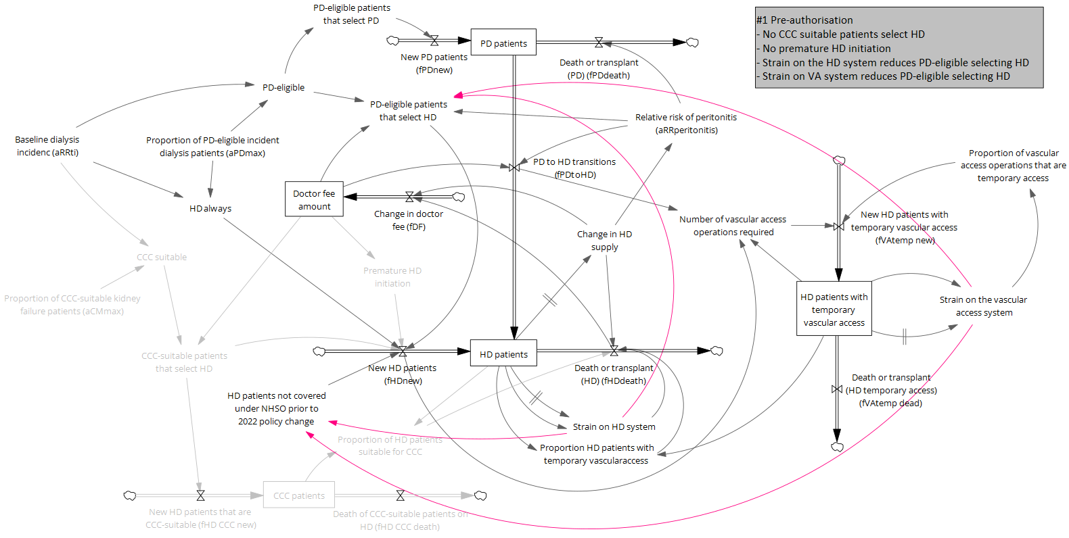
FigS3a. Model diagram for the pre-authorisation policy. Following policy implementation, the light grey lines represent parts of the model structure that are switched off and the pink lines those that are switched on.
CCC – comprehensive conservative care; HD – haemodialysis; PD – peritoneal dialysis; NHSO – National Health Security Office (NHSO) Board
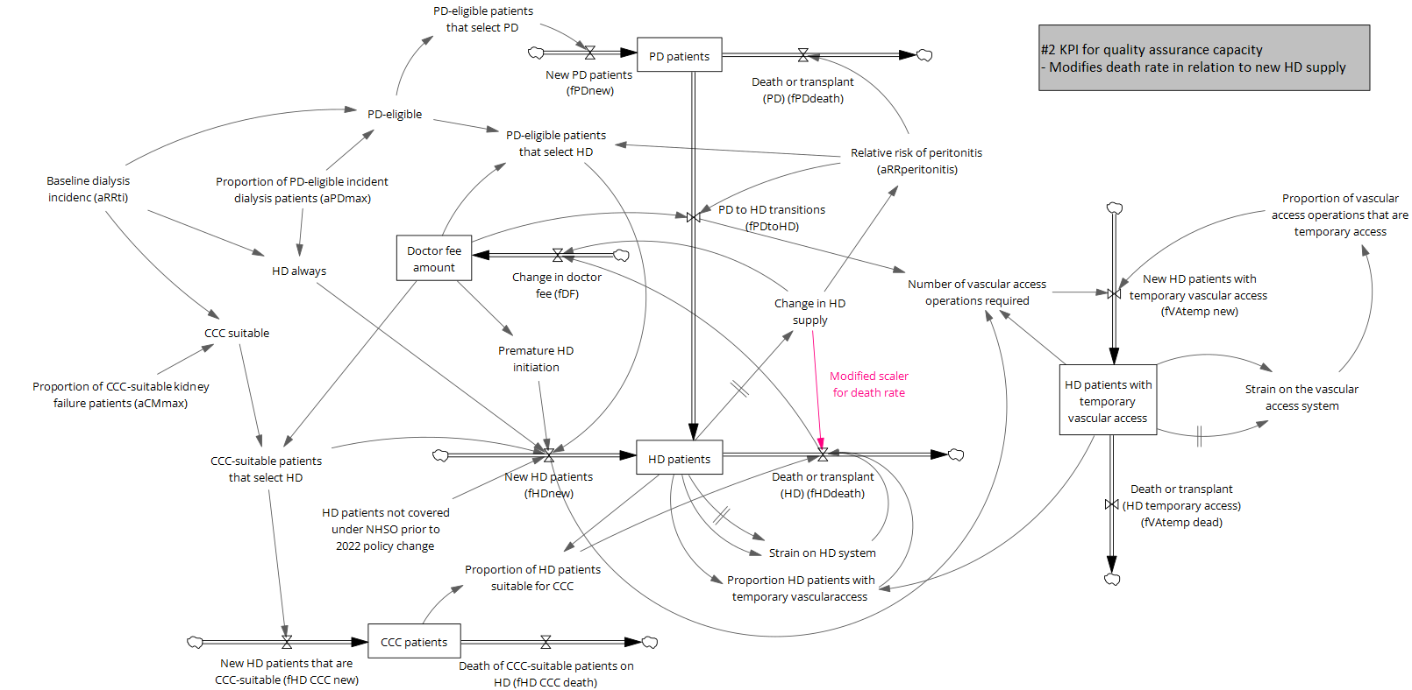
FigS3b. Model diagram for a key performance indicator (KPI) to ensure adequate quality assurance capacity to open new centres. Following policy implementation, the pink lines are switched on.
CCC – comprehensive conservative care; HD – haemodialysis; PD – peritoneal dialysis; NHSO – National Health Security Office (NHSO) Board
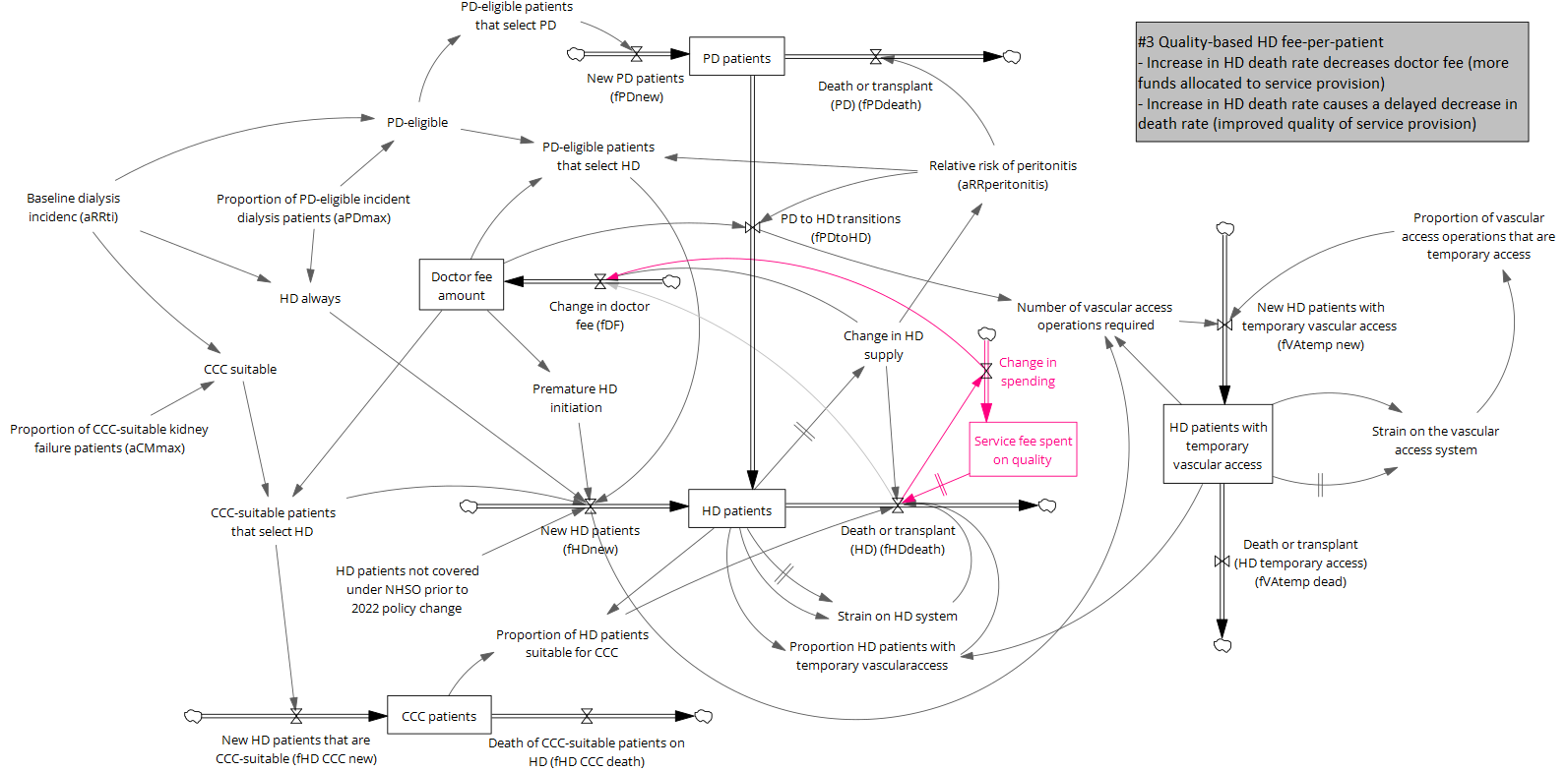
FigS3c. Model diagram for changing service provider payments from fee-for-service to quality-based fee-per-patient. The structures highlighted in pink are switched on following policy implementation.
CCC – comprehensive conservative care; HD – haemodialysis; PD – peritoneal dialysis; NHSO – National Health Security Office (NHSO) Board
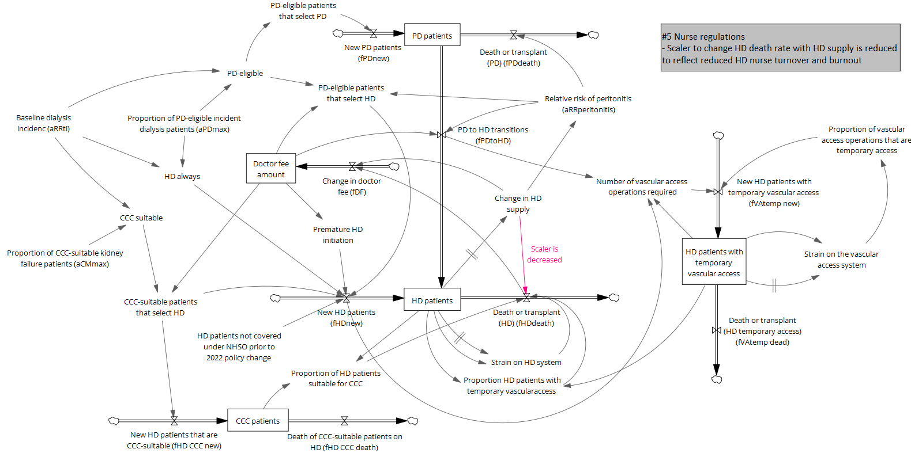
FigS3d. Model diagram for regulations around HD nurse shifts. The pink line is modified after policy implementation.
CCC – comprehensive conservative care; HD – haemodialysis; PD – peritoneal dialysis; NHSO – National Health Security Office (NHSO) Board
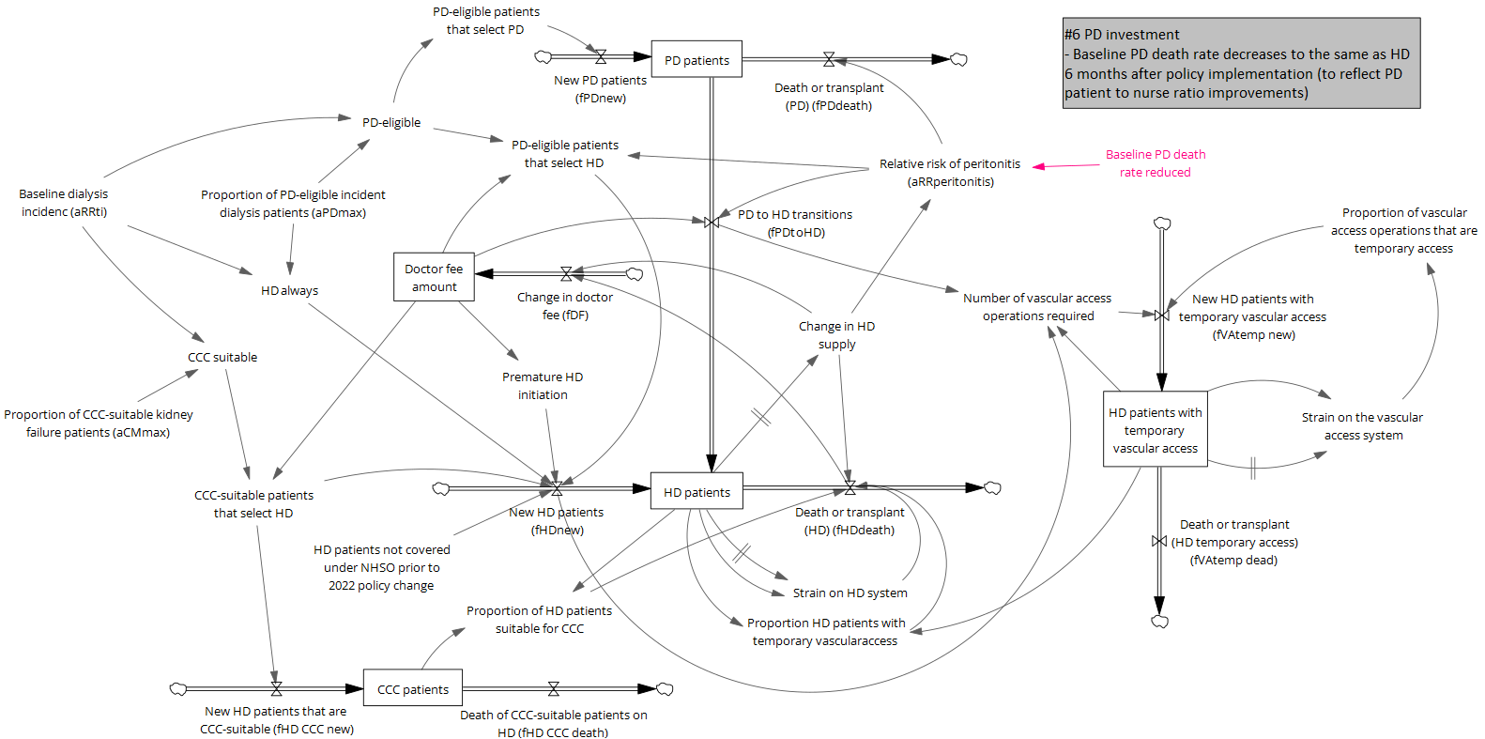
FigS3e. Model diagram for PD demand forecasting to determine investment in capacity. Pink text represents changes to the model following policy implementation.
CCC – comprehensive conservative care; HD – haemodialysis; PD – peritoneal dialysis; NHSO – National Health Security Office (NHSO) Board
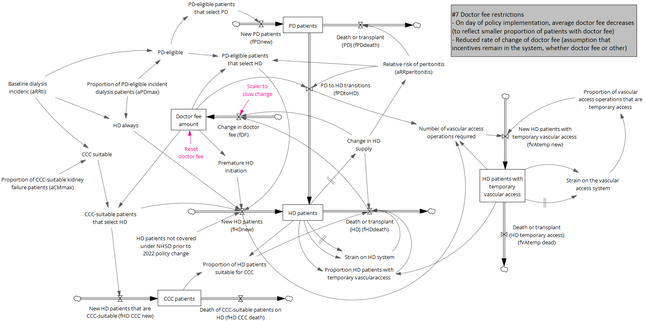
FigS3f. Model diagram for a policy to restrict payment of the doctor fee. Parts in pink are switched on following policy change.
CCC – comprehensive conservative care; HD – haemodialysis; PD – peritoneal dialysis; NHSO – National Health Security Office (NHSO) Board
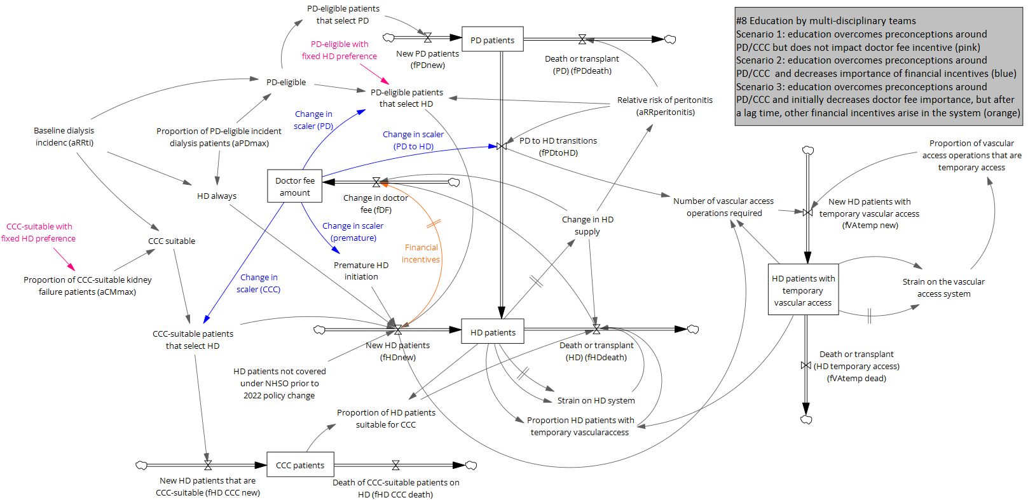
FigS3g. Model diagram for patient education by a multi-disciplinary team. Parts of the model in pink are changed following implementation of the base policy, the parts in blue an orange are changed in sensitivity analysis (see grey box for details).
CCC – comprehensive conservative care; HD – haemodialysis; PD – peritoneal dialysis; NHSO – National Health Security Office (NHSO) Board
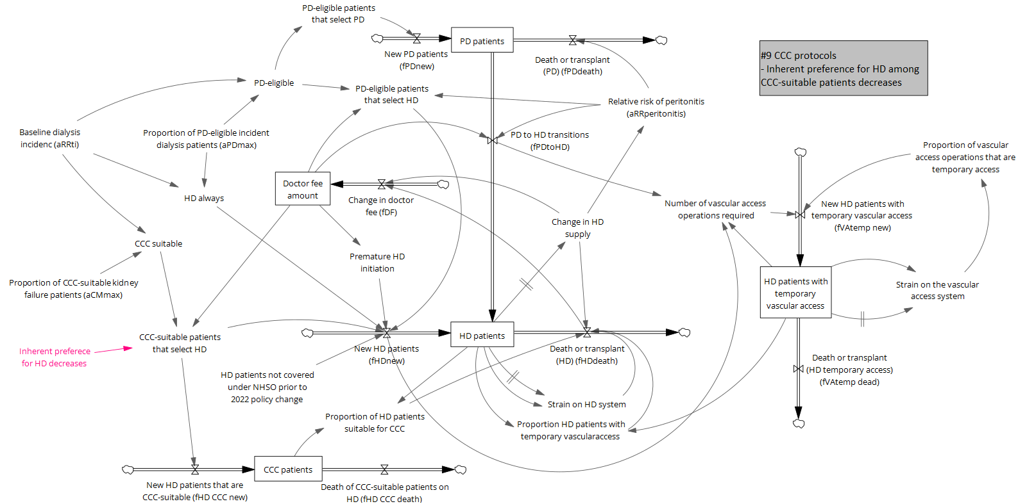
FigS3h. Model diagram for comprehensive conservative care (CCC) protocols. Changes to the base model structure following policy implementation are highlighted in pink.
CCC – comprehensive conservative care; HD – haemodialysis; PD – peritoneal dialysis; NHSO – National Health Security Office (NHSO) Board
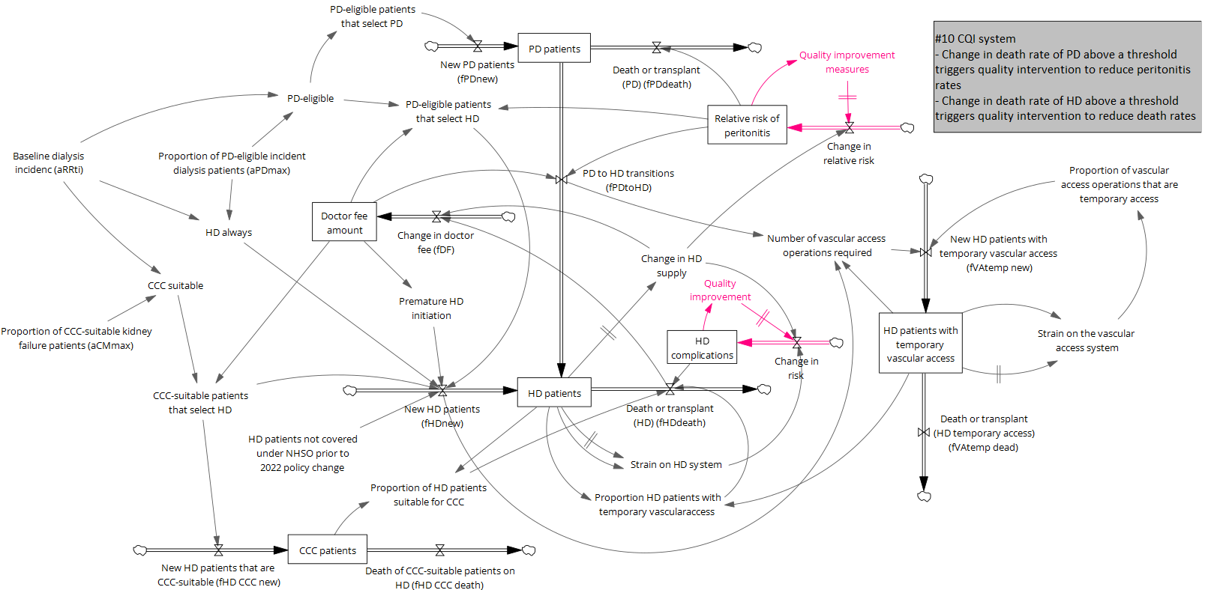
FigS3i. Model diagram for a continuous quality improvement (CQI) scheme. Changes to model structure following policy implementation are shown in pink.
CCC – comprehensive conservative care; HD – haemodialysis; PD – peritoneal dialysis; NHSO – National Health Security Office (NHSO) Board
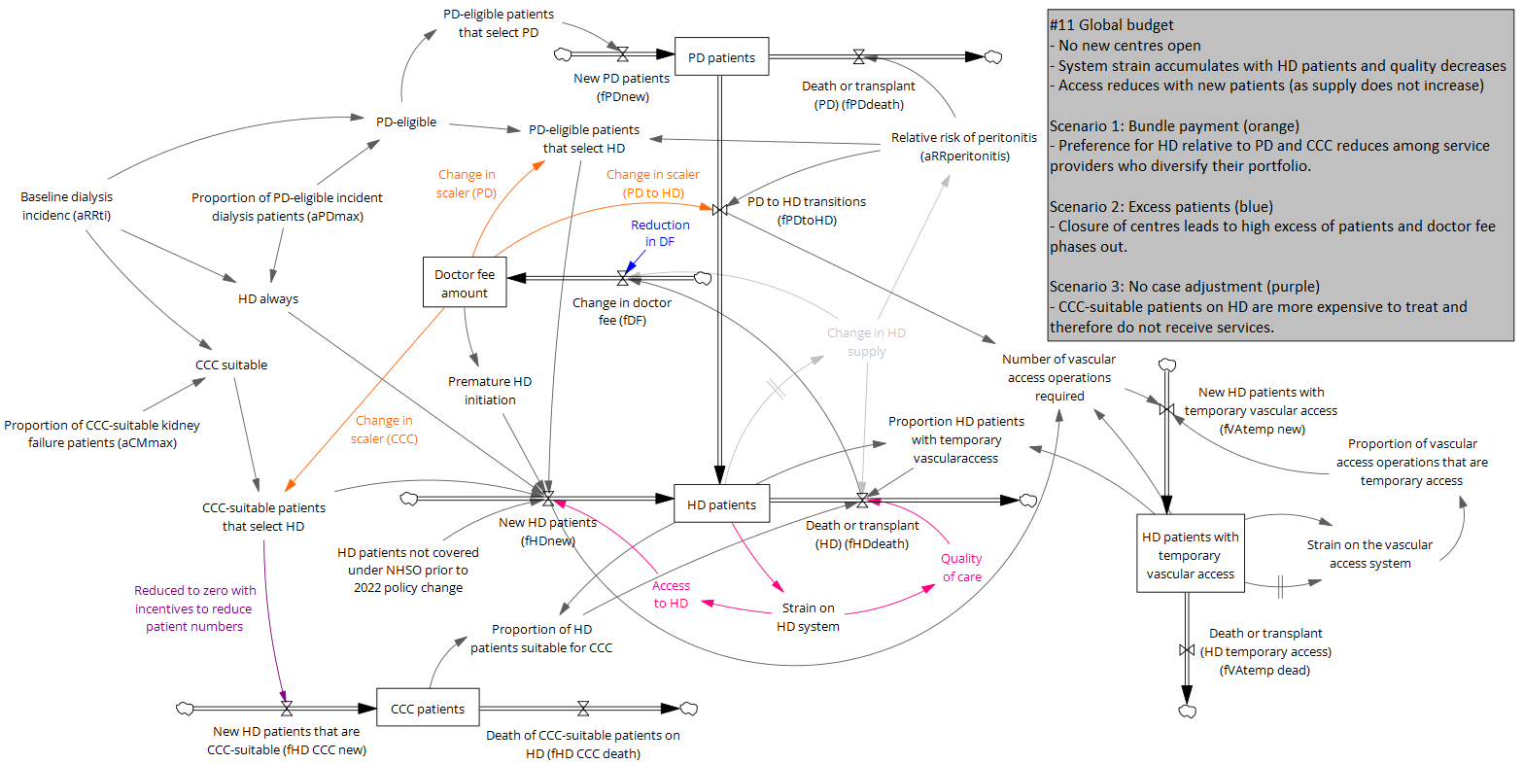
FigS3j. Model diagram for the global budget policy. Following policy implementation, the light grey lines represent parts of the model structure that are switched off, parts of the model that are switched on are shown in pink, and parts in orange, blue, or purple are switched on/off dependent on the scenario (details in the grey box).
CCC – comprehensive conservative care; HD – haemodialysis; PD – peritoneal dialysis; NHSO – National Health Security Office (NHSO) Board
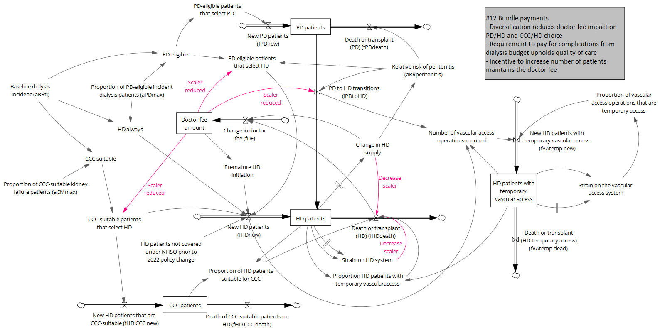
FigS3k. Model diagram for bundle payments. Following policy implementation, the scalers associated with the parts of the model highlighted in pink are modified.
CCC – comprehensive conservative care; HD – haemodialysis; PD – peritoneal dialysis; NHSO – National Health Security Office (NHSO) Board

