Additional File 4: base case analysis (2022 policy)

Figure S4a. Base case projection of number of dialysis patients registered under the Universal Coverage Scheme (UCS) per year, from 2025-2029, showing a decreasing proportion of patients on peritoneal dialysis (PD) and an increasing proportion of patients on haemodialysis (HD) over time.
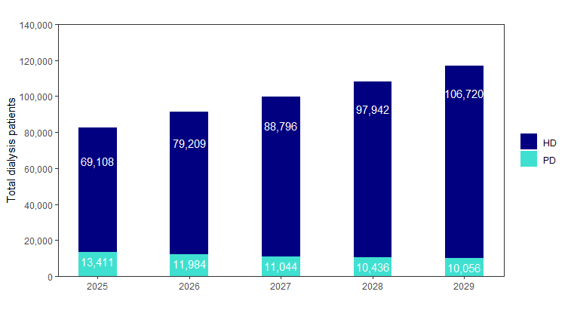HD – haemodialysis; PD – peritoneal dialysis

Figure S4b. Profile of new dialysis patients under the base case scenario, from 2025-2029. 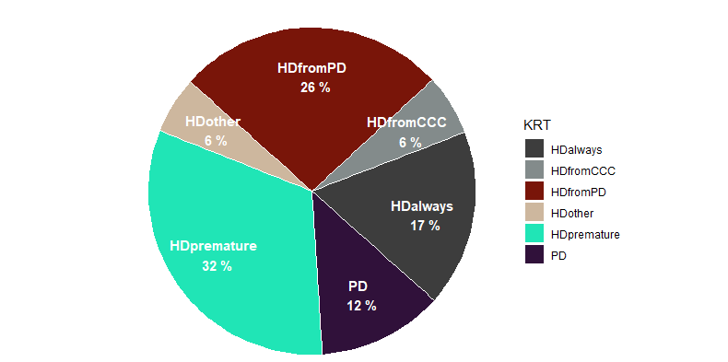
HDalways – haemodialysis (HD) patients that are best suited to HD; HDfromCCC – haemodialysis (HD) patients that would be best suited to comprehensive conservative care; HDfromPD – haemodialysis (HD) patients that are eligible for peritoneal dialysis (PD); HDother – haemodialysis (HD) patients that would not have registered for dialysis services under NHSO prior to the 2022 policy change, either because they preferred to self-pay for HD under the PD-first policy or because they were registered under another health insurance scheme (administered by the Social Security Office, SSO) prior to initiating dialysis; HD premature – haemodialysis (HD) patients that have residual kidney function and have initiated HD prematurely; KRT – kidney replacement therapy; PD – peritoneal dialysis.

Figure S4c. Deterministic sensitivity analysis of parameters in the base case model projection. The chart shows the five parameters with the greatest influence on total dialysis patients. The grey dotted line shows the total dialysis patients at the end of the projection period (December 2029) under the base case. For each of the five parameters listed on the left-hand side, the red bar shows the difference in number of dialysis patients using the parameter lower bound and the blue-grey bar shows the difference using the parameter upper bound.
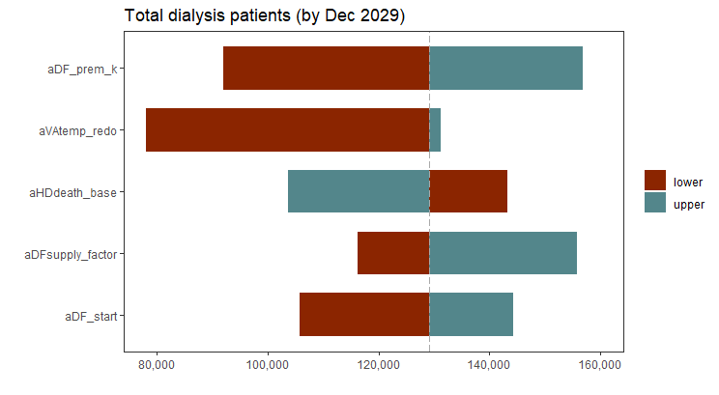
aDF_prem_k – factor scaling the doctor fee to number of new patients initiating HD prematurely; aVAtemp_redo – average length of time before an HD patient with temporary access requires a subsequent vascular access operation; aHDdeath_base – base death rate among HD patients (i.e. with optimal standard of care); aDFsupply_factor – factor scaling the rate of increase in the doctor fee to the rate of change in HD supply; aDF_start – average doctor fee paid by private HD centres to doctors for patient referrals, per patient per session, at the start of model projections (January 2018).

Figure S4d. Deterministic sensitivity analysis of parameters in the base case model projection. The chart shows the five parameters with the greatest influence on proportion of new patients selecting PD. The grey dotted line shows the average proportion of new dialysis patients selecting PD over the projection period (2025-2029) under the base case. For each of the five parameters listed on the left-hand side, the red bar shows the difference using the lower bound and the blue-grey bar shows the difference using the upper bound.
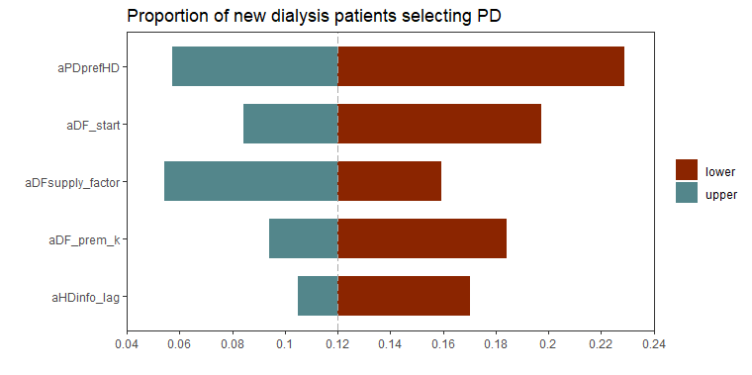
aPDprefHD – proportion of PD patients with a preference for HD that is not modified by peritonitis rates or the doctor fee (for example, patient education, healthcare worker training, etc); aDF_start – starting value of the doctor fee in the model (January 2018); aDFsupply_factor – factor scaling the rate of increase in the doctor fee to the rate of change in HD supply; aDF_prem_k – factor scaling the doctor fee to number of new patients initiating HD prematurely; aHDinfo_lag – reference time point in the past used to make decisions around opening new HD centres (affects HD supply).

Figure S4e. Latin hypercube sampling to show uncertainty across parameter inputs, for total dialysis patients. The top figure shows the results from all runs, whereas the bottom figure shows the average from all runs (green line) plotted against the base case deterministic result (navy line).
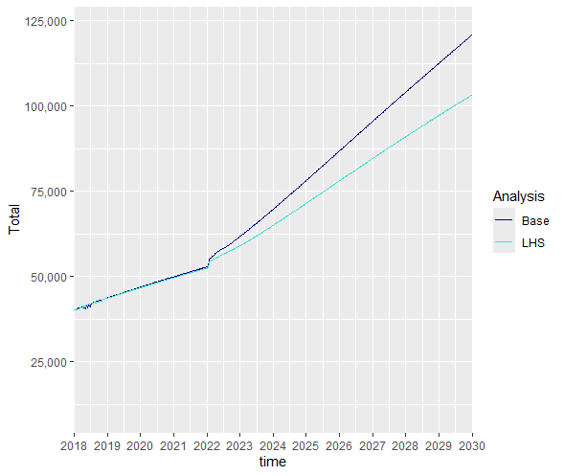
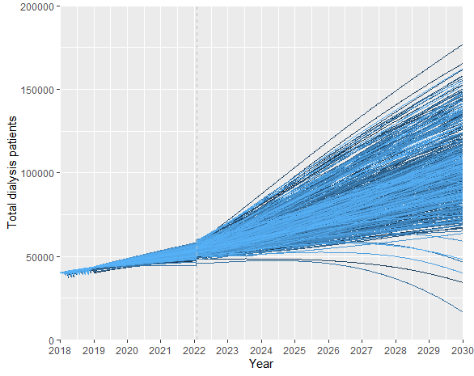

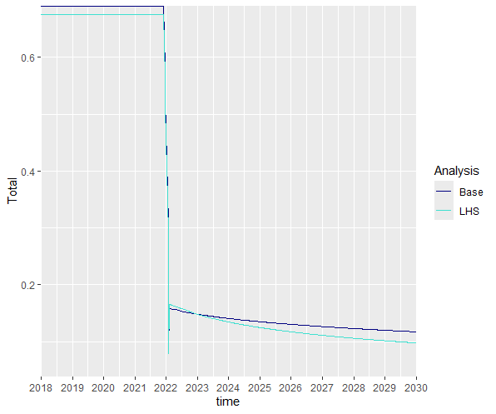
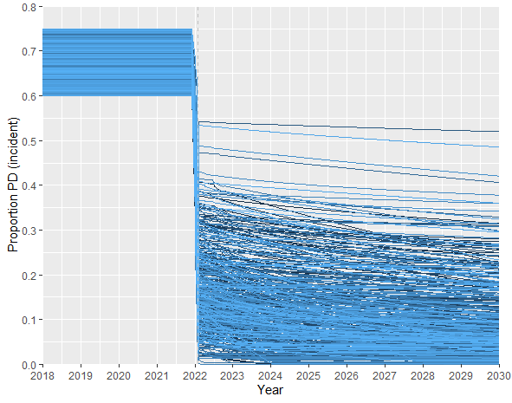
Figure S4f. Latin hypercube sampling to show uncertainty across parameter inputs, for proportion of incident patients initiating dialysis on PD. The top figure shows the results from all runs, whereas the bottom figure shows the average from all runs (green line) plotted against the base case deterministic result (navy line).

