Additional File 7: model validation

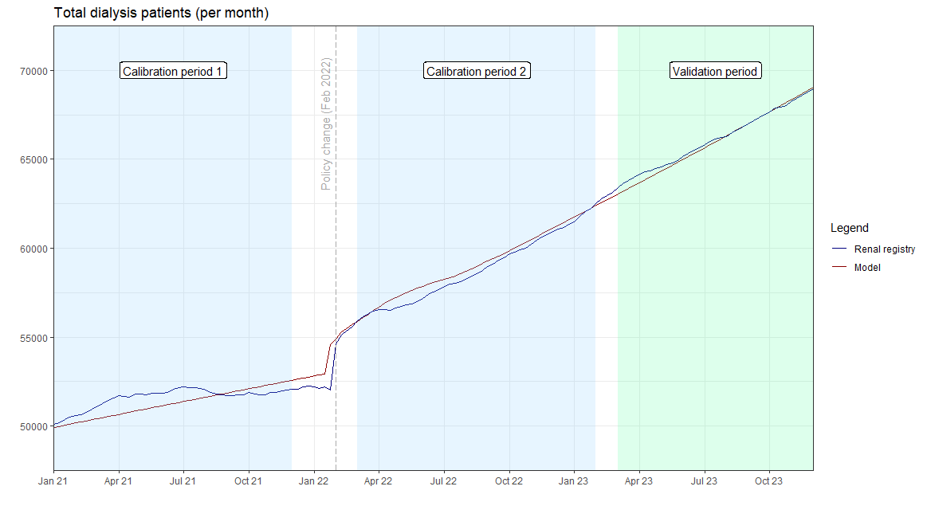
Figure S7a. Validation of model behaviour against renal registry data for total dialysis patients.
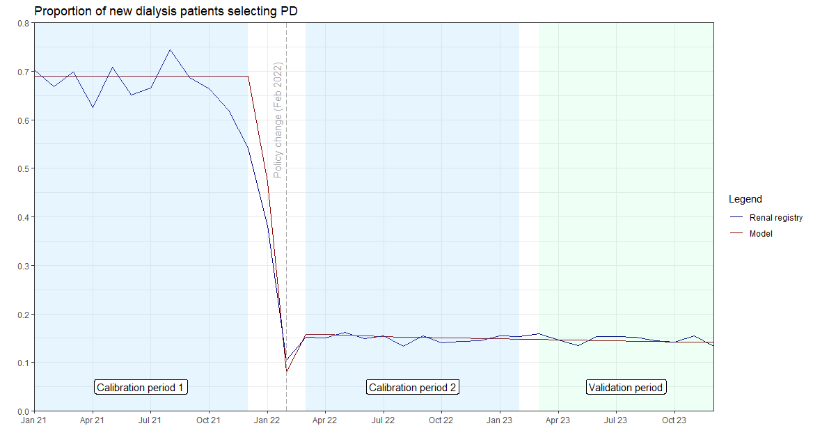
Figure S7b. Validation of model behaviour against renal registry data for proportion of incident dialysis patients on PD.

Figure S7c. Calibration of parameters associated with PD death against total PD cases, prior to 2022 policy change. Purple line – renal registry data; pink-red line – model projection.
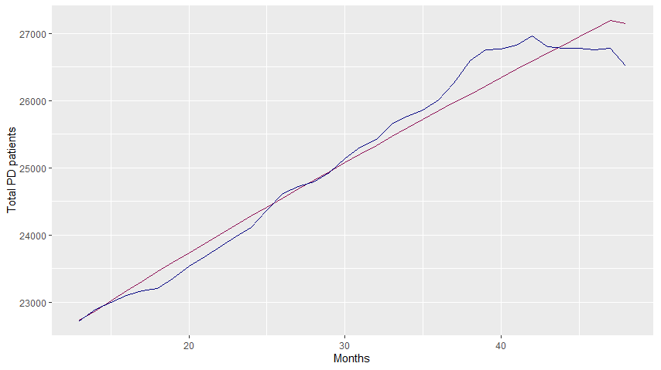

Figure S7d. Calibration of parameters associated with HD death against total HD cases, prior to 2022 policy change.
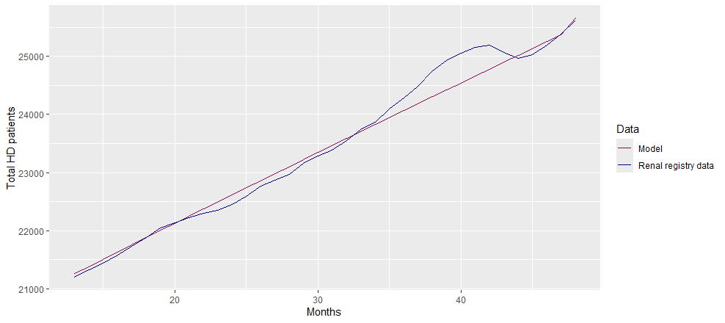

Figure S7e. Calibration of parameters associated with new HD cases against total dialysis cases, for 1-year after the 2022 policy change.
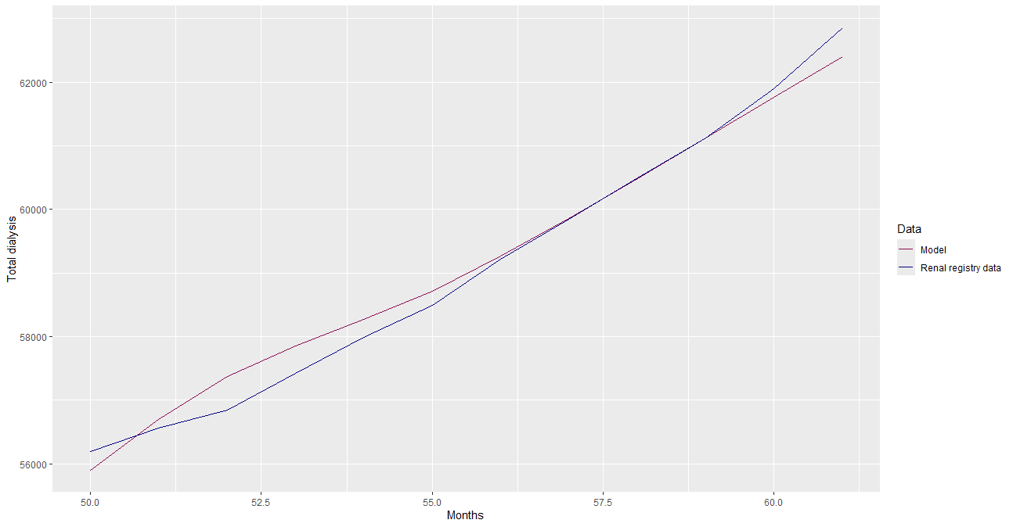

Figure S7f. Calibration of parameters associated with proportion of new cases selecting PD, for 1-year after the 2022 policy change.

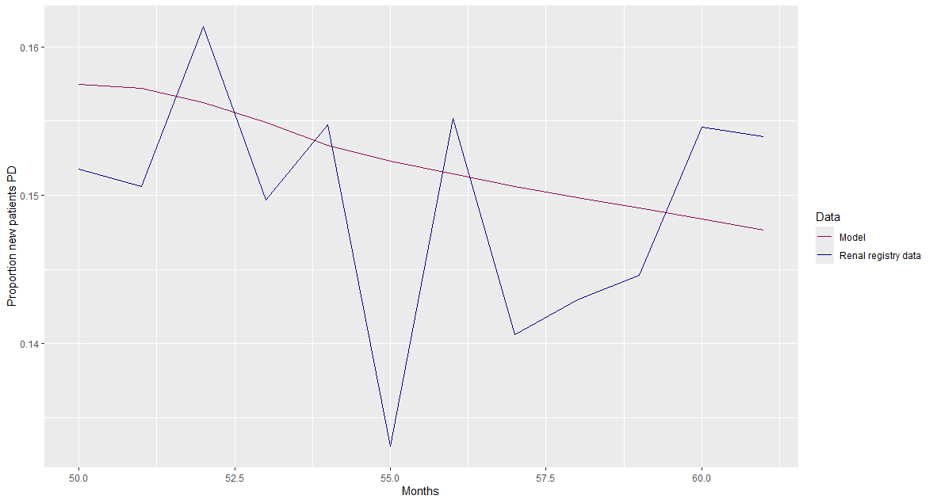

Figure S7g. PD patients switching to HD per month, as estimated by the model and renal registry data for the model validation period. The dashed lines at months 49, 50, and 61 represent the 2022 policy change, start and end of the calibration period, respectively.
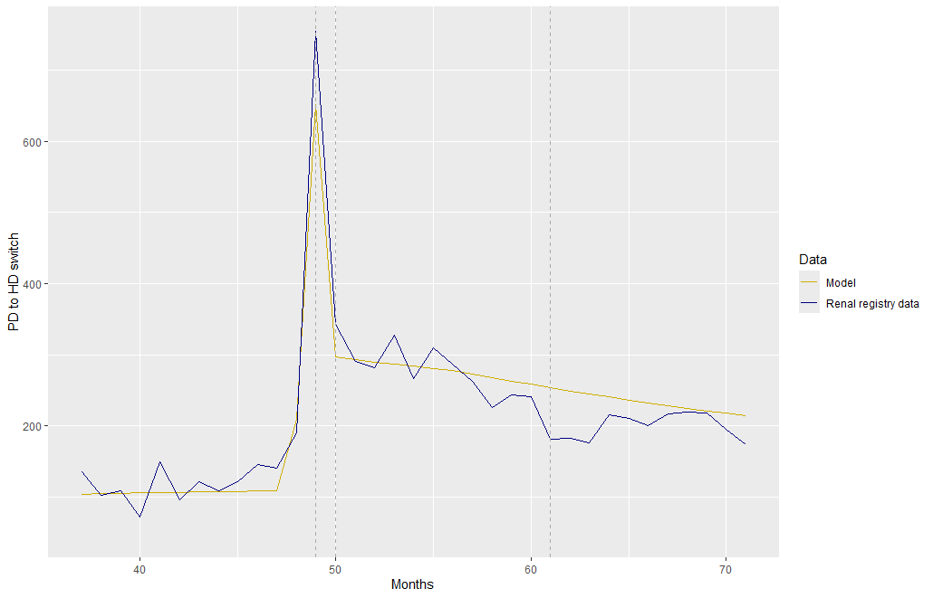
Figure S7h. Proportion of total HD patients with temporary vascular access (catheter), as estimated by the model and renal registry data for the model validation period. The dashed lines at months 49 and 61 represent the 2022 policy change and end of the calibration period, respectively.
