Figure S1. Geographical distribution of user access to the web application “www.humtelemed.it” between December 2022 and September 2024 and flowchart for the selection of the final cohort
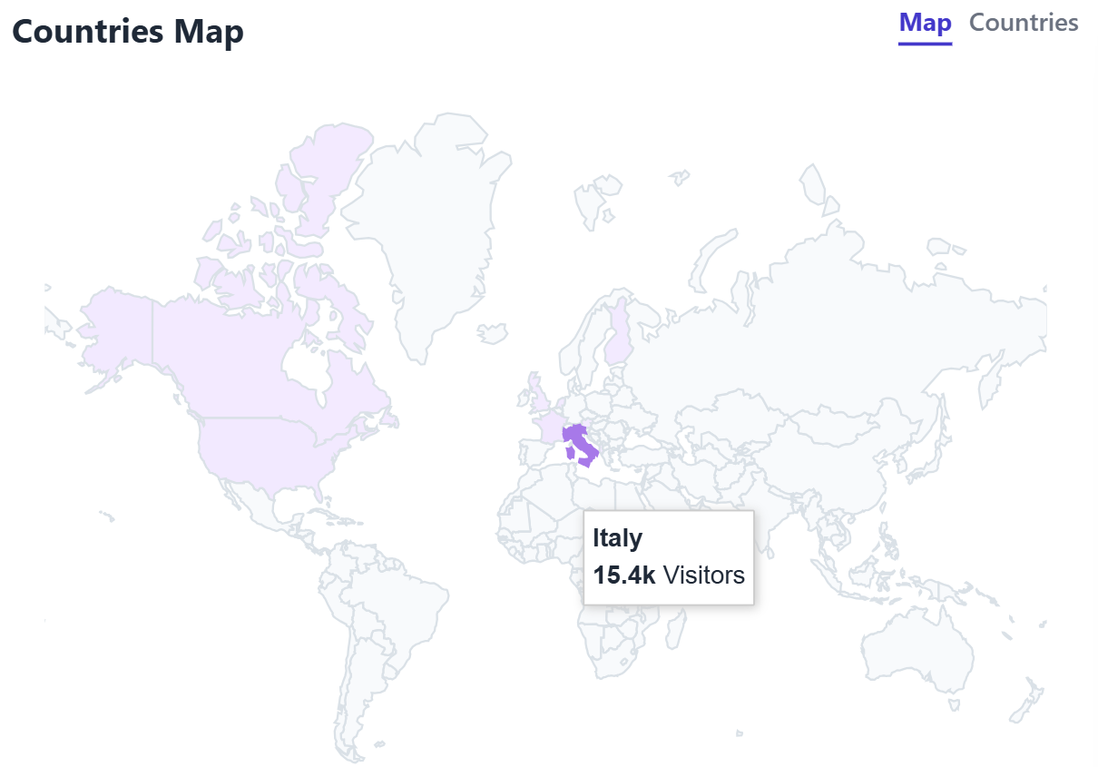
The greater the intensity of the colour, the greater the number of user accesses.
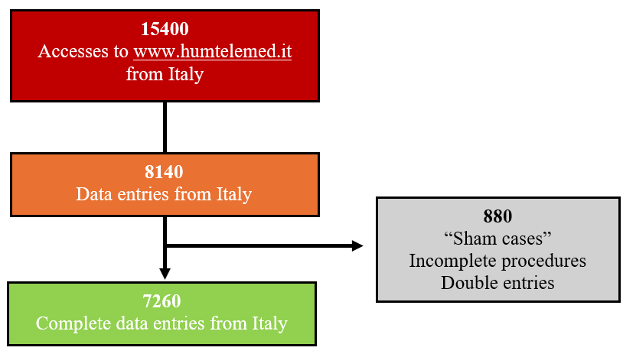

Table S1. General characteristics of the study population according to sex (n = 7260).
 | Sex
 | Female (n = 3234) | Male (n = 4026) | p-value
Age (years) | 61.1±12.2 | 58.0±11.3 | <0.001
BMI (kg/m2) | 25.6±5.0 | 26.7±.4.1 | <0.001
eGFR (mL/min/1.73 m2) | 78.9±20.0 | 83.6±21.4 | <0.001
Office SBP (mmHg) | 125.9±15.0 | 129.3±13.3 | <0.001
Office DBP (mmHg) | 76.3±9.5 | 79.8±9.3 | <0.001
Total cholesterol (mg/dL) | 206±42.3 | 193.8±42.2 | <0.001
HDL-Cholesterol (mg/dL) | 62.4±15.4 | 52.9±14.1 | <0.001
Triglycerides (mg/dL) | 94.0 (70.0 – 128.0) | 104.0 (79.0 – 144) | <0.001
LDL-Cholesterol (mg/dL) | 121.5±46.0 | 116.2±55.8 | <0.001
Smoking habit (%) | 29.6 (n=957) | 44.3 (n=1784) | <0.001
PAD (%) | 15.3 (n=497) | 16.5 (n=668) | 0.157
Hypertension (%, n) | 46.3 (n=1498) | 46.5 (n=1875) | 0.830
T2DM (%, n) | 7.8 (n=253) | 9.0 (n=364) | 0.064
CKD (eGFR < 60 mL/min/1.73m2) (%, n) | 14.4 (n=466) | 9.8 (n=394) | <0.001
ASCVD (%, n) | 0.46 (n=15) | 0.44 (n=18) | 0.927
FH (%, n) | 4.3 (n=139) | 4.5 (n=182) | 0.616
SCORE2/SCORE2-OP (%, IQR) | 5 (3-9) | 7 (4-11) | <0.001
Low-to-moderate CVR (%, n) | 34.4 (n=1113) | 11.9 (n=480) | <0.001
High CVR (%, n) | 31.4 (n=1015) | 43.4 (n=1749) | <0.001
Very High/Extreme CVR (%, n) | 34.2 (n=1106) | 44.6 (n=1797) | <0.001
LDL-Cholesterol at goal (%, n) | 12.0 (n=391) | 10.6 (n=428) | 0.050
LLT (%, n) | 29.7 (n=961) | 29.4 (n=1186) | 0.057
LDL-C at goal in LLT (%, n) | 13.1 (n=126) | 18.2 (n=216) | 0.001
Office BP at goal (%, n) | 78.7 (n=2547) | 73.1 (n=2945) | <0.001
Office BP at goal in antihypertensive therapy (%, n) | 69.8 (n=1047) | 67.0 (n=1257) | 0.076
BMI: Body Mass Index, eGFR: estimated Glomerular Filtration Rate, SBP: Systolic Blood Pressure, DBP: Diastolic Blood Pressure, HDL: High-Density Lipoprotein, LDL: Low-Density Lipoprotein, PAD: Peripheral Artery Disease, T2DM: Type 2 Diabetes Mellitus, CKD: Chronic Kidney Disease, ASCVD: Atherosclerotic Cardiovascular Disease, FH: Familial Hypercholesterolemia, CVR: Cardiovascular Risk, LLT: Lower Lipid Treatment, BP: Blood Pressure.

Table S2. General characteristics of the study population according to age (n = 7260).
 | Age (years)
 | <70 (n=5736) | ≥70 (n=1524) | p-value
Age (years) | 54.8±8.4 | 76.6±5.3 | <0.001
Male sex (%, n) | 58.4 (n=3354) | 44.1 (n=672) | <0.001
BMI (kg/m²) | 26.2±4.6 | 26.3±4.3 | 0.242
eGFR (mL/min/1.73 m²) | 85.2±20.3 | 67.8±17.3 | <0.001
Office SBP (mmHg) | 126.8±13.8 | 131.6±14.8 | <0.001
Office DBP (mmHg) | 78.9±9.5 | 75.3±9.4 | <0.001
Total cholesterol (mg/dL) | 202.2±42.1 | 187.7±43.4 | <0.001
HDL-Cholesterol (mg/dL) | 57.1±15.7 | 57.3±14.8 | 0.630
Triglycerides (mg/dL) | 100.0 (74.0 – 139.0) | 100.0 (77.0 – 133.0) | 0.412
LDL-Cholesterol (mg/dL) | 121.6±50.5 | 107.5±54.6 | <0.001
Smoking habit (%, n) | 37.4 (n=2144) | 36.8 (n=561) | 0.306
PAD (%, n) | 12.2 (n= 699) | 30.6 (n=466) | <0.001
Hypertension (%, n) | 40.6 (n=2333) | 68.2 (n=1040) | <0.001
T2DM (%, n) | 6.3 (n=358) | 16.9 (n=259) | <0.001
CKD (eGFR < 60 mL/min) (%, n) | 7.4 (n=425) | 28.5 (n=435) | <0.001
ASCVD (%, n) | 0.4 (n=24) | 0.6 (n=9) | <0.001
FH (%, n) | 4.7 (n=271) | 3.3 (n=50) | 0.017
Low-to-moderate CVR (%, n) | 25.7 (n=1479) | 7.5 (n=114) | <0.001
High CVR (%, n) | 46.3 (n=2485) | 18.3 (n=279) | <0.001
Very High/Extreme CVR (%, n) | 30.9 (n=1772) | 74.2 (n=1131) | <0.001
LDL-Cholesterol at goal (%, n) | 11.4 (n= 657) | 10.6 (n=162) | 0.366
LLT (%, n) | 24.9 (n=1432) | 46.9 (n=715) | <0.001
LDL-C at goal in patients on LLT (%, n) | 15.4 (n=221) | 16.9 (n=121) | 0.374
Office BP at goal (%, n) | 76.9 (n=4412) | 70.8 (n=1080) | <0.001
Office BP at goal in antihypertensive therapy (%, n) | 68.4 (n=1597) | 67.9 (n=707) | 0.785
BMI: Body Mass Index, eGFR: estimated Glomerular Filtration Rate, SBP: Systolic Blood Pressure, DBP: Diastolic Blood Pressure, HDL: High-Density Lipoprotein, LDL: Low-Density Lipoprotein, PAD: Peripheral Artery Disease, T2DM: Type 2 Diabetes Mellitus, CKD: Chronic Kidney Disease, ASCVD: Atherosclerotic Cardiovascular Disease, FH: Familial Hypercholesterolemia, CVR: Cardiovascular Risk, LLT: Lower Lipid Treatment, BP: Blood Pressure.

Table S3. General characteristics of the study population according to BMI class (n = 7260).
 | BMI class (kg/m²)
 | ≤25 (n = 3174) | 25-29 (n = 2640) | ≥30 (n = 1298) | p-value
Age (years) | 58.7±12.3 | 60.0±11.6 | 60.3±11.1 | <0.001
Male sex (%, n) | 47.4 (n=1507) | 66.3 (n=1750) | 56.4 (n=733) | <0.001
eGFR (mL/min/1.73 m²) | 83.0±22.3 | 80.8±19.6 | 79.7±20.1 | <0.001
Office SBP (mmHg) | 124.3±13.6 | 129.4±13.5 | 132.9±14.6 | <0.001
Office DBP (mmHg) | 76.7±9.7 | 79.0±8.9 | 80.6±9.8 | <0.001
Total Cholesterol (mg/dL) | 200.1±42.2 | 198.8±42.5 | 196.1±44.6 | 0.018
HDL-Cholesterol (mg/dL) | 61.6±15.9 | 54.4±14.2 | 51.5±13.8 | <0.001
Triglycerides (mg/dL) | 88.5 (66-117) | 106 (80-145) | 120 (88-164) | <0.001
LDL-Cholesterol (mg/dL) | 117.0±53.7 | 119.7±55.0 | 118.7±39.6 | 0.133
Smoking habit (%, n) | 31.1 (n=989) | 43.8 (n=1158) | 42.4 (n=551) | <0.001
PAD (%, n) | 13.9 (n=442) | 17.1 (n=452) | 20.3 (n=264) | <0.001
Hypertension (%, n) | 33.0 (n=1048) | 50.8 (n=1341) | 68.4 (n=889) | <0.001
T2DM (%, n) | 5.0 (n=161) | 9.0 (n=239) | 16.7 (n=217) | <0.001
CKD (eGFR < 60 mL/min/) (%, n) | 9.9 (n=314) | 12.6 (n=334) | 15.4 (n=200) | <0.001
ASCVD (%, n) | 0.12 (n=4) | 0.79 (n=21) | 0.46 (n=6) | <0.001
FH (%, n) | 4.8 (n=154) | 4.9 (n=131) | 2.7 (n=36) | 0.004
SCORE2/SCORE2-OP (%, IQR) | 5 (3-10) | 7 (4-11) | 7 (4-11) | <0.001
Low-moderate CVR (%, n) | 29.2 (n=926) | 16.1 (n=425) | 13.9 (n=181) | <0.001
High CVR (%, n) | 36.8 (n=1170) | 41.1 (n=1085) | 34.0 (n=442) | <0.001
Very-high/Extreme CVR (%, n) | 34 (n=1078) | 42.8 (n=1130) | 52.0 (n=675) | <0.001
LDL-Cholesterol at goal (%, n) | 13.8 (n=438) | 9.4 (n=249) | 9.0 (n=117) | <0.001
LLT (%, n) | 24.8 (n=790) | 32.5 (n=859) | 36.3 (n=471) | <0.001
LDL-C at goal in LLT (%, n) | 19.1 (n=151) | 14.5 (n=125) | 13.3 (n=63) | 0.009
Office BP at goal (%, n) | 83.1 (n=2638) | 72.3 (n=1910) | 63.0 (n=818) | <0.001
Office BP at goal in antihypertensive therapy (%, n) | 74.3 (n=779) | 66.9 (n=897) | 61.6 (n=548) | <0.001
BMI: Body Mass Index, eGFR: estimated Glomerular Filtration Rate, SBP: Systolic Blood Pressure, DBP: Diastolic Blood Pressure, HDL: High-Density Lipoprotein, LDL: Low-Density Lipoprotein, PAD: Peripheral Artery Disease, T2DM: Type 2 Diabetes Mellitus, ASCVD: Atherosclerotic Cardiovascular Disease, FH: Familial Hypercholesterolemia, CVR: Cardiovascular Risk, LLT: Lower Lipid Treatment, BP: Blood Pressure.

