Online supplementary material

Supplement to: Integration of Gut Microbiome and Lipid Metabolism Reveals the Anti-Cancer Effects of Pentadecanoic Acid on Bladder Cancer

Table of contents (Table S3- Table S15 were provided in Additional file 2)
Table S1 Description of dietary and PEA in the UK Biobank and the BCPP
Table S2 Baseline characteristics of the participants from the UK Biobank and the BCPP
Table S3 Differential analysis on serum proteomics between BC model and PEA-treated groups (i.e., BC PEAL and BC PEAH) at both occurrence and invasion stages respectively
Table S4 LEfSe on fecal bacteria between BC model and PEA-treated groups (i.e., BC PEAL and BC PEAH) at both occurrence and invasion stages respectively
Table S5 LEfSe on fecal fungi between BC model and PEA-treated groups (i.e., BC PEAL and BC PEAH) at both occurrence and invasion stages respectively
Table S6 Functional profiling of PEA-DEFs using FUNGuild
Table S7 Spearman correlation between PEA-DEPs and PEA-DEBs, and between PEA-DEPs and PEA-DEFs
Table S8 Spearman correlation between PEA-DEBs and PEA-DEFs
Table S9 Differential lipid analysis between BC model and PEA-treated groups (i.e., BC PEAL and BC PEAH)
Table S10 Pathway-level lipid metabolism analysis based on Lipid Ontology and KEGG pathways
Table S11 Spearman correlation between PEA-DELs and PEA-DEBs, and between PEA-DELs and PEA-DEFs
Table S12 K-Means clustering analysis of differential lipid abundance in different groups
Table S13 Spearman correlation between lipid clusters and PEA-DEBs, and between lipid clusters and PEA-DEFs
Table S14 Mediation analysis of PEA effects on BC via microbiota and lipidomic
Table S15 Spearman correlation between PEA-DELs and PEA-DEPs
Figure S1 PEA inhibits the migration, invasion, and proliferation of T24 BC cells
Figure S2 GO pathway enrichment analyses of 122 unique proteins identified
Figure S3 Venn analysis between groups of gut bacteria at BC occurrence and invasion stages
Figure S4 Phylum- and genus-level of relative abundance composition of gut bacteria at BC occurrence and invasion stages
Figure S5 Phylum- and genus-level of relative abundance composition of gut fungi at BC occurrence and invasion stages
Figure S6 Functional profiling of PEA-DEFs based on FUNGuild analysis
Figure S7 Relative abundance composition of fecal lipid species in the samples at BC occurrence and invasion stages
Figure S8 Principal component analysis (PCA) of fecal lipidomics in different groups
Figure S9 Sparse Canonical Correlation Analysis (sCCA) of PEA-DELs, PEA-DEBs, and PEA-DEFs
Figure S10 Spearman correlation analysis between 11 PEA-DELs and PEA-DEPs
Table S1 Description of food and PEA intake in the UK Biobank and the BCPP
Field ID | Food | Description¹ | Portion size² | PEA³
UK Biobank
1289 | Cooked vegetable | On average how many heaped tablespoons of COOKED vegetables would you eat per DAY? (Do not include potatoes) (tablespoons/day) | 40 | 0.01
1299 | Salad / raw vegetable | On average how many heaped tablespoons of SALAD or RAW vegetables would you eat per DAY? (Include lettuce, tomato in sandwiches) (tablespoons/day) | 45 | 0.01
1309 | Fresh fruit | About how many pieces of FRESH fruit would you eat per DAY? (Count one apple, one banana, 10 grapes etc. as one piece) (pieces/day) | 80 | 0
1319 | Dried fruit | About how many pieces of DRIED fruit would you eat per DAY? (Count one prune, one dried apricot, 10 raisins as one piece) (pieces/day) | 10 | 0
1319 | Oily fish | How often do you eat oily fish? (e.g., sardines, salmon, mackerel, herring) | 60 | 0.024
1339 | Non-oily fish | How often do you eat other types of fish? (e.g., cod, tinned tuna, haddock) | 60 | 0.02
1349 | Processed meat | How often do you eat processed meats (such as bacon, ham, sausages, meat pies, kebabs, burgers, chicken nuggets) | 50 | 0.01
1359 | Poultry | How often do you eat chicken, turkey or other poultry? (Do not count processed meats) | 90 | 0.10
1369 | Beef | How often do you eat beef? (Do not count processed meats) | 90 | 0.037
1379 | Lamb/mutton | How often do you eat lamb/mutton? (Do not count processed meats) | 90 | 0.05
1389 | Pork | How often do you eat pork? (Do not count processed meats such as bacon or ham) | 90 | 0.014
1408 | Cheese | How often do you eat cheese? (Include cheese in pizzas, quiches, cheese sauce etc.) | 40 | 0.42
1448 | Bread | How many slices of bread do you eat each week? (slices/week) | 35 | 0.01
1458 | Cereal | How many bowls of cereal do you eat a week? (slices/week) | 40 | 0
100520 | Milk | How many glasses/carton/ 250ml of milk did you consume yesterday? (250ml/day) | 257.5 | 0.12
BCPP
- | Bread | How often on average do you have eaten bread? | 70 | 0.01
- | Potatoes | How often on average do you have eaten potatoes? | 170 | 0
- | Pasta | How often on average do you have eaten pasta (e.g., Macaroni, spaghetti)? | 75 | 0.058
- | Rice | How often on average do you have eaten rice? | 50 | 0.01
- | Noodles | How often on average do you have eaten noodles? | 65 | 0
- | Wheat | How often on average do you have eaten wheat (e.g., Whole grain bread)? | 50 | 0
- | Cereal | How often on average do you have eaten cereal (e.g., Oats, bran, corn)? | 60 | 0
- | Meat (no organs) | How often on average do you have eaten meat without organs (e.g., pork, steak, beef, lamb)? | 90 | 0.034
- | Organ Meat | How often on average do you have eaten organ meat (e.g., liver, heart, kidney)? | 60 | 0
- | Chicken | How often on average do you have eaten chicken? | 90 | 0.056
- | Poultry | How often on average do you have eaten other poultry (e.g., goose, duck, pigeon)? | 90 | 0.1
- | Dark fish | How often on average do you have eaten dark fleshed fish (e.g., mackerel, salmon, tuna, anchovies)? | 80 | 0.024
- | White fish | How often on average do you have eaten white fleshed fish (e.g., cod, haddock, hake, halibut, sea, bass, skate, sole, plaice)? | 90 | 0.02
- | Seafood | How often on average do you have eaten seafood (e.g., prawn, crab, lobster, cockles,  winkles, squid, octopus, mussels)? | 70 | 0.028
- | Fruit vegetables | How often on average do you have eaten fruit vegetables (e.g., tomato, cucumber, aubergine)? | 60 | 0.01
- | Flower vegetables | How often on average do you have eaten fruit vegetables (e.g., broccoli, cauliflower)? | 60 | 0.01
- | Leafy vegetables | How often on average do you have eaten leafy vegetables (e.g., spainach, cabbage, lettuce)? | 80 | 0.015
- | Stem vegetables | How often on average do you have eaten stem vegetables (e.g., asparagus, celery, fennel)? | 80 | 0
- | Mushrooms | How often on average do you have eaten mushrooms? | 60 | 0.03
- | Bulbs | How often on average do you have eaten bulbs (e.g., onion, garlic, leek, shallot)? | 25 | 0
- | Roots | How often on average do you have eaten roots (e.g., beetroot, swede, carrot, parsnip)? | 60 | 0
- | Citrus fruit | How often on average do you have eaten citrus fruit (e.g., orange, lemon, lime, grapefruit)? | 120 | 0
- | Stone fruit | How often on average do you have eaten stone fruit (e.g., plum, apricot, peach, cherry)? | 110 | 0
- | Soft fruit | How often on average do you have eaten stone fruit (e.g., raspberry, strawberry, redcurrant,  blackberry)? | 100 | 0
- | Fleshy fruit | How often on average do you have eaten fleshy fruit (e.g., apple, pear, banana, pineapple)? | 100 | 0
- | Vine fruit | How often on average do you have eaten fleshy fruit (e.g., grape, melon, cantaloupe)? | 100 | 0
- | Cream | How often on average do you have eaten cream? | 30 | 0.115
- | Butter/Margarine | How often on average do you have eaten butter/ margarine? | 20 | 0.28
- | Yogurt | How often on average do you have eaten yogurt? | 120 | 0.06
- | Cheese | How often on average do you have eaten cheese? | 40 | 0.42
- | Egg | How often on average do you have eaten egg? | 60 | 0
- | Pulses | How often on average do you have eaten pulse (e.g., pea, bean, lentil)? | 70 | 0
- | Nuts and seeds | How often on average do you have eaten nuts and seeds? | 50 | 0
- | Soy/Tofu products | How often on average do you have eaten soy/tofu products (e.g., soy milk, tofu, soya meat)? | 100 | 0
- | Sweets snacks | How often on average do you have eaten sweets and snacks (e.g., crisps, cakes, ice cream, chocolate)? | 50 | 0.06
- | Milk | How often do you have drunk 1/2-pint glass of milk? | 292.72g | 0.12
¹ Refers to the questions asked regarding each food item in the respective cohorts and the types of foods included in these foods.
² Portion size (unit: g) was determined based on the average grams per unit of food, as reported in the MAFF Handbook, corresponding to the food unit specified in each cohort's questionnaire.
³ PEA (unit: g/100g food) for each food is the average value of the PEA content for that type of food recorded in the Composition of Foods Integrated Dataset (CoFID).
Abbreviations: PEA, Pentadecanoic acid

Table S2 Baseline characteristics of the participants from the UK Biobank and the BCPP
Characteristics | BC occurrence |  |  |  |  |  | p value¹
UK Biobank | Total |  | BC Case |  | Non-BC control |  | p value¹
Count, n (%) | 3,858 |  | 1,929 (50.00) |  | 1,929 (50.00)
Sex, n (%) |  |  |  |  |  |  | -
Males | 2,860 (74.13) |  | 1,430 (74.13) |  | 1,430 (74.13)
Females | 998 (25.87) |  | 499 (25.87) |  | 499 (25.87)
Age (years), mean (SD) | 62.38 (6.03) |  | 62.38 (6.03) |  | 62.38 (6.03) |  | -
Ethnicity, n (%) |  |  |  |  |  |  | 0.532
White | 3,690 (95.65) |  | 1,852 (96.01) |  | 1,838 (95.28)
Non-white | 145 (3.76) |  | 66 (3.42) |  | 79 (4.10)
Prefer not to answer | 23 (0.60) |  | 11 (0.57) |  | 12 (0.62)
Smoking status, n (%) |  |  |  |  |  |  | -
Never | 664 (17.21) |  | 654 (33.90) |  | 654 (33.90)
Former | 1,886 (48.89) |  | 943 (48.89) |  | 943 (48.89)
Current | 1,308 (33.90) |  | 332 (17.21) |  | 332 (17.21)
BMI (kg/m²), mean (SD) | 27.92 (4.51) |  | 28.19 (4.67) |  | 27.64 (4.33) |  | 0.001
Household income, n (%) |  |  |  |  |  |  | 0.667
less than 18,000 | 1,004 (26.28) |  | 524 (27.45) |  | 480 (25.10)
18,000 to 30,999 | 954 (24.97) |  | 461 (24.15) |  | 493 (25.78)
31,000 to 51,999 | 732 (19.16) |  | 364 (19.07) |  | 368 (19.25)
52,000 to 100,000 | 466 (12.20) |  | 233 (12.21) |  | 233 (12.19)
Greater than 100,000 | 113 (2.96) |  | 55 (2.88) |  | 58 (3.03)
Prefer not to answer | 552 (14.45) |  | 272 (14.25) |  | 280 (14.64)
Qualification, n (%) |  |  |  |  |  |  | 0.040
College or University degree | 989 (25.80) |  | 454 (23.68) |  | 535 (27.91)
A levels/AS levels or equivalent | 324 (8.45) |  | 154 (8.03) |  | 170 (8.87)
O levels/GCSEs or equivalent | 764 (19.93) |  | 401 (20.92) |  | 363 (18.94)
CSEs or equivalent | 113 (2.95) |  | 58 (3.03) |  | 55 (2.87)
NVQ or HND or HNC or equivalent | 346 (9.02) |  | 179 (9.34) |  | 167 (8.71)
Other professional qualifications e.g., nursing, teaching | 256 (6.68) |  | 135 (7.04) |  | 121 (6.31)
None of the above | 993 (25.90) |  | 517 (26.97) |  | 476 (24.83)
Prefer not to answer | 49 (1.28) |  | 19 (0.99) |  | 30 (1.56)
Dietary PEA (g/week), mean (SD) | 0.93 (0.55) |  | 0.91 (0.51) |  | 0.95 (0.59) |  | <0.001
 | BC invasion²
BCPP | Total | Ta |  | T1 |  | ≥T2
Count, n (%) | 1,135 | 596 (52.51) |  | 302 (26.61) |  | 237 (20.88)
Sex, n (%) |  |  |  |  |  |  | 0.024
Males | 902 (78.50) | 457 (76.68) |  | 254 (84.11) |  | 181 (76.37)
Females | 247 (21.50) | 139 (23.32) |  | 48 (15.89) |  | 56 (23.63)
Age (years), mean (SD) | 70.22 (10.77) | 68.85 (11.04) |  | 70.96 (10.18) |  | 72.67 (10.34) | 0.206
Ethnicity, n (%) |  |  |  |  |  |  | 0.493
White | 1,120 (97,48) | 581 (97.48) |  | 292 (96.69) |  | 233 (98.31)
Non-white | 29 (2.52) | 15 (2.52) |  | 10 (3.31) |  | 4 (1.69)
Smoking status, n (%) |  |  |  |  |  |  | 0.019
Never | 241 (21.23) | 138 (23.15) |  | 71 (23.51) |  | 32 (13.50)
Former | 654 (57.62) | 340 (57.05) |  | 163 (53.97) |  | 151 (63.71)
Current | 240 (21.15) | 118 (19.80) |  | 68 (22.52) |  | 54 (22.78)
Dietary PEA (g/week), median (IQR) | 1.80 (1.36–2.63) | 1.84 (1.40–2.73) |  | 1.79 (1.30–2.64) |  | 1.68 (1.33–2.40) | 0.036
¹ After 1:1 exact matching in UK Biobank, no significant differences were found between BC cases and non-BC controls in terms of key demographic and lifestyle factors such as age, sex, and smoking status.
² BC invasion refers to the invasion stage as categorized by the Union for International Cancer Control (UICC). Invasion stage range from Ta (non-invasive papillary carcinoma), T1 (tumor invades the subepithelial connective tissue), T2 (tumor invades the muscle layer) in the BCPP.
Abbreviations: BCPP, The Bladder Cancer Prognosis Programme; BC, bladder cancer; g, grams; SD, standard deviation; IQR, interquartile ran
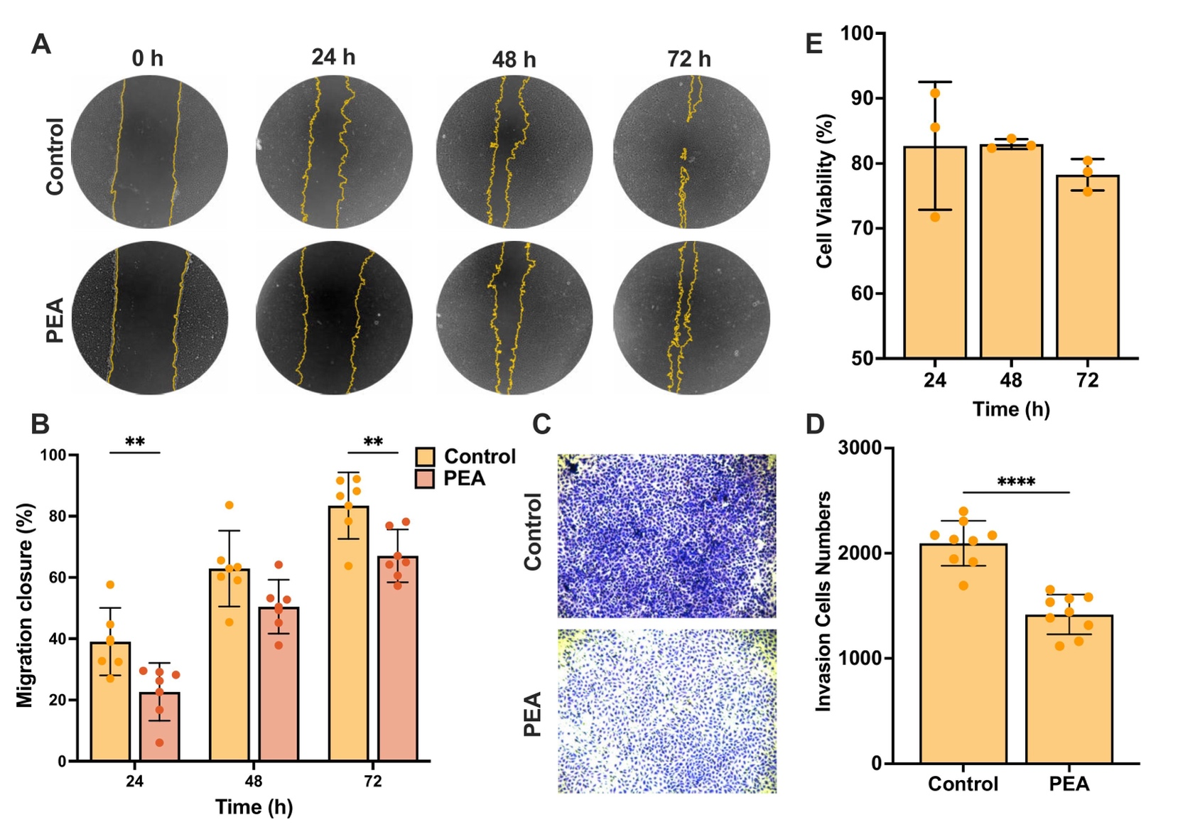
Figure S1 PEA inhibits the migration, invasion, and proliferation of T24 BC cells, including (A) Images of the wound healing assay indicating migration abilities of T24 BC cells treated with or without PEA at different time points; (B) Migration closure of T24 cells treated with or without PEA; (J) Images of transwell assay of T24 BC cells treated with or without PEA; (C) Invasion cells numbers of T24 BC cells treated with or without PEA; (L) CCK-8 assay showing the proliferation of T24 BC cells treated with or without PEA at 24 h, 48 h and 72 h (p = 0.0036). Statistical significance is indicated by asterisks (*p < 0.05, **p < 0.01, ***p < 0.001, ****p < 0.0001).
Abbreviations: PEA, pentadecanoic acid

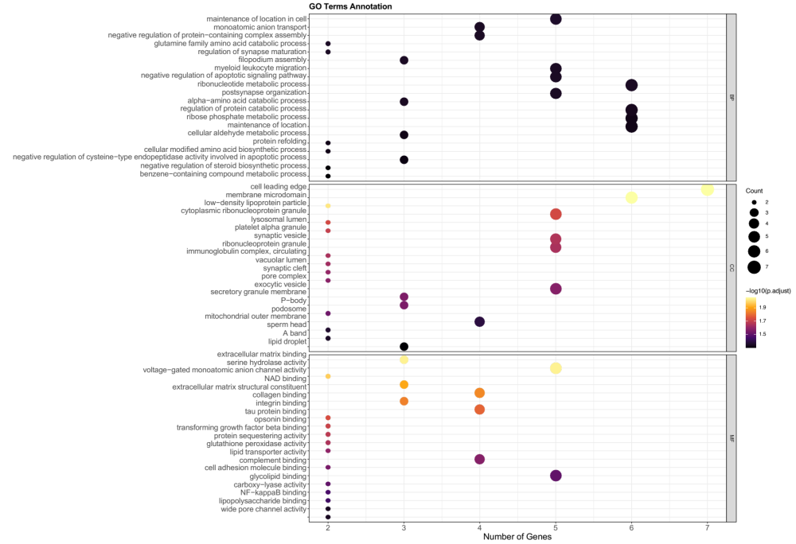
Figure S2 GO pathway enrichment analyses of 122 unique proteins identified. The size of the circles represents the number of genes associated with each GO pathway. The circle color indicates -Log₁₀ (adjusted p value), with darker colors reflecting higher significance.
Abbreviations: BP, biological process; CC, cellular component; MF, molecular function.
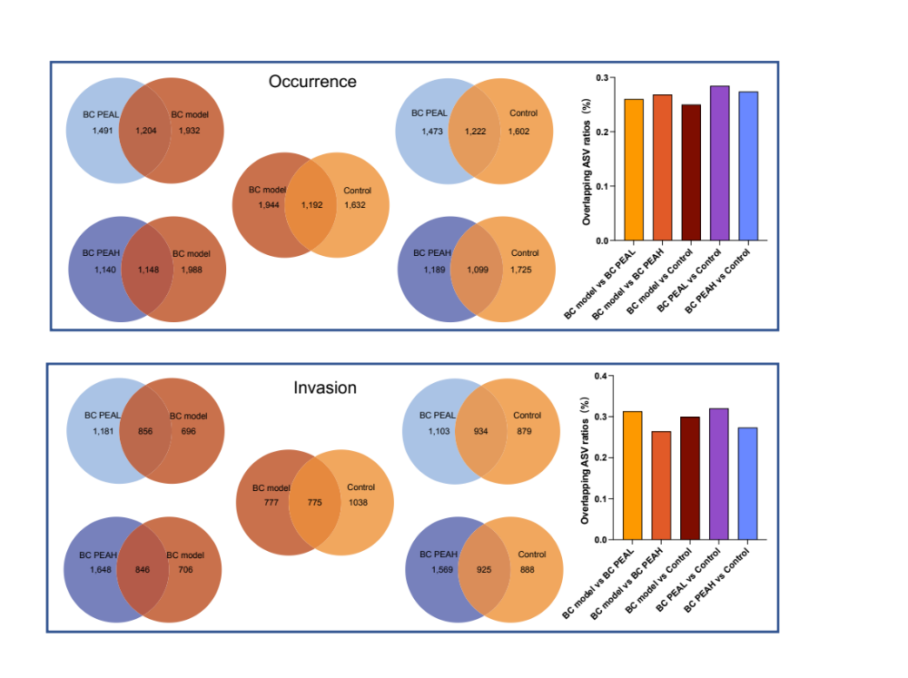
Figure S3 Venn analysis between groups of gut bacteria at BC occurrence and invasion stages. The Venn diagrams display overlaps of ASVs, while the bar plots show the percentage of shared ASVs, where y-axis represents the overlapping ASVs rates (%), and the x-axis lists the comparison groups. Higher bars indicate more shared ASVs, highlighting similarities between groups.
Abbreviations: ASV, amplicon sequence variants; BC PEAL, low-dose PEA-treated group; BC PEAH, high-dose PEA-treated group.
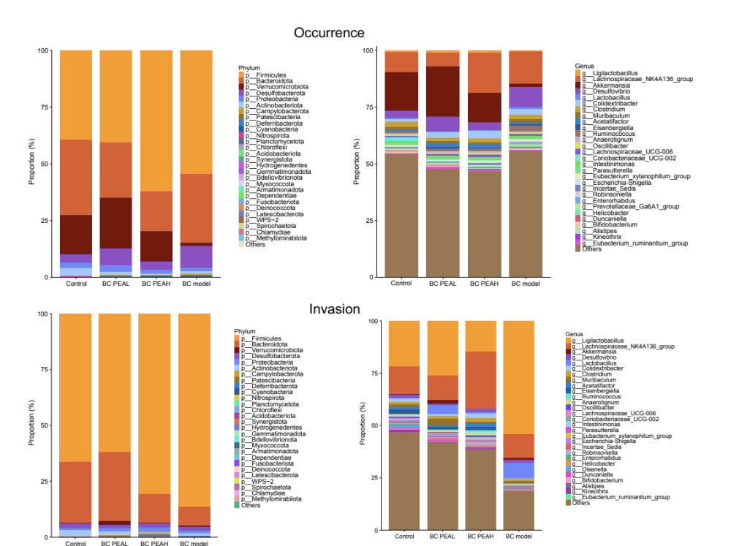
Figure S4 Phylum- and genus-level of relative abundance composition of gut bacteria at BC occurrence and invasion stages. The y-axis represents the relative abundance (%), while the x-axis lists the groups. Each color segment in the bars corresponds to a specific bacterial phylum or genus.
Abbreviations: BC PEAL, low-dose PEA-treated group; BC PEAH, high-dose PEA-treated group.
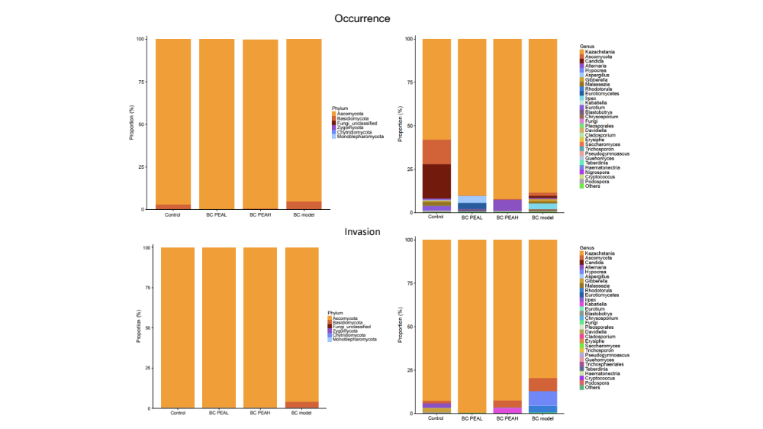
Figure S5 Phylum- and genus-level of relative abundance composition of gut fungi at BC occurrence and invasion stages. The y-axis represents the relative abundance (%), while the x-axis lists the groups. Each color segment in the bars corresponds to a specific fungi phylum or genus.
Abbreviations: BC PEAL, low-dose PEA-treated group; BC PEAH, high-dose PEA-treated group.

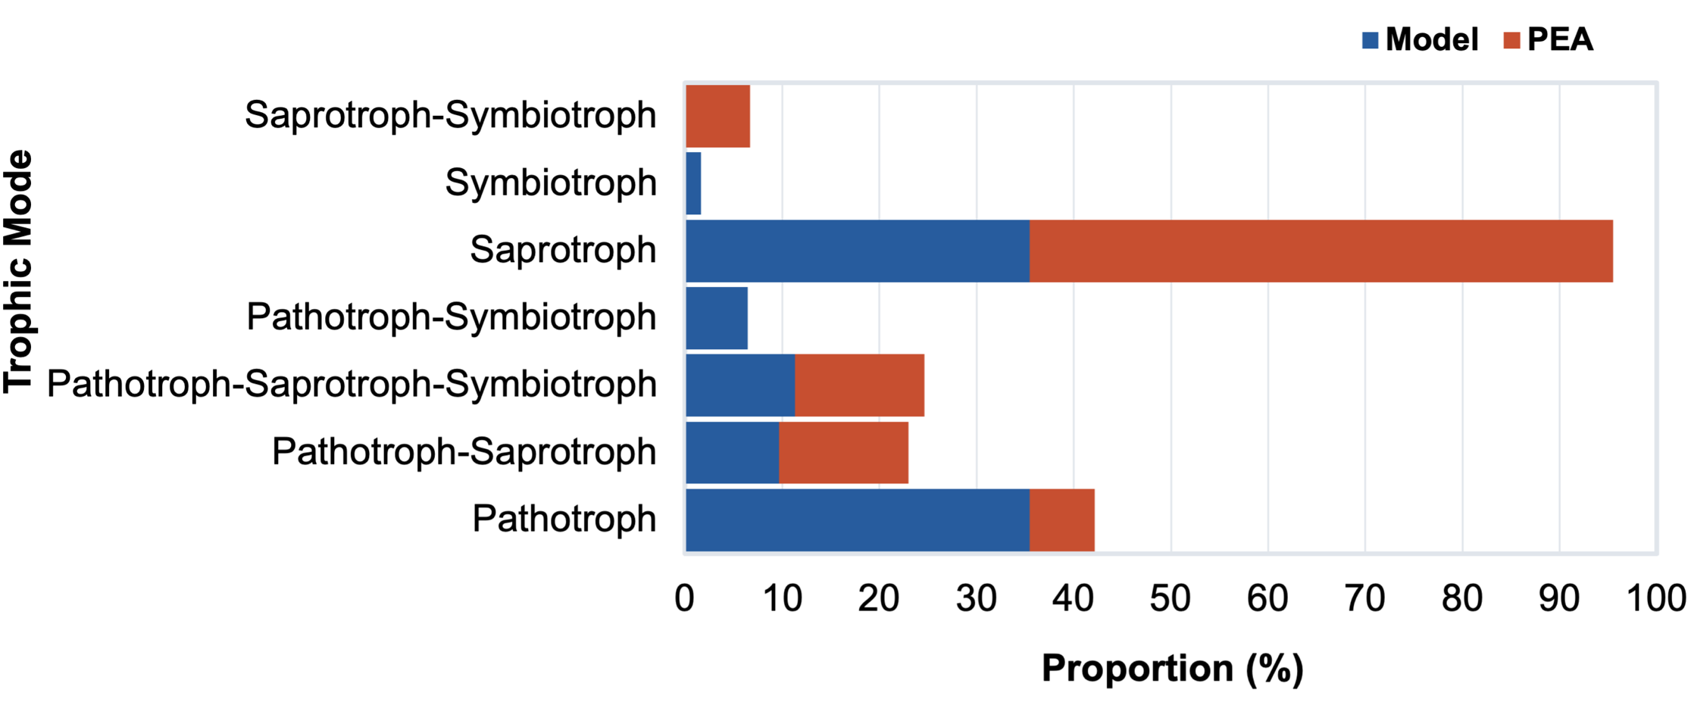

Figure S6 Functional profiling of PEA-DEFs based on FUNGuild analysis. Stacked bar plot shows the predicted trophic mode of fungal taxa that were more abundant in one group compared to the other (PEA-treated vs. BC model group) (below class level).

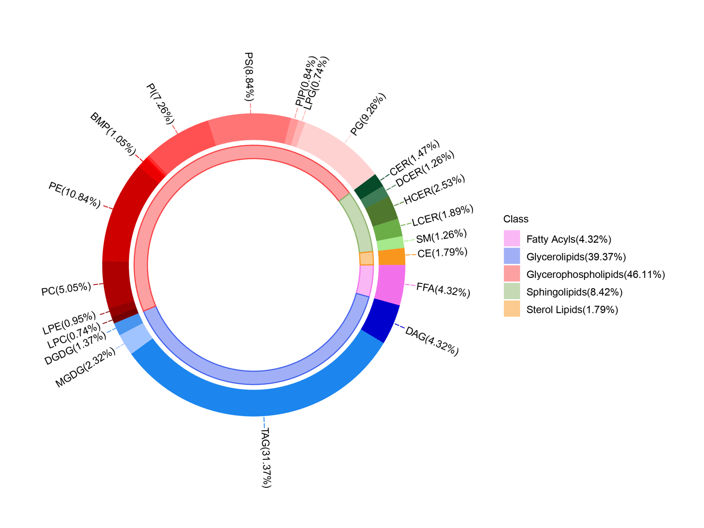

Figure S7 Relative abundance composition of fecal lipid species in the samples at the BC occurrence and invasion stages. The inner circle represents the major lipid classes, while the outer circle further categorizes lipids into multiple subtypes based on their head groups or other structural characteristics. The proportion of different lipid compositions provides an overall analysis of lipid distribution in the samples.
Abbreviations: TAG, Diacylglycerols; MGDG, Monogalactosyldiacylglycerol; DGDG, Digalactosyldiacylglycerol; LPC, Lysophosphatidylcholines; LPE, Lysophosphatidylethanolamines; PC, Phosphatidylcholines; PE, Phosphatidylethanolamines; BMP, Bis(monoacylglycero)phosphate; PI, Phosphatidylinositol; PS, Phosphatidylserine; PIP, Phosphatidylinositol phosphate; LPG, Lyso-phosphatidylglycerol; PG, Phosphatidylglycerol; CER, Ceramides; DCER, Dihydroceramides; HCER, Hexosylceramides; LCER, Lactosylceramides; SM, Sphingomyelins; CE, Cholesterol Esters; FFA, Free Fatty Acids; DAG, Diacylglycerols.

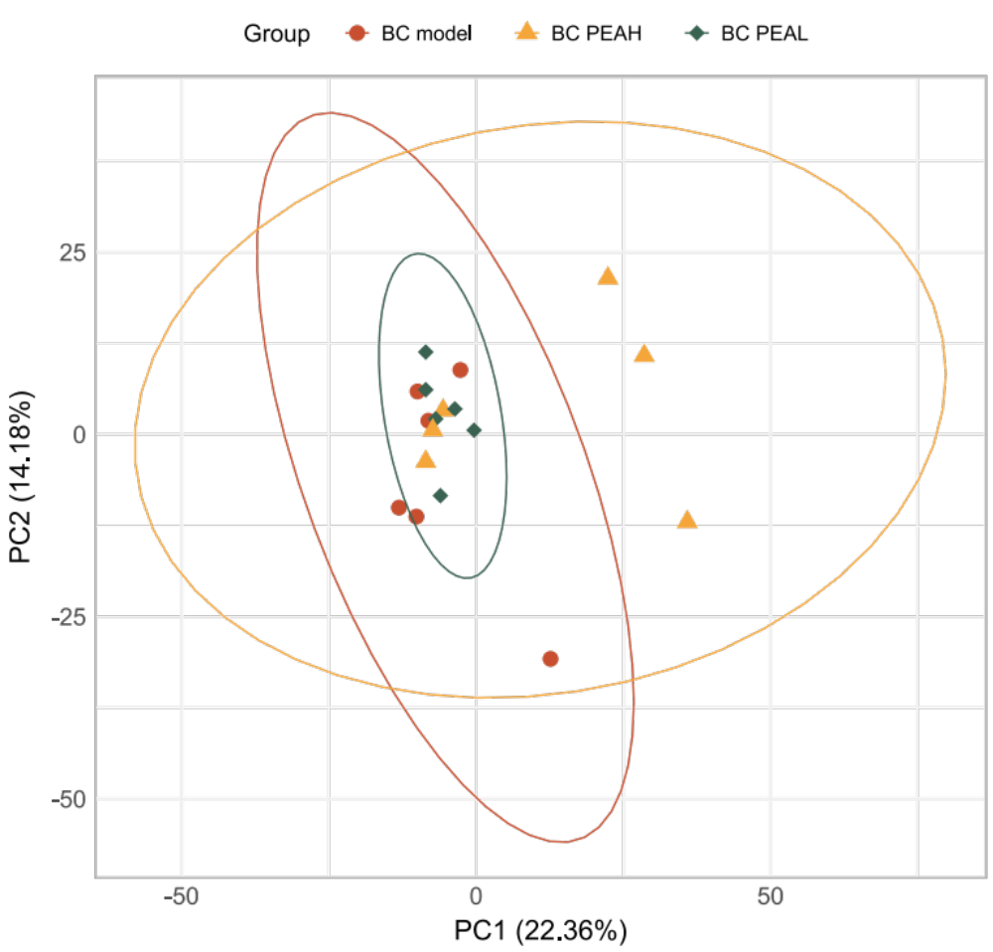
Figure S8 Principal component analysis (PCA) of fecal lipidomics in different groups. The x-axis (PC1) and y-axis (PC2) represent the first and second principal components, respectively, which explain the major variance in lipidomic profiles across samples. Each scatter point represents an individual sample, with different colors and shapes indicating distinct groups.
Abbreviations: BC PEAL, low-dose PEA-treated group; BC PEAH, high-dose PEA-treated group

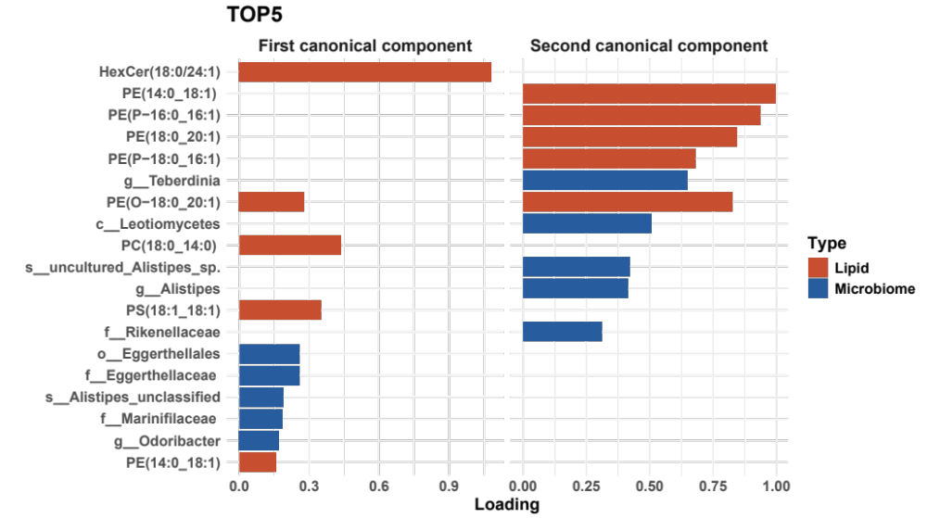
Figure S9 Sparse Canonical Correlation Analysis (sCCA) of PEA-DELs, PEA-DEBs, and PEA-DEFs. The plot displays the first and second canonical components derived from sCCA. Shown are the top 5 contributing pairs with the highest loadings for each component, highlighting the strongest associations among PEA-DELs, PEA-DEBs, and PEA-DEFs.
Abbreviations: PE, Phosphatidylethanolamines; PC, Phosphatidylcholines; PS, Phosphatidylserine.
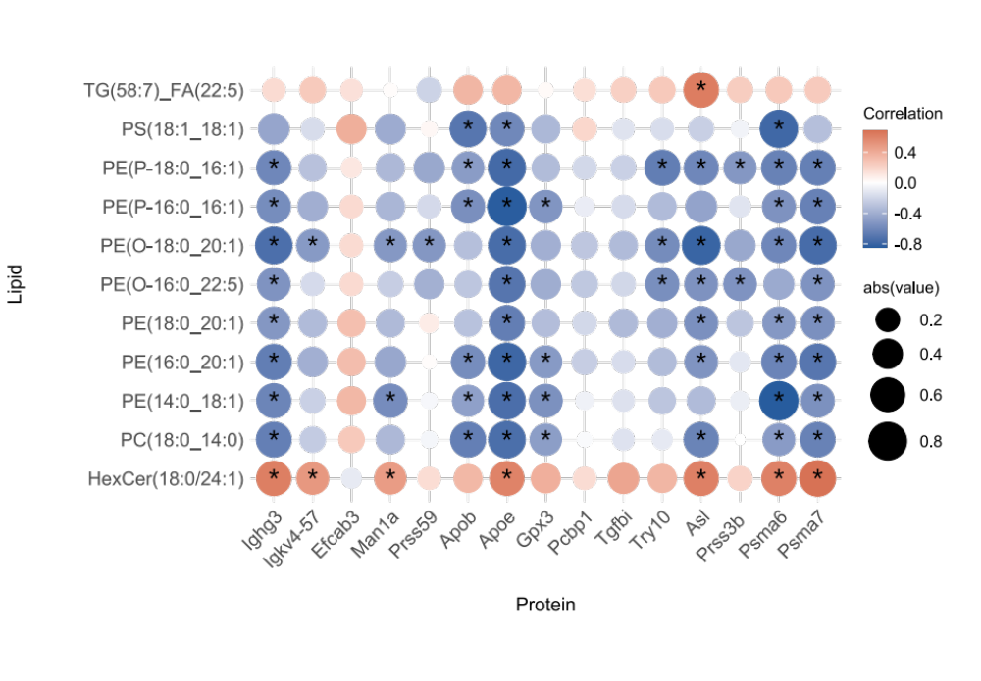
Figure S10 The Spearman correlation analysis between 11 PEA-DELs and PEA-DEPs. Correlation strength and direction are indicated by the color of the circles in the heatmap, with blue representing negative correlations and red representing positive correlations. The size of the circles reflects the absolute value of the correlation coefficient, with larger circles indicating stronger correlations. Asterisks indicate statistical significance (*p < 0.05).
Abbreviations: PEA-DEL, PEA-differentially enriched lipid; PEA-DEP, PEA-differentially expressed protein.

