Supplementary materials
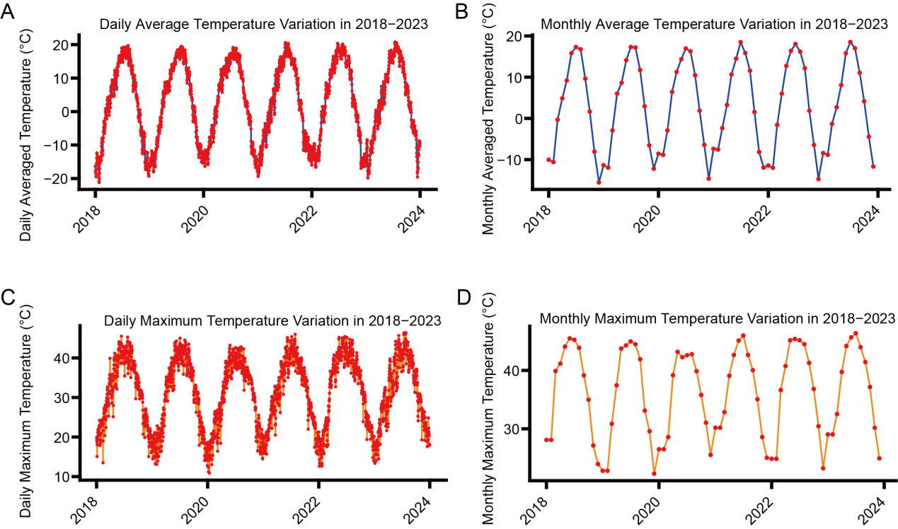
Supplementary Figures.
Figure S1 Temporal trends of mean temperature and maximum temperature in the study area from 2018 to 2023 (A)Temporal trends for daily average temperature (2) Temporal trends for monthly average temperature (3) Temporal trends for daily maximum temperature (4) Temporal trends for monthly maximum temperature

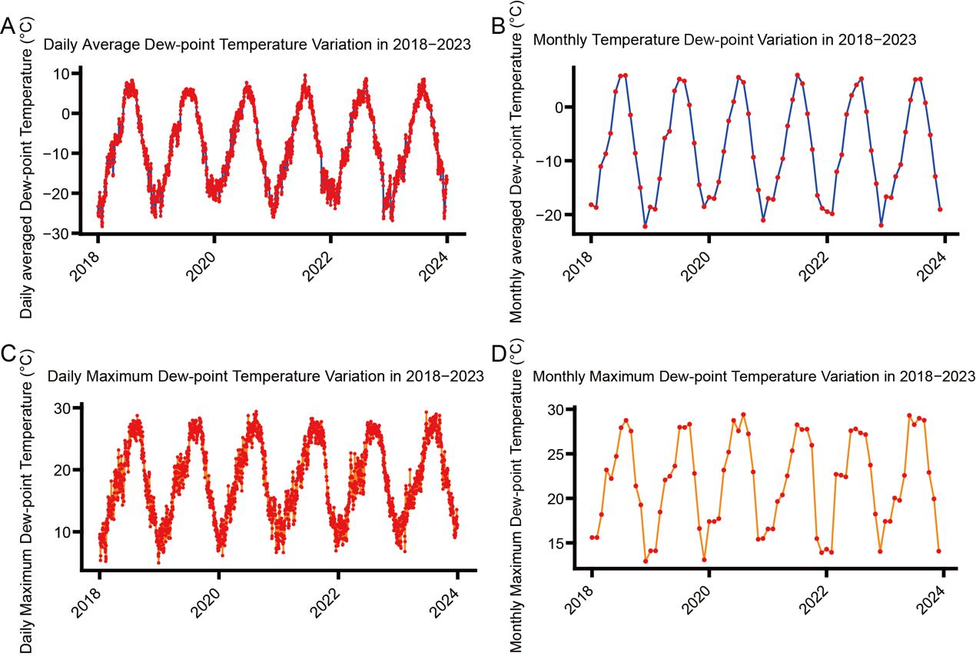
Figure S2 Temporal trends of mean dew-point temperature and maximum dew-point temperature in the study area from 2018 to 2023 (A)Temporal trends for daily average dew-point temperature (2) Temporal trends for monthly average temperature (3) Temporal trends for daily maximum dew-point temperature (4) Temporal trends for monthly maximum dew-point temperature

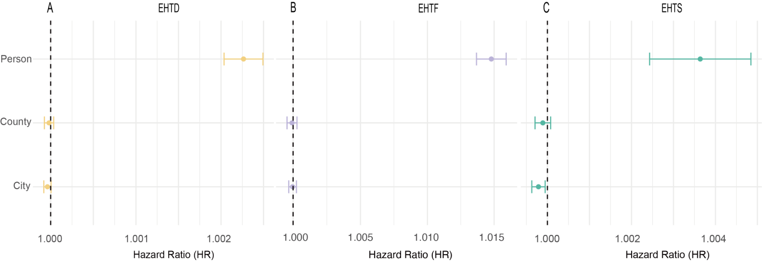
Figure S3 HRs of different indicators of extreme high temperature at individual, county and city threshold. (A-C) Hazard ratios for EHTD, EHTF and EHTS under thresholds of personal (street level), county and city level.
Cox model was used to explore the association between extreme high temperature and mortality, adjusting for age, sex, blood type, education level, ethnicity, marital status, occupation, body mass index (BMI), waist circumference, and residential area; annual average temperature, humidity, PM_{2.5} concentration, and O₃ concentration; frequency of physical exercise, smoking status, alcohol consumption frequency, and dietary habits; kitchen ventilation, fuel type, drinking water source, and toilet type. Numeric results were provided in Table 2.

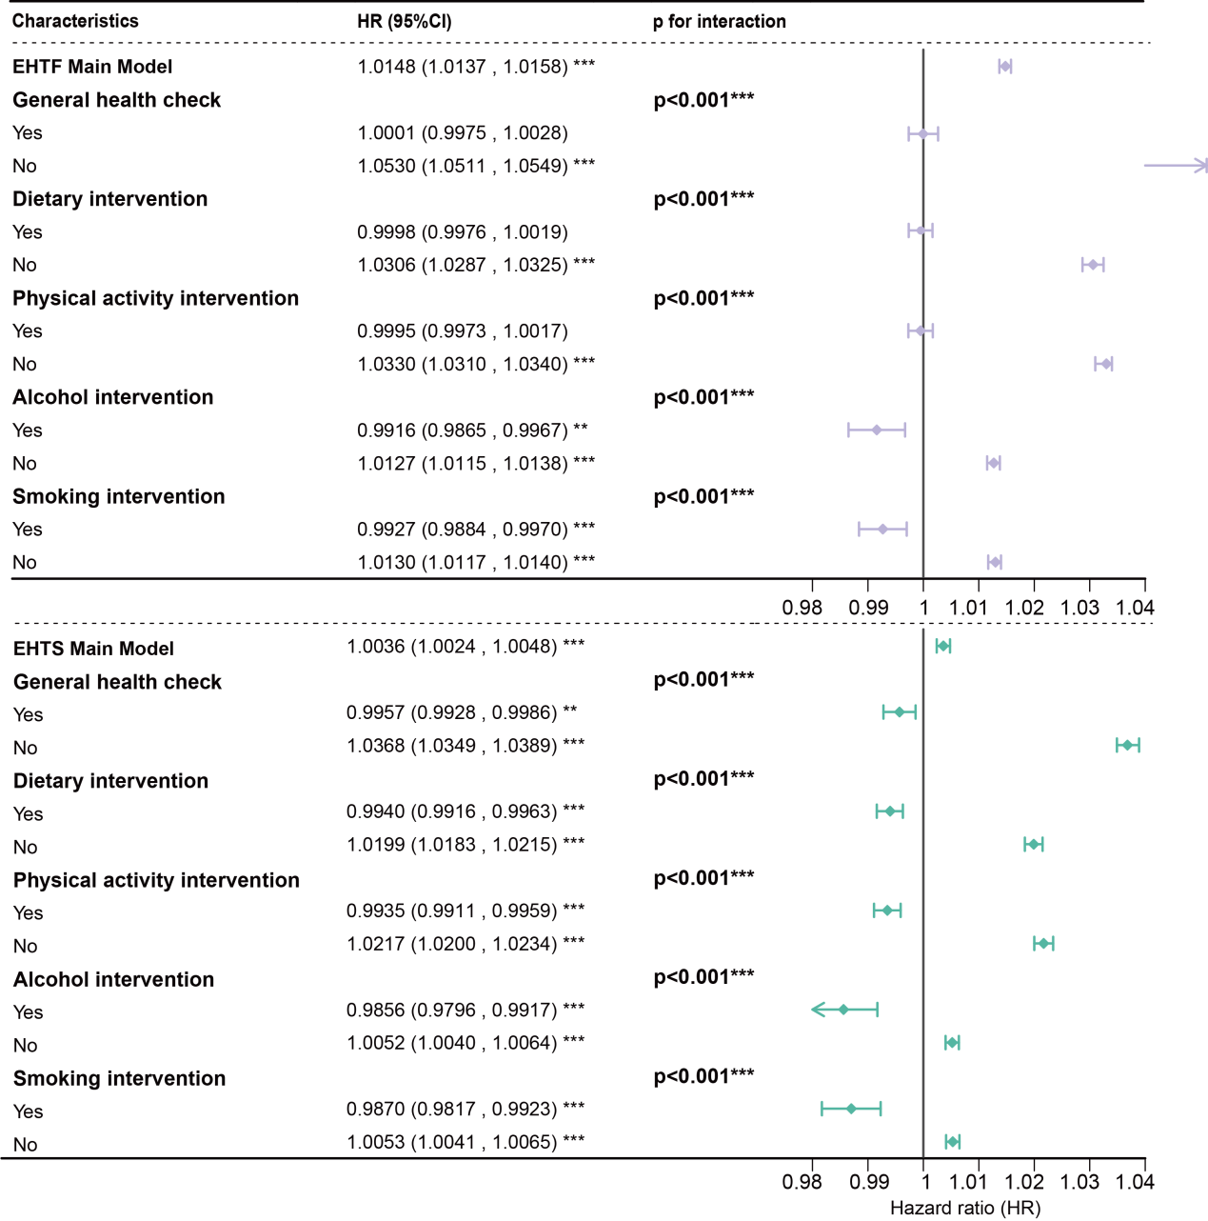
Figure S4 Different mortality risk associated extreme high temperature (EHTF and EHTS) between people with general health checks and people with no general health checks.

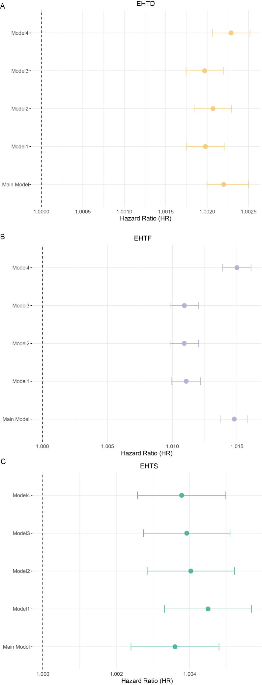
Figure S5 Sensitivity analysis of Model1-Model4. The difference between Model1 and main model was that Model1 excluded demographic variables from main model. The difference between Model2 and main model was that Model2 excluded environmental variables from main model. The difference between Model3 and main model was that Model3 excluded lifestyle-related variables from main model. The difference between Model4 and main model was that Model4 excluded household variables from main model.

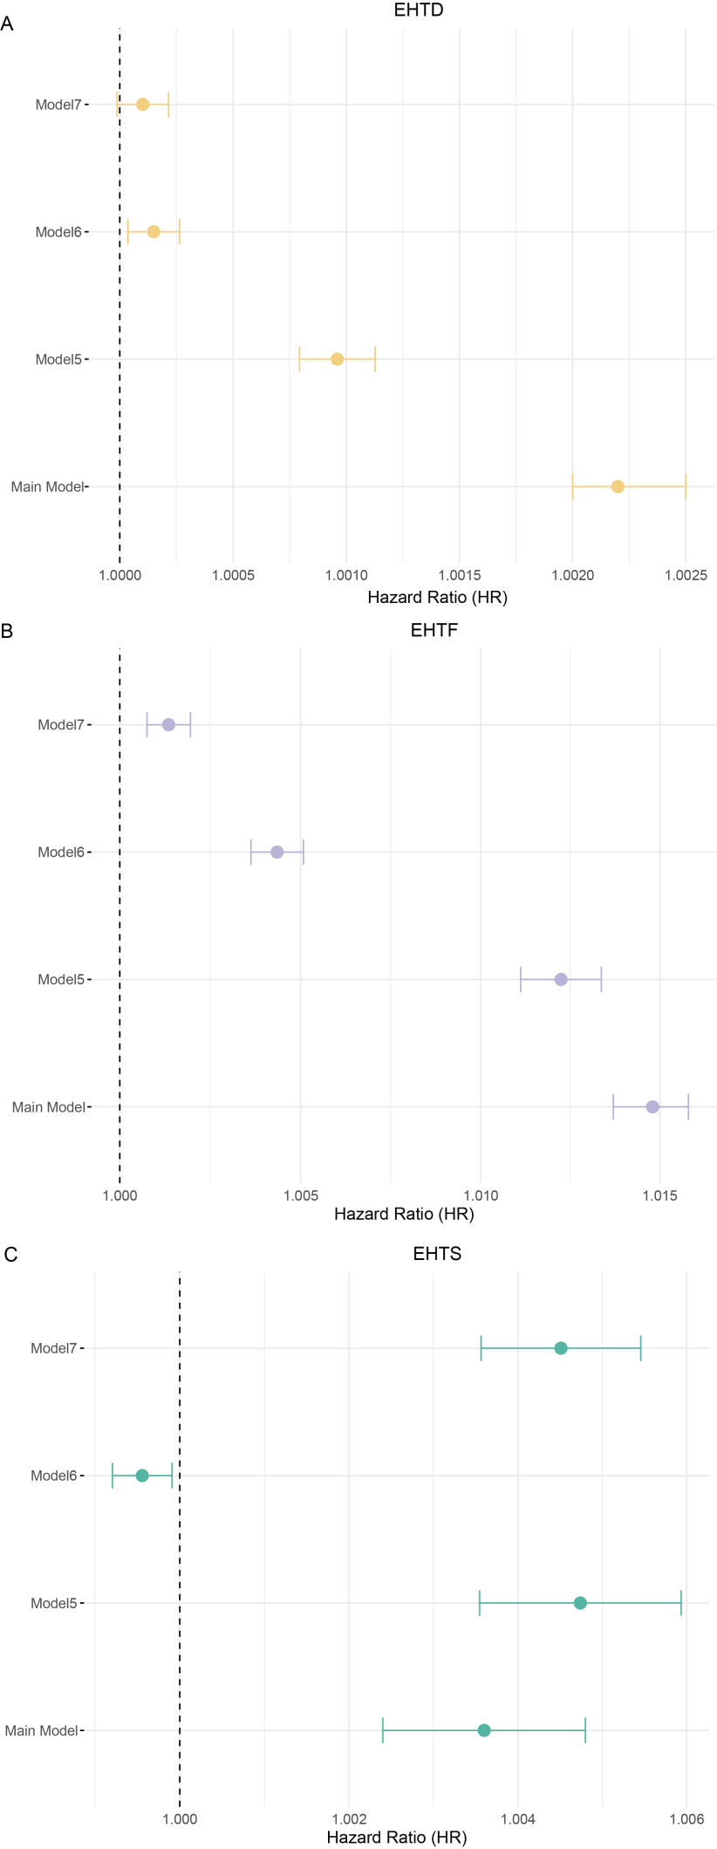
Figure S6 Sensitivity analysis of Model5-Model7. The difference between Model5 and main model was that Model5 calculated extreme high temperature data from a given year instead of a given summer. The difference between Model6 and main model was that Model6 altered the threshold for extreme high temperature to 98th percentiles instead of the 99th. The difference between Model6 and main model was that Model7 altered the threshold for extreme high temperature to 95th percentiles instead of the 99th.

Supplementary Tables.
Table S1. | Annual Health Exam Project
Patient ID ______________ Examiner _____________ Date____________
Items |  | PROJECTS
Part 1. General health status
Current symptoms:
1.None, 2.Headache, 3.Dizziness, 4.Palpitations, 5.Chest tightness, 6.Chest pain, 7.Chronic cough, 8.Sputum production, 9.Shortness of breath, 10.Excessive thirst, 11.Frequent urination, 12.Weight loss, 13.Fatigue, 14.Joint swelling and pain, 15.Blurred vision, 16.Numbness in hands or feet, 17.Urgency of urination, 18.Painful urination, 1.Constipation, 20.Diarrhea, 21.Nausea and vomiting, 22.Dizziness, 23.Tinnitus, 24.Breast tenderness, 25.Other
 | Temperature |  |  | ℃ | Pulse Rate | beats/min
 | Respiratory rate |  |  | beats/min | Blood Pressure | Left | / mmHg
 |  |  |  |  |  | Right | / mmHg
 | Height |  |  | cm | Weight | kg
 | Waist Circumference |  |  | cm | Body Mass Index (BMI) | Kg/m²
Part 2. Elderly health self-assessment
Elderly health self-assessment
1.Satisfied, 2. Basically satisfied, 3. Unclear, 4. Not very satisfied, 5. Dissatisfied
Elderly Self-assessment of ability to perform daily activities *
Independent [0–3 points],
Mild dependence [4–8 points],
Moderate dependence [9–18 points],
Unable to perform daily activities [≥19 points]
Elderly Cognitive function
1. Negative preliminary screening
2. Positive preliminary screening, total score from a simple mental state examination
Elderly Emotional state Emotional state*
1. Negative preliminary screening
2. Positive preliminary screening, total score from a depression rating scale for the elderly
Part 3. Lifestyle
 | Exercise |  | Frequency:  1.Daily, 2. More than once a week, 3.Occasionally, 4.No exercise
 |  |  | Duration of each exercise session: min |  |  | Years of consistent exercise: years
 |  |  | Type of exercise:
 | Diet |  | 1.Balanced diet, 2Mainly meat, 3. Mainly vegetarian,  4. Salt preference, 5. Oil preference, 6.Sugar preference
 | Smoking |  | Smoking status:  1.Never smoked, 2. Quit smoking, 3. Currently smoking
 |  |  | Daily smoking quantity:
 |  |  | Age started smoking: |  |  | Age quit smoking:
 | Drink |  | Frequency:  1.Never, 2. Occasionally,3. Regularly,4. Daily
 |  |  | Daily alcohol consumption:
Quit drinking or not:
1.Not Quit 2.Quit，Age quit drinking years:
 |  |  | Age started drinking: (year)
 |  |  | History of drunkenness in the past year: 1. Yes 2.No
Type of alcohol:
1.Liquor, 2. Beer, 3. Wine,4. Rice wine,5. Other
 | History of exposure to occupational disease hazards |  |  | History of exposure to occupational disease hazards:  1 None 2 Yes (work type: work duration: years)
Types of Toxic Substances:
1.Dust 2. Radioactive Substances 3.Physical Factors 4.Chemical Substances 5.Other
 |  |  |  | Protective Measures: 1. None 2. Have
Part 4. Physical examination
 | Oral Cavity |  |  | Lips: 1. Healthy pink, 2. Pale, 3. Cyanosis, 4. Chapped, 5. Herpes
 |  |  |  | Teeth: 1. Normal, 2. Missing teeth, 3. Caries, 4. Dentures (false teeth)
 |  |  |  | Throat: 1. No congestion, 2. Congested, 3. Lymph follicle hypertrophy
 | Vision |  |  | Left eye: ____  Right eye: ____  (Corrected vision: Left eye: ____ Right eye: ____)
 | Hearing |  |  | 1.Can hear  2.Cannot hear clearly or cannot hear at all
 | Motor Function |  |  | 1.Can complete movements  2.Cannot complete any movements independently
 | Fundoscopy (Eye Exam)* |  |  | 1.Normal 2. Abnormal
 | Skin |  |  | 1.Normal,2.Flushed,3.Pale,4.Cyanosis,5.Jaundice,6.Hyperpigmentation,7.Others
 | Sclera |  |  | 1.Normal 2. Jaundiced 3.Congested 4.Others:
 | Lymph Nodes |  |  | 1.Not palpable 2. Supraclavicular 3.Axillary 4.Others:
 | Lungs |  |  | Barrel Chest: 1. No 2. Yes
 |  |  |  | Breath Sounds: 1. Normal 2. Abnormal
 |  |  |  | Rales: 1. None 2. Dry rales 3. Wet rales 4. Others:
 | Heart |  |  | Heart Rate: ____ beats/min  Murmurs: 1. None 2. Present  Rhythm: 1. Regular 2. Irregular 3. Atrial fibrillation
 | Abdomen |  |  | Tenderness: 1.None 2.Present (describe)  Masses: 1.None 2.Present (describe)  Hepatomegaly: 1.None 2.Present (describe)  Splenomegaly: 1.None 2.Present (describe)  Shifting dullness: 1.None 2.Present (describe)
 | Lower Limb Edema |  |  | 1.None 2.Unilateral 3.Bilateral asymmetrical 4.Bilateral symmetrical
 | Dorsalis Pedis Artery Pulse |  |  | 1.Not palpable  2.Palpable, symmetrical  3.Palpable, weaker on the left or absent  4.Palpable, weaker on the right or absent
 | Digital Rectal Exam: |  |  | 1.No abnormalities 2.Tenderness 3.Masses 4.Prostate abnormalities 5.Others
 | Breast Exam |  |  | 1.No abnormalities 2.Mastectomy 3.Abnormal lactation 4.Breast lumps 5.Others
 | Gynecological Exam |  |  | External Genitalia: 1.No abnormalities 2.Abnormalities  Vagina: 1.No abnormalities 2.Abnormalities  Cervix: 1.No abnormalities 2.Abnormalities  Uterus: 1.No abnormalities 2.Abnormalities  Adnexa: 1.No abnormalities 2.Abnormalities
 | Others:*
Part 5. Biochemical tests
 | Blood Routine Test |  |  | Hemoglobin g/L White blood cells: ×109/L Platelets ×109/L Others
 | Urine Routine Test |  |  | Urine protein Urine glucose Urine ketones Urine occult blood Others
 | Fasting Blood Glucose |  |  | ____ mmol/L
 | Electrocardiogram (ECG) |  |  | 1.Normal 2.Abnormal (describe)
 | Fecal Occult Blood Tes |  |  | 1.Negative 2.Positive
 | Fecal Occult Blood Tes |  |  | 1.Negative 2.Positive
 | Glycosylated Hemoglobin (HbA1c) |  |  | %
 | Hepatitis B Surface Antigen |  |  | 1.Negative 2.Positive
 | Liver Function |  |  | Serum Alanine Aminotransferase (ALT): U/L  Albumin: g/L  Conjugated Bilirubin: μmol/L  Serum Aspartate Aminotransferase (AST): U/L  Total Bilirubin: μmol/L
 | Kidney Function |  |  | Serum Creatinine μmol/L  Blood Potassium mmol/L  Blood Urea Nitrogen (BUN) mmol/L  Blood Sodium mmol/L
 | Blood Lipids |  |  | Total Cholesterol(TC) mmol/L  Triglycerides(TG) mmol/L  Serum Low-Density Lipoprotein Cholesterol (LDL-C) mmol/L  Serum High-Density Lipoprotein Cholesterol (HDL-C) mmol/L
Part 6. Instrumental examinations
 | Chest X-Ray |  |  | 1.Normal 2.Abnormal (describe)
 | Ultrasound (B-Scan) |  |  | Abdominal Ultrasound: 1.Normal 2.Abnormal (describe)
 |  |  |  | Other 1.Normal 2.Abnormal (describe)
 | Cervical Smear |  |  | 1.Normal 2.Abnormal (describe)
 | Others
Part 7. Health Evaluation and Guidance
 | Cerebrovascular Diseases |  |  | 1.None found 2.Ischemic stroke 3.Cerebral hemorrhage 4.Subarachnoid hemorrhage 5.Transient ischemic attack 6.Other:
 | Kidney Diseases |  |  | 1.None found 2.Diabetic nephropathy 3.Renal failure 4.Acute nephritis 5.Chronic nephritis 6.Other:
 | Heart Diseases |  |  | 1.None found 2.Myocardial infarction 3.Angina pectoris 4.Coronary artery bypass grafting (CABG) 5.Congestive heart failure 6.Precordial pain 7.Other
 | Vascular Diseases |  |  | 1.None found 2.Aortic dissection 3.Arterial occlusive disease 4.Other
 | Eye Diseases |  |  | 1.None found 2.Retinal hemorrhage or exudation 3.Papilledema 4.Cataract 5.Other:
 | Neurological Diseases |  |  | 1.None found 2.Present (describe)
 | Other Systemic Diseases |  |  | 1.None found 2.Present (describe)
1.No abnormalities detected in the physical examination
2.Abnormalities detected:
Abnormality 1: _____
Abnormality 2: _____
Abnormality 3: _____
Abnormality 4: _____
 | 1.Included in chronic disease management  2.Recommended follow-up  3.Recommended referral |  |  | Risk Factor Control  1.Quit smoking  2.Healthy drinking  3.Diet  4.Exercise  5.Weight loss (Target: _____ Kg)  6.Recommended vaccination  7.Other: _____
 | 1.Included in chronic disease management  2.Recommended follow-up  3.Recommended referral |  |  | Risk Factor Control  1.Quit smoking  2.Healthy drinking  3.Diet  4.Exercise  5.Weight loss (Target: _____ Kg)  6.Recommended vaccination  7.Other: _____
Form Instructions:
1.This form is used for annual health check-ups of the elderly, patients with hypertension, type 2 diabetes, and severe mental disorders. It may also be used for general population health check-ups. However, it is not required for tuberculosis patients, pregnant women, or children aged 0-6 years.
2.General Condition:
- Body Mass Index (BMI) = weight (kg) / height squared (m²).
- Self-Care Ability Assessment for the Elderly: This item must be completed by people aged 65 and above. Please refer to the appendix of the elderly health management service specification (Supernumerary table 2).
- Cognitive Function Screening for the Elderly: Tell the examinee, "I am going to say the names of three objects (e.g., pencil, truck, book), please repeat them immediately." After one minute, ask the examinee to repeat the three object names again. If the examinee cannot immediately repeat them or cannot recall the three names after one minute, the result is considered positive, requiring further examination with the "Mini-Mental State Examination (MMSE)" scale (Supernumerary table 3).
- Emotional State Screening for the Elderly: Ask the examinee, "Do you often feel sad or depressed?" or "How is your mood?" If the answer is "Yes" or "I think it's not very good," the result is considered positive, requiring further examination using the "Geriatric Depression Scale (GDS) (Supernumerary table 4)."
3.Lifestyle:
- Physical Exercise: This refers to intentional exercise activities aimed at fitness. It does not include activities required for work or other needs, such as cycling to work or performing heavy physical labor. The most commonly used exercise method should be specified.
- Smoking Status: Those who have never smoked do not need to fill in the "daily cigarette consumption," "starting age of smoking," or "quitting age." Those who have quit smoking should fill in the relevant information about their smoking habits before quitting.
- Alcohol Consumption: Those who never drink do not need to fill in any other alcohol-related fields. Those who have quit drinking should fill in the relevant information before quitting. The daily alcohol consumption should be converted to equivalent white spirit amounts (Beer/10 = white spirit amount, Red wine/4 = white spirit amount, Yellow wine/5 = white spirit amount).
- Occupational Exposure: This refers to contact with chemicals, toxins, or radiation due to the patient's occupation. If present, specify the chemical, toxin, or radiation source, or fill in "unknown."
- History of Exposure to Occupational Disease Risk Factors: This refers to exposure to dust, radioactive materials, physical factors, or chemical substances due to the patient's occupation. If present, specify the specific dust, radioactive material, physical factors, or chemical substances, or fill in "unknown."
4. Organ Function:
- Vision: Record the specific value measured using the logarithmic vision chart (five-point scale). For those wearing glasses, measure the corrected vision while wearing their usual glasses.
- Hearing: Whisper "What is your name?" next to the examinee’s ear (ensure the examiner's face is out of the examinee's sight), and assess the hearing ability.
- Motor Function: Ask the examinee to perform the following actions: "Touch the back of your head with both hands," "Pick up this pen," "Stand up from the chair, walk a few steps, turn around, and sit down." These actions help assess the motor function.
5. Physical Examination:
If any abnormalities are found, specify them on the lines provided, such as the location and number of palpable lymph nodes, heart murmurs, or the size of the liver or spleen upon palpation. It is recommended that regions capable of conducting fundoscopy, especially for hypertensive or diabetic patients, perform the test.
Fundoscopy: If abnormalities are found, describe the specific results.
Dorsalis Pedis Artery Pulse: Diabetic patients must undergo this test.
Breast: Examine for any abnormalities in appearance, abnormal lactation, or lumps.
Gynecology:
  - External Genitalia: Record the development and reproductive status (e.g., unmarried, married without children, or multipara). If abnormalities are found, provide a detailed description.
  - Vagina: Record whether it is patent, the condition of the mucous membrane, the quantity, color, and characteristics of the discharge, and whether there is an odor.
  - Cervix: Record the size, texture, and whether there is erosion, tearing, polyps, or glandular cysts; and whether there is contact bleeding or tenderness.
  - Uterus: Record the position, size, texture, mobility, and whether there is tenderness.
  - Adnexa: Record whether there are any masses, thickening, or tenderness. If a mass is palpable, describe its position, size, texture, surface smoothness, mobility, tenderness, and relationship with the uterus and pelvic wall. Record findings for both sides separately.
6. Auxiliary Examinations:
This item is conducted based on local circumstances and for specific populations. Free auxiliary examinations for elderly patients, hypertensive patients, type 2 diabetes patients, and those with severe mental disorders are implemented according to the corresponding service specifications.
- Urine Routine: Record "negative" as "–," and "positive" based on the results as "+," "++," "+++," or "++++," or fill in quantitative results with measurement units.
- Fecal Occult Blood, Liver Function, Kidney Function, Chest X-ray, and Ultrasound (B-Scan) Results: If abnormalities are found, provide a detailed description of the abnormal results. For B-scan ultrasound, specify the examined area. Abdominal B-scan ultrasound is a free examination item for elderly individuals aged 65 and above.
- Other: Record any other auxiliary examination results not listed in the table under "Other."
7. Existing Major Health Problems:
This refers to diseases that have appeared or are continuously present and affect current health conditions. Multiple selections are allowed. If hypertension, diabetes, or other existing diseases are present or new diseases have been diagnosed, they should also be recorded in the medical history section of the individual's basic information.
8 Health Evaluation:
No abnormalities mean no newly diagnosed diseases, and existing diseases are well controlled without worsening or progression. If abnormalities are present, specify them, including conditions such as hypertension, diabetes, impaired self-care, and psychological screening abnormalities.
9. Health Guidance:
Chronic disease management includes regular follow-ups and health check-ups for key populations such as those with hypertension, diabetes, and severe mental disorders. The weight loss target refers to the specific weight reduction goal that should be achieved before the next health check-up, based on the individual’s condition.

Table S2. Elderly Self-Care Ability Assessment Form
This is a self-assessment form. The evaluation is based on five aspects as outlined in the table below. After summing the scores from each aspect, the results are interpreted as follows: 0 to 3 points: Independent, 4 to 8 points: Mild dependence, 9 to 18 points: Moderate dependence, ≥19 points: Unable to care for oneself.
Assessment Items  Content and Scoring | Level of Dependence |  |  |  | Scoring
Assessment Items  Content and Scoring | Independent | Mild dependence | Moderate dependence | Unable to care for oneself | Scoring
Eating: Activities such as using utensils to bring food to the mouth, chewing, and swallowing. | Independently completed | - | Requires assistance, such as cutting or mixing food | Completely needs assistance;
Scoring | 0 | 0 | 3 | 5
Grooming: Activities such as combing hair, washing the face, brushing teeth, shaving, and bathing. | Independently completed | Can independently wash hair, comb hair, wash face, brush teeth, and shave; requires assistance for bathing | With assistance and within an appropriate amount of time, can complete part of the grooming activities. | Completely needs assistance;
Scoring | 0 | 1 | 3 | 7
Dressing: Activities such as putting on clothes, pants, socks, and shoes | Independently completed | - | Requires assistance and can complete part of the dressing within an appropriate time; | Completely needs assistance;
Scoring | 0 | 0 | 3 | 5
Toileting: Activities related to urination, defecation, and self-control. | No assistance needed, self-controllable | Occasional incontinence, but generally able to use the toilet or a bedpan | Frequent incontinence, but can still use the toilet or bedpan with frequent reminders and assistance; | complete incontinence, fully requires assistance
Scoring | 0 | 0 | 5 | 10
Mobility: Activities such as standing, walking indoors, climbing stairs, and outdoor activities. | Independently completes all activities | Can complete standing, walking, and climbing stairs with minor assistance or the use of assistive devices | Needs significant physical assistance to stand and walk, unable to climb stairs. | Bedridden, all activities require full assistance
Scoring | 0 | 0 | 5 | 10
Total score

Table S3. | The Mini-Mental State Exam¹
Patient ID ______________ Examiner _____________ Date____________
Items | Describe | Maximum  score | Scoring
Orientation | What is the (year) (season) (date) (day) (month)? | 5
Orientation | Where are we (state) (country) (town) (hospital) (floor)? | 5
Registration | Name 3 objects: 1 second to say each. Then ask the patient.  all 3 after you have said them. Give 1 point for each correct answer.  Then repeat them until he/she learns all 3. Count trials and record. | 3
Attention and Calculation | Serial 7’s. 1 point for each correct answer. Stop after 5 answers. | 5
Recall | Ask for the 3 objects repeated above. Give 1 point for each correct answer | 3
Language | Name a pencil and watch | 2
Language | Repeat a sentence | 1
Language | Follow a 3-stage command:“Take a paper in your hand, fold it in half, and put it on the floor.” | 3
Language | Read and obey the following: CLOSE YOUR EYES | 1
Language | Write a sentence. | 1
Language | Copy the design shown. | 1
Total score |  | 30

Table S4. | Geriatric Depression Scale^{2,3}
Patient ID ______________ Examiner _____________ Date____________
Instructions: Choose the answer that best reflects how you have felt over the past week. (Yes, No)
- Are you generally satisfied with your life? (No)
- Have you dropped many of your activities and interests? (Yes)
- Do you feel your life is empty? (Yes)
- Do you often feel bored? (Yes)
- Do you feel hopeful about the future? (No)
- Are you bothered by thoughts you can't get out of your head? (Yes)
- Do you feel full of energy most of the time? (No)
- Are you afraid something bad is going to happen to you? (Yes)
- Do you feel happy most of the time? (No)
- Do you often feel helpless? (Yes)
- Do you frequently feel restless and can’t sit still? (Yes)
- Do you prefer to stay at home rather than doing new things? (Yes)
- Do you frequently worry about the future? (Yes)
- Do you feel your memory is worse than it used to be? (Yes)
- Do you find life to be wonderful now? (No)
- Do you often feel downhearted and blue? (Yes)
- Do you feel that your life is meaningless as it is now? (Yes)
- Do you often feel troubled by things from the past? (Yes)
- Do you find life exciting? (No)
- Is it hard for you to start new projects? (Yes)
- Do you feel full of life? (No)
- Do you feel that your situation is hopeless? (Yes)
- Do you feel that most people are better off than you? (Yes)
- Do you often get upset over little things? (Yes)
- Do you frequently feel like crying? (Yes)
- Do you have trouble concentrating? (Yes)
- Do you feel cheerful in the morning? (No)
- Do you avoid social gatherings? (Yes)
- Is it easy for you to make decisions? (No)
- Is your mind as clear as it used to be? (No)
Scoring:
Each response in parentheses after the question indicates depression, and a matching answer receives 1 point.
- 0-10 points: Normal
- 11-20 points: Mild depression
- 21-30 points: Moderate to severe depression
Total score:

Table S5 | Statics of the death records
Variables | Observation | Mean | Std.Dev. | Missing  Observation
Death | 224900
Age (years old) | 224900 | 68.45 | 14.42 | 0
BMI (kg/m²) | 221823 | 24.82 | 13.30 | 3077
Waist Circumference (cm) | 222151 | 87.22 | 4.58 | 2749
SBP (mmHg) | 222929 | 132.8 | 22.54 | 1971
DBP (mmHg) | 222840 | 77.94 | 13.08 | 2060
FBG (mmol/L) | 220258 | 6.069 | 2.78 | 4642
TG (mmol/L) | 219209 | 1.468 | 0.94 | 5691
TC (mmol/L) | 218915 | 4.517 | 1.19 | 5985
Hypertension  Yes  No | 116910 (51.98%)  105972 (47.12%) |  |  | 2018
Unknown | 2018 (0.90%)
Hyperglycemia  Yes  No | 90732 (40.34%)  129526 (57.59%) |  |  | 4624
Unknown | 4642 (2.06%)
Hyperlipidemia  Yes  No | 84998 (37.79%)  134001 (59.58%) |  |  | 5901
Unknown | 5901 (2.62%)
Gender  Male  Female | 129133 (57.42%)  95767 (42.58%) |  |  | 0
Education  Junior high school and below  Secondary school or high school  College or above | 201258 (89.49%)  14550 (6.47%)  5014 (2.23%) |  |  | 4078
Unknown | 4078 (1.81%)
Marriage Status  Married  Divorced  Widowed  Not married | 173463 (77.13%)  5081 (2.26%)  38889 (17.29%)  6900 (3.07%) |  |  | 567
Unknown | 567 (0.25)
Area  Urban  Rural | 53273 (23.69%)  171627 (76.31%) |  |  | 0
Physical activity frequency  Never  Occasionally  More than once a week  Everyday | 198161 (88.11%)  6311 (2.81%)  3469 (1.54%)  14841 (6.60%) |  |  | 2118
Unknown | 2118 (0.94%)
Smoking Status  Never  Currently smoking  Quit smoking | 194945 (86.68%)  23153 (10.29%)  3890 (1.73%) |  |  | 2912
Unknown | 2912 (1.29%)
Alcohol frequency  Never  Occasionally  Often  Everyday | 205883 (91.54%)  13173 (5.86%)  1357 (0.60%)  481 (0.21%) |  |  | 4006
Unknown | 4006 (1.78%)
Dietary  Balanced diet  More Meat  More vegetarian food | 191683 (85.23%)  8031 (3.57%)  7726 (3.43%) |  |  | 17460
Unknown | 17460 (7.76%)

Table S6 The differences mortality rates associated with extreme high temperature between hypertension, hyperglycemia hyperlipidemia and normal people.
Group | HR | Lower_95%CI | Upper_95%CI | p for interaction
EHTD Main Model | 1.0022 | 1.0020 | 1.0025
Hypertensionª |  |  |  | p<0.001***
Yes | 1.0024 | 1.0020 | 1.0029
No | 1.0017 | 1.0014 | 1.0020
Hyperglycemia^{b} |  |  |  | p<0.001***
Yes | 1.0026 | 1.0022 | 1.0031
No | 1.0016 | 1.0013 | 1.0019
Hyperlipidemia^{c} |  |  |  | p<0.001***
Yes | 1.0026 | 1.0022 | 1.0030
No | 1.0019 | 1.0016 | 1.0022
EHTF Main Model | 1.0148 | 1.0137 | 1.0159
Hypertension |  |  |  | p=0.13
Yes | 1.0123 | 1.0102 | 1.0144
No | 1.0111 | 1.0096 | 1.0126
Hyperglycemia |  |  |  | p<0.001***
Yes | 1.0142 | 1.0121 | 1.0162
No | 1.0092 | 1.0078 | 1.0105
Hyperlipidemia |  |  |  | p<0.01**
Yes | 1.0132 | 1.0112 | 1.0154
No | 1.0111 | 1.0098 | 1.0125
EHTS Main Model | 1.0036 | 1.0024 | 1.0048
Hypertension |  |  |  | p<0.001***
Yes | 1.0060 | 1.0036 | 1.0084
No | 1.0023 | 1.0007 | 1.0039
Hyperglycemia |  |  |  | p<0.001***
Yes | 1.0078 | 1.0054 | 1.0101
No | 1.0017 | 1.0002 | 1.0031
Hyperlipidemia |  |  |  | p<0.01**
Yes | 1.0067 | 1.0043 | 1.0090
No | 1.0038 | 1.0024 | 1.0053
Notes: Hypertension, hyperglycemia and hyperlipidemia are all defined at baseline.
ª Hypertension was defined as systolic blood pressure higher than 130 mmHg or diastolic blood pressure higher than 90 mmHg at baseline.
^{b} Hyperglycemia was defined as fast blood-glucose higher than 5.6 mmol/L at baseline.
^{c} Hyperlipidemia was defined as total cholesterol higher than 5.2 mmol/L or triglyceride higher than 1.7 mmol/L at baseline.

Table S7 | Subgroup analysis of EHTD
Group | HR | lower | upper | HR (95%CI) | p for interaction
Main Model | 1.0022 | 1.002 | 1.0025 | 1.0022 (1.0020, 1.0025) ***
Age |  |  |  |  | p<0.001***
Below 60 years old | 0.9995 | 0.9991 | 0.9998 | 0.9995 (0.9991, 0.9998) **
Above 60 years old | 1.0027 | 1.0022 | 1.0033 | 1.0027 (1.0022, 1.0033) ***
Gender |  |  |  |  | No significant
Female | 1.0023 | 1.0018 | 1.0027 | 1.0023 (1.0018, 1.0027) ***
Male | 1.0021 | 1.0018 | 1.0023 | 1.0021 (1.0018, 1.0023) ***
Area |  |  |  |  | p<0.001***
Rural | 1.0012 | 1.0006 | 1.0016 | 1.0012 (1.0006, 1.0016) ***
Urban | 1.0053 | 1.0049 | 1.0057 | 1.0053 (1.0049, 1.0057) ***
Humidity |  |  |  |  | p<0.001***
Below average humidity | 1.0017 | 1.0014 | 1.0019 | 1.0017 (1.0014, 1.0019) ***
Above average humidity | 1.0027 | 1.0023 | 1.0032 | 1.0027 (1.0023, 1.0032) ***
Temperature |  |  |  |  | p<0.001***
Below average temperature | 1.0029 | 1.0025 | 1.0032 | 1.0029 (1.0022, 1.0032) ***
Above average temperature | 1.0018 | 1.0013 | 1.0022 | 1.0018 (1.0013, 1.0022) ***

Table S8 | Subgroup analysis of EHTE
Group | HR | low | up | HR (95%CI) | p for interaction
Main Model | 1.0148 | 1.0137 | 1.0158 | 1.0148 (1.0137, 1.0158) ***
Age |  |  |  |  | p<0.001***
Below 60 years old | 1.0037 | 1.0019 | 1.0054 | 1.0037 (1.0019, 1.0054) **
Above 60 years old | 1.016 | 1.0134 | 1.0185 | 1.0160 (1.0134, 1.0185) ***
Gender |  |  |  |  | No significant
Female | 1.0127 | 1.0114 | 1.014 | 1.0127 (1.0114, 1.0140) ***
Male | 1.0116 | 1.0096 | 1.0137 | 1.0116 (1.0009, 1.0137) ***
Area |  |  |  |  | p<0.001***
Rural | 1.0067 | 1.0041 | 1.0093 | 1.0067 (1.0041, 1.0093) ***
Urban | 1.029 | 1.0271 | 1.0308 | 1.0290 (1.0271, 1.0308) ***
Humidity |  |  |  |  | p<0.001***
Below average humidity | 1.0098 | 1.0084 | 1.0112 | 1.0098 (1.0084, 1.0112) ***
Above average humidity | 1.0143 | 1.0122 | 1.0165 | 1.0143 (1.0220, 1.0165) ***
Temperature |  |  |  |  | p<0.001***
Below average temperature | 1.0159 | 1.0143 | 1.0175 | 1.0159 (1.0143, 1.0175) ***
Above average temperature | 1.0105 | 1.0083 | 1.0128 | 1.0105 (1.0083, 1.0128) ***

Table S9 | Subgroup analysis of EHTS
Group | HR | low | up | HR (95%CI) | P for interaction
Main Model | 1.0036 | 1.0024 | 1.0048 | 1.0036 (1.0024, 1.0048) ***
Age |  |  |  |  | p<0.001***
Below 60 years old | 0.9925 | 0.9904 | 0.9945 | 0.9925 (0.9904, 0.9945) **
Above 60 years old | 1.0076 | 1.0047 | 1.0106 | 1.0076 (1.0047, 1.0106) ***
Gender |  |  |  |  | No significant
Female | 1.005 | 1.0027 | 1.0074 | 1.0050 (1.0027, 1.0074) ***
Male | 1.0045 | 1.0031 | 1.0059 | 1.0045 (1.0031, 1.0059) ***
Area |  |  |  |  | p<0.001***
Rural | 1.0016 | 0.9985 | 1.0046 | 1.0016 (0.9985, 1.0046)
Urban | 1.0166 | 1.0145 | 1.0187 | 1.0166 (1.0145, 1.0187) ***
Humidity |  |  |  |  | p<0.001***
Below average humidity | 1.0011 | 0.9996 | 1.0025 | 1.0011 (0.9996, 1.0025)
Above average humidity | 1.0094 | 1.007 | 1.0117 | 1.0094 (1.0070, 1.0117) ***
Temperature |  |  |  |  | p<0.001***
Below average temperature | 1.0083 | 1.0065 | 1.01 | 1.0083 (1.0065, 1.0100) ***
Above average temperature | 1.0029 | 1.0003 | 1.0055 | 1.0029 (1.0003, 1.0055) *

Table S10 | Effects of general health checks on EHTD
Group | HR | low | up | HR (95%CI) | P for interaction
Main Model | 1.0022 | 1.002 | 1.0025 | 1.0022 (1.0020, 1.0025) ***
General health check |  |  |  |  | p<0.001***
Yes | 1 | 0.9995 | 1.0005 | 1.0000 (0.9995, 1.0005)
No | 1.0094 | 1.009 | 1.0098 | 1.0094 (1.0090, 1.0098) ***
Dietary intervention |  |  |  |  | p<0.001***
Yes | 0.9998 | 0.9993 | 1.0002 | 0.9998 (0.9993, 1.0002)
No | 1.0056 | 1.0053 | 1.0059 | 1.0056 (1.0053, 1.0059) ***
Physical activity intervention |  |  |  |  | p<0.001***
Yes | 0.9997 | 0.9993 | 1.0001 | 0.9997 (0.9993, 1.0001)
No | 1.006 | 1.0057 | 1.0063 | 1.0060 (1.0057, 1.0063) ***
Alcohol intervention |  |  |  |  | p<0.001***
Yes | 0.9982 | 0.9971 | 0.9992 | 0.9982 (0.9971, 0.9992) **
No | 1.0023 | 1.002 | 1.0025 | 1.0023 (1.0020, 1.0025) ***
Smoking intervention |  |  |  |  | p<0.001***
Yes | 0.9983 | 0.9974 | 0.9992 | 0.9983 (0.9974, 0.9992) ***
No | 1.0023 | 1.002 | 1.0025 | 1.0023 (1.0020, 1.0025) ***
Weight intervention |  |  |  |  | p = 0.43
Yes | 1.002 | 1.0015 | 1.0025 | 1.0020 (1.0015, 1.0025) ***
No | 1.0022 | 1.002 | 1.0024 | 1.0022 (1.0020, 1.0024) ***

Table S11 | Effects of general health checks on EHTF
Group | HR | low | up | HR (95%CI) | P for interaction
Main Model | 1.0148 | 1.0137 | 1.0158 | 1.0148 (1.0137, 1.0158) ***
General health check |  |  |  |  | p<0.001***
Yes | 1 | 0.9995 | 1.0005 | 1.0000 (0.9995, 1.0005)
No | 1.0368 | 1.0349 | 1.0389 | 1.0094 (1.0090, 1.0098) ***
Dietary intervention |  |  |  |  | p<0.001***
Yes | 0.9998 | 0.9976 | 1.0019 | 0.9998 (0.9993, 1.0002)
No | 1.0306 | 1.0287 | 1.0325 | 1.0056 (1.0053, 1.0059) ***
Physical activity intervention |  |  |  |  | p<0.001***
Yes | 0.9995 | 0.9973 | 1.0017 | 0.9995 (0.9973, 1.0017)
No | 1.033 | 1.031 | 1.034 | 1.0033 (1.0031, 1.0034) ***
Alcohol intervention |  |  |  |  | p<0.001***
Yes | 0.9916 | 0.9865 | 0.9967 | 0.9916 (0.9865, 0.9967) **
No | 1.0127 | 1.0115 | 1.0138 | 1.0127 (1.0115, 1.0138) ***
Smoking intervention |  |  |  |  | p<0.001***
Yes | 0.9927 | 0.9884 | 0.997 | 0.9927 (0.9884, 0.9970) ***
No | 1.013 | 1.0117 | 1.014 | 1.0130 (1.0117, 1.0140) ***
Weight intervention |  |  |  |  | p = 0.26
Yes | 1.011 | 1.0085 | 1.0136 | 1.0110 (1.0085, 1.0136) ***
No | 1.0124 | 1.0111 | 1.0135 | 1.0124 (1.0111, 1.0135) ***

Table S12 | Effects of general health checks on EHTS
Group | HR | low | up | HR (95%CI) | P for interaction
Main Model | 1.0036 | 1.0024 | 1.0048 | 1.0036 (1.0024, 1.0048) ***
General health check |  |  |  |  | p<0.001***
Yes | 0.9957 | 0.9928 | 0.9986 | 0.9957 (0.9928, 0.9986) **
No | 1.0368 | 1.0349 | 1.0389 | 1.0368 (1.0349, 1.00389) ***
Dietary intervention |  |  |  |  | p<0.001***
Yes | 0.994 | 0.9916 | 0.9963 | 0.9940 (0.9916, 0.9963) ***
No | 1.0199 | 1.0183 | 1.0215 | 1.0199 (1.0183, 1.0215) ***
Physical activity intervention |  |  |  |  | p<0.001***
Yes | 0.9935 | 0.9911 | 0.9959 | 0.9935 (0.9911, 0.9957) ***
No | 1.0217 | 1.02 | 1.0234 | 1.0217 (1.0200, 1.0234) ***
Alcohol intervention |  |  |  |  | p<0.001***
Yes | 0.9856 | 0.9796 | 0.9917 | 0.9916 (0.9865, 0.9967) ***
No | 1.0052 | 1.004 | 1.0064 | 1.0052 (1.0040, 1.0064) ***
Smoking intervention |  |  |  |  | p<0.001***
Yes | 0.987 | 0.9817 | 0.9923 | 0.9870 (0.9817, 0.9923) ***
No | 1.0053 | 1.0041 | 1.0065 | 1.0053 (1.0041, 1.0065) ***
Weight intervention |  |  |  |  | p = 0.43
Yes | 1.0037 | 1.0006 | 1.0068 | 1.0037 (1.0006, 1.0068) *
No | 1.0048 | 1.0036 | 1.0061 | 1.0048 (1.0036, 1.0061) ***

Table S13 | Sensitivity analysis of Model5-Model7
Variable | HR | se | CI_lower | CI_upper
EHTD
Model5 | 1.00096 | 0.00008510 | 1.0007932 | 1.0011268
Model6 | 1.00015 | 0.00005819 | 1.00003556 | 1.00026366
Model7 | 1.00010 | 0.00005803 | 0.99998786 | 1.00021534
EHTE
Model5 | 1.01224 | 0.0005743 | 1.01111437 | 1.01336563
Model6 | 1.00435 | 0.0003708 | 1.00362323 | 1.00507677
Model7 | 1.00135 | 0.0003057 | 1.00075083 | 1.00194917
EHTS
Model5 | 1.00474 | 0.0006097 | 1.00354499 | 1.00593501
Model6 | 0.99956 | 0.0001796 | 0.99920568 | 0.99990972
Model7 | 1.00451 | 0.0004831 | 1.00356312 | 1.00545688

Table S14 | Sensitivity analysis of Model1-Model4
Variable | HR | se | CI_lower | CI_upper
EHTD
Model1 | 1.00198 | 0.0001155 | 1.00175362 | 1.00220638
Model2 | 1.00207 | 0.0001156 | 1.00184342 | 1.00229658
Model3 | 1.00197 | 0.0001150 | 1.0017446 | 1.0021954
Model4 | 1.00229 | 0.0001163 | 1.00206205 | 1.00251795
EHTE
Model1 | 1.01107 | 0.0005683 | 1.00995613 | 1.01218387
Model2 | 1.01092 | 0.0005631 | 1.00981632 | 1.01202368
Model3 | 1.01093 | 0.0005652 | 1.00982221 | 1.01203779
Model4 | 1.01500 | 0.0005623 | 1.01389789 | 1.01610211
EHTS
Model1 | 1.00450 | 0.0006049 | 1.0033144 | 1.0056856
Model2 | 1.00403 | 0.0006065 | 1.00284126 | 1.00521874
Model3 | 1.00392 | 0.0006029 | 1.00273832 | 1.00510168
Model4 | 1.00378 | 0.0006145 | 1.00257558 | 1.00498442

Supplementary Note.
Supplementary Note 1: Methods for cohort establishment. Our population-based cohorts included almost all residents of northwestern China with community healthcare center registers files, approximately 20 million individuals. This cohort was established using data from all local primary healthcare institutions, including township health centers, village clinics, and community health service centers. The baseline was formed from resident health profiles, which included demographic information and tracked participants' status as active, migrated, or deceased, similar to Denmark's register-based cohort study. The individual-level health profiles of residents are developed under China's comprehensive primary healthcare (PHC) policy, which is overseen by the National Health Commission of China, led by governments at various levels, and implemented by primary healthcare institutions such as township health centers, village clinics, and community health service centers. Primary healthcare personnel create health records for residents, documenting their basic information and health management status. These records are regularly updated by primary medical staff, either when residents seek medical services or during routine follow-up visits, ensuring timely documentation of changes such as relocation or death. Individuals with established health profiles can receive annual health exam at local healthcare institutions free of charge. The health exam includes general health examinations, lifestyle assessments, health status evaluations, biochemical tests, instrumental examinations, and health evaluation and guidance (see supplementary table 1-4).
We linked the health profiles of residents to medical admission records and annual health exam project using personal identification numbers. We excluded unmatched records, including those with missing personal identification numbers or errors that rendered matching impossible. For covariates with missing data, we did not perform deletions or imputations but instead created a new category to represent missing values. We also converted individuals' residential addresses into geographic coordinates and matched them with publicly available and published database data, including temperature, humidity, PM_{2.5} and other environmental factors.

Supplementary Note 2: Methods for cohort establishment. We utilized hourly near-surface temperature data from ERA5, which has been widely validated for epidemiological studies examining temperature-mortality associations, including in China. Several lines of evidence support its reliability, particularly for our study region:
Global and national applicability: Burkart et al. demonstrated the validity of ERA5 temperature data in estimating temperature-related mortality burdens across China as part of the Global Burden of Disease Study, a large-scale analysis that included hourly exposure metrics to capture diurnal temperature variations. Their findings confirmed ERA5's ability to reflect meaningful temperature-mortality relationships at fine temporal scales.
Trend accuracy: Yilmaz systematically evaluated the accuracy of temperature trends from ERA5 and ERA5-Land against observed data, reporting high consistency (correlation coefficients > 0.9) between reanalysis-derived and in-situ temperature measurements. This includes strong agreement in hourly temperature fluctuations, which is critical for our analysis of short-term exposure patterns.
Regional relevance to northwest China: Liu⁶ et al. specifically applied ERA5 data to quantify heat-related mortality burdens in Xinjiang (a key region in our study area), showing that ERA5 effectively captures the spatial and temporal patterns of temperature exposure relevant to mortality risk in northwest China. Their work supports the suitability of ERA5 for regional analyses of temperature-related health effects, including those relying on hourly data.
To further strengthen confidence, we note that our study's use of ERA5 hourly data aligns with these precedents, and the consistency of our findings with regional patterns reported by Liu et al. provides additional indirect validation of the data's reliability in our study area.
Supplementary Note 3: more information for PM_{2.5} and O₃ data. The TAP team utilized machine learning algorithms and multi-source data to establish a data fusion system that integrates various information sources, including ground observation data, satellite remote sensing information, high-resolution emission inventories, and air quality model simulations. This system significantly enhances the spatiotemporal accuracy of atmospheric aerosol component retrieval results. Supported by this technical framework, the TAP team developed the Near Real-Time Atmospheric Composition Dataset for China (TAP), which provides daily, full-coverage atmospheric composition concentration products. Moreover, by integrating cloud computing and big data technologies, the team enables real-time dynamic computation and customized online downloads of data products.

