Dapagliflozin alleviates sunitinib-induced cardiotoxicity through AMPKα-PPARα axis and enhances the sensitivity of renal cell carcinoma to sunitinib.
Shi-yu Huang ^{1 #}, Min Hu ^{2 #}, Yu-jie Chen ^{1, 3 #}, Jia-chen Liu ^{1, 3}, Zhi-yuan Yao ^{1, 3}, Zhi-yuan Chen ^{1, 3}*, Xiu-heng Liu ^{1, 3}*, Lei Wang ^{1, 3}*,

¹Department of Urology, Renmin Hospital of Wuhan University, Wuhan, 430060 Hubei, China
²Department of Cardiology, Renmin Hospital of Wuhan University, Wuhan, Hubei, 430060, China
³Institute of Urologic Disease, Renmin Hospital of Wuhan University, Wuhan, 430060 Hubei, China

#These authors made equal contributions to this work.
*Corresponding author:
Xiu-heng Liu, Zhi-yuan Chen and Lei Wang
Tel/Fax: +86 027-88041911
E-mail: drliuxh@whu.edu.cn (Xiuheng Liu), drchenzy@whu.edu.cn (Zhiyuan Chen) and drwanglei@whu.edu.cn (Lei Wang).

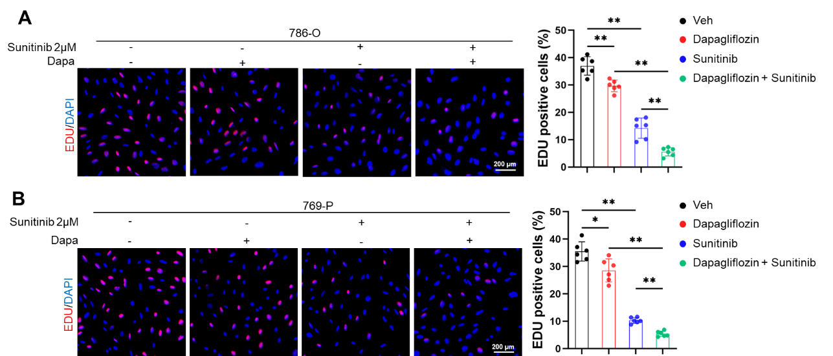
Figure S1. Dapagliflozin sensitizes renal cell carcinoma to sunitinib therapy
A Representative images and quantitative results of EDU staining (n = 6). B Representative images and quantitative results of EDU staining (n = 6). All data are expressed as the mean ± S.D., and analyzed using one-way ANOVA followed by Tukey post hoc test. *P< 0.05, **P< 0.01 versus the matched group.

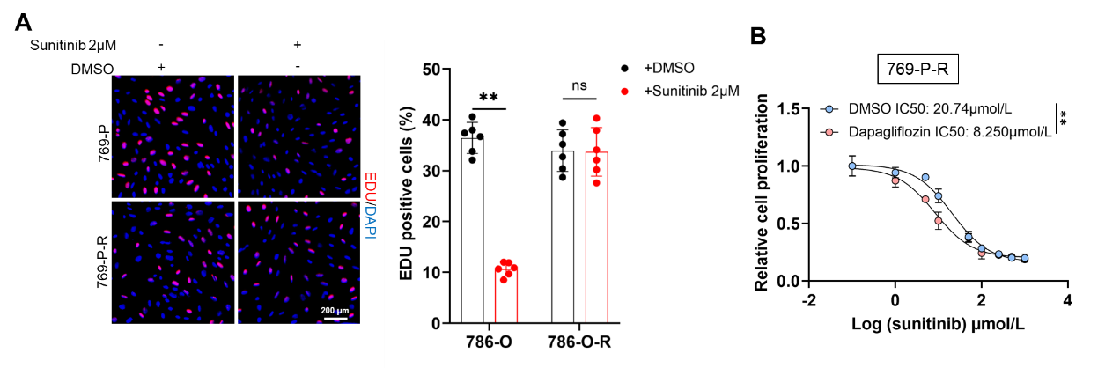
Figure S2. Dapagliflozin alleviates sunitinib resistance
A Representative images and quantitative results of EDU staining (n = 6). B 769-P-R cells administration with dapagliflozin were treated with a serial dose of sunitinib for 24 h and the IC50 values of sunitinib in each group were measured using the CCK-8 assay. All data are expressed as the mean ± S.D., and analyzed using one-way ANOVA followed by Tukey post hoc test. *P< 0.05, **P< 0.01 versus the matched group.

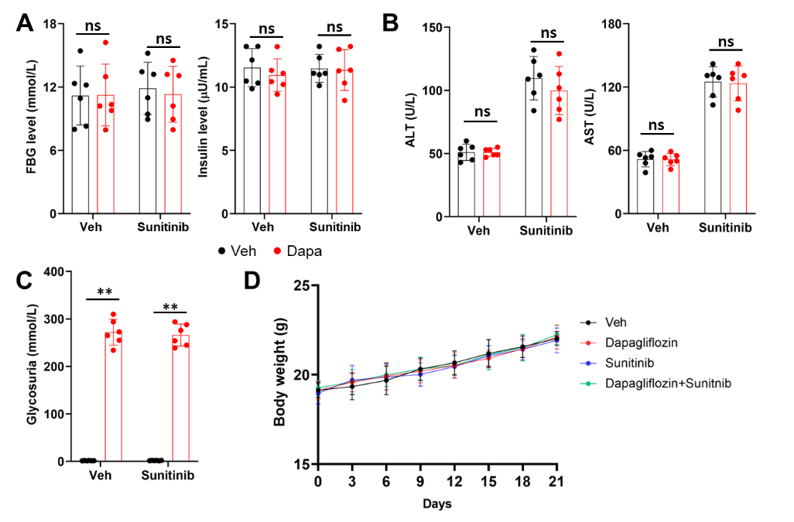
Figure S3. Dapagliflozin treatment has no effect on blood glucose and body weight
A FBG and insulin level in nude mice (n = 6). B Serum ALT and AST level in mice (n = 6). C Glycosuria level in mice (n = 6). D Body weight of mice (n = 6). All data are expressed as the mean ± S.D., and analyzed using one-way ANOVA followed by Tukey post hoc test. *P< 0.05, **P< 0.01 versus the matched group.

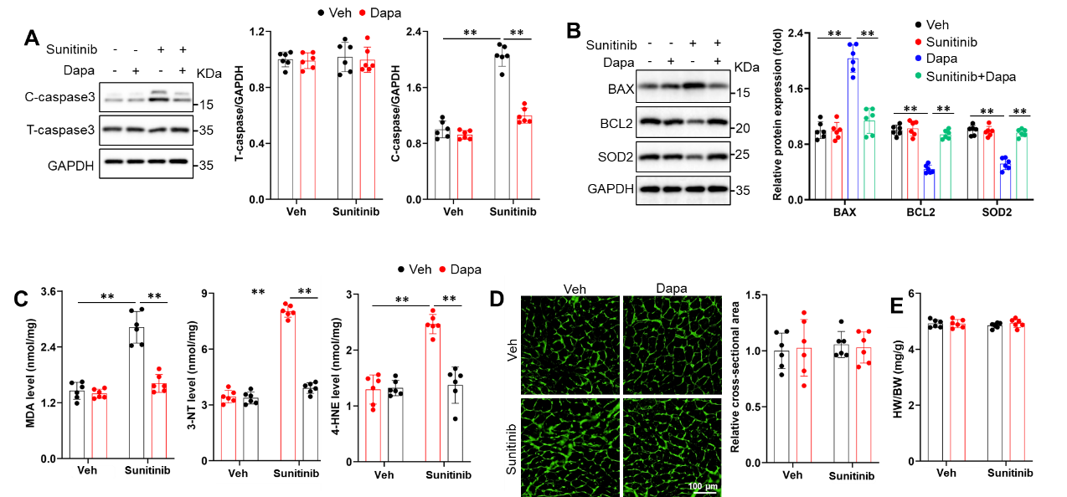
Figure S4. Dapagliflozin administration mitigated sunitinib-induced cardiotoxicity in nude mice
A-B Representative western blot images and quantitative results (n = 6). C The levels of MDA, 3-NT and 4-HNE in hearts (n = 6). D Representative images of wheat germ agglutinin (WGA) and quantitative results of cell area (n = 6). E Heart weight-to-body weight ratio (HW/BW) (n = 6). All data are expressed as the mean ± S.D., and analyzed using one-way ANOVA followed by Tukey post hoc test. *P< 0.05, **P< 0.01 versus the matched group.

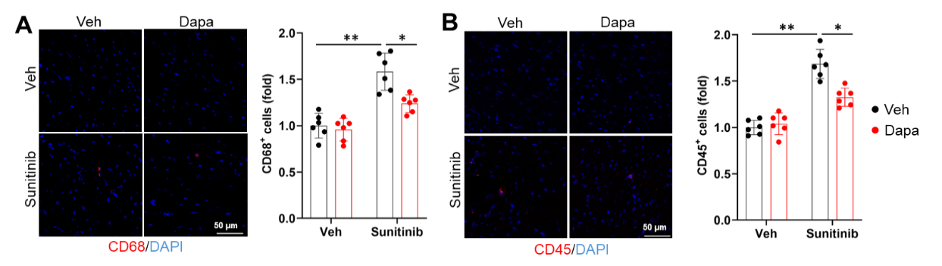
Figure S5. Dapagliflozin administration mitigated inflammation cell infiltration in immunocompetent mice
A Represent images and quantitative results of CD68 in hearts (n = 6). B Represent images and quantitative results of CD45 in hearts (n = 6). All data are expressed as the mean ± S.D., and analyzed using one-way ANOVA followed by Tukey post hoc test. *P< 0.05, **P< 0.01 versus the matched group.

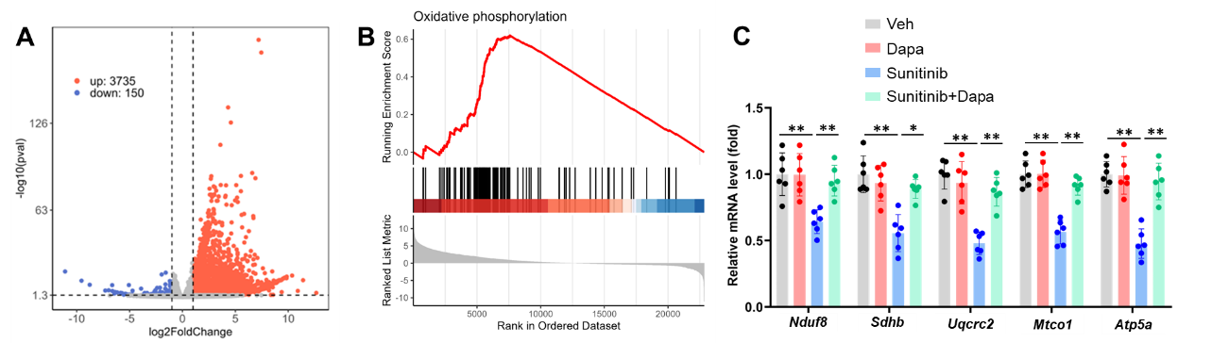
Figure S6. Dapagliflozin administration upregulated oxidative phosphorylation in sunitinib-induced heart
A Volcano plots of the upregulated genes (red) and downregulated genes (blue) of sunitinib and sunitinib+ dapagliflozin groups (n = 3). B GSEA of oxidative phosphorylation pathway. C MRNA level of Nduf8, Sdhb, Uqcrc2, Mtco1 and Atp5a (n = 6). All data are expressed as the mean ± S.D., and analyzed using one-way ANOVA followed by Tukey post hoc test. *P< 0.05, **P< 0.01 versus the matched group.

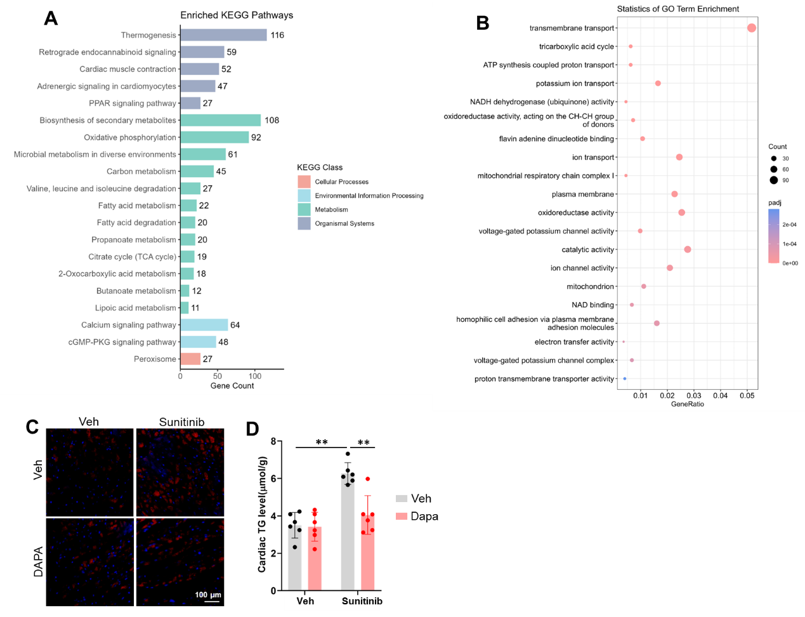
Figure S7. Dapagliflozin prevents sunitinib-induced mitochondrial dysfunction and lipotoxicity
A Enrich KEGG pathway of RNA-seq. B Enrich GO pathway of RNA-seq. C Nile red staining in hearts (n = 6). D Cardiac TG level (n = 6). All data are expressed as the mean ± S.D., and analyzed using one-way ANOVA followed by Tukey post hoc test. *P< 0.05, **P< 0.01 versus the matched group.

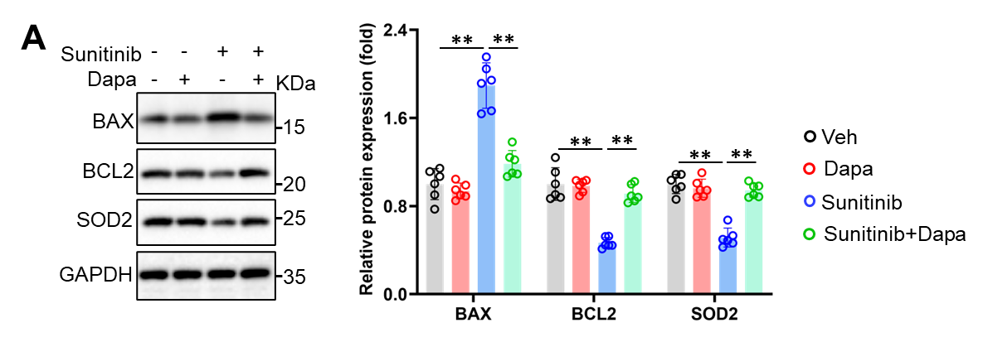
Figure S8. Sunitinib caused oxidative stress and cardiomyocyte apoptosis in NRCMs was reversed by dapagliflozin.
A Representative western blot images and quantitative results (n = 6). All data are expressed as the mean ± S.D., and analyzed using one-way ANOVA followed by Tukey post hoc test. *P< 0.05, **P< 0.01 versus the matched group.

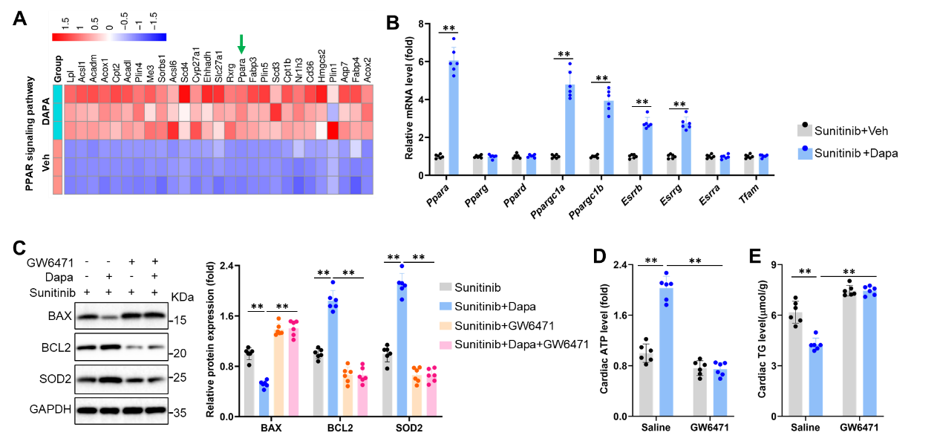
Figure S9. Dapagliflozin ameliorates sunitinib-induced cardiotoxicity through PPAR signaling pathway
A By unbiased transcriptome analysis, we show the expression of genes involved in PPAR signaling pathway in heart samples from sunitinib treated mice with or without dapagliflozin (n = 3). B Relative mRNA level in heart (n = 6). C Representative western blot images and quantitative results (n = 6). D Cardiac ATP level (n = 6). E Cardiac TG level (n = 6). All data are expressed as the mean ± S.D., and analyzed using one-way ANOVA followed by Tukey post hoc test. *P< 0.05, **P< 0.01 versus the matched group.

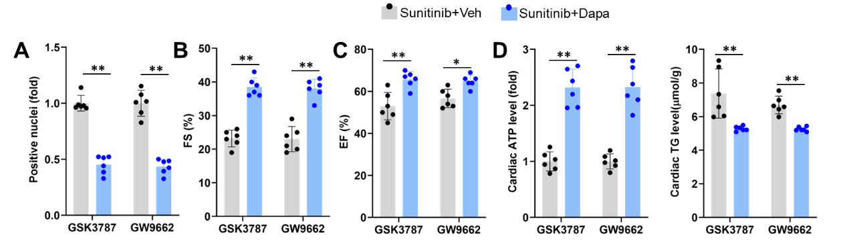
Figure S10. Inhibition of PPARδ or PPARγ did not attenuate the protective effects of dapagliflozin against sunitinib-induced cardiomyocyte apoptosis, cardiac dysfunction, or mitochondrial impairment.
A Quantitative result of TUNEL staining result (n = 6). B-C Quantitative results of FS and EF in mice after sunitinib administration (n = 6). D Cardiac ATP level (n = 6). E Cardiac TG level (n = 6). All data are expressed as the mean ± S.D., and analyzed using one-way ANOVA followed by Tukey post hoc test. *P< 0.05, **P< 0.01 versus the matched group.

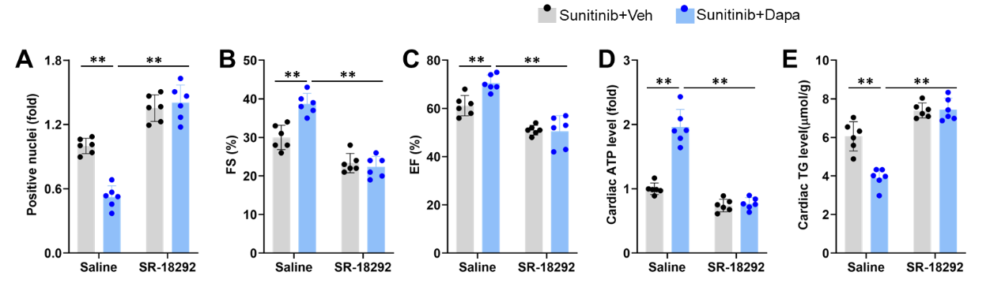
Figure S11. The ameliorate role of dapagliflozin in sunitinib-induced cardiotoxicity was nullified by PGC1α inhibition
A Quantitative result of TUNEL staining result (n = 6). B-C Quantitative results of FS and EF in mice after sunitinib administration (n = 6). D Cardiac ATP level (n = 6). E Cardiac TG level (n = 6). All data are expressed as the mean ± S.D., and analyzed using one-way ANOVA followed by Tukey post hoc test. *P< 0.05, **P< 0.01 versus the matched group.
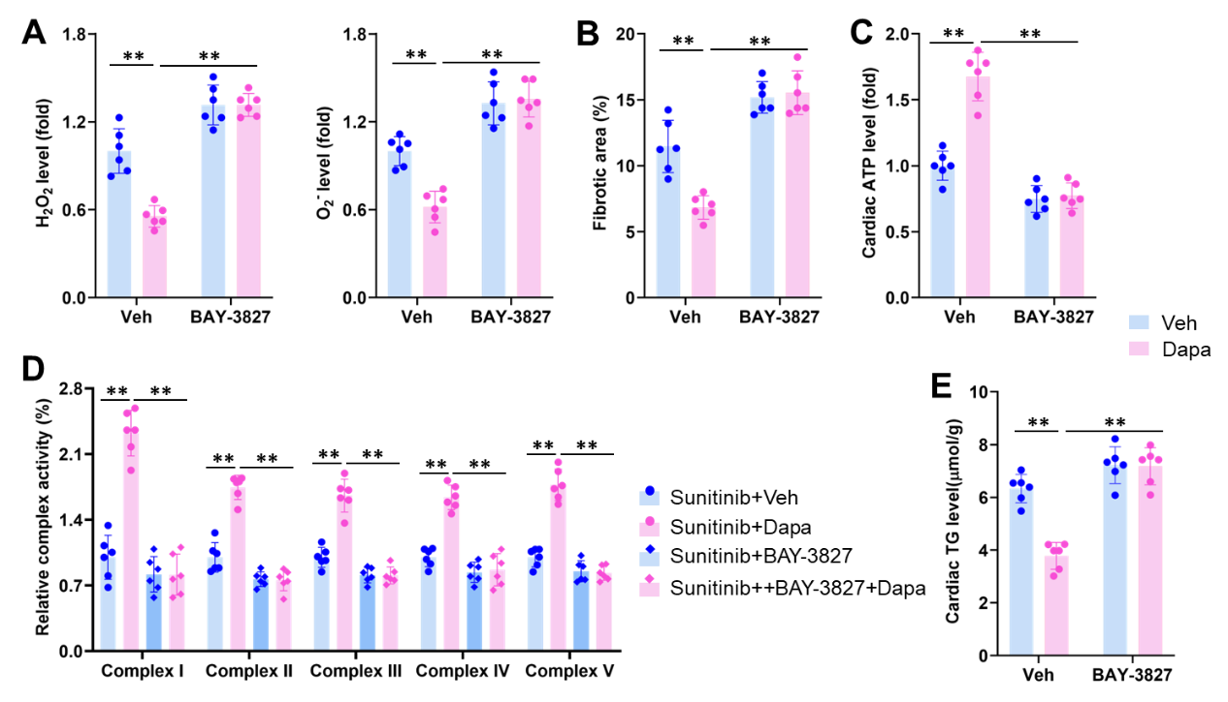
Figure S12. Dapagliflozin enhances the PPARα signaling pathway through AMPKα activation in sunitinib-treated mice
A Quantitative result of H₂O₂ and O₂⁻ level in hearts (n = 6). B Quantitative result of fibrotic area (n = 6). C Cardiac ATP level (n = 6). D The activities of mitochondrial complex I, II, III, IV and V were measured using commercial kits (n = 6). E Cardiac TG level (n = 6). All data are expressed as the mean ± S.D., and analyzed using one-way ANOVA followed by Tukey post hoc test. *P< 0.05, **P< 0.01 versus the matched group.
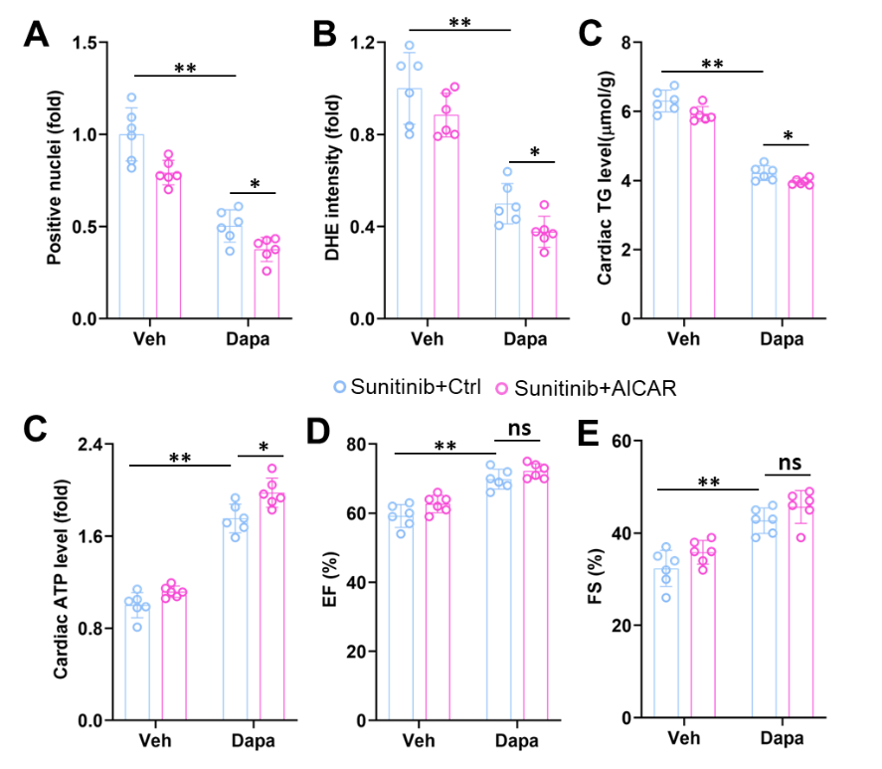
Figure S13. AICAR further enhanced the protective effect of dapagliflozin.
A Quantitative result of TUNEL staining result (n = 6). B Quantitative results of DHE intensity (n = 6). C Cardiac ATP level (n = 6). D-E Quantitative results of EF and FS in tumor-bearing mice after sunitinib administration (n = 6). All data are expressed as the mean ± S.D., and analyzed using one-way ANOVA followed by Tukey post hoc test. *P< 0.05, **P< 0.01 versus the matched group.

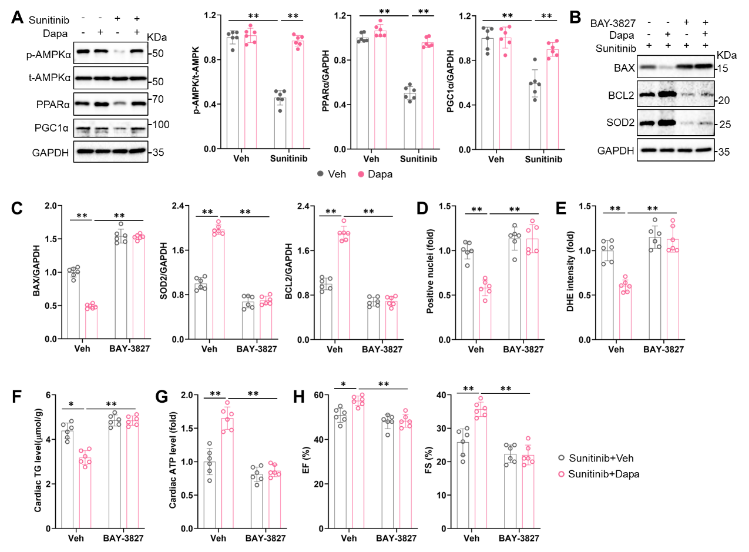
Figure S14. Dapagliflozin ameliorated sunitinib-induced cardiotoxicity in tumor-bearing mice via AMPKα-PPARα pathway.
A Representative western blot images and quantitative results (n = 6). B-C Representative western blot images and quantitative results (n = 6). D Quantitative result of TUNEL staining result (n = 6). E Quantitative results of DHE intensity (n = 6). F Cardiac TG level (n = 6). G Cardiac ATP level (n = 6). H Quantitative results of EF and FS in tumor-bearing mice after sunitinib administration (n = 6). All data are expressed as the mean ± S.D., and analyzed using one-way ANOVA followed by Tukey post hoc test. *P< 0.05, **P< 0.01 versus the matched group.

