Full unedited gel for Figure S4A
Full unedited gel for Figure S4B
Full unedited gel for Figure 3A

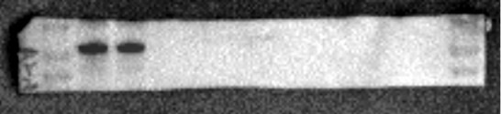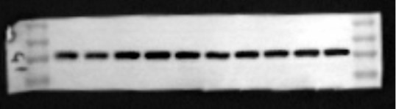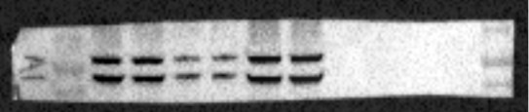
100
70
50
100
70
50
SGLT1
SGLT2
50
40
35
25
GAPDH

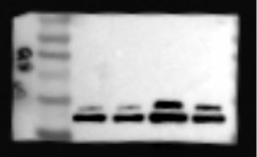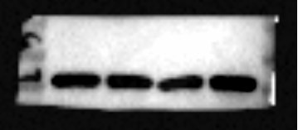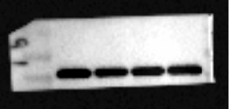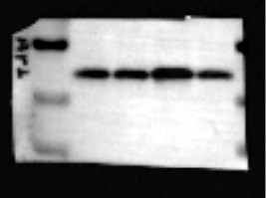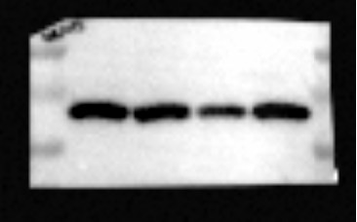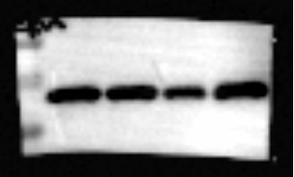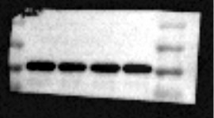
25
20
15
C-caspase3
50
40
35
T-caspase3
50
40
35
GAPDH
20
15
10
BAX
35
25
20
BCL2
35
25
20
SOD2
50
40
35
GAPDH

Full unedited gel for Figure 3B Full unedited gel for Figure 4C
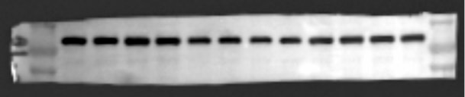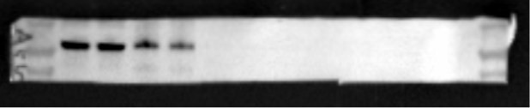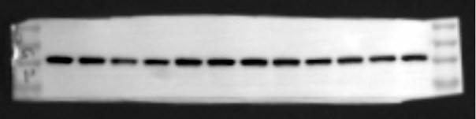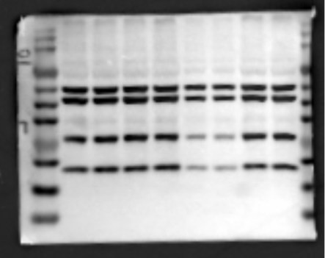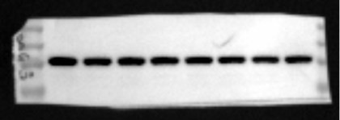
100
70
50
SGLT1
100
70
50
SGLT2
50
40
35
25
GAPDH
50
40
35
25
20
15
10
OXPHOS
50
40
35
25
GAPDH

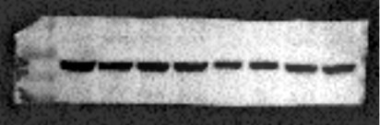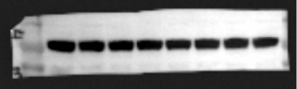Full unedited gel for Figure S8A
100
70
50
PPARα
100
70
50
Lamin B1
Full unedited gel for Figure 6B
Full unedited gel for Figure 6C

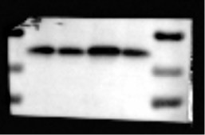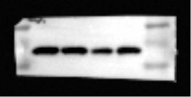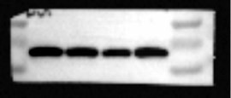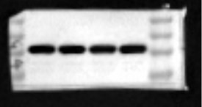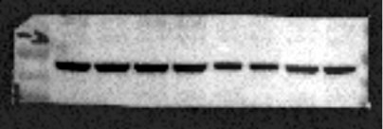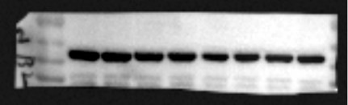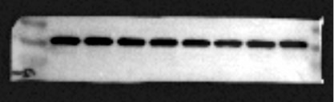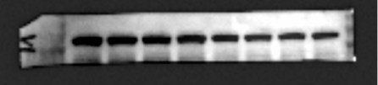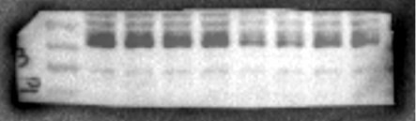
20
15
10
BAX
35
25
20
BCL2
35
25
20
SOD2
50
40
35
25
GAPDH
100
70
50
PPARα
100
70
50
PGC1α
150
100
PGC1β
50
40
35
ESRRB
50
40
35
ESRRG
40
35
25
GAPDH

Full unedited gel for Figure S9C
Full unedited gel for Figure 7B
Full unedited gel for Figure 7C

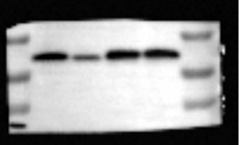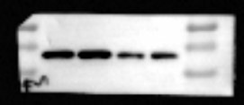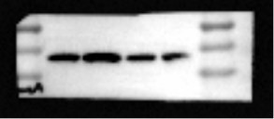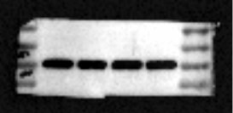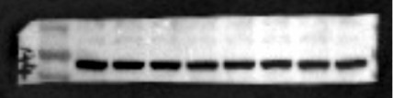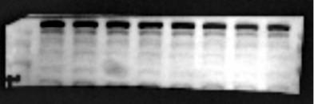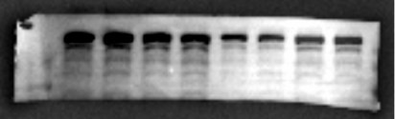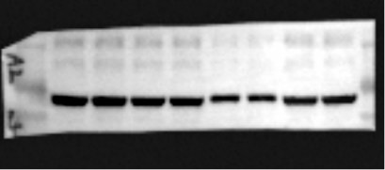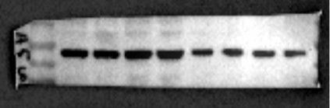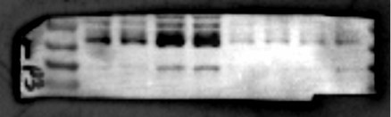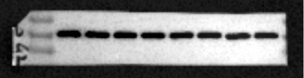
20
15
10
BAX
35
25
20
BCL2
35
25
20
SOD2
40
35
25
GAPDH
100
70
50
p-AMPKα
100
70
50
t-AMPKα
250
150
100
p-ACC
250
150
100
t-ACC
100
70
50
PPARα
100
70
50
PGC1α
40
35
25
GAPDH

Full unedited gel for Figure 7E
Full unedited gel for Figure S14A
Full unedited gel for Figure S14B

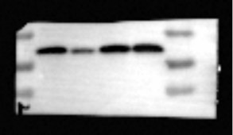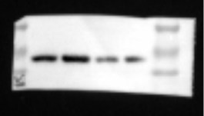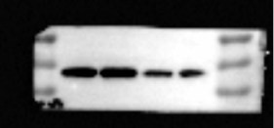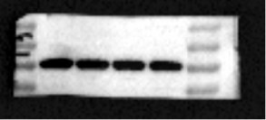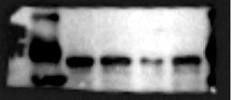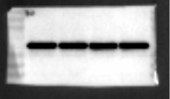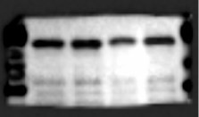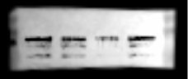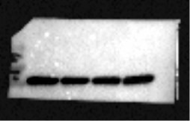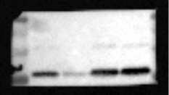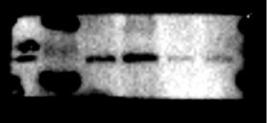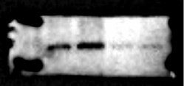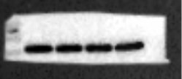
20
15
10
BAX
35
25
20
BCL2
35
25
20
SOD2
40
35
25
GAPDH
70
50
p-AMPKα
70
50
t-AMPKα
70
50
40
PPARα
150
100
70
PGC1α
50
40
35
GAPDH
25
20
15
BAX
35
25
20
BCL2
35
25
20
SOD2
40
35
GAPDH

