ADDITIONAL FILE 1
Table of contents:
Expanded Methods. Detailed Methods
Table S1. Baseline characteristics of the full PREDIMED cohort (n = 7,447) and the representative subcohort included in the present study (n = 603, including 76 overlapping cases).
Table S2. Commercial sources of the standards used in the analysis.
Table S3. Identification of the 62 phenolic compounds according to their standards, exact mass and MS/MS fragments.
Table S4. One-year changes of phenolic compounds (in units of standardized values as SD) in the MedDiet groups vs Control diet (reference) groups.
Table S5. Multivariable adjusted linear regression assessing the association between baseline MEDAS (independent variable) and the urinary multi-metabolite signature (outcome, in units of standardized values as SD).
Table S6. Risk of CVD according to the baseline adherence to the Mediterranean diet (continuous and categorized in quartiles).
Table S7. Associations between individual urinary phenolic metabolites (per 1-SD) and risk of CVD.
Table S8. Risk of each type of clinical cardiovascular event included in the composite end-point, according to the baseline urinary multi-metabolite signature of the MedDiet (continuous and categorized in quartiles).
Table S9. Risk of CVD according to the one-year changes in the urinary multi-metabolite signature predictive of adherence to the Mediterranean diet.
Figure S1. Flowchart of study participants.
Figure S2. Heat map (Pearson’s correlation coefficients) for the eight metabolites selected in the urinary multi-metabolite signature reflecting adherence to the MedDiet.
Figure S3. Heat map (Pearson’s correlation coefficients) for the 58 metabolites included in the analysis.
Figure S4. Pearson’s pairwise correlations of the 8 selected metabolites with each of the MEDAS components and the total MEDAS score at baseline.
Figure S5. Heat map (Pearson’s correlation coefficients) for the eight metabolites selected in the urinary multi-metabolite signature reflecting adherence to the MedDiet and the main food groups.
Expanded Methods
- Urinary phenolic compounds measurement
  - Sample preparation
A total of 20 µL of the urine samples were diluted 1:5 (v:v) with Milli-Q Water (Bedford, MA, USA) acidified with formic acid (Panreac Química S.A., Barcelona, Spain) at 0.05% in 96-well injection plates. When the deuterated form of the compound of interest was available it was used as internal standard. Therefore, enterodiol-d6 (Toronto Research Chemicals, North York, ON, Canada), vanillic acid -d3 (Toronto Research Chemicals), and hydroxytyrosol-d4 (Toronto Research Chemicals) were used as internal standard at 100 ng/mL for their respective aglycones, as well as their phase II metabolites. For the rest of the compounds, abscisic acid-d6 (Santa Cruz Biotechnology, Santa Cruz, CA, USA) was used as internal standard at 100 ng/mL.
  - QTOF LC/MS
The mass spectrometer was operated in negative ion mode. A total of 5 µL of sample were injected into the chromatographic column, and the flow rate was kept constant at 0.75 mL/min using the following non-linear gradient: 1.7min, 2% B; 4.7min, 8%B; 6min, 20%B; 7.3min, 30%B; 7.4min, 50%B; 8.7min, 100%B; 10min, 2%B, with a total run time of 12 minutes. Data acquisition was performed in the m/z range of 100–1700. The source voltage was 3.5 kV, with sheath gas flow at 12 L/min heated to 375 °C, and drying gas at 11 L/min and 325 °C. The nebulizer pressure was set to 40 psi, and the nozzle voltage was maintained at 800 V.
Chromatographic separation was performed on a Kinetex F5 100Å (50 x 4.6 mm x 2.6 µm) column from Phenomenex (Torrance, CA, USA), maintained at 40 °C, and coupled with a SecurityGuard™ UHPLC F5 4.6 mm precolumn cartridge from Phenomenex (Torrance, CA, USA), using the mobile phases (A) 0.05% acetic acid in water and 0.05% acetic acid in acetonitrile (Sigma-Aldrich, San Luis, MO, USA). Agilent Mass Hunter Software (Version 10.0) was used to identify and quantify the phenolic compounds. Compounds were identified by comparing their retention times and MS/MS fragmentation patterns with those of commercial standards. For phase II conjugates (glucuronides and sulfates), for which no standard was available, identification was supported by MS/MS fragmentation patterns obtained from targeted MS/MS, and comparison with reference spectra from published literature and the Human Metabolome Database (HMDB 5.0) [16]. Calibration curves were constructed with the available standards in synthetic urine and subjected to the same procedure as described before. Extracted ion chromatograms were obtained with a mass accuracy threshold of 50 ppm. A 1/x weighting factor was applied during calibration curve fitting. To quantify the phase II metabolites, calibration curves of the aglycone form were used. A list of the standards and their commercial source can be found in the Supplementary Materials (Table S1). The 100 ng/mL point of the calibration curve was used as quality control, which was injected every 25 samples to monitor system stability, retention time consistency, mass accuracy, and signal sensitivity. A mass error of up to 5 ppm was deemed acceptable between the expected and the theoretical mass.
- Statistical analyses
A total of 62 phenolic compounds were quantified, log-normalized and scaled to a mean of 0 and SD of 1. Metabolites with >20% of coefficient of variation and >80% of missing values were not considered for the analysis; this yielded 62 urinary metabolites. Among these metabolites, undetected values were imputed with “0” as recommended for targeted metabolomics of exogenous metabolites [18]. When the compounds were detected but the values were lower than the limit of detection (LOD), they were replaced with LOD/2. When the values were above the LOD but below the limit of quantification (LOQ), they were replaced with half the minimum between the LOQ and LOD. Given the high pairwise positive correlation coefficients found between 4 different urolithin A metabolites (urolithin A, urolithin A glucuronide, urolithin A sulphate 1 and urolithin A sulphate 2), as well as oleacein metabolites (oleacein aglycone and oleacein sulfate), they were merged in two single scores, using the mean of the standardized values of these highly correlated compounds as single candidate predictors.
We applied linear elastic net regression model (alpha = 0.1) to the 58 candidate compounds to identify a urinary multi-metabolite signature of adherence to the MedDiet as assessed by the validated Mediterranean Diet Adherence Screener (MEDAS, potential range: 0 to 14 points). The model was run using 10 iterations of 10-fold cross-validation. Compounds which were consistently selected in all 10 iterations were retained in the final signature, and their coefficients were averaged across iterations to construct the urinary multi-metabolite signature. It comprised 8 phenolic metabolites.
Multivariable linear regressions were used to assess associations between MEDAS (independent variable) and the baseline urinary multi-metabolite signature of the MedDiet (dependent variable). MEDAS was analyzed as a continuous variable (per 1-SD increment) and using quartiles, and the urinary multi-metabolite signature of the MedDiet was introduced as a continuous variable (per 1-SD increment). Model 1 was adjusted for age and sex. Model 2 was further adjusted for educational level, smoking habit, physical activity, total energy intake, waist-to-height ratio (quartiles), hypercholesterolemia, hypertension, diabetes, medication for dyslipidemia and hypertension, and family history of CVD. Robust variance estimators were used in all models to account for potential clustering effects by recruitment center. P-trend was assessed by modelling medians of each quartile as a continuous variable. We applied the same adjustment models to evaluate the association between one-year changes in the urinary multi-metabolite signature and the MEDAS, additionally adjusting for baseline values. We further examined the correlations between the 8 individual standardized metabolites that made up the urinary multi-metabolite signature and MEDAS (0-14) using Pearson correlation coefficient, as well as with each food component (yes/no) of the 14-item MEDAS and the main food groups performing a point pairwise correlation. The correlation coefficients were corrected for multiple testing using the Simes procedure [19].

Supplemental Tables
Table S1. Baseline characteristics of the full PREDIMED cohort (n = 7,447) and the representative subcohort included in the present study (n = 603, including 76 overlapping cases).
 | PREDIMED cohort (n = 7,447) | Subcohort (n = 603)
Age, years | 67.0 ± 6.2 | 67.2 ± 5.9
Women, n (%) | 4,282 (57.5) | 345 (57.2)
BMI, kg/m² | 30.0 ± 3.8 | 29.8 ± 3.6
Waist-to-height ratio | 0.63 ± 0.07 | 0.63 ± 0.06
Diabetes Mellitus, n (%) | 3,632 (48.8) | 280 (46.4)
Dyslipidemia, n (%) | 5,384 (72.3) | 438 (72.6)
Hypertension, n (%) | 6,163 (82.8) | 506 (83.9)
Educational level, n (%)
- Low (none or primary) | 5,792 (77.8) | 458 (76.0)
- High & medium (secondary/university) | 1,655 (22.2) | 145 (24.0)
Smoking habit, n (%)
- Current smokers | 1,047 (14.1) | 69 (11.4)
- Former smokers | 1,837 (24.7) | 166 (27.5)
Total energy intake, kcal/day | 2,275 ± 606 | 2,332 ± 609
MEDAS score | 8.6 ± 2.0 | 8.8 ± 2.0
Physical activity, MET·min/d | 230 ± 239 | 251 ± 245
Family history of early-onset CHD, n (%) | 1,668 (22.4) | 150 (24.9)
Lipid-lowering medication, n (%) | 3,587 (48.2) | 288 (47.8)
Anti-hypertensive agents, n (%) | 5,416 (72.7) | 456 (75.6)
Intervention group, n (%)
- MedDiet + EVOO | 2,543 (34.2) | 221 (36.7)
- MedDiet + nuts | 2,454 (33.0) | 195 (32.3)
- Control diet | 2,450 (32.9) | 187 (31.0)
BMI, body mass index; METS, metabolic task equivalents; CVD, cardiovascular disease; CHD, coronary heart disease, MEDAS, Mediterranean Diet Adherence Screener; MedDiet, Mediterranean diet; EVOO, extra-virgin olive oil.
Values are percentages for categorical variables and means ± SD for continuous variables.

Table S2. Commercial sources of the standards used in the analysis.
Compound | Commercial sources
3-Hydroxybenzoic acid | Fluka
3-Hydroxyphenylacetic acid | Sigma Aldrich
4-Hydroxybenzoic acid | Sigma Aldrich
Apigenin | Sigma Aldrich
Caffeic acid | Sigma Aldrich
Caffeic acid glucuronide | Toronto Research Chemicals (TRC)
Catechol | Phytolab
Chlorogenic acid | Acros Organics
Coumaric acid glucuronide | Toronto Research Chemicals (TRC)
Daidzein | Sigma Aldrich
Dihydroresveratrol | Cayman Chemicals
Elenolic acid | Toronto Research Chemicals (TRC)
Enterodiol | Sigma Aldrich
Enterolactone | Fluka
Epicatechin | Sigma-Aldrich
Epigallocatechin | Sigma Aldrich
Ferulic acid | Fluka
Gallic acid | Sigma Aldrich
Genistein | Sigma Aldrich
Hesperetin | Sigma Aldrich
Hesperidin | Sigma Aldrich
Hippuric acid | Sigma Aldrich
Homovanillic acid | Sigma Aldrich
Homovanillyl alcohol | Sigma Aldrich
Hydoxytyrosol glucuronide | Toronto Research Chemicals (TRC)
Hydroxytyrosol | Extrasynthese
Luteolin | Sigma Aldrich
Luteolin glucuronide | Biopurify
m-Coumaric acid | Sigma Aldrich
Naringenin | Sigma Aldrich
Naringenin glucuronide | LC Scientific Inc
o-Coumaric acid | Sigma Aldrich
Oleacein | PhytoLab
p-Coumaric acid | Fluka
Protocatechuic acid | HWI group
Quercetin | Sigma Aldrich
Sinapic acid | Sigma Aldrich
Syringic acid | Fluka
Tyrosol | Sigma Aldrich
Tyrosol glucuronide | Toronto Research Chemicals (TRC)
Urolithin A | Sigma Aldrich
Urolithin A glucuronide | Toronto Research CHemicals (TRC)
Urolithin B | Sigma Aldrich
Urolithin B glucuronide | Toronto Research CHemicals (TRC)
Urolithin C | Sigma Aldrich
Urolithin D | Sigma Aldrich
Vanillic acid | Cambridge Isotope Laboratories, INC
Vanillin | Sigma Aldrich

Table S3. Identification of the 62 phenolic compounds according to their standards, exact mass and MS/MS fragments.
Compounds | Neutral Molecular Formula | Rt (min) | ID level | Ion mass [M-H]- theoretical | mDa error | MS² fragment ions [M-H]-
3-Hydroxyphenylacetic acid | C8H8O3 | 4.957 | Standard | 151.0401 | 0 | -
4-Hydroxybenzoic acid | C7H6O3 | 3.557 | Standard | 137.0244 | -0.4 | 93.0346
Caffeic acid | C9H8O4 | 4.165 | Standard | 179.0350 | -0.6 | 135.0445
Caffeic acid glucuronide | C15H16O10 | 3.274 | Standard | 355.0671 | 0.5 | 179.0326, 135.0440
Catechol | C6H6O2 | 2.807 | Standard | 109.0295 | -0.3 | 108.0212
Catechol sulfate | C6H6O5S | 1.534 | MS² ions, accurate mass | 188.9863 | -0.7 | 109.0287, 108.0211
Catechol sulfate 2 | C6H6O5S | 2.375 | MS² ions, accurate mass | 188.9863 | -2.7 | 109.0287, 108.0211
Chlorogenic acid | C16H18O9 | 3.582 | MS2 ions, accurate mass | 353.0878 | 0.6 | 191.0564
Coumaric acid glucuronide | C15H16O9 | 2.791 | MS2 ions, accurate mass | 339.0722 | 4.6 | 321.0609, 175.0245, 163.0368
Coumaric acid sulfate | C9H8O6S | 3.808 | MS2 ions, accurate mass | 242.9969 | -0.3 | 163.0399, 119.0504
Daidzein | C15H10O4 | 6.922 | MS2 ions, accurate mass | 253.0506 | -0.1 | 223.0395, 195.0456, 135.0084, 117.0336
Homovanillic acid glucuronide 1 | C15H18O10 | 2.356 | MS2 ions, accurate mass | 357.0827 | -0.5 | 313.0922, 181.0489, 166.0253, 137.0584
Homovanillic acid glucuronide 2 | C15H18O10 | 2.714 | MS2 ions, accurate mass | 357.0827 | -0.2 | 313.0940, 181.0501, 137.0606, 122.0374
Dihydrocaffeic acid glucuronide | C15H18O10 | 2.991 | MS2 ions, accurate mass | 357.0827 | 0.4 | 181.0523, 137.0629
Dihydrocaffeic/Homovanillic acid sulfate 1 | C9H10O7S | 2.883 | MS2 ions, accurate mass | 261.0074 | -1.2 | 181.0505, 137.0607, 121.0293
Dihydroresveratrol glucuronide | C20H22O9 | 5.148 | MS2 ions, accurate mass | 405.1191 | -0.5 | 229.0868, 123.0453
Dihydroresveratrol sulfate | C14H14O6S | 5.407 | MS2 ions, accurate mass | 309.0438 | -0.4 | 229.0871, 123.0456
Enterodiol | C18H22O4 | 6.8 | Standard | 301.1445 | -1.6 | 106.0416
Enterodiol glucuronide 1 | C24H30O10 | 5.207 | MS2 ions, accurate mass | 477.1766 | -0.4 | 301.1441, 271.1332, 253.1233
Enterodiol sulfate | C18H22O7S | 5.512 | MS2 ions, accurate mass | 381.1013 | -0.6 | 301.1430, 253.2235, 106.0423
Enterolactone | C18H18O4 | 7.635 | Standard | 297.1132 | -0.4 | 253.1228, 107.0503
Enterolactone glucuronide | C24H26O10 | 6.198 | MS2 ions, accurate mass | 473.1453 | -0.7 | 297.1126, 253.1241, 175.0245
Enterolactone sulfate | C18H18O7S | 6.314 | MS2 ions, accurate mass | 377.0700 | -0.2 | 297.1128, 253.1226, 107.0507
Ferulic acid glucuronide 1 | C16H18O10 | 3.166 | MS2 ions, accurate mass | 369.0827 | -1.2 | 193.0509, 149.0624
Ferulic acid sulfate | C10H10O7S | 3.947 | MS2 ions, accurate mass | 273.0074 | -0.2 | 193.0501, 178.0270, 149.0603
Gallic acid sulfate | C7H6O8S | 2.447 | MS2 ions, accurate mass | 248.9711 | 0.7 | 169.0130, 125.0245
Genistein | C15H10O5 | 7.675 | Standard | 269.0455 | -1.6 | 117.0345, 65.0057
Genistein glucuronide | C21H18O11 | 5.884 | MS2 ions, accurate mass | 445.0776 | 0 | 269.0438
Hesperetin | C16H14O6 | 7.715 | Standard | 301.0718 | -0.1 | 164.0104
Hesperetin sulfate | C16H14O9S | 6.328 | MS2 ions, accurate mass | 381.0286 | -0.7 | 301.0712
Homovanillic acid | C9H10O4 | 4.102 | Standard | 181.0506 | 0.5 | 137.0616, 122.0374
Hydroxytyrosol | C8H10O3 | 2.665 | Standard | 153.0557 | -0.3 | 123.0452
Hydroxytyrosol glucuronide | C14H18O9 | 2.317 | Standard | 329.0878 | -0.5 | 153.0560, 123.0459, 59.0144
Hydroxytyrosol sulfate 1 | C8H10O6S | 1.18 | MS2 ions, accurate mass | 233.0125 | 0.7 | 153.0563,123.0460, 79.9481
Hydroxytyrosol sulfate 2 | C8H10O6S | 2.476 | Standard | 233.0125 | 0.7 | 153.0563,123.0460, 79.9481
m-Coumaric acid | C9H8O3 | 5.483 | Standard | 163.0401 | 0.6 | 119.0500
Naringenin | C15H12O5 | 7.613 | Standard | 271.0612 | -0.2 | 119.0499, 65.0031
Naringenin glucuronide | C21H20O11 | 5.864 | Standard | 447.0933 | 0.5 | 271.0606, 119.0504
Oleacein | C17H20O6 | 6.898 | Standard | 319.1187 | 0.2 | -
Protocatechuic acid | C7H6O4 | 2.825 | Standard | 153.0193 | -0.4 | 109.0291
Protocatechuic acid glucuronide | C13H14O10 | 1.425 | MS2 ions, accurate mass | 329.0514 | -0.1 | 153.0191, 109.0291
Protocatechuic acid sulfate | C7H6O7S | 2.188 | MS2 ions, accurate mass | 232.9761 | -0.8 | 153.0178, 109.0297
Sinapic acid | C11H12O5 | 5.699 | Standard | 223.0612 | 0 | 208.0363, 193.0130, 179.0689, 164.0484, 149.0238
Sinapic acid glucuronide 1 | C17H20O11 | 3.525 | MS2 ions, accurate mass | 399.0933 | -0.3 | 223.0608, 208.0373, 179.0715
Sinapic acid glucuronide 2 | C17H20O11 | 3.991 | MS2 ions, accurate mass | 399.0933 | -0.6 | 223.0608, 208.0369
Sinapic acid sulfate | C11H12O8S | 3.58 | MS2 ions, accurate mass | 303.0180 | -0.3 | 223.0607, 208.0373, 193.0140, 179.0709, 149.0243
Syringic acid | C9H10O5 | 4.39 | Standard | 197.0455 | 0 | 153.0557, 121.0295
Syringic acid glucuronide | C15H18O11 | 3.083 | MS2 ions, accurate mass | 373.0776 | -0.9 | 355.1039, 329.1321, 197.0456, 175.0249
Syringic acid sulfate | C9H10O8S | 2.821 | MS2 ions, accurate mass | 277.0024 | -0.9 | 197.0455, 182.0219, 167.0715
Tyrosol glucuronide | C14H18O8 | 2.15 | Standard | 313.0929 | -0.2 | 137.0604, 85.0300, 59.0144
Tyrosol sulfate | C8H10O5S | 4.749 | MS2 ions, accurate mass | 217.0176 | -0.8 | 137.0604
Urolithin A | C13H8O4 | 7.052 | Standard | 227.0350 | -0.3 | 183.0447
Urolithin A glucuronide | C19H16O10 | 4.686 | Standard | 403.0671 | -0.3 | 227.0351, 183.0444
Urolithin A sulfate 1 | C13H8O7S | 4.014 | MS2 ions, accurate mass | 306.9918 | -0.9 | 227.0347, 183.0458
Urolithin A sulfate 2 | C13H8O7S | 5.589 | MS2 ions, accurate mass | 306.9918 | -0.8 | 227.0347, 183.0458
Urolithin B glucuronide | C19H16O9 | 5.922 | Standard | 387.0722 | -0.9 | 211.0403, 167.0502
Urolithin D | C13H8O6 | 5.304 | Standard | 259.0248 | -3.4 | 198.9671
Vanillic acid | C8H8O4 | 4.09 | Standard | 167.0350 | 0.2 | 123.0461, 152.0129
Vanillic acid glucuronide 1 | C14H16O10 | 2.309 | MS2 ions, accurate mass | 343.0671 | -1.2 | 167.0346, 152.0107, 123.0461
Vanillic acid glucuronide 2 | C14H16O10 | 2.74 | MS2 ions, accurate mass | 343.0671 | -1.2 | 167.0346, 152.0107, 123.0461
Vanillic acid sulfate 2 | C8H8O7S | 2.842 | MS2 ions, accurate mass | 246.9918 | -1.8 | 167.0350, 152.0110, 123.0450, 108.0217
Vanillin glucuronide | C14H16O9 | 3.429 | MS2 ions, accurate mass | 327.0705 | -1.7 | 151.0399, 136.0179
Rt, retention time; Da, Dalton; MS,
¹Level of identification of high resolution – mass spectrometry analysis [17].
²mDa millidalton of error between the mass found and the accurate mass of each polyphenol.

Table S4. One-year changes of phenolic compounds (in units of standardized values as SD) in the MedDiet groups vs Control diet (reference) groups.
 | MedDiet groups (n=623) vs. Control group (n=278)
 | β (95% CI) | p-value
Urinary multimetabolite signature | +0.11 (-0.03 to +0.24) | 0.108
Urolithin A metabolites | +0.30 (+0.20 to +0.40) | <0.001
Tyrosol glucuronide | +0.09 (<+0.01 to +0.18) | 0.052
Coumaric acid sulfate | +0.17 (-0.01 to +0.36) | 0.057
Hydroxytyrosol sulfate 1 | +0.09 (-0.01 to +0.18) | 0.071
m-Coumaric acid | +0.11 (-0.01 to +0.24) | 0.071
Urolithin B glucuronide | +0.10 (-0.02 to +0.21) | 0.098
Catechol sulfate 2 | -0.07 (-0.17 to +0.03) | 0.149
Naringenin glucuronide | +0.14 (-0.06 to +0.34) | 0.151
Genistein | +0.11 (-0.05 to +0.27) | 0.156
Hydroxytyrosol sulfate 2 | -0.06 (-0.16 to +0.03) | 0.172
Chlorogenic acid | +0.07 (-0.04 to +0.18) | 0.185
Dihydrocaffeic/Homovanillic acid sulfate 1 | +0.07 (-0.04 to +0.17) | 0.185
Ferulic acid glucuronide 1 | -0.06 (-0.16 to +0.04) | 0.200
Hydroxytyrosol | +0.10 (-0.07 to +0.27) | 0.200
Dihydrocaffeic acid glucuronide 3 | +0.15 (-0.10 to +0.40) | 0.204
Naringenin | +0.08 (-0.06 to +0.21) | 0.217
Homovanillic acid glucuronide 1 | +0.07 (-0.05 to +0.18) | 0.219
Genistein glucuronide | +0.07 (-0.07 to +0.21) | 0.301
4-Hydroxybenzoic acid | +0.05 (-0.05 to +0.14) | 0.313
Hydroxytyrosol glucuronide | +0.07 (-0.09 to +0.24) | 0.327
Enterolactone | -0.05 (-0.17 to +0.07) | 0.357
Enterolactone sulfate 2 | -0.07 (-0.25 to +0.10) | 0.365
Sinapic acid sulfate | +0.08 (-0.12 to +0.29) | 0.378
Dihydroresveratrol sulfate 2 | +0.06 (-0.10 to +0.23) | 0.410
Tyrosol sulfate | +0.06 (-0.14 to +0.27) | 0.504
Caffeic acid | +0.06 (-0.13 to +0.24) | 0.505
Caffeic acid glucuronide | -0.03 (-0.14 to +0.08) | 0.513
Hesperetin sulfate | +0.05 (-0.14 to +0.25) | 0.559
Enterolactone glucuronide | -0.03 (-0.18 to +0.11) | 0.592
Vanillic acid | -0.04 (-0.20 to +0.12) | 0.601
Syringic acid glucuronide | +0.04 (-0.15 to +0.24) | 0.613
Urolithin D | -0.04 (-0.22 to +0.14) | 0.620
Syringic acid sulfate | +0.03 (-0.11 to +0.17) | 0.645
Catechol | -0.03 (-0.16 to +0.11) | 0.670
Oleacein metabolites | -0.04 (-0.26 to +0.18) | 0.687
Vanillic acid glucuronide 3 | +0.02 (-0.08 to +0.12) | 0.692
Vanillic acid sulfate 2 | +0.02 (-0.11 to +0.16) | 0.707
Sinapic acid | +0.03 (-0.17 to +0.23) | 0.725
Protocatechuic acid | +0.03 (-0.17 to +0.23) | 0.755
Syringic acid | -0.02 (-0.14 to +0.11) | 0.777
Dihydroresveratrol glucuronide | -0.02 (-0.22 to +0.17) | 0.786
Protocatechuic acid sulfate | +0.02 (-0.19 to +0.23) | 0.813
Gallic acid sulfate | +0.01 (-0.13 to +0.16) | 0.832
Sinapic acid glucuronide 1 | -0.02 (-0.18 to +0.15) | 0.833
Enterodiol glucuronide 1 | -0.02 (-0.19 to +0.16) | 0.846
Sinapic acid glucuronide 2 | +0.01 (-0.14 to +0.17) | 0.875
Homovanillic acid glucuronide 2 | -0.01 (-0.14 to +0.12) | 0.896
Vanillin glucuronide | +0.01 (-0.12 to +0.13) | 0.907
Catechol sulfate 1 | -0.01 (-0.14 to +0.13) | 0.912
Enterodiol sulfate | +0.01 (-0.17 to +0.18) | 0.918
Vanillic acid glucuronide 2 | <+0.01 (-0.15 to +0.14) | 0.966
Coumaric acid glucuronide | <+0.01 (-0.14 to +0.15) | 0.973
Homovanillic acid | <+0.01 (-0.16 to +0.16) | 0.973
Hesperetin | <+0.01 (-0.22 to +0.23) | 0.974
Ferulic acid sulfate | <+0.01 (-0.25 to +0.26) | 0.977
β regression coefficients were obtained from linear regression models adjusted for baseline concentration of each metabolite, age, sex, educational level, smoking habit, physical activity, total energy intake, waist-to-height ratio, hypercholesterolemia, hypertension, diabetes, recruitment center, and propensity scores.
* Metabolites significant after adjusting for multiple testing using the Simes procedure.

Table S5. Multivariable adjusted linear regression assessing the association between baseline MEDAS (independent variable) and the urinary multi-metabolite signature (outcome, in units of standardized values as SD).
β (95% CI) per 1-SD increment in MEDAS at baseline |  | p-value | β (95% CI) for quartiles of MEDAS
 |  | p-value | Q1 | Q2 vs. Q1 | Q3 vs. Q1 | Q4 vs. Q1 | p linear trend
Model 1 | 0.16 (0.05; 0.26) | 0.008 | 0 (Ref) | 0.17 (-0.03; 0.38) | 0.29 (-0.03; 0.53) | 0.48 (0.10; 0.85) | 0.008
Model 2 | 0.15 (0.06; 0.24) | 0.005 | 0 (Ref) | 0.18 (-0.01; 0.37) | 0.27 (0.07; 0.47) | 0.44 (0.09; 0.80) | 0.006
β (95% CI) per 1-SD increment in 1-year changes in MEDAS |  | p-value | β (95% CI) for quartiles of 1-year changes in MEDAS
 |  | p-value | Q1 | Q2 vs. Q1 | Q3 vs. Q1 | Q4 vs. Q1 | p linear trend
Model 1 | 0.15 (0.01; 0.29) | 0.034 | 0 (Ref) | -0.16 (-0.31; -0.02) | 0.07 (-0.05; 0.19) | 0.15 (0.03; 0.26) | 0.006
Model 2 | 0.14 (<0.01; 0.28) | 0.045 | 0 (Ref) | -0.17 (-0.33; -0.02) | 0.07 (-0.04; 0.17) | 0.11 (-0.01; 0.23) | 0.014
MEDAS, Mediterranean Diet Adherence Screener; Q, quartile.
Model 1 was adjusted for age and sex.
Model 2 was further adjusted for educational level, smoking habit, physical activity, total energy intake, waist-to-height ratio (quartiles), hypercholesterolemia, hypertension, diabetes, medication for dyslipidemia and hypertension, and family history of CHD. Models for 1-year changes analyses additionally included baseline values of the multi-metabolite signature and MEDAS.
Robust variance estimators were used in all models to account for potential clustering effects by recruitment center.
P-trend was assessed by modelling medians of each quartile as a continuous variable.

Table S6. Risk of CVD according to the baseline adherence to the Mediterranean diet (continuous and categorized in quartiles).
 | Continuous per 1-SD  (n=1,180) |  | Adherence to the MedDiet (MEDAS), quartiles
 |  |  | Q1 (n=331) | Q2 (n=224) | Q3 (n=244) | Q4 (n=381) | p linear trend
Cases | 653 |  | 204 | 131 | 144 | 174
Person-years | 6195.1 |  | 1481.9 | 1087.8 | 1247.3 | 2378.2
 | HR (95% CI) | p-value |  | HR (95% CI) | HR (95% CI) | HR (95% CI)
Model 1 | 0.85 (0.73; 0.99) | 0.032 | Ref | 0.92 (0.62; 1.37) | 0.87 (0.59; 1.28) | 0.58 (0.40; 0.83) | 0.003
Model 2 | 0.87 (0.74; 1.03) | 0.097 | Ref | 0.94 (0.58; 1.51) | 0.93 (0.59; 1.47) | 0.58 (0.38; 0.88) | 0.012
CVD, cardiovascular disease; Q, quartile; HR, hazard ratio.
The subcohort included 76 overlapping cases.
Model 1 was adjusted for age and sex and stratified by recruitment center.
Model 2 was further adjusted for smoking habit, physical activity, total energy intake, waist-to-height ratio (quartiles), hypercholesterolemia, hypertension, diabetes, medication for hypertension and dyslipidemia, family history of CHD, and stratified by educational level and intervention group (MedDiet vs Control).
P-trend was assessed by modelling medians of each quartile as a continuous variable.

Table S7. Associations between individual urinary phenolic metabolites (per 1-SD) and risk of CVD.
 | HR (CI95%) | p-value | Adjusted p-value
Hydroxytyrosol sulfate 2 | 0.75 (0.63;0.90) | 0.002 | 0.097
Syringic acid | 0.80 (0.67;0.94) | 0.009 | 0.238
Vanillin glucuronide | 0.84 (0.71;0.99) | 0.034 | 0.282
Hesperetin sulfate | 0.85 (0.73;1.00) | 0.046 | 0.282
Syringic acid glucuronide | 0.86 (0.72;1.02) | 0.076 | 0.282
Enterodiol glucuronide 1 | 0.86 (0.73;1.00) | 0.049 | 0.282
Dihydroresveratrol sulfate 2 | 0.86 (0.73;1.01) | 0.060 | 0.282
Hydroxytyrosol glucuronide | 0.86 (0.73;1.01) | 0.070 | 0.282
Hydroxytyrosol sulfate 1 | 0.86 (0.73;1.01) | 0.066 | 0.282
Naringenin glucuronide | 0.86 (0.74;1.00) | 0.055 | 0.282
Sinapic acid glucuronide 2 | 0.86 (0.74;1.01) | 0.063 | 0.282
Naringenin | 0.86 (0.75;1.00) | 0.056 | 0.282
Vanillic acid glucuronide 3 | 0.86 (0.75;1.00) | 0.047 | 0.282
Homovanillic acid glucuronide 1 | 0.87 (0.75;1.01) | 0.067 | 0.282
Sinapic acid sulfate | 0.87 (0.75;1.02) | 0.081 | 0.282
Urolithin B glucuronide | 0.88 (0.74;1.04) | 0.122 | 0.305
Urolithin A metabolites | 0.88 (0.75;1.02) | 0.098 | 0.298
Syringic acid sulfate | 0.88 (0.75;1.03) | 0.120 | 0.305
Enterolactone glucuronide | 0.88 (0.76;1.02) | 0.087 | 0.282
Sinapic acid | 0.88 (0.76;1.03) | 0.103 | 0.298
Urolithin D | 0.88 (0.76;1.03) | 0.109 | 0.299
Enterolactone sulfate 2 | 0.89 (0.75;1.05) | 0.153 | 0.367
Dihydroresveratrol glucuronide | 0.89 (0.76;1.05) | 0.167 | 0.377
Enterolactone | 0.90 (0.77;1.05) | 0.171 | 0.377
Catechol | 0.90 (0.78;1.05) | 0.194 | 0.409
Dihydrocaffeic/Homovanillic acid sulfate 1 | 0.91 (0.78;1.06) | 0.242 | 0.493
Tyrosol sulfate | 0.92 (0.77;1.10) | 0.335 | 0.594
Gallic acid sulfate | 0.93 (0.79;1.08) | 0.333 | 0.594
Homovanillic acid glucuronide 2 | 0.93 (0.81;1.07) | 0.297 | 0.563
Tyrosol glucuronide | 0.94 (0.79;1.11) | 0.451 | 0.690
Dihydrocaffeic acid glucuronide 3 | 0.94 (0.81;1.09) | 0.440 | 0.690
Vanillic acid glucuronide 2 | 0.94 (0.81;1.09) | 0.408 | 0.679
Vanillic acid sulfate 2 | 0.94 (0.81;1.09) | 0.427 | 0.690
Protocatechuic acid | 0.95 (0.80;1.12) | 0.507 | 0.716
Coumaric acid sulfate | 0.95 (0.81;1.11) | 0.495 | 0.716
Caffeic acid | 0.95 (0.82;1.11) | 0.521 | 0.716
Hesperetin | 0.95 (0.82;1.11) | 0.519 | 0.716
Hydroxytyrosol | 0.96 (0.83;1.12) | 0.641 | 0.794
Sinapic acid glucuronide 1 | 0.97 (0.82;1.14) | 0.692 | 0.810
Ferulic acid sulfate | 0.97 (0.82;1.15) | 0.710 | 0.814
Oleacein metabolites | 0.97 (0.83;1.12) | 0.656 | 0.794
Genistein glucuronide | 0.97 (0.83;1.13) | 0.664 | 0.794
Ferulic acid glucuronide 1 | 0.97 (0.85;1.11) | 0.652 | 0.794
Enterodiol sulfate | 0.99 (0.85;1.15) | 0.911 | 0.928
Catechol sulfate 1 | 1.00 (0.87;1.16) | 0.962 | 0.962
Protocatechuic acid sulfate | 1.01 (0.87;1.17) | 0.878 | 0.912
Coumaric acid glucuronide | 1.01 (0.87;1.18) | 0.859 | 0.908
Vanillic acid | 1.02 (0.87;1.19) | 0.827 | 0.892
Chlorogenic acid | 1.02 (0.87;1.20) | 0.790 | 0.869
4-Hydroxybenzoic acid | 1.03 (0.89;1.19) | 0.736 | 0.826
m-Coumaric acid | 1.04 (0.90;1.20) | 0.601 | 0.786
Homovanillic acid | 1.05 (0.90;1.22) | 0.560 | 0.752
Caffeic acid glucuronide | 1.07 (0.92;1.24) | 0.397 | 0.679
Genistein | 1.09 (0.93;1.28) | 0.262 | 0.515
Catechol sulfate 2 | 1.14 (0.98;1.31) | 0.084 | 0.282
P value were adjusted for multiple testing using the Simes procedure.
Adjusted for age, sex, smoking habit, physical activity, total energy intake, waist-to-height ratio (quartiles), hypercholesterolemia, hypertension, diabetes, medication for dyslipidemia and hypertension, family history of CHD, and stratified by recruitment center, educational level, and intervention group (MedDiet vs Control).

Table S8. Risk of each type of clinical cardiovascular event included in the composite end-point, according to the baseline urinary multi-metabolite signature of the MedDiet (continuous and categorized in quartiles).
 | Continuous per 1-SD  (n=1,180) |  | Urinary multimetabolite signature, quartiles
 |  |  | Q1 (n=295) | Q2 (n=295) | Q3 (n=295) | Q4 (n=295) | p linear trend
 | HR (95% CI) | p-value |  | HR (95% CI) | HR (95% CI) | HR (95% CI)
Heart Failure
Cases | 191 |  | 62 | 52 | 43 | 36
 | 0.72 (0.56; 0.94) | 0.015 | Ref. | 0.88 (0.47; 1.64) | 0.69 (0.37; 1.29) | 0.33 (0.15; 0.74) | 0.005
Myocardial infarction
Cases | 96 |  | 24 | 29 | 24 | 19
 | 0.60 (0.42; 0.86) | 0.006 | Ref. | 1.45 (0.57; 3.71) | 0.70 (0.29; 1.69) | 0.18 (0.05; 0.67) | 0.003
Stroke
Cases | 144 |  | 34 | 33 | 37 | 40
 | 0.87 (0.67; 1.13) | 0.307 | Ref. | 1.21 (0.55; 2.65) | 1.06 (0.49; 2.29) | 0.75 (0.35; 1.61) | 0.382
Death from CVD
Cases | 224 |  | 61 | 61 | 54 | 48
 | 0.92 (0.73; 1.16) | 0.458 | Ref. | 1.05 (0.54; 2.05) | 1.04 (0.57; 1.93) | 0.63 (0.31; 1.27) | 0.200
Myocardial infarction, stroke or CVD death
Cases | 464 |  | 119 | 123 | 115 | 107
 | 0.84 (0.70; 1.00) | 0.050 | Ref. | 1.19 (0.72; 1.95) | 0.93 (0.58; 1.50) | 0.57 (0.34; 0.96) | 0.029
CVD, cardiovascular disease; Q, quartile; HR, hazard ratio.
The subcohort included 76 overlapping cases.
Adjusted for age, sex, smoking habit, physical activity, total energy intake, waist-to-height ratio (quartiles), hypercholesterolemia, hypertension, diabetes, medication for hypertension and dyslipidemia, family history of CHD, and stratified by recruitment center, educational level and intervention group (MedDiet vs Control).
P-trend was assessed by modelling medians of each quartile as a continuous variable.

Table S9. Risk of CVD according to the one-year changes in the urinary multi-metabolite signature predictive of adherence to the Mediterranean diet.
 | Continuous per 1-SD |  | One-year changes in urinary multi-metabolite signature, quartiles,  (using quartile 4 as reference) |  |  |  |  | One-year changes in urinary multi-metabolite signature (using quartiles 2 to 4 as reference)
 |  |  | Q1 (n=224) | Q2 (n=231) | Q3 (n=232) | Q4 (n=224) |  | Q1 (n=224) | Q2 -Q4  (n=687)
Urinary multi-metabolite signature |  |  | -4.37 to -0.64 | -0.63 to -0.002 | 0.001 to 0.70 | 0.71 to 3.49
Cases | 431 |  | 109 | 104 | 114 | 104 |  | 109 | 322
Person-years | 4970 |  | 1184 | 1287 | 1267 | 1232 |  | 1184 | 3786
 | HR (95% CI) | p-value | HR (95% CI) | HR (95% CI) | HR (95% CI) |  | p linear trend | HR (95% CI) |  | p value
Model 1 | 0.96 (0.81; 1.13) | 0.618 | 1.32 (0.82; 2.11) | 1.02 (0.66; 1.57) | 0.92 (0.60; 1.41) | Ref. | 0.241 | 1.35 (0.93; 1.96) | Ref | 0.120
Model 2 | 0.98 (0.78; 1.22) | 0.853 | 1.36 (0.76; 2.44) | 0.86 (0.50; 1.46) | 0.73 (0.43; 1.23) | Ref | 0.313 | 1.61 (1.01; 2.56) | Ref | 0.043
MedDiet intervention group
Cases | 295 |  | 72 | 74 | 74 | 75 |  | 72 | 223
Person-years | 3465 |  | 841 | 898 | 832 | 893 |  | 841 | 2624
Model 2 | 1.07 (0.81; 1.42) | 0.615 | 1.16 (0.58; 2.32) | 0.79 (0.40; 1.57) | 0.91 (0.49; 1.69) | Ref | 0.781 | 1.33 (0.77; 2.84) | Ref | 0.310
Control group
Cases | 136 |  | 37 | 30 | 40 | 29 |  | 37 | 99
Person-years | 1505 |  | 342 | 389 | 435 | 338 |  | 342 | 1163
Model 2 | 0.84 (0.51; 1.40) | 0.512 | 3.17 (0.61; 16.40) | 0.92 (0.28; 3.04) | 0.47 (0.14; 1.55) | Ref | 0.212 | 3.97 (1.09; 14.47) | Ref | 0.036
CVD, cardiovascular disease; Q, quartile; HR, hazard ratio.
Participants in Q4 and Q2–Q4 were used as the reference group to compare against those individuals with the lower urinary polyphenol excretion.
Model 1 was adjusted for the phenolic signature at baseline, age and sex, and stratified by recruitment center.
Model 2 was further adjusted for educational level, smoking habit, physical activity, total energy intake, waist-to-height ratio (quartiles), hypercholesterolemia, hypertension, diabetes, medication for hypertension and dyslipidemia, family history of CHD, intervention group (MedDiet vs Control).
The urinary multi-metabolite signature is presented with the interquartile range (Q1-Q3).
P-trend was assessed by modelling medians of each quartile as a continuous variable.
The p-value for interaction (intervention group * one-year changes in the urinary multimetabolite signature) was derived from a Cox model adjusted as model 2, and it was not statistically significant (p _{for interaction} = 0.151)

Supplemental Figures

7447 participants in PREDIMED
603 non-cases
n=527 non-cases
n=76 overlapped cases (included in the 653 incident cases
653 total incident cases of CVD
Baseline: 1,180
n=527 non-cases
n=653 CVD cases
1-year: 901
n=470 non-cases
n=431 CVD cases
628
(10% random subcohort)
816 total incident cases of CVD
Exclusions
n=264 without available urine samples or missing data

Figure S1. Flowchart of study participants.

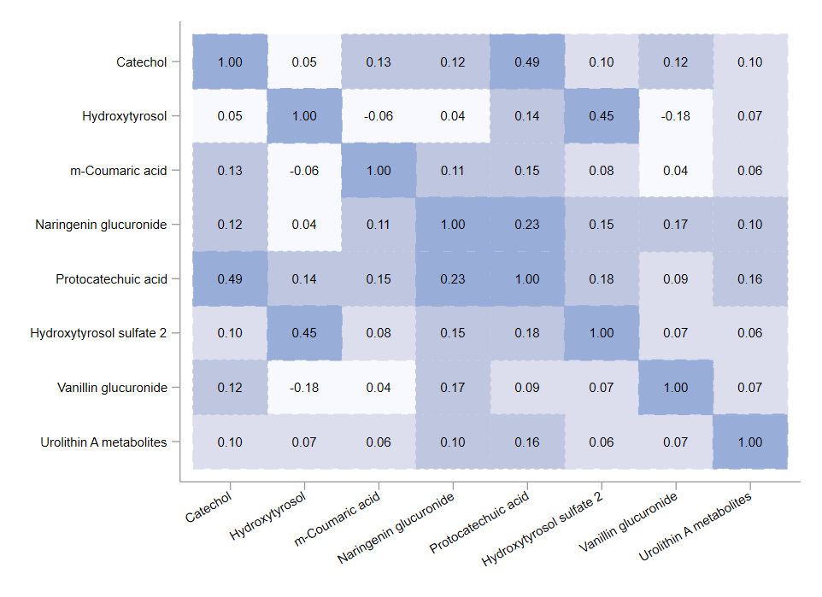
Figure S2. Heat map (Pearson’s correlation coefficients) for the eight metabolites selected in the urinary multi-metabolite signature reflecting adherence to the MedDiet.

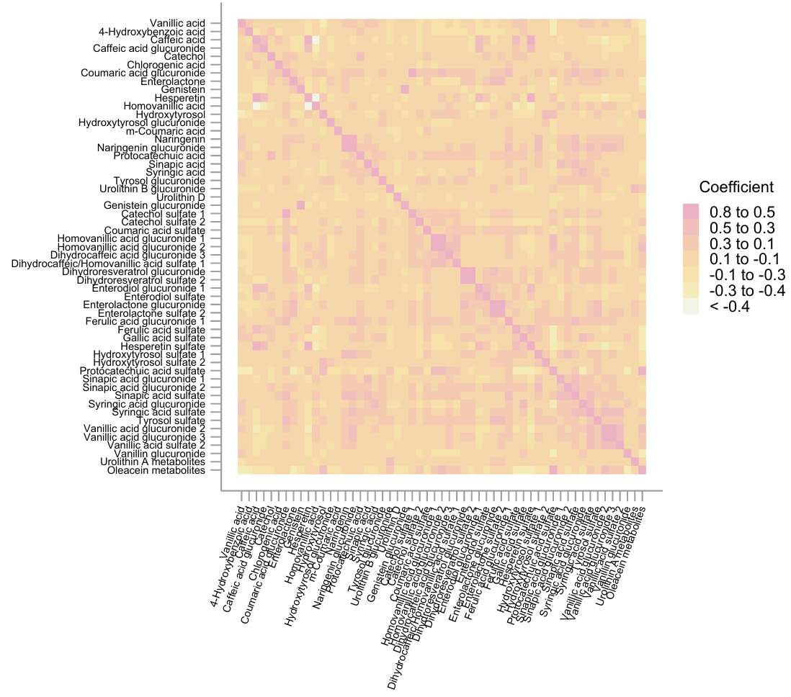
Figure S3. Heat map (Pearson’s correlation coefficients) for the 58 metabolites included in the analysis.

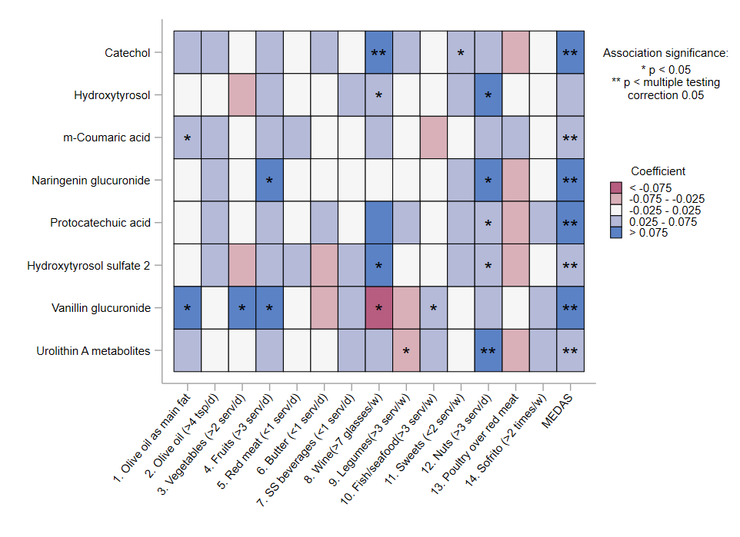Figure S4. Pearson’s pairwise correlations of the 8 selected metabolites with each of the MEDAS components and the total MEDAS score at baseline. Coefficients for associations with food items and MEDAS indicate the SD changes in the metabolites per dietary score increment. Colors denote the association directions (blue-positive and red-negative) and magnitudes (the darker the color, the stronger the magnitude). Asterisks represent association significance (*p<0.05 and **p<0.05, multiple testing corrected using the Simes method).
MEDAS, Mediterranean Diet Adherence Screener.

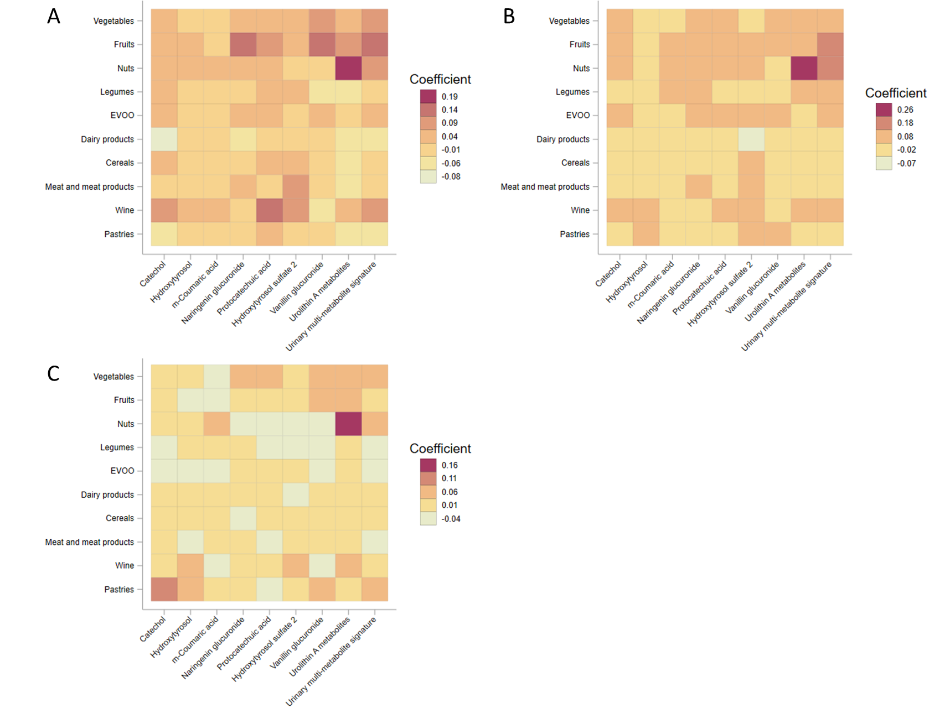
Figure S5. Heat map (Pearson’s correlation coefficients) for the eight metabolites selected in the urinary multi-metabolite signature reflecting adherence to the MedDiet and the main food groups at baseline (A), one-year of follow-up (B), and one-year changes (C).

