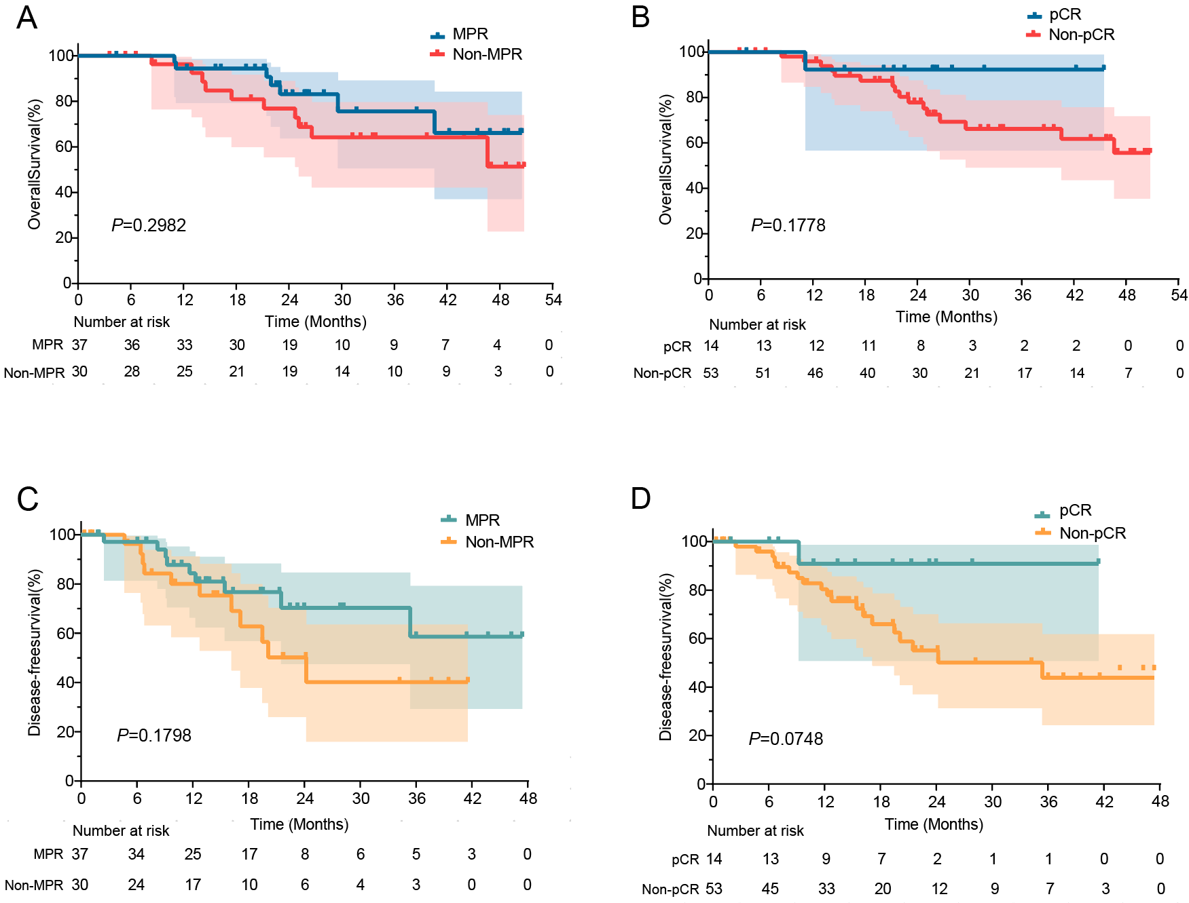
Additional file 1: Figure S1. Association between pathological response and survival outcomes. Kaplan-Meier curves comparing overall survival (OS) and disease-free survival (DFS) in pathological responders versus non-responders. (A, B) Responders with major pathological response (MPR) and pathological completer response (pCR) showed a trend toward improved OS compared to non-responders, though the difference did not reach statistical significance. (C, D) MPR and pCR responders exhibited suggestive but statistically nonsignificant DFS benefits.

Supplemental Table 1. Surgical outcomes of patients who underwent surgery (n = 67).
Characteristics | n (%) or median (IQR)
Successful R0 resection with curative intent | 67 (100%)
Surgical approach, n (%)
Robot | 25 (37.3%)
Laparoscopy | 42 (62.7%)
Time interval between last administration of conversion therapy and surgery, days, median (IQR) | 39.0 (9.0)
Intraoperative blood loss, ml, median (IQR) | 200.0 (200.0)
Intraoperative operation time, min, median (IQR) | 330.0 (135.0)
Postoperative hospital stays, days, median (IQR) | 10.0 (3.0)
ICU stay | 9 (13.4%)
Number of lymph nodes removed, median (IQR) | 33.0 (20.0)
Number of lymph node stations removed, median (IQR) | 14.0 (6.0)
Postoperative complications, n (%)
Any complications | 62 (92.5%)
Pleural effusion | 54 (80.6%)
Pneumothorax | 29 (43.3%)
Pneumonia | 22 (32.8%)
Atelectasis | 13 (19.4%)
Arrhythmia | 13 (19.4%)
Vocal cord paralysis | 2 (3.0%)
Respiratory failure | 2 (3.0%)
Wound infections | 1 (1.5%)
Data are expressed as n (%) or median (IQR) as appropriate. Surgical outcomes were evaluated in 67 patients who underwent on-site surgery. Two cases performed externally were excluded from this analysis.

Supplemental Table 2. Postoperative complications graded by Clavien-Dindo (n = 67).
Postoperative complications | Overall incidence, n (%) | Clavien-Dindo Classification
Postoperative complications | Overall incidence, n (%) | I, n (%) | II, n (%) | III, n (%) | IV, n (%) | V, n (%)
Pleural effusion | 65 (97.0) | 56 (83.6) | 0 | 9 (13.4) | 0 | 0
Pneumothorax | 29 (43.3) | 27 (40.3) | 0 | 0 | 2 (3.0) | 0
Pneumonia | 27 (40.3) | 19 (28.4) | 8 (11.9) | 0 | 0 | 0
Arrhythmia | 13 (19.4) | 0 | 12 (17.9) | 0 | 1 (1.5) | 0
Atelectasis | 13 (19.4) | 13 (19.4) | 0 | 0 | 0 | 0
Respiratory failure | 4 (6.0) | 0 | 0 | 0 | 4 (6.0) | 0
Vocal cord paralysis | 2 (3.0) | 2 (3.0) | 0 | 0 | 0 | 0
Anemia | 1 (1.5) | 0 | 1 (1.5) | 0 | 0 | 0
Delirium | 1 (1.5) | 0 | 0 | 0 | 1 (1.5) | 0
Chylothorax | 1 (1.5) | 0 | 1 (1.5) | 0 | 0 | 0
Tracheal Fistula | 1 (1.5) | 0 | 1 (1.5) | 0 | 0 | 0
Esophageal Fistula | 1 (1.5) | 0 | 0 | 0 | 1 (1.5) | 0
Wound infections | 1 (1.5) | 0 | 1 (1.5) | 0 | 0 | 0
Surgical outcomes were evaluated in 67 patients who underwent on-site surgery. Two cases performed externally were excluded from this analysis.

