Table S1: Number of participants (hysterectomy/non-hysterectomy) stratified by age
 | 18-34y | 35-44y | 45-59y | ≥60y
N | 1247/3,110,515 | 9862/2,169,398 | 143,470/2,638,408 | 56,214/884,348
BMI
Underweight | 58/371,182 | 178/74,042 | 1484/38,660 | 690/15,872
Normal weight | 596/1,882,126 | 4548/1,204,106 | 54,323/1,168,309 | 19,505/332,675
Overweight | 317/397,118 | 3002/483,365 | 55,149/885,297 | 22,583/335,173
Obesity | 136/121,187 | 1144/136,073 | 21,476/276,744 | 9548/132,288
Geographical region
North | 140/324,253 | 1111/255,848 | 17,755/318,659 | 7331/113,983
East | 300/962,951 | 2554/673,091 | 43,298/757,867 | 18,988/268,223
South-central | 408/963,131 | 2674/598,797 | 34,017/691,908 | 11,969/219,927
Northeast | 152/207,233 | 1134/201,616 | 19,398/304,044 | 8274/118,234
Northwest | 97/174,446 | 590/121,874 | 7805/167,385 | 2803/46,461
Southwest | 150/478,501 | 1799/318,172 | 21,197/398,545 | 6849/117,520
City size
Medium /smaller | 540/692,114 | 3801/649,576 | 49,256/927,589 | 16,117/282,347
Large | 493/1,267,168 | 3795/870,154 | 59,362/1,073,308 | 23,128/350,694
Mega/larger | 214/1,151,233 | 2266/649,668 | 34,852/637,511 | 16,969/251,307
Metabolic disorders
Hypertension | 216/71,881 | 1467/149,170 | 48,358/651,427 | 30,078/454,909
Diabetes | 54/10,341 | 303/26,732 | 11,345/129,520 | 8387/114,240
Hyperglycemia | 92/34,489 | 654/72,221 | 21,330/266,265 | 13,593/193,236
Dyslipidemia | 286/271,112 | 2150/289,219 | 48,093/695,322 | 22,294/328,053
MAFLD | 336/291,669 | 2831/383,436 | 62,642/869,768 | 28384/393125
Metabolic syndrome | 81/39,650 | 611/57,910 | 13,810/159,292 | 7030/94,497
Metabolic indicators
Elevated TC
No | 1086/2,865,870 | 8666/1,950,321 | 116,065/2,183,780 | 43,660/692,265
Yes | 110/67,586 | 656/83,149 | 23,046/329,710 | 11,599/174,339
Elevated TG
No | 1050/2,850,245 | 8225/1,915,172 | 114,205/2,182,991 | 44,627/714,166
Yes | 143/81,621 | 1092/117,058 | 24,808/328,632 | 10,597/152,154
Elevated FBG
No | 979/2,773,727 | 7651/1,798,168 | 98,201/1,927,048 | 33,092/538,228
Yes | 204/153,540 | 1620/222,194 | 39,892/566,743 | 21,663/321,553
Elevated HbA1c
No | 74/201,733 | 727/170,685 | 11,101/211,737 | 3985/63,981
Yes | 18/16,800 | 163/24,795 | 6648/93,691 | 4258/65,196
Elevated BP
No | 858/2,660,022 | 6848/1,682,032 | 69,441/1,484,898 | 16,718/271,090
Yes | 295/200,573 | 2308/284,948 | 66,707/959,903 | 37,157/569,218
Elevated UA
No | 1001/2,557,508 | 8025/1,819,050 | 115,069/2,143,996 | 43,586/689,869
Yes | 138/272,326 | 879/136,846 | 17,286/244,641 | 9127/135,552
Elevated TC was defined as TC ≥6.22 mmol/L. Elevated TG was defined as TG ≥2.26 mmol/L. Elevated FBG was defined as FBG >5.6 mmol/L. Elevated HbA1c was defined as HbA1c≥5.7%. Elevated BP was defined as SBP >130 mmHg and/or DBP >85 mmHg. Elevated UA was defined as UA≥360 μmol/L. BMI: Body mass index; BP, blood pressure; DBP: Diastolic blood pressure; FBG: Fasting blood glucose; HbA1c: Hemoglobin A1c; SBP: Systolic blood pressure; TC: Total cholesterol; TG: Triglyceride; UA, uric acid.

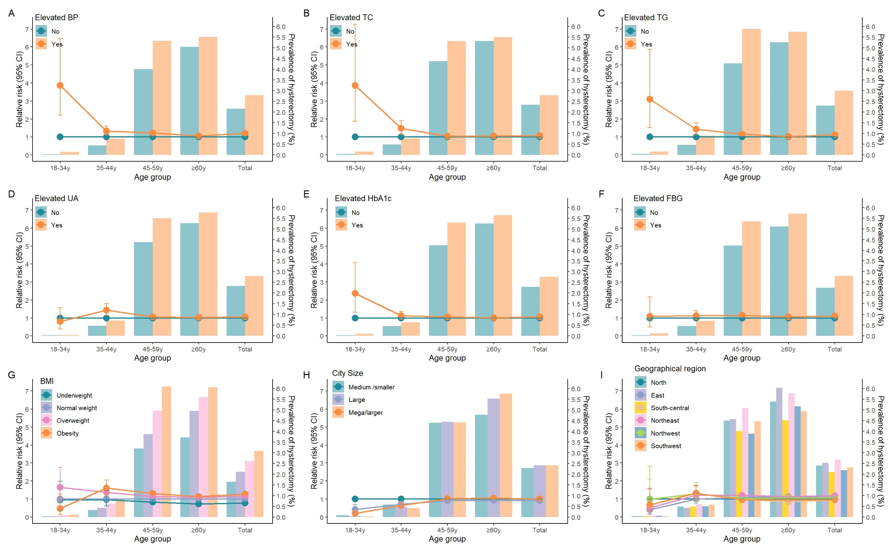
Fig. S1: Relative risk (95% CI) for associations of hysterectomy with clinical indicators and socioeconomic factors by age
Columns: age-standardized prevalence of hysterectomy (%) in the age group; curve: relative risk of an association between hysterectomy and risk factors. Relative risk estimation by log-binomial regression. A stepwise selection method for multivariable log-binomial regression was used with the SAS proc hpgenselect statement. The significance level for entry (SLE) and stay (SLS) were set at 0.05. After selecting variables based on the total population, age (≤29, 30-39, 40-49, 50-59, 60-69, ≥70 years), BMI (underweight, normal weight, overweight, obesity), city size (Medium/smaller, Large, Mega/larger), geographic region (North, East, South-central, Northeast, Northwest, Southwest), elevated TC (No/Yes), elevated TG (No/Yes), elevated FBG (No/Yes), elevated HbA1c (No/Yes), elevated BP (No/Yes), and elevated UA (No/Yes), were adjusted in the multivariable regression models. All ten factors were included simultaneously in the same model. BMI: Body mass index; BP, blood pressure; CI, Confidence interval; FBG: Fasting blood glucose; HbA1c: Hemoglobin A1c; RR, Relative risk; TC: Total cholesterol; TG: Triglyceride.

