Results
Baseline characteristics of patients lost to follow-up
We have conducted additional analysis and provided the number and baseline characteristics of patients lost to follow-up at one and three months versus those retained (Table S3 and Table S4). The retained individuals, no matter at one- or three-month follow-up, were younger and less female; had more obesity, prior history of ASCVD, hypertension, hyperlipidemia, diabetes mellitus, as well as smoking; and included high proportion of STEMI, multi-vessel disease as well as PCI. In addition, at one-month, the retained ones’ serum creatinine was lower; and at three-month, there were more family history of early-onset CVD and lower BNP values in followed subjects. All Cohen d estimate and Phi (φ) were less than 0.2 at both one- and three-month, indicating a very small effect size.

Subgroup analysis between extremely high-risk and high-risk groups
We found that a sizable percentage of the population were at extremely high-risk both at one- or three-month. However, proportion in each stage has no statistical significance (Table S6-S7).
At one-month, the extremely high-risk group showed little more MIS monotherapy (81.95% VS 79.75%, P=0.0325) and less MIS plus Ezetimibe (7.96% VS
10.10%, P=0.0036), the other schemes were similar, including the LLT with PCSK9i (Table S8). In extremely high-risk group, there were more patients attained the LDL-C goal, except the MIS plus ezetimibe and PCSK9i group (Table S9).
In three-month sample, each LLT strategies distributed similarly between the extremely high-risk and high-risk patients (Table S10). Interestingly, no matter under which LLT strategies, the LDL-C goal attainment rate was significantly better in the extremely high-risk group (Table S11).
In general, these results suggest that the more stringent target set for the extremely high-risk group seemed not the reason for the lower attainment rate.

Analysis based on smoking and troponin added propensity score matching (PSM) model
For the PSM process, limiting covariates to only age, sex, ACS type, prior ASCVD, multivessel disease, diabetes, and self-reported hyperlipidemia may be insufficient. Considering the relatively higher proportion of missing data of BMI (or obesity), we added the smoking and troponin, in which missing data was relatively lower, to the matching factors and reanalyzed the baselines at one- and three-month. All the standardized mean differences (SMD) were less than 0.1. After PSM, obesity and coronary multi-vessel disease were significantly higher in the observational group at one-month follow-up. All characteristics were balanced well at three-month (Table S12-S13). Then we found the same trends of LLT at one- and three-month follow-up. (Figure S16-S17).
Under the new PSM strategy, the lipid file had similar trends at one- and three-month follow-up (Figure S18-S19). The LDL-C goal attainment rate still had no significant change at one-month (Figure S20). Interestingly, the general LDL-C goal attainment rate became statistically insignificant in the general sample, MIS plus ezetimibe and PCSK9i, ezetimibe monotherapy, PCSK9i monotherapy as well as HIS monotherapy groups, although the P values were near 0.05 (Figure S21). Furthermore, after the smoking and troponin added strategy of PSM, we evaluated the contribution of each strategy to the total goal attainment rate improvement. The data showed that MIS monotherapy and MIS plus PCSK9i substantially improved the attainment rate, as the same to the original model (Table S14).

Supplementary Tables
Table S1. Baseline Demographic and Clinical Characteristics at One-Month Follow-Up before Propensity Score Matching
Characteristics | Individuals, No. (%) |  | P value
Characteristics | Control group  （N=6973） | Observational group（N=5626） | P value
Age, mean (SD) | 59.99(11.11) | 60.26(11.12) | .1733
Female, n, (%) | 1759(25.23) | 1315(23.37) | .0170
Obesity (BMI≥28.0), n, (%) | 428(6.14) | 402(7.15) | .0257
Prior history of ASCVD | 4130(59.23) | 3151(56.01) | .0003
Comorbidity
Hypertension, n, (%) | 3962(56.82) | 3130(55.63) | .1887
Hyperlipidemia, n, (%) | 2531(36.3) | 1640(29.15) | <.0001
Diabetes mellitus, n, (%) | 1961(28.12) | 1557(27.68) | .5914
Smoking, n, (%) | 3258(46.72) | 2511(44.63) | .0201
Family history of early-onset CVD | 167(2.39) | 121(2.15) | .3943
Coronary multi-vessel disease | 3416(48.99) | 2968(52.76) | <.0001
STEMI | 3533(50.67) | 3017(53.63) | .0042
NSTEMI | 2057(29.5) | 1553(27.6) | .0042
UA | 1383(19.83) | 1056(18.77) | .0042
Laboratory tests
Troponin, N(Missing) | 5561(1412) | 4761(865) | .0001
Mean(SD) | 107.75(1372.89) | 30.47(544.39) | .0001
BNP, N(Missing) | 679(6294) | 648(4978) | .8712
Mean(SD) | 563.02(2741.08) | 541.35(2099.03) | .8712
Serum creatinine, N(Missing) | 5880(1093) | 4436(1190) | .0889
Mean(SD) | 81.21(51.42) | 83.42(74.14) | .0889
Complete lipid profile, n, (%) | 6948(99.64) | 5615(99.8) | .1245
LDL-C, Mean(SD) | 3.53(27.49) | 3.09(5.93) | .1974
PCI, n, (%) | 2560(36.71) | 2341(41.61) | .2472
Abbreviations: BMI: body mass index; ASCVD: atherosclerotic cardiovascular disease; CVD: cardiovascular disease; ACS: acute coronary syndromes; STEMI; ST-elevation myocardial infarction; NSTEMI: non-ST-elevation myocardial infarction; UA: unstable angina; CK-MB: creatine kinase-MB; BNP: brain natriuretic peptide; LDL-C: low-density lipoprotein-cholesterol; PCI: percutaneous coronary intervention.

Table S2. Baseline Demographic and Clinical Characteristics at Three-Month Follow-Up before Propensity Score Matching
Characteristics | Individuals, No. (%) |  | P value
Characteristics | Control group  (N=4465) | Observational group (N=3817) | P value
Age, mean (SD) | 59.72(11.16) | 60.49(11.19) | .0018
Female, n, (%) | 1150(25.76) | 948(24.84) | .3504
Obesity (BMI≥28.0), n, (%) | 285(6.38) | 274(7.18) | .1632
Prior history of ASCVD | 2485(55.66) | 2040(53.45) | .0464
Comorbidity
Hypertension, n, (%) | 2579(57.76) | 2180(57.11) | .5675
Hyperlipidemia, n, (%) | 1567(35.10) | 1136(29.76) | <.0001
Diabetes mellitus, n, (%) | 1222(27.37) | 1021(26.75) | .5434
Smoking, n, (%) | 1961(43.92) | 1636(42.86) | .3439
Family history of early-onset CVD | 131(2.93) | 103(2.70) | .5632
Coronary multi-vessel disease | 2124(47.57) | 1888(49.46) | .0899
STEMI | 2200(49.27) | 1915(50.17) | .5836
NSTEMI | 1242(27.82) | 1024(26.83) | .5836
UA | 1023(22.91) | 878(23.00) | .5836
Laboratory tests
Troponin, N(Missing) | 3651(814) | 3249(568) | .5373
Mean(SD) | 58.3(1065.36) | 42.98(997.41) | .5373
BNP, N(Missing) | 453(4012) | 433(3384) | .6932
Mean(SD) | 405.15(1426.54) | 446.63(1684.3) | .6932
Serum creatinine, N(Missing) | 3635(830) | 3043(774) | .1732
Mean(SD) | 86(206.74) | 81.08(62.63) | .1732
Complete lipid profile, n, (%) | 4447(99.60) | 3811(99.84) | .0614
LDL-C, Mean(SD) | 3.12(11.00) | 2.99(5.29) | .4704
PCI, n, (%) | 1660(37.18) | 1544(40.45) | .2108
Abbreviations as in Table S1.

Table S3. Baseline Demographic and Clinical Characteristics at One-Month Follow-Up between Missing and Not Missing
Characteristics | Individuals, No. (%) |  | P value | Cohen d estimate/Phi (φ)
Characteristics | Missing  （N=777230） | Not Missing  （N=12599） | P value | Cohen d estimate/Phi (φ)
Age, mean (SD) | 62.23(10.93) | 60.11(11.11) | <.0001 | 0.1939
Female, n, (%) | 225850(29.06) | 3074(24.40) | <.0001 | 0.0129
Obesity (BMI≥28.0), n, (%) | 45563(5.86) | 830(6.59) | .0006 | 0.0039
Prior history of ASCVD | 423212(54.45) | 7281(57.79) | <.0001 | 0.0084
Comorbidity
Hypertension, n, (%) | 425880(54.79) | 7092(56.29) | .0009 | 0.0037
Hyperlipidemia, n, (%) | 175733(22.61) | 4171(33.11) | <.0001 | 0.0313
Diabetes mellitus, n, (%) | 191273(24.61) | 3518(27.92) | <.0001 | 0.0096
Smoking, n, (%) | 251092(32.31) | 5769(45.79) | <.0001 | 0.0361
Family history of early-onset CVD | 18254(2.35) | 288(2.29) | .6641 | 0.0005
Coronary multi-vessel disease | 255871(32.92) | 6384(50.67) | <.0001 | 0.0472
ACS types
STEMI | 295602(38.03) | 6550(51.99) | <.0001 | 0.0501
NSTEMI | 181425(23.34) | 3610(28.65) | <.0001 | 0.0501
UA | 300203(38.62) | 2439(19.36) | <.0001 | 0.0501
Laboratory tests
Troponin, N(Missing) | 584704(192526) | 10322(2277) | .3339 | 0.0017
Mean(SD) | 56.99(8810.74) | 72.1(1074.03) | .3339 | 0.0017
BNP, N(Missing) | 108461(668769) | 1327(11272) | .4366 | 0.0073
Mean(SD) | 607.70(7580.63) | 552.44(2447.79) | .4366 | 0.0073
Serum creatinine, N(Missing) | 557069(220161) | 10316(2283) | <.0001 | 0.0096
Mean(SD) | 85.83(384.39) | 82.16(62.22) | <.0001 | 0.0096
Complete lipid profile, n, (%) | 674910(86.84) | 12563(99.71) | <.0001 | 0.0480
LDL-C, Mean(SD) | 3.31(70.84) | 3.33(20.84) | .9326 | 0.0003
PCI, n, (%) | 180680(23.25) | 4901(38.9) | <.0001 | 0.0086
Abbreviations as in Table S1.

Table S4. Baseline Demographic and Clinical Characteristics at Three-Month Follow-Up between Missing and Not Missing
Characteristics | Individuals, No. (%) |  | P value | Cohen d estimate/Phi (φ)
Characteristics | Missing  （N=781547） | Not Missing  （N=8282） | P value | Cohen d estimate/Phi (φ)
Age, mean (SD) | 62.22(10.93) | 60.08(11.18) | <.0001 | 0.1957
Female, n, (%) | 226826(29.02) | 2098(25.33) | <.0001 | 0.0083
Obesity (BMI≥28.0), n, (%) | 45834(5.86) | 559(6.75) | .0007 | 0.0038
Prior history of ASCVD | 425968(54.5) | 4525(54.64) | .8170 | 0.0003
Comorbidity
Hypertension, n, (%) | 428213(54.79) | 4759(57.46) | <.0001 | 0.0055
Hyperlipidemia, n, (%) | 177201(22.67) | 2703(32.64) | <.0001 | 0.0242
Diabetes mellitus, n, (%) | 192548(24.64) | 2243(27.08) | <.0001 | 0.0058
Smoking, n, (%) | 253264(32.41) | 3597(43.43) | <.0001 | 0.0240
Family history of early-onset CVD | 18308(2.34) | 234(2.83) | .0044 | 0.0032
Coronary multi-vessel disease | 258243(33.04) | 4012(48.44) | <.0001 | 0.0333
ACS types
STEMI | 298037(38.13) | 4115(49.69) | <.0001 | 0.0329
NSTEMI | 182769(23.39) | 2266(27.36) | <.0001 | 0.0329
UA | 300741(38.48) | 1901(22.95) | <.0001 | 0.0329
Laboratory tests
Troponin, N(Missing) | 588126(193421) | 6900(1382) | .7121 | 0.0007
Mean(SD) | 57.33(8785.51) | 51.09(1033.88) | .7121 | 0.0007
BNP, N(Missing) | 108902(672645) | 886(7396) | .0014 | 0.0243
Mean(SD) | 608.51(7568.77) | 425.42(1557.10) | .0014 | 0.0243
Serum creatinine, N(Missing) | 560707(220840) | 6678(1604) | .3117 | 0.0053
Mean(SD) | 85.79(382.84) | 83.76(158.29) | .3117 | 0.0053
Complete lipid profile, n, (%) | 679215(86.91) | 8258(99.71) | <.0001 | 0.0388
LDL-C, Mean(SD) | 3.32(70.67) | 3.06(8.84) | .0464 | 0.0037
PCI, n, (%) | 182377(23.34) | 3204(38.69) | .0192 | 0.0049
Abbreviations as in Table S1.

Table S5. Contribution of Each Lipid Lowering Therapies to the Total LDL-C Goal Attainment Rate Improvement at Three-Month Follow-Up after Propensity Score Matching
Characteristics | Individuals, No. (%) |  | P value
Characteristics | Control group  (N=530) | Observational group  (N=598) | P value
Patients with at least one of the listed seven lipid-lowering medications | 512(96.60) | 576(96.32) | .9244
MIS | 363(68.49) | 446(74.58) | .0277
MIS+Ezetimibe | 94(17.74) | 41(6.86) | <.0001
HIS | 37(6.98) | 35(5.85) | .5146
MIS+PCSK9i | 8(1.51) | 38(6.35) | <.0001
MIS +Ezetimibe+PCSK9i | 7(1.32) | 11(1.84) | .6485
Ezetimibe monotherapy | 2(0.38) | 4(0.67) | .7935
PCSK9i monotherapy | 1(0.19) | 1(0.17) | >.9999
Abbreviations: MIS: moderate-intensity statins, including atorvastatin (10-20 mg/day), rosuvastatin (5-10 mg/day), fluvastatin (80 mg/day), lovastatin (40 mg/day), pivastatin (2-4 mg/day), pravastatin (40 mg/day), simvastatin (20-40 mg/day). HIS: High-intensity statins, including atorvastatin (40 mg/day), rosuvastatin (20 mg/day). PCSK9: preprotein converting enzyme subtilisin kexin 9. LDL-C: low-density lipoprotein-cholesterol.

Table S6. Extremely High-risk Proportion at One-Month Follow-Up before Propensity Score Matching
Characteristics | Individuals, No. (%) |  | P value
Characteristics | Control group  (N=6973) | Observational group  (N=5626) | P value
High-risk | 967(13.87) | 717(12.74) | .0694
Extremely High-risk | 6006(86.13) | 4909(87.26) | .0694

Table S7. Extremely High-risk Proportion at Three-Month Follow-Up before Propensity Score Matching
Characteristics | Individuals, No. (%) |  | P value
Characteristics | Control group  (N=4465) | Observational group  (N=3817) | P value
High-risk | 651(14.58) | 578(15.14) | .4920
Extremely High-risk | 3814(85.42) | 3239(84.86) | .4920

Table S8. Lipid Lowering Therapies at One-Month Follow-Up between High-risk and Extremely High-risk
Characteristics | Individuals, No. (%) |  | P value
Characteristics | high-risk (N=1684) | Extremely High-risk (N=10915) | P value
Patients with at least one of the listed seven lipid-lowering medications | 1612(95.72) | 10550(96.66) | .0611
MIS | 1343(79.75) | 8945(81.95) | .0325
MIS+Ezetimibe | 170(10.1) | 869(7.96) | .0036
HIS | 62(3.68) | 473(4.33) | .2421
MIS+PCSK9i | 22(1.31) | 149(1.37) | .9358
MIS +Ezetimibe+PCSK9i | 8(0.48) | 51(0.47) | >.9999
Ezetimibe monotherapy | 6(0.36) | 55(0.5) | .5329
PCSK9i monotherapy | 1(0.06) | 8(0.07) | >.9999
Abbreviations as in Table S5.

Table S9. LDL-C Goal Attainment Rate on Different Lipid Lowering Therapies at One-Month between High-risk and Extremely High-risk
Characteristics | Individuals, No. (%) |  | P value
Characteristics | high-risk (N=1684) | Extremely High-risk (N=10915) | P value
Patients with at least one of the listed seven lipid-lowering medications | 100(6.20) | 1660(15.73) | <.0001
MIS | 63(4.69) | 1228(13.73) | <.0001
MIS+Ezetimibe | 17(10.00) | 225(25.89) | <.0001
HIS | 5(8.06) | 84(17.76) | <.0001
MIS+PCSK9i | 9(40.91) | 84(56.38) | <.0001
MIS +Ezetimibe+PCSK9i | 6(75.00) | 28(54.90) | <.0001
Ezetimibe monotherapy | 0(-) | 9(16.36) | <.0001
PCSK9i monotherapy | 0(-) | 2(25.00) | <.0001
Abbreviations as in Table S5.

Table S10. Lipid Lowering Therapies at Three-Month Follow-Up between High-risk and Extremely High-risk
Characteristics | Individuals, No. (%) |  | P value
Characteristics | high-risk (N=1229) | Extremely High-risk (N=7053) | P value
Patients with at least one of the listed seven lipid-lowering medications | 1167(94.96) | 6781(96.14) | .0607
MIS | 987(80.31) | 5723(81.14) | .5168
MIS+Ezetimibe | 112(9.11) | 540(7.66) | .0905
HIS | 41(3.34) | 322(4.57) | .0619
MIS+PCSK9i | 18(1.46) | 111(1.57) | .8725
MIS +Ezetimibe+PCSK9i | 4(0.33) | 45(0.64) | .2640
Ezetimibe monotherapy | 5(0.41) | 30(0.43) | >.9999
PCSK9i monotherapy | 0(-) | 10(0.14) | .3811
Abbreviations as in Table S5.

Table S11. LDL-C Goal Attainment Rate on Different Lipid Lowering Therapies at Three-Month between High-risk and Extremely High-risk
Characteristics | Individuals, No. (%) |  | P value
Characteristics | high-risk (N=1229) | Extremely High-risk (N=7053) | P value
Patients with at least one of the listed seven lipid-lowering medications | 65(5.57) | 1112(16.4) | <.0001
MIS | 44(4.46) | 829(14.49) | <.0001
MIS+Ezetimibe | 13(11.61) | 141(26.11) | <.0001
HIS | 1(2.44) | 75(23.29) | <.0001
MIS+PCSK9i | 6(33.33) | 42(37.84) | <.0001
MIS +Ezetimibe+PCSK9i | 1(25) | 17(37.78) | <.0001
Ezetimibe monotherapy | 0(-) | 6(20.00) | <.0001
PCSK9i monotherapy | 0(-) | 2(20.00) | <.0001
Abbreviations as in Table S5.

Table S12. Baseline Demographic and Clinical Characteristics at One-Month Follow-Up after Propensity Score Matching added Smoking and Troponin
Characteristics | Individuals, No. (%) |  | P value | SMD
Characteristics | Control group (N=4761) | Observational group (N=4761) | P value | SMD
Age, mean (SD) | 60.4(11.05) | 60.4(11.11) | .9852 | 0.0004
Female, n, (%) | 1145(24.05) | 1095(23.00) | .2365 | 0.0250
Obesity (BMI≥28.0), n, (%) | 293(6.15) | 364(7.65) | .0046
Prior history of ASCVD | 2659(55.85) | 2575(54.09) | .0873 | 0.0354
Comorbidity
Hypertension, n, (%) | 2749(57.74) | 2679(56.27) | .1532
Hyperlipidemia, n, (%) | 1431(30.06) | 1417(29.76) | .7711 | 0.0064
Diabetes mellitus, n, (%) | 1329(27.91) | 1294(27.18) | .4354 | 0.0165
Smoking, n, (%) | 2115(44.42) | 2121(44.55) | .9179 | 0.0025
Family history of early-onset CVD | 124(2.60) | 113(2.37) | .5107
Coronary multi-vessel disease | 2359(49.55) | 2490(52.30) | .0077 | 0.0551
ACS types
STEMI | 2402(50.45) | 2495(52.40) | .1124 | 0.0273
NSTEMI | 1478(31.04) | 1392(29.24) | .1124 | 0.0273
UA | 881(18.50) | 874(18.36) | .1124 | 0.0273
Laboratory tests
Troponin, N(Missing) | 4761(0) | 4761(0) | .6340 | 0.0105
Mean(SD) | 36.17(622.63) | 30.47(544.39) | .6340 | 0.0105
BNP, N(Missing) | 546(4215) | 601(4160) | .8390
Mean(SD) | 583.77(2751.06) | 553.88(2160.48) | .8390
Serum creatinine, N(Missing) | 4037(724) | 3855(906) | .1098
Mean(SD) | 81.06(53.91) | 83.43(75.16) | .1098
Complete lipid profile, n, (%) | 4761(100.00) | 4761 (100.00) | -
LDLC, Mean(SD) | 3.17(12.74) | 3.08(6.01) | .6774
PCI, n, (%) | 1837(38.58) | 2003(42.07) | .9152
Abbreviations as in Table S1.

Table S13. Baseline Demographic and Clinical Characteristics at Three-Month Follow-Up after Propensity Score Matching added Smoking and Troponin
Characteristics | Individuals, No. (%) |  | P value | SMD
Characteristics | Control group (N=3249) | Observational group (N=3249) | P value | SMD
Age, mean (SD) | 60.23(11.10) | 60.57(11.20) | .2181 | 0.0304
Female, n, (%) | 817(25.15) | 800(24.62) | .6462 | 0.0121
Obesity (BMI≥28.0), n, (%) | 219(6.74) | 233(7.17) | .5261
Prior history of ASCVD | 1740(53.55) | 1702(52.39) | .3578 | 0.0234
Comorbidity
Hypertension, n, (%) | 1869(57.53) | 1869(57.53) | >.9999
Hyperlipidemia, n, (%) | 1006(30.96) | 1001(30.81) | .9145 | 0.0033
Diabetes mellitus, n, (%) | 882(27.15) | 876(26.96) | .8890 | 0.0042
Smoking, n, (%) | 1383(42.57) | 1403(43.18) | .6339 | 0.0124
Family history of early-onset CVD | 103(3.17) | 91(2.8) | .4227
Coronary multi-vessel disease | 1591(48.97) | 1629(50.14) | .3586 | 0.0234
ACS types
STEMI | 1607(49.46) | 1623(49.95) | .9235 | 0.0084
NSTEMI | 914(28.13) | 904(27.82) | .9235 | 0.0084
UA | 728(22.41) | 722(22.22) | .9235 | 0.0084
Laboratory tests
Troponin, N(Missing) | 3249(0) | 3249(0) | .6691 | 0.0095
Mean(SD) | 33.46(784.54) | 42.98(997.41) | .6691 | 0.0095
BNP, N(Missing) | 358(2891) | 388(2861) | .5875
Mean(SD) | 415.37(1508.78) | 480.65(1774.16) | .5875
Serum creatinine, N(Missing) | 2669(580) | 2644(605) | .2499
Mean(SD) | 87.19(238.25) | 81.68(66.13) | .2499
Complete lipid profile, n, (%) | 3249(100.00) | 3249(100.00) | -
LDLC, Mean(SD) | 3.09(12.06) | 3(5.72) | .7209
PCI, n, (%) | 1263(38.87) | 1344(41.37) | .3281
Abbreviations as in Table S1.

Table S14. Contribution of Each Lipid Lowering Therapies to the Total LDL-C Goal Attainment Rate Improvement at Three-Month Follow-Up after Propensity Score Matching added Smoking and Troponin
Characteristics | Individuals, No. (%) |  | P value
Characteristics | Control group  (N=449) | Observational group  (N=501) | P value
Patients with at least one of the listed seven lipid-lowering medications | 435(96.88） | 483(96.41) | .8221
MIS | 304(67.71） | 383(76.45) | .0034
MIS+Ezetimibe | 88(19.6） | 32(6.39) | <.0001
HIS | 28(0.06） | 29(0.06） | .8782
MIS+PCSK9i | 9(2.00） | 24(4.79) | .0305
MIS +Ezetimibe+PCSK9i | 3(0.67） | 11(2.20) | .0928
Ezetimibe monotherapy | 2(0.45） | 3(0.60) | >.9999
PCSK9i monotherapy | 1(0.22） | 1(0.20) | >.9999
Abbreviations as in Table S5.

Supplementary Figures with Legends

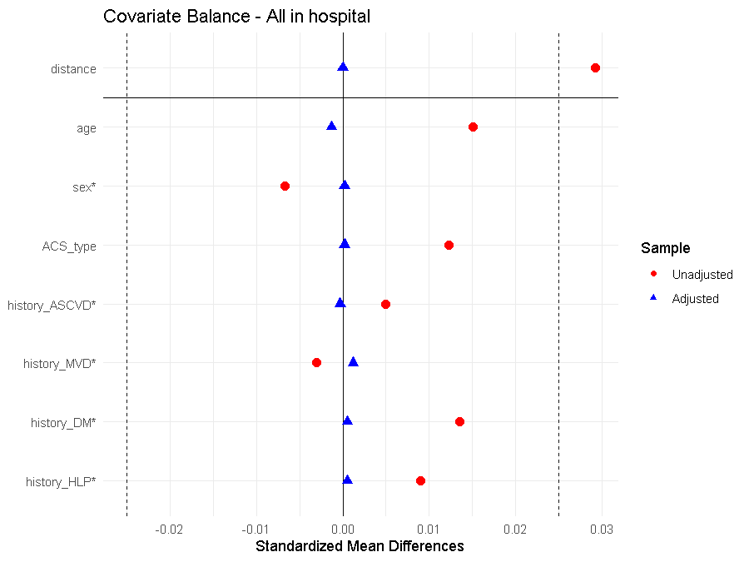
Figure S1. Propensity Score Distribution before and after Propensity Score Matching at Discharge
Abbreviations: ACS: acute coronary syndromes. ASCVD: atherosclerotic cardiovascular disease. MVD: multi-vessel disease. DM： diabetes mellitus. HLP: hyperlipidemia. Vertical dashed line stands for ±0.025.

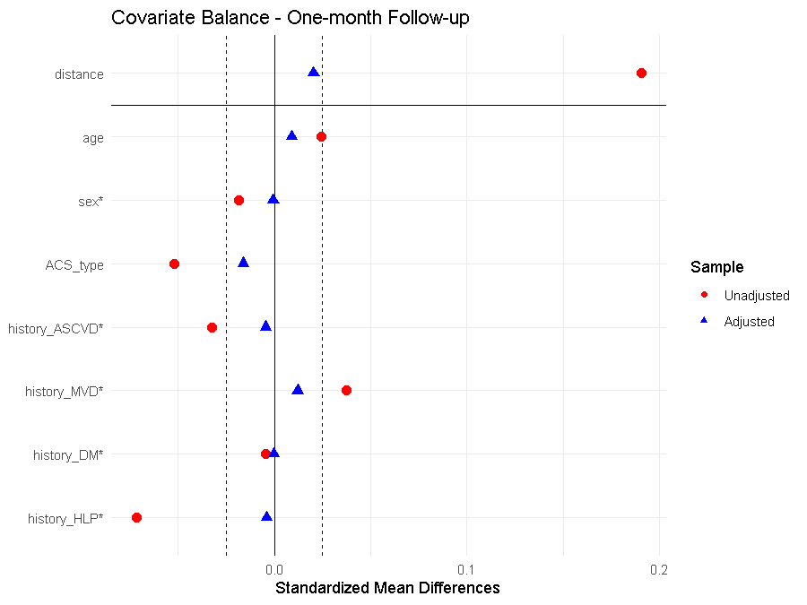
Figure S2. Propensity Score Distribution before and after Propensity Score Matching at One-month Follow-Up
Abbreviations as in Figure S1.

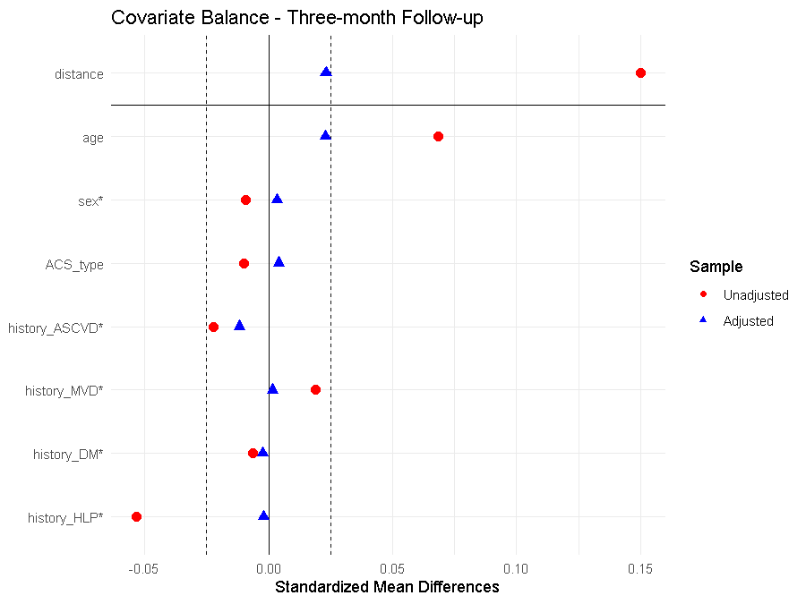
Figure S3. Propensity Score Distribution before and after Propensity Score Matching at Three-month Follow-Up
Abbreviations as in Figure S1.

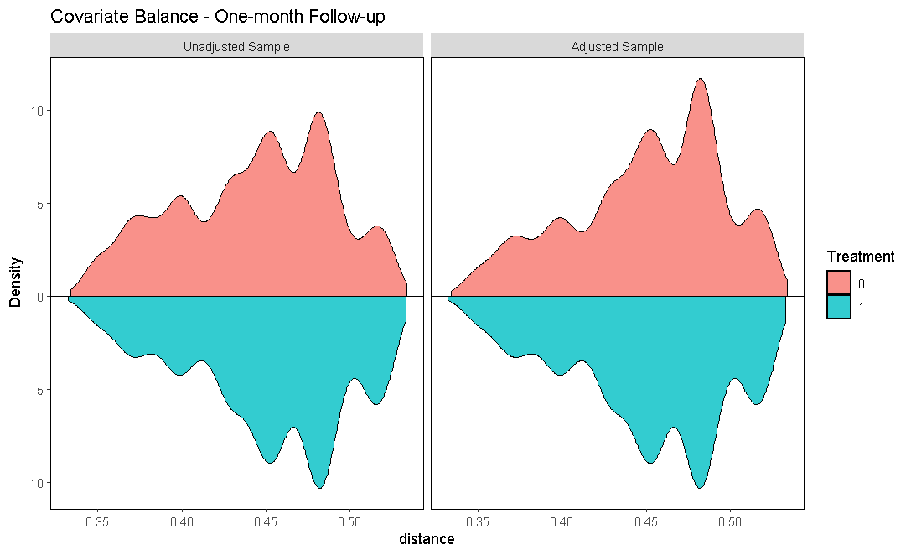
Figure S4. Kernel Density Estimate plot at One-Month Follow-Up after Propensity Score Matching

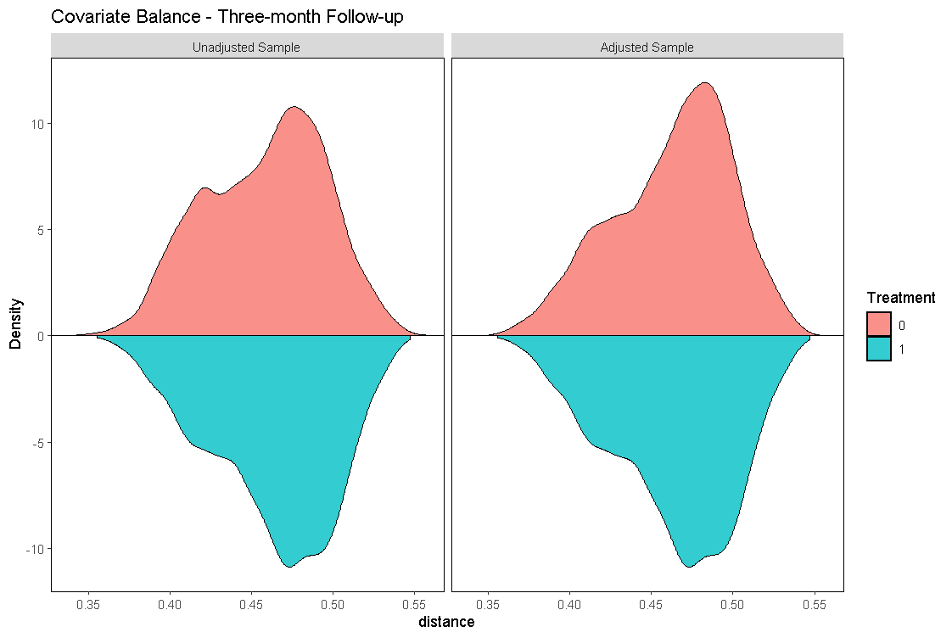
Figure S5. Kernel Density Estimate plot at Three-Month Follow-Up after Propensity Score Matching

Figure S6. Lipid Lowering Therapies at Discharge before Propensity Score Matching
Abbreviations: MIS: moderate-intensity statins, including atorvastatin (10-20 mg/day), rosuvastatin (5-10 mg/day), fluvastatin (80 mg/day), lovastatin (40 mg/day), pivastatin (2-4 mg/day), pravastatin (40 mg/day), simvastatin (20-40 mg/day). HIS: High-intensity statins, including atorvastatin (40-80 mg/day), rosuvastatin (20 mg/day; 40mg was not approved in Chinese market). PCSK9: preprotein converting enzyme subtilisin kexin 9. *: statistically significant. Y-axis is log₁₀ scale.

Figure S7. Lipid Lowering Therapies at One-Month Follow-Up before Propensity Score Matching
Abbreviations as in Figure S6. *: statistically significant. Y-axis is log₁₀ scale.

Figure S8. Lipid Profile at One-Month Follow-Up before Propensity Score Matching

Figure S9. Lipid Profile at One-Month Follow-Up after Propensity Score Matching

Figure S10. LDL-C goal Attainment rate at One-Month Follow-Up before Propensity Score Matching
Abbreviations as in Figure S6.

Figure S11. LDL-C Goal Attainment Rate at One-Month Follow-Up after Propensity Score Matching
Abbreviations as in Figure S6.

Figure S12. Lipid Lowering Therapies at Three-Month Follow-Up before Propensity Score Matching
Abbreviations as in Figure S6. *: statistically significant. Y-axis is log₁₀ scale.

Figure S13. Lipid Profile at Three-Month Follow-Up before Propensity Score Matching
*: statistically significant.

Figure S14. Lipid Profile at Three-Month Follow-Up after Propensity Score Matching
*: statistically significant.

Figure S15. LDL-C Goal Attainment Rate at Three-Month Follow-Up after Propensity Score Matching
Abbreviations as in Figure S6. *: statistically significant.

Figure S16. Lipid Lowering Therapies at One-Month Follow-Up after Propensity Score Matching added Smoking and Troponin
Abbreviations as in Figure S6. *: statistically significant. Y-axis is log₁₀ scale.
Figure S17. Lipid Lowering Therapies at Three-Month Follow-Up after Propensity Score Matching added Smoking and Troponin
Abbreviations as in Figure S6. *: statistically significant. Y-axis is log₁₀ scale.
Figure S18. Lipid Profile at One-Month Follow-Up after Propensity Score Matching added Smoking and Troponin
*: statistically significant.

Figure S19. Lipid Profile at Three-Month Follow-Up after Propensity Score Matching added Smoking and Troponin
*: statistically significant.

Figure S20. LDL-C Goal Attainment at One-Month Follow-Up after Propensity Score Matching added Smoking and Troponin
Abbreviations as in Figure S6.
Figure S21. LDL-C Goal Attainment at Three-Month Follow-Up after Propensity Score Matching added Smoking and Troponin
Abbreviations as in Figure S6. *: statistically significant.

