Additional File 4 Supplement to Network Meta-Analysis Based on Potassium Chloride Content

Figure S1 Network plots for the outcomes

4.1.1. Network plot of comparisons for all-cause mortality
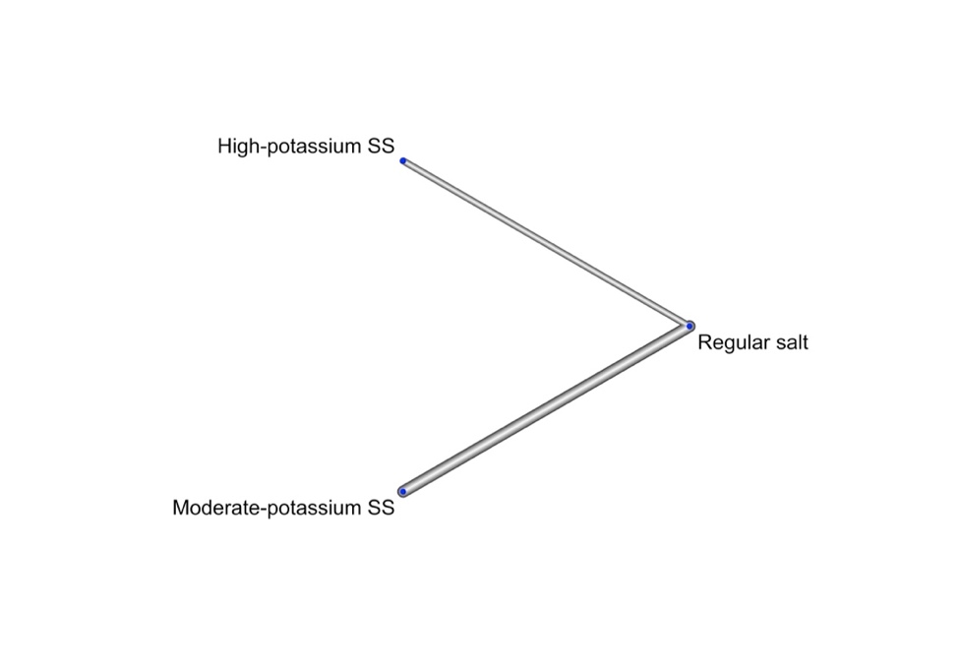

4.1.2. Network plot of comparisons for cardiovascular mortality
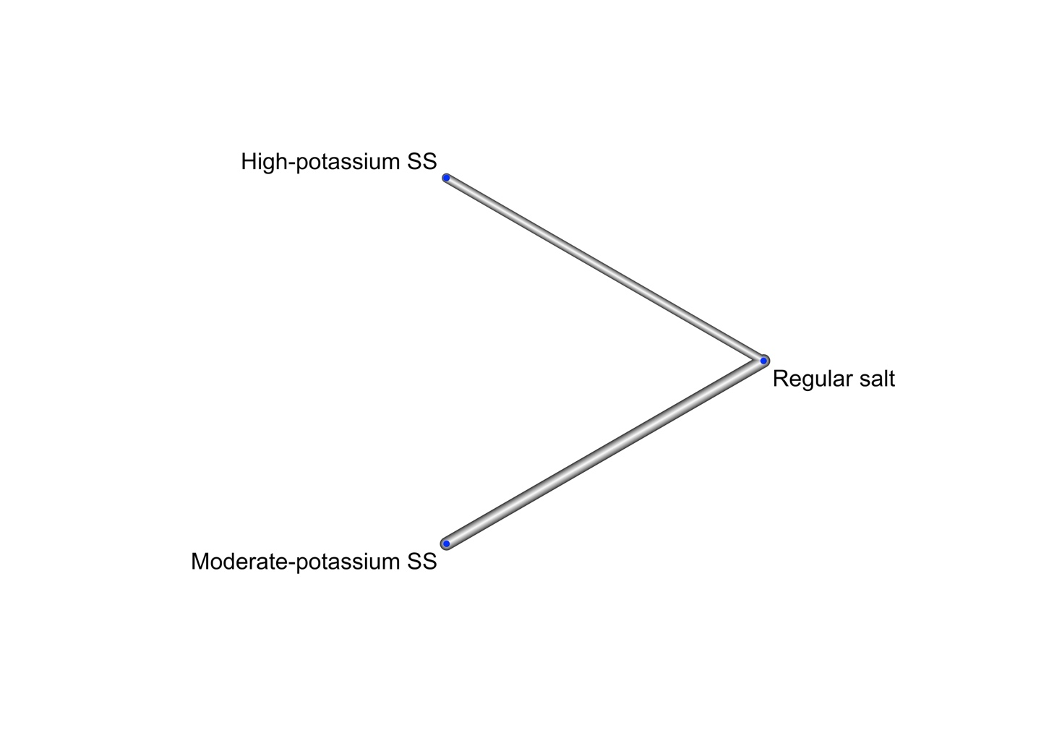

4.1.3. Network plot of comparisons for non-fatal cardiovascular events
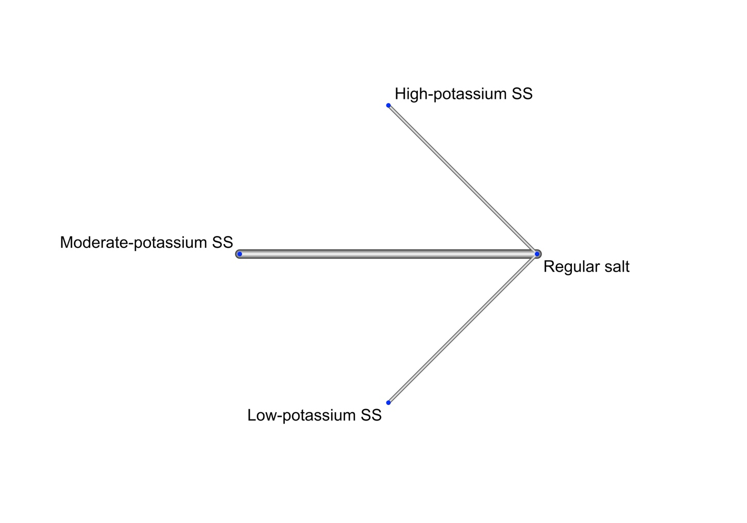

4.1.4. Network plot of comparisons for systolic blood pressure
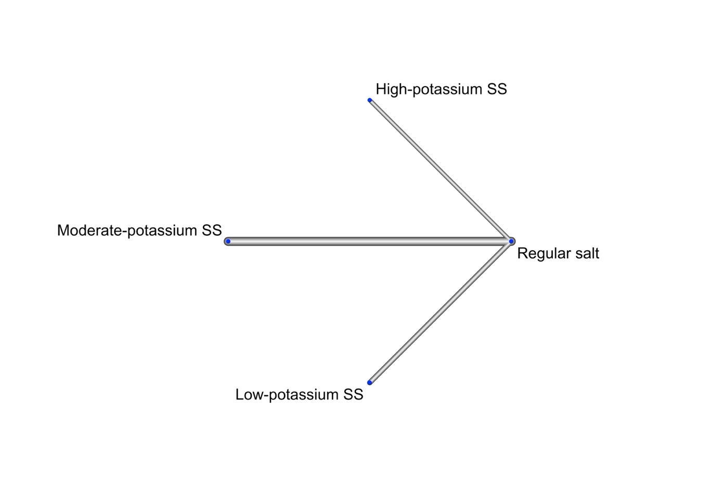

4.1.5. Network plot of comparisons for diastolic blood pressure
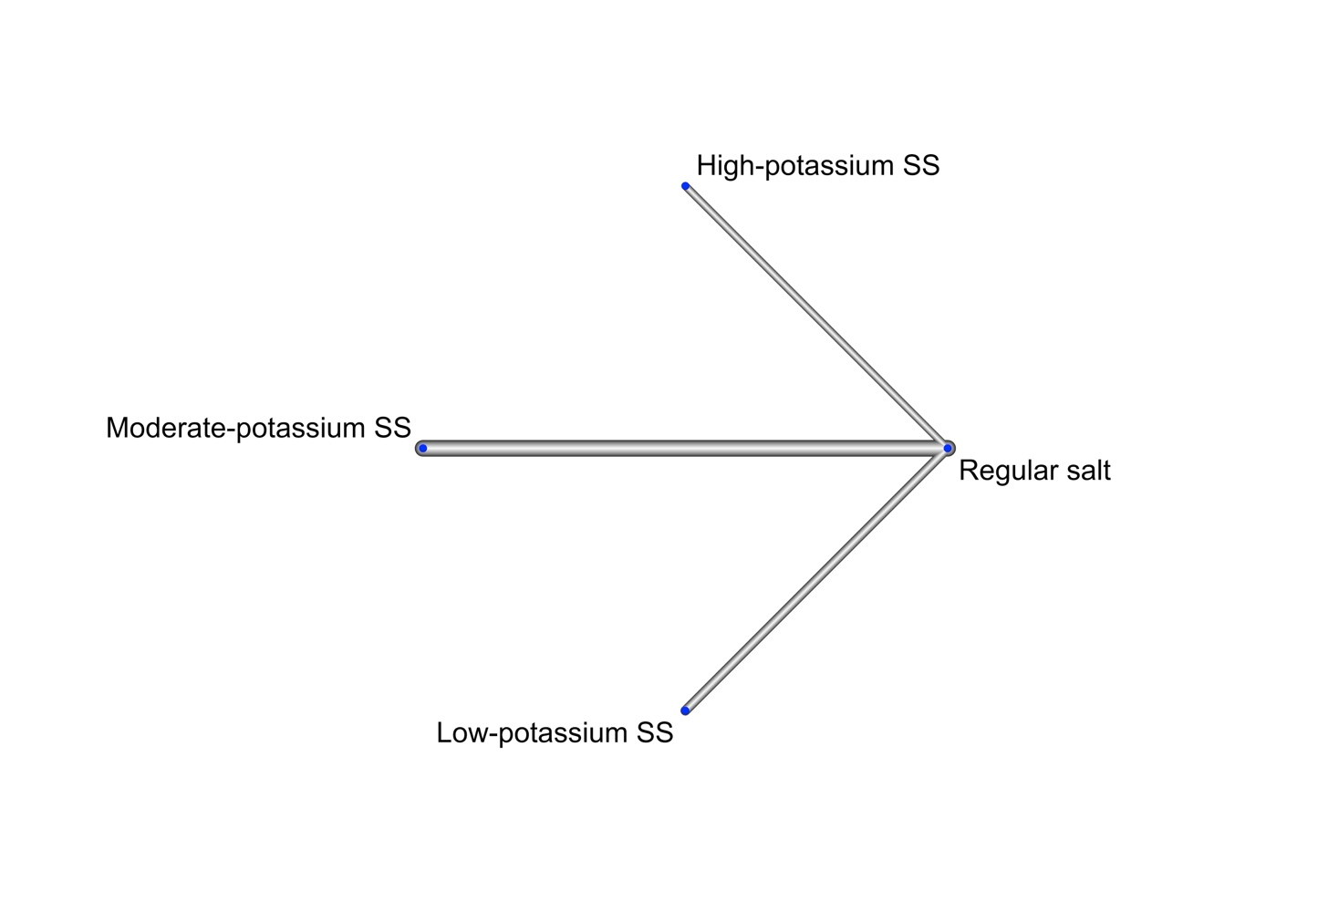

4.1.6. Network plot of comparisons for adverse events related to intervention
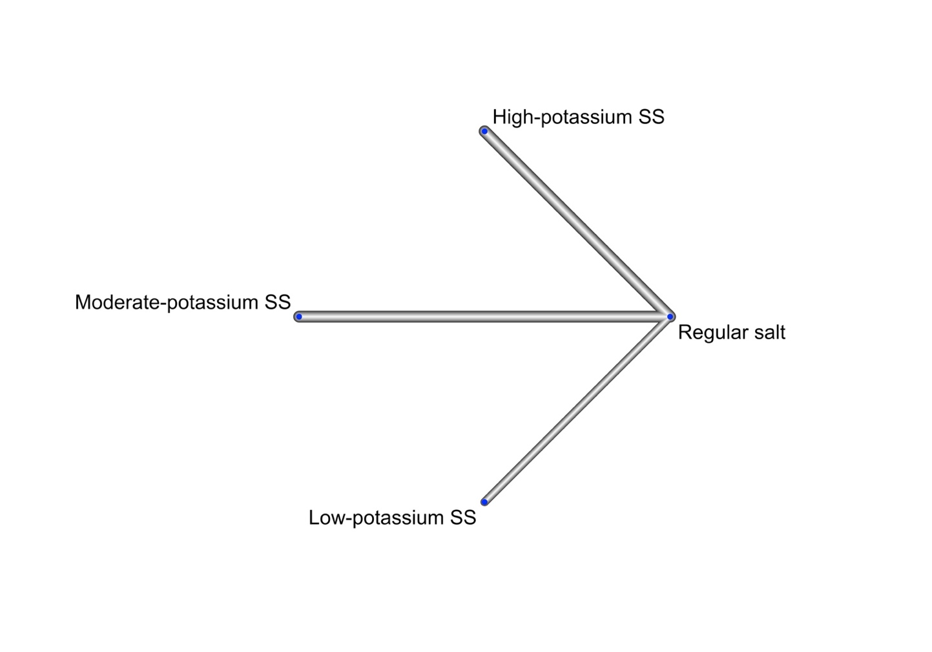

4.1.7. Network plot of comparisons for withdrawals due to any reason
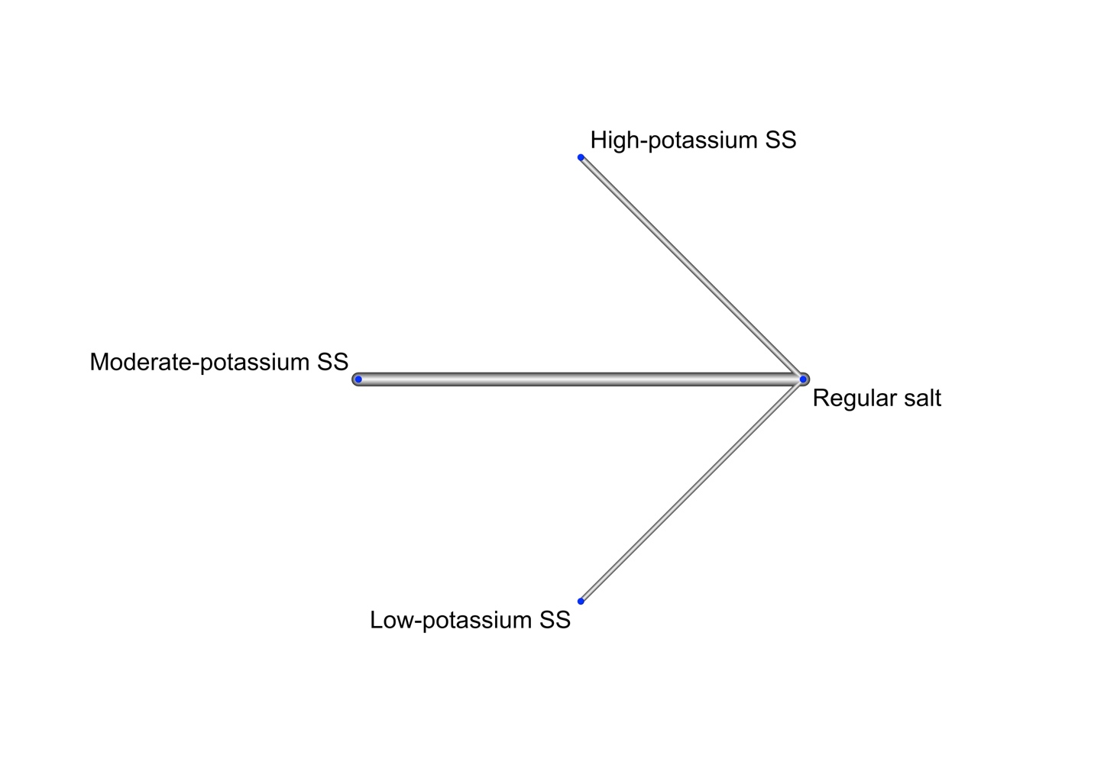

4.1.8. Network plot of comparisons for serum potassium concentration
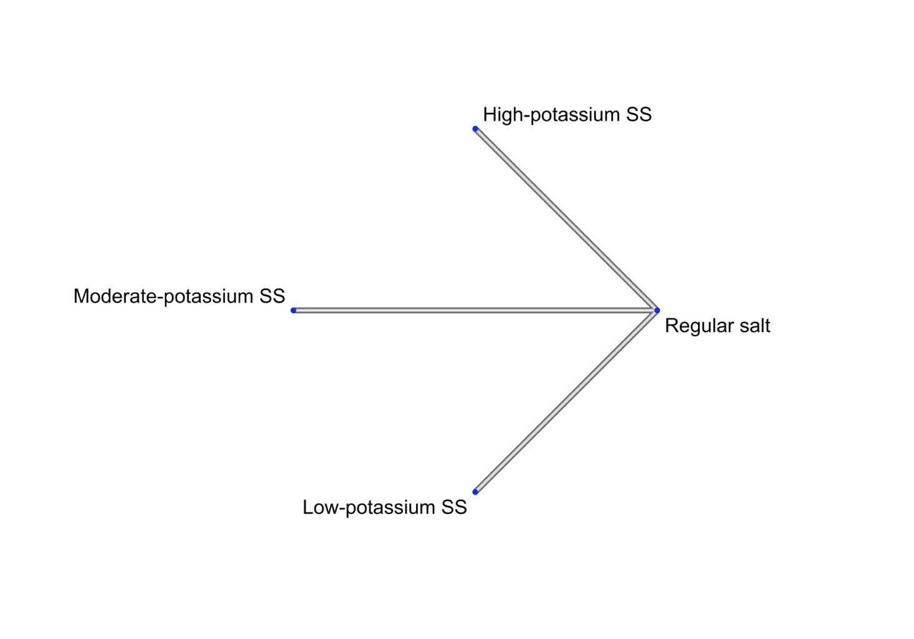

4.1.9. Network plot of comparisons for serum sodium concentration
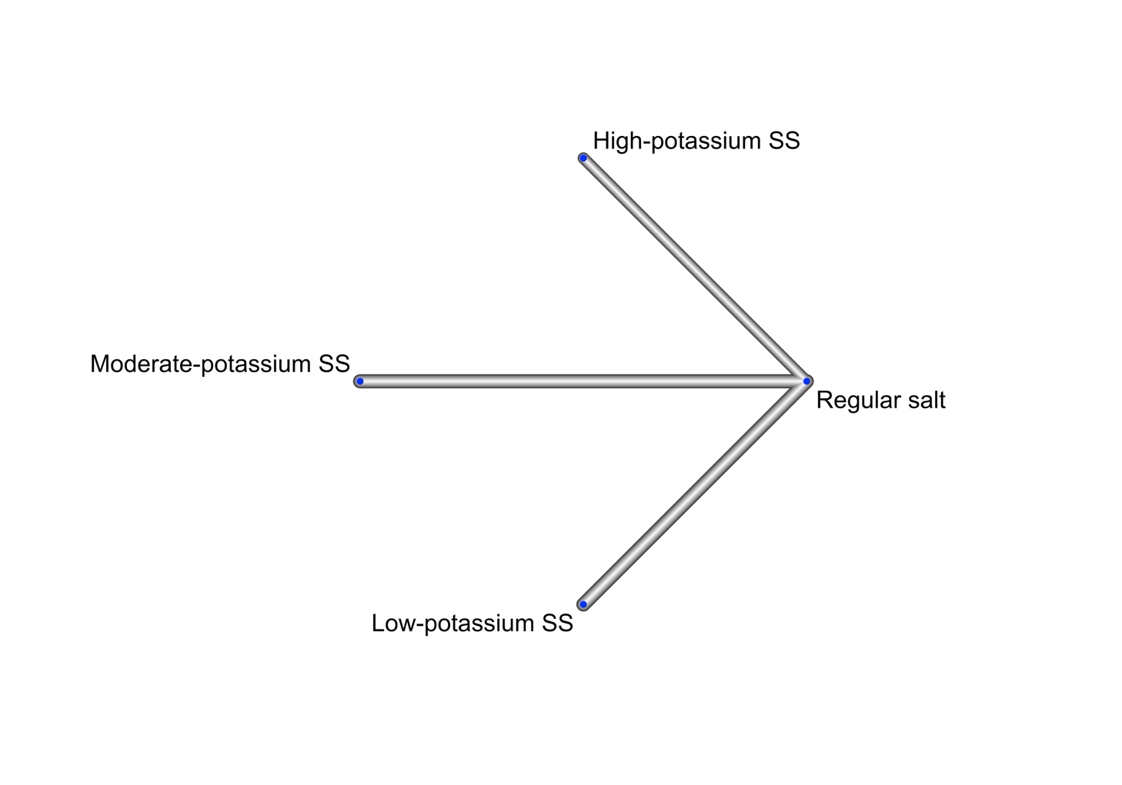

4.1.10. Network plot of comparisons for 24-hour urinary potassium excretion
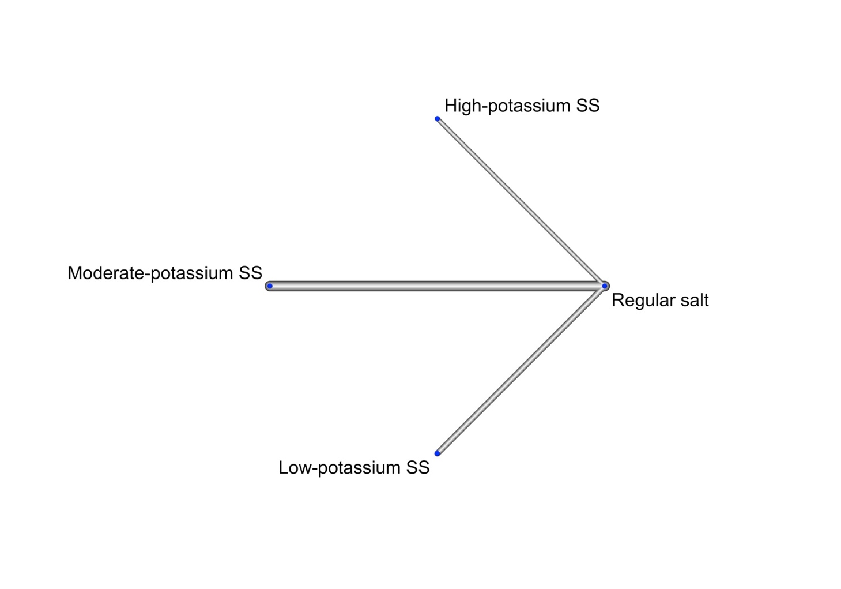

4.1.11. Network plot of comparisons for 24-hour urinary sodium excretion
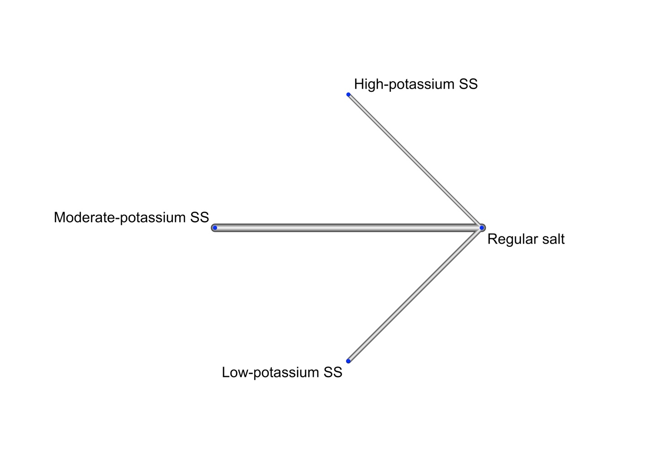

Figure S2 League tables
High certainty | Moderate certainty | Low certainty | Very low certainty

4.2.1. Absolute estimates for all-cause mortality and cardiovascular mortality (intermediate baseline risk)
Intermediate risk | Cardiovascular mortality (upper right)
All-cause mortality (lower left) | High-potassium SS | -7 (-15 to 8) | -10 (-17 to 1)
All-cause mortality (lower left) | 6 (-5 to 18) | Moderate-potassium SS | -5 (-9 to 0)
All-cause mortality (lower left) | -2 (-11 to 7) | -7 (-11 to -3) | Regular salt
Salt substitutes network meta-analysis results as anticipate risk differences per 1000 over five years with 95% confidence interval and corresponding GRADE certainty of evidence.

4.2.2. Absolute estimates for all-cause mortality and cardiovascular mortality (high baseline risk)
High risk | Cardiovascular mortality (upper right)
All-cause mortality (lower left) | High-potassium SS | -21 (-49 to 26) | -33 (-55 to 3)
All-cause mortality (lower left) | 13 (-11 to 41) | Moderate-potassium SS | -16 (-28 to -1)
All-cause mortality (lower left) | -6 (-24 to 17) | -16 (-24 to -7) | Regular salt
Salt substitutes network meta-analysis results as anticipate risk differences per 1000 over five years with 95% confidence interval and corresponding GRADE certainty of evidence.

4.2.3. Absolute estimates for non-fatal cardiovascular events (intermediate baseline risk)
High-potassium SS
134 (-57 to 2362) | Moderate-potassium SS
453 (-65 to 29507) | 115 (-68 to 4670) | Low-potassium SS
78 (-62 to 1677) | -20 (-35 to 0) | -53 (-74 to 461) | Regular salt
Salt substitutes network meta-analysis results as anticipate risk differences per 1000 over five years with 95% confidence interval and corresponding GRADE certainty of evidence.

4.2.4. Absolute estimates for non-fatal cardiovascular events (high baseline risk)
High-potassium SS
445 (-190 to 7873) | Moderate-potassium SS
1510 (-218 to 98355) | 383 (-225 to 15568) | Low-potassium SS
260 (-205 to 5590) | -68 (-115 to 0) | -178 (-248 to 1538) | Regular salt
Salt substitutes network meta-analysis results as anticipate risk differences per 1000 over five years with 95% confidence interval and corresponding GRADE certainty of evidence.

4.2.5. Estimates for systolic and diastolic blood pressure
 | DBP (upper right)
SBP (lower left) | High-potassium SS | -1.28 (-4.69 to 2.14) | 1.32 (-2.74 to 5.39) | -3.26 (-6.45 to -0.07)
SBP (lower left) | -2.90 ( -7.23 to 1.43) | Moderate-potassium SS | 2.60 (-0.20 to 5.41) | -1.98 (-3.20 to -0.76)
SBP (lower left) | -0.47 ( -5.43 to 4.49) | 2.43 ( -0.70 to 5.56) | Low-potassium SS | -4.58 (-7.11 to -2.05)
SBP (lower left) | -7.54 (-11.63 to -3.44) | -4.64 ( -6.05 to -3.24) | -7.07 ( -9.87 to -4.27) | Regular salt
Salt substitutes network meta-analysis results as mean difference (mmHg) with 95% confidence interval and corresponding GRADE certainty of evidence.

4.2.6. Absolute estimates for withdrawals due to any reason and adverse events related to intervention
 | AEs related to intervention (upper right)
Dropouts due to any reason (lower left) | High-potassium SS | -4 (-18 to 27) | 156 (-21 to 3706) | 2 (-9 to 20)
Dropouts due to any reason (lower left) | 5 (-70 to 131) | Moderate-potassium SS | 180 (-20 to 4337) | 7 (-11 to 38)
Dropouts due to any reason (lower left) | 92 (-121 to 1082) | 85 (-119 to 967) | Low-potassium SS | -25 (-30 to 72)
Dropouts due to any reason (lower left) | 25 (-54 to 151) | 18 (-14 to 59) | -45 (-149 to 403) | Regular salt
Salt substitutes network meta-analysis results as anticipate risk differences per 1000 over five years with 95% confidence interval and corresponding GRADE certainty of evidence.

4.2.7. Estimates for serum potassium and sodium
 | Serum sodium (upper right)
Serum potassium (lower left) | High-potassium SS | 1.26 (-0.40 to 2.92) | 1.75 (-0.05 to 3.55) | 0.73 (-0.88 to 2.34)
Serum potassium (lower left) | -0.05 (-0.12 to 0.02) | Moderate-potassium SS | 0.49 (-0.39 to 1.37) | -0.53 (-0.91 to -0.15)
Serum potassium (lower left) | -0.08 (-0.20 to 0.05) | -0.02 (-0.16 to 0.11) | Low-potassium SS | -1.02 (-1.81 to -0.23)
Serum potassium (lower left) | 0.10 ( 0.05 to 0.14) | 0.15 ( 0.09 to 0.20) | 0.17 ( 0.05 to 0.29) | Regular salt
Salt substitutes network meta-analysis results as mean difference (mmol/L) with 95% confidence interval and corresponding GRADE certainty of evidence.

4.2.8. Estimates for urinary potassium and sodium
 | Urinary sodium (upper right)
Urinary potassium (lower left) | High-potassium SS | -40.69 ( -81.53 to 0.16) | -59.38 (-105.72 to -13.04) | -57.39 ( -96.21 to -18.57)
Urinary potassium (lower left) | 18.34 (6.64 to 30.04) | Moderate-potassium SS | -18.70 ( -46.99 to 9.60) | -16.71 ( -29.39 to -4.02)
Urinary potassium (lower left) | 23.99 (10.60 to 37.39) | 5.65 (-2.84 to 14.14) | Low-potassium SS | 1.99 ( -23.30 to 27.28)
Urinary potassium (lower left) | 31.04 (19.99 to 42.09) | 12.70 (8.86 to 16.53) | 7.05 (-0.53 to 14.62) | Regular salt
Salt substitutes network meta-analysis results as mean difference (mmol/24h) with 95% confidence interval and corresponding GRADE certainty of evidence.

Figure S3 Forest plots for network evidence

4.3.1. Forest plot of network meta-analysis estimates for all-cause mortality
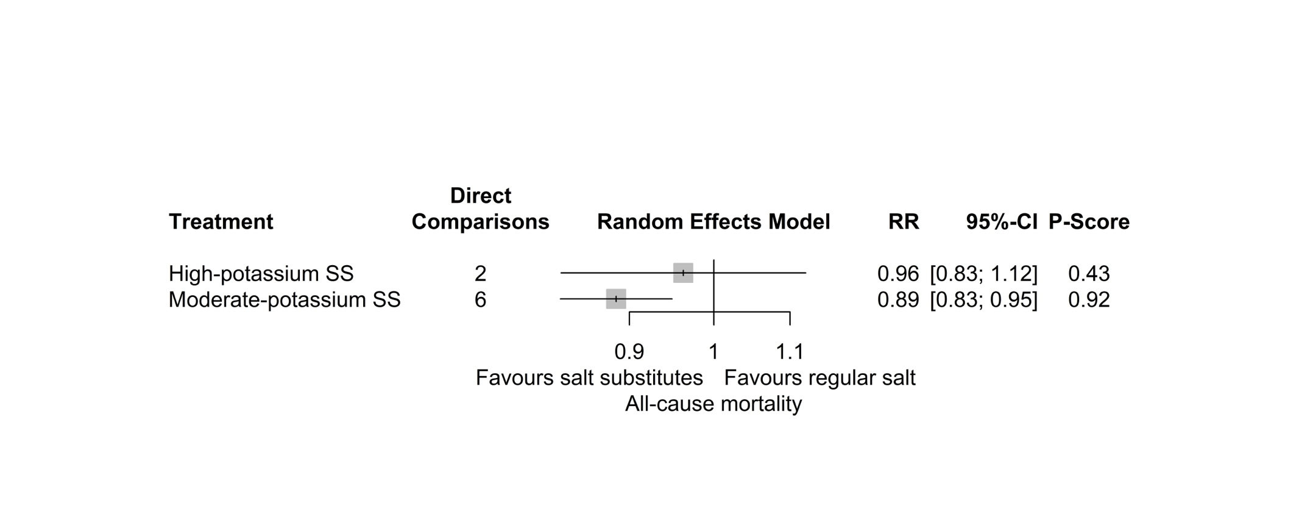

4.3.2. Forest plot of network meta-analysis estimates for cardiovascular mortality
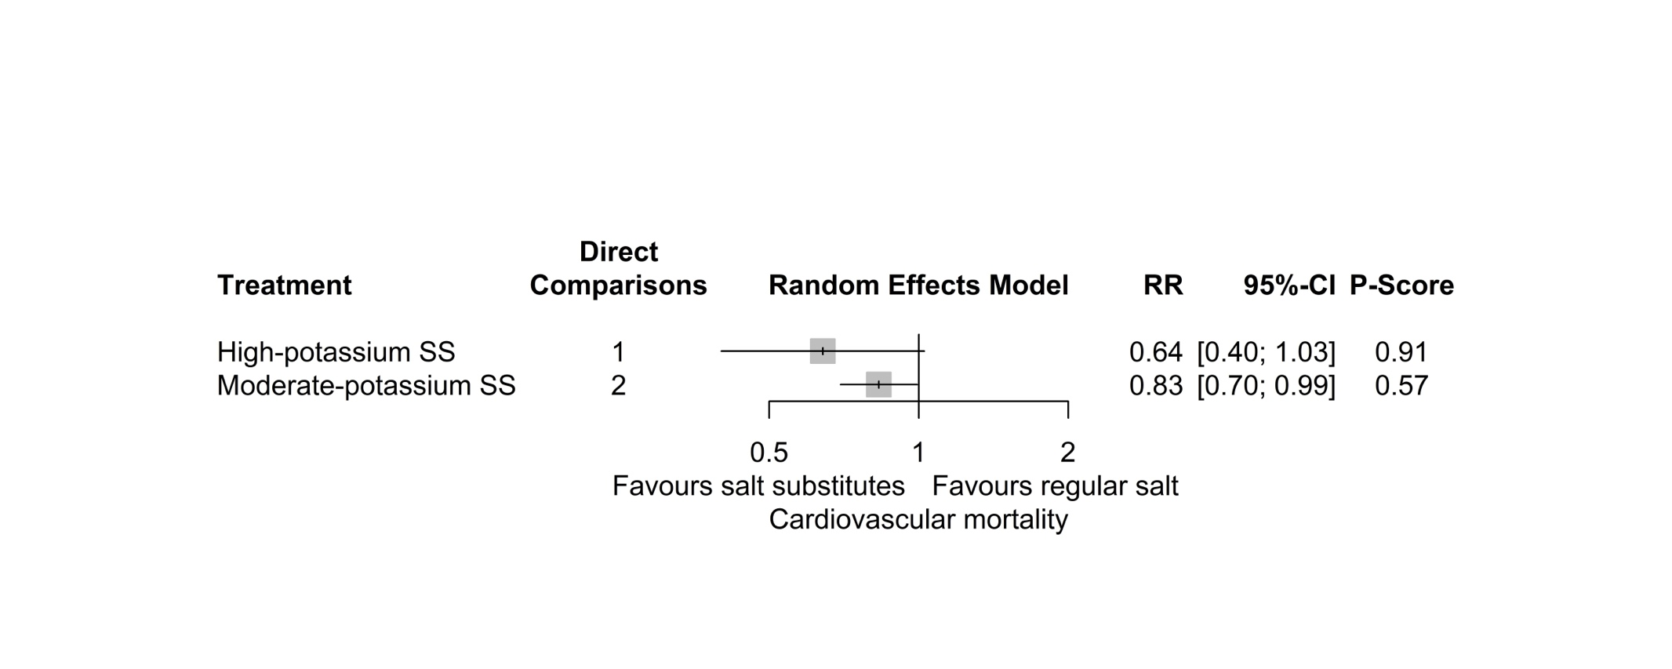

4.3.3. Forest plot of network meta-analysis estimates for non-fatal cardiovascular events
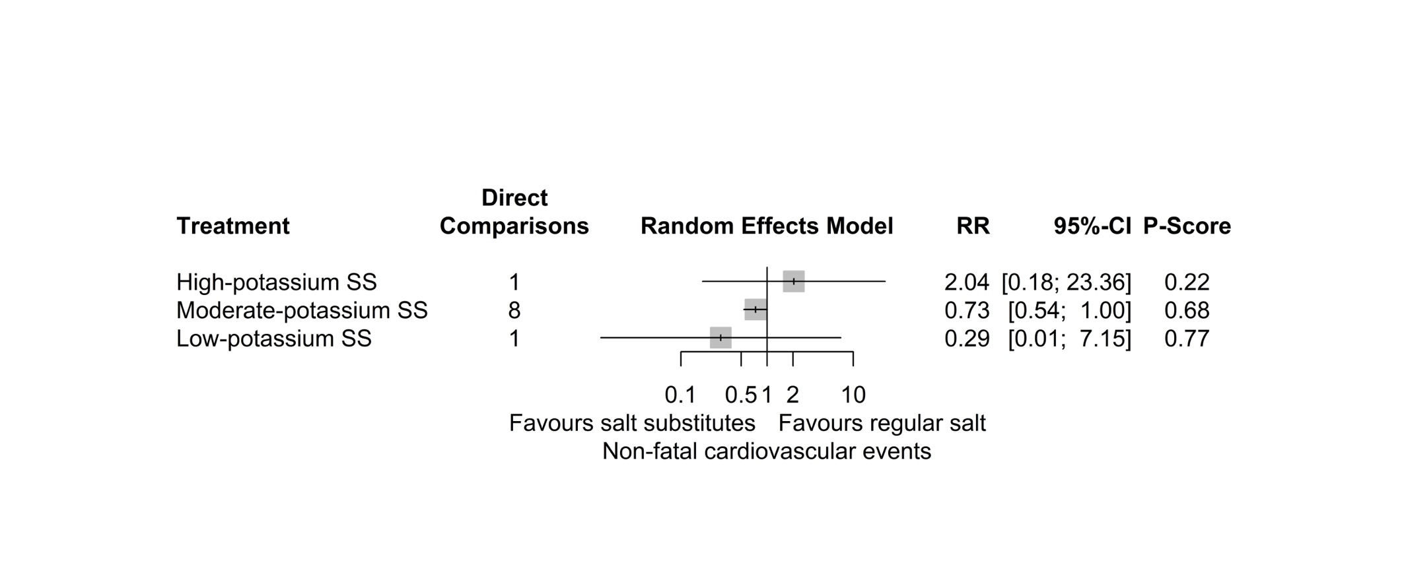

4.3.4. Forest plot of network meta-analysis estimates for systolic blood pressure
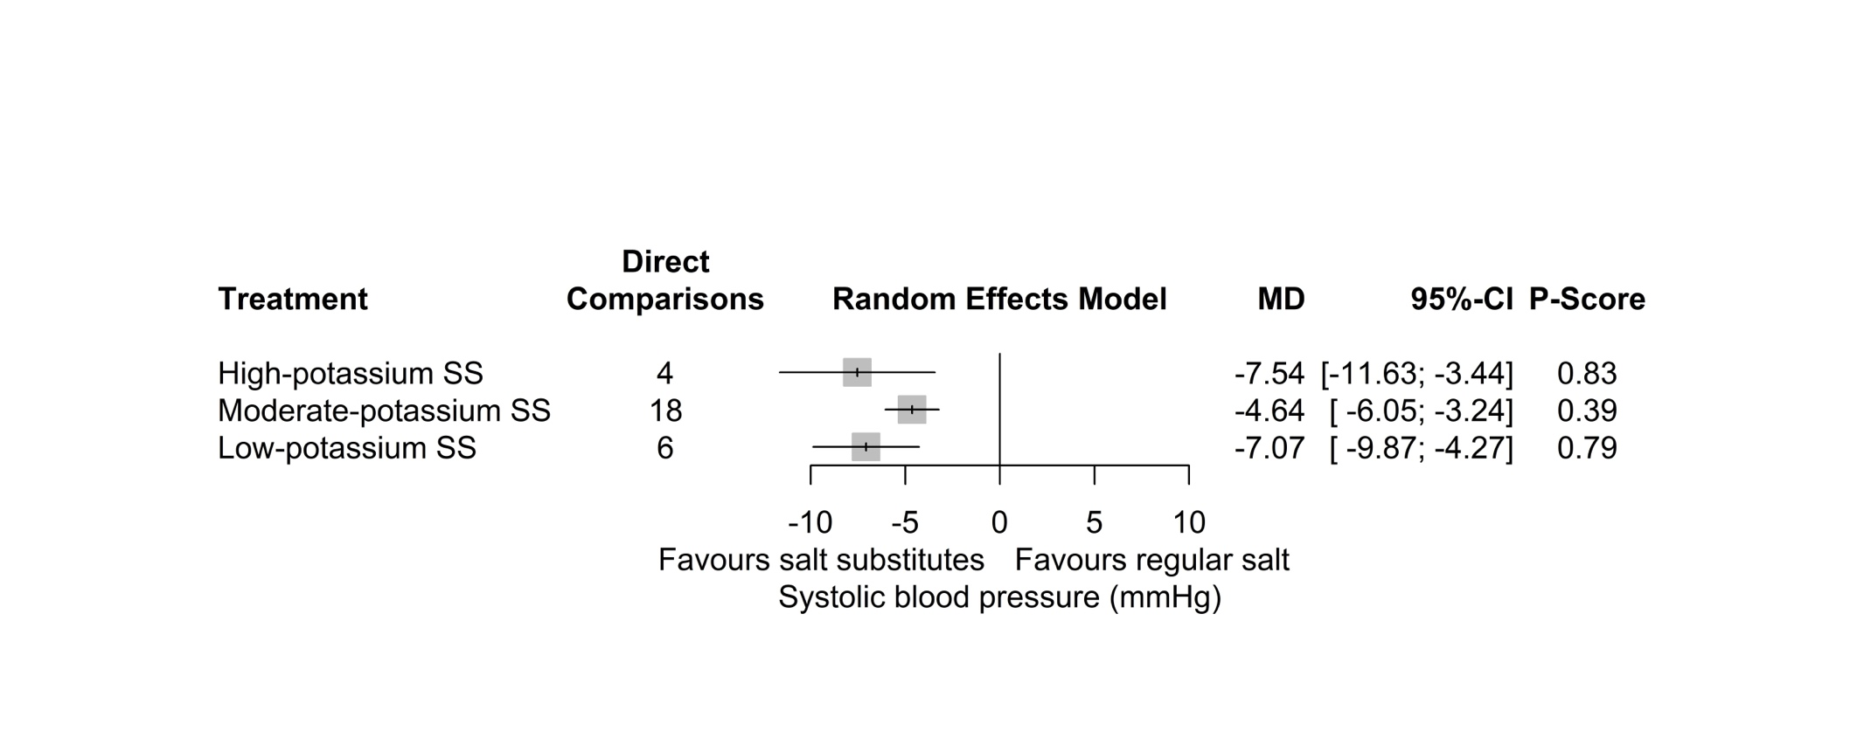

4.3.5. Forest plot of network meta-analysis estimates for diastolic blood pressure
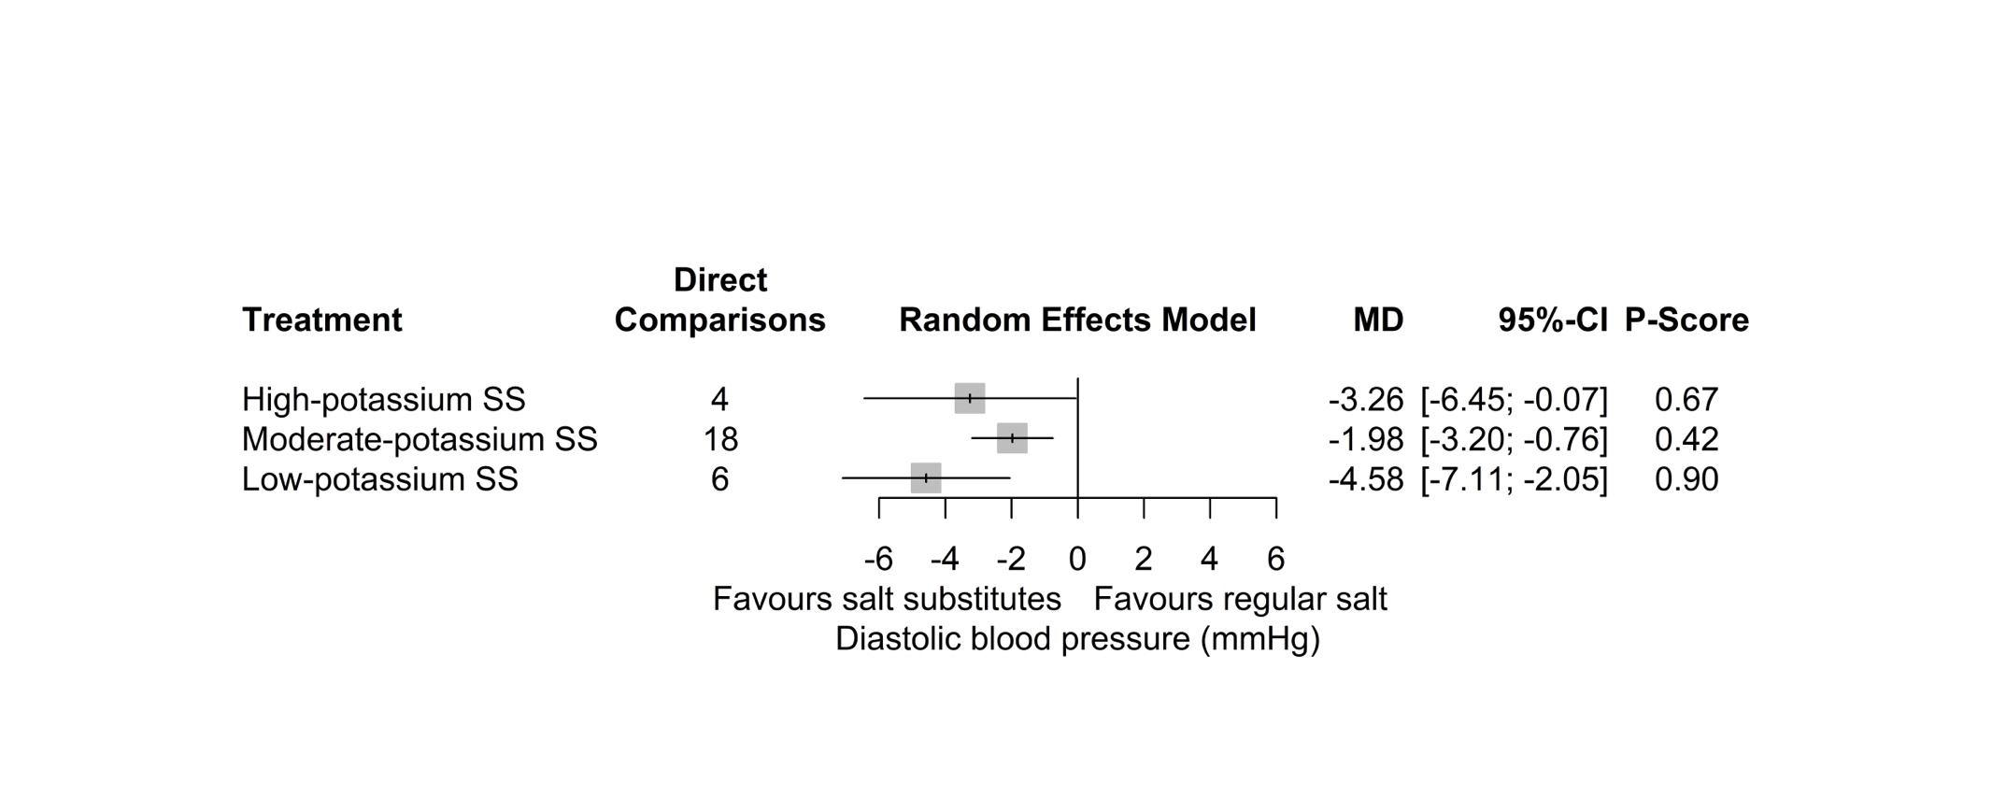

4.3.6. Forest plot of network meta-analysis estimates for adverse events related to intervention
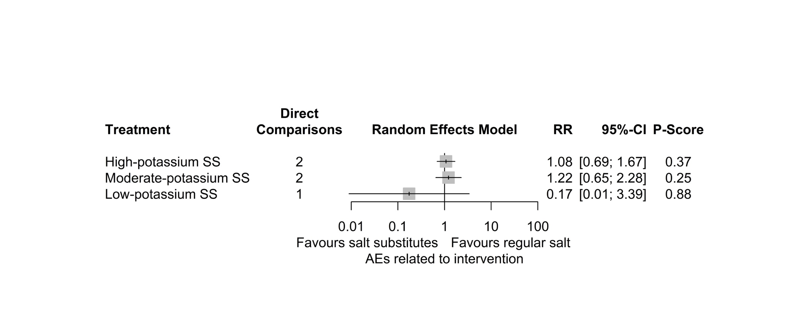

4.3.7. Forest plot of network meta-analysis estimates for withdrawals due to any reason
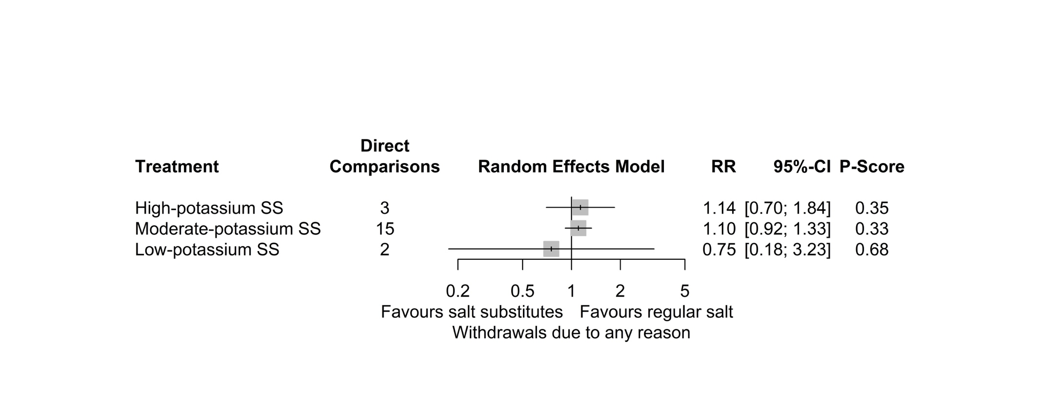

4.3.8. Forest plot of network meta-analysis estimates for serum potassium concentration
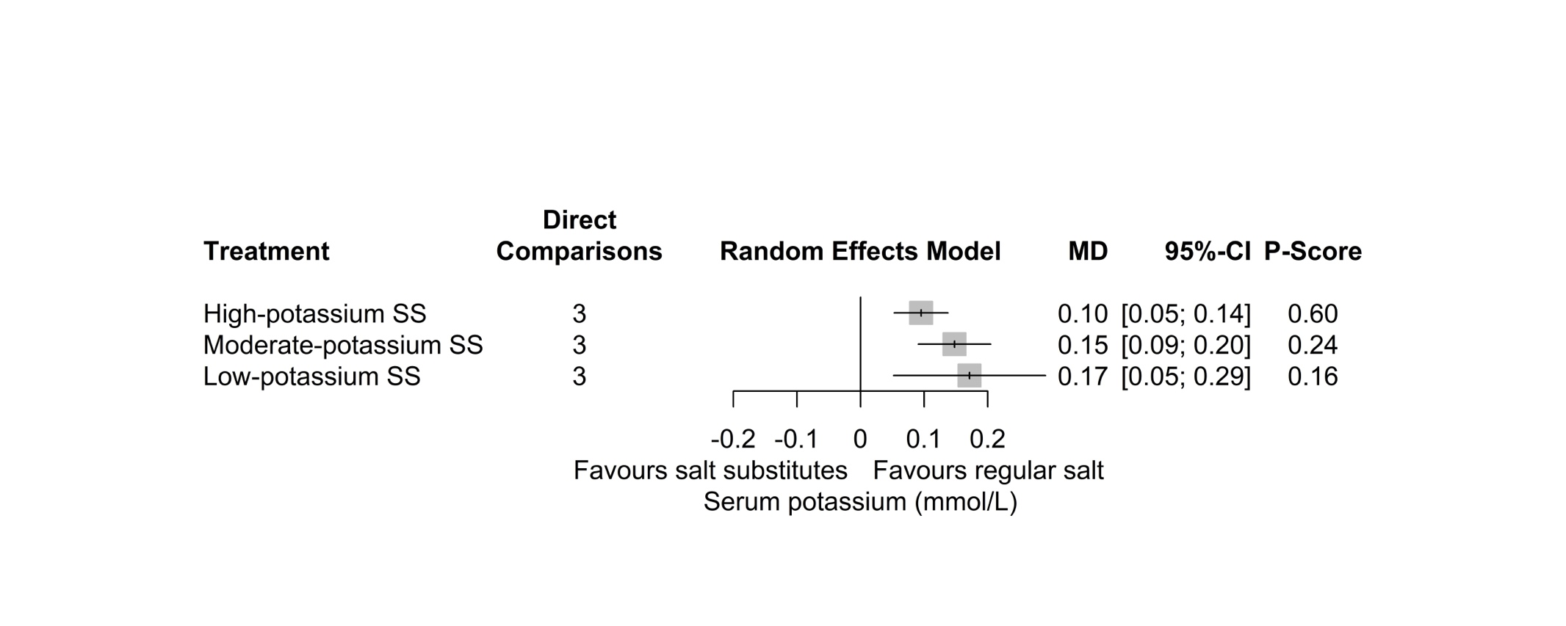

4.3.9. Forest plot of network meta-analysis estimates for serum sodium concentration
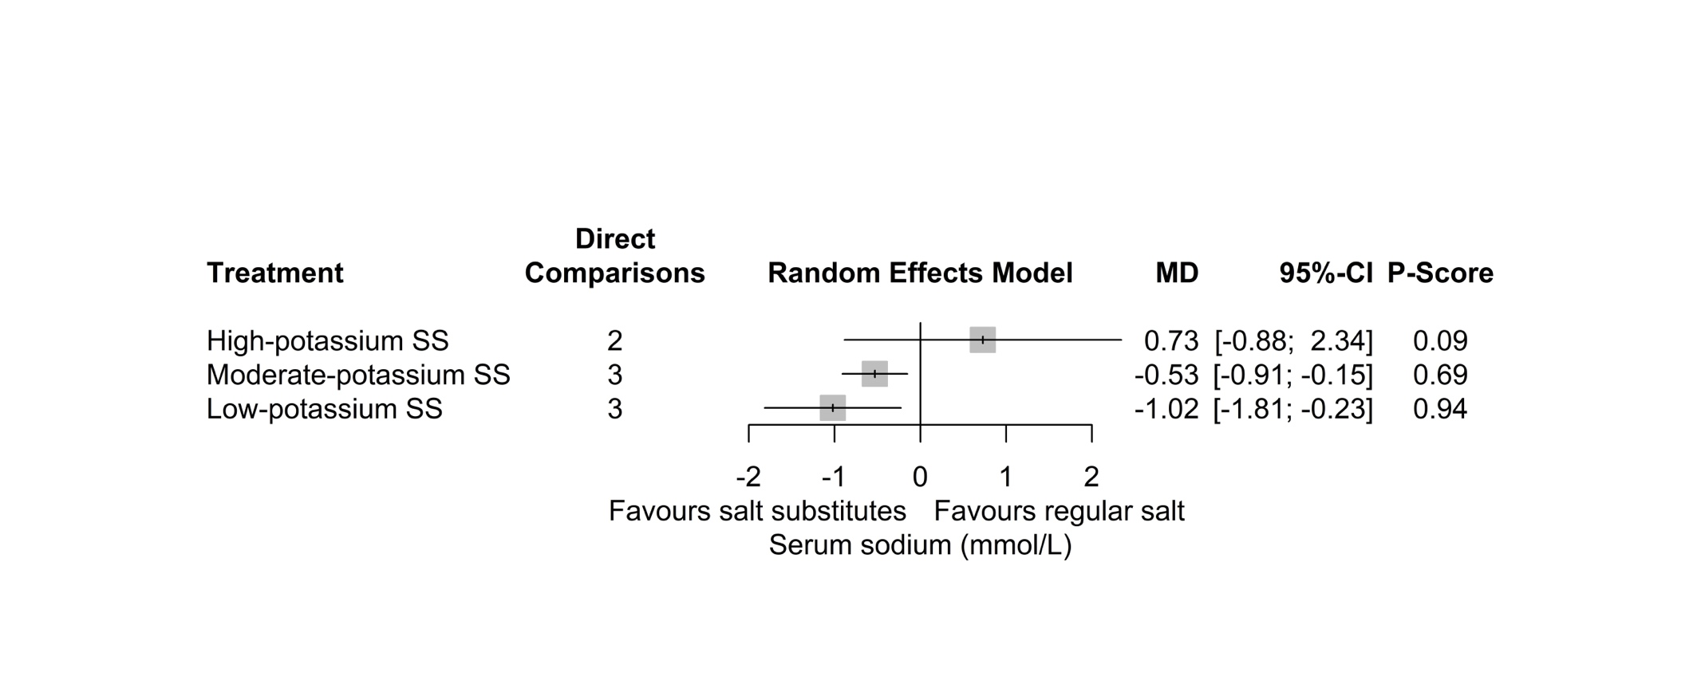

4.3.10. Forest plot of network meta-analysis estimates for 24-hour urinary potassium excretion
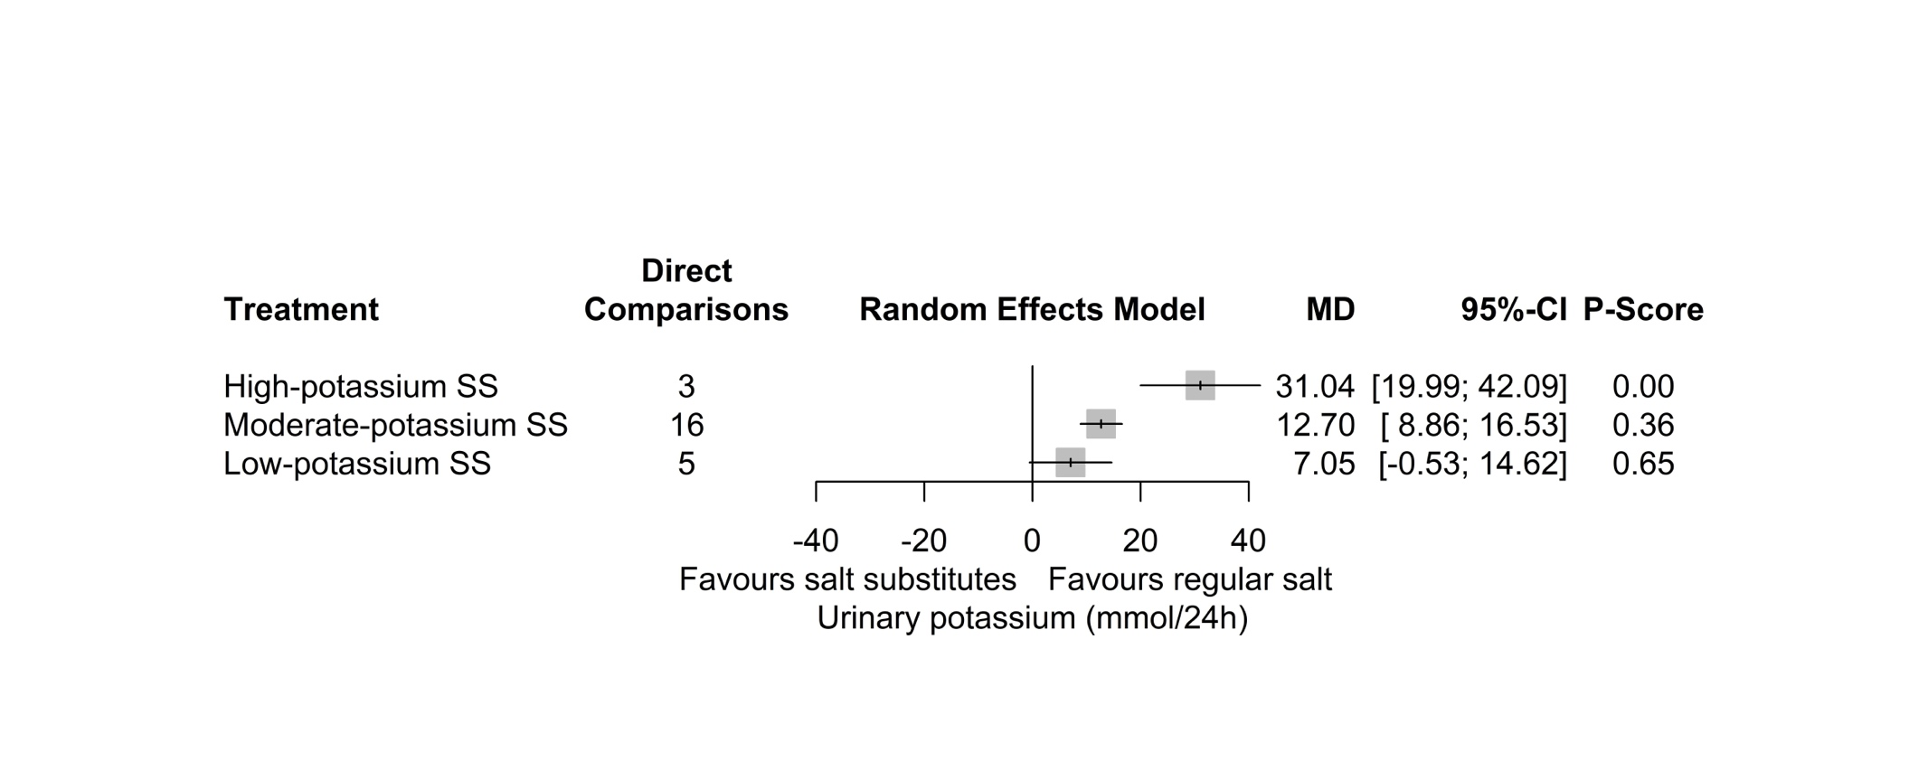

4.3.11. Forest plot of network meta-analysis estimates for 24-hour urinary sodium excretion
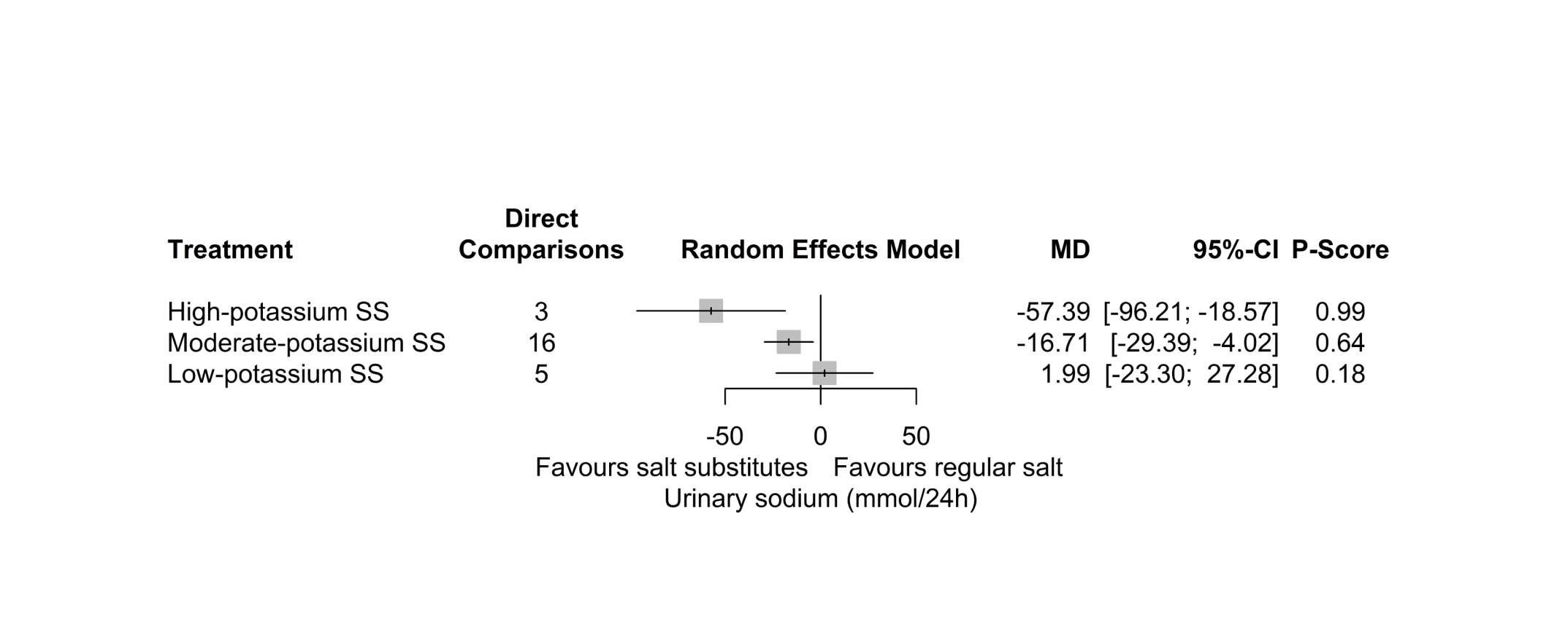

Figure S4 Forest plots for direct comparison evidence

4.4.1. Forest plot of direct comparison estimates for all-cause mortality
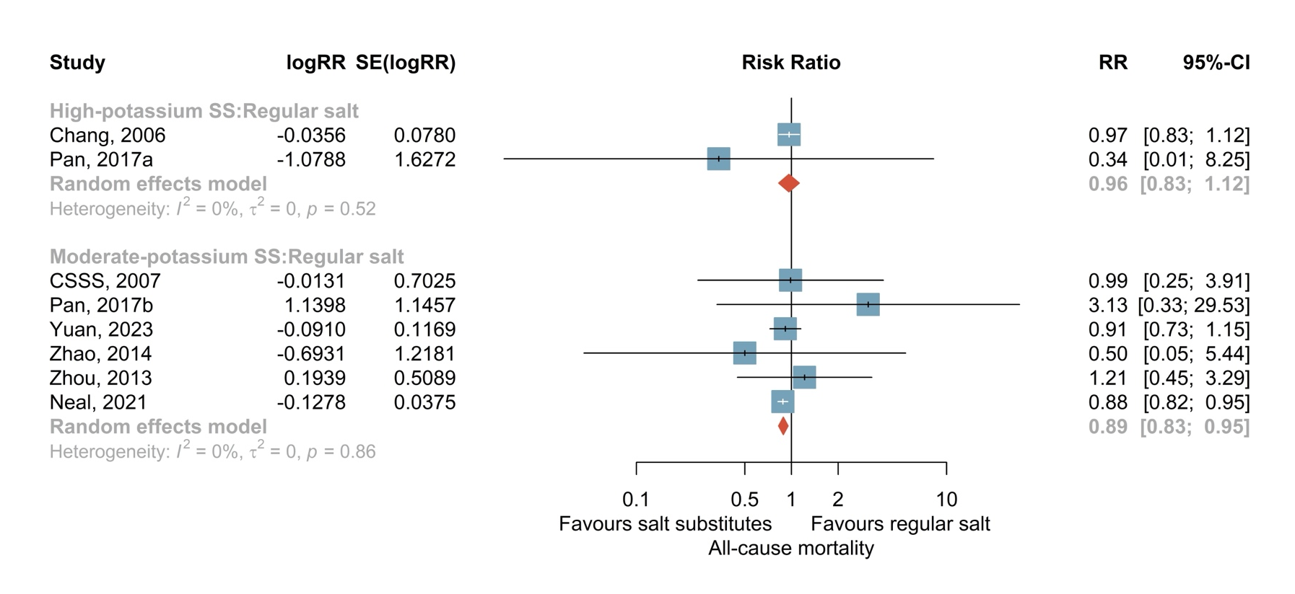

4.4.2. Forest plot of direct comparison estimates for cardiovascular mortality
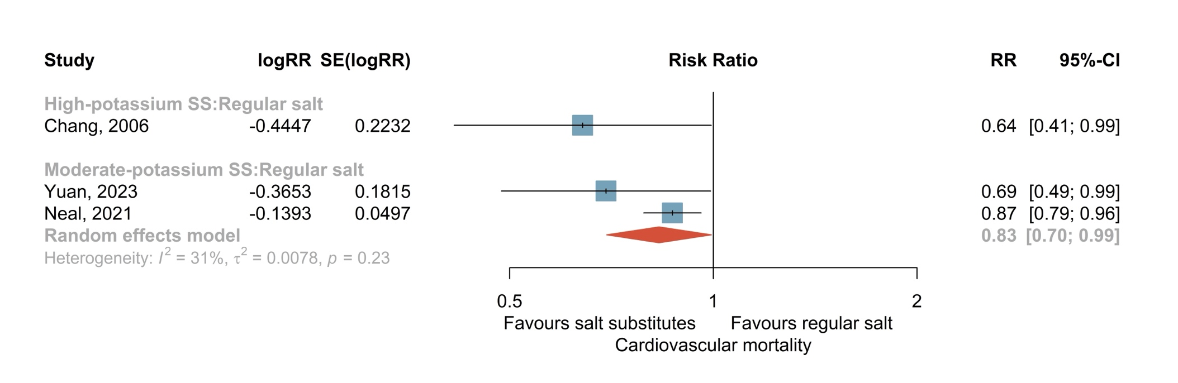

4.4.3. Forest plot of direct comparison estimates for non-fatal cardiovascular events
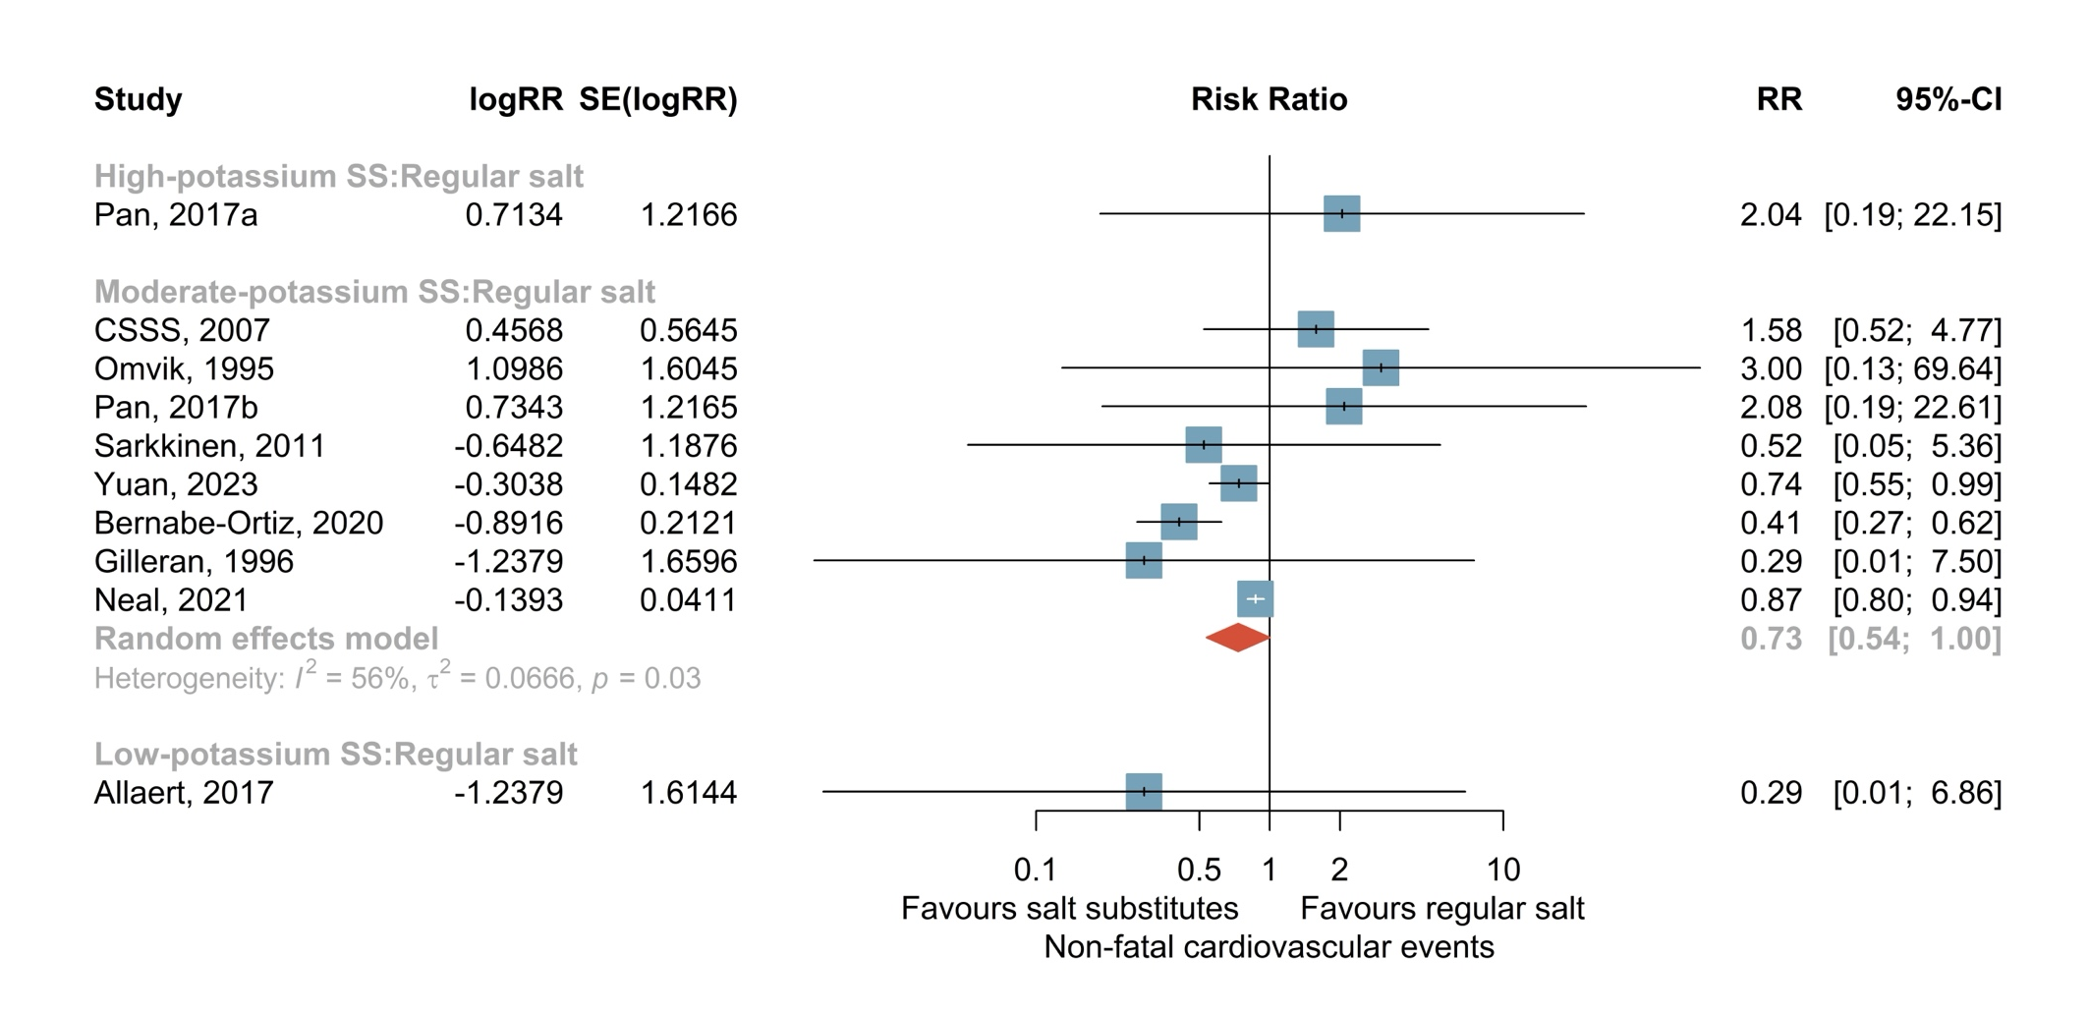

4.4.4. Forest plot of direct comparison estimates for systolic blood pressure
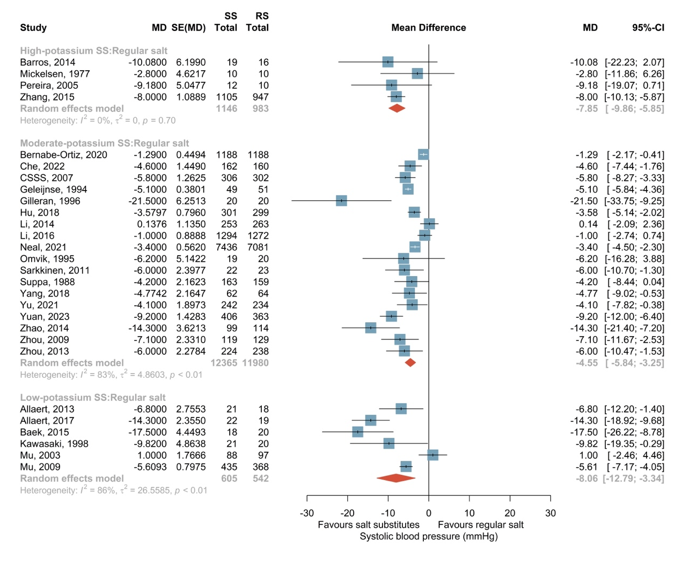

4.4.5. Forest plot of direct comparison estimates for diastolic blood pressure
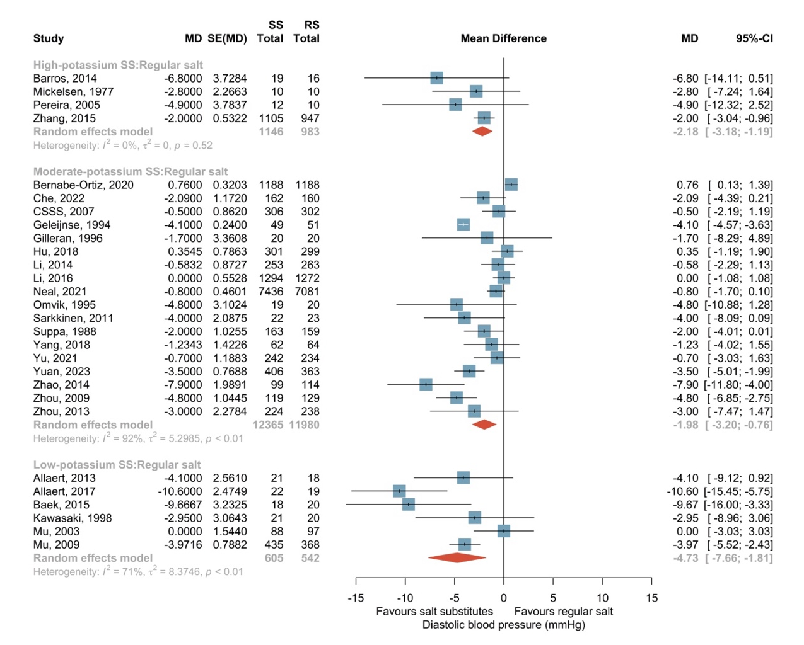

4.4.6. Forest plot of direct comparison estimates for adverse events related to intervention
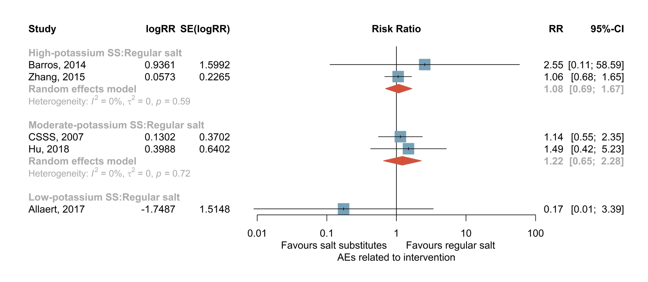

4.4.7. Forest plot of direct comparison estimates for withdrawals due to any reason
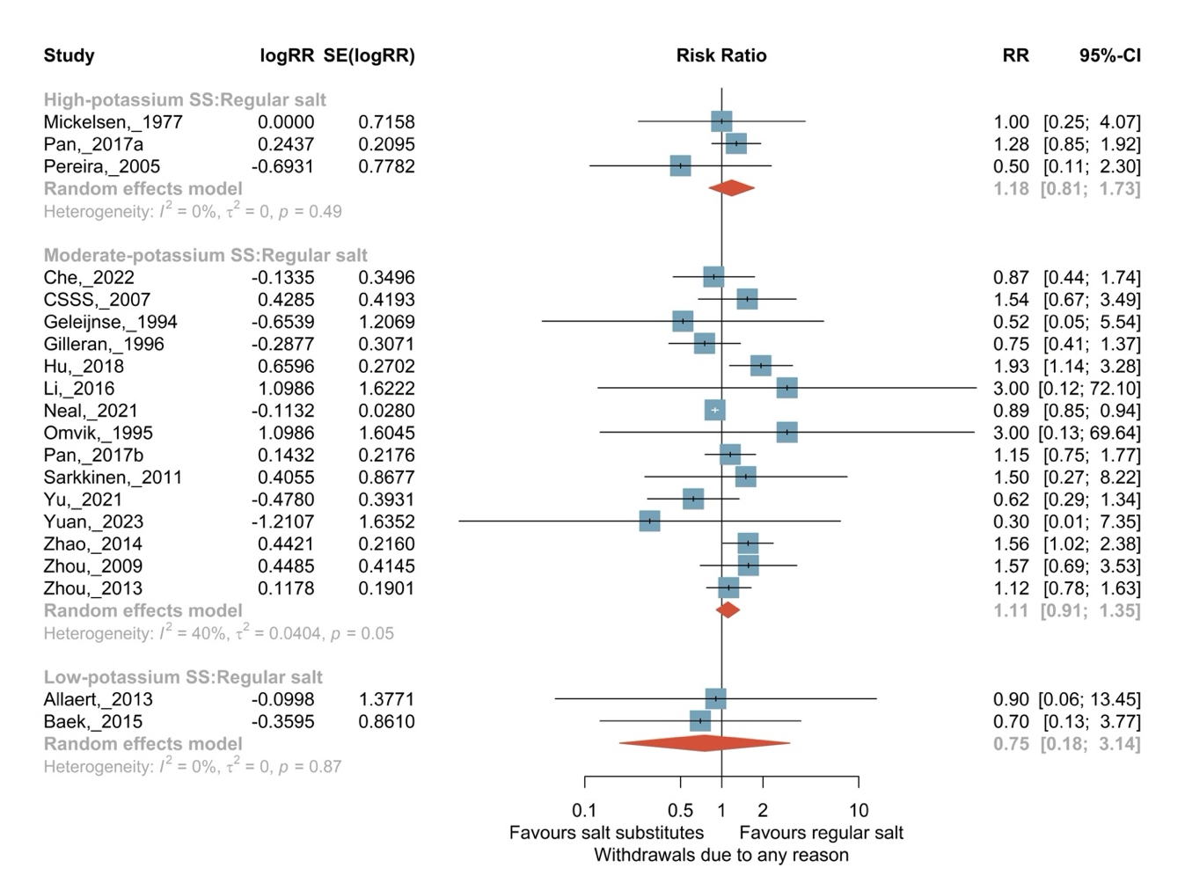

4.4.8. Forest plot of direct comparison estimates for serum potassium concentration
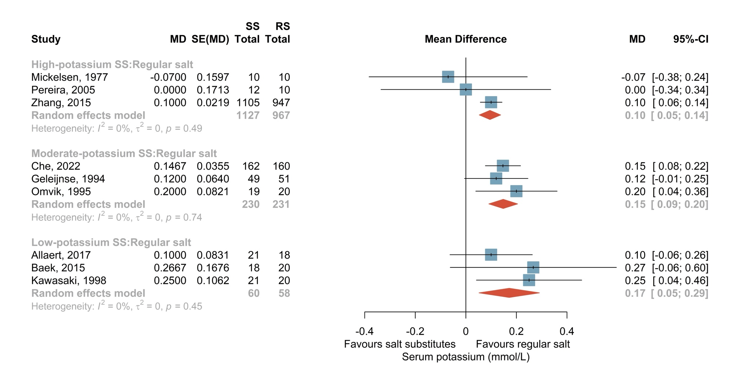

4.4.9. Forest plot of direct comparison estimates for serum sodium concentration
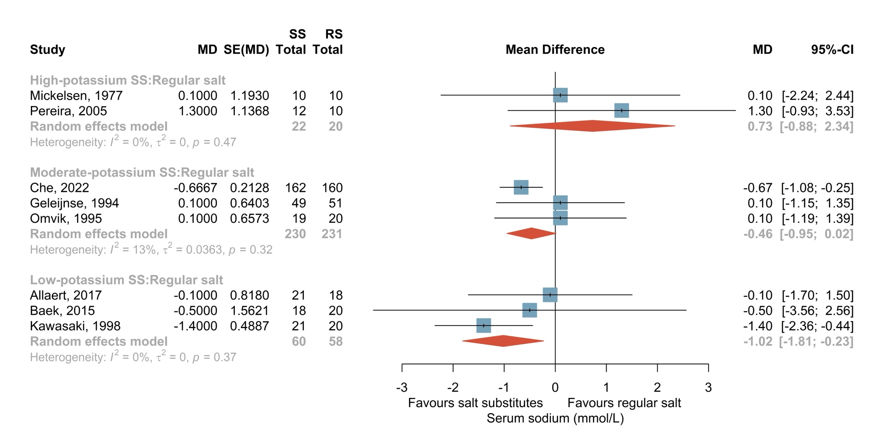

4.4.10. Forest plot of direct comparison estimates for 24-hour urinary potassium excretion
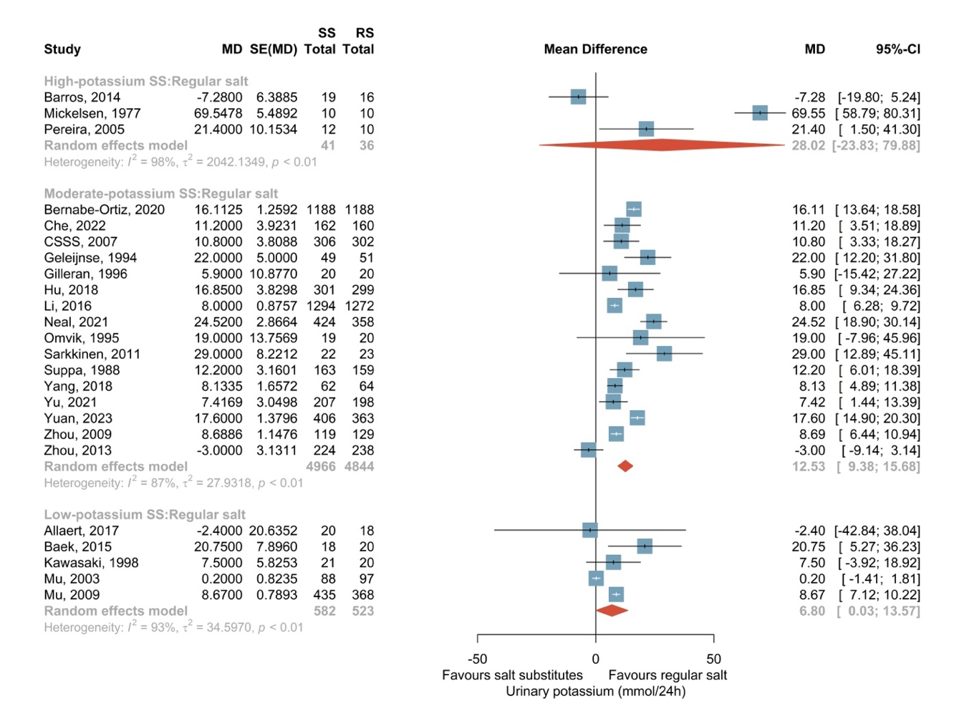

4.4.11. Forest plot of direct comparison estimates for 24-hour urinary sodium excretion
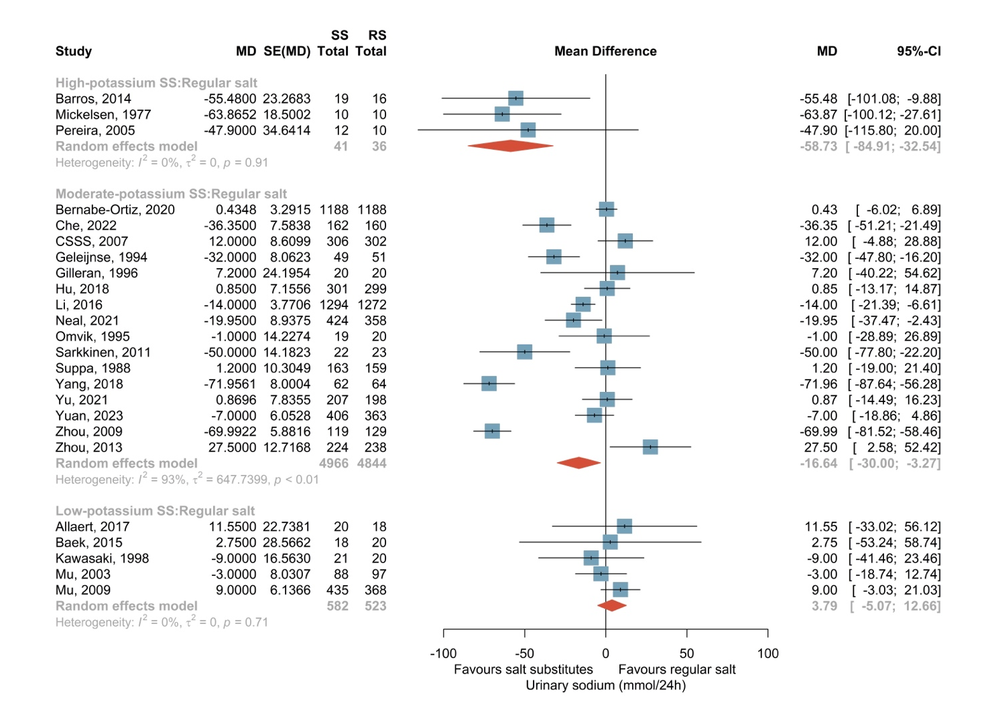

Figure S5 Results of intransitivity assessments

4.5.1. Distribution of age across treatment arms in the network
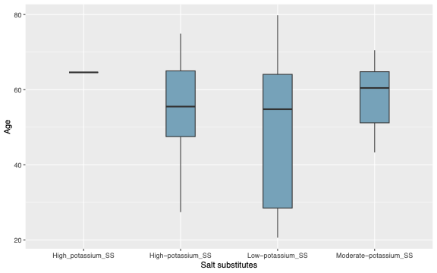

4.5.2. Distribution of proportion of female participants across treatment arms in the network
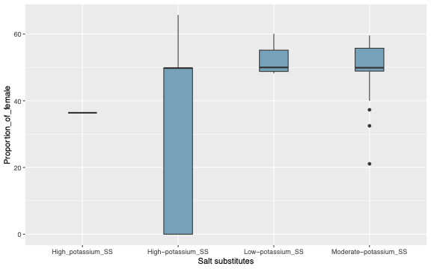

4.5.3. Distribution of body mass index (BMI) across treatment arms in the network
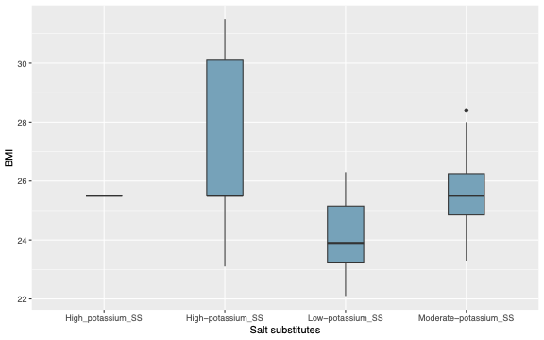

4.5.4. Distribution of systolic blood pressure across treatment arms in the network
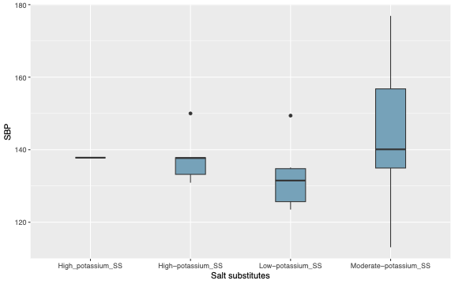

4.5.5. Distribution of diastolic blood pressure across treatment arms in the network
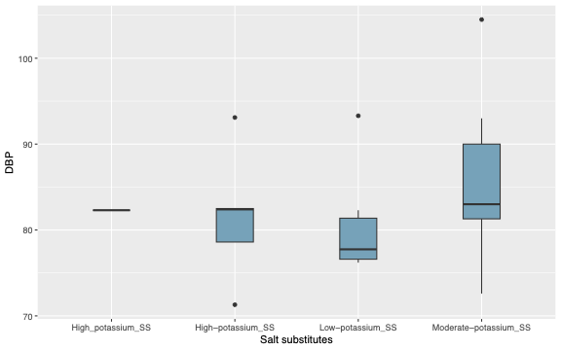

4.5.6. Distribution of proportion of participants with hypertension across treatment arms in the network
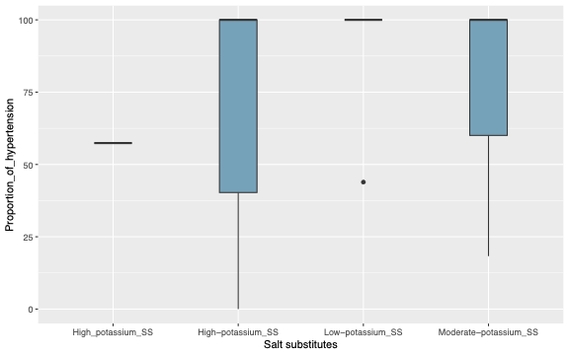

4.5.7. Distribution of proportion of participants receiving antihypertensive therapy across treatment arms in the network
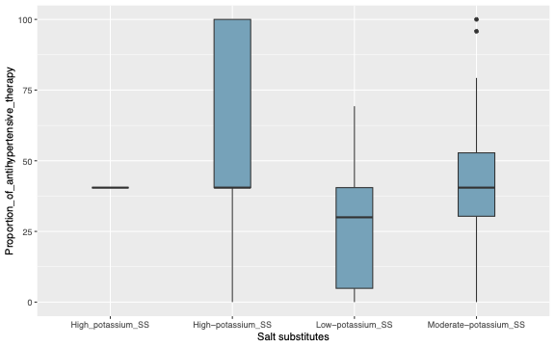

4.5.8. Distribution of proportion of participants with cardiovascular disease or stroke across treatment arms in the network
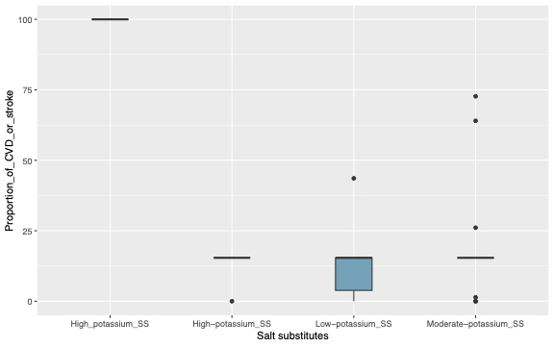

4.5.9. Distribution of proportion of participants with diabetes across treatment arms in the network
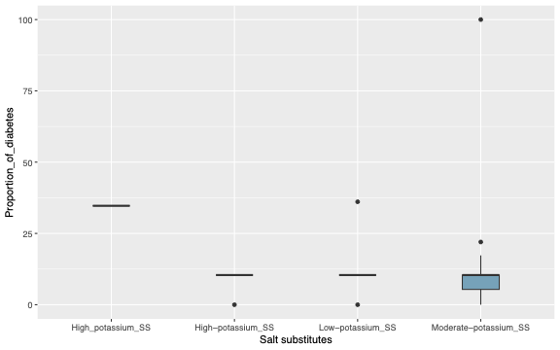

4.5.10. Distribution of proportion of participants with renal impairment across treatment arms in the network
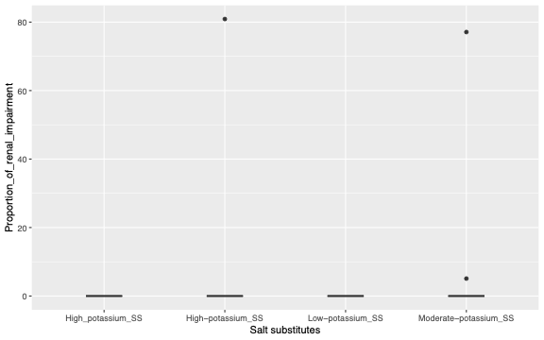

Figure S6 Results of network meta-regression

4.6.1. Network meta-regression results for all-cause mortality
vs. Regular_salt | Network meta-regression variables
 | Mean age
 | 2.50% | 25% | 50% | 75% | 97.50%
High_potassium_SS | -0.6561 | -0.1676 | 0.03977 | 0.25282 | 0.7606
Moderate_potassium_SS | -0.5471 | -0.2076 | -0.05921 | 0.08791 | 0.4162
Coefficients | -0.8878 | -0.3557 | -0.12474 | 0.09205 | 0.538
 | Proportion_of_females
 | 2.50% | 25% | 50% | 75% | 97.50%
High_potassium_SS | -0.874731 | -0.25585 | 0.01715 | 0.30415 | 0.9624
Moderate_potassium_SS | -0.556165 | -0.2186 | -0.06584 | 0.08644 | 0.4256
Coefficients | -0.768052 | -0.18306 | 0.06761 | 0.33277 | 0.988
 | Baseline_BMI
 | 2.50% | 25% | 50% | 75% | 97.50%
High_potassium_SS | -0.80029 | -0.1812 | 0.1037 | 0.41785 | 1.2271
Moderate_potassium_SS | -0.65978 | -0.2935 | -0.1318 | 0.02894 | 0.3992
Coefficients | -0.77009 | -0.1144 | 0.1746 | 0.51516 | 1.4991
 | Baseline_SBP
 | 2.50% | 25% | 50% | 75% | 97.50%
High_potassium_SS | -0.781174 | -0.25435 | -0.03591 | 0.18494 | 0.7125
Moderate_potassium_SS | -0.55636 | -0.22866 | -0.07883 | 0.07134 | 0.4097
Coefficients | -0.995567 | -0.26968 | 0.01518 | 0.29883 | 1.0138
 | Baseline_DBP
 | 2.50% | 25% | 50% | 75% | 97.50%
High_potassium_SS | -0.878785 | -0.29898 | -0.035463 | 0.2309 | 0.8529
Moderate_potassium_SS | -0.550032 | -0.22602 | -0.081562 | 0.06433 | 0.4054
Coefficients | -0.953978 | -0.27709 | 0.009582 | 0.29888 | 1.0513

4.6.2. Network meta-regression results for cardiovascular mortality
vs. Regular_salt | Network meta-regression variables
 | Mean age
 | 2.50% | 25% | 50% | 75% | 97.50%
High_potassium_SS | -1.57885 | -0.7584 | -0.44602 | -0.1144 | 1.5868
Moderate_potassium_SS | -2.43772 | -0.7379 | -0.42059 | -0.1262 | 0.6839
Coefficients | -5.69648 | -0.5158 | -0.03483 | 0.3844 | 2.5989
 | Proportion_of_females
 | 2.50% | 25% | 50% | 75% | 97.50%
High_potassium_SS | -1.72635 | -0.7708 | -0.45405 | -0.1277 | 1.8698
Moderate_potassium_SS | -2.71928 | -0.717 | -0.4088 | -0.1094 | 0.8524
Coefficients | -3.24667 | -0.4047 | 0.02101 | 0.4834 | 6.4402
 | Baseline_BMI
 | 2.50% | 25% | 50% | 75% | 97.50%
High_potassium_SS | -2.65207 | -0.8055 | -0.481324 | -0.1654 | 1.216
Moderate_potassium_SS | -2.05625 | -0.6915 | -0.390284 | -0.0848 | 1.84
Coefficients | -6.01869 | -0.4519 | -0.008406 | 0.4208 | 4.562
 | Baseline_SBP
 | 2.50% | 25% | 50% | 75% | 97.50%
High_potassium_SS | -2.0807 | -0.7913 | -0.47565 | -0.16497 | 0.9906
Moderate_potassium_SS | -1.85521 | -0.6834 | -0.387352 | -0.09346 | 1.1869
Coefficients | -4.30015 | -0.4407 | -0.007533 | 0.41689 | 3.9097
 | Baseline_DBP
 | 2.50% | 25% | 50% | 75% | 97.50%
High_potassium_SS | -2.83627 | -0.7983 | -0.48212 | -0.17121 | 0.8345
Moderate_potassium_SS | -1.68234 | -0.6803 | -0.38617 | -0.08501 | 1.9778
Coefficients | -6.60566 | -0.4561 | -0.01266 | 0.41029 | 3.2963

4.6.3. Network meta-regression results for non-fatal cardiovascular events
vs. Regular_salt | Network meta-regression variables
 | Mean age
 | 2.50% | 25% | 50% | 75% | 97.50%
High_potassium_SS | -1.79001 | 0.1673 | 1.1765 | 2.274 | 4.8971
Low_potassium_SS | -29.98188 | -16.029 | -9.487 | -4.61472 | 0.4256
Moderate_potassium_SS | -0.77866 | -0.0743 | 0.272 | 0.63696 | 1.4541
Coefficients | -2.73733 | -1.2791 | -0.6617 | -0.09801 | 1.0822
 | Proportion_of_females
 | 2.50% | 25% | 50% | 75% | 97.50%
High_potassium_SS | -1.9553 | -0.004903 | 0.988 | 2.0633 | 4.7856
Low_potassium_SS | -27.17977 | -14.797713 | -8.5859 | -4.1148 | 0.7006
Moderate_potassium_SS | -0.7849 | -0.174802 | 0.1051 | 0.4003 | 1.1321
Coefficients | -1.00829 | -0.04264 | 0.3362 | 0.6962 | 1.4674
 | Baseline_BMI
 | 2.50% | 25% | 50% | 75% | 97.50%
High_potassium_SS | -29.83034 | -15.19431 | -9.0241 | -4.461466 | 0.6232
Low_potassium_SS | -0.75732 | 0.04915 | 0.456 | 0.875441 | 1.7922
Moderate_potassium_SS | -1.56345 | -0.6969 | -0.3699 | 0.004139 | 1.1398
Coefficients | -2.75041 | -1.19039 | -0.5529 | 0.012288 | 1.1332
 | Baseline_SBP
 | 2.50% | 25% | 50% | 75% | 97.50%
High_potassium_SS | -29.39482 | -14.4382 | -8.3892 | -4.0029 | 0.8591
Low_potassium_SS | -1.09127 | -0.1342 | 0.3408 | 0.8342 | 1.8766
Moderate_potassium_SS | -1.32766 | -0.4693 | -0.1526 | 0.229 | 1.3855
Coefficients | -1.44404 | -0.2806 | 0.2536 | 0.8187 | 2.1363
 | Baseline_DBP
 | 2.50% | 25% | 50% | 75% | 97.50%
High_potassium_SS | -31.15874 | -14.93439 | -8.25571 | -3.8136 | 0.8544
Low_potassium_SS | -1.04739 | -0.06711 | 0.45203 | 0.969 | 2.08
Moderate_potassium_SS | -1.63819 | -0.60875 | -0.17869 | 0.2955 | 1.5258
Coefficients | -2.13635 | -0.58165 | 0.03884 | 0.6601 | 2.1271

4.6.4. Network meta-regression results for systolic blood pressure
vs. Regular_salt | Network meta-regression variables
 | Mean age
 | 2.50% | 25% | 50% | 75% | 97.50%
High_potassium_SS | -12.417 | -9.262 | -7.746 | -6.274 | -3.4
Low_potassium_SS | -11.352 | -9.099 | -8.017 | -6.98 | -4.977
Moderate_potassium_SS | -6.109 | -4.863 | -4.302 | -3.775 | -2.784
Coefficients | -7.649 | -5.581 | -4.586 | -3.611 | -1.654
 | Proportion_of_females
 | 2.50% | 25% | 50% | 75% | 97.50%
High_potassium_SS | -12.949 | -9.317 | -7.5193 | -5.723 | -2.139
Low_potassium_SS | -11.527 | -8.81 | -7.5254 | -6.274 | -3.844
Moderate_potassium_SS | -7.088 | -5.614 | -4.9321 | -4.279 | -3.016
Coefficients | -4.309 | -1.596 | -0.2204 | 1.132 | 3.739
 | Baseline_BMI
 | 2.50% | 25% | 50% | 75% | 97.50%
High_potassium_SS | -12.017 | -8.456 | -6.662 | -4.8273 | -1.038
Low_potassium_SS | -12.455 | -9.622 | -8.277 | -6.9845 | -4.514
Moderate_potassium_SS | -7.114 | -5.655 | -4.985 | -4.3531 | -3.13
Coefficients | -6.951 | -3.939 | -2.47 | -0.9942 | 1.941
 | Baseline_SBP
 | 2.50% | 25% | 50% | 75% | 97.50%
High_potassium_SS | -12.297 | -9.075 | -7.483 | -5.911 | -2.789
Low_potassium_SS | -11.901 | -9.394 | -8.207 | -7.082 | -4.977
Moderate_potassium_SS | -6.559 | -5.287 | -4.7 | -4.139 | -3.0469
Coefficients | -7.235 | -4.974 | -3.91 | -2.9 | -0.9279
 | Baseline_DBP
 | 2.50% | 25% | 50% | 75% | 97.50%
High_potassium_SS | -12.526 | -9.311 | -7.703 | -6.07 | -2.7404
Low_potassium_SS | -11.766 | -9.214 | -8.02 | -6.872 | -4.6774
Moderate_potassium_SS | -6.776 | -5.465 | -4.862 | -4.281 | -3.1464
Coefficients | -7 | -4.683 | -3.594 | -2.513 | -0.3701

4.6.5. Network meta-regression results for diastolic blood pressure
vs. Regular_salt | Network meta-regression variables
 | Mean age
 | 2.50% | 25% | 50% | 75% | 97.50%
High_potassium_SS | -7.6101 | -5.788 | -4.874 | -3.981 | -2.243
Low_potassium_SS | -6.8277 | -5.405 | -4.712 | -4.03 | -2.7221
Moderate_potassium_SS | -2.4453 | -1.789 | -1.49 | -1.202 | -0.6296
Coefficients | -4.2612 | -3.103 | -2.525 | -1.936 | -0.7413
 | Proportion_of_females
 | 2.50% | 25% | 50% | 75% | 97.50%
High_potassium_SS | -7.538 | -5.4554 | -4.4079 | -3.354 | -1.2636
Low_potassium_SS | -6.913 | -5.2716 | -4.4731 | -3.695 | -2.1906
Moderate_potassium_SS | -2.925 | -2.1334 | -1.7648 | -1.41 | -0.7079
Coefficients | -1.853 | -0.3226 | 0.4591 | 1.243 | 2.7547
 | Baseline_BMI
 | 2.50% | 25% | 50% | 75% | 97.50%
High_potassium_SS | -7.333 | -5.294 | -4.259 | -3.2155 | -1.1013
Low_potassium_SS | -7.369 | -5.638 | -4.796 | -3.9778 | -2.4083
Moderate_potassium_SS | -2.931 | -2.139 | -1.773 | -1.4204 | -0.7307
Coefficients | -3.763 | -2.007 | -1.14 | -0.2804 | 1.3552
 | Baseline_SBP
 | 2.50% | 25% | 50% | 75% | 97.50%
High_potassium_SS | -7.5281 | -5.591 | -4.628 | -3.6654 | -1.7674
Low_potassium_SS | -7.0101 | -5.419 | -4.656 | -3.9156 | -2.4771
Moderate_potassium_SS | -2.7265 | -1.987 | -1.65 | -1.3279 | -0.6843
Coefficients | -2.9848 | -1.798 | -1.227 | -0.6405 | 0.631
 | Baseline_DBP
 | 2.50% | 25% | 50% | 75% | 97.50%
High_potassium_SS | -7.584 | -5.69 | -4.737 | -3.783 | -1.8483
Low_potassium_SS | -6.9693 | -5.413 | -4.661 | -3.9284 | -2.5009
Moderate_potassium_SS | -2.7569 | -2.026 | -1.699 | -1.3817 | -0.7453
Coefficients | -3.3383 | -2.114 | -1.495 | -0.8478 | 0.5526

4.6.6. Network meta-regression results for adverse events related to intervention
vs. Regular_salt | Network meta-regression variables
 | Mean age
 | 2.50% | 25% | 50% | 75% | 97.50%
High_potassium_SS | -1.53226 | -0.07158 | 0.5876 | 1.3384 | 3.493
Low_potassium_SS | -47.74852 | -24.28728 | -14.945 | -7.4861 | -1.106
Moderate_potassium_SS | -1.4209 | -0.17085 | 0.2504 | 0.6746 | 1.895
Coefficients | -3.28917 | -1.23889 | -0.4629 | 0.2542 | 1.798
 | Proportion_of_females
 | 2.50% | 25% | 50% | 75% | 97.50%
High_potassium_SS | -1.30165 | -0.07788 | 0.4298 | 1.0751 | 3.0952
Low_potassium_SS | -43.91754 | -22.66172 | -13.2922 | -6.7423 | -0.5542
Moderate_potassium_SS | -1.32861 | -0.14664 | 0.258 | 0.7011 | 2.0019
Coefficients | -1.94377 | -0.25252 | 0.5763 | 1.5434 | 4.5219
 | Baseline_BMI
 | 2.50% | 25% | 50% | 75% | 97.50%
High_potassium_SS | -1.18542 | 0.04372 | 0.5398 | 1.182 | 3.1443
Low_potassium_SS | -38.63611 | -20.5112 | -12.498 | -6.209 | -0.2804
Moderate_potassium_SS | -1.08725 | 0.13043 | 0.6741 | 1.319 | 3.153
Coefficients | -1.77711 | 0.18838 | 1.3668 | 3.176 | 10.0309
 | Baseline_SBP
 | 2.50% | 25% | 50% | 75% | 97.50%
High_potassium_SS | -1.37714 | -0.08899 | 0.3745 | 0.9707 | 2.905
Low_potassium_SS | -45.31099 | -25.34068 | -15.4586 | -8.1018 | -1.198
Moderate_potassium_SS | -1.37773 | -0.11792 | 0.3512 | 0.8362 | 2.108
Coefficients | -2.62203 | -0.99476 | -0.3661 | 0.2353 | 1.651
 | Baseline_DBP
 | 2.50% | 25% | 50% | 75% | 97.50%
High_potassium_SS | -1.44159 | -0.1768 | 0.2309 | 0.8022 | 2.7071
Low_potassium_SS | -39.53793 | -20.5039 | -12.2216 | -6.3462 | -0.8225
Moderate_potassium_SS | -1.41059 | -0.1302 | 0.3515 | 0.8569 | 2.1743
Coefficients | -2.449 | -0.86 | -0.2595 | 0.3221 | 1.7558

4.6.7. Network meta-regression results for withdrawals due to any reason
vs. Regular_salt | Network meta-regression variables
 | Mean age
 | 2.50% | 25% | 50% | 75% | 97.50%
High_potassium_SS | -1.77143 | -0.66099 | -0.07914 | 0.51661 | 1.6965
Low_potassium_SS | -2.03321 | -0.76279 | -0.13754 | 0.4826 | 1.7407
Moderate_potassium_SS | -0.11884 | 0.07443 | 0.16583 | 0.26185 | 0.4801
Coefficients | -1.06438 | -0.55794 | -0.31513 | -0.06837 | 0.4666
 | Proportion_of_females
 | 2.50% | 25% | 50% | 75% | 97.50%
High_potassium_SS | -1.6259 | -0.48108 | 0.09833 | 0.6837 | 1.8661
Low_potassium_SS | -2.3209 | -1.0401 | -0.4268 | 0.1799 | 1.3673
Moderate_potassium_SS | -0.1732 | 0.0351 | 0.13582 | 0.2406 | 0.4713
Coefficients | -0.5979 | -0.05297 | 0.22473 | 0.51 | 1.1122
 | Baseline_BMI
 | 2.50% | 25% | 50% | 75% | 97.50%
High_potassium_SS | -1.6929 | -0.4947 | 0.12767 | 0.7614 | 2.0371
Low_potassium_SS | -2.287 | -1.01086 | -0.38403 | 0.2226 | 1.406
Moderate_potassium_SS | -0.188 | 0.03928 | 0.14898 | 0.2594 | 0.4947
Coefficients | -0.9183 | -0.3232 | -0.04286 | 0.2329 | 0.759
 | Baseline_SBP
 | 2.50% | 25% | 50% | 75% | 97.50%
High_potassium_SS | -1.6447 | -0.49546 | 0.08564 | 0.6814 | 1.8615
Low_potassium_SS | -2.2583 | -0.97511 | -0.35673 | 0.2519 | 1.4477
Moderate_potassium_SS | -0.1578 | 0.05473 | 0.15581 | 0.2599 | 0.4938
Coefficients | -0.5365 | -0.16022 | 0.01262 | 0.1904 | 0.5861
 | Baseline_DBP
 | 2.50% | 25% | 50% | 75% | 97.50%
High_potassium_SS | -1.6189 | -0.47938 | 0.110286 | 0.7109 | 1.8969
Low_potassium_SS | -2.1985 | -0.96084 | -0.346057 | 0.2545 | 1.4246
Moderate_potassium_SS | -0.1547 | 0.05653 | 0.155157 | 0.2588 | 0.4897
Coefficients | -0.5839 | -0.17779 | -0.001835 | 0.1718 | 0.5319

4.6.8. Network meta-regression results for serum potassium concentration
vs. Regular_salt | Network meta-regression variables
 | Mean age
 | 2.50% | 25% | 50% | 75% | 97.50%
High_potassium_SS | -0.078751 | 0.03669 | 0.07138 | 0.10261 | 0.1866
Low_potassium_SS | 0.015359 | 0.11902 | 0.16726 | 0.21569 | 0.3221
Moderate_potassium_SS | 0.034691 | 0.1116 | 0.14144 | 0.172 | 0.2579
Coefficients | -0.11369 | 0.00715 | 0.06727 | 0.12844 | 0.2614
 | Proportion_of_females
 | 2.50% | 25% | 50% | 75% | 97.50%
High_potassium_SS | -0.08666 | 0.04421 | 0.08046 | 0.10984 | 0.192
Low_potassium_SS | 0.01538 | 0.11902 | 0.16937 | 0.22035 | 0.3315
Moderate_potassium_SS | 0.02705 | 0.10825 | 0.14133 | 0.17534 | 0.2648
Coefficients | -0.15349 | -0.02418 | 0.03674 | 0.09885 | 0.2325
 | Baseline_BMI
 | 2.50% | 25% | 50% | 75% | 97.50%
High_potassium_SS | -0.067238 | 0.05352 | 0.08449 | 0.1105 | 0.1872
Low_potassium_SS | -0.014187 | 0.09104 | 0.14353 | 0.19792 | 0.3156
Moderate_potassium_SS | 0.051099 | 0.12334 | 0.15079 | 0.17878 | 0.2574
Coefficients | -0.327227 | -0.17329 | -0.09702 | -0.02233 | 0.1316
 | Baseline_SBP
 | 2.50% | 25% | 50% | 75% | 97.50%
High_potassium_SS | -0.114073 | 0.02689 | 0.07237 | 0.10871 | 0.1976
Low_potassium_SS | 0.014671 | 0.12875 | 0.18332 | 0.23845 | 0.3649
Moderate_potassium_SS | 0.016884 | 0.11482 | 0.14821 | 0.18052 | 0.281
Coefficients | -0.167606 | -0.038 | 0.01257 | 0.06421 | 0.196
 | Baseline_DBP
 | 2.50% | 25% | 50% | 75% | 97.50%
High_potassium_SS | -0.096389 | 0.03829 | 0.07832 | 0.10909 | 0.1928
Low_potassium_SS | 0.002507 | 0.11346 | 0.167 | 0.22092 | 0.3428
Moderate_potassium_SS | 0.033174 | 0.11744 | 0.14867 | 0.18121 | 0.2766
Coefficients | -0.206264 | -0.07861 | -0.02742 | 0.0227 | 0.1396

4.6.9. Network meta-regression results for serum sodium concentration
vs. Regular_salt | Network meta-regression variables
 | Mean age
 | 2.50% | 25% | 50% | 75% | 97.50%
High_potassium_SS | -1.6683 | -0.3325 | 0.3605 | 1.04869 | 2.4377
Low_potassium_SS | -2.1383 | -1.3376 | -0.9596 | -0.56803 | 0.3014
Moderate_potassium_SS | -1.1911 | -0.6032 | -0.3562 | -0.07434 | 0.6855
Coefficients | -2.1526 | -0.8719 | -0.2939 | 0.26074 | 1.4736
 | Proportion_of_females
 | 2.50% | 25% | 50% | 75% | 97.50%
High_potassium_SS | -1.48901 | -0.1854 | 0.48053 | 1.15138 | 2.5109
Low_potassium_SS | -2.17916 | -1.371 | -1.00217 | -0.62531 | 0.2407
Moderate_potassium_SS | -1.27823 | -0.6389 | -0.35286 | -0.05477 | 0.7022
Coefficients | -1.67235 | -0.6125 | -0.09659 | 0.42845 | 1.6417
 | Baseline_BMI
 | 2.50% | 25% | 50% | 75% | 97.50%
High_potassium_SS | -2.06413 | -0.6849 | 0.01921 | 0.7197 | 2.0812
Low_potassium_SS | -1.95005 | -1.0542 | -0.6073 | -0.1531 | 0.7848
Moderate_potassium_SS | -1.15394 | -0.6281 | -0.41384 | -0.1694 | 0.5553
Coefficients | -0.88214 | 0.2957 | 0.92363 | 1.6227 | 3.0944
 | Baseline_SBP
 | 2.50% | 25% | 50% | 75% | 97.50%
High_potassium_SS | -1.28291 | -0.0927034 | 0.5214 | 1.149 | 2.3601
Low_potassium_SS | -2.07957 | -1.2703015 | -0.8959 | -0.5168 | 0.376
Moderate_potassium_SS | -1.33616 | -0.668813 | -0.4318 | -0.1747 | 0.6512
Coefficients | -0.98484 | 0.0001256 | 0.4155 | 0.8211 | 1.7372
 | Baseline_DBP
 | 2.50% | 25% | 50% | 75% | 97.50%
High_potassium_SS | -1.61585 | -0.3884 | 0.2469 | 0.86844 | 2.1036
Low_potassium_SS | -1.89775 | -1.0938 | -0.7168 | -0.31923 | 0.5665
Moderate_potassium_SS | -1.1488 | -0.5363 | -0.2996 | -0.05779 | 0.5551
Coefficients | -0.5712 | 0.3134 | 0.7227 | 1.14158 | 2.1183

4.6.10. Network meta-regression results for 24-hour urinary potassium excretion
vs. Regular_salt | Network meta-regression variables
 | Mean age
 | 2.50% | 25% | 50% | 75% | 97.50%
High_potassium_SS | 8.605 | 21.741 | 28.182 | 34.56 | 47.31
Low_potassium_SS | -6.874 | 2.766 | 7.471 | 12.18 | 21.86
Moderate_potassium_SS | 5.711 | 10.836 | 13.323 | 15.84 | 21.02
Coefficients | -14.663 | -6.453 | -2.18 | 2.05 | 10.28
 | Proportion_of_females
 | 2.50% | 25% | 50% | 75% | 97.50%
High_potassium_SS | 7.676 | 17.409 | 22.256 | 27.02 | 36.515
Low_potassium_SS | -1.011 | 5.791 | 9.153 | 12.57 | 19.719
Moderate_potassium_SS | 8.68 | 12.23 | 13.957 | 15.7 | 19.33
Coefficients | -28.119 | -21.7 | -18.552 | -15.41 | -9.199
 | Baseline_BMI
 | 2.50% | 25% | 50% | 75% | 97.50%
High_potassium_SS | 13.838 | 28.399 | 35.589 | 42.862 | 58.16
Low_potassium_SS | -13.376 | -2.059 | 3.338 | 8.686 | 19.38
Moderate_potassium_SS | 5.398 | 10.323 | 12.725 | 15.147 | 20.17
Coefficients | -28.06 | -14.801 | -8.878 | -3.308 | 7.67
 | Baseline_SBP
 | 2.50% | 25% | 50% | 75% | 97.50%
High_potassium_SS | 10.327 | 23.07 | 29.288 | 35.414 | 47.74
Low_potassium_SS | -7.333 | 2.987 | 7.9577 | 12.905 | 22.96
Moderate_potassium_SS | 5.399 | 10.514 | 13.0174 | 15.547 | 20.82
Coefficients | -13.686 | -3.542 | 0.8604 | 5.256 | 13.92
 | Baseline_DBP
 | 2.50% | 25% | 50% | 75% | 97.50%
High_potassium_SS | 10.147 | 22.801 | 28.886 | 34.964 | 47.11
Low_potassium_SS | -6.21 | 3.991 | 8.916 | 13.878 | 24.06
Moderate_potassium_SS | 5.458 | 10.491 | 12.951 | 15.413 | 20.53
Coefficients | -10.34 | -1.098 | 3.414 | 7.859 | 16.39

4.6.11. Network meta-regression results for 24-hour urinary sodium excretion
vs. Regular_salt | Network meta-regression variables
 | Mean age
 | 2.50% | 25% | 50% | 75% | 97.50%
High_potassium_SS | -107.24 | -79.753 | -65.6982 | -51.513 | -23.503
Low_potassium_SS | -27.08 | -9.624 | -0.8007 | 8.108 | 26.263
Moderate_potassium_SS | -28.71 | -19.589 | -15.1552 | -10.677 | -1.512
Coefficients | -41.19 | -24.672 | -16.3503 | -8.033 | 8.955
 | Proportion_of_females
 | 2.50% | 25% | 50% | 75% | 97.50%
High_potassium_SS | -104.46 | -76.664 | -62.288 | -47.75 | -19.048
Low_potassium_SS | -24.62 | -6.272 | 2.817 | 11.905 | 30.159
Moderate_potassium_SS | -30.11 | -20.835 | -16.241 | -11.686 | -2.247
Coefficients | -34.97 | -18.375 | -9.831 | -1.206 | 15.943
 | Baseline_BMI
 | 2.50% | 25% | 50% | 75% | 97.50%
High_potassium_SS | -111.04 | -80.3703 | -64.909 | -49.38 | -18.629
Low_potassium_SS | -23.91 | -3.1364 | 7.206 | 17.47 | 37.884
Moderate_potassium_SS | -30.19 | -20.8394 | -16.275 | -11.64 | -2.163
Coefficients | -21.51 | 0.9276 | 11.894 | 22.81 | 43.894
 | Baseline_SBP
 | 2.50% | 25% | 50% | 75% | 97.50%
High_potassium_SS | -99.1 | -71.832 | -57.787 | -43.669 | -16.28
Low_potassium_SS | -27.7 | -8.665 | 0.804 | 10.342 | 29.7
Moderate_potassium_SS | -30.58 | -21.034 | -16.341 | -11.665 | -1.92
Coefficients | -27.87 | -11.965 | -3.786 | 4.359 | 21.45
 | Baseline_DBP
 | 2.50% | 25% | 50% | 75% | 97.50%
High_potassium_SS | -99.05 | -71.843 | -58.02 | -44.21 | -17.091
Low_potassium_SS | -22.43 | -3.38 | 6.08 | 15.61 | 34.901
Moderate_potassium_SS | -31.08 | -21.784 | -17.21 | -12.64 | -3.217
Coefficients | -13.03 | 3.878 | 12.26 | 20.74 | 38.251

4.6.12. ICEMAN assessments for network meta-regression analyses
Interaction effect of mean age on SBP
Credibility assessment
1. Is the analysis of effect modification based on comparison within rather than between trials?
Completely between [✅] | Mostly between or unclear [ ] | Mostly within [ ] | Completely within [ ]
2. If two or more within-trial comparisons are available, is the effect modification similar from trial to
trial? [✅] Not applicable: no or one within-RCT comparison
Definitely not similar [ ] | Probably not similar or unclear [ ] | Mostly similar [ ] | Definitely similar [ ]
3. For between-RCT comparisons, is the number of studies large?
Very small [ ] | Rather small or unclear [ ] | Rather large [ ] | Large [✅]
4. Was the direction of effect modification correctly hypothesized a priori?
Definitely no [ ] | Probably no or unclear [ ] | Probably yes [ ] | Definitely yes[✅]
5. Does a test for interaction suggest that chance is an unlikely explanation of the apparent effect modification?
Chance a very likely explanation [ ] | Chance a likely explanation or unclear [ ] | Chance may not explain [ ] | Chance an unlikely explanation [✅]
6. Did the authors test only a small number of effect modifiers or consider the number in their statistical analysis?
Definitely no [ ] | Probably no or unclear [✅] | Probably yes [ ] | Definitely yes[ ]
7. Did the authors use a random effects model?
Definitely no [ ] | Probably no or unclear [ ] | Probably yes [ ] | Definitely yes[✅]
8. If the effect modifier is a continuous variable, were arbitrary cut points avoided? [✅] Not applicable
Definitely no [ ] | Probably no or unclear [ ] | Probably yes [ ] | Definitely yes[ ]
9. Optional: Are there any additional considerations that may increase or decrease credibility? [✅] Not applicable
Yes, probably decrease [ ] |  | Yes, probably increase [ ]
10. How would you rate the overall credibility of the proposed effect modification?
 | ✅
Very low credibility | Low credibility | Moderate credibility | High credibility
Very likely no effect modification  Use overall effect for each  subgroup | Likely no effect modification  Use overall effect for each subgroup but note remaining uncertainty | Likely effect modification  Use separate effects for each subgroup but note remaining uncertainty | Very likely effect modification  Use separate effects for each subgroup

Interaction effect of baseline SBP on SBP
Credibility assessment
1. Is the analysis of effect modification based on comparison within rather than between trials?
Completely between [✅] | Mostly between or unclear [ ] | Mostly within [ ] | Completely within [ ]
2. If two or more within-trial comparisons are available, is the effect modification similar from trial to
trial? [✅] Not applicable: no or one within-RCT comparison
Definitely not similar [ ] | Probably not similar or unclear [ ] | Mostly similar [ ] | Definitely similar [ ]
3. For between-RCT comparisons, is the number of studies large?
Very small [ ] | Rather small or unclear [ ] | Rather large [ ] | Large [✅]
4. Was the direction of effect modification correctly hypothesized a priori?
Definitely no [ ] | Probably no or unclear [ ] | Probably yes [ ] | Definitely yes[✅]
5. Does a test for interaction suggest that chance is an unlikely explanation of the apparent effect modification?
Chance a very likely explanation [ ] | Chance a likely explanation or unclear [ ] | Chance may not explain [ ] | Chance an unlikely explanation [✅]
6. Did the authors test only a small number of effect modifiers or consider the number in their statistical analysis?
Definitely no [ ] | Probably no or unclear [✅] | Probably yes [ ] | Definitely yes[ ]
7. Did the authors use a random effects model?
Definitely no [ ] | Probably no or unclear [ ] | Probably yes [ ] | Definitely yes[✅]
8. If the effect modifier is a continuous variable, were arbitrary cut points avoided? [✅] Not applicable
Definitely no [ ] | Probably no or unclear [ ] | Probably yes [ ] | Definitely yes[ ]
9. Optional: Are there any additional considerations that may increase or decrease credibility? [✅] Not applicable
Yes, probably decrease [ ] |  | Yes, probably increase [ ]
10. How would you rate the overall credibility of the proposed effect modification?
 | ✅
Very low credibility | Low credibility | Moderate credibility | High credibility
Very likely no effect modification  Use overall effect for each  subgroup | Likely no effect modification  Use overall effect for each subgroup but note remaining uncertainty | Likely effect modification  Use separate effects for each subgroup but note remaining uncertainty | Very likely effect modification  Use separate effects for each subgroup

Interaction effect of baseline DBP on SBP
Credibility assessment
1. Is the analysis of effect modification based on comparison within rather than between trials?
Completely between [✅] | Mostly between or unclear [ ] | Mostly within [ ] | Completely within [ ]
2. If two or more within-trial comparisons are available, is the effect modification similar from trial to
trial? [✅] Not applicable: no or one within-RCT comparison
Definitely not similar [ ] | Probably not similar or unclear [ ] | Mostly similar [ ] | Definitely similar [ ]
3. For between-RCT comparisons, is the number of studies large?
Very small [ ] | Rather small or unclear [ ] | Rather large [ ] | Large [✅]
4. Was the direction of effect modification correctly hypothesized a priori?
Definitely no [ ] | Probably no or unclear [ ] | Probably yes [✅]] | Definitely yes[ ]
5. Does a test for interaction suggest that chance is an unlikely explanation of the apparent effect modification?
Chance a very likely explanation [ ] | Chance a likely explanation or unclear [ ] | Chance may not explain [ ] | Chance an unlikely explanation [✅]
6. Did the authors test only a small number of effect modifiers or consider the number in their statistical analysis?
Definitely no [ ] | Probably no or unclear [✅] | Probably yes [ ] | Definitely yes[ ]
7. Did the authors use a random effects model?
Definitely no [ ] | Probably no or unclear [ ] | Probably yes [ ] | Definitely yes[✅]
8. If the effect modifier is a continuous variable, were arbitrary cut points avoided? [✅] Not applicable
Definitely no [ ] | Probably no or unclear [ ] | Probably yes [ ] | Definitely yes[ ]
9. Optional: Are there any additional considerations that may increase or decrease credibility? [✅] Not applicable
Yes, probably decrease [ ] |  | Yes, probably increase [ ]
10. How would you rate the overall credibility of the proposed effect modification?
 | ✅
Very low credibility | Low credibility | Moderate credibility | High credibility
Very likely no effect modification  Use overall effect for each  subgroup | Likely no effect modification  Use overall effect for each subgroup but note remaining uncertainty | Likely effect modification  Use separate effects for each subgroup but note remaining uncertainty | Very likely effect modification  Use separate effects for each subgroup

Interaction effect of mean age on DBP
Credibility assessment
1. Is the analysis of effect modification based on comparison within rather than between trials?
Completely between [✅] | Mostly between or unclear [ ] | Mostly within [ ] | Completely within [ ]
2. If two or more within-trial comparisons are available, is the effect modification similar from trial to
trial? [✅] Not applicable: no or one within-RCT comparison
Definitely not similar [ ] | Probably not similar or unclear [ ] | Mostly similar [ ] | Definitely similar [ ]
3. For between-RCT comparisons, is the number of studies large?
Very small [ ] | Rather small or unclear [ ] | Rather large [ ] | Large [✅]
4. Was the direction of effect modification correctly hypothesized a priori?
Definitely no [ ] | Probably no or unclear [ ] | Probably yes [✅] | Definitely yes[ ]
5. Does a test for interaction suggest that chance is an unlikely explanation of the apparent effect modification?
Chance a very likely explanation [ ] | Chance a likely explanation or unclear [ ] | Chance may not explain [ ] | Chance an unlikely explanation [✅]
6. Did the authors test only a small number of effect modifiers or consider the number in their statistical analysis?
Definitely no [ ] | Probably no or unclear [✅] | Probably yes [ ] | Definitely yes[ ]
7. Did the authors use a random effects model?
Definitely no [ ] | Probably no or unclear [ ] | Probably yes [ ] | Definitely yes[✅]
8. If the effect modifier is a continuous variable, were arbitrary cut points avoided? [✅] Not applicable
Definitely no [ ] | Probably no or unclear [ ] | Probably yes [ ] | Definitely yes[ ]
9. Optional: Are there any additional considerations that may increase or decrease credibility? [✅] Not applicable
Yes, probably decrease [ ] |  | Yes, probably increase [ ]
10. How would you rate the overall credibility of the proposed effect modification?
 | ✅
Very low credibility | Low credibility | Moderate credibility | High credibility
Very likely no effect modification  Use overall effect for each  subgroup | Likely no effect modification  Use overall effect for each subgroup but note remaining uncertainty | Likely effect modification  Use separate effects for each subgroup but note remaining uncertainty | Very likely effect modification  Use separate effects for each subgroup

Interaction effect of proportion of females on urinary potassium
Credibility assessment
1. Is the analysis of effect modification based on comparison within rather than between trials?
Completely between [✅] | Mostly between or unclear [ ] | Mostly within [ ] | Completely within [ ]
2. If two or more within-trial comparisons are available, is the effect modification similar from trial to
trial? [✅] Not applicable: no or one within-RCT comparison
Definitely not similar [ ] | Probably not similar or unclear [ ] | Mostly similar [ ] | Definitely similar [ ]
3. For between-RCT comparisons, is the number of studies large?
Very small [ ] | Rather small or unclear [ ] | Rather large [ ] | Large [✅]
4. Was the direction of effect modification correctly hypothesized a priori?
Definitely no [ ] | Probably no or unclear [✅] | Probably yes [ ] | Definitely yes[ ]
5. Does a test for interaction suggest that chance is an unlikely explanation of the apparent effect modification?
Chance a very likely explanation [ ] | Chance a likely explanation or unclear [ ] | Chance may not explain [✅] | Chance an unlikely explanation [ ]
6. Did the authors test only a small number of effect modifiers or consider the number in their statistical analysis?
Definitely no [ ] | Probably no or unclear [✅] | Probably yes [ ] | Definitely yes[ ]
7. Did the authors use a random effects model?
Definitely no [ ] | Probably no or unclear [ ] | Probably yes [ ] | Definitely yes[✅]
8. If the effect modifier is a continuous variable, were arbitrary cut points avoided? [✅] Not applicable
Definitely no [ ] | Probably no or unclear [ ] | Probably yes [ ] | Definitely yes[ ]
9. Optional: Are there any additional considerations that may increase or decrease credibility? [✅] Not applicable
Yes, probably decrease [ ] |  | Yes, probably increase [ ]
10. How would you rate the overall credibility of the proposed effect modification?
✅
Very low credibility | Low credibility | Moderate credibility | High credibility
Very likely no effect modification  Use overall effect for each  subgroup | Likely no effect modification  Use overall effect for each subgroup but note remaining uncertainty | Likely effect modification  Use separate effects for each subgroup but note remaining uncertainty | Very likely effect modification  Use separate effects for each subgroup

Figure S7 Funnel plots of network meta-analyses

4.7.1. Funnel plot for assessment of publication bias in network meta-analysis of all-cause mortality
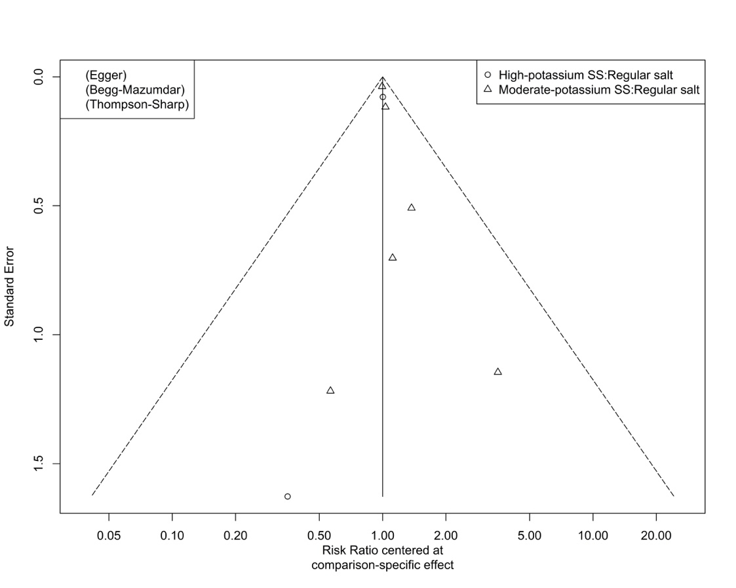

4.7.2. Funnel plot for assessment of publication bias in network meta-analysis of cardiovascular mortality
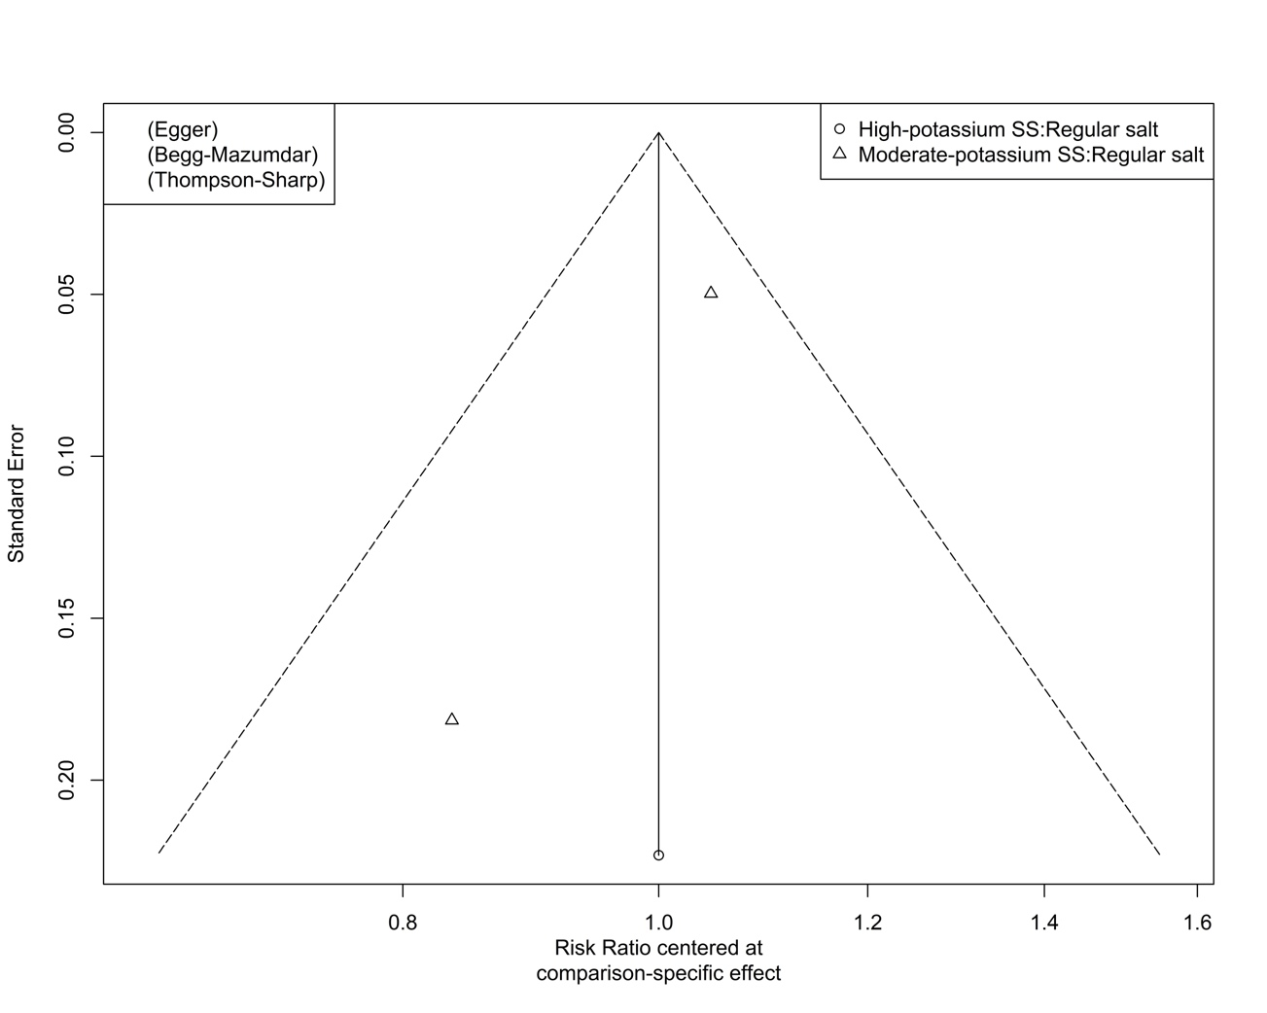

4.7.3. Funnel plot for assessment of publication bias in network meta-analysis of non-fatal cardiovascular events
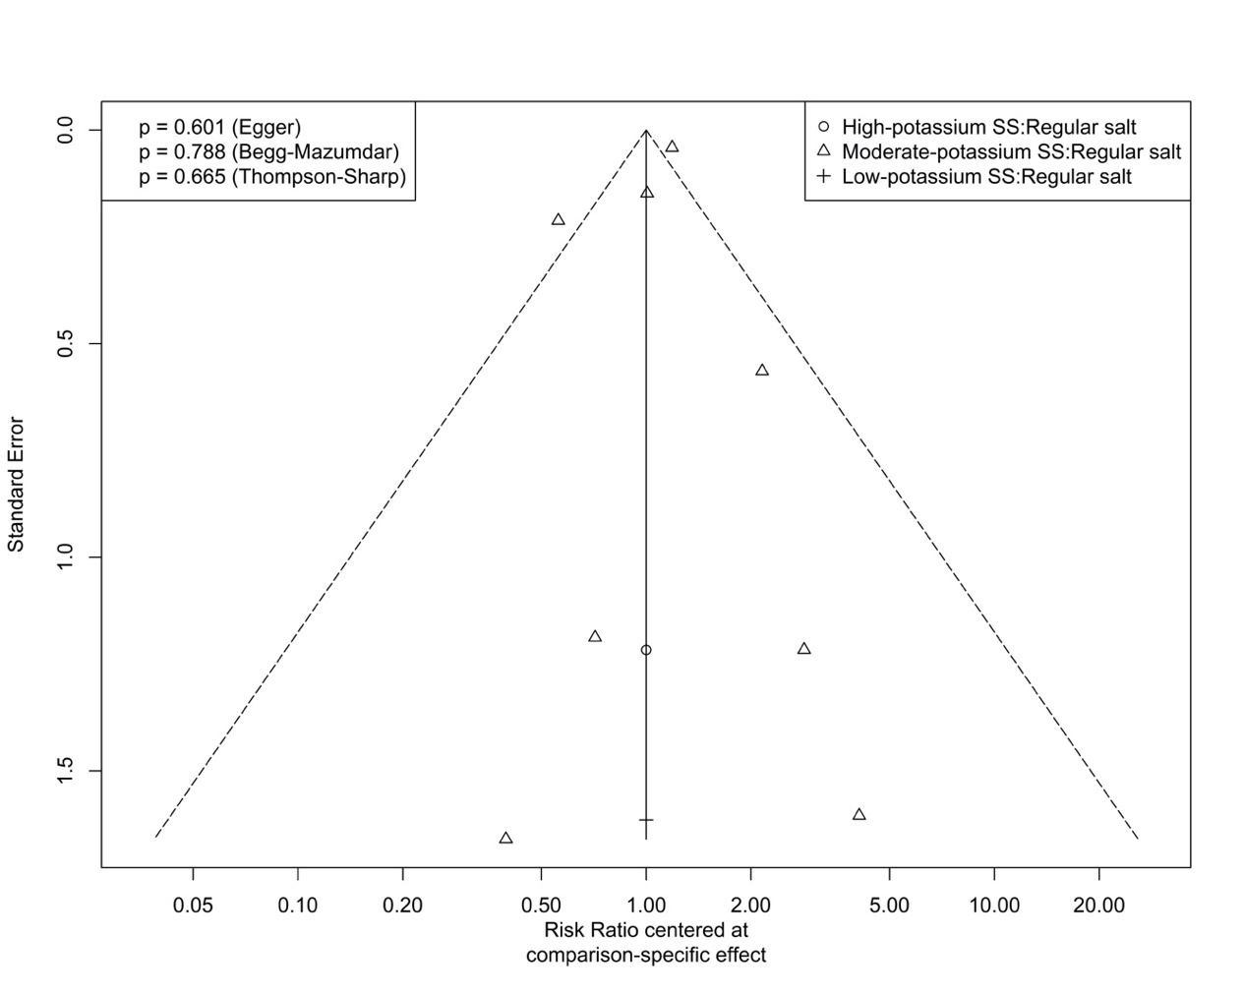

4.7.4. Funnel plot for assessment of publication bias in network meta-analysis of systolic blood pressure
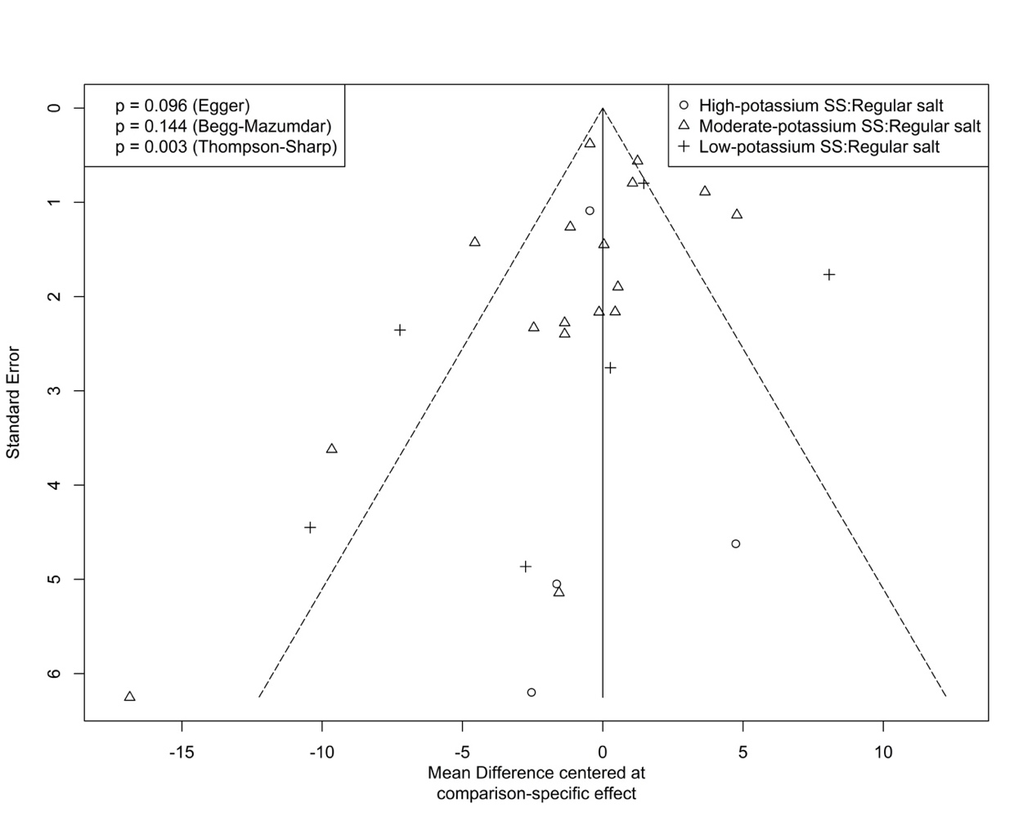

4.7.5. Funnel plot for assessment of publication bias in network meta-analysis of diastolic blood pressure
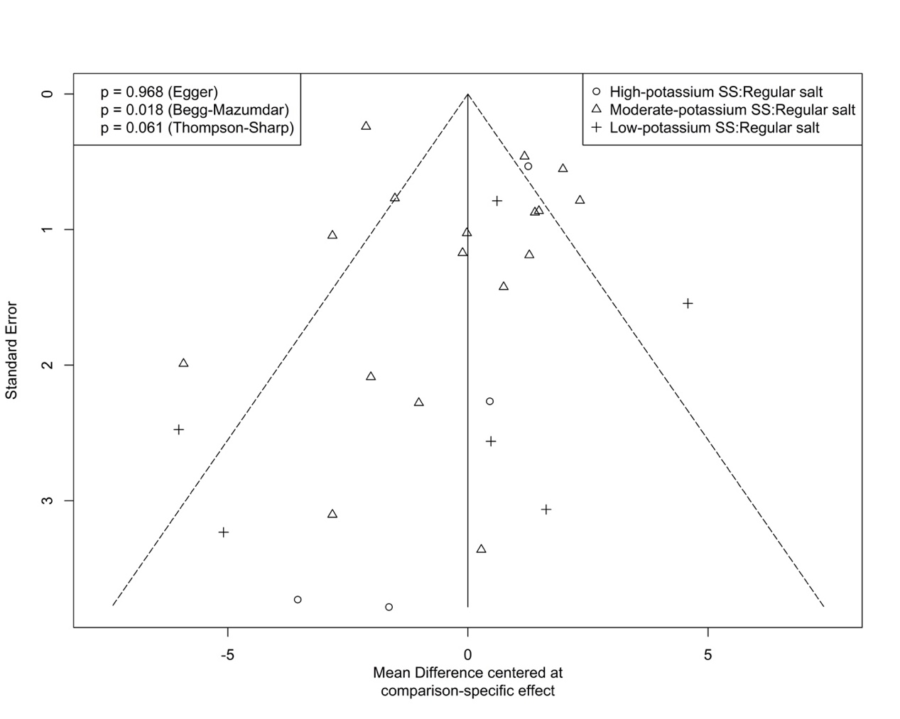

4.7.6. Funnel plot for assessment of publication bias in network meta-analysis of adverse events related to intervention
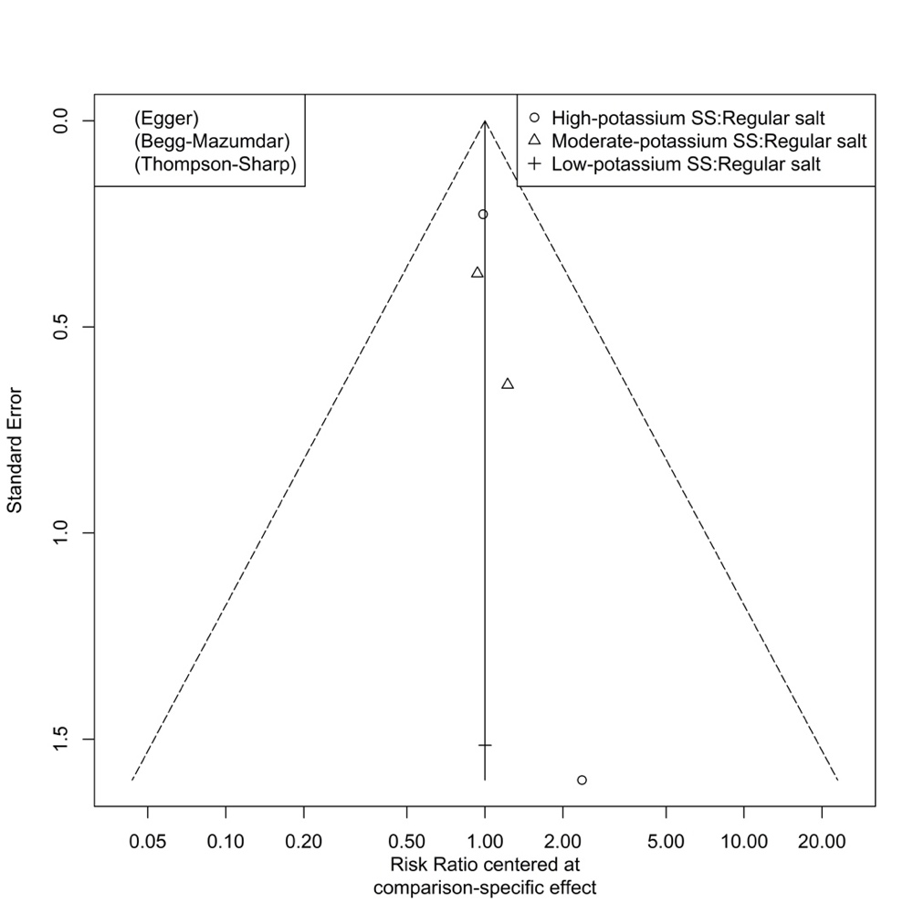

4.7.7. Funnel plot for assessment of publication bias in network meta-analysis of withdrawals due to any reason
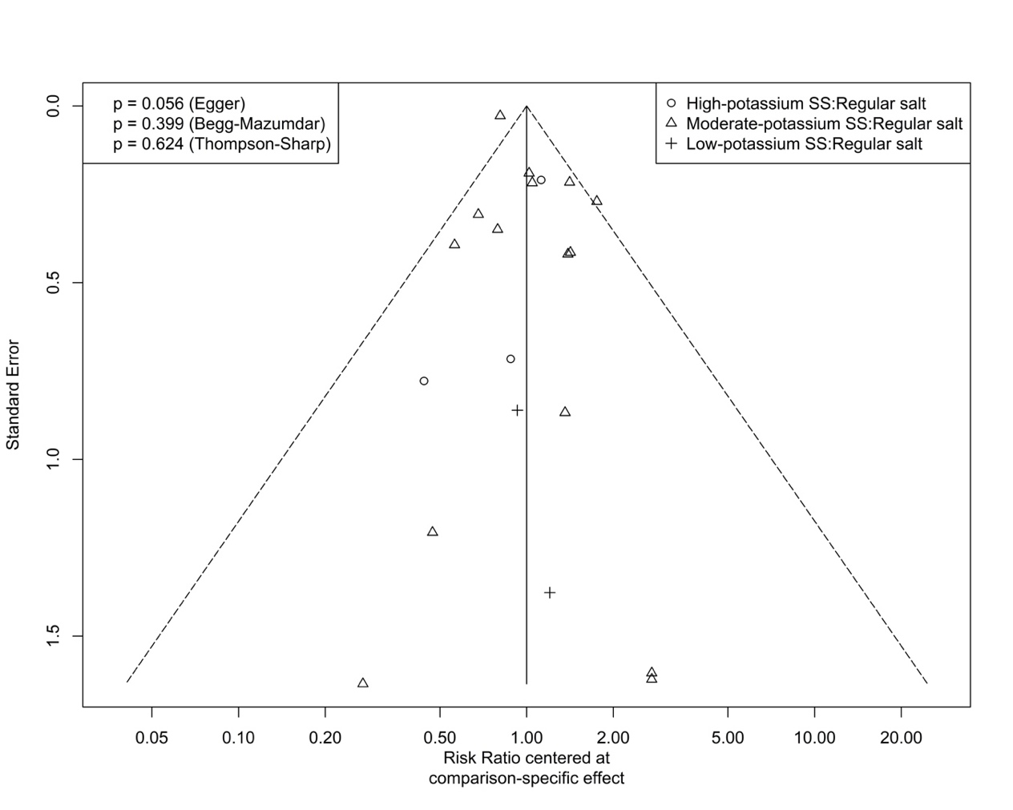

4.7.8. Funnel plot for assessment of publication bias in network meta-analysis of serum potassium concentration
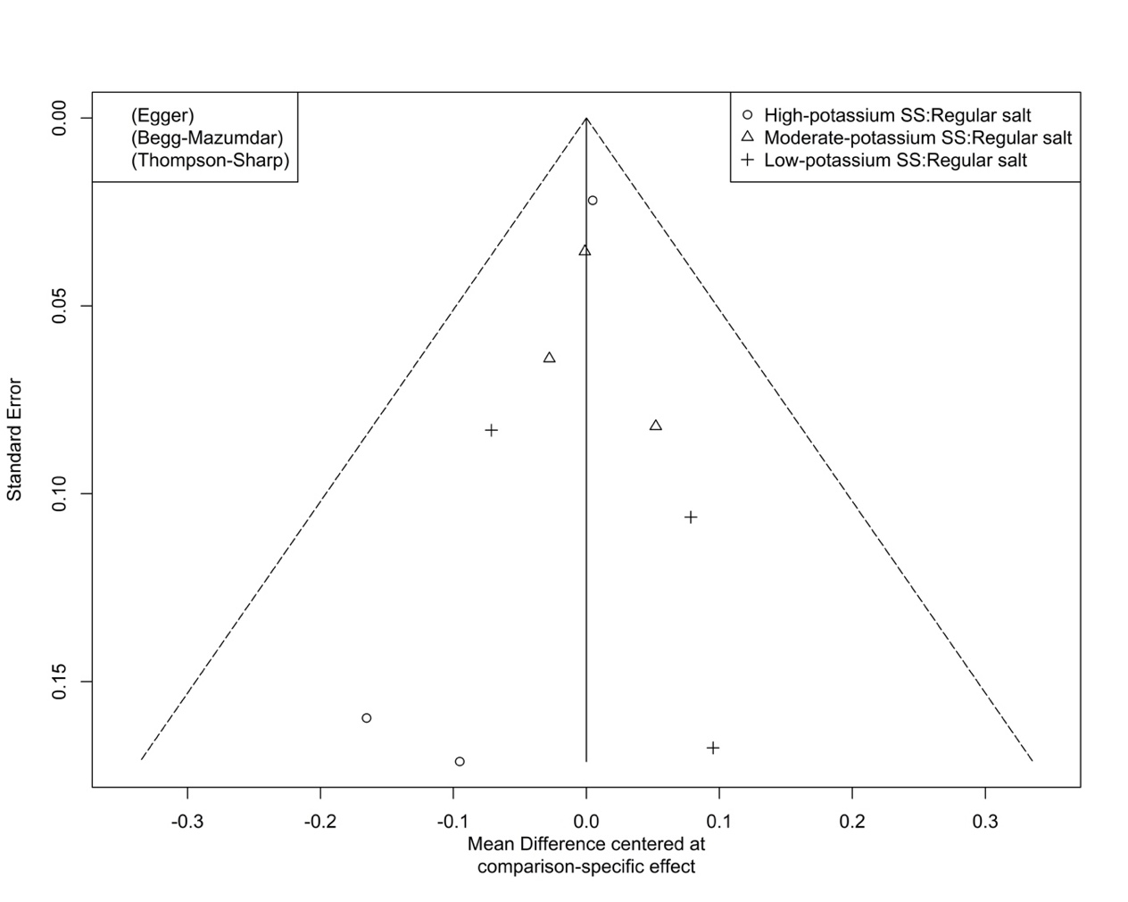

4.7.9. Funnel plot for assessment of publication bias in network meta-analysis of serum sodium concentration
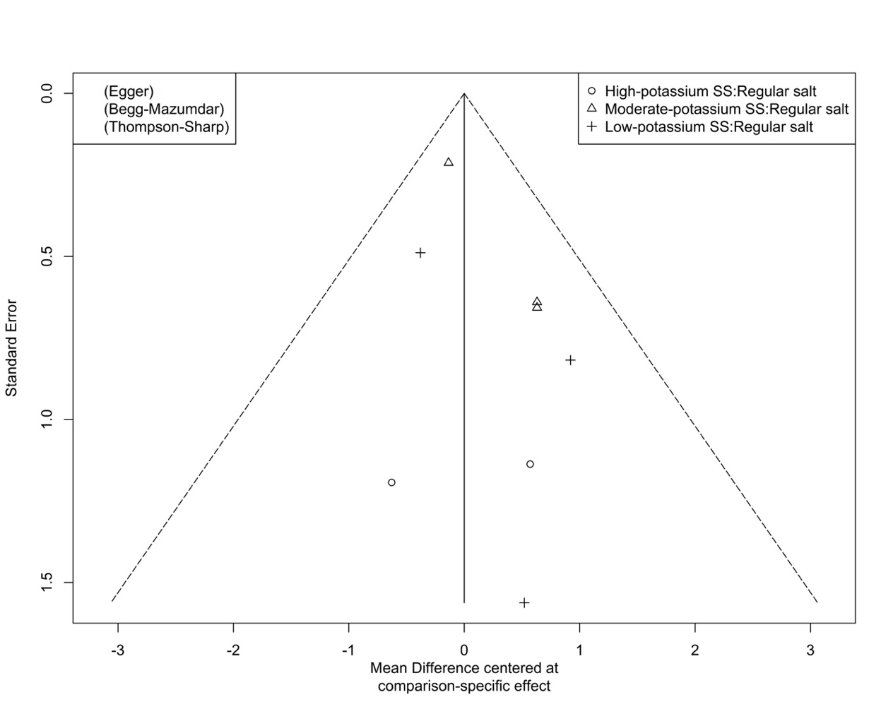

4.7.10. Funnel plot for assessment of publication bias in network meta-analysis of 24-hour urinary potassium excretion
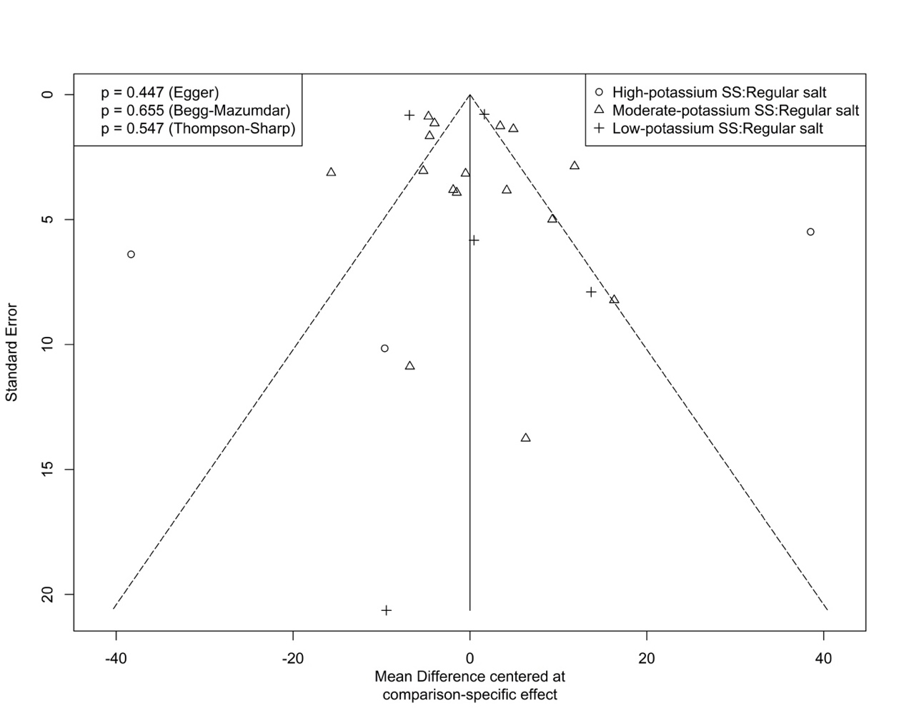

4.7.11. Funnel plot for assessment of publication bias in network meta-analysis of 24-hour urinary sodium excretion
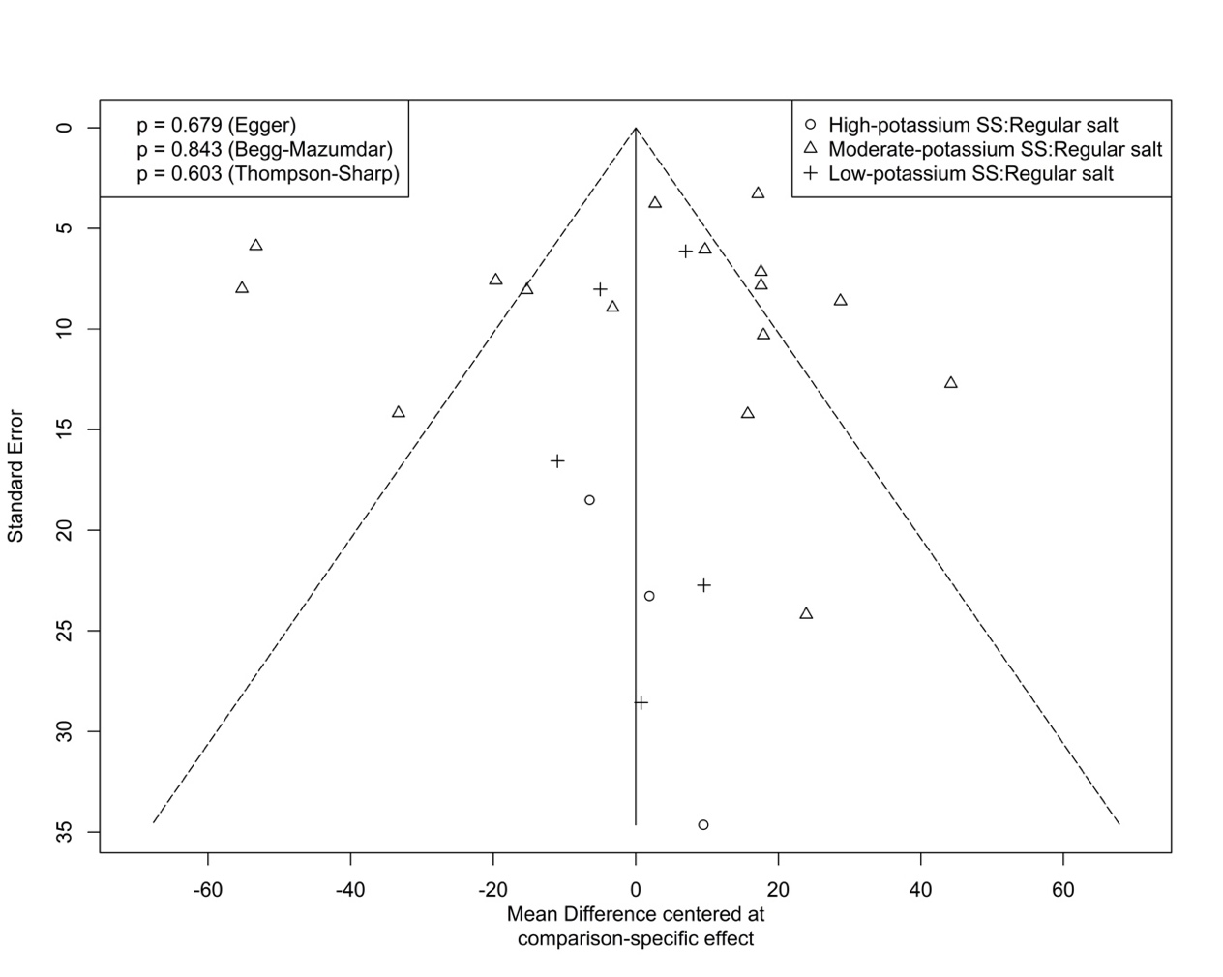

Table S1 Results of assessments of the certainty of evidence for direct, indirect and network estimates

4.8.1. GRADE assessment of certainty of evidence for all-cause mortality comparisons
Arm 1 | Arm 2 | No. of study | Sample size | I² | Direct estimate | ROB | Inconsistency | Indirectness | Publication bias | Direct rating without imprecision | Indirect estimate | Certainty of evidence for arm1 | Certainty of evidence for arm2 | Intransitivity | Indirect rating without imprecision | Network meta-analysis | Risk stratum | Baseline risk | Anticipated absolute effects | Higher rating of direct and indirect without imprecision | Incoherence | NMA Imprecision | Final network rating
High-potassium SS | Moderate-potassium SS | 0 |  | . | . | . | . | . | . | . | 1.09 (0.92 to 1.29) | Moderate | High | Not serious | Moderate | 1.09 (0.92 to 1.29) | Intermediate risk | 0.062 | 6 (-5 to 18) | Moderate | Not serious | Serious | Low
 |  |  |  |  |  |  |  |  |  |  |  |  |  |  |  |  | High risk | 0.143 | 13 (-11 to 41) | Moderate | Not serious | Very serious | Very low
High-potassium SS | Regular salt | 2 | 1931 | 0.00% | 0.96 (0.83 to 1.12) | Serious | Not serious | Not serious | Undetected | Moderate | . | . | . | . | . | 0.96 (0.83 to 1.12) | Intermediate risk | 0.062 | -2 (-11 to 7) | Moderate | Not serious | Very serious | Very low
 |  |  |  |  |  |  |  |  |  |  |  |  |  |  |  |  | High risk | 0.143 | -6 (-24 to 17) | Moderate | Not serious | Very serious | Very low
Moderate-potassium SS | Regular salt | 6 | 24106 | 0.00% | 0.89 (0.83 to 0.95) | Not serious | Not serious | Not serious | Undetected | High | . | . | . | . | . | 0.89 (0.83 to 0.95) | Intermediate risk | 0.062 | -7 (-11 to -3) | High | Not serious | Serious | Moderate
 |  |  |  |  |  |  |  |  |  |  |  |  |  |  |  |  | High risk | 0.143 | -16 (-24 to -7) | High | Not serious | Not serious | High

4.8.2. GRADE assessment of certainty of evidence for cardiovascular mortality comparisons
Arm 1 | Arm 2 | No. of study | Sample size | I² | Direct estimate | ROB | Inconsistency | Indirectness | Publication bias | Direct rating without imprecision | Indirect estimate | Certainty of evidence for arm1 | Certainty of evidence for arm2 | Intransitivity | Indirect rating without imprecision | Network meta-analysis | Risk stratum | Baseline risk | Anticipated absolute effects | Higher rating of direct and indirect without imprecision | Incoherence | NMA Imprecision | Final network rating
High-potassium SS | Moderate-potassium SS | 0 | . | . | . | . | . | . | . | . | 0.77 (0.47 to 1.28) | Moderate | High | Not serious | Moderate | 0.77 (0.47 to 1.28) | Intermediate risk | 0.029 | -7 (-15 to 8) | Moderate | Not serious | Very serious | Very low
 |  |  |  |  |  |  |  |  |  |  |  |  |  |  |  |  | High risk | 0.092 | -21 (-49 to 26) | Moderate | Not serious | Very serious | Very low
High-potassium SS | Regular salt | 1 | 1777 | . | 0.64 (0.40 to 1.03) | Serious | Not serious | Not serious | Undetected | Moderate | . | . | . | . | . | 0.64 (0.40 to 1.03) | Intermediate risk | 0.029 | -10 (-17 to 1) | Moderate | Not serious | Serious | Low
 |  |  |  |  |  |  |  |  |  |  |  |  |  |  |  |  | High risk | 0.092 | -33 (-55 to 3) | Moderate | Not serious | Serious | Low
Moderate-potassium SS | Regular salt | 2 | 22607 | 30.70% | 0.83 (0.70 to 0.99) | Not serious | Not serious | Not serious | Undetected | High | . | . | . | . | . | 0.83 (0.70 to 0.99) | Intermediate risk | 0.029 | -5 (-9 to 0) | High | Not serious | Serious | Moderate
 |  |  |  |  |  |  |  |  |  |  |  |  |  |  |  |  | High risk | 0.092 | -16 (-28 to -1) | High | Not serious | Serious | Moderate

4.8.3. GRADE assessment of certainty of evidence for non-fatal cardiovascular events comparisons
Arm 1 | Arm 2 | No. of study | Sample size | I² | Direct estimate | ROB | Inconsistency | Indirectness | Publication bias | Direct rating without imprecision | Indirect estimate | Certainty of evidence for arm1 | Certainty of evidence for arm2 | Intransitivity | Indirect rating without imprecision | Network meta-analysis | Risk stratum | Baseline risk | Anticipated absolute effects | Higher rating of direct and indirect without imprecision | Incoherence | NMA Imprecision | Final network rating
High-potassium SS | Moderate-potassium SS | 0 | . | . | . | . | . | . | . | . | 2.78 (0.24 to 32.49) | Moderate | Moderate | Not serious | Moderate | 2.78 (0.24 to 32.49) | Intermediate risk | 0.075 | 134 (-57 to 2362) | Moderate | Not serious | Very serious | Very low
 |  |  |  |  |  |  |  |  |  |  |  |  |  |  |  |  | High risk | 0.25 | 445 (-190 to 7873) | Moderate | Not serious | Very serious | Very low
High-potassium SS | Low-potassium SS | 0 | . | . | . | . | . | . | . | . | 7.04 (0.13 to 394.42) | Moderate | High | Not serious | Moderate | 7.04 (0.13 to 394.42) | Intermediate risk | 0.075 | 453 (-65 to 29507) | Moderate | Not serious | Very serious | Very low
 |  |  |  |  |  |  |  |  |  |  |  |  |  |  |  |  | High risk | 0.25 | 1510 (-218 to 98355) | Moderate | Not serious | Very serious | Very low
High-potassium SS | Regular salt | 1 | 291 | . | 2.04 (0.18 to 23.36) | Serious | Not serious | Not serious | Undetected | Moderate | . | . | . | . | . | 2.04 (0.18 to 23.36) | Intermediate risk | 0.075 | 78 (-62 to 1677) | Moderate | Not serious | Very serious | Very low
 |  |  |  |  |  |  |  |  |  |  |  |  |  |  |  |  | High risk | 0.25 | 260 (-205 to 5590) | Moderate | Not serious | Very serious | Very low
Moderate-potassium SS | Low-potassium SS | 0 | . | . | . | . | . | . | . | . | 2.53 (0.10 to 63.27) | Moderate | High | Not serious | Moderate | 2.53 (0.10 to 63.27) | Intermediate risk | 0.075 | 115 (-68 to 4670) | Moderate | Not serious | Very serious | Very low
 |  |  |  |  |  |  |  |  |  |  |  |  |  |  |  |  | High risk | 0.25 | 383 (-225 to 15568) | Moderate | Not serious | Very serious | Very low
Moderate-potassium SS | Regular salt | 7 | 25945 | 56.10% | 0.73 (0.54 to 1.00) | Not serious | Serious | Not serious | Undetected | Moderate | . | . | . | . | . | 0.73 (0.54 to 1.00) | Intermediate risk | 0.075 | -20 (-35 to 0) | Moderate | Not serious | Serious | Moderate*
 |  |  |  |  |  |  |  |  |  |  |  |  |  |  |  |  | High risk | 0.25 | -68 (-115 to 0) | Moderate | Not serious | Very serious | Low*
Low-potassium SS | Regular salt | 1 | 41 | . | 0.29 (0.01 to 7.15) | Not serious | Not serious | Not serious | Undetected | High | . | . | . | . | . | 0.29 (0.01 to 7.15) | Intermediate risk | 0.075 | -53 (-74 to 461) | High | Not serious | Very serious | Low
 |  |  |  |  |  |  |  |  |  |  |  |  |  |  |  |  | High risk | 0.25 | -178 (-248 to 1538) | High | Not serious | Very serious | Low
*We rated down for inconsistency. Although there also was concern about imprecision, we did not further rate down the certainty of evidence because the inconsistency is most likely the cause of imprecision.

4.8.4. GRADE assessment of certainty of evidence for systolic blood pressure comparisons
Arm 1 | Arm 2 | No. of study | Sample size | I² | Direct estimate | ROB | Inconsistency | Indirectness | Publication bias | Direct rating without imprecision | Indirect estimate | Certainty of evidence for arm1 | Certainty of evidence for arm2 | Intransitivity | Indirect rating without imprecision | Network meta-analysis | Higher rating of direct and indirect without imprecision | Incoherence | NMA Imprecision | Final network rating
High-potassium SS | Moderate-potassium SS | 0 | . | . | . | . | . | . | . | . | -2.90 (-7.23 to 1.43) | Moderate | Moderate | Not serious | Moderate | -2.90 ( -7.23 to 1.43) | Moderate | Not serious | Serious | Low
High-potassium SS | Low-potassium SS | 0 | . | . | . | . | . | . | . | . | -0.47 (-5.43 to 4.49) | Moderate | Low | Not serious | Low | -0.47 ( -5.43 to 4.49) | Low | Not serious | Very serious | Very low
High-potassium SS | Regular salt | 4 | 2129 | 0.00% | -7.54 (-11.63 to -3.44) | Serious | Not serious | Not serious | Undetected | Moderate | . | . | . | . | . | -7.54 (-11.63 to -3.44) | Moderate | Not serious | Not serious | Moderate
Moderate-potassium SS | Low-potassium SS | 0 | . | . | . | . | . | . | . | . | 2.43 (-0.70 to 5.56) | Moderate | Low | Not serious | Low | 2.43 ( -0.70 to 5.56) | Low | Not serious | Serious | Very low
Moderate-potassium SS | Regular salt | 18 | 24345 | 83.40% | -4.64 ( -6.05 to -3.24) | Not serious | Serious | Not serious | Not serious | Moderate | . | . | . | . | . | -4.64 ( -6.05 to -3.24) | Moderate | Not serious | Not serious | Moderate
Low-potassium SS | Regular salt | 6 | 1147 | 86.00% | -7.07 ( -9.87 to -4.27) | Serious | Serious | Not serious | Undetected | Low | . | . | . | . | . | -7.07 ( -9.87 to -4.27) | Low | Not serious | Not serious | Low

4.8.5. GRADE assessment of certainty of evidence for diastolic blood pressure comparisons
Arm 1 | Arm 2 | No. of study | Sample size | I² | Direct estimate | ROB | Inconsistency | Indirectness | Publication bias | Direct rating without imprecision | Indirect estimate | Certainty of evidence for arm1 | Certainty of evidence for arm2 | Intransitivity | Indirect rating without imprecision | Network meta-analysis | Higher rating of direct and indirect without imprecision | Incoherence | NMA Imprecision | Final network rating
High-potassium SS | Moderate-potassium SS | 0 | . | . | . | . | . | . | . | . | -1.28 (-4.69 to 2.14) | Moderate | Moderate | Not serious | Moderate | -1.28 (-4.69 to 2.14) | Moderate | Not serious | Very serious | Very low
High-potassium SS | Low-potassium SS | 0 | . | . | . | . | . | . | . | . | 1.32 (-2.74 to 5.39) | Moderate | Low | Not serious | Low | 1.32 (-2.74 to 5.39) | Low | Not serious | Very serious | Very low
High-potassium SS | Regular salt | 4 | 2129 | 0.00% | -3.26 (-6.45 to -0.07) | Serious | Not serious | Not serious | Undetected | Moderate | . | . | . | . | . | -3.26 (-6.45 to -0.07) | Moderate | Not serious | Serious | Low
Moderate-potassium SS | Low-potassium SS | 0 | . | . | . | . | . | . | . | . | 2.60 (-0.20 to 5.41) | Moderate | Low | Not serious | Low | 2.60 (-0.20 to 5.41) | Low | Not serious | Serious | Very low
Moderate-potassium SS | Regular salt | 18 | 24345 | 91.80% | -1.98 (-3.20 to -0.76) | Not serious | Serious | Not serious | Not serious | Moderate | . | . | . | . | . | -1.98 (-3.20 to -0.76) | Moderate | Not serious | Serious | Moderate*
Low-potassium SS | Regular salt | 6 | 1147 | 70.60% | -4.58 (-7.11 to -2.05) | Serious | Serious | Not serious | Undetected | Low | . | . | . | . | . | -4.58 (-7.11 to -2.05) | Low | Not serious | Not serious | Low
*We rated down for inconsistency. Although there also was concern about imprecision, we did not further rate down the certainty of evidence because the inconsistency is most likely the cause of imprecision.

4.8.6. GRADE assessment of certainty of evidence for adverse events related to intervention comparisons
Arm 1 | Arm 2 | No. of study | Sample size | I² | Direct estimate | ROB | Inconsistency | Indirectness | Publication bias | Direct rating without imprecision | Indirect estimate | Certainty of evidence for arm1 | Certainty of evidence for arm2 | Intransitivity | Indirect rating without imprecision | Network meta-analysis | Baseline risk | Anticipated absolute effects | Higher rating of direct and indirect without imprecision | Incoherence | NMA Imprecision | Final network rating
High-potassium SS | Moderate-potassium SS | 0 | . | . | . | . | . | . | . | . | 0.88 (0.41 to 1.90) | Moderate | High | Not serious | Moderate | 0.88 (0.41 to 1.90) | 0.03 | -4 (-18 to 27) | Moderate | Not serious | Not serious | Moderate
High-potassium SS | Low-potassium SS | 0 | . | . | . | . | . | . | . | . | 6.19 (0.31 to 124.53) | Moderate | High | Not serious | Moderate | 6.19 (0.31 to 124.53) | 0.03 | 156 (-21 to 3706) | Moderate | Not serious | Very serious | Very low
High-potassium SS | Regular salt | 2 | 2087 | 0.00% | 1.08 (0.69 to 1.67) | Serious | Not serious | Not serious | Undetected | Moderate | . | . | . | . | . | 1.08 (0.69 to 1.67) | 0.03 | 2 (-9 to 20) | Moderate | Not serious | Not serious | Moderate
Moderate-potassium SS | Low-potassium SS | 0 | . | . | . | . | . | . | . | . | 7.00 (0.34 to 145.58) | High | High | Not serious | High | 7.00 (0.34 to 145.58) | 0.03 | 180 (-20 to 4337) | High | Not serious | Very serious | Low
Moderate-potassium SS | Regular salt | 2 | 1208 | 0.00% | 1.22 (0.65 to 2.28) | Not serious | Not serious | Not serious | Undetected | High | . | . | . | . | . | 1.22 (0.65 to 2.28) | 0.03 | 7 (-11 to 38) | High | Not serious | Serious | Moderate
Low-potassium SS | Regular salt | 1 | 41 | . | 0.17 (0.01 to 3.39) | Not serious | Not serious | Not serious | Undetected | High | . | . | . | . | . | 0.17 (0.01 to 3.39) | 0.03 | -25 (-30 to 72) | High | Not serious | Very serious | Low

4.8.7. GRADE assessment of certainty of evidence for withdrawals due to any reason comparisons
Arm 1 | Arm 2 | No. of study | Sample size | I² | Direct estimate | ROB | Inconsistency | Indirectness | Publication bias | Direct rating without imprecision | Indirect estimate | Certainty of evidence for arm1 | Certainty of evidence for arm2 | Intransitivity | Indirect rating without imprecision | Network meta-analysis | Baseline risk | Anticipated absolute effects | Higher rating of direct and indirect without imprecision | Incoherence | NMA Imprecision | Final network rating
High-potassium SS | Moderate-potassium SS | 0 | . | . | . | . | . | . | . | . | 1.03 (0.61 to 1.73) | Moderate | High | Not serious | Moderate | 1.03 (0.61 to 1.73) | 0.18 | 5 (-70 to 131) | Moderate | Not serious | Very serious | Very low
High-potassium SS | Low-potassium SS | 0 | . | . | . | . | . | . | . | . | 1.51 (0.33 to 7.01) | Moderate | High | Not serious | Moderate | 1.51 (0.33 to 7.01) | 0.18 | 92 (-121 to 1082) | Moderate | Not serious | Very serious | Very low
High-potassium SS | Regular salt | 3 | 208 | 0.00% | 1.14 (0.70 to 1.84) | Serious | Not serious | Not serious | Undetected | Moderate | . | . | . | . | . | 1.14 (0.70 to 1.84) | 0.18 | 25 (-54 to 151) | Moderate | Not serious | Very serious | Very low
Moderate-potassium SS | Low-potassium SS | 0 | . | . | . | . | . | . | . | . | 1.47 (0.34 to 6.37) | High | High | Not serious | High | 1.47 (0.34 to 6.37) | 0.18 | 85 (-119 to 967) | High | Not serious | Very serious | Low
Moderate-potassium SS | Regular salt | 15 | 25298 | 40.40% | 1.10 (0.92 to 1.33) | Not serious | Not serious | Not serious | Undetected | High | . | . | . | . | . | 1.10 (0.92 to 1.33) | 0.18 | 18 (-14 to 59) | High | Not serious | Serious | Moderate
Low-potassium SS | Regular salt | 2 | 83 | 0 | 0.75 (0.18 to 3.23) | Not serious | Not serious | Not serious | Undetected | High | . | . | . | . | . | 0.75 (0.18 to 3.23) | 0.18 | -45 (-148 to 401) | High | Not serious | Very serious | Low

4.8.8. GRADE assessment of certainty of evidence for serum potassium concentration comparisons
Arm 1 | Arm 2 | No. of study | Sample size | I² | Direct estimate | ROB | Inconsistency | Indirectness | Publication bias | Direct rating without imprecision | Indirect estimate | Certainty of evidence for arm1 | Certainty of evidence for arm2 | Intransitivity | Indirect rating without imprecision | Network meta-analysis | Higher rating of direct and indirect without imprecision | Incoherence | NMA Imprecision | Final network rating
High-potassium SS | Moderate-potassium SS | 0 | . | . | . | . | . | . | . | . | -0.05 (-0.12 to 0.02) | High | Moderate | Not serious | Moderate | -0.05 (-0.12 to 0.02) | Moderate | Not serious | Not serious | Moderate
High-potassium SS | Low-potassium SS | 0 | . | . | . | . | . | . | . | . | -0.08 (-0.20 to 0.05) | High | High | Not serious | High | -0.08 (-0.20 to 0.05) | High | Not serious | Serious | Moderate
High-potassium SS | Regular salt | 3 | 2094 | 0.00% | 0.10 (0.05 to 0.14) | Not serious | Not serious | Not serious | Undetected | High | . | . | . | . | . | 0.10 ( 0.05 to 0.14) | High | Not serious | Serious | Moderate
Moderate-potassium SS | Low-potassium SS | 0 | . | . | . | . | . | . | . | . | -0.02 (-0.16 to 0.11) | Moderate | High | Not serious | Moderate | -0.02 (-0.16 to 0.11) | Moderate | Not serious | Serious | Low
Moderate-potassium SS | Regular salt | 3 | 461 | 0.00% | 0.15 (0.09 to 0.20) | Serious | Not serious | Not serious | Undetected | Moderate | . | . | . | . | . | 0.15 ( 0.09 to 0.20) | Moderate | Not serious | Very serious | Very low
Low-potassium SS | Regular salt | 3 | 118 | 0.00% | 0.17 (0.05 to 0.29) | Not serious | Not serious | Not serious | Undetected | High | . | . | . | . | . | 0.17 ( 0.05 to 0.29) | High | Not serious | Very serious | Low

4.8.9. GRADE assessment of certainty of evidence for serum sodium concentration comparisons
Arm 1 | Arm 2 | No. of study | Sample size | I² | Direct estimate | ROB | Inconsistency | Indirectness | Publication bias | Direct rating without imprecision | Indirect estimate | Certainty of evidence for arm1 | Certainty of evidence for arm2 | Intransitivity | Indirect rating without imprecision | Network meta-analysis | Higher rating of direct and indirect without imprecision | Incoherence | NMA Imprecision | Final network rating
High-potassium SS | Moderate-potassium SS | 0 | . | . | . | . | . | . | . | . | 1.26 (-0.40 to 2.92) | High | Moderate | Not serious | Moderate | 1.26 (-0.40 to 2.92) | Moderate | Not serious | Serious | Low
High-potassium SS | Low-potassium SS | 0 | . | . | . | . | . | . | . | . | 1.75 (-0.05 to 3.55) | High | High | Not serious | High | 1.75 (-0.05 to 3.55) | High | Not serious | Serious | Moderate
High-potassium SS | Regular salt | 2 | 42 | 0.00% | 0.73 (-0.88 to 2.34) | Not serious | Not serious | Not serious | Undetected | High | . | . | . | . | . | 0.73 (-0.88 to 2.34) | High | Not serious | Very serious | Low
Moderate-potassium SS | Low-potassium SS | 0 | . | . | . | . | . | . | . | . | 0.49 (-0.39 to 1.37) | Moderate | High | Not serious | Moderate | 0.49 (-0.39 to 1.37) | Moderate | Not serious | Serious | Low
Moderate-potassium SS | Regular salt | 3 | 461 | 13.00% | -0.53 (-0.91 to -0.15) | Serious | Not serious | Not serious | Undetected | Moderate | . | . | . | . | . | -0.53 (-0.91 to -0.15) | Moderate | Not serious | Very serious | Very low
Low-potassium SS | Regular salt | 3 | 118 | 0.00% | -1.02 (-1.81 to -0.23) | Not serious | Not serious | Not serious | Undetected | High | . | . | . | . | . | -1.02 (-1.81 to -0.23) | High | Not serious | Very serious | Low

4.8.10. GRADE assessment of certainty of evidence for 24-hour urinary potassium excretion comparisons
Arm 1 | Arm 2 | No. of study | Sample size | I² | Direct estimate | ROB | Inconsistency | Indirectness | Publication bias | Direct rating without imprecision | Indirect estimate | Certainty of evidence for arm1 | Certainty of evidence for arm2 | Intransitivity | Indirect rating without imprecision | Network meta-analysis | Higher rating of direct and indirect without imprecision | Incoherence | NMA Imprecision | Final network rating
High-potassium SS | Moderate-potassium SS | 0 | . | . | . | . | . | . | . | . | 18.34 ( 6.64 to 30.04) | Moderate | Moderate | Not serious | Moderate | 18.34 ( 6.64 to 30.04) | Moderate | Not serious | Serious | Low
High-potassium SS | Low-potassium SS | 0 | . | . | . | . | . | . | . | . | 23.99 (10.60 to 37.39) | Moderate | Low | Not serious | Low | 23.99 (10.60 to 37.39) | Low | Not serious | Not serious | Low
High-potassium SS | Regular salt | 3 | 77 | 97.70% | 31.04 (19.99 to 42.09) | Not serious | Serious | Not serious | Undetected | Moderate | . | . | . | . | . | 31.04 (19.99 to 42.09) | Moderate | Not serious | Serious | Low
Moderate-potassium SS | Low-potassium SS | 0 | . | . | . | . | . | . | . | . | 5.65 (-2.84 to 14.14) | Moderate | Low | Not serious | Low | 5.65 (-2.84 to 14.14) | Low | Not serious | Serious | Very low
Moderate-potassium SS | Regular salt | 16 | 9810 | 86.90% | 12.70 ( 8.86 to 16.53) | Not serious | Serious | Not serious | Not serious | Moderate | . | . | . | . | . | 12.70 ( 8.86 to 16.53) | Moderate | Not serious | Serious | Moderate*
Low-potassium SS | Regular salt | 5 | 1105 | 93.30% | 7.05 (-0.53 to 14.62) | Serious | Serious | Not serious | Undetected | Low | . | . | . | . | . | 7.05 (-0.53 to 14.62) | Low | Not serious | Serious | Low*
*We rated down for inconsistency. Although there also was concern about imprecision, we did not further rate down the certainty of evidence because the inconsistency is most likely the cause of imprecision.

4.8.11. GRADE assessment of certainty of evidence for 24-hour urinary sodium excretion comparisons
Arm 1 | Arm 2 | No. of study | Sample size | I² | Direct estimate | ROB | Inconsistency | Indirectness | Publication bias | Direct rating without imprecision | Indirect estimate | Certainty of evidence for arm1 | Certainty of evidence for arm2 | Intransitivity | Indirect rating without imprecision | Network meta-analysis | Higher rating of direct and indirect without imprecision | Incoherence | NMA Imprecision | Final network rating
High-potassium SS | Moderate-potassium SS | 0 | . | . | . | . | . | . | . | . | -40.69 ( -81.53 to 0.16) | High | Moderate | Not serious | Moderate | -40.69 ( -81.53 to 0.16) | Moderate | Not serious | Serious | Low
High-potassium SS | Low-potassium SS | 0 | . | . | . | . | . | . | . | . | -59.38 (-105.72 to -13.04) | High | Moderate | Not serious | Moderate | -59.38 (-105.72 to -13.04) | Moderate | Not serious | Serious | Low
High-potassium SS | Regular salt | 3 | 77 | 0.00% | -57.39 (-96.21 to -18.57) | Not serious | Not serious | Not serious | Undetected | High | . | . | . | . | . | -57.39 ( -96.21 to -18.57) | High | Not serious | Serious | Moderate
Moderate-potassium SS | Low-potassium SS | 0 | . | . | . | . | . | . | . | . | -18.70 ( -46.99 to 9.60) | Moderate | Moderate | Not serious | Moderate | -18.70 ( -46.99 to 9.60) | Moderate | Not serious | Serious | Low
Moderate-potassium SS | Regular salt | 16 | 9810 | 93.00% | -16.71 (-29.39 to -4.02) | Not serious | Serious | Not serious | Not serious | Moderate | . | . | . | . | . | -16.71 ( -29.39 to -4.02) | Moderate | Not serious | Serious | Moderate*
Low-potassium SS | Regular salt | 5 | 1105 | 0.00% | 1.99 (-23.30 to 27.28) | Serious | Not serious | Not serious | Undetected | Moderate | . | . | . | . | . | 1.99 ( -23.30 to 27.28) | Moderate | Not serious | Very serious | Very low
*We rated down for inconsistency. Although there also was concern about imprecision, we did not further rate down the certainty of evidence because the inconsistency is most likely the cause of imprecision.

Table S2 Studies not connected in network
Outcome | Study not connected in network | Reason
Any AE related to intervention | Allaert, 2013 | Both groups have zero events
Any AE related to intervention | Li, 2014 | Both groups have zero events
Any AE related to intervention | Pan, 2017 | Both groups have zero events
Any AE related to intervention | Yu, 2021 | Both groups have zero events
Any AE related to intervention | Bernabe-Ortiz, 2020 | Both groups have zero events
DBP | Arzilli, 1986 | No arm-based data is available
SBP | Arzilli, 1986 | No arm-based data is available
Non-fatal cardiovascular events | Zhou, 2009 | Both groups have zero events
Withdrawals due to any reason | Allaert, 2017 | Both groups have zero events
Withdrawals due to any reason | Kawasaki, 1998 | Both groups have zero events
Withdrawals due to any reason | Suppa, 1988 | Both groups have zero events
Withdrawals due to any reason | Yang, 2018 | Both groups have zero events

