Additional File 6 Supplement to Additional Analysis

Table S1 Network meta-analysis of salt substitutes after exclusion of the Neal, 2021 trial

Network meta-analysis of salt substitutes classified by potassium content (excluding the Neal, 2021 trial)
Outcome | Treatment | Direct comparisons | RR (Risk ratio) | 95% Confidence interval | Baseline risk (intermediate risk) | Anticipated absolute effect (95% CI, intermediate risk) | Baseline risk (high risk) | Anticipated absolute effect (95% CI, high risk)
All-cause mortality | High-potassium SS | 2 | 0.96 | (0.83, 1.12) | 0.062 | -2 (-11, 7) | 0.143 | -6 (-11, 7)
All-cause mortality | Moderate-potassium SS | 5 | 0.93 | (0.75, 1.16) | 0.062 | -4 (-16, 10) | 0.143 | -10 (-16, 10)
Cardiovascular mortality | High-potassium SS | 1 | 0.64 | (0.41, 0.99) | 0.29 | -104 (-171, -3) | 0.92 | -331 (-171, -3)
Cardiovascular mortality | Moderate-potassium SS | 1 | 0.69 | (0.49, 0.99) | 0.29 | -90 (-148, -3) | 0.92 | -285 (-148, -3)
Non-fatal cardiovascular events | High-potassium SS | 1 | 2.04 | (0.17, 24.10) | 0.075 | 78 (-62, 1733) | 0.25 | 260 (-62, 1733)
Non-fatal cardiovascular events | Moderate-potassium SS | 7 | 0.68 | (0.43, 1.07) | 0.075 | -24 (-43, 5) | 0.25 | -80 (-43, 5)
Non-fatal cardiovascular events | Low-potassium SS | 1 | 0.29 | (0.01, 7.32) | 0.075 | -53 (-74, 474) | 0.25 | -178 (-74, 474)

Network meta-analysis of salt substitutes classified by sodium content (excluding the Neal, 2021 trial)
Outcome | Treatment | Direct comparisons | RR (Risk ratio) | 95% Confidence interval | Baseline risk (intermediate risk) | Anticipated absolute effect (95% CI, intermediate risk) | Baseline risk (high risk) | Anticipated absolute effect (95% CI, high risk)
All-cause mortality | Low-sodium SS | 4 | 0.92 | (0.74, 1.15) | 0.062 | -5 (-16, 9) | 0.143 | -11 (-16, 9)
All-cause mortality | Very Low-sodium SS | 3 | 0.97 | (0.83, 1.13) | 0.062 | -2 (-11, 8) | 0.143 | -4 (-11, 8)
Cardiovascular mortality | Low-sodium SS | 1 | 0.69 | (0.49, 0.99) | 0.29 | -90 (-148, -3) | 0.92 | -285 (-148, -3)
Cardiovascular mortality | Very Low-sodium SS | 1 | 0.64 | (0.41, 0.99) | 0.29 | -104 (-171, -3) | 0.92 | -331 (-171, -3)
Non-fatal cardiovascular events | Reduced-sodium SS | 1 | 0.29 | (0.01, 7.31) | 0.075 | -53 (-74, 473) | 0.25 | -178 (-74, 473)
Non-fatal cardiovascular events | Low-sodium SS | 3 | 0.65 | (0.40, 1.05) | 0.075 | -26 (-45, 4) | 0.25 | -88 (-45, 4)
Non-fatal cardiovascular events | Very Low-sodium SS | 5 | 1.19 | (0.36, 3.97) | 0.075 | 14 (-48, 223) | 0.25 | 48 (-48, 223)

Table S2 Outcomes not amenable to meta-analysis

SBP and DBP
Study, year | Study description of the outcome
Arzilli, 1986 | “Mean Blood prssure was significanlty (P<0.01) reduced to a similar extent in both groups in the first 4 days, and declined significantly (P<0.01) only in the K/Na group in the following 8 days, reaching values significantly (P<0.01) lower than those of the CS group.”

Any AE occurred during the intervention
Study, year | Study description
Allaert, 2013 | "One patient suffered increased hypertension during the second period when taking Symbiosal and was withdrawn from the tudy for this reason. Another patient had two AEs (asthenia and tachycardia) during the second period when taking NaCl but did not need to stop the trial."
Allaert, 2017 | "Only one adverse events corresponding to influenza was described in the Symbiosal group and which were considered as having no relation with the product, and two in the NaCl group, one dorsalgia and one angina which were also considered as having also no relation with the product. No serious side effect was described."
Arzilli, 1986 | No description of safety was found. No dropout due to adverse events was reported.
Baek, 2015 | No description of safety was found. No dropout due to adverse events was reported.
Barros, 2014 | "This clinical trial detected an adverse effect among IG patients. Due to its peculiar taste, light salt had low acceptance by 89.5% of IG individuals, who claimed there were taste changes in the prepared foods. Nevertheless, patients agreed to use that salt throughout the study period. The above-mentioned adverse effect was considered mild and study interruption was not necessary."
Bernabe-Ortiz, 2020 | "No severe adverse effects were reported for the duration of the study."
Chang, 2006 | No description of safety was found. No dropout due to adverse events was reported.
Che, 2022 | "None of the participants suffered hyperkalemia or severe deterioration of renal function."
Geleijnse, 1994 | No description of safety was found. No dropout due to adverse events occurred.
CSSS, 2007 | "There were 28 serious adverse events recorded (15 active and 13 control) of which 13 were cardiovascular (eight active and five control) and eight were fatal (four active and four control). There was no detectable difference in the occurrence of these serious adverse events between randomized groups (all P > 0.4). There were no episodes of severe hyperkalemia recorded."
Hu, 2018 | In the intervention group, 4 acute myocardial infarction, 1 nephrosis, and 1 stroke events were detected during follow-up; in the control group, 1 acute myocardial infarction, 1 nephrosis, 1 appendicitis, and 1 stroke events were detected during follow-up.
Kawasaki, 1998 | No description of safety was found. No dropout due to adverse events occurred.
Li, 2009 | No description of safety was found. No dropout due to adverse events occurred.
Li, 2014 | "There was no adverse event reported during the trial in either group."
Li, 2016 | "The most commonly reported adverse events occurring during the study period were dizziness, headache, weakness, stomach ache, hypotension, and fall which occurred at similar rates in the two randomised groups (all p>0.41). Serious vascular events were reported by few of those surveyed with no significant differences between randomised groups for stroke, coronary heart disease, heart failure, kidney disease or hyperkalaemia (all p>0.15)."
Maleki, 2016 | No description of safety was found. No dropout due to adverse events was reported.
Mickelsen, 1977 | No description of safety was found. No dropout due to adverse events was reported.
Mu, 2003 | No description of safety was found. No dropout due to adverse events was reported.
Mu, 2009 | "There were no reports of adverse events among the three groups during follow-up. No episodes of severe hyperkalemia, hypercalcemia, or kidney calculi were recorded."
Neal, 2021 | "There were two participants who had definite or probable hyperkalemia (one in the salt-substitute group and one in the regular-salt group). An additional 313 participants, including 302 who died and 11 who had a nonfatal event, were identified as having possible hyperkalemia. There was no evidence of a significant difference between the trial groups in the analyses that included data from participants who had definite, probable, or possible hyperkalemic events, either in the overall population (3.35 events vs. 3.30 events per 1000 person-years; rate ratio, 1.04; 95% CI, 0.80 to 1.37; P = 0.76) or in any participant subgroup."
Omvik, 1995 | No description of safety was found. No dropout due to adverse events was reported.
Pan, 2017 | "No serious adverse events were reported."
Pereira, 2005 | No description of safety was found. No dropout due to adverse events was reported.
Sarkkinen, 2011 | "During the intervention period, there were 7 reports of respiratory symptoms (Smart Salt group n = 5/Regular salt group n = 2), 17 reports of abdominal/intestinal symptoms (12/5) and 3 reports of cardiovascular symptoms (1/2). None of the adverse events were deemed to be related to the test salts."
Suppa, 1988 | No description of safety was found. No dropout due to adverse events was reported.
Yang, 2018 | "No adverse cardiovascular events happened during the follow-up period."
Yu, 2021 | "Two serious adverse events occurred during the study, 1 in each of the randomized study groups, and neither event was related to the study intervention."
Yuan, 2023 | "Safety was assessed among 1,086 participants with Blood assays during follow-up. Participants without assays were more likely to be older, women, better educated, bedridden or severely ill (Supplementary Table 3) but there was no difference in baseline characteristics between randomized groups in those with and without Blood assays. Salt substitute compared with usual salt increased mean serum potassium by 0.26 mmol l–1 (95% CI 0.15–0.36; P < 0.001) and decreased mean serum sodium by –0.92 mmol l–1 (95% CI –1.43 to –0.41; P < 0.001). Compared with usual salt, the risk of biochemical hyperkalemia was increased with salt substitute (7.0% versus 2.4%, risk ratio (RR) 3.29, 95% CI 1.45–7.45; P = 0.004) with a corresponding fall in the risk of hypokalemia (0.7% versus 3.0%, RR 0.24, 95% CI 0.07–0.79; P = 0.02)—a supplementary safety outcome. There was no different effect on the risk of biochemical hyperkalemia by age, sex, health status or hyperkalemia risk at baseline (all P values for interaction > 0.3). Among the 51 patients with biochemical hyperkalemia, two died— one from complications secondary to hip fracture in the intervention group and one from suspected lung cancer in the control group. In addition, among these 51 patients there were none in the intervention group and one in the control group who had a subsequent major cardiovascular event. Persistent biochemical hyperkalemia occurred in only three participants, none of whom died or experienced a cardiovascular event. No effects were observed on risk of incident hyponatremia (RR 1.60, 95% CI 0.48–5.41) or renal dysfunction (RR 1.41, 95% CI 0.47–4.24). There were no effects on safety outcomes with restricted supply (all P values > 0.05)."
Zhang, 2015 | "Neverthless, the incidence of hyperkalemia (>5.5mmol/L) was similar in both groups at 3.8% vs. 3.6% (intervention vs. control, NS)."
Zhao, 2014 | "Three people died during the study period, two in control arm and one in the intervention arm. Two of the three died from cerebral hemorrhage, one in each group, and the third death was due to liver cancer."
Zhou, 2009 | "No adverse cardiovascular events were reported during the follow-up."
Zhou, 2013 | No description of safety was found. No dropout due to adverse events was reported.

Acceptance
Study, year | Study description of the outcome
Allaert, 2017 | “The subjects were also asked to give their opinion on the taste of the salt they eat and on the efficacy they feel it has on their BP ac- cording the results they personally measured at home. With a percentage of 77.1%, the subjects are much or very much satisfied with the taste of Symbiosal and 73.7% in the NaCl group (P=NS) and 72.7% declare they were much or very much globally satisfied about the use of Symbiosal during the last 8 weeks to control BP vs. 52.6% for the NaCl (P=NS).”
Hu, 2018 | One participant in the salt substitutes group and one participant in the regular salt group withdrew from the trial because they did not like/were dissatisfied with the salt.
Li, 2009 | “For the primary analyses, there were no detectable differences in the ratings between the randomised groups for saltiness, flavour or overall acceptability. This was true for both home-cooked foods and the standard soup (all P>0.08).”
Maleki, 2016 | “More than 80 % of participants who either did not distinguish between the two salts even in high potassium-enriched salts or preferred potassium-enriched salt (P < 0.001). The number of participants who preferred the flavor of potassium-enriched salt was greater than the number of subjects who preferred the flavor of regular sodium chloride.”
Yu, 2021 | “At 1 mo and at the end of the trial, participants completed a set of survey questions related to the acceptability and use of the study salts. On average, there were no significant differences between the salt substitute and control groups’ responses to the questions (P ≥ 0.09 for all). Overall, the participants reported that they enjoyed the taste of the study salts; on a scale of 1–10 (1 = disliked the taste a lot, 10 = liked the taste a lot), the mean ± SD scores for the salt substitute and regular salt were 8.6 ± 1.2 and 8.5 ± 1.1 at the end of the trial (P = 0.41).”

Figure S1 Additional analysis for effects of salt substitutes on blood pressure reduction at different intervention times

SBP
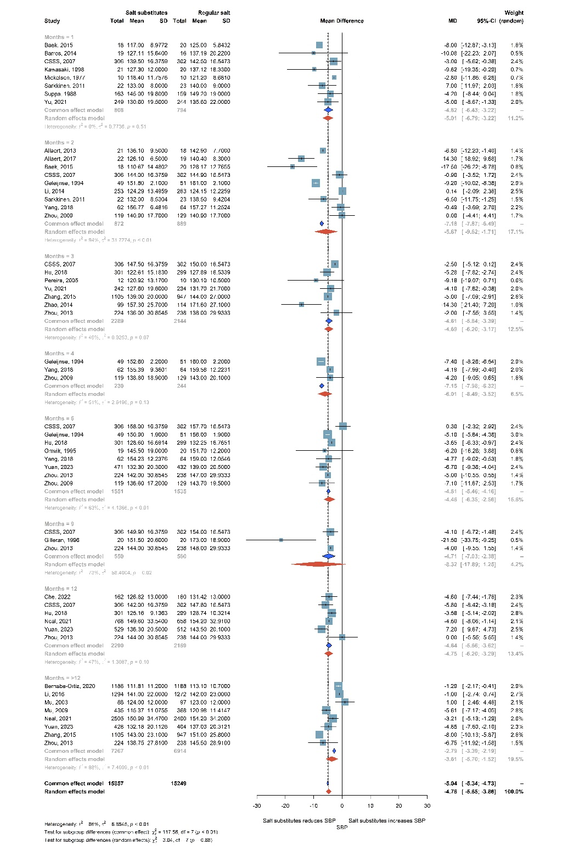

DBP
