Supplementary material
Title: Overdiagnosis of gestational diabetes mellitus during Ramadan: a retrospective population-based study in Catalonia, Spain
Short running title: Overdiagnosis of GDM during Ramadan.
Authors:
Marta Carrasco, MD; Bogdan Vlacho, PharmD, MSc, PhD; Josep Franch-Nadal, MD, PhD ; Jordi Real, PhD ; Gabriela Monroy, MD, PhD ; Berta Soldevila, MD, PhD ; Dídac Mauricio, MD, PhD; Marta Hernández, MD, PhD

Title | Page
Additional File 1: Fig. S1. Flow-chart of participant selection and allocation | 2
Additional File 2: Table 1: Number of episodes per year of control and MMC groups post-matching. | 3
Additional File 3: Table 2: Distribution of subjects in Muslim majority countries | 4
Additional File 4: Table 3. Baseline characteristics of the study before matching | 5
Additional File 5: Table 4. Differences in blood glucose values during the 50g glucose loading test and 100g-OGTT (mg/dl) between study groups during and outside the Ramadan period, among women with more than one pregnancy who underwent screening in both periods. | 6
Additional File 6: Table 5. Sensitivity analysis: adjusted Odds Ratios for gestational diabetes according to different definitions. | 7

Additional File 1: Fig. S1: Study flow-chart
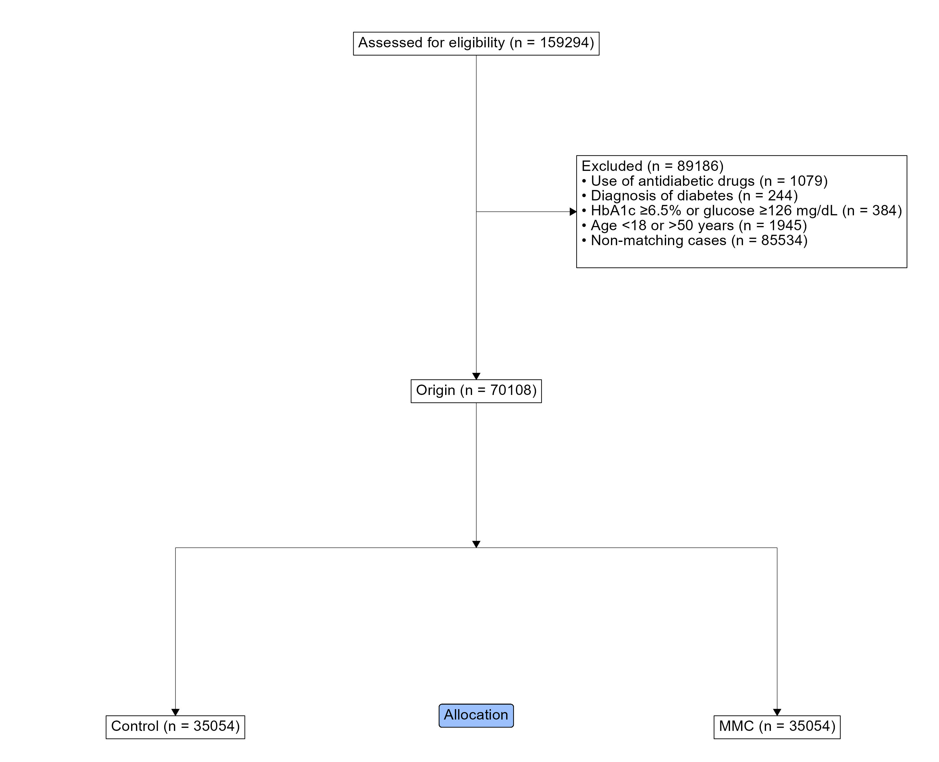

Additional File 2: Table 1: Number of episodes per year of control and MMC groups post-matching.
 | MMC group, n (%) | Control group, n (%)
 | n = 35,054 | n = 35,054
2010 | 3,813 (10.9) | 3,813 (10.9)
2011 | 3,869 (11.0) | 3,869 (11.0)
2012 | 3,745 (10.7) | 3,745 (10.7)
2013 | 3,557 (10.1) | 3,557 (10.1)
2014 | 3,625 (10.3) | 3,625 (10.3)
2015 | 3,672 (10.5) | 3,672 (10.5)
2016 | 3,554 (10.1) | 3,554 (10.1)
2017 | 3,809 (10.9) | 3,809 (10.9)
2018 | 3,486 (9.94) | 3,486 (9.94)
2019 | 1,924 (5.49) | 1,924 (5.49)
MMC-group, a group of women from Muslim-majority countries.

Additional File 3: Table 2: Distribution of subjects in Muslim majority countries
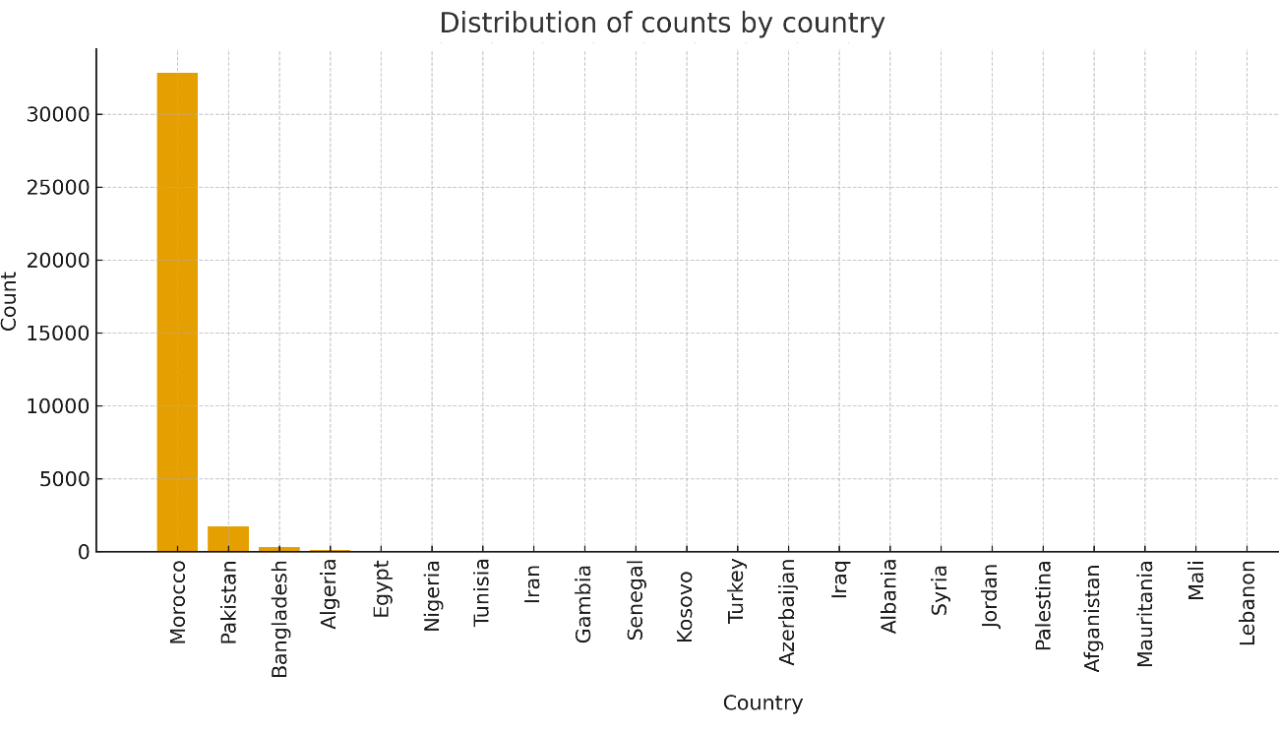

Additional File 4: Table 3. Baseline characteristics of the study subjects stratifying during and outside of the Ramadan period

 | Control group |  |  | MMC group
 | Outside the Ramadan | During Ramadan | p-value | Outside the Ramadan | During Ramadan | p-value
 | N=30997 | N=4057 |  | N=31353 | N=3701
Age, Mean (±SD) | 30.1 (5.67) | 30.1 (5.73) | 0.955 | 30.1 (5.69) | 30.1 (5.61) | 0.693
BMI, kg/m², mean (±SD) | 26.3 (4.79) | 26.0 (4.82) | <0.001 | 27.4 (4.44) | 27.1 (4.39) | <0.001
Systolic blood pressure, mmHg, mean (±SD) | 114 (11.9) | 112 (11.9) | <0.001 | 114 (12.4) | 112 (12.1) | <0.001
Diastolic blood pressure, mmHg, mean (±SD) | 68.0 (8.46) | 67.4 (8.53) | <0.001 | 67.8 (8.39) | 67.3 (8.44) | 0.001
QMEDEA, N (%): |  |  | 0.858 |  |  | 0.691
Missing | 8835 (28.5) | 1141 (28.1) |  | 5724 (18.3) | 703 (19.0)
Q1 | 2631 (8.49) | 345 (8.50) |  | 1630 (5.20) | 175 (4.73)
Q2 | 4016 (13.0) | 538 (13.3) |  | 3287 (10.5) | 372 (10.1)
Q3 | 4495 (14.5) | 600 (14.8) |  | 3723 (11.9) | 437 (11.8)
Q4 | 5065 (16.3) | 681 (16.8) |  | 6053 (19.3) | 715 (19.3)
Q5 | 5955 (19.2) | 752 (18.5) |  | 10936 (34.9) | 1299 (35.1)
Number of pregnancies, mean (±SD) | 1.50 (0.69) | 1.50 (0.68) | 0.860 | 2.19 (0.93) | 2.19 (0.93) | 0.910
BMI: body mass index; SD: standard deviation; MMC: Muslim majority country; QMEDEA: deprivation index (Q1: least deprived quintile; Q5: most deprived quintile)
Additional File 5: Table 4. Differences in blood glucose values during the 50g glucose loading test and 100g-OGTT (mg/dL) between study groups during and outside the Ramadan period, among women with more than one pregnancy who underwent screening in both periods.

 | MMC-group | Control group | p-value overall
50-g GLT | 15.7 (38.6) | 3.86 (31.4) | <0.001
Fasting 100-g OGTT | 2.05 (13.5) | -3.13 (10.6) | 0.034
1 hour100-g OGTT | 13.5 (45.0) | 0.83 (39.9) | 0.058
2-hour 100-g OGTT | 18.0 (47.6) | 16.7 (44.6) | 0.878
3-hour 100-g OGTT | 11.8 (40.4) | 5.17 (36.7) | 0.352
MMC-group: a group of women from Muslim-majority countries. 50-g GLT: 1-hour 50-g glucose loading test. 100-g OGTT: 3 h our100-g oral glucose tolerance test. The values are means (SD) unless otherwise indicated.

Additional File 6: Table 5. Sensitivity analysis: adjusted Odds Ratios for gestational diabetes according to different definitions

Variable | OR¹ | 95%CI¹ | p² | OR² | 95%CI² | p²
Interaction:  Ramadan Period × Group MMC | 1.71 | 1.37-2.12 | <0.001 | 1.27 | 1.03-1.57 | 0.024
Main effect:  Ramadan period | 1.10 | 0.93-1.31 | 0.267 | 0.99 | 0.84-1.18 | 0.938
Main effect:  Group MMC | 1.68 | 1.55-1.81 | <0.001 | 1.66 | 1.55-1.79 | <0.001
Observations | 70,108 |  |  | 70,108
¹Outcome: Gestational diabetes according the diagnostic codes; ^{2:} Outcome: Gestational diabetes according the glucose load; OR: odds ratios

