Additional file 1
Statistical approaches to analyse the combined effect of seven air pollutants and breast cancer risk in the French E3N-Generations cohort
Camille Giampiccolo^{a,b,c,#},Béatrice Fervers^{a,b,#}, Thomas Coudon^{a,b}, Delphine Praud^{a,b}, Arnaud Vigneron^{d}, Lény Grassot^{a,b}, Benoît Mercoeur ^{a,b}, Elodie Faure^{e}, Pauline Frenoy^{e}, Maximilien Génard-Walton^{f}, Florian Couvidat^{g}, Gianluca Severi^{e,h}, Francesca Romana Mancini^{e}, Pascal Roy^{c,i,j}, Amina Amadou^{a,b,*}
ª Department of Prevention Cancer Environnent, Centre Léon Bérard, Lyon, France
^{b} Inserm U1296 Radiations : Défense, Santé, Environnement, Lyon, France
^{c} Laboratoire de Biométrie Et Biologie Evolutive, CNRS UMR 5558, Villeurbanne, France
^{d} Centre de Recherche en Cancérologie de Lyon, INSERM U1052-CNRS UMR5286
^{e} Centre de Recherche en Epidémiologie et Santé des Populations (CESP, Inserm U1018), Facultés de Médecine, Université Paris-Saclay, UPS UVSQ, Gustave Roussy, Villejuif, France
^{f} Université Grenoble Alpes, Inserm, CNRS, IAB, Site Santé, Allée des Alpes, 38700, La Tronche, France
^{g} National Institute for industrial Environment and Risks (INERIS), Verneuil-en-Halatte, France
^{h} Department of Statistics, Computer Science and Applications (DISIA), University of Florence, Italy
^{i} Service de Biostatistique-Bioinformatique, Pôle Santé Publique, Hospices Civils de Lyon, Lyon, France
^{j} Université Claude Bernard Lyon 1, Lyon, France

#These two authors share first authorship
* Corresponding author
Amina Amadou
Département Prévention Cancer Environnement, Centre Léon Bérard
Inserm U1296 Radiations : Défense, Santé, Environnement
28 rue Laënnec, 69373 Lyon Cedex 08, France
E-mail: amina.amadou@lyon.unicancer.fr
Table of contents
Table S1: Demographic and lifestyle characteristics of BC cases and their matched controls in the case-control study.
Table S2: Descriptive statistics of exposure concentrations to BaP, cadmium, dioxins, PCB153, NO₂, PM₁₀ and PM_{2.5.}
Table S3: Posterior inclusion probabilities (PIPs) from the BKMR model with hierarchical variable selection.
Table S4: Mixture component weights from a quantile g-computation model of the joint effect of air pollutant mixture.
Table S5: Association between BC risk and air pollutant mixture, using QGC model, from sensitivity analysis.
Table S6: Mixture component weights from a quantile g-computation model of the joint effect of air pollutant mixture from sensitivity analysis.
Figure S1: Flow chart of the selection of subjects in the case-control study nested within the E3N-generations cohort, France, 1990-2011.
Figure S2: Directed acyclic graph of identified confounders.
Figure S3: Average annual evolution of hourly BaP, cadmium, dioxins, PCB153, NO₂, PM₁₀ and PM_{2.5} atmospheric concentrations (mean) at the addresses of the study subjects by year, from 1990 to 2011.
Figure S4: Pearson’s correlation matrix between the average of the annual mean concentrations (1990-2011) for each of the seven pollutants (BaP, dioxins, cadmium, PCB153, NO₂, PM₁₀, PM_{2.5}).
Figure S5: Estimated effect (with 95% credible intervals) of air pollutant exposures (excluding PM₁₀) on BC risk assessed by BKMR model.
Figure S6: Exposure–response plots (95% credible intervals) for associations between BC outcome and concentrations of individual air pollutant when the other air pollutants were fixed at their median concentrations, for all women and in subgroups, assessed by BKMR model.
Figure S7: Bivariate exposure-response plots for BC outcome and concentrations of individual air pollutants when a second pollutant is fixed at its 10th, 50th, or 90th percentile and the other air pollutants are fixed at their medians.
Table S1: Demographic and lifestyle characteristics of BC cases and their matched controls in the case-control study
Characteristics | Cases (5222) |  | Controls (5222) | P-value
Body mass index (kg/m²), n (%)  < 25  [25-30[  ≥ 30 | 4329 (82.9)  744 (14.2)  149 (2.9) |  | 4345 (83.2)  715 (13.7)  162(3.1) | >0.05
Age at inclusion (years), mean ± SD | 49.6 ± 6.3 |  | 49.5 ± 6.3 | 0.002
Age at diagnosis (years), mean ± SD | 60.6 ± 8.1
Smoking status, n (%)  Non-smokers  Current smokers  Ex-smokers | 2815 (53.9)  781 (15.0)  1626 (31.1) |  | 2876 (55.1)  743 (14.2)  1603 (30.7) | >0.05
Alcohol consumption (g/day), n (%)  0  0-6.7  >6.7  Missing | 402 (7.7)  1291 (24.7)  2002 (38.4)  1527 (29.3) |  | 473 (9.0)  1391 (26.6)  1865 (35.7)  1493 (28.6) | 0.001
Urban-rural status at birth, n (%)  Rural  Urban  Missing | 1378 (26.4)  3261 (62.4)  583 (11.2) |  | 1429 (27.4)  3190 (61.1)  603 (11.5) | >0.05
Physical activity (METs-h/week), n (%)  < 25.3  25.3-35.6  35.6-51.8  ≥51.8 | 1304 (25.0)  1390 (26.6)  1341 (25.7)  1187 (22.7) |  | 1229 (23.5)  1359 (26.0)  1335 (25.6)  1299 (24.9) | 0.007
Level of education, n (%)  Secondary  1- to 2-year university degree  ≥ 3-year university degree | 802 (15.4)  2497 (47.8)  1923 (36.8) |  | 874 (16.7)  2621 (50.2)  1727 (33.1) | <0.001
Menopausal status at inclusion, n (%)  Premenopausal  Postmenopausal | 3131 (60.0)  2091 (40.0) |  | 3144 (60.2)  2078 (39.8) | >0.05
Menopausal status at index date, n (%)  Premenopausal  Postmenopausal | 874 (16.7)  4348 (83.3) |  | 806 (15.4)  4416 (84.6) | 0.002
Use of oral contraceptives, n (%)  No  Yes | 2147 (41.1)  3075 (58.9) |  | 2158 (41.3)  3064 (58.7) | >0.05
Use of menopausal hormone therapy, n (%)  No  Yes  Missing | 2049 (39.2)  3064 (58.7)  109 (2.1) |  | 2195 (42.0)  2913 (55.8)  114 (2.2) | <0.001
Age at menarche (years), n (%)  <12  12-14  ≥14 | 1098 (21.0)  2704 (51.8)  1420 (27.2) |  | 1050 (20.1)  2702 (51.7)  1470 (28.2) | >0.05
Age at first pregnancy (years), n (%)  Nulliparous  < 30 years  ≥ 30 years | 674 (12.9)  3867 (74.1)  681 (13.0) |  | 562 (10.8)  4101 (78.5)  559 (10.7) | >0.05
Parity, n (%)  0  1 à 2  ≥ 3 | 674 (12.9)  3198 (61.2)  1350 (25.9) |  | 562 (10.8)  3101 (59.4)  1559 (29.9) | <0.001
Breastfeeding, n (%)  No  Yes | 2383 (45.6)  2839 (54.4) |  | 2373 (45.4)  2849 (54.6) | >0.05
Family history of cancer, n (%)  No  Yes | 4336 (83.0)  886 (17.0) |  | 4667 (89.4)  555 (10.6) | <0.001
P value comparing the distribution of the baseline characteristics of the study according to cases and controls: conditional logistic regression models at the threshold of 5%; SD: standard deviation, MET: Metabolic Equivalent of Task, Menopausal status at index date: date of diagnosis of the case in the case-control pair. N: numbers; %: percentage.

Table S2: Descriptive statistics of exposure concentrations to BaP, cadmium, dioxins, PCB153, NO₂, PM₁₀ and PM_{2.5}
 | min | mean | sd | max
BaP | 0.04 | 0.19 | 0.11 | 1.84
cadmium | 36.53 | 157.32 | 112.45 | 2163.44
dioxins | 1.19 | 9.95 | 8.47 | 227.7
NO2 | 1.12 | 13.12 | 9.24 | 40.28
PCB153 | 1.88 | 9.81 | 4.09 | 33.28
PM10 | 7.78 | 21.51 | 6.17 | 45.08
PM2.5 | 6.71 | 18.94 | 5.92 | 41.87
BaP: benzo[a]pyrene (ng/m³); cadmium: (pg/m³); dioxins: (fg-TEQ/m³); PCB153: polychlorinated biphenyl 153 (pg/m³); NO₂: nitrogen dioxide (µg/m³); PM₁₀: particulate matter ≤10 µm (µg/m³); PM₂.₅: particulate matter ≤2.5 µm (µg/m³); min: minimum; sd: standard deviation; max: maximum.

Table S3: Posterior inclusion probabilities (PIPs) from the BKMR model with hierarchical variable selection.
Pollutant | Group | GroupPIP | CondPIP
BaP | 1 | 0.19 | 1.00
Cadmium | 2 | 0.07 | 0.75
Dioxin | 2 | 0.07 | 0.25
PCB153 | 3 | 0.73 | 0.15
NO2 | 3 | 0.73 | 0.49
PM10 | 3 | 0.73 | 0.16
PM25 | 3 | 0.73 | 0.20
GroupPIP: posterior probability that at least one pollutant within the group is associated with breast cancer risk; condPIP: relative importance of each pollutant within its group; BaP: benzo[a]pyrene; PCB153: polychlorinated biphenyl 153; NO₂: nitrogen dioxide; PM₁₀: particulate matter ≤10 µm; PM₂.₅: particulate matter ≤2.5 µm.

Table S4: Mixture component weights from a quantile g-computation model of the joint effect of air pollutant mixture
Weight | BaP | Cadmium | Dioxins | NO₂ | PCB153 | PM₁₀ | PM_{2.5}
Overall
Pos weight | 0.07 | 0.30 | 0.12 | 0.29 | 0.21 | x | x
Neg weight | x | x | x | x | x | 0.09 | 0.91
Premenopausal at inclusion and at index date
Pos weight | x | 0.24 | 0.17 | x | x | 0.57 | 0.01
Neg weight | 0.16 | x | x | 0.63 | 0.21 | x | x
Premenopausal at inclusion and postmenopausal at index
Pos weight | x | 0.44 | x | 0.40 | 0.16 | x | x
Neg weight | 0.14 | x | 0.19 | x | x | 0.65 | 0.03
Postmenopausal at inclusion and index date
Pos weight | 0.20 | x | 0.10 | 0.63 | 0.06 | x | x
Neg weight | x | 0.19 | x | x | x | 0.41 | 0.41
ER -
Pos weight | x | 0.41 | 0.54 | 0.02 | x | x | 0.03
Neg weight | 0.03 | x | x | x | 0.11 | 0.86 | x
ER +
Pos weight | 0.02 | 0.19 | x | 0.52 | 0.27 | x | x
Neg weight | x | x | 0.48 | x | x | 0.49 | 0.03
Weights in a given direction (positive or negative) sum to 1, and thus the size of each weight is relative to others acting in the same direction, not across directions.
QGC: quantile G computation; Pos weight: positive weight; Neg weight: negative weight; ER: hormone receptor status; BaP: benzo[a]pyrene; PCB153: polychlorinated biphenyl 153; NO₂: nitrogen dioxide; PM₁₀: particulate matter ≤10 µm; PM₂.₅: particulate matter ≤2.5 µm.

Table S5: Association between BC risk and air pollutant mixture, using QGC model, from sensitivity analysis
 | Matched cases/controls (n) |  | OR (95% CI)
Overall |  | 5,222/5,222 | 1.13 (1.04 -1.22)
Model was adjusted for physical activity, alcohol intake, BMI, smoking status, menopausal hormone treatment, municipality status at birthplace, municipality status at inclusion (rural, urban), breastfeeding, oral contraceptive use, parity and AFP, and mammography screening.
AFP: age at first full-term pregnancy; BC: breast cancer; QGC: quantile G computation; OR: odds ratio, CI: confidence interval;

Table S6: Mixture component weights from a quantile g-computation model of the joint effect of air pollutant mixture from sensitivity analysis
Weight | Cadmium | NO₂ | PCB153 | Dioxin | BaP | PM_{2.5}
Positive weight | 0.31 | 0.30 | 0.19 | 0.12 | 0.08 | x
Negative weight | x | x | x | x | x | 1
Weights in a given direction (positive or negative) sum to 1, and thus the size of each weight is relative to others acting in the same direction, not across directions.
BaP: benzo[a]pyrene; PCB153: polychlorinated biphenyl 153; NO₂: nitrogen dioxide; PM₁₀: particulate matter ≤10 µm; PM₂.₅: particulate matter ≤2.5 µm.

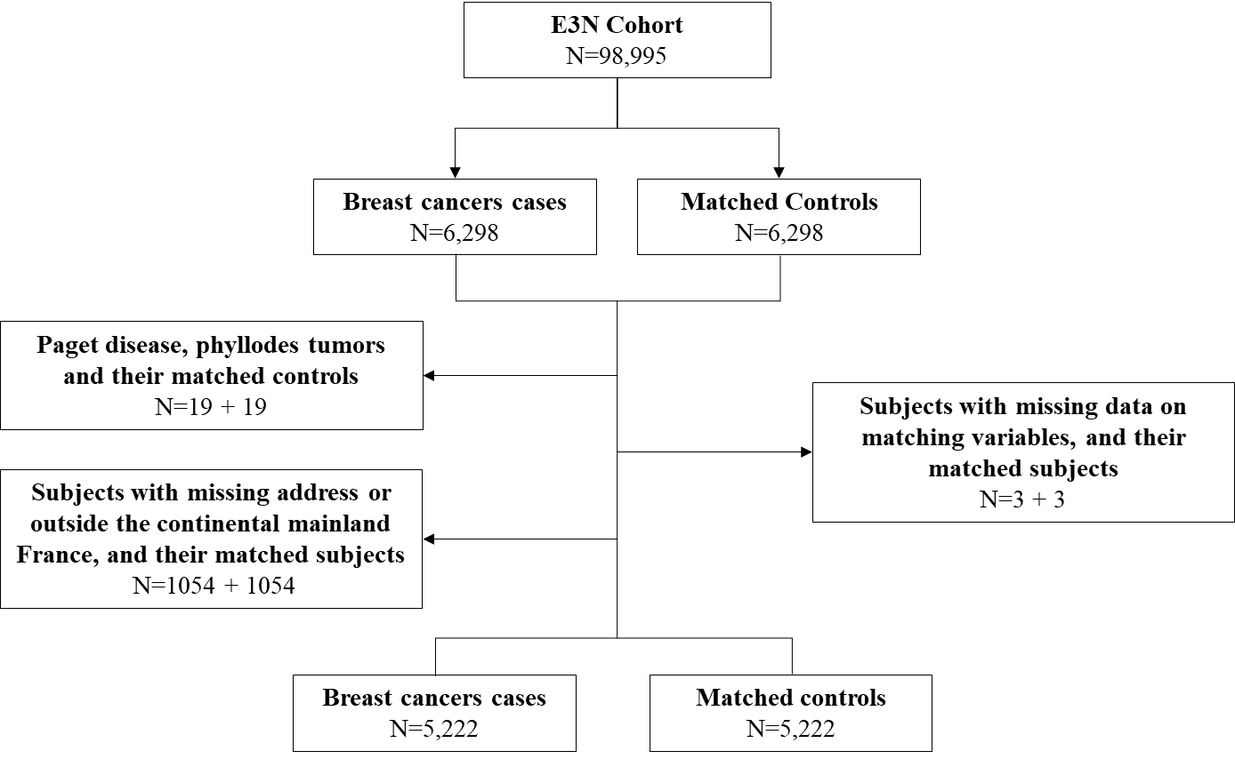
Figure S1: Flow chart of the selection of subjects in the case-control study nested within the E3N-generations cohort, France, 1990-2011

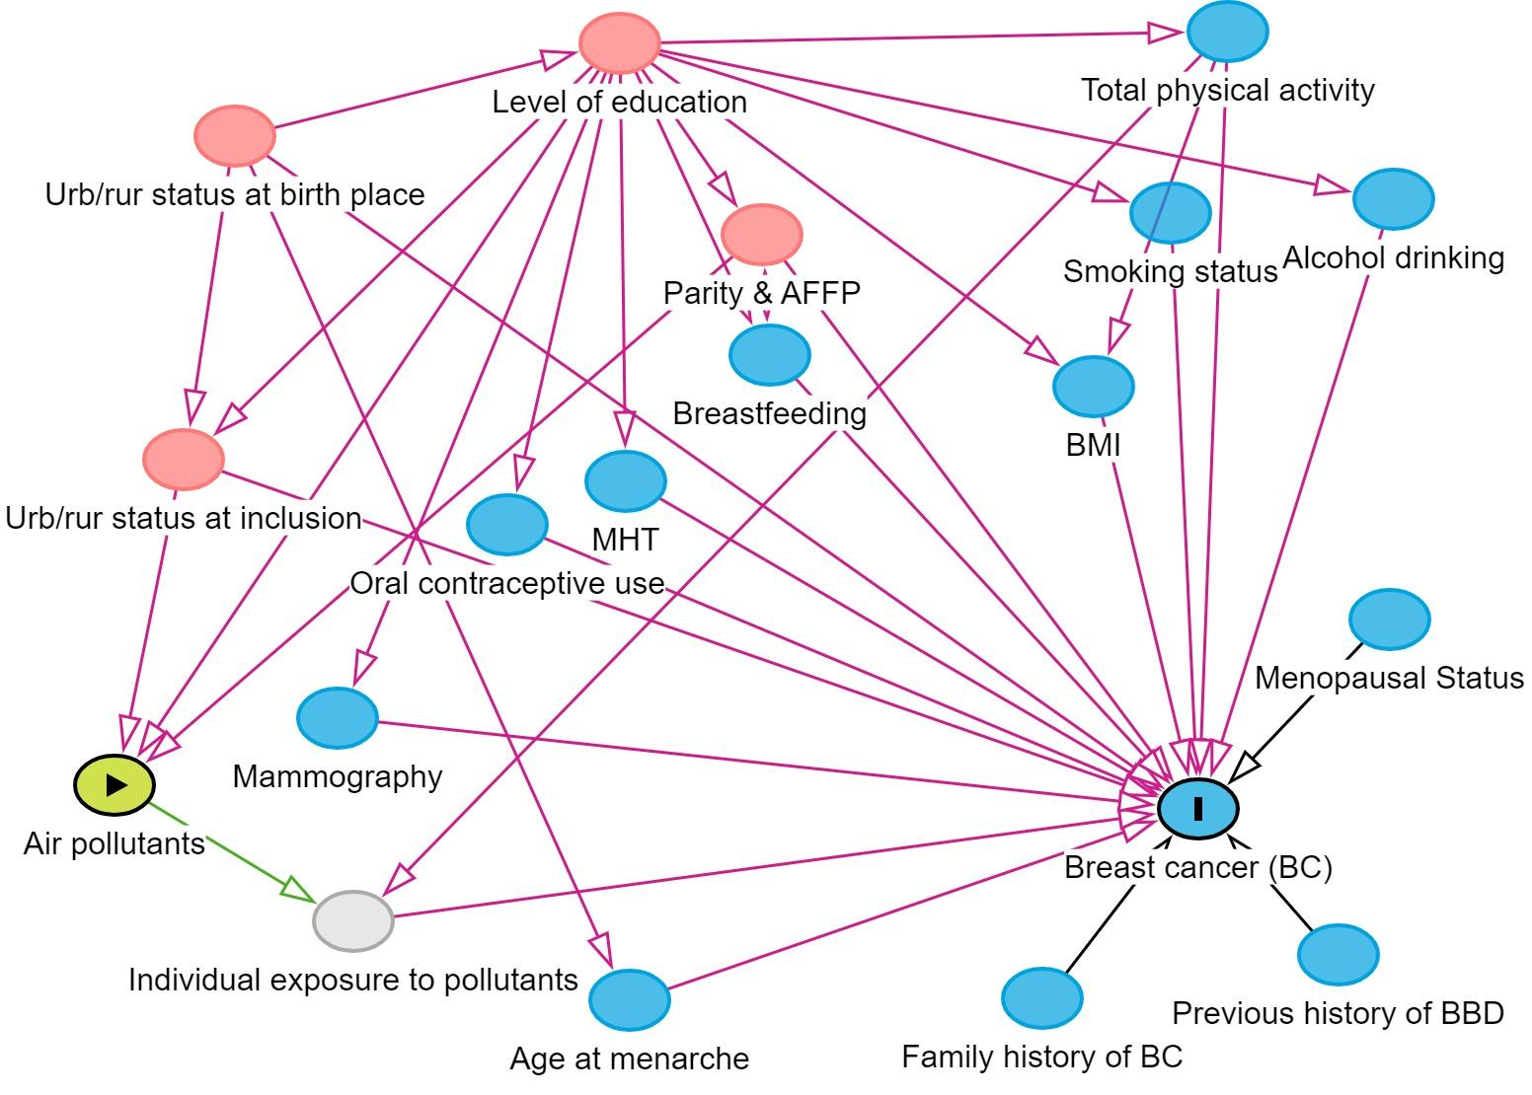
.
Figure S2: Directed acyclic graph of identified confounders
Two minimal sufficient adjustment sets of variables have been proposed. The first includes physical activity (<25.3, 25.3-35.5, 35.6-51.8, and ≥ 51.8 METs-h/week), alcohol intake (0, 1-6.7, > 6.7 g/day), body mass index (BMI) (<25, 25-<30, and ≥30 kg/m2), breastfeeding (ever, never), oral contraceptive use (ever, never), menopausal hormone treatment (ever, never), status of birthplace (rural, urban), status of inclusion (rural, urban), smoking status (never, current, and former), parity and age at first full-term pregnancy (AFP) (0, 1-2 children & AFP < 30 years, 1-2 children & AFP ≥ 30 years, and 3 children), and mammography screening (yes, no). The second includes the level of education, considered as a proxy of socio-economic status.

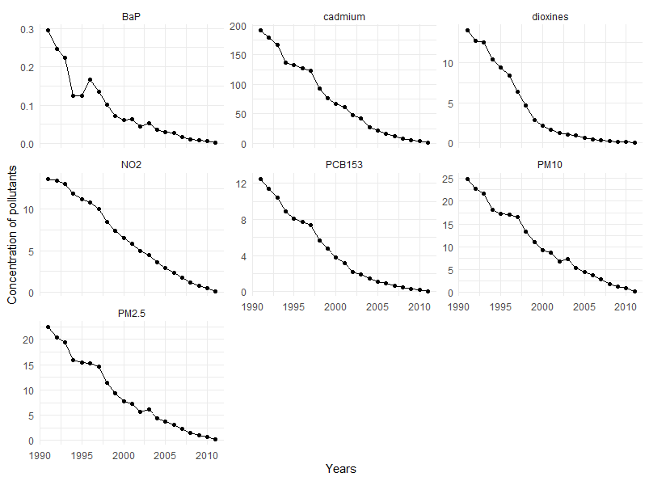

Figure S3: Average annual evolution of hourly BaP, cadmium, dioxins, PCB153, NO₂, PM₁₀ and PM_{2.5} atmospheric concentrations (mean) at the addresses of the study subjects by year, from 1990 to 2011.
BaP: benzo[a]pyrene; PCB153: polychlorinated biphenyl 153; NO₂: nitrogen dioxide; PM₁₀: particulate matter ≤10 µm; PM₂.₅: particulate matter ≤2.5 µm.

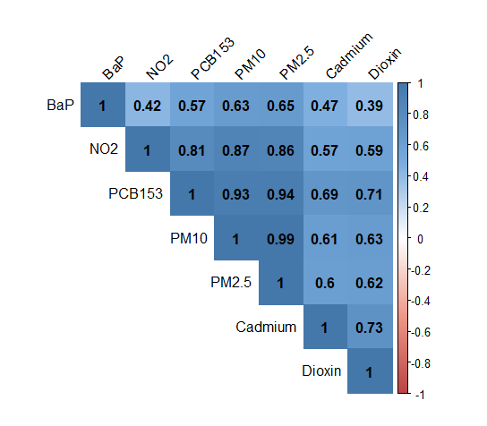
Figure S4: Pearson’s correlation matrix between the average of the annual mean concentrations (1990-2011) for each of the seven pollutants (BaP, dioxins, cadmium, PCB153, NO₂, PM₁₀, PM_{2.5}).
BaP: benzo[a]pyrene; PCB153: polychlorinated biphenyl 153; NO₂: nitrogen dioxide; PM₁₀: particulate matter ≤10 µm; PM₂.₅: particulate matter ≤2.5 µm.

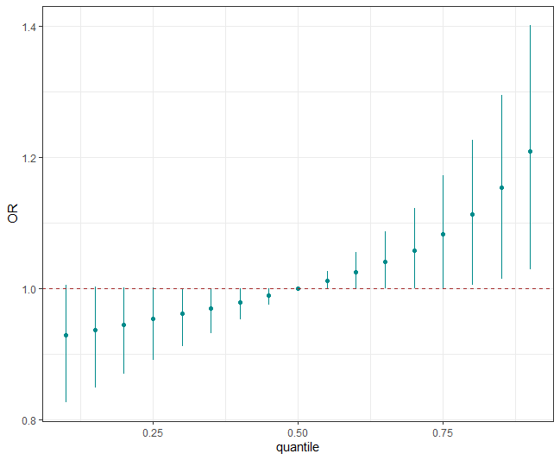
Figure S5: Estimated effect (with 95% credible intervals) of air pollutant exposures (excluding PM₁₀) on BC risk assessed by BKMR model.
Estimates represent the OR in each outcome when all air pollutant concentrations are at one percentile compared with the outcome when all air pollutant concentrations are at the 50th percentile. Model was adjusted for physical activity, alcohol intake, BMI, smoking status, menopausal hormone treatment, status of birthplace, municipality status at inclusion (rural, urban), breastfeeding, oral contraceptive use, parity and AFP, and mammography screening. Note: BC, breast cancer; BMI, body mass index; BKMR, Bayesian kernel machine regression; AFP, age at first full-term pregnancy.

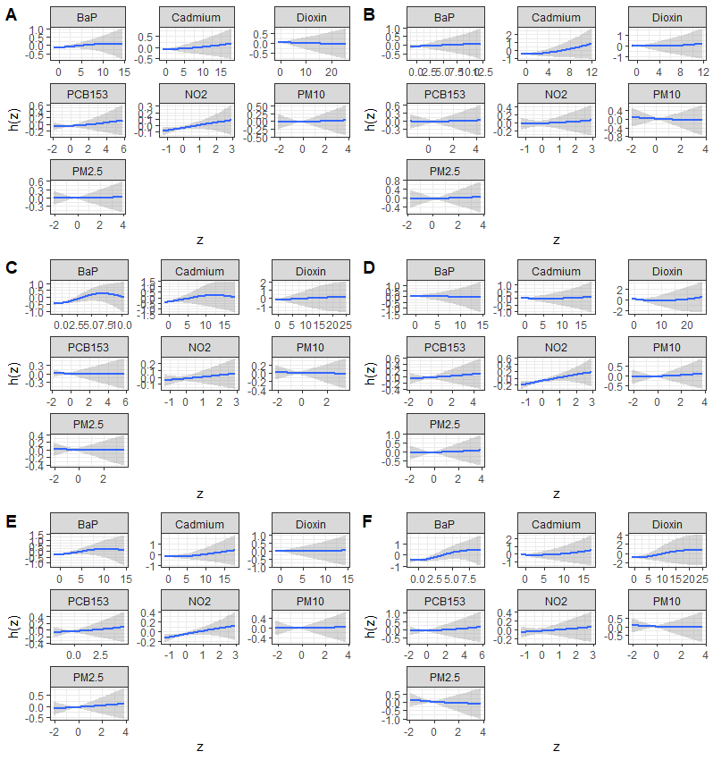
Figure S6: Exposure–response plots (95% credible intervals) for associations between BC outcome and concentrations of individual air pollutant when the other air pollutants were fixed at their median concentrations, for all women and in subgroups, assessed by BKMR model.
(A) All women; (B) pre-menopausal women; (C) women in menopausal transition (D) post-menopausal women (E) ER+ breast tumors (F) ER- breast tumors. All models were adjusted for physical, alcohol intake, BMI, smoking status, menopausal hormone treatment, status of birthplace, status of inclusion (rural, urban), breastfeeding, oral contraceptive use, parity and AFP, and mammography screening. AFP: age at first full-term pregnancy; BC, breast cancer; BMI, body mass index; BKMR, Bayesian kernel machine regression; BMI, body mass index; AFP, age at first full-term pregnancy; BaP: benzo[a]pyrene; PCB153: polychlorinated biphenyl 153; NO₂: nitrogen dioxide; PM₁₀: particulate matter ≤10 µm; PM₂.₅: particulate matter ≤2.5 µm.

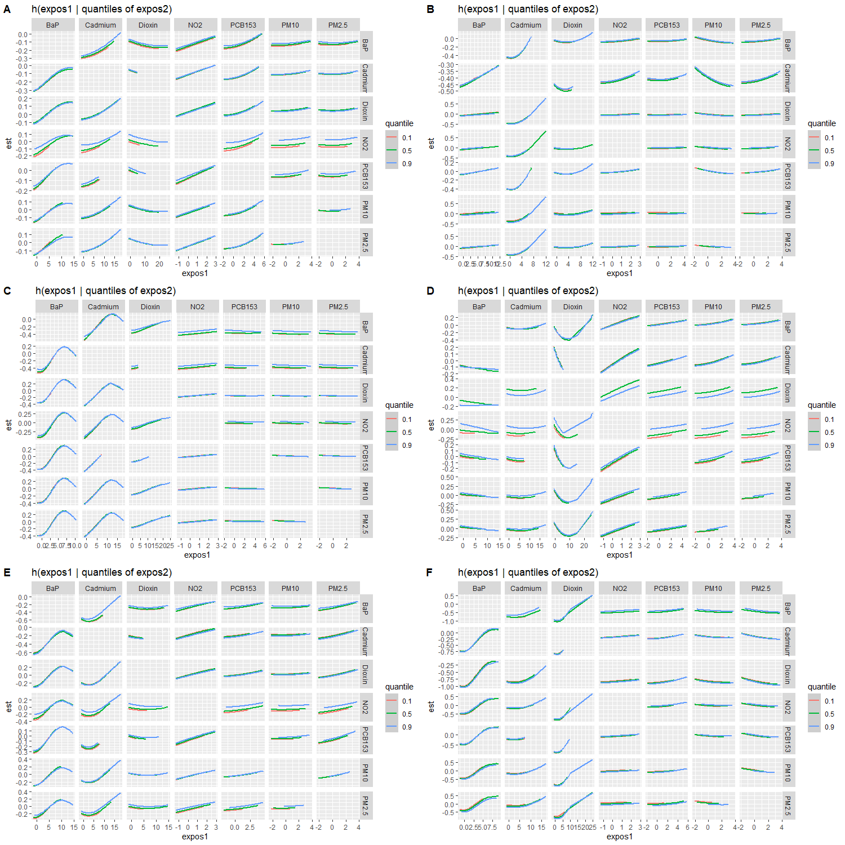
Figure S7: Bivariate exposure-response plots for BC outcome and concentrations of individual air pollutants when a second pollutant is fixed at its 10th, 50th, or 90th percentile and the other air pollutants are fixed at their medians.
(A) All women; (B) pre-menopausal women; (C) women in menopausal transition (D) post-menopausal women (E) ER+ breast tumors (F) ER- breast tumors. All models were adjusted for physical activity, alcohol intake, BMI, smoking status, menopausal hormone treatment, status of birthplace, status of inclusion (rural, urban), breastfeeding, oral contraceptive use, parity and AFP, and mammography screening. BC: breast cancer; BMI: body mass index; BKMR: Bayesian kernel machine regression; BMI: body mass index; AFP: age at first full-term pregnancy; BaP: benzo[a]pyrene; PCB153: polychlorinated biphenyl 153; NO₂: nitrogen dioxide; PM₁₀: particulate matter ≤10 µm; PM₂.₅: particulate matter ≤2.5 µm.
The name of the pollutants associated with the dose-response relationship is located at the top of each panel. The names of the pollutants set at three thresholds (10th, 50th, and 90th percentiles) are indicated on the right side of each panel.

