A neuroimaging biomarker for disease staging in clinically diagnosed
Alzheimer’s disease
S01. Supplementary data description 1
ADNI dataset 2
EDSD dataset 3
MCADI dataset (In-house dataset 1) 3
NACC dataset 9
In-house dataset 9
S02. Image Preprocessing 10
S03. Supplementary Methods 11
S04. Overlap regions in AD and MCI 13
S05 BAS Distribution Across Populations and Diagnostic Capability 14
S06 Determination of the optimal number of disease stages 16
S07 Longitudinal progression risk across disease stages in MCI subgroups. 17
S08 Sensitivity analysis. 18
S09 Reproducibility of individualized AD stages in two independent datasets. 21

S01. Supplementary data description
A total of 7491 MRI examinations were included in five independent cohorts: the Alzheimer’s Disease Neuroimaging Initiative (ADNI) (N = 1654), European DTI Study on Dementia (EDSD) (N = 561), Multi-Center Alzheimer Disease Imaging Consortium Dataset (MCADI) (N = 1034), National Alzheimer’s Coordinating Center (NACC) (N = 3995), and in-house dataset (N = 145). The MCADI and EDSD dataset were used to train a pseudo-healthy image synthesis method. The ADNI cohort served as a discovery dataset. The NACC cohort and an in-house Xuanwu dataset served as validated datasets.
Table S1. Detailed information about the subjects of four independent cohorts.
 | MCADI | EDSD | ADNI | NACC | In-house Dataset
Number of subjects | 1034 | 561 | 1654 | 3995 | 145
Age | 67.55±3.61 | 70.78±3.10 | 73.46±2.75 | 68.45±8.20 | 62.88±9.12
Gender (M/F) | 439/595 | 267/294 | 881/773 | 1626/2369 | 84/61
Education | 8.64±5.50 | - | 16.02±2.78 | 16.80±4.52 | -
Diagnosis at baseline
CN | 335 | 224 | 605 | 2617 | 0
MCI | 300 | 180 | 767 | 185 | 41
AD | 399 | 157 | 283 | 908 | 114
VaD | - | - | - | 82 | -
LBD | - | - | - | 83 | -
FTLD | - | - | - | 120 | -
MMSE | 22.99±5.54 | 25.76±3.70 | 27.36±2.40 | 28.96±1.36 | 18.15±6.62
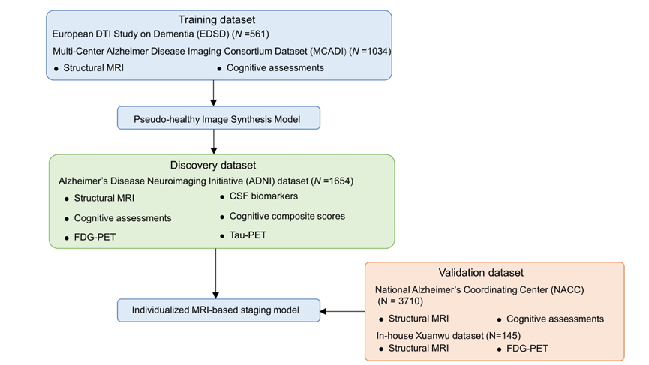
Fig. S1. Overview of the study cohorts.

ADNI dataset
The Alzheimer’s Disease Neuroimaging Initiative (ADNI) was launched in 2003 as a public-private partnership and is a longitudinal natural history study whose primary purpose is to inform the design of therapeutic trials in AD. Additional information about the ADNI dataset is available at http://adni.loni.usc.edu/wp-content/uploads/how_to_apply/ADNI_Acknowledgement_List.pdf. The clinical information (https://ida.loni.usc.edu/pages/access/studyData.jsp) at baseline was used in this study. Briefly, the CN participants were required to meet the following inclusion criteria: 1) no memory complaints; 2) normal memory documented by scoring below education-adjusted cutoffs on the Logical Memory II subscale from the Wechsler Memory Scale-Revised; 3) MMSE score between 24 and 30 points inclusive (exceptions may be made for participants with less than 8 years of education at the discretion of the project director); and 4) Clinical Dementia Rating = 0. The memory box score must be at least 0. Inclusion criteria for participants with MCI in the ADNI dataset were as follows: 1) participants must express a subjective memory concern; 2) abnormal memory function was documented by scoring below education-adjusted cutoffs on the Logical Memory II subscale (Delayed Paragraph Recall, Paragraph A only) from the Wechsler Memory Scale-Revised; 3) MMSE score between 24 and 30 points inclusive (exceptions may be made for participants with less than 8 years of education at the discretion of the project director); 4) CDR = 0.5 and The memory box score must be at least 0.5; 5) general cognition and functional performance must be sufficiently preserved such that a diagnosis of AD cannot be made by the site physician at the time of the screening visit. Inclusion criteria for patients with AD in the ADNI dataset were as follows: 1) participants must express a subjective memory concern; 2) abnormal memory function documented by scoring below education-adjusted cutoffs on the Logical Memory II subscale (Delayed Paragraph Recall, Paragraph A only) from the Wechsler Memory Scale-Revised; 3) MMSE score between 20 and 24 points inclusive (exceptions for scores of 24 and 25 may be made for participants with less than 8 years of education at the discretion of the project director); 4) CDR = 0.5 or 1.0; and 5) NINCDS/ADRDA criteria for probable AD.
The exclusion criteria for the ADNI dataset mainly included the following: 1) any significant neurological disease other than AD; 2) screening/baseline MRI brain scan with evidence of infection, infarction, or other focal lesions or multiple lacunes or lacunes in a critical memory structure; 3) subjects who had any contraindications for MRI studies, including the presence of cardiac pacemakers, metal fragments or foreign objects in the eyes, skin or body; and 4) major depression or bipolar disorder as described in DSM-IV within the past 1 year, including psychotic features, agitation, or behavioral problems within the last 3 months could lead to difficulty complying with the protocol. The completed inclusion and exclusion criteria are described in the Clinical Protocols in ADNI (adni.loni.usc.edu/methods/documents/).
In this study, there are two parts of the ADNI datasets: one is the baseline MRI scans, which included 283 AD, 767 MCI, and 605 cognitively normal (CN) individuals to capture the individualized brain atrophy patterns and define the stages of AD, and the other is longitudinal MRI data of MCI patients over three years (N = 253).

EDSD dataset
The European DTI Study on Dementia (EDSD) is a multicenter framework, which consists of Amsterdam (Netherlands), Brescia (Italy), Dublin (Ireland), Frankfurt (Germany), Freiburg (Germany), Milano (Italy), Mainz (Germany), Munich (Germany), and Rostock (Germany). The data is publicly available on the Neugrid N4U platform (https://neugrid4you.eu). It is a cross-sectional multisite study characterized by 561 T1-weighted MRI scans (including 224 CNs, 180 MCI, and 157 AD) included in this study after quality control.

MCADI dataset (In-house dataset 1)
The Multi-Center Alzheimer Disease Imaging Consortium Dataset (MCADI) is a multi-center cohort from different data sites around China. Part of the data from this dataset was used in previous studies to evaluate generalizable, reproducible, and neuroscientifically interpretable imaging biomarkers in Alzheimer’s disease (AD). Detailed information, including the ethical permissions and inclusion criteria, can be found elsewhere in previous studies and supplemental material.
PL_G, PL_S, and PL_S2
This study was approved by the Medical Ethics Committee. Written informed consent was given by each enrolled subject or his/her authorized guardian. All participants were recruited by an advertisement (Chinese version). Written consent forms were given by all subjects or their legal guardians under protocols approved by the ethics committee. Before selection for this study, all the participants were given free physical, psychological, and laboratory examinations, and all patients received professional suggestions for further treatment.
All of the subjects were right-handed and underwent a battery of neuropsychological tests, including the Mini-Mental State Examination (MMSE), Auditory Verbal Learning Test (AVLT), Geriatric Depression Scale (GDS), Clinical Dementia Rating (CDR), and Activities of Daily Living (ADL) Scale. The AVLT consists of a learning trial in which a list of 10 Chinese double-character words is read and the subject is asked to immediately recall as many items as possible. The procedure was repeated a total of 3 times with a new set of words each time, and the immediate recall score was the average number of accurate recalls over the 3 times. After a 5-minute delay, each subject was asked to recall the words from the initial list (AVLT-delayed recall). The subjects were then told to identify the 10 studied words, which were intermixed with 10 new words (AVLT recognition).
The recruited AD patients fulfilled the following inclusion criteria: (1) diagnosed using the criteria of the National Institute of Neurological and Communicative Disorders and Stroke and the Alzheimer’s Disease and Related Disorders Association for probable AD; (2) CDR = 1 or 2; (3) currently receiving no nootropic drugs, such as cholinesterase inhibitors; and (4) able to perform the neuropsychological tests and tolerate magnetic resonance (MR) scanning.
The diagnostic criteria for mild cognitive impairment (MCI) were determined as previously described and included the following: (1) memory complaints lasting at least 6 months; (2) CDR = 0.5; (3) intact functional status and ADL <26; and (4) lack of dementia. The criteria for the NCs included the following: (1) normal physical status; (2) CDR = 0; and (3) no memory complaints.
The exclusion criteria for the participants in this study included the following: (1) metabolic conditions, such as hypothyroidism and vitamin B12/folic acid deficiencies; (2) psychiatric disorders, such as schizophrenia and depression; (3) infarction or brain hemorrhaging, as indicated by MR/computed tomography (CT) imaging; and (4) Parkinsonian syndrome, epilepsy, or other nervous system diseases that can influence cognitive function. In addition, patients with a metallic foreign body, such as a cochlear implant, heart stent, or other relevant MR scanning contraindications, were excluded from the study.
MR images for PL_S were acquired on a 3.0 T MR scanner (Siemens Skyra, Siemens, Germany). T1-weighted MR images were acquired using a magnetization-prepared rapid acquisition gradient echo (MP-RAGE) sequence (repetition time (TR) = 2530 ms; echo time (TE) = 3.43 ms; flip angle (FA) = 7°; field of view (FOV) = 256 mm × 256 mm; matrix = 256 × 256; inversion time = 1100 ms; slice thickness = 1 mm, no gap; 192 slices).
MR images for PL_G were acquired on a 3.0 T MR scanner (GE Signa HDx, GE, USA). T1- FSPGR anatomical scans were acquired with the following parameters: TR = 7 ms; TE = 2.9 ms; FA = 8°; FOV = 240 mm × 240 mm; matrix = 256 × 256; inversion time = 450 ms; slice thickness = 1.2 mm, no gap; 166 slices.
Further details are available in previously published studies.
HH_Z
This dataset followed the protocol used in PL_G and PL_S and was approved by the Medical Ethics Committee. The control subjects were recruited from the local community using advertisements. Written informed consent was given by each enrolled subject or his/her authorized guardian. The participants underwent general physical, psychological, and laboratory examinations before enrollment in the formal study. The participants did not take medications that might have influenced their cognition during the scans, and all patients received professional suggestions for further treatment.
MR images were acquired on a 3.0 T MR scanner (Magnetom Trio, Siemens, Germany). T1- weighted MR images were acquired using an MP-RAGE sequence (TR = 2000 ms; TE = 2.3 ms; FA = 9°; FOV = 232 mm × 256 mm; matrix = 232 × 256; inversion time = 900 ms; slice thickness = 1 mm, no gap; 192 slices; one subject with FOV = 222 mm × 208 mm and matrix = 256 × 240; one subject with FOV = 216 mm × 256 mm and matrix = 216 × 256).
QL_W
This dataset followed the protocol used in PL_G and PL_S and was approved by the Medical Ethics Committee. The patients were recruited from the memory clinic. The control subjects were recruited from the local community using advertisements. Written informed consent was given by each enrolled subject or his/her authorized guardian. The participants underwent general physical, psychological, and laboratory examinations before enrollment in the formal study. The participants did not take medications that might have influenced their cognition during the scans, and all patients received professional suggestions for further treatment.
MR images were acquired on a 3.0 T MR scanner (Siemens Verio, Siemens, Germany). T1- weighted MR images were acquired using an MP-RAGE sequence (TR = 1900 or 2000 ms; TE = 2.3 ms; FA = 9°; FOV = 256 mm × 256 mm; matrix = 256 × 256; inversion time = 900 ms; slice thickness = 1 mm, no gap; 176 slices).
XW_H
The study was approved by the Medical Research Ethics Committee and Institutional Review Board (ClinicalTrials.gov identifiers: NCT02353884 and NCT02225964). Some of the data have been used in previous studies, and detailed information can be found elsewhere.
All subjects underwent a series of standardized clinical evaluations, including a medical history interview, a neurological examination, and a battery of neuropsychological tests. The neuropsychological tests included the Chinese version of the MMSE, the Beijing version of the Montreal Cognitive Assessment (MoCA), the CDR Scale, the AVLT, an ADL assessment, the Hachinski Ischemic Scale, the Hamilton Depression Rating (HAMD) Scale, and the Center for Epidemiologic Studies Depression scale. Confirmation of diagnosis for all subjects was made by the consensus of at least two experienced neurologists. The diagnoses were based on the data available from the neuropsychological assessment evaluation, a battery of general neurological examinations, and the subject's symptoms, as well as functional capacity reports.
The inclusion criteria for an MCI diagnosis included the following: (a) memory complaints confirmed by an informant; (b) objectively impaired memory confirmed by neuropsychological tests; (c) a definitive history of cognitive decline; (d) not meeting the criteria for dementia according to the Diagnostic and Statistical Manual of Mental Disorders, Fourth Edition, Revised (DSM-IV-R); and (e) a CDR score of 0.5.
AD subjects were diagnosed according to the National Institute of Aging-Alzheimer’s Association (NIA-AA) criteria for clinically probable AD as follows: (a) meeting the criteria for dementia; (b) insidious and gradual onset (not sudden) over >6 months; (c) definitive history of declining cognition; (d) initial and most prominent cognitive deficits evident in amnestic or non-amnestic performance; and (e) hippocampal atrophy confirmed by structural magnetic resonance imaging (MRI).
The NC subjects were required to meet the following research criteria: (a) no memory concerns; (b) MMSE and MoCA scores within the normal ranges (adjusted for age, sex, and education); and (c) a CDR score of 0.
The exclusion criteria applied to all subjects included the following: (a) vascular cognitive impairment (Hachinski Ischemic Scale score >4 points) or a history of stroke; (b) severe depression (HAMD score >24 points or Center for Epidemiological Studies Depression Scale score >21 points); (c) other central nervous system diseases that could cause cognitive decline (e.g., epilepsy, brain tumors, Parkinson’s disease, or encephalitis); (d) systemic diseases that could cause cognitive impairments (e.g., anthracemia, syphilis, thyroid dysfunctions, severe anemia, or HIV); (e) history of psychosis or congenital mental growth retardation; (f) severe hypopsia or dysacusis; (g) cognitive decline caused by traumatic brain injury; (h) severe end-stage disease or severe diseases in acute stages; or (i) unable to complete neuropsychological tests or contraindication with MRI.
MR images were acquired on a 3.0 T MR scanner (Magnetom Trio, Siemens, Germany). T1- weighted MR images were acquired using an MP-RAGE sequence (TR = 1900 ms; TE = 2.2 ms; FA = 9°; FOV = 256 mm × 224 mm; matrix = 512 × 448; inversion time = 900 ms; slice thickness = 1 mm, no gap; 176 slices).
XW_Z
All participants were recruited by advertisements and supported throughout the testing procedures at a specialized neuropsychological research facility. Patients and informants (usually family members) were interviewed clinically by a senior psychiatrist (X. Zhang). Written consent forms were given by all subjects or their legal guardians (usually a family member). The study was approved by the ethics committee. AD subjects were diagnosed using standard operationalized criteria (DSM-IV [American Psychiatric Association, 1994] and NINCDS-ADRDA). Patients with a diagnosis of AD and a CDR score of 1 were classified as having mild AD, while patients with a CDR score of 2 or 3 were diagnosed with severe AD.
MCI was diagnosed according to standard criteria, including subjective memory loss with objective evidence of memory impairment in the context of normal or near-normal performance on other domains of cognitive functioning, minimal impairment of daily living activities, and a CDR score of 0.5. Normal volunteers had a CDR score of 0.
All participants satisfied the following inclusion criteria: (1) no history of an affective disorder within one month before assessment; (2) normal vision and audition; (3) able to cooperate with cognitive testing; (4) aged between 50 and 90 years; (5) no clinical history of stroke or other severe cerebrovascular diseases; and (6) no more than one lacunar infarction, without patchy or diffuse leukoaraiosis, on neuroradiological assessment of conventional MR images.
The exclusion criteria included the following: (1) severe general medical disorders of the cardiovascular, endocrine, renal, or hepatic systems; neurological disorders associated with potential cognitive dysfunction, including local brain lesions, traumatic brain injury with loss of consciousness or confusion, and dementia associated with neurosyphilis, Parkinsonism, or Lewy body disease; psychiatric disorders, including depression, alcohol, or drug abuse; (2) concomitant use of psychotropic medication; or (3) insufficient cognitive capacity to understand and cooperate with the study procedures.
All patients underwent a complete physical and neurological examination, an extensive battery of neuropsychological assessments, and standard laboratory tests. In addition, healthy volunteers underwent a brief clinical interview and the MMSE to confirm that they satisfied the exclusion criteria for cognitive deficits, psychoactive drug use, and clinical disorders. Detailed information can be found in previous studies.
MR images were acquired on a 3.0 T MR scanner (Magnetom Trio, Siemens, Germany). T1- weighted MR images were acquired using an MP-RAGE sequence (TR = 2000 ms; TE = 2.6 ms; FA = 9°; FOV = 256 mm × 224 mm; matrix = 256 × 224; inversion time = 900 ms; slice thickness = 1 mm, no gap; 176 slices).
ZJ_L
The subjects were recruited from the Memory Clinic. All participants were right-handed and were asked to provide written informed consent, and the study was approved by the local Ethics Committee.
MRI data were acquired using a G.E. 3-Tesla scanner (MR 750) equipped with an 8-channel head coil (GE, USA). Three-dimensional T1- magnetization fast spoiled gradient echo (FSPGR) sagittal images were collected using the following parameters: slice thickness/gap = 1/0 mm; in-plane resolution = 256 × 256; TR = 6.6 ms; TE = 2.9 ms; inversion time =450 ms; flip angle = 90°; FOV = 256 mm × 256 mm; and voxel size = 1 mm × 1 mm × 1 mm, 192 sagittal slices (Note: Among all the subjects, one had 190 slices, one had 188 slices, one had 184 slices, one had 182 slices, one had 168 slices, one had 164 slices, and two had 160 slices).

NACC dataset
The National Alzheimer's Coordinating Center was established in 1999 by the National Institute on Aging/NIH to facilitate collaborative research. Using data collected from NIA-funded Alzheimer's Disease Research Centers (ADRCs) across the United States, NACC has developed and maintains a large relational database of standardized clinical and neuropathological research data. In partnership with the Alzheimer's Disease Genetics Consortium (ADGC), the National Centralized Repository for Alzheimer's Disease and Related Disorders (NCRAD), and the NIA Genetics of Alzheimer's Disease Data Storage Site (NIAGADS), NACC provides a valuable resource for both exploratory and explanatory Alzheimer's disease research. NACC data are freely available to all researchers. In this study, 2617 CNs, 185 MCI, 908 AD, 82 VaD, 120 LBD and 83 FTLD were included after quality control (https://naccdata.org/nacc-collaborations/about-nacc). The Uniform Data Set contains longitudinal data, collected since 2005 during standardized annual evaluations conducted at the NIA-funded Alzheimer’s Disease Research Centers (ADRCs) across the country. Participants in the study represent the entire Clinical Core enrollment of the ADRCs, with cognitive status ranging from demented to mild cognitive impairment to cognitively normal.

In-house dataset
The in-house dataset was recruited from the Chinese Hospital. This study was approved by the Medical Ethics Committee. Written informed consent was obtained from each enrolled subject or his/her authorized guardian. In this study, 41 MCIs and 114 ADs were included after quality control.

S02. Image Preprocessing
The T1-weighted image for each participant is preprocessed using CAT12 toolbox (http://
www.neuro.uni-jena.de/cat/, v12.8) with the standard pipelines: (1) interpolation, (2) denoising, (3) affine preprocessing, (4) segmentation the brain tissue into grey matter (GM), white matter (WM), and cerebrospinal fluid (CSF), (5) skull-stripping, (6) spatial normalization to Montreal Neurological Institute (MNI) at 1mm×1mm ×1mm.

S03. Supplementary Methods
The proposed DGM framework contains seven components: 1) EG, encodes the input image into a latent feature space Cz representing normal CXR attributes; 2) EA, encodes the input image into another latent feature space Ca representing abnormal attributes (residue map); 3) DG, decodes the normal part from Cz; 4) DA, decodes the abnormal part from Cs; 5) DJ, decodes the input image jointly from Cz and Cs; 6) D, discriminates real normal MRI and synthesized ones generated by DG. (7) M, keeps the orthogonality between disease-related features and normal features shared by both disease and cognitively normal (CN). All seven components are trained in an end-to-end fashion. Although the encoders and decoders have similar structures, their weights are not shared, so each module will avoid learning highly correlated information. In the present study, we used the mutual information neural estimator (MINE) via a back-propagation algorithm to estimate the mutual information. The MINE and adversarial learning strategy together ensure independence between disease-related features and features shared by both disease and CN.
The DDGM framework jointly optimizes all the branches in an end-to-end manner. The loss function of DDGM includes generator loss, discriminator loss, and mutual information loss. The generator loss is comprised of identity loss L1, L2, penalty loss L3, adversarial loss LA, and total variation loss LTV. The identity loss is defined as the L1-distance to capture the high-frequency information from input images. The identity loss is defined as follows:
$$L_{1}={\left\|D_{J}\left(E_{G}\left(X\right),E_{A}\left(X\right)\right)-X\right\|}_{1}$$ | (1)
$$L_{2}={\left\|D_{G}\left(E_{G}\left(X\right)\right)-X-D_{A}\left(E_{A}\left(X\right)\right)\right\|}_{1}$$ | (2)
Penalty loss L3 forces the residual map to be 0 when the input is normal controls. Hence, we penalize a residual map for a normal MRI by
$L_{3}={\left\|a\right\|}_{1 }={\left\|D_{A}\left(E_{A}\left(X\right)\right)\right\|}_{1}$ , $\text{X }\text{∈}\text{images of healthy subjects}$ | (3)
Adversarial loss guarantees the healthiness of pseudo-healthy images. The sigmoid cross-entropy loss is adopted as the adversarial loss. The adversarial loss function is defined as follows:
$$L_{A}=E_{X\sim P_{X}}\left(-log\left(D\left(D_{G}\left(E_{G}\left(X\right)\right)\right)\right)\right)$$ | (4)
Total variation (TV) regularization loss is optimized using the block iterative regularized algebraic reconstruction technique to solve the image-denoising problems.
$$L_{TV}=\sum_{i,j,k}{\sqrt{{\left(X_{i,j,k}-X_{i-1,j,k}\right)}^{2}+{\left(X_{i,j,k}-X_{i,j-1,k}\right)}^{2}+{\left(X_{i,j,k}-X_{i,j,k-1}\right)}^{2}}}$$ | (5)
Where i, j, k denote the image coordinate. Mutual Information (MI) loss is used to minimize the mutual information to keep the orthogonality between $C_{z}$ and $C_{a}$. The lost function of mutual information is defined as
$$L_{MI}=- I\left(C_{z},C_{a}\right)=-\frac{1}{n}\sum_{i=1}^{n}{\left(T\left(C_{z},C_{a},θ\right)+log\frac{1}{n}\sum_{i=1}^{n}{e^{T\left(C_{z},C_{a}^{'},θ\right)}}\right)}$$ | (6)
For patch discriminator D optimization, the cross-entropy loss is adopted as the discriminator loss:
$$L_{D}=-y_{i}log\left(D\left(X_{1}\right)\right)-\left(1-\left(y_{i}\right)\right)log\left(1-D\left(D_{G}\left(E_{G}\left(X\right)\right)\right)\right)$$ | (7)
Additional methodological details and validation of DDGM are available in our previous study, “Disentangled Representation Learning for Capturing Individualized Brain Atrophy via Pseudo-Healthy Synthesis,” published in the IEEE Journal of Biomedical and Health Informatics.

S04. Overlap regions in AD and MCI
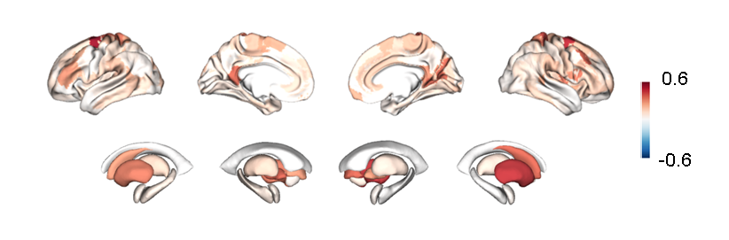
We integrated 30 brain regions with the most severe brain atrophy to define the disease stages. The main overlapping regions in AD included the parahippocampal gyrus, entorhinal cortex, posterior cingulate/precuneus, parietal association cortex, orbitofrontal cortex, as well as the thalamus and amygdala.
Fig. S2. Overlap showing the percentage of patients with brain atrophy.

S05 BAS Distribution Across Populations and Diagnostic Capability
We measured the differences in brain atrophy scores between the CN, MCI, and AD groups. The results showed that the BAS exhibited significant differences between the CN, MCI, and AD groups in the ADNI dataset (F= 126.49, p < 0.001, Figure S3).
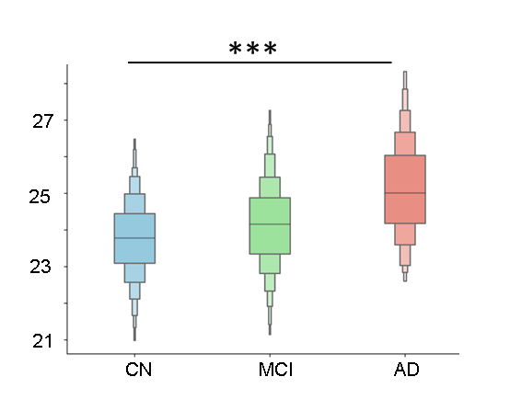
Fig. S3. The BAS of different populations in the ADNI dataset.
We further evaluated whether BAS can distinguish clinically diagnosed AD dementia from other common dementia syndromes, including vascular dementia (VaD), frontotemporal lobar degeneration (FTLD), and Lewy body dementia (LBD). We implemented a pairwise classification model using logistic regression. A 10-fold cross-validation strategy was employed to assess the model’s generalization performance. As shown in Figure S4, BAS achieved high discriminative performance for AD versus each non-AD dementia group.
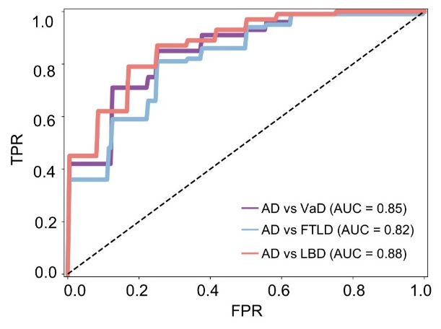
Fig. S4. The discriminative performance of brain atrophy scores for distinguishing AD from VaD, LBD, and FTLD.
We additionally BAS against established regional MRI markers, including hippocampus, entorhinal, and middle temporal volume measures. As shown in the Figure S5, BAS consistently achieve better discriminative performance than these conventional MRI signatures across multiple diagnostic contrasts, with AUCs of 0.94 (AD vs CN), 0.71 (MCI vs CN), and 0.80 (AD vs MCI), compared with hippocampus volume, entorhinal volume, and middle temporal volume. These results demonstrate that BAS provides stronger classification performance than single-region volume.
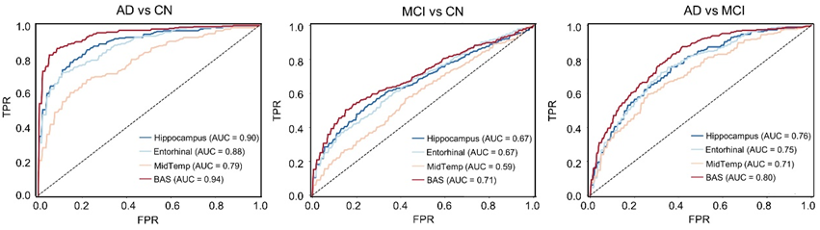
Fig. S5. The diagnostic capability of brain atrophy scores in the ADNI dataset.

S06 Determination of the optimal number of disease stages
To define the disease stages, we applied the Jenks natural breaks optimization method to the BAS distribution. The optimal number of stages was determined using the goodness of variance fit (GVF) criterion, which quantifies the proportion of total variance explained by the partitioning. The results showed that the continuum from MCI to AD were divided into four stages (Figure S6).
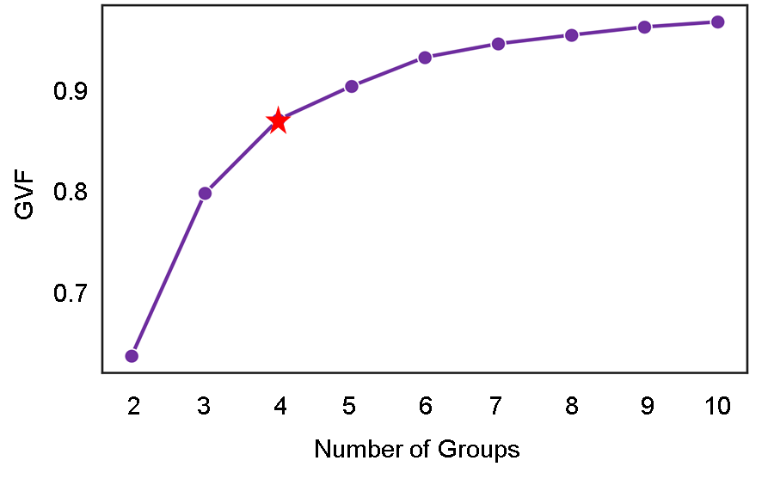
Fig. S6. Determination of the optimal number of disease stages using the Jenks natural breaks optimization method.

S07 Longitudinal progression risk across disease stages in MCI subgroups.
We stratified MCI patients into four subgroups—A-T-, A+T-, A-T+, and A+T+—to evaluate longitudinal disease progression across different stages. Survival analysis demonstrated that MCI patients in the A−T− group at stage Ⅳ had a significantly higher risk of progressing to clinically diagnosed AD. In the A+/T− subgroup, Kaplan–Meier survival curves revealed progressively increasing probabilities of conversion from MCI to AD across advancing disease stages, with the highest risk observed in stage Ⅲ (p = 0.02, Figure S7). The number of participants in stage IV was limited, which precluded a reliable estimation of its conversion risk. Because of the small sample sizes in the A−T+ and A+T+ subgroups, the statistical power to assess progression from MCI to AD was insufficient.
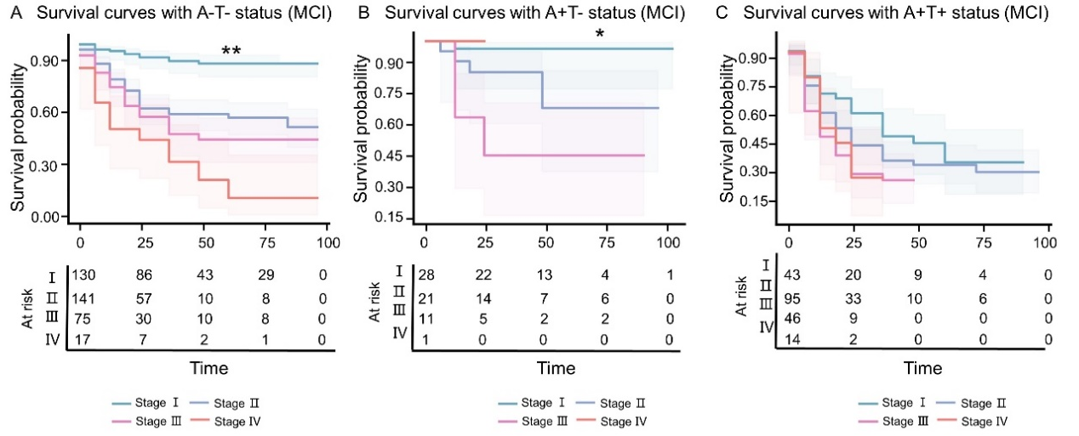
Fig. S7. (A) Survival curves for conversion from MCI to AD with A-T- status. (B) Survival curves for conversion from MCI to AD with A+T- status. (C) Survival curves for conversion from MCI to AD with A+T+ status. The "*" represents significant differences across different AD stages (*: P < .05, **: P < .01, ***: P < .001).

S08 Sensitivity analysis.
We re-examined stage-specific brain structural differences in the A+T+ subset relative to cognitively normal controls. As the disease stage progressed from stage I to stage IV, we observed a clear stepwise pattern of progressive gray matter atrophy. Notably, the spatial atrophy patterns derived from biomarker-confirmed AD were highly consistent with those obtained in the clinically diagnosed ADNI cohort, yielding stage-wise Pearson correlations ranging from 0.62 to 0.89 (Figure S8).
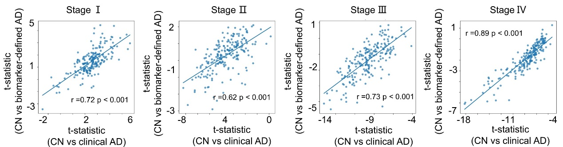
Fig. S8. Correlation of gray matter differences across disease stages between clinically defined and biomarker-confirmed AD.
We examined cognitive trajectories across the MRI-based stages within the biomarker-confirmed A+T+ subset. As stage progressed from I to IV, cognition showed a clear stepwise worsening: all four cognitive composite domains (memory, executive function, visuospatial ability, and language) declined monotonically, MMSE decreased, while ADAS-Cog13 and CDR-SB increased, and mPACCdigit exhibited a marked downward trend. Higher disease stages were associated with more pronounced abnormalities in CSF Abeta and reduced glucose metabolism, as indicated by FDG-PET (Figure S9).

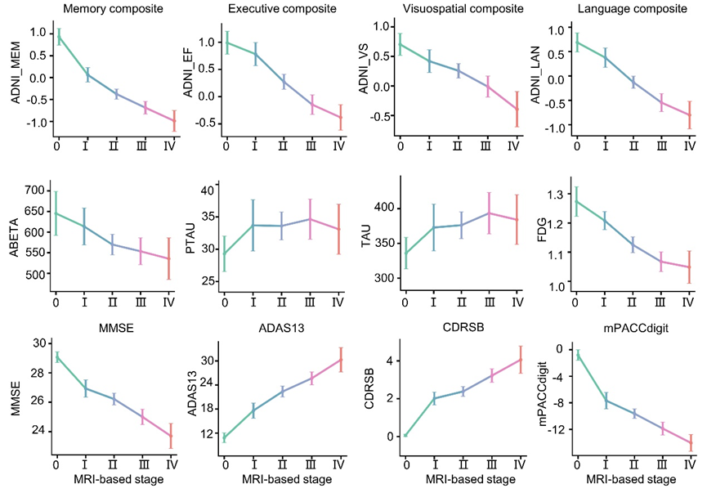
Fig. S9. Summary cognitive assessments and CSF measures by MRI-based stage in biomarker-confirmed AD. MRI-based stage was associated with dementia severity, with higher stages showing progressively greater abnormalities in CSF biomarkers and cognitive performance.
We further evaluated longitudinal progression from MCI to AD across the four MRI-based stages within the biomarker-confirmed AD. The Kaplan–Meier curves showed an ordinal trend toward earlier progression with increasing stage. The non-significant global log-rank result may reflect limited power in the A+T+ subgroup, as stages III and IV contained relatively few participants. Compared with individuals at stage I, participants at stage II-IV had hazard ratios of 1.10 (95% CI: 0.68–1.77, p = 0.69), 2.06 (95% CI: 1.22–3.49, p = 0.006), and 3.45 (95% CI: 1.62–7.36, p < 0.001), respectively (Figure S10).
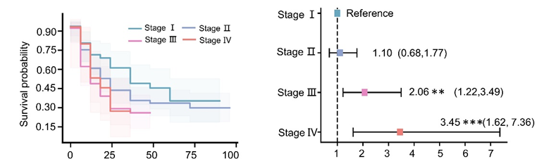
Fig. S10. The survival curves illustrate the probability of MCI participants progressing to biomarker-confirmed AD across different disease stages. Stage-specific hazard ratios for time to AD conversion were estimated for each stage using Stage I as the reference.

S09 Reproducibility of individualized AD stages in two independent datasets.
We used two independent datasets to validate the reproducibility of individualized stages of AD. Participants with AD and MCI were divided into four stages. The grey matter volumes and SUVR values of FDG were z-transformed to show the change across different stages. As the disease progressed, there was a gradual atrophy of gray matter, accompanied by progressively abnormal glucose metabolism from stage Ⅰ to Ⅳ (Figure S11, Figure S12). Consistently, in the NACC cohort, we also observed progressive gray matter atrophy with advancing disease stages (Figure S13, Figure S14).
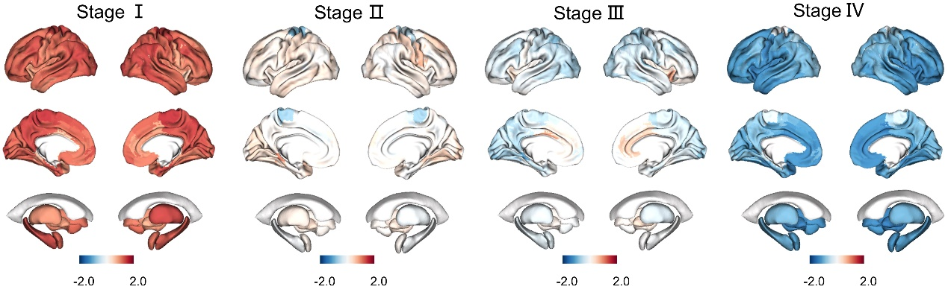
Fig. S11. Grey matter changes across different disease stages in the Xuanwu cohort.
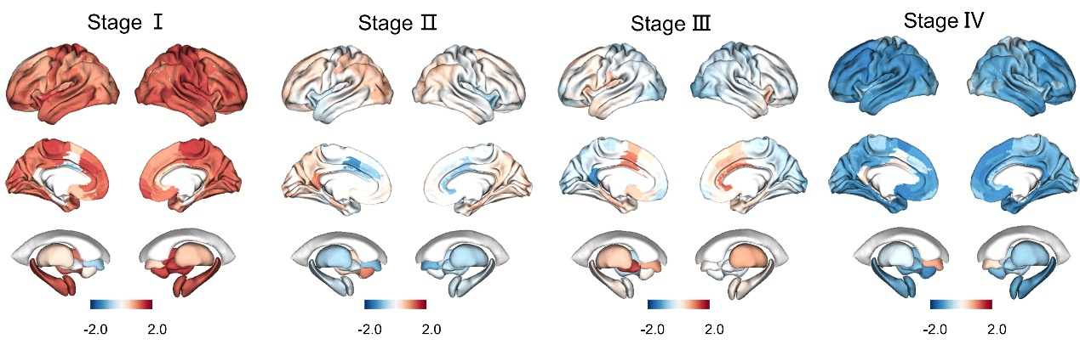
Fig. S12. The SUVR values of FDG across different disease stages in the Xuanwu cohort.
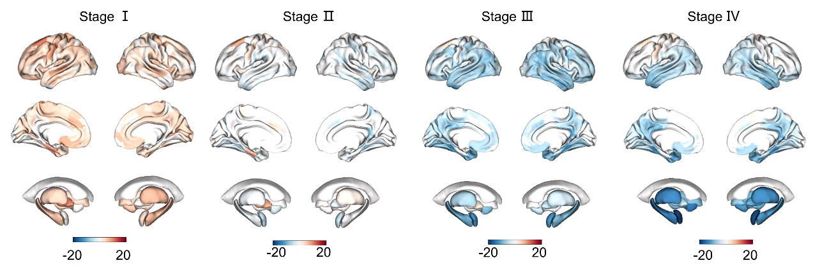
Fig. S13. Grey matter changes across different disease stages in the NACC cohort.
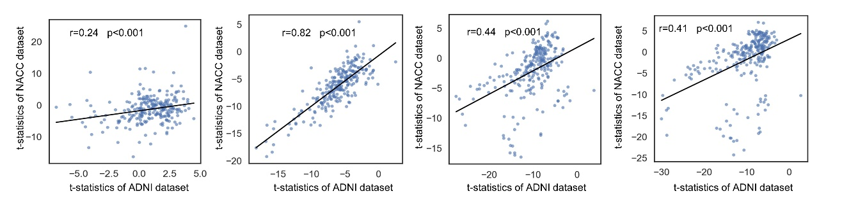
Fig. S14. Correlation of gray matter differences across disease stages between the ADNI dataset and the NACC cohort.

