Supplementary material

Supplementary Methods 3
Supplementary Tables 6
Table S1. Routine inflammatory indices. 6
Table S2. List of variants considered as candidate drivers of clonal hematopoiesis. 7
Table S3. Office of Population Censuses and Surveys Classification of Surgical Operations and Procedures (OPCS) codes used to define percutaneous coronary intervention in UK Biobank. 12
Table S4. Codes used to diagnose in UK Biobank. 13
Table S5. Associations between gene-specific CHIP and 2-year outcomes 15
Table S6. Associations between routine inflammatory indices and adverse outcomes. 16
Table S7. Joint impact of CHIP and routine inflammatory indices on 5-year all-cause mortality. 19
Table S8. Joint impact of CHIP and routine inflammatory indices on secondary outcomes. 20
Supplementary Figures 22
Figure S1. Participants selection flow chart in the UK Biobank. 22
Figure S2. Distribution of baseline age by CHIP status in the (a) overall cohort (N = 3,640) and (b) the age-matched subgroup (N = 2,397). 23
Figure S3. Gene-specific distribution of CHIP. 24
Figure S4. Heatmap for the beta coefficients of associations between CHIP and blood cell and inflammatory parameters. 25
Figure S5. Spearman correlation between each pair of routine inflammatory indices. 26
Figure S6. Associations between CHIP and 5-year outcomes by acute coronary syndromes (ACS) status. 27
Figure S7. Associations of CHIP and its subtypes with 5-year outcomes in the age-matched subgroup. 28
Figure S8. Associations between CHIP and 5-year all-cause mortality stratified by routine inflammatory indices in the age-matched subgroup. 29
Figure S9. Associations between CHIP and secondary outcomes stratified by routine inflammatory indices. 30
Figure S10. Associations between CHIP and 5-year all-cause mortality stratified by quartiles of systemic inflammation indicators 31
Figure S11. Summary of external validation analyses in the UK Biobank. 32
Figure S12. Associations between CHIP and 5-year all-cause mortality jointly stratified by hsCRP and inflammatory hematological parameters. 33
Figure S13. Sensitivity analysis for associations between CHIP and 5-year all-cause death jointly stratified by hsCRP and inflammatory hematological parameters. 34

Supplementary Methods
Ascertainment of clinical characteristics
Body mass index was calculated as weight in kilograms divided by height in square meters. The smoking status of the patients is defined based on their current self-reported smoking status. Common standards of blood testing were adopted for all participants. Lipid profiles were measured with automatic biochemistry analyzers (Hitachi 7150, Tokyo, Japan), and LDL-c was calculated using the Friedewald Equation. Diabetes was defined as fasting plasma glucose ≥7.0 mmol/L, glycated hemoglobin ≥48 mmol/mol, or self-reported diabetes. A history of revascularization is defined as having undergone percutaneous coronary intervention (PCI) or coronary artery bypass grafting (CABG) in the past. The type of coronary heart disease is categorized as acute coronary syndrome (ACS) or chronic coronary syndrome (CCS). The estimated glomerular filtration rate (eGFR) is categorized as a binary variable based on the threshold of 60 mL/min/1.73m². The Synergy between Percutaneous Coronary Intervention with Taxus and Cardiac Surgery (SYNTAX) score (SS) was assessed by two of the three experienced cardiologists in an independent angiographic core laboratory who were blinded to clinical outcomes, and the score was categorized as follows: low (≤22), intermediate (23 to 32), and high (≥33). The GRACE score incorporates eight readily available clinical variables collected at hospital admission: age, heart rate, systolic blood pressure, serum creatinine, Killip class, cardiac arrest at admission, ST-segment deviation on electrocardiogram, and elevated cardiac biomarkers. Each variable is assigned a weighted point value based on its relative contribution to mortality risk. The total GRACE score is calculated as the sum of these points, with higher scores indicating greater mortality risk.
Variable imputation
Among the variable included in the analysis, only GFR and LDL-c had missing values, with missing rates of 4.8% and 1.6%, respectively. We imputed the missing values using multiple imputation by chained equations (MICE) in R software (version 4.2.1), assuming that the missing data were at random. In total, five imputed datasets were generated, and results were combined using Rubin’s rules.
Variant identification
We designed a custom panel focusing on 90 leukemia-related genes beforehand to detect somatic mutations. After mapping the reads to the hg19 reference genome, variant calling, and quality control, we utilized Mutect2 software to call CHIP carrier status and subsequently implemented an orientation bias filter to mitigate substitution errors that manifest on a single DNA strand prior to sequencing. The potential somatic mutations were further refined using FilterMutectCalls software, taking into account the possibility of contamination. In the second phase, the potential somatic mutations were subjected to annotation using ANNOVAR software. Next, we performed additional manual filtering steps which consisted of (1) selecting variants occurring in genes and a pre-specified mutation list that has been recurrently associated with CHIP according to recent reports, (2) excluding variants with a minor allele frequency (MAF) ≥ 1% found in either public databases or our population, (3) ensuring an alternate allele depth (AD) ≥ 3, (4) removing sites with variant allele frequency (VAF) < 0.5% by considering the median sequencing depth of 985×, (5) identifying mutations that did not meet the criteria of a one-sided exact binomial test with P < 0.001 as potential germline variants, which were subsequently excluded from further analysis.
External validation and sensitivity analysis
External validation was conducted using the UK Biobank (UKB) data (application number: 240547). We identified 3,987 independent participants with available whole-exome sequencing (WES) data who underwent first percutaneous coronary intervention (PCI) within a 3-year interval around baseline. After excluding individuals with missing inflammatory indices, 3,715 participants remained for analysis (Figure S1). To ensure methodological consistency and rationality, follow-up was censored at 5 years after PCI, covariates were imputed using the same procedures as in the main analysis, and CHIP was defined using a 2% VAF threshold given the relatively low sequencing depth of WES.
Considering that CHIP and mortality are both highly age-dependent, we also constructed an age-matched subgroup from the overall cohort to minimize the potential influence of age at the design stage of the analysis. We employed a propensity score approach to generate age-matched subgroup. Specifically, we used nearest-neighbor matching without replacement at a 1:2 ratio, selecting this ratio to include as many eligible controls as possible and preserve statistical power. Ultimately, the age-matched subgroup comprised 2,397 individuals, with no significant differences in age between CHIP groups (Figure S2).

Supplementary Tables

Table S1. Routine inflammatory indices.
Indices | Unit/Formula | Median
WBC | ×10⁹/L | 6.68
NEU | ×10⁹/L | 4.08
MONO | ×10⁹/L | 0.40
LY | ×10⁹/L | 1.90
PLT | ×10⁹/L | 201.00
NLR | Neutrophils ÷ lymphocytes | 2.12
MLR | Monocytes ÷ lymphocytes | 0.21
PLR | Platelets ÷ lymphocytes | 105.42
SIRI | Neutrophils × monocytes ÷ lymphocytes | 0.84
SII | Neutrophils × platelets ÷ lymphocytes | 426.83
AISI | Neutrophils × monocytes × platelets ÷ lymphocytes | 170.27
hsCRP | mg/L | 1.68
Abbreviations: WBC, white blood cell count; NEU, neutrophil count; MONO, monocyte count; LY, lymphocyte count; PLT, platelet count; NLR, neutrophil-lymphocyte ratio; MLR, monocyte-lymphocyte ratio; PLR, platelet-lymphocyte ratio; SIRI, systemic inflammatory response index; SII, systemic immune-inflammatory index; AISI, aggregate index of systemic inflammation; hsCRP, high-sensitivity C-reaction protein.

Table S2. List of variants considered as candidate drivers of clonal hematopoiesis.
Gene name | Reported mutations used for variant calling | Accession
ASXL1 | Frameshift/nonsense/splice-site in exon 11-12 | NM_015338
BCOR | Frameshift/nonsense/splice-site | NM_001123385
BCORL1 | Frameshift/nonsense/splice-site | NM_021946
BRAF | G464E, G464V, G466E, G466V, G469R, G469E, G469A, G469V, V471F, V472S, L485W, N581S, I582M, I592M, I592V, D594N, D594G, D594V, D594E, F595L, F595S, G596R, L597V, L597S, L597Q, L597R, A598V, V600M, V600L, V600K, V600R, V600E, V600A, V600G, V600D, K601E, K601N, R603*, W604R, W604G, S605G, S605F, S605N, G606E, G606A, G606V, H608R, H608L, G615R, S616P, S616F, L618S, L618W | NM_004333
BRCC3 | Frameshift/nonsense/splice-site | NM_024332
CBL | RING finger missense p.381-421 | NM_005188
CREBBP | Frameshift/nonsense/splice-site, D1435E, R1446L, R1446H, R1446C, Y1450C, P1476R, Y1482H, H1487Y, W1502C, Y1503D, Y1503H, Y1503F, S1680del | NM_004380
CUX1 | Frameshift/nonsense | NM_181552
DNMT3A | Frameshift/nonsense/splice-site, F290I, F290C, V296M, P307S, P307R, R326H, R326L, R326C, R326S, G332R, G332E, V339A, V339M, V339G, L344Q, L344P, R366P, R366H, R366G, A368T, A368V, R379H, R379C, I407T, I407N, I407S, F414L, F414S, F414C, A462V, K468R, C497G, C497Y, Q527H, Q527P, Y533C, S535F, C537G, C537R, G543A, G543S, G543C, L547H, L547P, L547F, M548I, M548K, G550R, W581R, W581G, W581C, R604Q, R604W, R635W, R635Q, S638F, G646V, G646E, L653W, L653F, I655N, V657A, V657M, R659H, Y660C, V665G, V665L, M674V, R676W, R676Q, G685R, G685E, G685A, D686Y, D686G, R688H, G699R, G699S, G699D, P700L, P700S, P700R, P700Q, P700T, P700A, D702N, D702Y, V704M, V704G, I705F, I705T, I705S, I705N, G707D, G707V, C710S, C710Y, S714C, V716D, V716F, V716I, N717S, N717I, P718L, R720H, R720G, K721R, K721T, Y724C, R729Q, R729W, R729G, F731C, F731L, F731Y, F731I, F732del, F732C, F732S, F732L, E733G, E733A, F734L, F734C, Y735C, Y735N, Y735S, R736H, R736C, R736P, L737H, L737V, L737F, L737R, A741V, P742P, P743R, P743L, R749C, R749L, R749H, R749G, F751L, F751C, F752del, F752C, F752L, F752I, F752V, W753G, W753C, W753R, L754P, L754R, L754H, F755S, F755I, F755L, M761I, M761V, G762C, V763I, S770L, S770W, S770P, R771Q, F772I, F772V, L773R, L773V, E774K, E774D, E774G, I780T, D781G, R792H, W795C, W795L, G796D, G796V, N797Y, N797H, N797S, P799S, P799R, P799H, R803S, R803W, P804L, P804S, K826R, S828N, K829R, T835M, N838D, K841Q, Q842E, P849L, D857N, W860R, E863D, F868S, G869S, G869V, M880V, S881R, S881I, R882H, R882P, R882C, R882G, A884P, A884V, Q886R, L889P, L889R, G890D, G890R, G890S, V895M, P896L, V897G, V897D, R899L, R899H, R899C, L901R, L901H, P904L, F909C, P904Q, A910P, C911R, C911Y | NM_022552
EZH2 | Frameshift/nonsense/splice-site, Q62R, N102S, F145S, F145C, F145Y, F145L, G159R, E164D, R202Q, K238E, E244K, R283Q, H292R, P488S, R497Q, R561H, T568I, K629E, Y641N, Y641H, Y641S, Y641C, Y641F, D659Y, D659G, V674M, A677G, A677V, R679C, R679H, R685C, R685H, A687V, N688I, N688K, H689Y, S690P, I708V, I708T, I708M, E720K, E740K | NM_001203247
FLT3 | V579A, V592A, V592I, F594L, FY590-591GD, D835Y, D835H, D835E, del835 | NM_004119
GNAS | R201S, R201C, R201H, R201L, Q227K, Q227R, Q227L, Q227H, R374C | NM_000516
GNB1 | K57N, K57M, K57E, K57T, I80T, I80N | NM_002074
IDH2 | R140W, R140Q, R140L, R140G, R172W, R172G, R172K, R172T, R172M, R172N, R172S | NM_002168
IKZF1 | Frameshift/nonsense | NM_006060
JAK2 | N533D, N533Y, N533S, H538R, K539E, K539L, I540T, I540V, V617F, R683S, R683G, del/ins537-539L, del/ins538-539L, del/ins540-543MK, del/ins540-544MK, del/ins541-543K, del542-543, del543-544, ins11546-547 | NM_004972
KDM6A | Frameshift/nonsense/splice-site, del419 | NM_021140
KIT | ins503, V559A, V559D, V559G, V559I, V560D, V560A, V560G, V560E, del560, E561K, del579, P627L, P627T, R634W, K642E, K642Q, V654A, V654E, H697Y, H697D, E761D, K807R, D816H, D816Y, D816F, D816I, D816V, D816H, del551-559 | NM_000222
KRAS | G12D, G12A, G12E, G12V, G13D, G13C, G13Y, G13F, G13R, G13A, G13V, G13E, V14I, T58I, G60D, G60A, G60V, Q61K, Q61E, Q61P, Q61R, Q61L, Q61H, K117E, K117N, A146T, A146P, A146V | NM_033360
LUC7L2 | Frameshift/nonsense/splice-site | NM_016019
MPL | S505G, S505N, S505C, L510P, del513, W515A, W515R, W515K, W515S, W515L, A519T, A519V, Y591D, W515-518KT | NM_005373
NRAS | G12S, G12R, G12C, G12N, G12P, G12Y, G12D, G12A, G12V, G12E, G13S, G13R, G13C, G13N, G13P, G13Y, G13D, G13A, G13V, G13E, G60E, G60R, Q61R, Q61L, Q61K, Q61P, Q61H, Q61Q | NM_002524
PPM1D | Frameshift/nonsense, exon 5 or 6 | NM_003620
PRPF40B | Frameshift/nonsense/splice-site, P15H, M58I, P405L, P562S | NM_001031698
PTPN11 | G60V, G60R, G60A, D61Y, D61V, D61G, Y63C, E69K, E69G, E69D, E69Q, F71L, F71K, A72T, A72V, A72D, T73I, E76K, E76Q, E76M, E76A, E76G, E139G, E139D, N308D, N308T, N339S, P491L, S502P, S502A, S502L, G503V, G503G, G503A, G503E, Q506P, T507A, T507K | NM_002834
RAD21 | Frameshift/nonsense/splice-site, R65Q, H208R, Q474R | NM_006265
SETD2 | Frameshift/nonsense, V1190M | NM_014159
SETDB1 | Frameshift/nonsense, K715E | NM_001145415
SF1 | Frameshift/nonsense/splice-site, T454M, Y476C, A508G | NM_004630
SF3B1 | G347V, R387W, R387Q, E592K, E622D, Y623C, R625L, R625C, R625G, H662Q, H662D, T663I, K666N, K666T, K666E, K666R, K700E, V701F, A708T, G740R, G740E, A744P, D781G, E783K, R831Q, L833F, E862K, R957Q | NM_012433
SRSF2 | Y44H, P95H, P95L, P95T, P95R, P95A, P107H, P95fs | NM_003016
SMC3 | Frameshift/nonsense, R155I, Q367E, D392V, K571R, R661P, G662C | NM_005445
SUZ12 | Frameshift/nonsense | NM_015355
TET2 | Frameshift/nonsense/splice-site, missense mutations in catalytic domains (p.1104-1481 and 1843-2002) | NM_001127208
TP53 | Frameshift/nonsense/splice-site, S46F, G105C, G105R, G105D, G108S, G108C, R110L, R110C, T118A, T118R, T118I, S127F, S127Y, L130V, L130F, K132Q, K132E, K132W, K132R, K132M, K132N, F134V. F134L, F134S, C135W, C135S, C135F, C135G, C135Y, Q136K, Q136E, Q136P, Q136R, Q136L, Q136H, A138P, A138V, A138A, A138T, T140I, C141R, C141G, C141A, C141Y, C141S, C141F, C141W, V143M, V143A, V143E, L145Q, W146C, W146L, L145R, V147G, P151T, P151A, P151S, P151H, P151R, P152S, P152R, P152L, T155P, T155A, V157F, R158H, R158L, A159V, A159P, A159S, A159D, A161T, A161D, Y163N, Y163H, Y163D, Y163S, Y163C, K164E, K164M, K164N, K164P, H168Y, H168P, H168R, H168L, H168Q, M169I, M169T, M169V, E171K, E171Q, E171G, E171A, E171V, E171D, V172D, V173M, V173L, V173G, R174W, R175G, R175C, R175H, C176R, C176G, C176Y, C176F, C176S, P177R, P177R, P177L, H178D, H178P, H178Q, H179Y, H179R, H179Q, R181C, R181Y, D186G, G187S, P190L, P190T, H193N, H193P, H193L, H193R, L194F, L194R, I195F, I195N, I195T, R196P, V197L, G199V, Y205N, Y205C, Y205H, D208V, R213Q, R213P, R213L, R213Q, H214D, H214R, S215G, S215I, S215R, V216M, V217G, Y220N, Y220H, Y220S, Y220C, E224D, I232F, I232N, I232T, I232S, Y234N, Y234H, Y234S, Y234C, Y236N, Y236H, Y236C, M237V, M237K, M237I, C238R, C238G, C238Y, C238W, N239T, N239S, S241Y, S241C, S241F, C242G, C242Y, C242S, C242F, G244S, G244C, G244D, G245S, G245R, G245C, G245D, G245A, G245V, G245S, M246V, M246K, M246R, M246I, N247I, R248W, R248G, R248Q, R249G, R249W, R249T, R249M, P250L, I251N, L252P, I254S, I255F, I255N, I255S, L257Q, L257P, E258K, E258Q, D259Y, S261T, G262D, G262V, L265P, G266R, G266E, G266V, R267W, R267Q, R267P, E271K, V272M, V272L, R273S, R273G, R273C, R273H, R273P, R273L, V274F, V274D, V274A, V274G, V274L, C275Y, C275S, C275F, A276P, C277F, C277Y, P278T, P278A, P278S, P278H, P278R, P278L, G279E, R280G, R280K, R280T, R280I, R280S, D281N, D281H, D281Y, D281G, D281E, R282G, R282W, R282Q, R282P, E285K, E285V, E286G, E286V, E286K, K320N, L330R, G334V, R337C, R337L, A347T, L348F, T377P | NM_001126112
U2AF1 | D14G, S34F, S34Y, R35L, R156H, R156Q, Q157R, Q157P | NM_006758
ZRSR2 | Frameshift/nonsense, R126P, E133G, C181F, H191Y, I202N, F239V, F239Y, N261Y, C280R, C302R, C326R, H330R, N382K | NM_005089

Table S3. Office of Population Censuses and Surveys Classification of Surgical Operations and Procedures (OPCS) codes used to define percutaneous coronary intervention in UK Biobank.
 | Operative procedures - OPCS4
percutaneous coronary intervention (PCI) | K49.1, K49.2, K49.3, K49.4, K49.8, K49.9, K50.1, K50.2, K50.4, K75.1, K75.2, K75.3, K75.4, K75.8, K75.9

Table S4. Codes used to diagnose in UK Biobank.
 | International Classification of Diseases (ICD)-10 codes
Myocardial infarction | I21, I21.0, I21.1, I21.2, I21.3, I21.4, I21.9, I22, I22.0, I22.1, I22.8, I22.9, I23, I23.0, I23.1, I23.2, I23.3, I23.4, I23.5, I23.6, I23.8, I25.1, I25.2
Ischemic stroke | I63.0, I63.1, I63.2, I63.3, I63.4, I63.5, I63.6, I63.8, I63.9
Circulatory system (cardiovascular mortality) | A39.5, B33.2, B37.6, E10.5, E11.5, E14.5, G45.0, G45.1, G45.2, G45.4, G45.8, G45.9, G46.0, G46.1, G46.2, G46.3, G46.4, G46.5, G46.6, G46.7, G46.8, I01, I01.0, I01.1, I01.2, I01.8, I01.9, I02.0, I05, I05.0, I05.1, I05.2, I05.8, I05.9, I06, I06.0, I06.1, I06.2, I06.8, I06.9, I07, I07.0, I07.1, I07.2, I07.8, I07.9, I08.0, I08.1, I08.1, I08.1, I08.2, I08.2, I08.2, I08.3, I08.8, I08.8, I08.9, I08.9, I09, I09.0, I09.1, I09.2, I09.8, I09.9, I10, I11, I11.0, I11.9, I12, I12.0, I12.9, I13, I13.0, I13.1, I13.2, I13.9, I15, I15.0, I15.1, I15.2, I15.8, I15.9, I20, I20.0, I20.1, I20.8, I20.9, I21, I21.0, I21.1, I21.2, I21.3, I21.4, I21.9, I22, I22.0, I22.1, I22.8, I22.9, I23, I23.0, I23.1, I23.2, I23.3, I23.4, I23.5, I23.6, I23.8, I24, I24.0, I24.1, I24.8, I24.9, I25, I25.0, I25.1, I25.2, I25.3, I25.4, I25.5, I25.6, I25.8, I25.9, I26, I26.0, I26.9, I27.0, I27.1, I27.8, I27.9, I28, I28.0, I28.1, I28.8, I28.9, I30, I30.0, I30.1, I30.8, I30.9, I31, I31.0, I31.1, I31.2, I31.3, I31.8, I31.9, I32, I32.0, I32.1, I32.8, I33, I33.0, I33.9, I34, I34.0, I34.0, I34.1, I34.1, I34.1, I34.2, I34.8, I34.9, I35, I35.1, I35.2, I35.8, I35.9, I35.9, I36, I36.0, I36.1, I36.2, I36.8, I36.9, I37, I37.0, I37.1, I37.2, I37.9, I38, I39, I40, I40.0, I40.1, I40.8, I40.9, I41, I41.2, I41.8, I42, I42.0, I42.1, I42.2, I42.3, I42.4, I42.5, I42.6, I42.7, I42.8, I42.9, I43, I43.8, I44.0, I44.1, I44.2, I44.3, I44.4, I44.5, I44.6, I44.6, I44.7, I45.0, I45.1, I45.2, I45.3, I45.4, I45.5, I45.6, I45.8, I45.9, I46, I46.0, I46.1, I46.9, I47, I47.0, I47.1, I47.2, I47.9, I48, I49.0, I49.1, I49.2, I49.3, I49.4, I49.4, I49.5, I49.8, I49.9, I50, I50.0, I50.1, I50.9, I51.0, I51.1, I51.2, I51.3, I51.4, I51.5, I51.7, I51.8, I51.9, I52, I60, I60.0, I60.0, I60.1, I60.2, I60.3, I60.4, I60.5, I60.6, I60.7, I60.8, I60.9, I61, I61.0, I61.1, I61.2, I61.3, I61.4, I61.5, I61.6, I61.8, I61.9, I62.0, I62.1, I62.9, I63, I63.0, I63.1, I63.2, I63.2, I63.3, I63.4, I63.5, I63.5, I63.6, I63.8, I63.9, I64, I65, I65.0, I65.1, I65.2, I65.3, I65.8, I65.9, I66, I66.0, I66.1, I66.2, I66.3, I66.4, I66.8, I66.9, I67, I67.0, I67.1, I67.2, I67.4, I67.5, I67.6, I67.7, I67.8, I67.9, I68, I68.0, I68.2, I68.8, I69, I69.0, I69.1, I69.2, I69.3, I69.4, I69.8, I70, I70.0, I70.1, I70.2, I70.8, I70.9, I71.0, I71.1, I71.2, I71.3, I71.4, I71.5, I71.6, I71.8, I71.9, I72, I72.0, I72.1, I72.2, I72.3, I72.4, I72.8, I72.9, I73, I73.0, I73.1, I73.8, I73.9, I74, I74.0, I74.1, I74.2, I74.3, I74.4, I74.5, I74.8, I74.9, I77, I77.0, I77.1, I77.2, I77.3, I77.4, I77.5, I77.6, I77.8, I77.9, I78, I78.0, I78.8, I78.9, I79.0, I79.1, I79.2, I79.8, I80, I80.0, I80.1, I80.2, I80.3, I80.8, I80.9, I81, I82, I82.0, I82.1, I82.2, I82.3, I82.8, I82.9, I83, I83.0, I83.1, I83.2, I83.9, I84, I84.0, I84.1, I84.2, I84.3, I84.4, I84.5, I84.6, I84.7, I84.8, I84.9, I86, I86.0, I86.1, I86.2, I86.3, I86.4, I86.8, I87.0, I87.1, I87.2, I87.8, I87.9, I89, I89.0, I89.1, I89.8, I89.9, I95, I95.0, I95.1, I95.2, I95.8, I95.9, I97.0, I97.1, I97.2, I99, K55, K55.0, K55.1, K55.8, K55.9, M05.2, M30, M30.0, M30.1, M30.2, M30.3, M30.8, M31.0, M31.1, M31.2, M31.3, M31.4, M31.5, M31.6, M31.8, M31.9, Q27.3, R00, R00.0, R00.1, R00.2, R01, R01.0, R01.1, R01.2, R03.1, R07.2, R07.3, R07.4, R09.8, R58, R94.3, S06.4, T86.3, Z86.7, Z94.1, Z94.3, Z95.0, Z95.1, Z95.2, Z95.3, Z95.4, Z95.5, Z95.9

Table S5. Associations between gene-specific CHIP and 2-year outcomes
Group | No. of events/Total | Incidence rateª | HR (95% CI)^{b}
Group | No. of events/Total | Incidence rateª | Model 1 | Model 2 | Model 3
2-year all-cause mortality
Non-CHIP | 23/2841 | 0.39 | Ref. | Ref. | Ref.
CHIP | 12/799 | 0.73 | 1.86 (0.93-3.74) | 1.44 (0.70-2.96) | 1.53 (0.74-3.16)
Gene-specific CHIP
DT CHIP | 8/560 | 0.69 | 1.77 (0.79-3.95) | 1.37 (0.60-3.15) | 1.49 (0.65-3.41)
Non-DT CHIP | 4/239 | 0.81 | 2.08 (0.72-6.02) | 1.64 (0.56-4.84) | 1.71 (0.58-5.04)
CHIP clone sizes
VAF 0.5-2% | 5/392 | 0.62 | 1.58 (0.60-4.16) | 1.33 (0.50-3.53) | 1.46 (0.55-3.89)
VAF ≥2% | 7/407 | 0.83 | 2.13 (0.91-4.96) | 1.53 (0.64-3.68) | 1.59 (0.66-3.85)
2-year cardiac mortality
Non-CHIP | 12/2841 | 0.20 | Ref. | Ref. | Ref.
CHIP | 3/799 | 0.18 | 0.89 (0.25-3.16) | 0.85 (0.23-3.09) | 0.94 (0.26-3.46)
Gene-specific CHIP
DT CHIP | 3/560 | 0.26 | 1.27 (0.36-4.50) | 1.22 (0.33-4.48) | 1.38 (0.37-5.12)
Non-DT CHIP | 0/239 | 0.00 | 0.00 (0.00-Inf) | 0.00 (0.00-Inf) | 0.00 (0.00-Inf)
CHIP clone sizes
VAF 0.5-2% | 1/392 | 0.12 | 0.61 (0.08-4.66) | 0.59 (0.08-4.59) | 0.69 (0.09-5.43)
VAF ≥2% | 2/407 | 0.24 | 1.17 (0.26-5.21) | 1.09 (0.23-5.10) | 1.15 (0.24-5.46)
2-year MACCE
Non-CHIP | 357/2841 | 6.57 | Ref. | Ref. | Ref.
CHIP | 107/799 | 7.05 | 1.07 (0.86-1.33) | 1.07 (0.85-1.33) | 1.09 (0.87-1.36)
Gene-specific CHIP
DT CHIP | 79/560 | 7.44 | 1.13 (0.89-1.44) | 1.13 (0.88-1.45) | 1.15 (0.90-1.48)
Non-DT CHIP | 28/239 | 6.13 | 0.93 (0.64-1.37) | 0.93 (0.63-1.37) | 0.95 (0.65-1.40)
CHIP clone sizes
VAF 0.5-2% | 58/392 | 7.87 | 1.19 (0.90-1.57) | 1.20 (0.90-1.58) | 1.23 (0.93-1.62)
VAF ≥2% | 49/407 | 6.27 | 0.95 (0.71-1.29) | 0.94 (0.69-1.28) | 0.96 (0.71-1.31)
Abbreviations: CHIP, clonal hematopoiesis of indeterminate potential; DT, DNMT3A and/or TET2; VAF, variant allele fraction; HR, hazard ratio; CI, confidence interval; MACCE, major adverse cardiovascular and cerebrovascular events; Ref., Reference.
ª Per 100 person-years.
^{b} Model 1 was unadjusted; Model 2 adjusted for age, sex and body mass index; Model 3 further adjusted for smoking, hypertension, diabetes, low-density lipoprotein cholesterol, abnormal glomerular filtration rate, prior percutaneous coronary intervention or coronary artery bypass grafting, acute coronary syndromes, and SYNTAX score.

Table S6. Associations between routine inflammatory indices and adverse outcomes.
Indices | No. of events/Total  (High-level index) | Incidence rateª  (High-level index) | No. of events/Total  (Low-level index) | Incidence rate  (Low-level index) | HR (95% CI)^{b}
5-year all-cause mortality
AISI | 66/1820 | 0.77 | 53/1820 | 0.61 | 1.21 (0.83-1.74)
LY | 59/1826 | 0.68 | 60/1814 | 0.70 | 1.16 (0.80-1.68)
MLR | 69/1820 | 0.80 | 50/1820 | 0.57 | 1.25 (0.86-1.83)
MONO | 69/1854 | 0.78 | 50/1786 | 0.59 | 1.33 (0.91-1.92)
NEU | 62/1830 | 0.72 | 57/1810 | 0.66 | 1.02 (0.70-1.47)
NLR | 70/1820 | 0.82 | 49/1820 | 0.56 | 1.23 (0.85-1.78)
PLR | 62/1820 | 0.72 | 57/1820 | 0.65 | 1.02 (0.71-1.47)
PLT | 53/1836 | 0.61 | 66/1804 | 0.77 | 0.88 (0.60-1.28)
SII | 56/1820 | 0.65 | 63/1820 | 0.72 | 0.83 (0.58-1.20)
SIRI | 72/1820 | 0.84 | 47/1820 | 0.54 | 1.40 (0.96-2.06)
WBC | 61/1820 | 0.70 | 58/1820 | 0.67 | 1.05 (0.72-1.51)
hsCRP | 62/1609 | 0.82 | 57/2031 | 0.59 | 1.31 (0.90-1.90)
5-year cardiac mortality
AISI | 41/1820 | 0.48 | 24/1820 | 0.27 | 1.56 (0.93-2.61)
LY | 34/1826 | 0.39 | 31/1814 | 0.36 | 1.28 (0.78-2.11)
MLR | 39/1820 | 0.45 | 26/1820 | 0.30 | 1.29 (0.77-2.15)
MONO | 36/1854 | 0.41 | 29/1786 | 0.34 | 1.11 (0.67-1.82)
NEU | 36/1830 | 0.42 | 29/1810 | 0.34 | 1.10 (0.66-1.81)
NLR | 42/1820 | 0.49 | 23/1820 | 0.26 | 1.52 (0.90-2.55)
PLR | 37/1820 | 0.43 | 28/1820 | 0.32 | 1.25 (0.76-2.05)
PLT | 36/1836 | 0.41 | 29/1804 | 0.34 | 1.38 (0.83-2.29)
SII | 36/1820 | 0.42 | 29/1820 | 0.33 | 1.12 (0.68-1.85)
SIRI | 42/1820 | 0.49 | 23/1820 | 0.26 | 1.57 (0.93-2.66)
WBC | 36/1820 | 0.42 | 29/1820 | 0.34 | 1.16 (0.70-1.92)
hsCRP | 41/1609 | 0.54 | 24/2031 | 0.25 | 2.04 (1.21-3.45)
5-year MACCE
AISI | 419/1794 | 5.65 | 351/1801 | 4.51 | 1.19 (1.03-1.38)
LY | 393/1803 | 5.16 | 377/1792 | 4.97 | 1.06 (0.91-1.22)
MLR | 414/1796 | 5.57 | 356/1799 | 4.59 | 1.14 (0.98-1.32)
MONO | 425/1828 | 5.57 | 345/1767 | 4.56 | 1.17 (1.01-1.35)
NEU | 417/1810 | 5.55 | 353/1785 | 4.60 | 1.15 (0.99-1.33)
NLR | 404/1793 | 5.39 | 366/1802 | 4.75 | 1.07 (0.93-1.23)
PLR | 391/1794 | 5.20 | 379/1801 | 4.93 | 1.06 (0.92-1.23)
PLT | 374/1813 | 4.86 | 396/1782 | 5.28 | 0.96 (0.83-1.11)
SII | 404/1794 | 5.43 | 366/1801 | 4.72 | 1.11 (0.96-1.28)
SIRI | 422/1794 | 5.69 | 348/1801 | 4.47 | 1.18 (1.02-1.37)
WBC | 423/1801 | 5.64 | 347/1794 | 4.51 | 1.20 (1.04-1.38)
hsCRP | 363/1592 | 5.47 | 407/2003 | 4.75 | 1.08 (0.93-1.25)
2-year all-cause mortality
AISI | 15/1836 | 0.40 | 20/1804 | 0.54 | 1.22 (0.62-2.41)
LY | 19/1820 | 0.51 | 16/1820 | 0.42 | 1.73 (0.87-3.45)
MLR | 16/1820 | 0.42 | 19/1820 | 0.51 | 1.00 (0.50-1.99)
MONO | 18/1854 | 0.47 | 17/1786 | 0.46 | 1.03 (0.52-2.02)
NEU | 20/1826 | 0.53 | 15/1814 | 0.40 | 1.80 (0.89-3.62)
NLR | 14/1842 | 0.37 | 21/1798 | 0.57 | 1.15 (0.58-2.28)
PLR | 17/1820 | 0.45 | 18/1820 | 0.48 | 0.78 (0.40-1.53)
PLT | 20/1820 | 0.53 | 15/1820 | 0.40 | 0.90 (0.45-1.80)
SII | 22/1820 | 0.59 | 13/1820 | 0.34 | 0.95 (0.49-1.87)
SIRI | 21/1820 | 0.56 | 14/1820 | 0.37 | 1.58 (0.78-3.21)
WBC | 19/1820 | 0.51 | 16/1820 | 0.42 | 1.75 (0.87-3.49)
hsCRP | 20/1609 | 0.60 | 15/2031 | 0.36 | 2.01 (1.00-4.03)
2-year cardiac mortality
AISI | 9/1820 | 0.24 | 6/1820 | 0.16 | 1.62 (0.56-4.70)
LY | 10/1826 | 0.27 | 5/1814 | 0.13 | 2.57 (0.86-7.73)
MLR | 8/1820 | 0.21 | 7/1820 | 0.19 | 1.03 (0.36-2.96)
MONO | 7/1854 | 0.18 | 8/1786 | 0.22 | 0.89 (0.31-2.54)
NEU | 10/1830 | 0.26 | 5/1810 | 0.13 | 2.11 (0.70-6.33)
NLR | 8/1820 | 0.21 | 7/1820 | 0.19 | 0.92 (0.33-2.58)
PLR | 7/1820 | 0.19 | 8/1820 | 0.21 | 0.77 (0.27-2.18)
PLT | 10/1836 | 0.26 | 5/1804 | 0.13 | 2.60 (0.84-8.04)
SII | 8/1820 | 0.21 | 7/1820 | 0.19 | 1.11 (0.39-3.12)
SIRI | 9/1820 | 0.24 | 6/1820 | 0.16 | 1.45 (0.49-4.27)
WBC | 9/1820 | 0.24 | 6/1820 | 0.16 | 1.73 (0.60-5.01)
hsCRP | 10/1609 | 0.30 | 5/2031 | 0.12 | 3.79 (1.23-11.69)
2-year MACCE
AISI | 257/1794 | 7.47 | 207/1801 | 5.89 | 1.20 (1.00-1.45)
LY | 243/1803 | 7.00 | 221/1792 | 6.35 | 1.11 (0.92-1.34)
MLR | 267/1796 | 7.78 | 197/1799 | 5.60 | 1.29 (1.07-1.56)
MONO | 266/1828 | 7.60 | 198/1767 | 5.74 | 1.23 (1.02-1.48)
NEU | 259/1810 | 7.49 | 205/1785 | 5.87 | 1.22 (1.01-1.46)
NLR | 248/1793 | 7.19 | 216/1802 | 6.17 | 1.10 (0.92-1.33)
PLR | 235/1794 | 6.77 | 229/1801 | 6.58 | 1.06 (0.88-1.27)
PLT | 226/1813 | 6.45 | 238/1782 | 6.90 | 0.98 (0.81-1.18)
SII | 254/1794 | 7.38 | 210/1801 | 5.98 | 1.21 (1.01-1.46)
SIRI | 265/1794 | 7.72 | 199/1801 | 5.66 | 1.26 (1.04-1.52)
WBC | 264/1801 | 7.68 | 200/1794 | 5.69 | 1.29 (1.07-1.55)
hsCRP | 246/1801 | 7.22 | 218/1794 | 6.24 | 1.11 (0.92-1.34)
Abbreviations:HR, hazard ratio; CI, confidence interval; MACCE, major adverse cardiovascular and cerebrovascular events; WBC, white blood cell count; NEU, neutrophil count; MONO, monocyte count; LY, lymphocyte count; PLT, platelet count; NLR, neutrophil-lymphocyte ratio; MLR, monocyte-lymphocyte ratio; PLR, platelet-lymphocyte ratio; SIRI, systemic inflammatory response index; SII, systemic immune-inflammatory index; AISI, aggregate index of systemic inflammation; hsCRP, high-sensitivity C-reaction protein.
ª Per 100 person-years.
^{b} Adjusted age, sex, body mass index smoking, hypertension, diabetes, low-density lipoprotein cholesterol, abnormal glomerular filtration rate, prior percutaneous coronary intervention or coronary artery bypass grafting, acute coronary syndromes, and SYNTAX score.

Table S7. Joint impact of CHIP and routine inflammatory indices on 5-year all-cause mortality.
Indices | HR (95% CI)ª |  |  |  | P for interactionª | adjusted P for interaction^{b}
Indices | non-CHIP & low-level index | non-CHIP & high-level index | CHIP &  low-level index | CHIP &  high-level index | P for interactionª | adjusted P for interaction^{b}
AISI | Ref. | 0.83 (0.52-1.32) | 0.98 (0.53-1.82) | 2.21 (1.37-3.59) | 0.012 | 0.036
LY | Ref. | 1.31 (0.82-2.09) | 2.02 (1.20-3.39) | 1.99 (1.13-3.50) | 0.458 | 0.500
MLR | Ref. | 0.84 (0.53-1.35) | 0.90 (0.46-1.73) | 2.24 (1.38-3.64) | 0.008 | 0.033
MONO | Ref. | 0.95 (0.59-1.51) | 1.02 (0.54-1.90) | 2.40 (1.47-3.90) | 0.022 | 0.053
NEU | Ref. | 0.74 (0.46-1.18) | 1.13 (0.63-2.01) | 1.90 (1.16-3.09) | 0.033 | 0.057
NLR | Ref. | 0.88 (0.55-1.41) | 1.01 (0.53-1.93) | 2.19 (1.34-3.58) | 0.027 | 0.054
PLR | Ref. | 0.79 (0.49-1.25) | 1.24 (0.69-2.20) | 1.86 (1.14-3.04) | 0.123 | 0.148
PLT | Ref. | 0.70 (0.43-1.14) | 1.34 (0.80-2.26) | 1.70 (1.01-2.85) | 0.093 | 0.139
SII | Ref. | 0.50 (0.31-0.82) | 0.93 (0.52-1.65) | 1.66 (1.04-2.66) | 0.001 | 0.009
SIRI | Ref. | 0.86 (0.54-1.39) | 0.70 (0.33-1.45) | 2.45 (1.52-3.94) | 0.001 | 0.009
WBC | Ref. | 0.83 (0.52-1.32) | 1.29 (0.74-2.25) | 1.92 (1.17-3.17) | 0.121 | 0.148
hsCRP | Ref. | 1.24 (0.77-2.00) | 1.66 (0.96-2.87) | 2.27 (1.34-3.84) | 0.799 | 0.799
Abbreviations:HR, hazard ratio; CI, confidence interval; MACCE, major adverse cardiovascular and cerebrovascular events; WBC, white blood cell count; NEU, neutrophil count; MONO, monocyte count; LY, lymphocyte count; PLT, platelet count; NLR, neutrophil-lymphocyte ratio; MLR, monocyte-lymphocyte ratio; PLR, platelet-lymphocyte ratio; SIRI, systemic inflammatory response index; SII, systemic immune-inflammatory index; AISI, aggregate index of systemic inflammation; hsCRP, high-sensitivity C-reaction protein; Ref., Reference.
ª Adjusted age, sex, body mass index smoking, hypertension, diabetes, low-density lipoprotein cholesterol, abnormal glomerular filtration rate, prior percutaneous coronary intervention or coronary artery bypass grafting, acute coronary syndromes, and SYNTAX score.
^{b} P-value for interaction after false discovery rates (FDR) correction

Table S8. Joint impact of CHIP and routine inflammatory indices on secondary outcomes.
Indices | HR(95% CI)ª |  |  |  | P for interactionª | adjusted P for interaction^{b}
Indices | non-CHIP & low-level index | non-CHIP & high-level index | CHIP & low-level index | CHIP & high-level index | P for interactionª | adjusted P for interaction^{b}
5-year cardiac mortality
AISI | Ref. | 1.25 (0.65-2.4) | 1.54 (0.66-3.64) | 3.33 (1.68-6.62) | 0.310 | 0.532
LY | Ref. | 1.51 (0.78-2.89) | 2.65 (1.29-5.43) | 2.77 (1.30-5.93) | 0.474 | 0.580
MLR | Ref. | 0.80 (0.42-1.52) | 0.97 (0.39-2.45) | 2.75 (1.45-5.23) | 0.026 | 0.245
MONO | Ref. | 0.72 (0.38-1.37) | 1.16 (0.51-2.66) | 2.49 (1.31-4.73) | 0.041 | 0.245
NEU | Ref. | 1.07 (0.56-2.06) | 2.14 (1.01-4.53) | 2.40 (1.18-4.89) | 0.930 | 0.930
NLR | Ref. | 1.31 (0.68-2.52) | 1.71 (0.72-4.08) | 3.25 (1.61-6.54) | 0.488 | 0.580
PLR | Ref. | 0.88 (0.46-1.67) | 1.32 (0.57-3.02) | 2.74 (1.43-5.25) | 0.108 | 0.324
PLT | Ref. | 1.06 (0.56-2.04) | 1.51 (0.69-3.29) | 3.15 (1.60-6.19) | 0.194 | 0.387
SII | Ref. | 0.81 (0.43-1.55) | 1.4 (0.63-3.11) | 2.50 (1.29-4.81) | 0.135 | 0.324
SIRI | Ref. | 1.11 (0.58-2.13) | 1.19 (0.46-3.04) | 3.21 (1.64-6.26) | 0.118 | 0.324
WBC | Ref. | 1.01 (0.53-1.93) | 1.83 (0.86-3.93) | 2.55 (1.28-5.09) | 0.532 | 0.580
hsCRP | Ref. | 2.35 (1.18-4.68) | 2.72 (1.21-6.15) | 4.41 (2.07-9.40) | 0.477 | 0.580
5-year MACCE
AISI | Ref. | 1.08 (0.92-1.27) | 0.84 (0.65-1.10) | 1.39 (1.11-1.74) | 0.016 | 0.063
LY | Ref. | 1.08 (0.91-1.27) | 1.10 (0.87-1.40) | 1.10 (0.86-1.41) | 0.666 | 0.666
MLR | Ref. | 1.04 (0.88-1.23) | 0.85 (0.65-1.11) | 1.32 (1.05-1.66) | 0.022 | 0.067
MONO | Ref. | 1.08 (0.92-1.28) | 0.89 (0.69-1.16) | 1.33 (1.06-1.67) | 0.068 | 0.114
NEU | Ref. | 1.06 (0.90-1.25) | 0.89 (0.69-1.15) | 1.31 (1.04-1.65) | 0.060 | 0.114
NLR | Ref. | 1.00 (0.85-1.18) | 0.91 (0.70-1.18) | 1.21 (0.96-1.52) | 0.100 | 0.133
PLR | Ref. | 0.99 (0.84-1.17) | 0.91 (0.70-1.17) | 1.22 (0.97-1.53) | 0.076 | 0.114
PLT | Ref. | 0.89 (0.75-1.05) | 0.91 (0.72-1.16) | 1.11 (0.88-1.41) | 0.064 | 0.114
SII | Ref. | 0.99 (0.84-1.17) | 0.82 (0.63-1.06) | 1.31 (1.05-1.64) | 0.006 | 0.050
SIRI | Ref. | 1.07 (0.91-1.26) | 0.81 (0.62-1.06) | 1.38 (1.10-1.72) | 0.008 | 0.050
WBC | Ref. | 1.13 (0.96-1.34) | 0.93 (0.72-1.21) | 1.34 (1.06-1.68) | 0.175 | 0.209
hsCRP | Ref. | 1.05 (0.89-1.25) | 1.01 (0.80-1.29) | 1.18 (0.93-1.50) | 0.571 | 0.623
2-year all-cause mortality
AISI | Ref. | 0.95 (0.41-2.17) | 0.99 (0.31-3.11) | 2.02 (0.8-5.13) | 0.301 | 0.604
LY | Ref. | 1.91 (0.82-4.46) | 1.78 (0.62-5.11) | 2.62 (0.92-7.5) | 0.719 | 0.863
MLR | Ref. | 0.69 (0.30-1.59) | 0.76 (0.21-2.70) | 1.67 (0.68-4.08) | 0.141 | 0.491
MONO | Ref. | 0.64 (0.27-1.48) | 0.65 (0.18-2.30) | 1.81 (0.76-4.32) | 0.063 | 0.491
NEU | Ref. | 1.38 (0.60-3.19) | 0.89 (0.24-3.27) | 2.77 (1.10-7.00) | 0.302 | 0.604
NLR | Ref. | 0.82 (0.36-1.87) | 0.77 (0.22-2.78) | 1.89 (0.77-4.67) | 0.164 | 0.491
PLR | Ref. | 0.74 (0.32-1.69) | 1.44 (0.54-3.87) | 1.22 (0.45-3.32) | 0.846 | 0.923
PLT | Ref. | 0.90 (0.39-2.10) | 1.53 (0.60-3.93) | 1.38 (0.47-3.99) | 0.997 | 0.997
SII | Ref. | 0.78 (0.34-1.80) | 1.14 (0.40-3.26) | 1.59 (0.62-4.12) | 0.422 | 0.724
SIRI | Ref. | 1.09 (0.47-2.50) | 0.60 (0.13-2.75) | 2.42 (0.98-5.96) | 0.138 | 0.491
WBC | Ref. | 1.52 (0.66-3.51) | 1.18 (0.37-3.84) | 2.66 (1.03-6.90) | 0.596 | 0.795
hsCRP | Ref. | 1.70 (0.73-3.95) | 1.14 (0.36-3.64) | 3.09 (1.19-8.00) | 0.532 | 0.795
2-year cardiac mortality
AISI | Ref. | 1.1 (0.35-3.50) | 0.00 (0.00-Inf) | 2.03 (0.48-8.66) | 0.997 | 0.998
LY | Ref. | 2.46 (0.73-8.33) | 0.84 (0.09-7.71) | 2.56 (0.46-14.41) | 0.874 | 0.998
MLR | Ref. | 0.68 (0.21-2.23) | 0.00 (0.00-Inf) | 1.38 (0.33-5.79) | 0.997 | 0.998
MONO | Ref. | 0.51 (0.15-1.76) | 0.00 (0.00-Inf) | 1.44 (0.36-5.77) | 0.998 | 0.998
NEU | Ref. | 1.49 (0.46-4.82) | 0.00 (0.00-Inf) | 2.31 (0.53-10.06) | 0.997 | 0.998
NLR | Ref. | 0.59 (0.19-1.90) | 0.00 (0.00-Inf) | 1.28 (0.31-5.25) | 0.998 | 0.998
PLR | Ref. | 1.85 (0.56-6.17) | 0.00 (0.00-Inf) | 2.81 (0.63-12.49) | 0.533 | 0.998
PLT | Ref. | 0.66 (0.20-2.11) | 0.59 (0.07-4.94) | 0.91 (0.18-4.59) | 0.997 | 0.998
SII | Ref. | 0.70 (0.22-2.25) | 0.00 (0.00-Inf) | 1.55 (0.38-6.28) | 0.998 | 0.998
SIRI | Ref. | 1.05 (0.32-3.37) | 0.00 (0.00-Inf) | 1.71 (0.39-7.40) | 0.997 | 0.998
WBC | Ref. | 1.16 (0.36-3.71) | 0.00 (0.00-Inf) | 2.12 (0.51-8.78) | 0.998 | 0.998
hsCRP | Ref. | 2.83 (0.85-9.45) | 0.00 (0.00-Inf) | 3.75 (0.83-16.91) | 0.998 | 0.998
2-year MACCE
AISI | Ref. | 1.12 (0.91-1.38) | 0.91 (0.65-1.28) | 1.40 (1.05-1.88) | 0.158 | 0.271
LY | Ref. | 1.11 (0.90-1.38) | 1.11 (0.81-1.51) | 1.20 (0.88-1.64) | 0.903 | 0.903
MLR | Ref. | 1.18 (0.96-1.46) | 0.86 (0.60-1.23) | 1.51 (1.13-2.03) | 0.081 | 0.271
MONO | Ref. | 1.15 (0.93-1.43) | 0.93 (0.66-1.32) | 1.41 (1.05-1.89) | 0.233 | 0.343
NEU | Ref. | 1.09 (0.88-1.35) | 0.83 (0.58-1.18) | 1.45 (1.09-1.94) | 0.037 | 0.271
NLR | Ref. | 1.04 (0.85-1.29) | 0.95 (0.68-1.33) | 1.27 (0.95-1.71) | 0.257 | 0.343
PLR | Ref. | 0.91 (0.73-1.12) | 0.93 (0.68-1.28) | 1.16 (0.86-1.58) | 0.554 | 0.610
PLT | Ref. | 1.02 (0.83-1.26) | 1.02 (0.74-1.40) | 1.19 (0.88-1.61) | 0.154 | 0.271
SII | Ref. | 1.11 (0.90-1.36) | 0.87 (0.61-1.23) | 1.43 (1.07-1.91) | 0.079 | 0.271
SIRI | Ref. | 1.16 (0.94-1.44) | 0.88 (0.61-1.26) | 1.45 (1.09-1.94) | 0.124 | 0.271
WBC | Ref. | 1.20 (0.97-1.48) | 0.90 (0.64-1.28) | 1.49 (1.12-2.00) | 0.151 | 0.271
hsCRP | Ref. | 1.07 (0.87-1.33) | 1.02 (0.75-1.39) | 1.25 (0.92-1.70) | 0.559 | 0.610
Abbreviations:HR, hazard ratio; CI, confidence interval; MACCE, major adverse cardiovascular and cerebrovascular events; WBC, white blood cell count; NEU, neutrophil count; MONO, monocyte count; LY, lymphocyte count; PLT, platelet count; NLR, neutrophil-lymphocyte ratio; MLR, monocyte-lymphocyte ratio; PLR, platelet-lymphocyte ratio; SIRI, systemic inflammatory response index; SII, systemic immune-inflammatory index; AISI, aggregate index of systemic inflammation; hsCRP, high-sensitivity C-reaction protein; Ref., Reference.
ª Adjusted age, sex, body mass index smoking, hypertension, diabetes, low-density lipoprotein cholesterol, abnormal glomerular filtration rate, prior percutaneous coronary intervention or coronary artery bypass grafting, acute coronary syndromes, and SYNTAX score.
^{b} P-value for interaction after false discovery rates (FDR) correction

Supplementary Figures
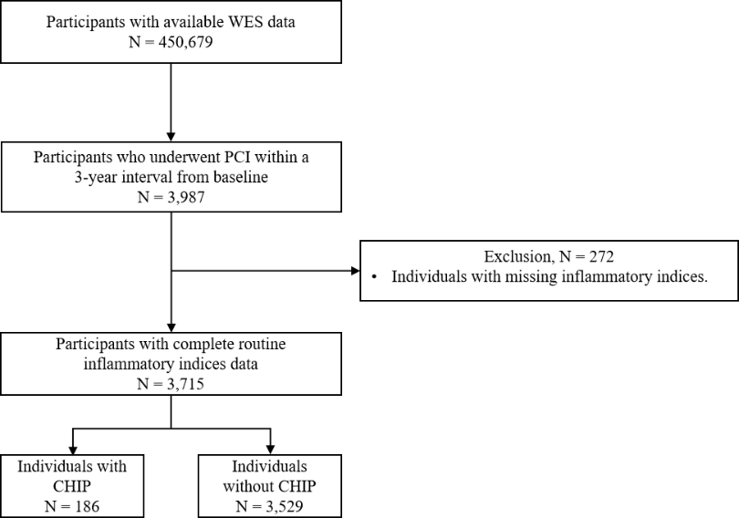

Figure S1. Participants selection flow chart in the UK Biobank.

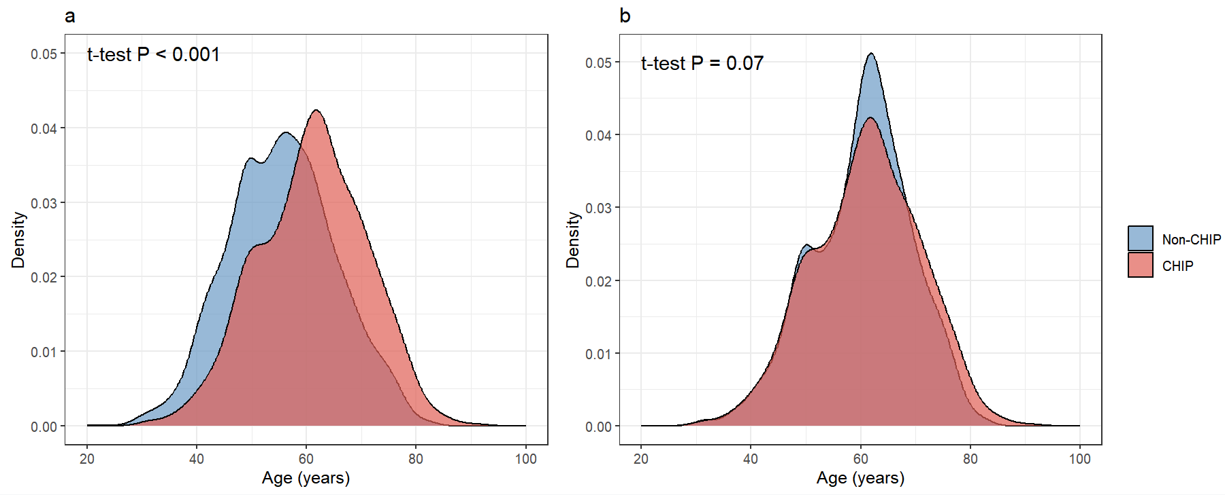

Figure S2. Distribution of baseline age by CHIP status in the (a) overall cohort (N = 3,640) and (b) the age-matched subgroup (N = 2,397).

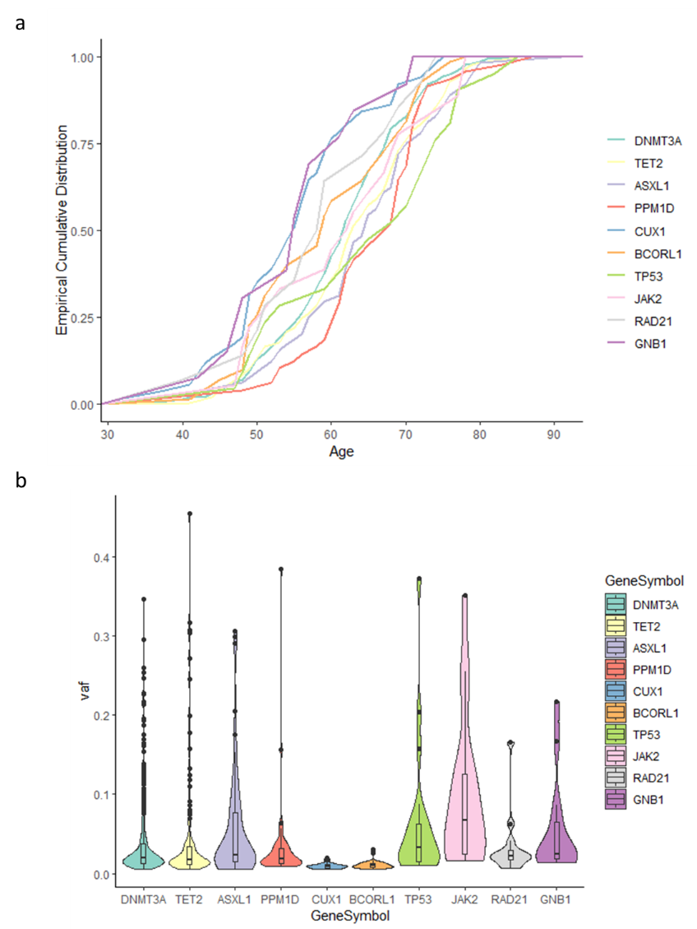

Figure S3. Gene-specific distribution of CHIP.
a. Empirical cumulative distribution of the age of individuals with CHIP stratified by the top 10 mutated CHIP genes. b. Distribution of variant allele frequency (VAF) of each gene.

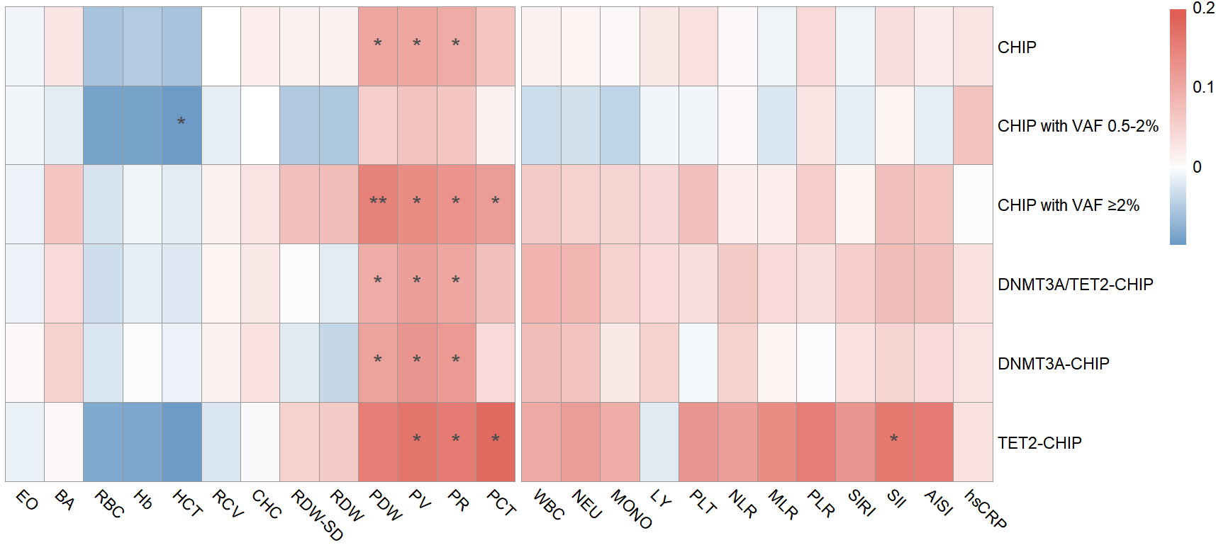

Figure S4. Heatmap for the beta coefficients of associations between CHIP and blood cell and inflammatory parameters.
Beta coefficients were calculated through linear regression between blood cell and inflammatory parameters and CHIP, with adjusting for age, sex, and body mass index. Blood cell and inflammatory parameters were scaled to a mean of 0 and SD of 1. Abbreviations: EO, eosinophil count; BA, basophil count; RBC, red blood cell count; Hb, hemoglobin; HCT, hematocrit; RCV, red cell volume; CHC, red cell hemoglobin content; RDW-SD, red cell volume distribution width standard deviation; RDW, red cell volume distribution width; PDW, platelet volume distribution width; PV, platelet volume; PR, platelet ratio; PCT, plateletcrit; WBC, white blood cell count; NEU, neutrophil count; MONO, monocyte count; LY, lymphocyte count; PLT, platelet count; NLR, neutrophil-lymphocyte ratio; MLR, monocyte-lymphocyte ratio; PLR, platelet-lymphocyte ratio; SIRI, systemic inflammatory response index; SII, systemic inflammatory index; AISI, aggregate index of systemic inflammation; hsCRP, high-sensitivity C-reaction protein; CHIP, clonal hematopoiesis of indeterminate potential; VAF, variant allele fraction.

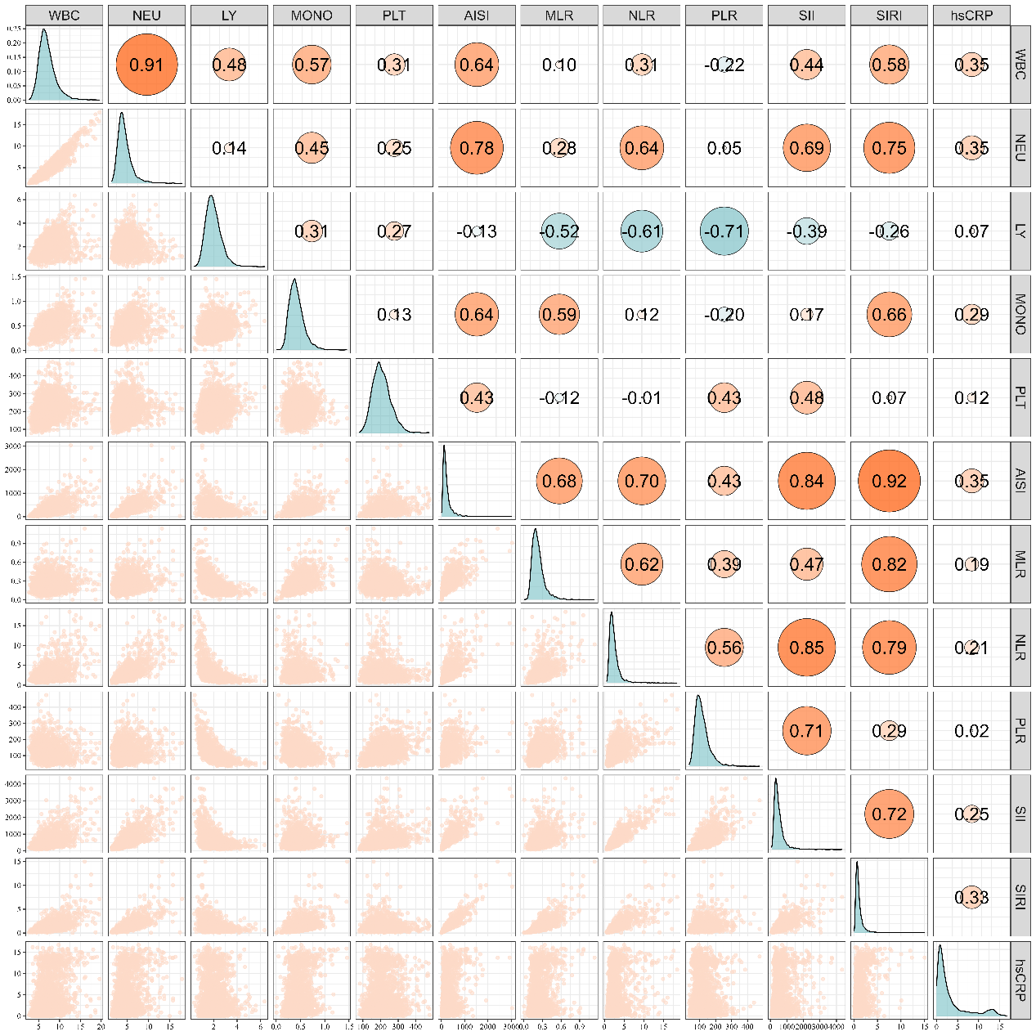

Figure S5. Spearman correlation between each pair of routine inflammatory indices.
Diagonal Panels display the distribution of each routine inflammatory index. Off-diagonal panels show scatter plots between each pair of routine inflammatory indices, and the orange circles with numbers inside them represent the correlation coefficients between variable pairs. Abbreviations: WBC, white blood cell count; NEU, neutrophil count; MONO, monocyte count; LY, lymphocyte count; PLT, platelet count; NLR, neutrophil-lymphocyte ratio; MLR, monocyte-lymphocyte ratio; PLR, platelet-lymphocyte ratio; SIRI, systemic inflammatory response index; SII, systemic immune-inflammatory index; AISI, aggregate index of systemic inflammation; hsCRP, high-sensitivity C-reaction protein.

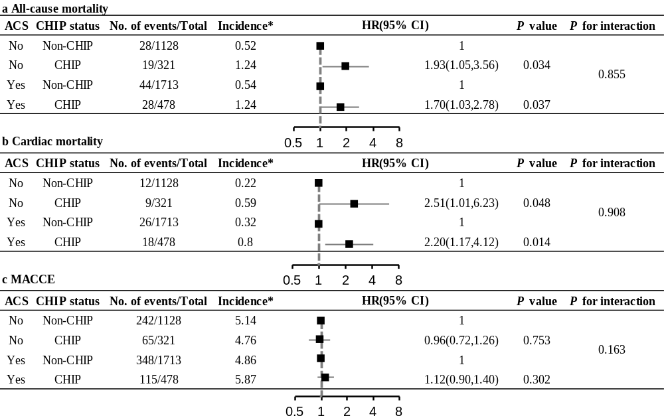

Figure S6. Associations between CHIP and 5-year outcomes by acute coronary syndromes (ACS) status.

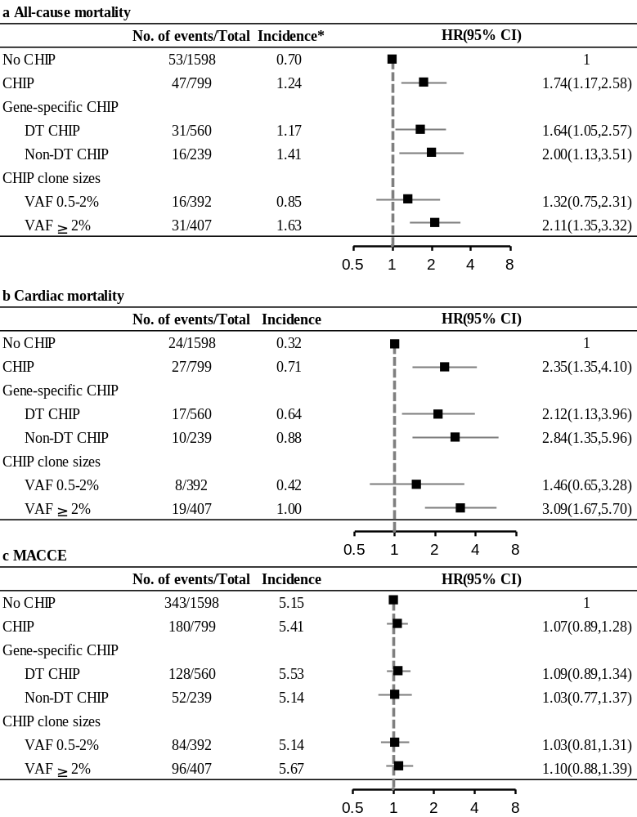

Figure S7. Associations of CHIP and its subtypes with 5-year outcomes in the age-matched subgroup.
The analyses were adjusted for age, sex, body mass index, smoking, hypertension, diabetes, low-density lipoprotein cholesterol, abnormal glomerular filtration rate, prior percutaneous coronary intervention or coronary artery bypass grafting, acute coronary syndromes, and SYNTAX score. Abbreviations: CHIP = clonal hematopoiesis of indeterminate potential; CI = confidence interval; DT = DNMT3A and/or TET2; HR = hazard ratio; MACCE = major adverse cardiovascular and cerebrovascular events; VAF = variant allele fraction. *Per 100 person-years.

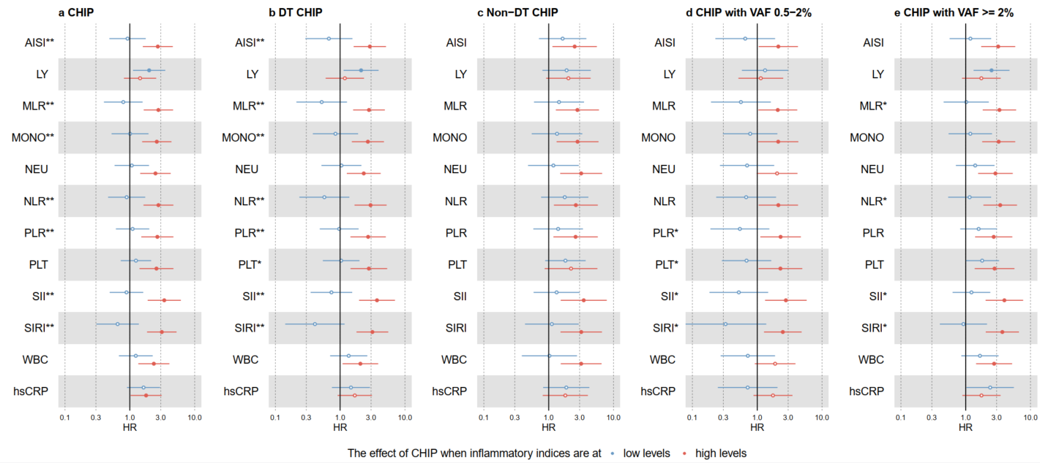

Figure S8. Associations between CHIP and 5-year all-cause mortality stratified by routine inflammatory indices in the age-matched subgroup.
The analyses were adjusted for age, sex, body mass index, smoking, hypertension, diabetes, low-density lipoprotein cholesterol, abnormal glomerular filtration rate, prior percutaneous coronary intervention or coronary artery bypass grafting, acute coronary syndromes, and SYNTAX score. The effect of CHIP and its subtypes was estimated in subgroups with low (blue) or high (red) levels of routine inflammatory indices. A solid circle indicates a significant association at P < 0.05 level. A single black star indicates statistically significant a significant interaction between CHIP and the corresponding inflammatory index at P < 0.05 level; two black star indicates statistical at false discovery rate (FDR) = 0.05 level. Abbreviations: WBC = white blood cell count; NEU = neutrophil count; MONO = monocyte count; LY = lymphocyte count; PLT = platelet count; NLR = neutrophil-lymphocyte ratio; MLR = monocyte-lymphocyte ratio; PLR = platelet-lymphocyte ratio; SIRI = systemic inflammatory response index; SII = systemic inflammatory index; AISI = aggregate index of systemic inflammation; hsCRP = high-sensitivity C-reaction protein; CHIP = clonal hematopoiesis of indeterminate potential; VAF = variant allele fraction.

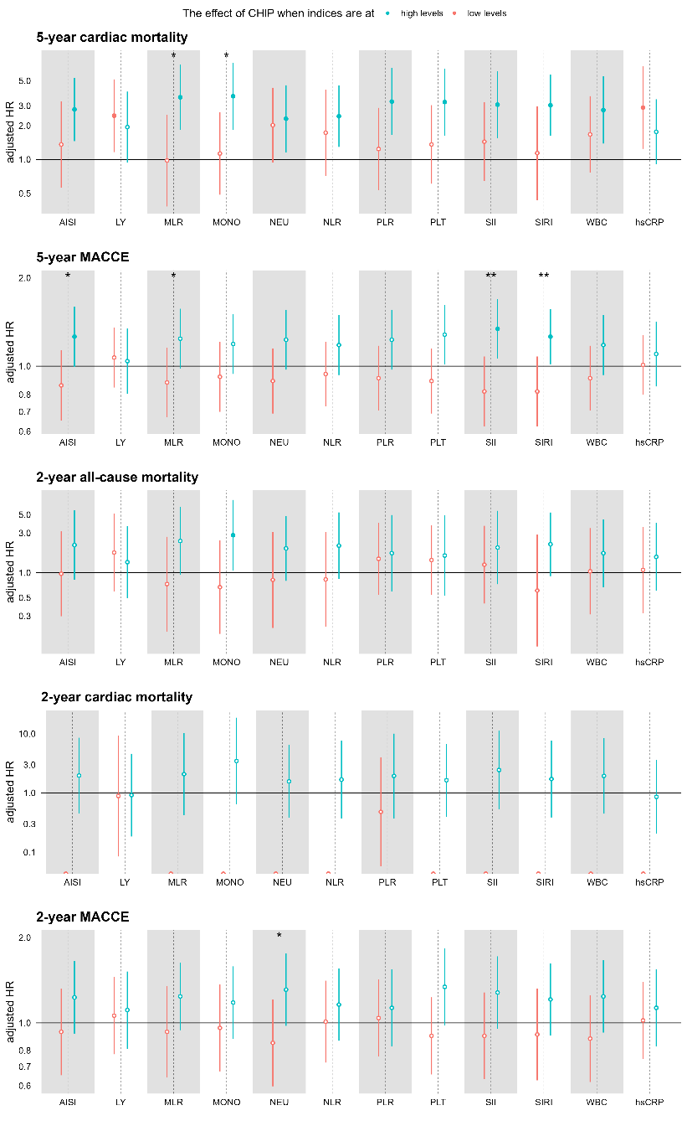

Figure S9. Associations between CHIP and secondary outcomes stratified by routine inflammatory indices.
The results were adjusted for age, sex, body mass index, smoking, hypertension, diabetes, low-density lipoprotein cholesterol, abnormal glomerular filtration rate, prior percutaneous coronary intervention or coronary artery bypass grafting, acute coronary syndromes, and SYNTAX score. The effect of CHIP was estimated in subgroups with low (red) or high (blue) levels of systemic inflammation for different secondary outcomes, as assessed by corresponding routine inflammatory indices. A single black star indicates statistical significance at P = 0.05 level; two black star indicates statistical significance at FDR=0.05 level. Abbreviations: WBC, white blood cell count; NEU, neutrophil count; MONO, monocyte count; LY, lymphocyte count; PLT, platelet count; NLR, neutrophil-lymphocyte ratio; MLR, monocyte-lymphocyte ratio; PLR, platelet-lymphocyte ratio; SIRI, systemic inflammatory response index; SII, systemic inflammatory index; AISI, aggregate index of systemic inflammation; hsCRP, high-sensitivity C-reaction protein; CHIP, clonal hematopoiesis of indeterminate potential; HR, hazard ratio; CI, confidence interval.

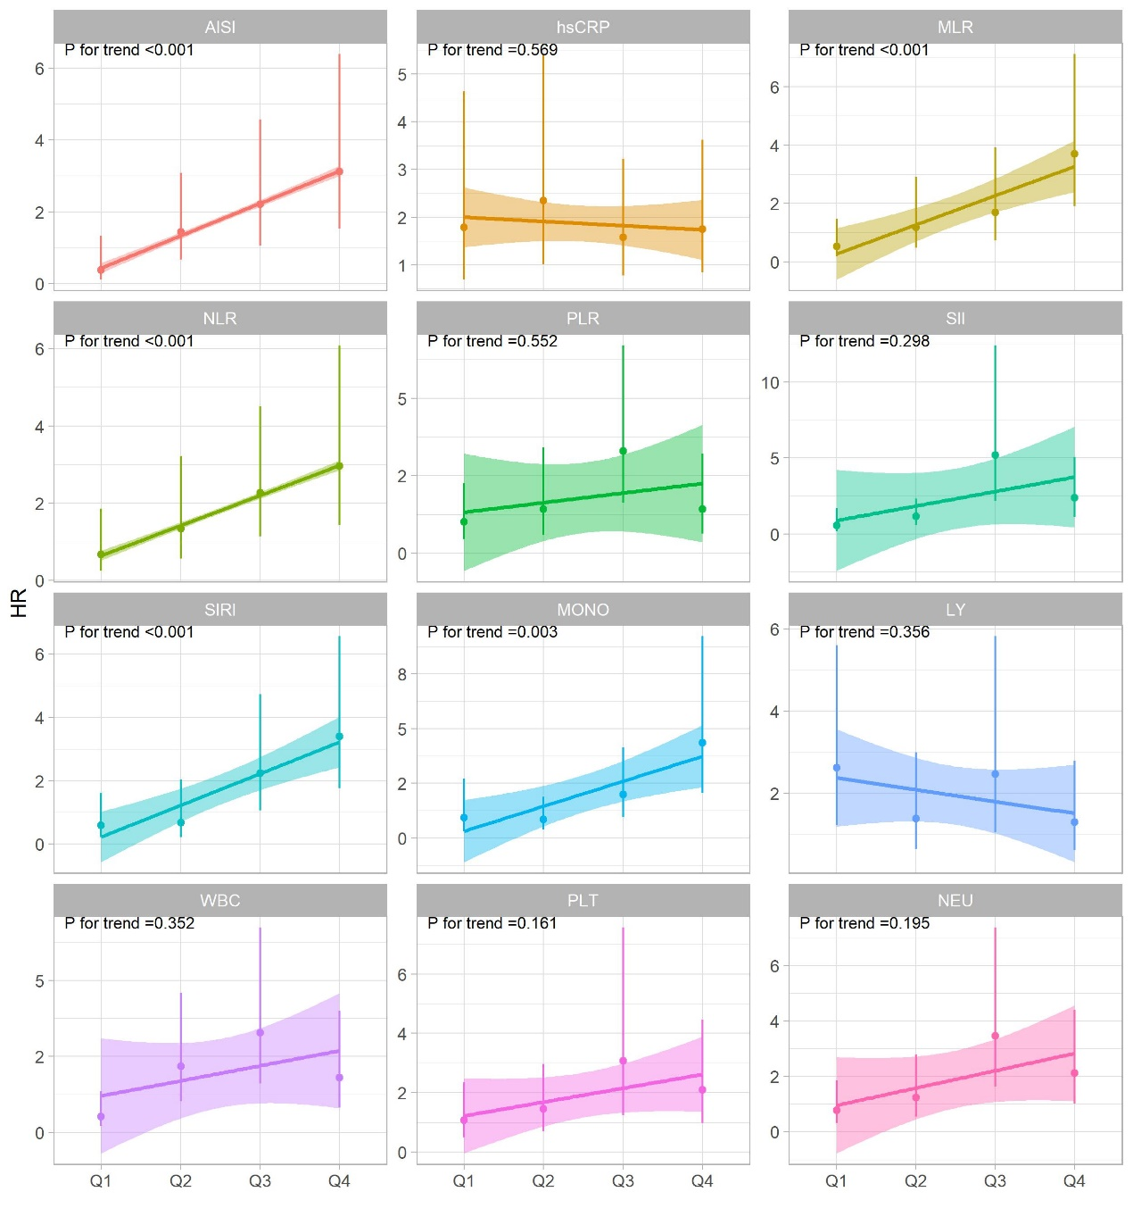

Figure S10. Associations between CHIP and 5-year all-cause mortality stratified by quartiles of systemic inflammation indicators
Abbreviations: WBC, white blood cell count; NEU, neutrophil count; MONO, monocyte count; LY, lymphocyte count; PLT, platelet count; NLR, neutrophil-lymphocyte ratio; MLR, monocyte-lymphocyte ratio; PLR, platelet-lymphocyte ratio; SIRI, systemic inflammatory response index; SII, systemic inflammatory index; AISI, aggregate index of systemic inflammation; hsCRP, high-sensitivity C-reaction protein; CHIP, clonal hematopoiesis of indeterminate potential; HR, hazard ratio.
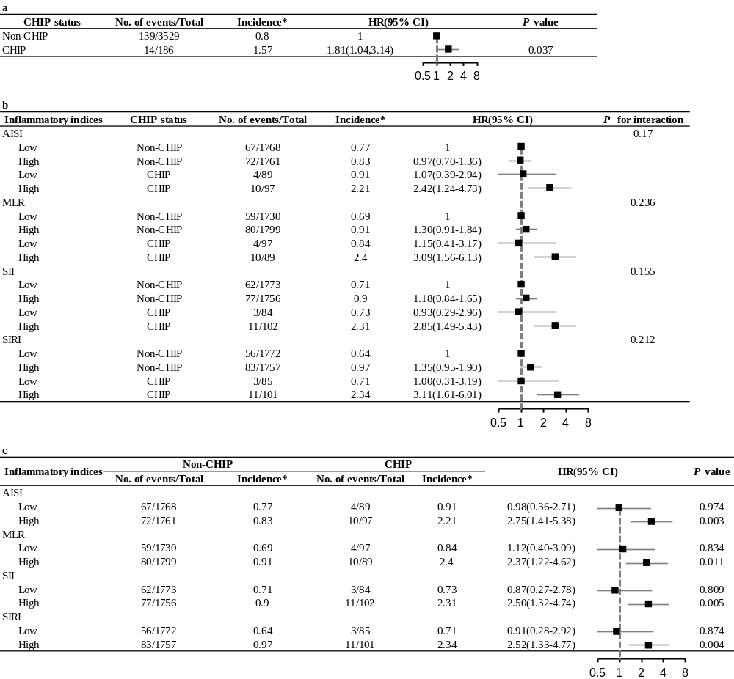

Figure S11. Summary of external validation analyses in the UK Biobank.
(a) Association between CHIP and 5-year all-cause mortality. (b) Joint impact of inflammation and CHIP on 5-year all-cause mortality. (c) The impact of CHIP on 5-year all-cause mortality by inflammatory levels. The analyses were adjusted for age, sex, body mass index, smoking, blood pressure, fasting blood glucose and low-density lipoprotein cholesterol. *Per 100 person-years. Abbreviations: AISI = aggregate index of systemic inflammation; MLR = monocyte-lymphocyte ratio; SII = systemic inflammatory index; SIRI = systemic inflammatory response index.

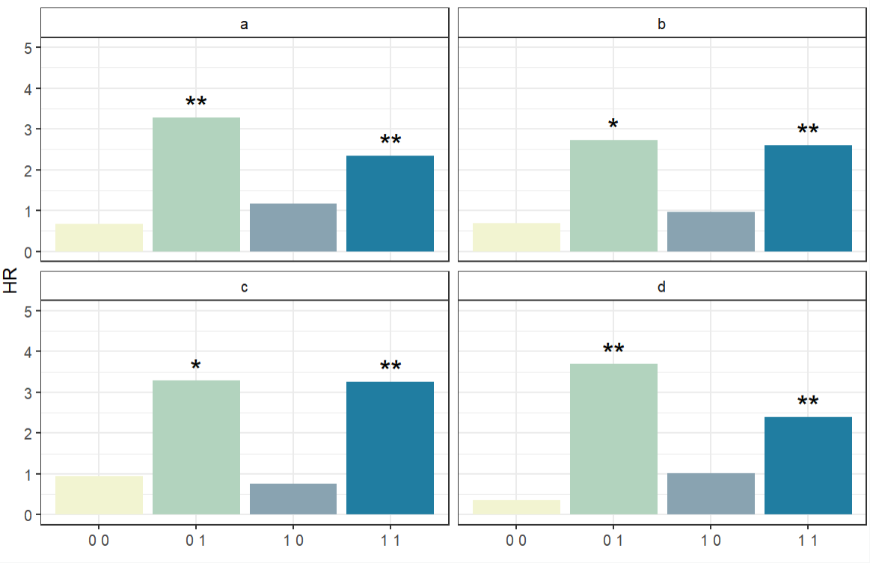

Figure S12. Associations between CHIP and 5-year all-cause mortality jointly stratified by hsCRP and inflammatory hematological parameters.
The analyses were adjusted for age, sex, body mass index, smoking, hypertension, diabetes, low-density lipoprotein cholesterol, abnormal glomerular filtration rate, prior percutaneous coronary intervention or coronary artery bypass grafting, acute coronary syndromes, and SYNTAX score. The study population was classified into four groups, named ‘0 0’, ‘0 1’, ‘1 0’, and ‘1 1’. The first digit (0/1) indicates whether hsCRP is below or above 2 mg/L; the second digit (0/1) indicates whether AISI (a), MLR (b), SII (c), and SIRI (d) are below or above their respective medians. A single black star indicates statistical significance at P<0.05 level; two black star indicates statistical significance at and P<0.01 level. Abbreviations as in Figures 1, 2, 3, and 4.

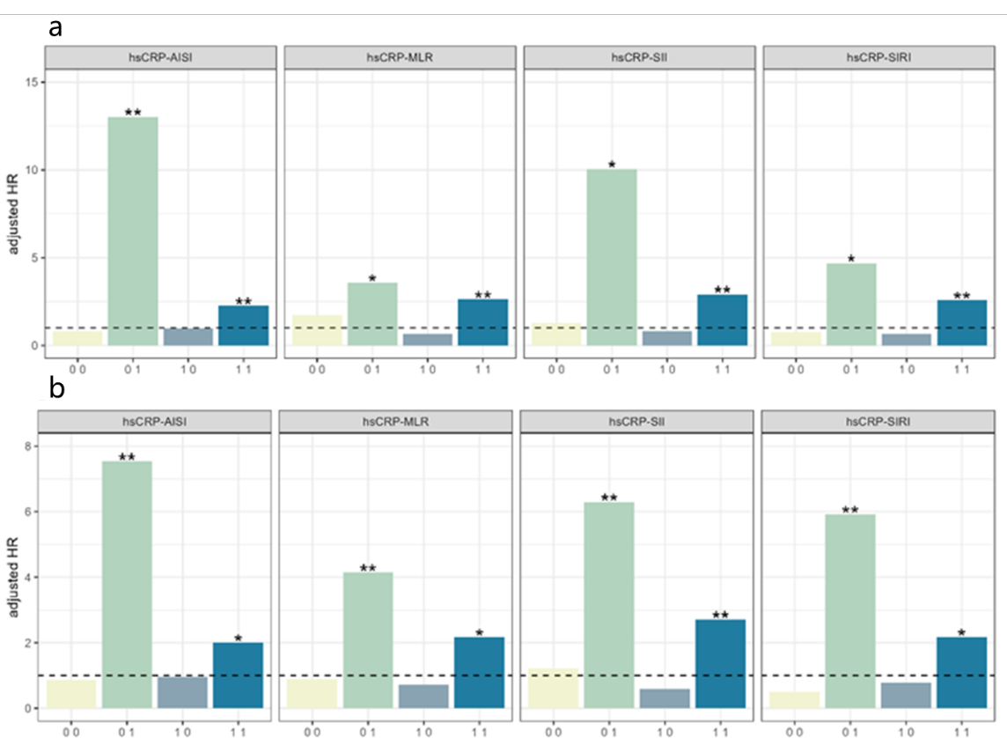

Figure S13. Sensitivity analysis for associations between CHIP and 5-year all-cause death jointly stratified by hsCRP and inflammatory hematological parameters.
The study population was classified into four groups, named 0 0, 0 1, 1 0, and 1 1. The first digit (0/1) indicates whether hsCRP is below or above 1 mg/L (a) or median (b); the second digit (0/1) suggests whether AISI, MLR, SII, and SIRI (from left to right) are below or above their respective medians. The results were adjusted for age, sex, body mass index, smoking, hypertension, diabetes, low-density lipoprotein cholesterol, abnormal glomerular filtration rate, prior percutaneous coronary intervention or coronary artery bypass grafting, acute coronary syndromes, and SYNTAX score. A single black star indicates statistical significance at P<0.05 level; two black stars indicate statistical significance at P<0.01 level. Abbreviations: AISI, aggregate index of systemic inflammation; MLR, monocyte-lymphocyte ratio; SII, systemic inflammatory index; SIRI, systemic inflammatory response index; CHIP, clonal hematopoiesis of indeterminate potential; HR, hazard ratio.

