Additional file 1

Table S1 Spearman correlations in metabolites
 | Citrate | Isocitrate | AKG | MMA | SA | Fumarate | Malate
Citrate | 1
Isocitrate | -0.0182 | 1
AKG | -0.0066 | -0.0357* | 1
MMA | -0.0018 | 0.0138 | -0.0026 | 1
SA | 0.0053 | -0.0025 | 0.3326* | 0.3169* | 1
Fumarate | 0.0304 | -0.0092 | 0.1681* | 0.1225* | 0.2731* | 1
Malate | 0.0001 | 0.0258 | 0.1664* | 0.1476* | 0.2386* | 0.004 | 1
Statistical significance is denoted by asterisks (*P < 0.05). AKG, α-ketoglutarate; MMA, methylmalonate; SA, succinate.

Table S2 Detailed TCA components, angiographic features, and medications
 | Total  (n = 4071) | TCA tertile 1  (n = 1357) | TCA tertile 2  (n = 1357) | TCA tertile 3  (n = 1357) | P Value
TCA components
Citrate, μmol/L | 55.08 (31.43, 77.45) | 55.26 (32.10, 77.46) | 53.82 (30.73, 76.12) | 56.20 (31.38, 78.64) | 0.734
Isocitrate, μmol/L | 5.70 (3.34, 7.91) | 5.65 (3.31, 7.96) | 5.81 (3.52, 7.95) | 5.68 (3.21, 7.81) | 0.790
AKG, μmol/L | 15.87 (12.21, 21.31) | 16.93 (12.77, 24.02) | 15.87 (11.92, 20.08) | 15.87 (11.94, 19.02) | <0.001
MMA, μmol/L | 0.25 (0.17, 0.36) | 0.16 (0.12, 0.22) | 0.25 (0.20, 0.33) | 0.39 (0.26, 0.57) | <0.001
SA, μmol/L | 32.36 (25.86, 41.43) | 27.69 (22.35, 43.70) | 32.36 (27.09, 39.31) | 37.96 (32.19, 52.64) | <0.001
Fumarate, μmol/L | 1.07 (0.67, 1.31) | 0.77 (0.62, 1.05) | 1.08 (0.74, 1.31) | 1.24 (1.06, 1.95) | <0.001
Malate, μmol/L | 10.47 (6.96, 17.04) | 8.00 (6.24, 11.33) | 10.84 (7.54, 16.28) | 15.15 (9.18, 23.59) | <0.001
In-hospital management
Aspirin | 3955 (97.15) | 1344 (99.04) | 1320 (97.27) | 1291 (95.14) | <0.001
Clopidogrel or ticagrelor | 3972 (97.57) | 1348 (99.34) | 1321 (97.35) | 1303 (96.02) | <0.001
Statins | 3920 (96.29) | 1335 (98.38) | 1298 (95.65) | 1287 (94.84) | <0.001
β-Blocker | 3962 (97.32) | 1336 (98.45) | 1315 (96.90) | 1311 (96.61) | 0.003
ACEI/ARB | 2976 (73.10) | 1015 (74.80) | 992 (73.10) | 969 (71.41) | 0.047
Coronary angiography features
Number of diseased vessels |  |  |  |  | <0.001
0 vessel, n (%) | 61 (1.55) | 47 (3.54) | 8 (0.61) | 6 (0.47)
1 vessel, n (%) | 1162 (29.58) | 385 (28.99) | 397 (30.24) | 380 (29.53)
2 vessels, n (%) | 1580 (40.22) | 525 (39.53) | 538 (40.97) | 517 (40.17)
3 vessels, n (%) | 1125 (28.64) | 371 (27.94) | 370 (28.18) | 384 (29.84)
Culprit vessel, n (%) |  |  |  |  | 0.003
None | 90 (2.29) | 49 (3.69) | 20 (1.52) | 21 (1.63)
LAD | 1850 (47.10) | 600 (45.18) | 621 (47.30) | 629 (48.87)
LCX | 973 (24.77) | 336 (25.30) | 327 (24.90) | 310 (24.09)
RCA | 1015 (25.84) | 343 (25.83) | 345 (26.28) | 327 (25.41)
Door-to-balloon (minutes) | 67 (47, 87) | 68 (48, 88) | 66 (46, 87) | 68 (47, 86) | 0.596
Values are presented as median (IQR) or n (%). Percentages for coronary angiography features were calculated based on the number of patients who underwent coronary angiography. ACEI/ARB, angiotensin-converting enzyme inhibitor/angiotensin receptor blocker; AKG, α-ketoglutarate; LAD, left anterior descending; LCX, left circumflex; MMA, methylmalonate; RCA, right coronary artery; SA, succinate; TCA, tricarboxylic acid.

Table S3 Baseline characteristics of all AMI patients
 | Total  (n = 4071) | Patients with Follow-up Sample (n = 1044) | Patients without Follow-up Sample (n = 3027) | P Value
Demographics
Age, years | 60.7 ± 11.6 | 57.2 ± 11.3 | 61.9 ± 11.4 | <0.001
Male | 2813 (69.10) | 787 (75.38) | 2026 (66.93) | <0.001
Cardiovascular risk factors
BMI, kg/m² | 25.0 ± 3.8 | 25.5 ± 3.8 | 24.8 ± 3.8 | <0.001
Current smoker | 2625 (64.48) | 711 (68.10) | 1914 (63.23) | <0.001
DM | 959 (23.56) | 246 (23.56) | 713 (23.55) | 0.996
Hypertension | 2130 (52.32) | 553 (52.97) | 1577 (52.10) | <0.001
Total cholesterol, mmol/L | 4.57 (3.94, 5.25) | 4.57 (3.93, 5.22) | 4.57 (3.94, 5.26) | 0.881
HDL, mmol/L | 1.22 (1.06, 1.42) | 1.22 (1.06, 1.42) | 1.22 (1.06, 1.42) | 0.744
LDL, mmol/L | 2.82 (2.28, 3.41) | 2.82 (2.31, 3.34) | 2.82 (2.28, 3.43) | 0.980
hs-CRP, mg/L | 5.75 (2.47, 11.71) | 5.09 (2.11, 10.93) | 5.75 (2.61, 11.96) | <0.001
eGFR, mL/min/1.73 m² | 81.5 (65.8, 96.9) | 85.2 (70.9, 100.2) | 80.2 (64.2, 95.5) | <0.001
Medical history
Myocardial infarction | 391 (9.60) | 79 (7.57) | 312 (10.31) | <0.001
Stroke | 877 (21.54) | 182 (17.43) | 695 (22.96) | <0.001
Cardiogenic shock | 98 (2.40) | 23 (2.20) | 75 (2.48) | 0.612
MI characteristics
GRACE score | 130 (110, 151) | 129 (109, 152) | 130 (111, 151) | 0.238
STEMI | 2917 (71.65) | 775 (74.23) | 2142 (70.76) | <0.001
EF, % | 57.1 ± 7.8 | 58.0 ± 6.9 | 56.8 ± 8.1 | <0.001
Troponin I, ng/L | 33.8 (9.6, 95.9) | 36.1 (10.7, 100.8) | 32.2 (9.3, 94.4) | 0.130
NT-ProBNP, pmol/L | 975 (343, 2551) | 718 (280, 1733.5) | 1091 (385, 2934) | <0.001
Medical treatment
Aspirin | 3955 (97.15) | 1034 (99.04) | 2921 (96.50) | <0.001
Clopidogrel or ticagrelor | 3972 (97.57) | 1039 (99.52) | 2933 (96.89) | <0.001
Statins | 3920 (96.29) | 1021 (97.80) | 2899 (95.77) | 0.003
β-Blocker | 3962 (97.32) | 1013 (97.03) | 2949 (97.42) | 0.498
ACEI/ARB | 2976 (73.10) | 838 (80.27) | 2138 (70.63) | <0.001
CAG | 3928 (96.49) | 1035 (99.14) | 2893 (95.57) | <0.001
PCI | 3361 (82.56) | 903 (86.49) | 2458 (81.20) | <0.001
Follow-up duration, years | 6.2 (5.7, 6.8) | 6.5 (5.9, 6.9) | 6.1 (5.6, 6.7) | <0.001
TCA components
TCA index | 0.01 (-0.19, 0.17) | -0.02 (-0.21, 0.16) | 0.01 (-0.18, 0.18) | <0.001
Citrate, μmol/L | 55.08 (31.43, 77.45) | 54.40 (32.47, 77.15) | 55.22 (30.94, 77.58) | 0.532
Isocitrate, μmol/L | 5.70 (3.34, 7.91) | 5.73 (3.36, 7.89) | 5.70 (3.33, 7.93) | 0.903
AKG, μmol/L | 15.87 (12.21, 21.31) | 15.87 (12.53, 21.84) | 15.87 (12.15, 21.05) | 0.027
MMA, μmol/L | 0.25 (0.17, 0.36) | 0.25 (0.16, 0.34) | 0.25 (0.17, 0.37) | <0.001
SA, μmol/L | 32.36 (25.86, 41.43) | 32.36 (26.50, 40.72) | 32.36 (25.66, 41.71) | 0.089
Fumarate, μmol/L | 1.07 (0.67, 1.31) | 1.06 (0.68, 1.30) | 1.07 (0.67, 1.31) | 0.873
Malate, μmol/L | 10.47 (6.96, 17.04) | 10.86 (7.23, 17.04) | 10.34 (6.84, 16.96) | 0.858
Coronary angiography features
Number of diseased vessels |  |  |  | 0.302
0 vessel, n (%) | 61 (1.55) | 19 (1.84) | 42 (1.45)
1 vessel, n (%) | 1162 (29.58) | 325 (31.40) | 837 (28.93)
2 vessels, n (%) | 1580 (40.22) | 396 (38.26) | 1184 (40.93)
3 vessels, n (%) | 1125 (28.64) | 295 (28.50) | 830 (28.69)
Culprit vessel, n (%) |  |  |  | 0.751
None | 90 (2.29) | 25 (2.42) | 65 (2.25)
LAD | 1850 (47.10) | 474 (45.80) | 1376 (47.56)
LCX | 973 (24.77) | 267 (25.80) | 706 (24.40)
RCA | 1015 (25.84) | 269 (25.99) | 746 (25.79)
Door-to-balloon (minutes) | 67 (47, 87) | 67 (48, 87) | 67 (47, 87) | 0.852
Values are mean (SD), median (IQR) or n (%). Percentages for coronary angiography features were calculated based on the number of patients who underwent coronary angiography. AKG, α-ketoglutarate; BMI, body mass index；eGFR, chronic kidney disease epidemiology collaboration; LAD, left anterior descending; LCX, left circumflex; MMA, methylmalonate; RCA, right coronary artery; SA, succinate

Table S4 Association between the follow-up TCA index tertiles and MACE
 | Tertile 1  (n = 348) | Tertile 2  (n = 348) | Tertile 3  (n = 348) | P trend | Increase per SD | P Value
MACE
No. of events (%) | 55 (15.8) | 88 (25.3) | 106 (30.5) | / | 249 (23.9) | /
Events/1000 patient-years | 39.0 | 51.6 | 67.5 | / | - | /
Unadjusted | Reference | 1.71 (1.21-2.41) | 2.14 (1.54-2.98) | <0.001 | 1.22 (1.08-1.37) | 0.001
Model 1 | Reference | 1.69 (1.20-2.36) | 2.07 (1.50-2.87) | <0.001 | 1.19 (1.06-1.33) | 0.004
A total of 1,044 AMI patients who had outpatient record and took plama tests at baseline and follow-up, were included in this analysis. Model 1 was adjusted for age, sex, DM, hypertension, smoking status, BMI, previous myocardial infarction, previous stroke, PCI, TnI, NTpro-BNP, hs-CRP and eGFR.

Table S5 Association between TCA tertiles and outcomes among patients survived more than 30 days
 | Tertile 1  (n = 1336) | Tertile 2  (n = 1315) | Tertile 3  (n = 1279) | P trend | Increase per SD | P Value
MACE (n = 944)
Unadjusted | Reference | 1.26 (1.07-1.49) | 2.00 (1.72-2.34) | <0.001 | 1.36 (1.28-1.44) | <0.001
Model 1 | Reference | 1.12 (0.95-1.32) | 1.49 (1.27-1.75) | <0.001 | 1.17 (1.10-1.24) | <0.001
All-cause death (n = 531)
Unadjusted | Reference | 1.38 (1.08-1.75) | 2.48 (2.00-3.09) | <0.001 | 1.53 (1.41-1.65) | <0.001
Model 1 | Reference | 1.09 (0.85-1.39) | 1.51 (1.20-1.90) | <0.001 | 1.23 (1.13-1.34) | <0.001
Cardiovascular death (n = 265)
Unadjusted | Reference | 1.26 (0.90-1.78) | 2.45 (1.81-3.33) | <0.001 | 1.59 (1.42-1.78) | <0.001
Model 1 | Reference | 0.99 (0.70-1.41) | 1.55 (1.12-2.13) | 0.003 | 1.28 (1.14-1.44) | <0.001
Heart failure (n = 374)
Unadjusted | Reference | 1.14 (0.87-1.49) | 1.84 (1.43-2.35) | <0.001 | 1.30 (1.17-1.44) | <0.001
Model 1 | Reference | 0.99 (0.76-1.31) | 1.39 (1.07-1.80) | 0.009 | 1.12 (1.01-1.24) | 0.029
A total of 3,930 AMI patients were included in this analysis. Model 1 was adjusted for age, sex, DM, hypertension, smoking status, BMI, previous myocardial infarction, previous stroke, PCI, TnI, NTpro-BNP, hs-CRP and eGFR.

Table S6 Association between TCA tertiles and outcomes with EF replacing NT-proBNP
 | Tertile 1  (n = 1357) | Tertile 2  (n = 1357) | Tertile 3  (n = 1357) | P trend | Increase per SD | P Value
MACE (n = 1263)
Unadjusted | Reference | 1.25 (1.07-1.45) | 2.05 (1.78-2.37) | <0.001 | 1.40 (1.32-1.48) | <0.001
Model 2 | Reference | 1.10 (0.94-1.29) | 1.42 (1.22-1.65) | <0.001 | 1.16 (1.09-1.23) | <0.001
All-cause death (n = 672)
Unadjusted | Reference | 1.41 (1.13-1.77) | 2.45 (1.99-3.01) | <0.001 | 1.52 (1.41-1.64) | <0.001
Model 2 | Reference | 1.14 (0.90-1.43) | 1.47 (1.18-1.82) | <0.001 | 1.20 (1.11-1.30) | <0.001
Cardiovascular death (n = 373)
Unadjusted | Reference | 1.28 (0.95-1.74) | 2.50 (1.90-3.28) | <0.001 | 1.60 (1.45-1.76) | <0.001
Model 2 | Reference | 1.04 (0.77-1.42) | 1.50 (1.13-2.00) | 0.002 | 1.25 (1.12-1.38) | <0.001
Heart failure (n = 561)
Unadjusted | Reference | 1.12 (0.89-1.42) | 1.96 (1.59-2.43) | <0.001 | 1.41 (1.30-1.53) | <0.001
Model 2 | Reference | 1.06 (0.84-1.34) | 1.40 (1.12-1.74) | 0.002 | 1.12 (1.03-1.22) | 0.008
A total of 4,071 AMI patients were included in this analysis. Model 2 was adjusted for age, sex, DM, hypertension, smoking status, BMI, previous myocardial infarction, previous stroke, PCI, TnI, EF, hs-CRP and eGFR.

Table S7 Association between TCA tertiles and outcomes in sensitivity analyses
 | Tertile 1  (n = 1357) | Tertile 2  (n = 1357) | Tertile 3  (n = 1357) | P trend | Increase per SD | P Value
MACE (n = 1263)
Model 3 | Reference | 1.10 (0.94-1.29) | 1.50 (1.29-1.74) | <0.001 | 1.19 (1.12-1.26) | <0.001
Model 4 | Reference | 1.10 (0.94-1.29) | 1.54 (1.33-1.79) | <0.001 | 1.21 (1.15-1.28) | <0.001
All-cause death (n = 672)
Model 3 | Reference | 1.14 (0.90-1.43) | 1.50 (1.20-1.86) | <0.001 | 1.21 (1.12-1.31) | <0.001
Model 4 | Reference | 1.13 (0.90-1.42) | 1.53 (1.23-1.90) | <0.001 | 1.23 (1.14-1.34) | <0.001
Cardiovascular death (n = 373)
Model 3 | Reference | 1.03 (0.76-1.41) | 1.56 (1.17-2.08) | 0.001 | 1.27 (1.14-1.40) | <0.001
Model 4 | Reference | 1.03 (0.76-1.41) | 1.62 (1.21-2.15) | <0.001 | 1.30 (1.18-1.45) | <0.001
Heart failure (n = 561)
Model 3 | Reference | 0.98 (0.78-1.25) | 1.46 (1.17-1.82) | <0.001 | 1.20 (1.10-1.31) | <0.001
Model 4 | Reference | 0.99 (0.78-1.26) | 1.51 (1.21-1.88) | <0.001 | 1.23 (1.13-1.34) | <0.001
A total of 4,071 AMI patients were included in this analysis. Model 3 was adjusted for model 1, glucose and triglyceride levels. Model 4 was adjusted for age, sex, DM, hypertension, smoking status, BMI, previous myocardial infarction, previous stroke, PCI, TnI, EF, and hs-CRP.

Table S8 Association between TCA tertiles and outcomes treating death as a competing risk
 | Tertile 1  (n = 1357) | Tertile 2  (n = 1357) | Tertile 3  (n = 1357) | P trend | Increase per SD | P Value
Cardiovascular death (n = 373)
Unadjusted | Reference | 1.27 (0.94-1.72) | 2.41 (1.83-3.16) | <0.001 | 1.57 (1.42-1.73) | <0.001
Model 1 | Reference | 1.02 (0.74-1.40) | 1.51 (1.13-2.02) | 0.002 | 1.25 (1.13-1.39) | <0.001
Heart failure (n = 561)
Unadjusted | Reference | 1.11 (0.88-1.40) | 1.89 (1.54-2.34) | <0.001 | 1.38 (1.26-1.50) | <0.001
Model 1 | Reference | 0.99 (0.78-1.25) | 1.43 (1.15-1.78) | 0.001 | 1.19 (1.09-1.30) | <0.001
A total of 4,071 AMI patients were included in this analysis. Model 1 was adjusted for age, sex, DM, hypertension, smoking status, BMI, previous myocardial infarction, previous stroke, PCI, TnI, NTpro-BNP, hs-CRP and eGFR.

Table S9 Association between TCA tertiles and outcomes stratified by age
 | ≤60 (n = 1886) |  | >60 (n = 2185)
 | Increase per SD | P Value | Increase per SD | P Value | P for interaction
MACE
Unadjusted | 1.38 (1.25-1.54) | <0.001 | 1.28 (1.19-1.37) | <0.001
Adjusted | 1.24 (1.11-1.38) | <0.001 | 1.16 (1.08-1.24) | <0.001 | 0.106
All-cause death
Unadjusted | 1.57 (1.34-1.83) | <0.001 | 1.35 (1.23-1.48) | <0.001
Adjusted | 1.32 (1.12-1.55) | 0.001 | 1.16 (1.06-1.28) | 0.002 | 0.055
Cardiovascular death
Unadjusted | 1.63 (1.34-1.99) | <0.001 | 1.45 (1.29-1.63) | <0.001
Adjusted | 1.32 (1.08-1.63) | 0.008 | 1.24 (1.10-1.41) | 0.001 | 0.353
Heart failure
Unadjusted | 1.42 (1.21-1.66) | <0.001 | 1.28 (1.15-1.41) | <0.001
Adjusted | 1.26 (1.08-1.48) | 0.003 | 1.17 (1.05-1.29) | 0.003 | 0.236
A total of 4,071 AMI patients were included in this analysis. Models were adjusted for sex, DM, hypertension, smoking status, BMI, previous myocardial infarction, previous stroke, PCI, TnI, NTpro-BNP, hs-CRP and eGFR.

Table S10 Association between TCA tertiles and outcomes stratified by DM
 | DM (n = 959) |  | non-DM (n = 3112)
 | Increase per SD | P Value | Increase per SD | P Value | P for interaction
MACE
Unadjusted | 1.42 (1.28-1.58) | <0.001 | 1.39 (1.30-1.48) | <0.001
Adjusted | 1.23 (1.11-1.37) | <0.001 | 1.18 (1.10-1.26) | <0.001 | 0.862
All-cause death
Unadjusted | 1.57 (1.37-1.80) | <0.001 | 1.49 (1.36-1.64) | <0.001
Adjusted | 1.27 (1.11-1.47) | 0.001 | 1.19 (1.08-1.32) | 0.001 | 0.592
Cardiovascular death
Unadjusted | 1.65 (1.38-1.97) | <0.001 | 1.58 (1.40-1.78) | <0.001
Adjusted | 1.33 (1.11-1.60) | 0.002 | 1.24 (1.09-1.41) | 0.001 | 0.940
Heart failure
Unadjusted | 1.52 (1.29-1.78) | <0.001 | 1.37 (1.24-1.51) | <0.001
Adjusted | 1.34 (1.14-1.58) | 0.001 | 1.15 (1.04-1.27) | 0.006 | 0.372
A total of 4,071 AMI patients were included in this analysis. Models were adjusted for age, sex, hypertension, smoking status, BMI, previous myocardial infarction, previous stroke, PCI, TnI, NTpro-BNP, hs-CRP and eGFR.

Table S11 Association between TCA tertiles and outcomes stratified by MS
 | MS (n = 724) |  | non-MS (n = 3347)
 | Increase per SD | P Value | Increase per SD | P Value | P for interaction
MACE
Unadjusted | 1.46 (1.29-1.67) | <0.001 | 1.38 (1.30-1.47) | <0.001
Adjusted | 1.27 (1.11-1.45) | 0.001 | 1.18 (1.10-1.25) | <0.001 | 0.974
All-cause death
Unadjusted | 1.64 (1.38-1.93) | <0.001 | 1.49 (1.37-1.62) | <0.001
Adjusted | 1.33 (1.11-1.58) | 0.002 | 1.19 (1.08-1.30) | <0.001 | 0.732
Cardiovascular death
Unadjusted | 1.81 (1.45-2.25) | <0.001 | 1.55 (1.39-1.73) | <0.001
Adjusted | 1.39 (1.10-1.75) | 0.005 | 1.22 (1.08-1.37) | 0.001 | 0.494
Heart failure
Unadjusted | 1.60 (1.32-1.94) | <0.001 | 1.37 (1.25-1.50) | <0.001
Adjusted | 1.34 (1.09-1.65) | 0.005 | 1.16 (1.06-1.27) | 0.002 | 0.265
A total of 4,071 AMI patients were included in this analysis. Models were adjusted for age, sex, DM, hypertension, smoking status, BMI, previous myocardial infarction, previous stroke, PCI, TnI, NTpro-BNP, hs-CRP and eGFR.

Table S12 Baseline characteristics stratified by sex
 | Total  (n = 4071) | Male  (n = 2813) | Female  (n = 1258) | P Value
Demographics
Age, years | 60.7 ± 11.6 | 58.4 ± 11.6 | 65.9 ± 9.6 | <0.001
Cardiovascular risk factors
BMI, kg/m² | 25.0 ± 3.8 | 25.4 ± 3.8 | 24.1 ± 3.7 | <0.001
Current smoker | 2625 (64.48) | 2102 (74.72) | 523 (41.57) | <0.001
DM | 959 (23.56) | 590 (20.97) | 369 (29.33) | <0.001
Hypertension | 2130 (52.32) | 1349 (47.96) | 781 (62.08) | <0.001
Total cholesterol, mmol/L | 4.57 (3.94, 5.25) | 4.57 (3.94, 5.24) | 4.57 (3.93, 5.25) | 0.972
HDL, mmol/L | 1.22 (1.06, 1.42) | 1.22 (1.06, 1.42) | 1.22 (1.06, 1.42) | 0.326
LDL, mmol/L | 2.82 (2.28, 3.41) | 2.82 (2.28, 3.40) | 2.82 (2.29, 3.44) | 0.703
hs-CRP, mg/L | 5.75 (2.47, 11.71) | 5.75 (2.32, 11.48) | 6.39 (2.90, 12.25) | <0.001
eGFR, mL/min/1.73 m² | 81.5 (65.8, 96.9) | 84.8 (69.4, 100.4) | 74.8 (59.7, 89.5) | <0.001
Medical history
Myocardial infarction | 391 (9.60) | 292 (10.38) | 99 (7.87) | 0.012
Stroke | 877 (21.54) | 576 (20.48) | 301 (23.93) | 0.013
Cardiogenic shock | 98 (2.40) | 59 (2.10) | 39 (3.10) | 0.055
MI characteristics
GRACE score | 130 (110, 151) | 129 (109, 151) | 130.5 (113, 151) | 0.010
STEMI | 2917 (71.65) | 2038 (72.45) | 879 (69.87) | 0.079
EF, % | 57.1 ± 7.8 | 57.2 ± 7.9 | 57.0 ± 7.7 | 0.512
Troponin I, ng/L | 33.8 (9.6, 95.9) | 35.1 (10.0, 101.2) | 29.9 (8.5, 86.6) | 0.228
NT-ProBNP, pmol/L | 975 (343, 2551) | 779 (277, 1971) | 1688 (638, 4103) | <0.001
Medical treatment
Aspirin | 3955 (97.15) | 2734 (97.19) | 1221 (97.06) | 0.814
Clopidogrel or ticagrelor | 3972 (97.57) | 2753 (97.87) | 1219 (96.90) | 0.066
Statins | 3920 (96.29) | 2717 (96.59) | 1203 (95.63) | 0.135
β-Blocker | 3962 (97.32) | 2732 (97.12) | 1230 (97.77) | 0.234
ACEI/ARB | 2976 (73.10) | 2089 (74.26) | 887 (70.51) | 0.013
CAG | 3928 (96.49) | 2733 (97.16) | 1195 (94.99) | 0.001
PCI | 3361 (82.56) | 2334 (82.97) | 1027 (81.64) | 0.300
Follow-up duration, years | 6.2 (5.7, 6.8) | 6.2 (5.7, 6.8) | 6.1 (5.6, 6.7) | <0.001
TCA components
TCA index | 0.01 (-0.19, 0.17) | 0.00 (-0.20, 0.16) | 0.01 (-0.17, 0.18) | 0.018
Citrate, μmol/L | 55.08 (31.43, 77.45) | 55.23 (31.52, 79.09) | 54.18 (31.10, 74.71) | 0.131
Isocitrate, μmol/L | 5.70 (3.34, 7.91) | 5.67 (3.30, 7.86) | 5.81 (3.42, 8.12) | 0.117
AKG, μmol/L | 15.87 (12.21, 21.31) | 15.87 (12.26, 21.84) | 15.87 (12.17, 20.10) | 0.012
MMA, μmol/L | 0.25 (0.17, 0.36) | 0.25 (0.17, 0.36) | 0.25 (0.17, 0.36) | 0.638
SA, μmol/L | 32.36 (25.86, 41.43) | 32.36 (25.63, 41.16) | 32.36 (26.35, 41.87) | 0.939
Fumarate, μmol/L | 1.07 (0.67, 1.31) | 1.06 (0.65, 1.30) | 1.08 (0.70, 1.32) | 0.494
Malate, μmol/L | 10.47 (6.96, 17.04) | 10.40 (6.86, 17.03) | 10.61 (7.17, 17.04) | 0.952
Coronary angiography features
Number of diseased vessels |  |  |  | 0.064
0 vessel, n (%) | 61 (1.55) | 43 (1.57) | 18 (1.51)
1 vessel, n (%) | 1162 (29.58) | 773 (28.28) | 389 (32.55)
2 vessels, n (%) | 1580 (40.22) | 1120 (40.98) | 460 (38.49)
3 vessels, n (%) | 1125 (28.64) | 797 (29.16) | 328 (27.45)
Culprit vessel, n (%) |  |  |  | 0.280
None | 90 (2.29) | 64 (2.34) | 26 (2.18)
LAD | 1850 (47.10) | 1273 (46.58) | 577 (48.28)
LCX | 973 (24.77) | 666 (24.37) | 307 (25.69)
RCA | 1015 (25.84) | 730 (26.71) | 285 (23.85)
Door-to-balloon (minutes) | 67 (47, 87) | 67 (47, 87) | 67 (47, 87) | 0.931
Values are mean (SD), median (IQR) or n (%). Percentages for coronary angiography features were calculated based on the number of patients who underwent coronary angiography. AKG, α-ketoglutarate; BMI, body mass index; eGFR, chronic kidney disease epidemiology collaboration; LAD, left anterior descending; LCX, left circumflex; MMA, methylmalonate; RCA, right coronary artery; SA, succinate.

Table S13 Incremental predictive value of adding TCA index to reference models in AMI patients
 | MACE |  | All-cause Death |  | Cardiovascular Death |  | Heart Failure
Harrell’s C-index | Reference | Reference +TCA | Reference | Reference +TCA | Reference | Reference +TCA | Reference | Reference +TCA
C-index | 0.687 | 0.697 | 0.713 | 0.728 | 0.736 | 0.750 | 0.766 | 0.769
C-index increment | Reference | 0.010 | Reference | 0.015 | Reference | 0.015 | Reference | 0.003
Time-dependent AUC
1-year AUC | 0.695 | 0.705 | 0.722 | 0.743 | 0.753 | 0.776 | 0.768 | 0.775
1-year AUC increment | Reference | 0.01 | Reference | 0.021 | Reference | 0.023 | Reference | 0.007
3-year AUC | 0.701 | 0.714 | 0.728 | 0.746 | 0.752 | 0.769 | 0.787 | 0.792
3-year AUC increment | Reference | 0.013 | Reference | 0.018 | Reference | 0.017 | Reference | 0.005
Continuous NRI
1-year continuous NRI | Reference | 0.098 (0.051-0.138) | Reference | 0.116 (0.010-0.127) | Reference | 0.128 (0.013-0.194) | Reference | 0.090 (0.009-0.161)
3-year continuous NRI | Reference | 0.071 (0.009-0.111) | Reference | 0.095 (0.010-0.120) | Reference | 0.092 (0.006-0.132) | Reference | 0.057 (0.009-0.112)
Categorical NRI
1-year categorical NRI | Reference | 0.032 (0.017-0.058) | Reference | 0.030 (-0.058-0.039) | Reference | 0.010 (-0.026-0.051) | Reference | 0.038 (0.015-0.062)
3-year categorical NRI | Reference | 0.046 (0.025-0.073) | Reference | 0.063 (0.018-0.090) | Reference | 0.012 (-0.012-0.066) | Reference | 0.039 (0.002-0.072)
IDI
1-year IDI | Reference | 0.008 (0.003-0.013) | Reference | 0.008 (0.000-0.011) | Reference | 0.005 (0.001-0.011) | Reference | 0.008 (0.000-0.018)
3-year IDI | Reference | 0.008 (0.001-0.012) | Reference | 0.008 (0.001-0.017) | Reference | 0.005 (0.000-0.008) | Reference | 0.007 (0.001-0.010)
*Reference model includes the Grace score, TnI and NT-proBNP.

Table S14 Internal validation of predictive models using 1000 bootstrap samples
Outcome | Original C-index | Bootstrap-corrected C-index | 95% Confidence Interval
MACE | 0.696 | 0.696 | (0.683-0.711)
All-cause Death | 0.728 | 0.727 | (0.710-0.748)
Cardiovascular Death | 0.75 | 0.749 | (0.725-0.776)
Heart Failure | 0.769 | 0.769 | (0.748-0.790)
The predictive performance was evaluated based on a model including the TCA index, GRACE score, TnI, and NT-proBNP. Optimism-corrected C-indices were derived from 1,000 bootstrap resamples.

Table S15 Population attributable fraction stratified by sex
Variable | Female (n = 1258) | Male (n = 2813) | P Value
TCA Index Exposure
High TCA Index, n (%) | 645 (51.27) | 1390 (49.41) | 0.273
Outcome Incidence
MACE, n (%) | 454 (36.0) | 809 (28.7) | < 0.001
All-cause Death, n (%) | 262 (20.8) | 410 (14.5) | < 0.001
Cardiovascular Death, n (%) | 149 (11.8) | 224 (7.9) | < 0.001
Heart Failure, n (%) | 215 (17.0) | 346 (12.3) | < 0.001
Population Attributable Fraction (PAF)
MACE, % | 18.08 | 11.1 | -
All-cause Death, % | 24.7 | 10.05 | -
Cardiovascular Death, % | 24.13 | 15.07 | -
Heart Failure, % | 15.78 | 14.4 | -
High TCA Index defined as values above the median.

Fig. S1 Forest plot showing hazard ratios for MACE associated with TCA cycle metabolites in patients with AMI
A total of 4,071 AMI patients were included in this analysis. Adjusted for age, sex, DM, hypertension, smoking status, BMI, previous myocardial infarction, previous stroke, PCI, TnI, NTpro-BNP, hs-CRP and eGFR. AKG, α-ketoglutarate; MMA, methylmalonate; SA, succinate.

Fig. S2 Forest plot showing hazard ratios for MACE associated with TCA cycle metabolites in patients with AMI
A total of 4,071 AMI patients were included in this analysis. Adjusted for AKG, MMA, SA, fumarate and malate. AKG, α-ketoglutarate; MMA, methylmalonate; SA, succinate.

Fig. S3 Restricted cubic spline curves and histograms for TCA index and adverse outcomes
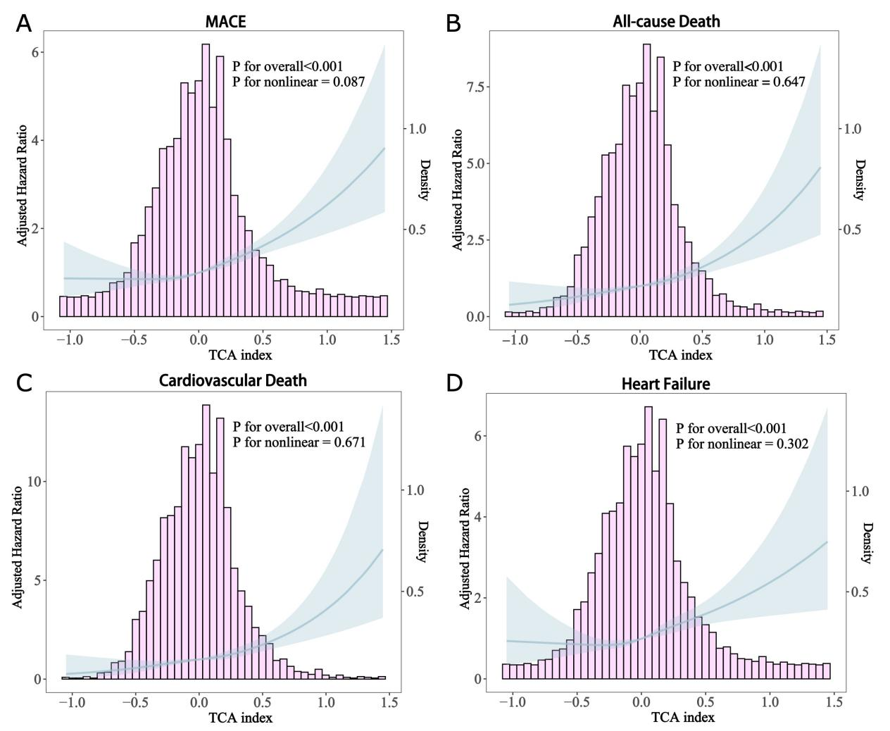
Restricted cubic spline curves and histograms for TCA index and MACE (A), all-cause death (B), cardiovascular death (C), and heart failure (D) in AMI patients (n = 4,071).

Fig. S4 Two measurements of patients’ plasma metabolites at baseline and outpatient follow-up
Two measurements of 1,044 AMI patients’ plasma AKG, MMA, SA, fumarate, malate, and TCA index at baseline and outpatient follow-up. The mean TCA index significantly decreased from -0.026 at baseline to -0.307 at follow-up (median [IQR]: -0.022 [-0.203 to 0.157] to -0.354 [-0.576 to -0.186]).

Fig. S5 Decision curve analysis for the prediction of clinical outcomes
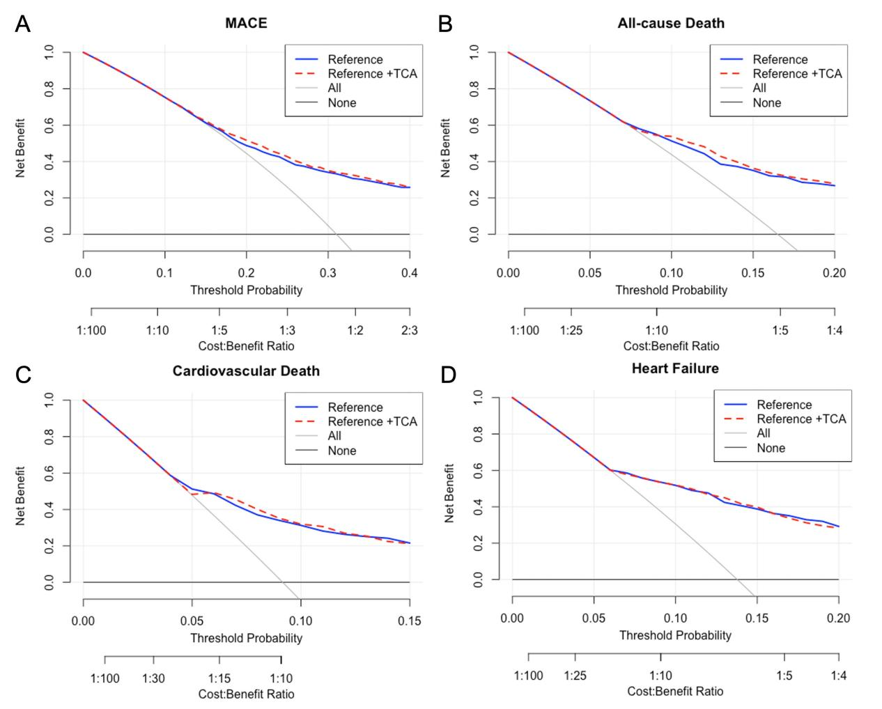
The decision curves compare the net benefit of reference model incorporating the TCA index for (A) MACE, (B) all-cause death, (C) cardiovascular death, and (D) heart failure. The Reference Model includes the GRACE score, NT-proBNP, and TnI. MACE, major adverse cardiovascular events; TCA, tricarboxylic acid.

Fig. S6 Decision curve analysis for the prediction of clinical outcomes
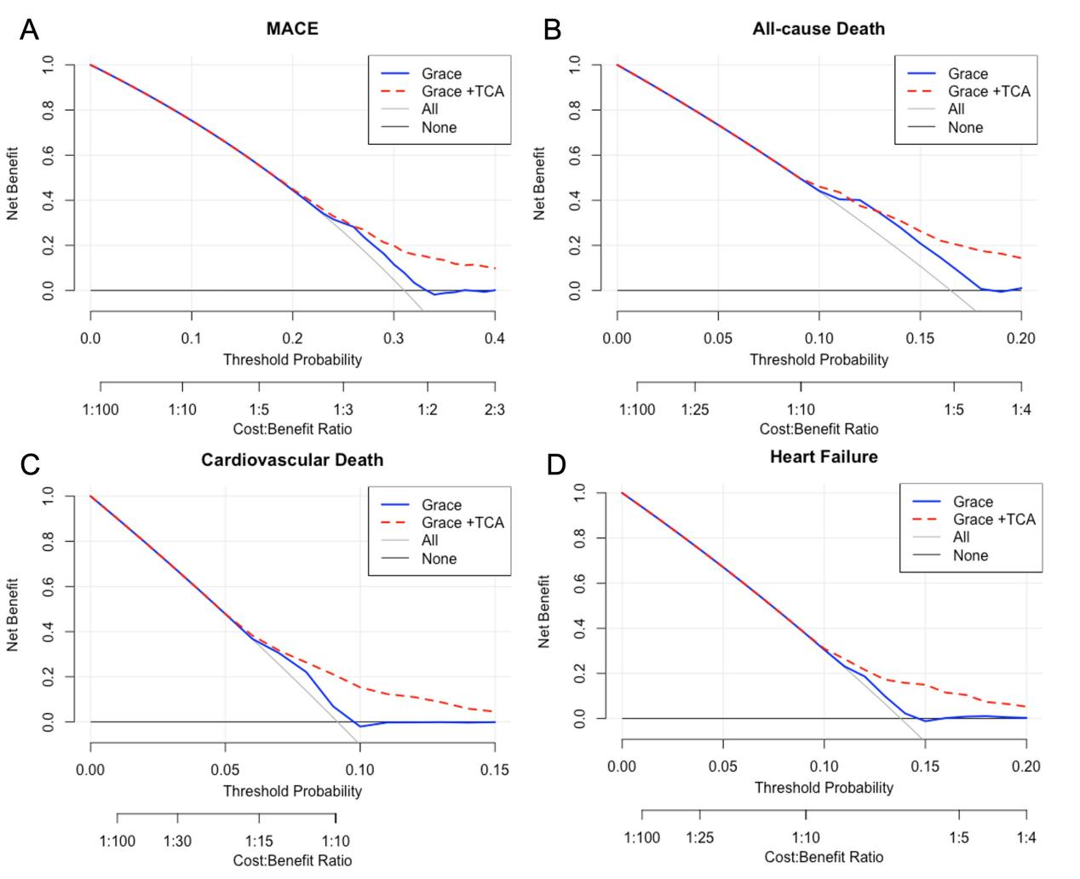
The decision curves compare the net benefit of the GRACE score incorporating the TCA index for (A) MACE, (B) all-cause death, (C) cardiovascular death, and (D) heart failure. MACE, major adverse cardiovascular events; TCA, tricarboxylic acid.

Fig. S7 Distribution of admission-day deaths according to TCA tertiles

