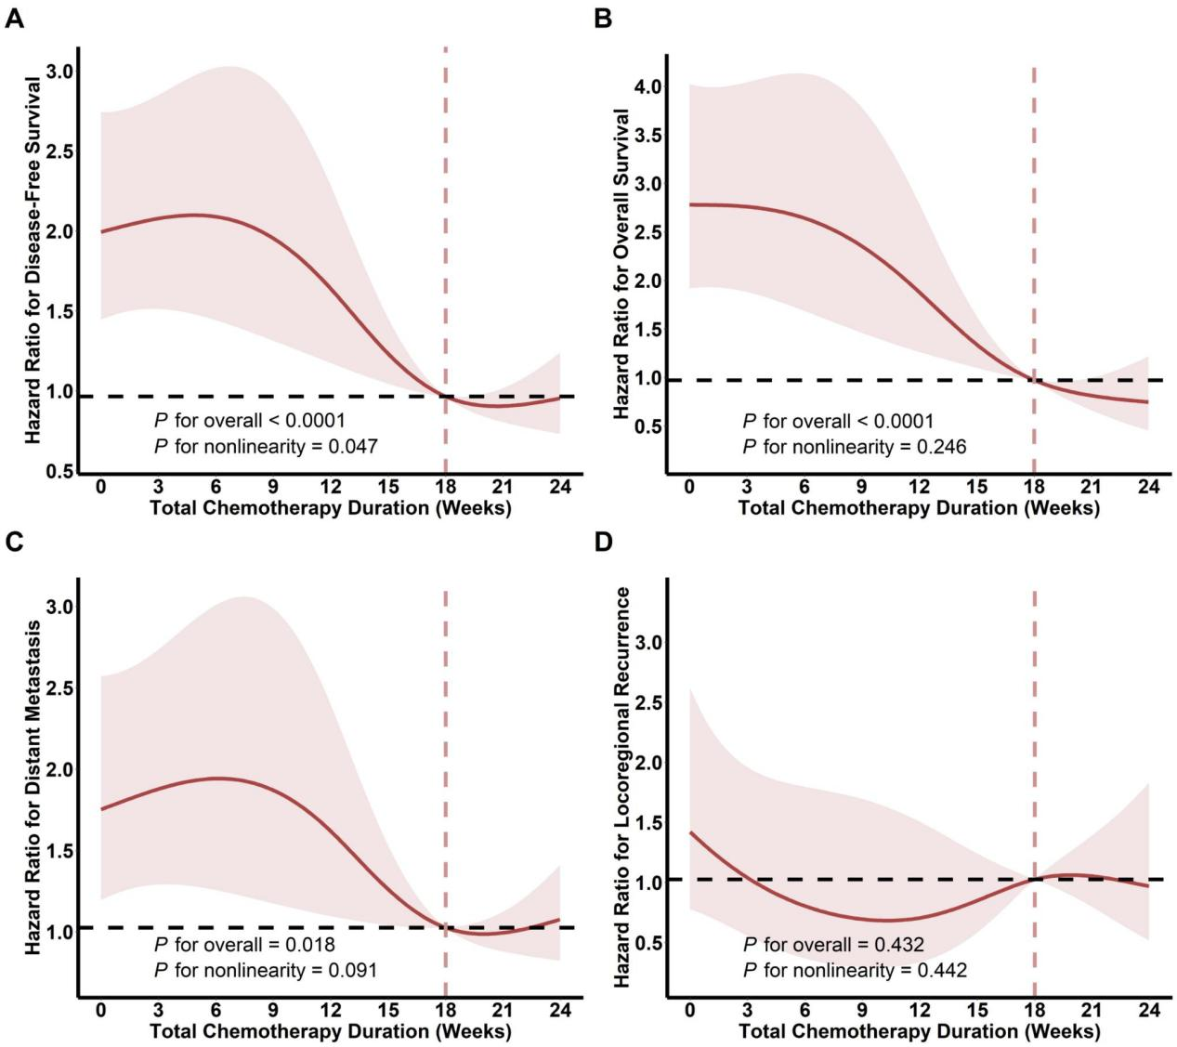
Fig. S1. Univariate restricted cubic spline regression analysis of total chemotherapy duration on (A) DFS, (B) OS, (C) DM, (D) LRR for patients with LARC.
Abbreviations: DFS, disease-free survival; OS, overall survival; DM, distant metastasis; LRR, locoregional recurrence; LARC, locally advanced rectal cancer.

