Table S1. Characteristics of included and excluded participants

Characteristic | Included participants (n=2446) | Excluded participants (n=2177) | P value
Childhood (1987)
Age, years | 12.0 (9.0, 14.0) | 14.0 (10.0, 16.0) | <0.001
Males, n (%) | 1323 (54.1) | 1201 (55.2) | 0.462
BMI, kg/m² | 15.8 (14.7, 17.4) | 17.1 (15.2, 18.9) | <0.001
BMI from childhood to adulthood (1989-2017)
BMI in 1989, kg/m² | 17.3 (15.7, 19.1) | 16.6 (15.1, 18.8) | <0.001
BMI in 1992, kg/m² | 19.2 (17.4, 20.9) | 19.7 (17.5, 21.3) | <0.001
BMI in 1995, kg/m² | 20.3 (18.9, 21.8) | 20.2 (19.0, 21.7) | 0.601
BMI in 2005, kg/m² | 21.8 (20.0, 24.2) | 23.7 (20.9, 24.8) | 0.123
BMI in 2013, kg/m² | 23.5 (21.6, 25.9) | 23.6 (21.8, 25.8) | 0.808
BMI in 2017, kg/m² | 23.7 (21.8, 26.1) | 23.9 (22.2, 25.9) | 0.386
Mid-adulthood (2023)
BMI, kg/m² | 24.5 (22.4, 26.6) | 24.5 (22.6, 26.7) | 0.923
Sleep quality score | 6.0 (3.0, 8.0) | 5.0 (3.0, 8.0) | 0.800
Smoking, n (%) | 739 (41.1) | 273 (39.7) | 0.529
Alcohol consumption, n (%) | 490 (27.3) | 186 (27.1) | 0.905
Physical activity, n (%) |  |  | 0.048
Vigorous | 239 (13.3) | 74 (10.8)
Moderate | 739 (41.2) | 277 (40.5)
Mild | 628 (35.0) | 238 (34.8)
No activity | 186 (10.4) | 95 (13.9)
Education, n (%) |  |  | 0.001
Middle school or less | 1167 (65.7) | 497 (72.6)
High school or more | 608 (34.3) | 188 (27.4)
Occupation, n (%) |  |  | 0.002
Farmers | 319 (17.9) | 159 (23.3)
Non-farmers | 1466 (82.1) | 524 (76.7)
Marital status, n (%) |  |  | <0.001
Married | 1696 (69.3) | 662 (30.4)
Unmarried/divorced/other | 750 (30.7) | 1515 (69.6)
LVMI, g/m^{2.7} | 34.0 (28.7, 40.3) | 34.3 (29.7, 40.0) | 0.253
LVH, n (%) | 100 (6.6) | 40 (7.2) | 0.605
baPWV, m/s | 12.8 (11.8, 14.0) | 13.1 (12.1, 14.6) | <0.001
Arterial stiffness, n (%) | 400 (25.4) | 196 (33.6) | 0.002
Note: Data are expressed as median (25th percentile, 75th percentile) for continuous variables or number (%) for categorical variables.
Abbreviations: BMI, body mass index; baPWV, brachial-ankle pulse wave velocity; LVMI, left ventricular mass index; LVH, left ventricular hypertrophy.

Table S2. Sex-specific effect modification of the associations of age-specific model-estimated BMI levels and level-adjusted change rates from childhood to adulthood with mid-adulthood subclinical cardiovascular measures

Age | Left ventricular mass index |  |  | Brachial-ankle pulse wave velocity
Age | P for interaction (sex×BMI level) | P for interaction  (sex×BMI change rate) |  | P for interaction (sex×BMI level) | P for interaction  (sex×BMI change rate)
6 | 0.075 | 0.004 |  | 0.504 | 0.233
7 | 0.063 | 0.005 |  | 0.602 | 0.213
8 | 0.054 | 0.007 |  | 0.716 | 0.199
9 | 0.047 | 0.009 |  | 0.842 | 0.190
10 | 0.041 | 0.013 |  | 0.975 | 0.187
11 | 0.036 | 0.017 |  | 0.894 | 0.189
12 | 0.031 | 0.022 |  | 0.772 | 0.197
13 | 0.027 | 0.028 |  | 0.663 | 0.209
14 | 0.023 | 0.036 |  | 0.570 | 0.227
15 | 0.019 | 0.046 |  | 0.494 | 0.248
16 | 0.016 | 0.059 |  | 0.433 | 0.274
17 | 0.013 | 0.076 |  | 0.385 | 0.302
18 | 0.011 | 0.097 |  | 0.348 | 0.331
19 | 0.009 | 0.125 |  | 0.319 | 0.361
20 | 0.007 | 0.159 |  | 0.297 | 0.392
21 | 0.006 | 0.201 |  | 0.279 | 0.421
22 | 0.005 | 0.250 |  | 0.266 | 0.449
23 | 0.005 | 0.307 |  | 0.256 | 0.475
24 | 0.004 | 0.371 |  | 0.248 | 0.499
25 | 0.004 | 0.442 |  | 0.241 | 0.521
26 | 0.003 | 0.517 |  | 0.236 | 0.541
27 | 0.003 | 0.596 |  | 0.232 | 0.560
28 | 0.003 | 0.677 |  | 0.229 | 0.576
29 | 0.003 | 0.759 |  | 0.227 | 0.591
30 | 0.003 | 0.840 |  | 0.224 | 0.605
31 | 0.002 | 0.918 |  | 0.223 | 0.617
32 | 0.002 | 0.994 |  | 0.221 | 0.628
33 | 0.002 | 0.934 |  | 0.220 | 0.637
34 | 0.002 | 0.866 |  | 0.219 | 0.646
35 | 0.002 | 0.802 |  | 0.218 | 0.654
36 | 0.002 | 0.742 |  | 0.217 | 0.662
37 | 0.002 | 0.687 |  | 0.216 | 0.668
38 | 0.002 | 0.636 |  | 0.215 | 0.674
39 | 0.002 | 0.589 |  | 0.214 | 0.680
40 | 0.002 | 0.546 |  | 0.214 | 0.685
41 | 0.002 | 0.507 |  | 0.213 | 0.690
42 | 0.003 | 0.471 |  | 0.212 | 0.694
43 | 0.003 | 0.438 |  | 0.212 | 0.698
44 | 0.003 | 0.408 |  | 0.211 | 0.702
45 | 0.003 | 0.381 |  | 0.211 | 0.705
46 | 0.003 | 0.356 |  | 0.210 | 0.709
47 | 0.003 | 0.333 |  | 0.210 | 0.712
48 | 0.003 | 0.312 |  | 0.209 | 0.714
49 | 0.003 | 0.293 |  | 0.209 | 0.717
50 | 0.003 | 0.276 |  | 0.208 | 0.720
51 | 0.003 | 0.260 |  | 0.208 | 0.722
52 | 0.003 | 0.245 |  | 0.207 | 0.724
Abbreviations: BMI, body mass index.

Table S3. Sex-specific effect modification of the associations of age-specific model-estimated BMI levels and level-adjusted change rates from childhood to adulthood with mid-adulthood subclinical cardiovascular outcomes

Age | Left ventricular hypertrophy |  |  | Arterial stiffness
Age | P for interaction (sex×BMI level) | P for interaction  (sex×BMI change rate) |  | P for interaction (sex×BMI level) | P for interaction  (sex×BMI change rate)
6 | 0.562 | 0.431 |  | 0.140 | 0.400
7 | 0.490 | 0.456 |  | 0.175 | 0.347
8 | 0.422 | 0.492 |  | 0.221 | 0.302
9 | 0.362 | 0.540 |  | 0.280 | 0.265
10 | 0.311 | 0.600 |  | 0.352 | 0.237
11 | 0.269 | 0.674 |  | 0.435 | 0.216
12 | 0.236 | 0.758 |  | 0.528 | 0.202
13 | 0.212 | 0.851 |  | 0.625 | 0.193
14 | 0.194 | 0.948 |  | 0.723 | 0.188
15 | 0.183 | 0.955 |  | 0.817 | 0.186
16 | 0.177 | 0.864 |  | 0.904 | 0.186
17 | 0.175 | 0.780 |  | 0.983 | 0.188
18 | 0.176 | 0.706 |  | 0.948 | 0.192
19 | 0.180 | 0.642 |  | 0.887 | 0.196
20 | 0.186 | 0.588 |  | 0.834 | 0.200
21 | 0.194 | 0.543 |  | 0.788 | 0.204
22 | 0.203 | 0.506 |  | 0.747 | 0.207
23 | 0.213 | 0.476 |  | 0.712 | 0.211
24 | 0.223 | 0.451 |  | 0.682 | 0.214
25 | 0.234 | 0.431 |  | 0.655 | 0.217
26 | 0.246 | 0.415 |  | 0.631 | 0.219
27 | 0.257 | 0.402 |  | 0.609 | 0.221
28 | 0.268 | 0.391 |  | 0.589 | 0.223
29 | 0.279 | 0.383 |  | 0.572 | 0.225
30 | 0.290 | 0.376 |  | 0.556 | 0.226
31 | 0.300 | 0.371 |  | 0.541 | 0.227
32 | 0.310 | 0.367 |  | 0.527 | 0.228
33 | 0.320 | 0.364 |  | 0.515 | 0.229
34 | 0.329 | 0.361 |  | 0.503 | 0.229
35 | 0.337 | 0.359 |  | 0.492 | 0.230
36 | 0.346 | 0.358 |  | 0.482 | 0.231
37 | 0.354 | 0.357 |  | 0.472 | 0.231
38 | 0.361 | 0.357 |  | 0.463 | 0.231
39 | 0.368 | 0.356 |  | 0.455 | 0.232
40 | 0.375 | 0.356 |  | 0.447 | 0.232
41 | 0.381 | 0.357 |  | 0.440 | 0.233
42 | 0.388 | 0.357 |  | 0.433 | 0.233
43 | 0.393 | 0.357 |  | 0.426 | 0.233
44 | 0.399 | 0.358 |  | 0.420 | 0.233
45 | 0.404 | 0.359 |  | 0.414 | 0.234
46 | 0.409 | 0.359 |  | 0.408 | 0.234
47 | 0.414 | 0.360 |  | 0.403 | 0.234
48 | 0.418 | 0.361 |  | 0.397 | 0.235
49 | 0.422 | 0.362 |  | 0.392 | 0.235
50 | 0.426 | 0.363 |  | 0.388 | 0.235
51 | 0.430 | 0.364 |  | 0.383 | 0.235
52 | 0.434 | 0.365 |  | 0.379 | 0.236
Abbreviations: BMI, body mass index.

Table S4. Random-effects variance-covariance matrix from mixed-effects models with restricted cubic splines for age
Parameter | Males |  |  | Females
Parameter | Estimate | Standard difference |  | Estimate | Standard difference
Random intercept variance | 3.175 | 1.782 |  | 2.987 | 1.728
Random slope variance | 0.009 | 0.093 |  | 0.008 | 0.088
Covariance between intercept and slope | 0.119 |  |  | 0.09
Correlation between intercept and slope | 0.714 |  |  | 0.595
Level-1 residual variance | 1.608 | 1.268 |  | 20175 | 1.475

Table S5. Sex-by-age interaction analysis in a mixed-effects model using restricted cubic splines (combined sample)

Term | Estimate | SD | t value | P value
ns1 × sex | -1.740 | 0.186 | -9.35 | <0.001
ns2 × sex | 0.399 | 0.296 | 1.35 | 0.179
ns3 × sex | 0.447 | 0.212 | 2.11 | 0.035
ns4 × sex | 0.616 | 0.429 | 1.44 | 0.151
ns5 × sex | 1.480 | 0.213 | 6.96 | <0.001
Note: Terms such as “ns1 × sex”, represent sex-by-age interaction effects derived from the restricted cubic spline basis functions for age. Collectively, these interaction terms capture sex-specific differences in the shape of the BMI trajectory across the lifespan.
Knots for the restricted cubic spline model were placed at age quartiles (14, 17, 23, and 40 years).
Abbreviations: BMI, body mass index; SD, standard error.

Table S6. Model-estimated BMI levels by sex and age (6-52 years)
Age (years) | Males (n=1323) | Females (n=1123) | P value
6 | 14.1 (13.4, 14.8) | 13.6 (12.9, 14.5) | <0.001
7 | 14.4 (13.7, 15.1) | 13.9 (13.2, 14.8) | <0.001
8 | 14.7 (14.0, 15.4) | 14.3 (13.6, 15.1) | <0.001
9 | 15.0 (14.3, 15.6) | 14.6 (13.9, 15.5) | <0.001
10 | 15.3 (14.6, 16.0) | 15.1 (14.3, 15.9) | <0.001
11 | 15.7 (15.0, 16.3) | 15.5 (14.8, 16.3) | 0.016
12 | 16.2 (15.5, 16.8) | 16.1 (15.4, 16.9) | 0.767
13 | 16.7 (16.0, 17.3) | 16.8 (16.0, 17.6) | <0.001
14 | 17.3 (16.6, 18.0) | 17.6 (16.9, 18.4) | <0.001
15 | 18.0 (17.3, 18.7) | 18.5 (17.8, 19.3) | <0.001
16 | 18.7 (17.9, 19.4) | 19.4 (18.6, 20.2) | <0.001
17 | 19.3 (18.6, 20.1) | 20.2 (19.4, 21.0) | <0.001
18 | 19.9 (19.1, 20.7) | 20.7 (19.9, 21.6) | <0.001
19 | 20.3 (19.5, 21.1) | 21.1 (20.2, 21.9) | <0.001
20 | 20.6 (19.8, 21.5) | 21.3 (20.4, 22.1) | <0.001
21 | 20.8 (20.0, 21.7) | 21.3 (20.4, 22.2) | <0.001
22 | 21.0 (20.1, 21.9) | 21.3 (20.4, 22.2) | <0.001
23 | 21.2 (20.3, 22.2) | 21.3 (20.3, 22.2) | 0.133
24 | 21.4 (20.4, 22.4) | 21.3 (20.3, 22.2) | 0.294
25 | 21.5 (20.5, 22.6) | 21.3 (20.3, 22.3) | 0.002
26 | 21.7 (20.7, 22.8) | 21.4 (20.3, 22.4) | <0.001
27 | 21.9 (20.8, 23.1) | 21.4 (20.4, 22.6) | <0.001
28 | 22.1 (21.0, 23.3) | 21.5 (20.5, 22.7) | <0.001
29 | 22.4 (21.2, 23.5) | 21.6 (20.6, 22.9) | <0.001
30 | 22.6 (21.3, 23.8) | 21.8 (20.7, 23.0) | <0.001
31 | 22.8 (21.5, 24.0) | 21.9 (20.9, 23.2) | <0.001
32 | 23.0 (21.6, 24.3) | 22.1 (21.0, 23.4) | <0.001
33 | 23.2 (21.8, 24.6) | 22.2 (21.1, 23.6) | <0.001
34 | 23.4 (22.0, 24.8) | 22.4 (21.3, 23.8) | <0.001
35 | 23.6 (22.1, 25.1) | 22.5 (21.4, 24.0) | <0.001
36 | 23.8 (22.3, 25.3) | 22.7 (21.5, 24.2) | <0.001
37 | 24.0 (22.4, 25.5) | 22.8 (21.6, 24.4) | <0.001
38 | 24.2 (22.5, 25.7) | 23.0 (21.7, 24.6) | <0.001
39 | 24.4 (22.6, 26.0) | 23.1 (21.8, 24.8) | <0.001
40 | 24.5 (22.7, 26.2) | 23.2 (21.9, 24.9) | <0.001
41 | 24.6 (22.8, 26.3) | 23.3 (22.0, 25.0) | <0.001
42 | 24.7 (22.8, 26.5) | 23.4 (22.0, 25.1) | <0.001
43 | 24.8 (22.9, 26.7) | 23.4 (22.0, 25.2) | <0.001
44 | 24.9 (22.9, 26.8) | 23.5 (22.0, 25.3) | <0.001
45 | 25.0 (22.9, 26.9) | 23.5 (22.0, 25.4) | <0.001
46 | 25.0 (22.9, 27.0) | 23.5 (21.9, 25.4) | <0.001
47 | 25.1 (22.9, 27.2) | 23.5 (21.9, 25.4) | <0.001
48 | 25.2 (22.9, 27.3) | 23.4 (21.8, 25.5) | <0.001
49 | 25.2 (22.9, 27.4) | 23.4 (21.8, 25.5) | <0.001
50 | 25.2 (22.9, 27.5) | 23.4 (21.7, 25.5) | <0.001
51 | 25.2 (22.9, 27.5) | 23.3 (21.6, 25.5) | <0.001
52 | 25.2 (22.8, 27.6) | 23.3 (21.5, 25.5) | <0.001
Note: Data are expressed as median (25th percentile, 75th percentile).
Values include fixed and random effects for each participant at each integer age.
Abbreviations: BMI, body mass index.

Table S7. Model-estimated BMI change rates by sex and age (6-52 years)
Age (years) | Males (n=1323) | Females (n=1123) | P value
6 | 0.26 (0.20, 0.31) | 0.31 (0.26, 0.35) | <0.001
7 | 0.26 (0.21, 0.32) | 0.31 (0.27, 0.36) | <0.001
8 | 0.28 (0.23, 0.34) | 0.34 (0.29, 0.38) | <0.001
9 | 0.31 (0.26, 0.37) | 0.38 (0.34, 0.43) | <0.001
10 | 0.36 (0.30, 0.41) | 0.44 (0.40, 0.49) | <0.001
11 | 0.41 (0.36, 0.47) | 0.52 (0.47, 0.57) | <0.001
12 | 0.48 (0.43, 0.54) | 0.61 (0.57, 0.66) | <0.001
13 | 0.56 (0.51, 0.62) | 0.73 (0.68, 0.77) | <0.001
14 | 0.66 (0.60, 0.71) | 0.86 (0.81, 0.90) | <0.001
15 | 0.72 (0.66, 0.77) | 0.93 (0.88, 0.97) | <0.001
16 | 0.70 (0.64, 0.75) | 0.86 (0.82, 0.91) | <0.001
17 | 0.60 (0.54, 0.66) | 0.67 (0.62, 0.72) | <0.001
18 | 0.47 (0.42, 0.53) | 0.43 (0.39, 0.48) | <0.001
19 | 0.37 (0.31, 0.42) | 0.24 (0.20, 0.29) | <0.001
20 | 0.28 (0.23, 0.34) | 0.10 (0.06, 0.15) | <0.001
21 | 0.22 (0.16, 0.28) | 0.02 (-0.03, 0.06) | <0.001
22 | 0.18 (0.12, 0.24) | -0.02 (-0.07, 0.02) | <0.001
23 | 0.16 (0.11, 0.22) | -0.01 (-0.06, 0.03) | <0.001
24 | 0.16 (0.11, 0.22) | 0.02 (-0.03, 0.07) | <0.001
25 | 0.18 (0.12, 0.23) | 0.05 (0.00, 0.10) | <0.001
26 | 0.19 (0.14, 0.25) | 0.08 (0.03, 0.12) | <0.001
27 | 0.20 (0.14, 0.26) | 0.10 (0.05, 0.15) | <0.001
28 | 0.21 (0.15, 0.26) | 0.12 (0.07, 0.17) | <0.001
29 | 0.21 (0.16, 0.27) | 0.13 (0.09, 0.18) | <0.001
30 | 0.21 (0.16, 0.27) | 0.15 (0.10, 0.19) | <0.001
31 | 0.22 (0.16, 0.27) | 0.16 (0.11, 0.20) | <0.001
32 | 0.22 (0.16, 0.27) | 0.16 (0.12, 0.21) | <0.001
33 | 0.21 (0.16, 0.27) | 0.17 (0.12, 0.21) | <0.001
34 | 0.21 (0.15, 0.26) | 0.17 (0.12, 0.21) | <0.001
35 | 0.20 (0.15, 0.26) | 0.16 (0.12, 0.21) | <0.001
36 | 0.19 (0.14, 0.25) | 0.16 (0.11, 0.20) | <0.001
37 | 0.18 (0.13, 0.24) | 0.15 (0.10, 0.19) | <0.001
38 | 0.17 (0.11, 0.23) | 0.13 (0.09, 0.18) | <0.001
39 | 0.15 (0.10, 0.21) | 0.11 (0.07, 0.16) | <0.001
40 | 0.14 (0.08, 0.19) | 0.09 (0.05, 0.14) | <0.001
41 | 0.12 (0.06, 0.18) | 0.07 (0.03, 0.12) | <0.001
42 | 0.10 (0.05, 0.16) | 0.05 (0.01, 0.10) | <0.001
43 | 0.09 (0.03, 0.15) | 0.04 (-0.01, 0.08) | <0.001
44 | 0.08 (0.02, 0.13) | 0.02 (-0.02, 0.07) | <0.001
45 | 0.06 (0.01, 0.12) | 0.01 (-0.04, 0.05) | <0.001
46 | 0.06 (0.00, 0.11) | -0.01 (-0.05, 0.04) | <0.001
47 | 0.05 (-0.01, 0.10) | -0.02 (-0.06, 0.03) | <0.001
48 | 0.04 (-0.01, 0.10) | -0.02 (-0.07, 0.02) | <0.001
49 | 0.03 (-0.02, 0.09) | -0.03 (-0.08, 0.02) | <0.001
50 | 0.03 (-0.02, 0.09) | -0.04 (-0.08, 0.01) | <0.001
51 | 0.03 (-0.03, 0.09) | -0.04 (-0.08, 0.01) | <0.001
52 | 0.03 (-0.03, 0.09) | -0.04 (-0.08, 0.01) | <0.001
Note: Data are expressed as median (25th percentile, 75th percentile).
Values include fixed and random effects for each participant at each integer age.
Abbreviations: BMI, body mass index.

Table S8. Sex differences in age-specific BMI change rates estimated from a piecewise linear spline model

Age group | Males | Females | β_{diff} | P value
6-12 years | 0.31 (0.27, 0.36) | 0.40 (0.35, 0.45) | -0.09 (-0.16, -0.02) | 0.006
12-18 years | 0.69 (0.67, 0.71) | 0.85 (0.82, 0.88) | -0.16 (-0.19, -0.12) | <0.001
18-25 years | 0.22 (0.19, 0.25) | 0.04 (0.01, 0.09) | 0.17 (0.12, 0.22) | <0.001
25-40 years | 0.21 (0.19, 0.22) | 0.14 (0.12, 0.15) | 0.07 (0.05, 0.09) | 0.000
40-50 years | 0.07 (0.05, 0.09) | 0.03 (0.01, 0.05) | 0.04 (0.01, 0.07) | 0.002
50-52 years | 0.16 (-0.05, 0.34) | 0.01 (-0.27, 0.20) | 0.15 (-0.13, 0.49) | 0.264
Notes. Slopes were estimated from piecewise linear spline mixed-effects models with knots at 12, 18, 25, 40, and 50 years. β_{diff} represents the male-female difference in segment-specific slopes.
Abbreviations: BMI, body mass index.

Table S9. Associations of age-specific model-estimated BMI levels and level-adjusted change rates from childhood to adulthood with mid-adulthood subclinical cardiovascular measures

Age | Left ventricular mass index |  |  | Brachial-ankle pulse wave velocity
Age | BMI levels | BMI change rates |  | BMI levels | BMI change rates
Age | β (95% CI) | β (95% CI) |  | β (95% CI) | β (95% CI)
6 | 0.128 (-0.270, 0.526) | 3.123 (2.716, 3.531) |  | -0.086 (-0.174, 0.002) | 0.372 (0.281, 0.462)
7 | 0.332 (-0.066, 0.731) | 3.111 (2.704, 3.518) |  | -0.061 (-0.149, 0.028) | 0.377 (0.286, 0.467)
8 | 0.542 (0.143, 0.941) | 3.084 (2.677, 3.490) |  | -0.034 (-0.122, 0.054) | 0.380 (0.290, 0.471)
9 | 0.755 (0.355, 1.155) | 3.041 (2.635, 3.447) |  | -0.007 (-0.095, 0.082) | 0.382 (0.292, 0.472)
10 | 0.968 (0.567, 1.369) | 2.982 (2.577, 3.387) |  | 0.022 (-0.067, 0.110) | 0.381 (0.291, 0.471)
11 | 1.178 (0.776, 1.579) | 2.908 (2.504, 3.311) |  | 0.050 (-0.039, 0.139) | 0.379 (0.289, 0.469)
12 | 1.381 (0.978, 1.783) | 2.819 (2.416, 3.221) |  | 0.077 (-0.012, 0.166) | 0.374 (0.285, 0.464)
13 | 1.574 (1.170, 1.977) | 2.717 (2.315, 3.119) |  | 0.104 (0.014, 0.193) | 0.368 (0.279, 0.457)
14 | 1.755 (1.351, 2.160) | 2.604 (2.203, 3.005) |  | 0.129 (0.040, 0.219) | 0.360 (0.271, 0.449)
15 | 1.923 (1.518, 2.328) | 2.484 (2.083, 2.884) |  | 0.153 (0.063, 0.243) | 0.350 (0.261, 0.439)
16 | 2.076 (1.670, 2.482) | 2.358 (1.958, 2.757) |  | 0.176 (0.085, 0.266) | 0.339 (0.251, 0.428)
17 | 2.214 (1.808, 2.621) | 2.229 (1.830, 2.628) |  | 0.196 (0.106, 0.286) | 0.328 (0.240, 0.416)
18 | 2.338 (1.931, 2.745) | 2.099 (1.701, 2.498) |  | 0.215 (0.124, 0.305) | 0.316 (0.228, 0.404)
19 | 2.448 (2.040, 2.855) | 1.971 (1.573, 2.368) |  | 0.231 (0.141, 0.322) | 0.304 (0.216, 0.392)
20 | 2.544 (2.136, 2.952) | 1.844 (1.447, 2.242) |  | 0.247 (0.156, 0.337) | 0.292 (0.204, 0.380)
21 | 2.629 (2.220, 3.037) | 1.722 (1.325, 2.119) |  | 0.260 (0.169, 0.351) | 0.280 (0.192, 0.368)
22 | 2.702 (2.294, 3.111) | 1.604 (1.207, 2.000) |  | 0.272 (0.181, 0.363) | 0.268 (0.180, 0.356)
23 | 2.766 (2.358, 3.175) | 1.490 (1.094, 1.887) |  | 0.283 (0.192, 0.374) | 0.257 (0.169, 0.344)
24 | 2.822 (2.413, 3.230) | 1.382 (0.986, 1.779) |  | 0.293 (0.202, 0.384) | 0.246 (0.158, 0.333)
25 | 2.869 (2.461, 3.278) | 1.280 (0.883, 1.676) |  | 0.301 (0.210, 0.392) | 0.235 (0.147, 0.323)
26 | 2.911 (2.502, 3.320) | 1.183 (0.786, 1.579) |  | 0.309 (0.218, 0.400) | 0.225 (0.137, 0.313)
27 | 2.946 (2.537, 3.355) | 1.091 (0.695, 1.487) |  | 0.316 (0.225, 0.407) | 0.215 (0.128, 0.303)
28 | 2.977 (2.568, 3.386) | 1.004 (0.608, 1.401) |  | 0.322 (0.231, 0.413) | 0.206 (0.119, 0.294)
29 | 3.003 (2.594, 3.412) | 0.923 (0.526, 1.319) |  | 0.327 (0.236, 0.418) | 0.198 (0.110, 0.285)
30 | 3.025 (2.616, 3.434) | 0.846 (0.449, 1.242) |  | 0.332 (0.241, 0.423) | 0.189 (0.102, 0.277)
31 | 3.044 (2.635, 3.453) | 0.773 (0.377, 1.170) |  | 0.336 (0.245, 0.427) | 0.182 (0.094, 0.269)
32 | 3.061 (2.652, 3.469) | 0.705 (0.309, 1.102) |  | 0.340 (0.249, 0.431) | 0.174 (0.087, 0.262)
33 | 3.075 (2.666, 3.483) | 0.641 (0.244, 1.038) |  | 0.344 (0.253, 0.435) | 0.167 (0.080, 0.255)
34 | 3.086 (2.678, 3.495) | 0.580 (0.184, 0.977) |  | 0.347 (0.256, 0.438) | 0.161 (0.073, 0.248)
35 | 3.096 (2.688, 3.505) | 0.523 (0.126, 0.920) |  | 0.350 (0.259, 0.440) | 0.154 (0.067, 0.242)
36 | 3.105 (2.696, 3.513) | 0.469 (0.072, 0.866) |  | 0.352 (0.261, 0.443) | 0.149 (0.061, 0.236)
37 | 3.112 (2.703, 3.520) | 0.418 (0.021, 0.815) |  | 0.354 (0.264, 0.445) | 0.143 (0.055, 0.231)
38 | 3.118 (2.709, 3.526) | 0.370 (-0.027, 0.767) |  | 0.357 (0.266, 0.447) | 0.138 (0.050, 0.225)
39 | 3.122 (2.714, 3.531) | 0.325 (-0.072, 0.722) |  | 0.358 (0.268, 0.449) | 0.133 (0.045, 0.220)
40 | 3.126 (2.718, 3.535) | 0.282 (-0.115, 0.679) |  | 0.360 (0.269, 0.451) | 0.128 (0.040, 0.216)
41 | 3.130 (2.721, 3.538) | 0.241 (-0.156, 0.638) |  | 0.362 (0.271, 0.453) | 0.123 (0.035, 0.211)
42 | 3.132 (2.724, 3.540) | 0.202 (-0.195, 0.599) |  | 0.363 (0.272, 0.454) | 0.119 (0.031, 0.207)
43 | 3.134 (2.726, 3.542) | 0.165 (-0.232, 0.563) |  | 0.365 (0.274, 0.455) | 0.115 (0.027, 0.203)
44 | 3.136 (2.727, 3.544) | 0.130 (-0.267, 0.528) |  | 0.366 (0.275, 0.456) | 0.111 (0.023, 0.199)
45 | 3.137 (2.729, 3.545) | 0.097 (-0.300, 0.495) |  | 0.367 (0.276, 0.458) | 0.107 (0.019, 0.195)
46 | 3.137 (2.729, 3.545) | 0.066 (-0.332, 0.463) |  | 0.368 (0.277, 0.459) | 0.104 (0.016, 0.191)
47 | 3.137 (2.730, 3.545) | 0.035 (-0.362, 0.433) |  | 0.369 (0.278, 0.460) | 0.100 (0.012, 0.188)
48 | 3.137 (2.730, 3.545) | 0.007 (-0.391, 0.404) |  | 0.370 (0.279, 0.460) | 0.097 (0.009, 0.185)
49 | 3.137 (2.729, 3.545) | -0.021 (-0.418, 0.377) |  | 0.370 (0.280, 0.461) | 0.094 (0.006, 0.182)
50 | 3.137 (2.729, 3.544) | -0.047 (-0.445, 0.351) |  | 0.371 (0.280, 0.462) | 0.091 (0.005, 0.179)
51 | 3.136 (2.728, 3.544) | -0.072 (-0.470, 0.326) |  | 0.372 (0.281, 0.463) | 0.088 (0.000, 0.176)
52 | 3.135 (2.728, 3.543) | -0.096 (-0.494, 0.302) |  | 0.372 (0.282, 0.463) | 0.085 (-0.003, 0.173)
Note: β coefficients represent the change in outcome measures per 1-SD change in BMI.
Abbreviations: BMI, body mass index; CI, confidence interval.

Table S10. Associations of age-specific model-estimated BMI levels and level-adjusted change rates from childhood to adulthood with mid-adulthood subclinical cardiovascular outcomes

Age | Left ventricular hypertrophy |  |  | Arterial stiffness
Age | BMI levels | BMI change rates |  | BMI levels | BMI change rates
Age | OR (95% CI) | OR (95% CI) |  | OR (95% CI) | OR (95% CI)
6 | 1.008 (0.822, 1.237) | 2.488 (2.013, 3.075) |  | 0.921 (0.817, 1.039) | 1.597 (1.412, 1.808)
7 | 1.069 (0.871, 1.313) | 2.481 (2.009, 3.062) |  | 0.951 (0.844, 1.073) | 1.606 (1.419, 1.817)
8 | 1.135 (0.924, 1.396) | 2.463 (1.998, 3.037) |  | 0.984 (0.872, 1.110) | 1.611 (1.424, 1.822)
9 | 1.207 (0.980, 1.486) | 2.435 (1.978, 2.999) |  | 1.019 (0.903, 1.149) | 1.611 (1.425, 1.822)
10 | 1.283 (1.041, 1.582) | 2.397 (1.949, 2.947) |  | 1.055 (0.935, 1.191) | 1.608 (1.423, 1.818)
11 | 1.363 (1.104, 1.682) | 2.349 (1.913, 2.884) |  | 1.093 (0.968, 1.234) | 1.601 (1.417, 1.809)
12 | 1.444 (1.169, 1.785) | 2.293 (1.869, 2.812) |  | 1.131 (1.005, 1.278) | 1.589 (1.407, 1.795)
13 | 1.527 (1.235, 1.889) | 2.230 (1.820, 2.731) |  | 1.170 (1.035, 1.322) | 1.574 (1.394, 1.777)
14 | 1.609 (1.300, 1.993) | 2.162 (1.767, 2.646) |  | 1.207 (1.068, 1.365) | 1.555 (1.378, 1.755)
15 | 1.690 (1.364, 2.094) | 2.092 (1.711, 2.558) |  | 1.243 (1.100, 1.406) | 1.534 (1.360, 1.731)
16 | 1.767 (1.425, 2.192) | 2.021 (1.654, 2.469) |  | 1.278 (1.130, 1.446) | 1.512 (1.340, 1.705)
17 | 1.841 (1.484, 2.284) | 1.950 (1.597, 2.381) |  | 1.310 (1.158, 1.483) | 1.488 (1.320, 1.678)
18 | 1.909 (1.538, 2.370) | 1.882 (1.542, 2.296) |  | 1.340 (1.184, 1.517) | 1.464 (1.299, 1.651)
19 | 1.973 (1.589, 2.450) | 1.816 (1.488, 2.215) |  | 1.368 (1.208, 1.548) | 1.441 (1.278, 1.624)
20 | 2.031 (1.636, 2.523) | 1.753 (1.437, 2.138) |  | 1.393 (1.230, 1.577) | 1.417 (1.257, 1.597)
21 | 2.085 (1.678, 2.589) | 1.694 (1.389, 2.066) |  | 1.416 (1.250, 1.603) | 1.395 (1.238, 1.572)
22 | 2.132 (1.717, 2.648) | 1.639 (1.344, 1.999) |  | 1.436 (1.268, 1.626) | 1.373 (1.218, 1.547)
23 | 2.175 (1.752, 2.701) | 1.588 (1.302, 1.936) |  | 1.454 (1.284, 1.647) | 1.352 (1.200, 1.524)
24 | 2.214 (1.783, 2.749) | 1.540 (1.263, 1.879) |  | 1.471 (1.299, 1.666) | 1.333 (1.183, 1.501)
25 | 2.248 (1.810, 2.791) | 1.496 (1.226, 1.825) |  | 1.485 (1.312, 1.682) | 1.314 (1.167, 1.481)
26 | 2.278 (1.835, 2.828) | 1.456 (1.193, 1.776) |  | 1.498 (1.323, 1.697) | 1.297 (1.151, 1.461)
27 | 2.304 (1.856, 2.860) | 1.418 (1.162, 1.731) |  | 1.510 (1.333, 1.710) | 1.281 (1.137, 1.443)
28 | 2.328 (1.876, 2.889) | 1.384 (1.133, 1.689) |  | 1.520 (1.343, 1.722) | 1.266 (1.123, 1.426)
29 | 2.348 (1.893, 2.914) | 1.352 (1.107, 1.650) |  | 1.530 (1.351, 1.732) | 1.251 (1.111, 1.410)
30 | 2.366 (1.908, 2.935) | 1.322 (1.083, 1.615) |  | 1.538 (1.358, 1.741) | 1.238 (1.099, 1.395)
31 | 2.382 (1.921, 2.954) | 1.295 (1.060, 1.582) |  | 1.545 (1.364, 1.750) | 1.226 (1.088, 1.381)
32 | 2.396 (1.932, 2.971) | 1.270 (1.039, 1.552) |  | 1.552 (1.370, 1.757) | 1.214 (1.078, 1.368)
33 | 2.408 (1.943, 2.985) | 1.247 (1.020, 1.524) |  | 1.557 (1.375, 1.764) | 1.203 (1.068, 1.356)
34 | 2.419 (1.952, 2.998) | 1.225 (1.005, 1.498) |  | 1.563 (1.380, 1.769) | 1.193 (1.059, 1.344)
35 | 2.428 (1.959, 3.009) | 1.205 (0.985, 1.473) |  | 1.567 (1.384, 1.775) | 1.183 (1.050, 1.333)
36 | 2.436 (1.966, 3.018) | 1.186 (0.970, 1.451) |  | 1.572 (1.388, 1.779) | 1.174 (1.042, 1.323)
37 | 2.443 (1.972, 3.026) | 1.169 (0.956, 1.430) |  | 1.575 (1.391, 1.784) | 1.166 (1.035, 1.314)
38 | 2.449 (1.978, 3.033) | 1.153 (0.942, 1.410) |  | 1.579 (1.394, 1.787) | 1.158 (1.028, 1.305)
39 | 2.454 (1.982, 3.039) | 1.138 (0.929, 1.392) |  | 1.582 (1.397, 1.791) | 1.151 (1.021, 1.297)
40 | 2.459 (1.986, 3.044) | 1.123 (0.918, 1.375) |  | 1.585 (1.400, 1.794) | 1.144 (1.015, 1.289)
41 | 2.463 (1.990, 3.048) | 1.110 (0.907, 1.359) |  | 1.587 (1.402, 1.797) | 1.137 (1.009, 1.281)
42 | 2.466 (1.993, 3.052) | 1.098 (0.896, 1.344) |  | 1.589 (1.404, 1.799) | 1.131 (1.005, 1.274)
43 | 2.469 (1.996, 3.055) | 1.086 (0.887, 1.330) |  | 1.591 (1.406, 1.801) | 1.125 (0.998, 1.268)
44 | 2.471 (1.998, 3.057) | 1.075 (0.877, 1.317) |  | 1.593 (1.407, 1.803) | 1.119 (0.993, 1.262)
45 | 2.474 (2.000, 3.060) | 1.064 (0.869, 1.304) |  | 1.595 (1.409, 1.805) | 1.114 (0.988, 1.256)
46 | 2.475 (2.001, 3.061) | 1.055 (0.861, 1.292) |  | 1.596 (1.410, 1.807) | 1.109 (0.984, 1.250)
47 | 2.477 (2.003, 3.063) | 1.045 (0.853, 1.281) |  | 1.598 (1.412, 1.808) | 1.104 (0.980, 1.245)
48 | 2.478 (2.004, 3.064) | 1.037 (0.846, 1.271) |  | 1.599 (1.413, 1.810) | 1.100 (0.976, 1.240)
49 | 2.479 (2.005, 3.064) | 1.028 (0.839, 1.261) |  | 1.600 (1.414, 1.811) | 1.095 (0.972, 1.235)
50 | 2.479 (2.006, 3.065) | 1.020 (0.832, 1.251) |  | 1.601 (1.415, 1.812) | 1.091 (0.968, 1.230)
51 | 2.480 (2.007, 3.065) | 1.013 (0.826, 1.242) |  | 1.602 (1.416, 1.813) | 1.087 (0.964, 1.226)
52 | 2.480 (2.007, 3.065) | 1.006 (0.820, 1.234) |  | 1.603 (1.416, 1.814) | 1.084 (0.961, 1.222)
Abbreviations: BMI, body mass index; CI, confidence interval; OR, odds ratio.

Table S11. Comparison of associations between window-mean BMI levels and level-adjusted change rates in childhood/adolescence vs. adulthood with mid-adulthood subclinical cardiovascular outcomes

 | OR₆₋₁₈ (95% CI) | P value |  | OR₁₉₋₅₂ (95% CI) | P value |  | ROR (95% CI) | P value
BMI level
Left ventricular hypertrophy | 1.34 (1.10, 1.63) | 0.003 |  | 2.50 (2.04, 3.06) | <0.001 |  | 0.54 (0.41, 0.71) | <0.001
Arterial stiffness | 1.11 (0.98, 1.25) | 0.090 |  | 1.57 (1.39, 1.78) | <0.001 |  | 0.71 (0.59, 0.84) | <0.001
BMI change rate
Left ventricular hypertrophy | 2.27 (1.87, 2.76) | <0.001 |  | 1.38 (1.10, 1.74) | 0.005 |  | 1.64 (1.21, 2.21) | 0.001
Arterial stiffness | 1.58 (1.40, 1.78) | <0.001 |  | 1.25 (1.10, 1.42) | <0.001 |  | 1.26 (1.06, 1.50) | 0.009
Abbreviations: BMI, body mass index; CI, confidence interval; ROR, ratio of odds ratio; OR, odds ratio.

Table S12. Marginal effects of BMI levels and level-adjusted change rates at representative ages on mid-adulthood subclinical cardiovascular outcomes

Age | Left ventricular hypertrophy |  |  | Arterial stiffness
Age | BMI level | BMI change rate |  | BMI level | BMI change rate
10 | 1.005 (1.004, 1.007) | 1.022 (1.020, 1.024) |  | 1.001 (1.000, 1.002) | 1.006 (1.005, 1.006)
18 | 1.015 (1.013, 1.017) | 1.015 (1.013, 1.017) |  | 1.004 (1.003, 1.005) | 1.004 (1.004, 1.005)
30 | 1.022 (1.020, 1.024) | 1.006 (1.005, 1.007) |  | 1.006 (1.005, 1.006) | 1.002 (1.002, 1.003)
45 | 1.023 (1.021, 1.025) | 1.001 (1.000, 1.002) |  | 1.006 (1.005, 1.007) | 1.001 (1.000, 1.001)
Note: The marginal effect is presented as the absolute risk difference (in percentage points) associated with a 1-SD increase in either BMI levels or level-adjusted change rates at each age.
Abbreviations: BMI, body mass index.

Table S13. Global sex interaction tests for model-estimated BMI levels and level-adjusted BMI change rates across ages 6-52 years in relation to mid-adulthood subclinical cardiovascular outcomes
Outcome | Exposure | Chisq | P for interaction
Subclinical cardiovascular measures
Left ventricular mass index | BMI level | 31.689 | <0.001
 | BMI change rate | 107.467 | <0.001
Brachial-ankle pulse wave velocity | BMI level | 7.480 | 0.113
 | BMI change rate | 1.367 | 0.850
Subclinical cardiovascular outcomes
Left ventricular hypertrophy | BMI level | 8.699 | 0.069
 | BMI change rate | 4.562 | 0.335
Arterial stiffness | BMI level | 5.677 | 0.225
 | BMI change rate | 1.401 | 0.844
Abbreviations: BMI, body mass index.

Figure S1. Flowchart of inclusion and exclusion of study participants
Abbreviation: BMI, body mass index.
Figure S2. Associations of age-specific model-estimated BMI levels and level-adjusted change rates from childhood to adulthood with mid-adulthood subclinical cardiovascular measures by sex: (A) Left ventricular mass index; (B) Brachial-ankle pulse wave velocity
Note: Data are presented as β coefficients with 95% CIs. β coefficients represents the change in outcome measures per 1-SD change in BMI.
Abbreviation: BMI, body mass index; CI, confidence interval.
Figure S3. Associations of age-specific model-estimated BMI levels and level-adjusted change rates from childhood to adulthood with mid-adulthood subclinical cardiovascular outcomes by sex: (A) Left ventricular hypertrophy; (B) Arterial stiffness
Note: Data are presented as ORs with 95% CIs.
Abbreviation: BMI, body mass index; CI, confidence interval; OR, odds ratio
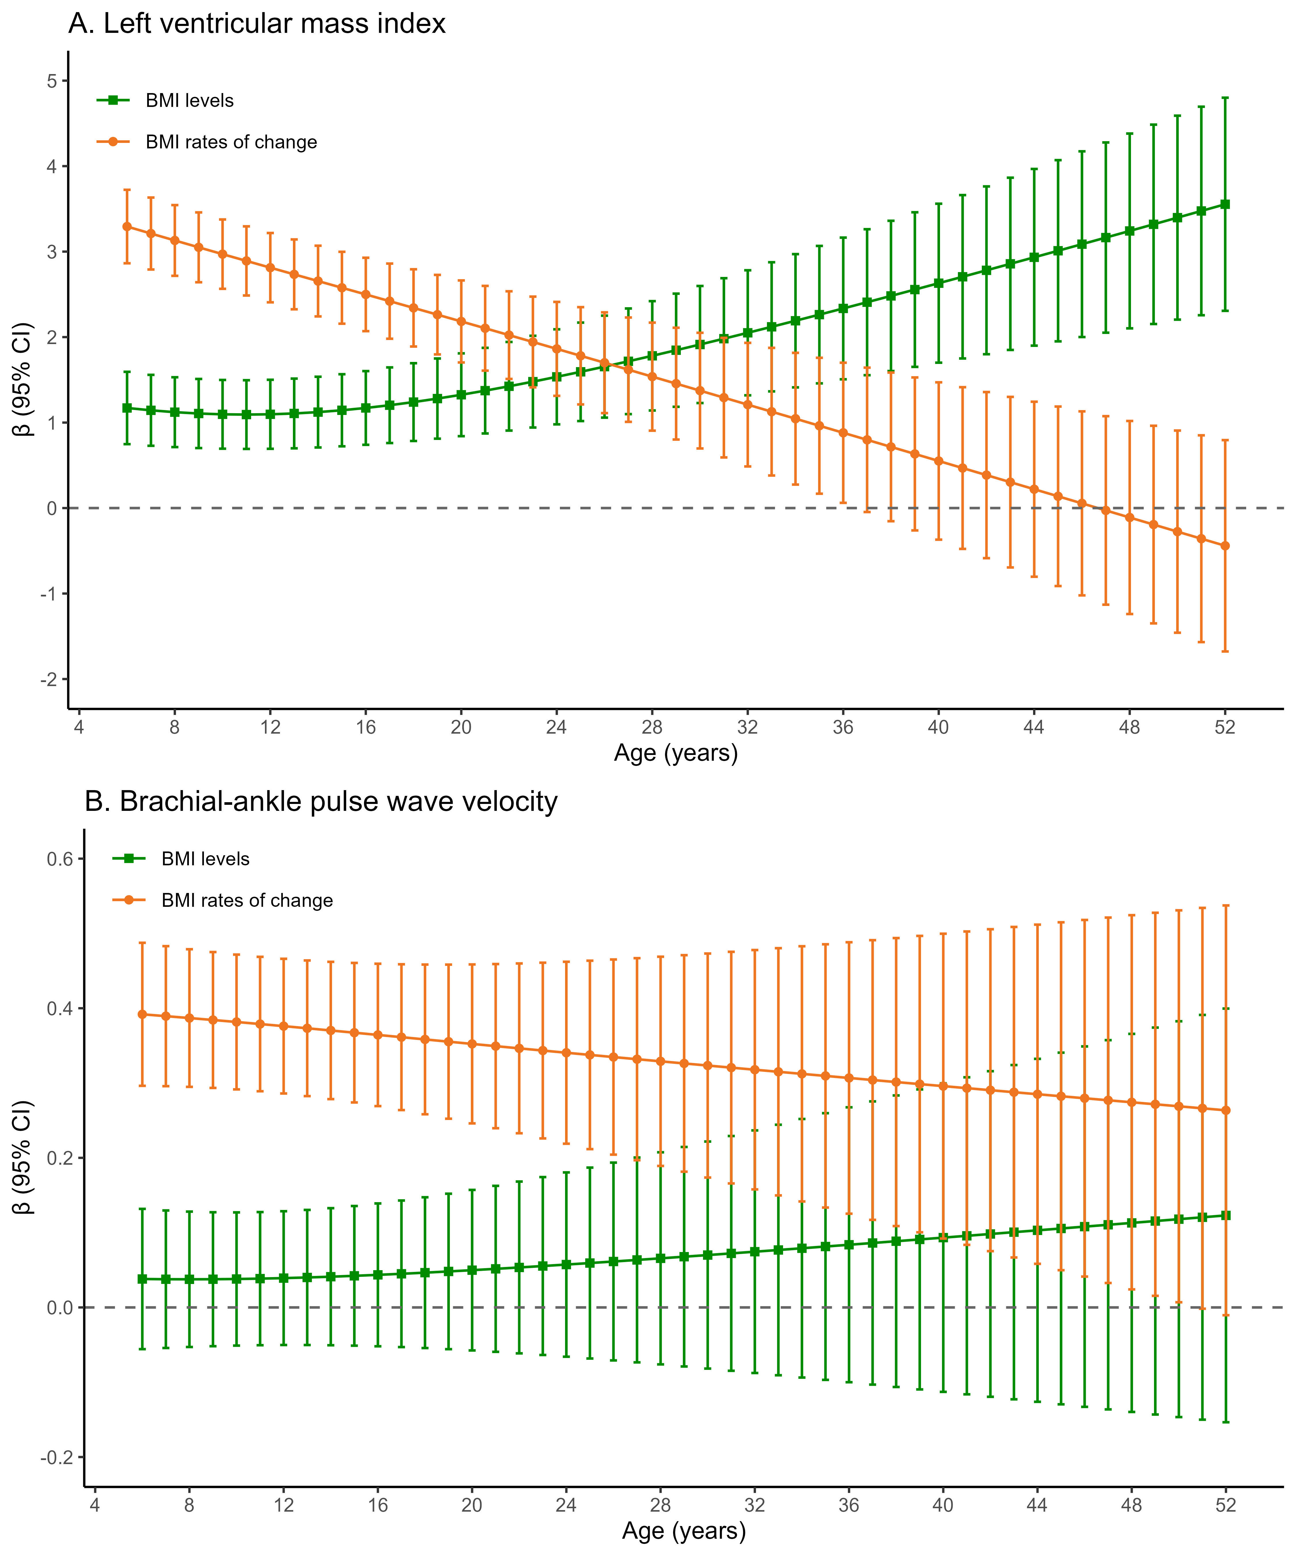
Figure S4. Sensitivity analyses of associations of age-specific model-estimated BMI levels and change rates from childhood to adulthood with mid-adulthood subclinical cardiovascular measures (when both BMI levels and unadjusted change rates were simultaneously included as exposures): (A) Left ventricular mass index; (B) Brachial-ankle pulse wave velocity
Note: Data are presented as β coefficients with 95% CIs. β coefficients represent the change in outcome measures per 1-SD change in BMI.
Abbreviations: BMI, body mass index; CI, confidence interval.

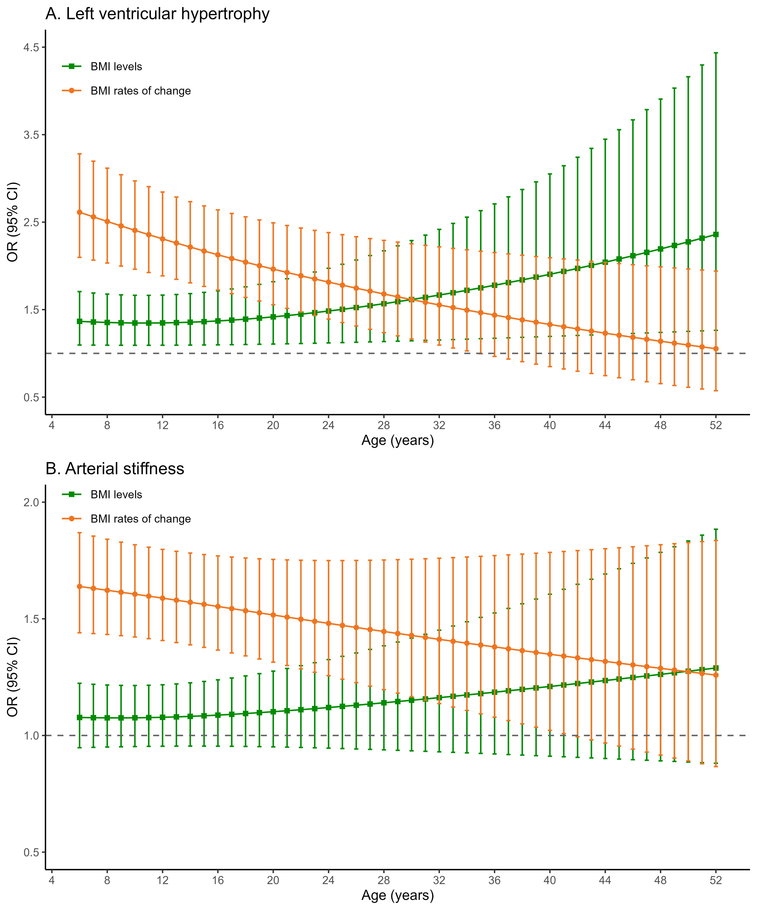
Figure S5. Sensitivity analyses of associations of age-specific model-estimated BMI levels and change rates from childhood to adulthood with mid-adulthood subclinical cardiovascular outcomes (when both BMI levels and unadjusted change rates were simultaneously included as exposures): (A) Left ventricular hypertrophy; (B) Arterial stiffness
Note. Data are presented as ORs with 95% CIs.
Abbreviations: BMI, body mass index; CI, confidence interval; OR, odds ratio.

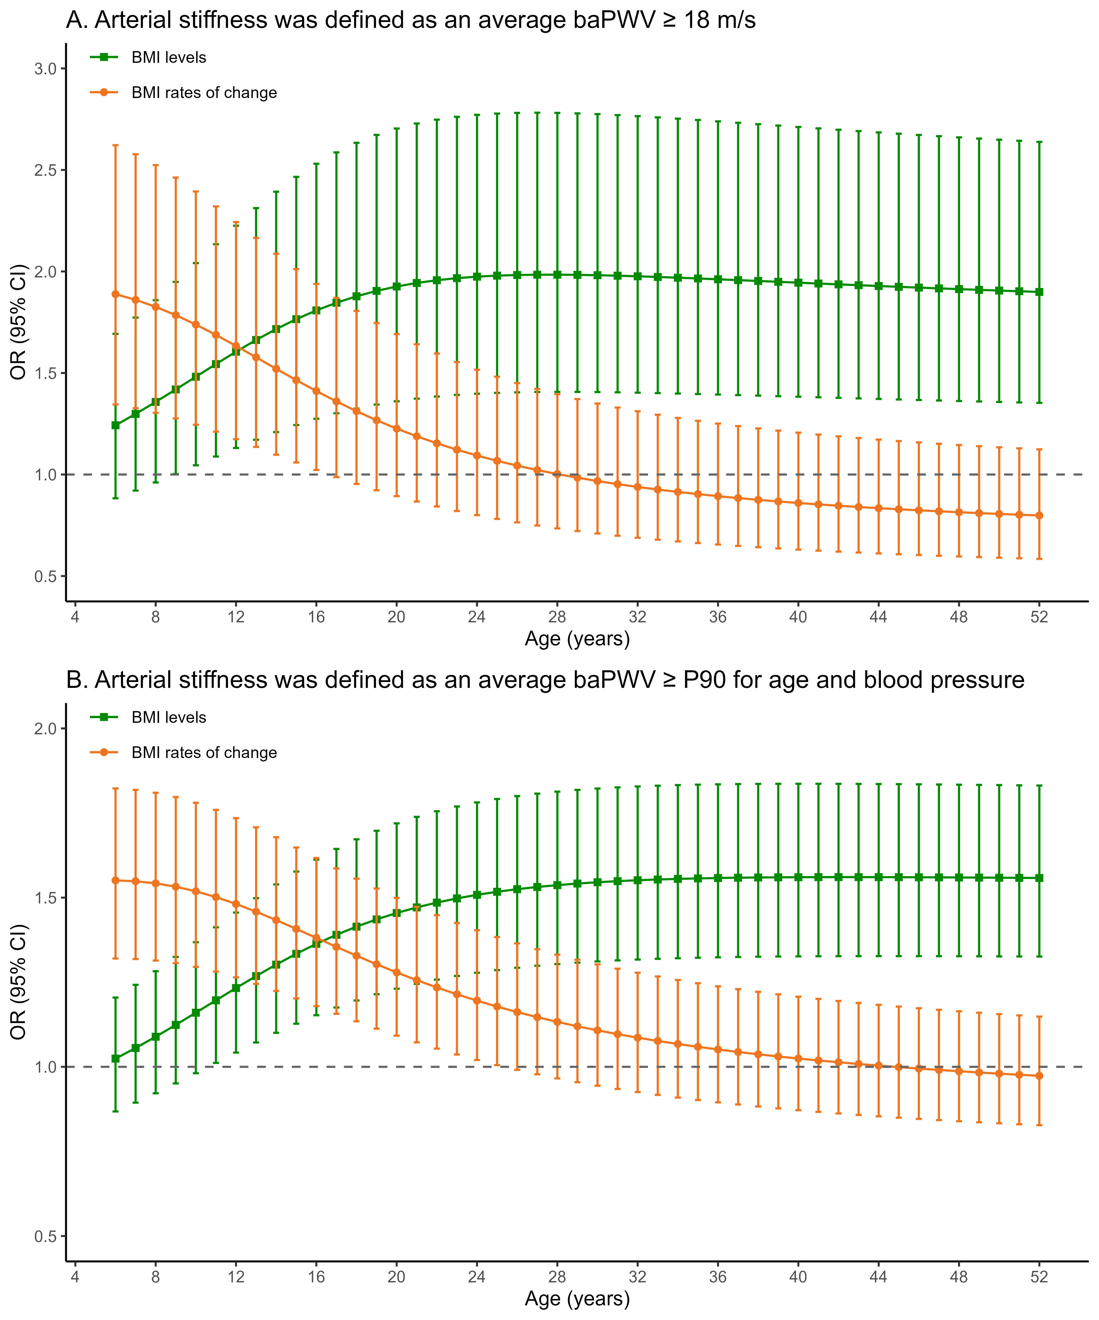Figure S6. Sensitivity analyses of associations of age-specific model-estimated BMI levels and level-adjusted change rates from childhood to adulthood with arterial stiffness (using two alternative definitions)
Note: Data are presented as ORs with 95% CIs.
Abbreviations: BMI, body mass index; CI, confidence interval; OR, odds ratio.

Figure S7. Sensitivity analyses of associations of age-specific model-estimated BMI levels and level-adjusted change rates from childhood to adulthood with mid-adulthood left ventricular mass index and brachial-ankle pulse wave velocity (after adjustment for different covariates)
Note: Data are presented as β coefficients with 95% CIs. β coefficients represent the change in outcome measures per 1-SD change in BMI.
Abbreviations: BMI, body mass index; CI, confidence interval.
Figure S8. Sensitivity analyses of associations of age-specific model-estimated BMI levels and level-adjusted change rates from childhood to adulthood with mid-adulthood left ventricular hypertrophy and arterial stiffness (after adjustment for different covariates)
Note: Data are presented as ORs with 95% CIs.
Abbreviations: BMI, body mass index; CI, confidence interval; OR, odds ratio.

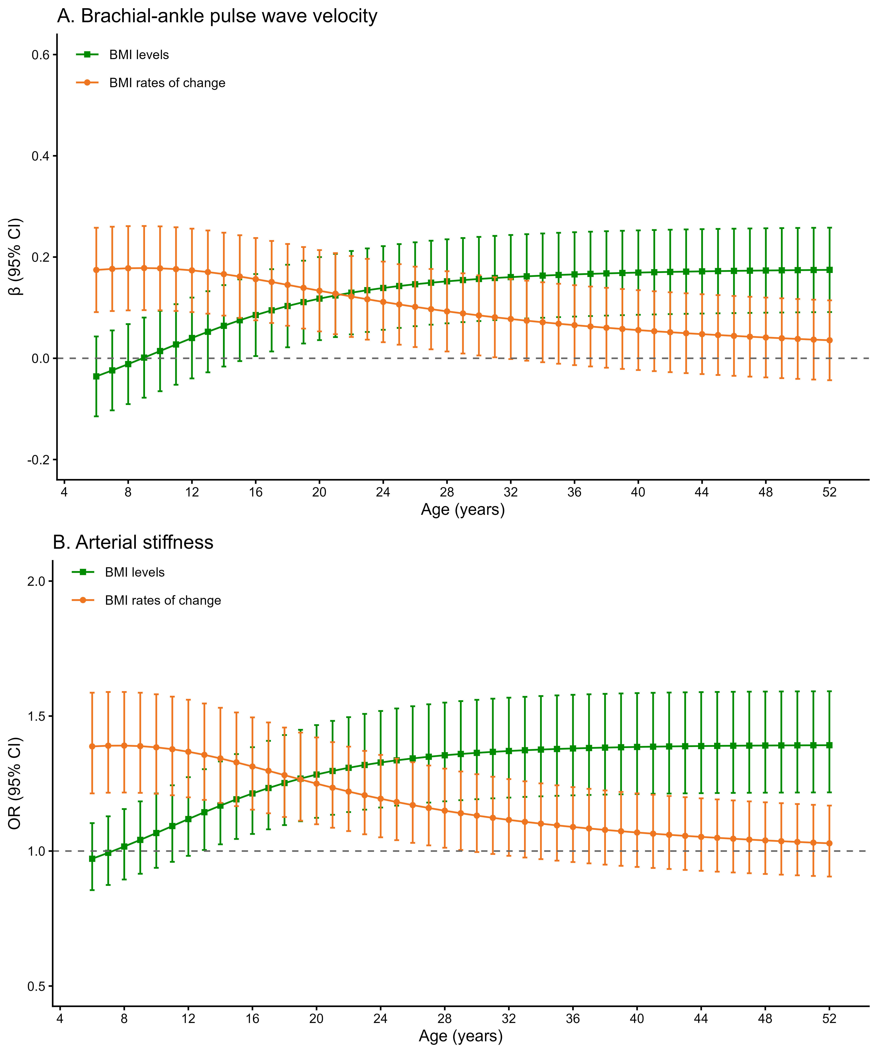
Figure S9. Sensitivity analyses of associations of age-specific model-estimated BMI levels and level-adjusted change rates from childhood to adulthood with (A) mid-adulthood brachial-ankle pulse wave velocity and (B) arterial stiffness (additional adjustment for mean arterial pressure)
Note. Data are presented as β coefficients with 95% CIs for brachial-ankle pulse wave velocity and ORs with 95% CIs for arterial stiffness.
β coefficients represent the change in outcome measures per 1-SD change in BMI.
Abbreviations: BMI, body mass index; CI, confidence interval; OR, odds ratio.

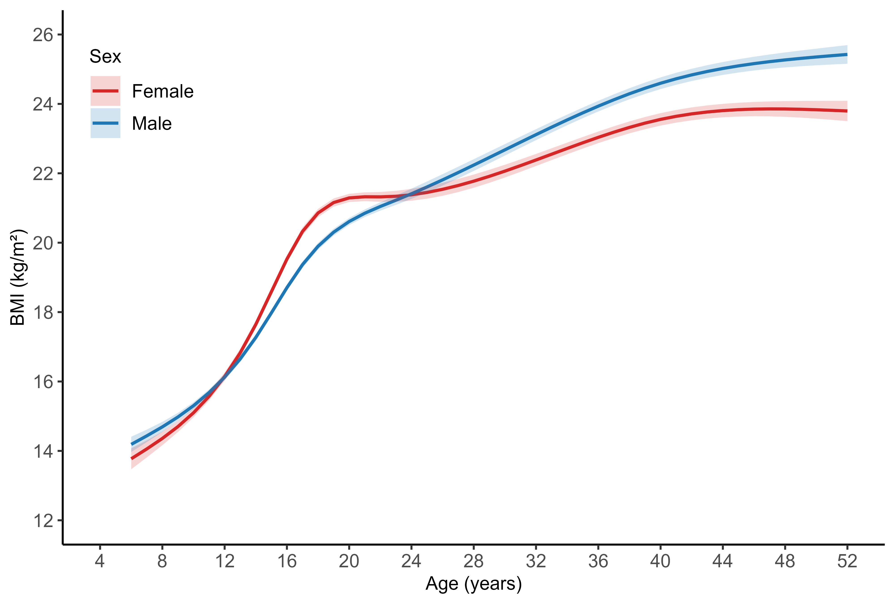
Figure S10. Sex-specific model-predicted mean BMI trajectories from childhood to adulthood (ages 6-52 years): a sensitivity analysis excluding the 2005 follow-up data
Note: Curves show population-average (fixed-effects only) estimates derived from sex-stratified mixed-effects models with restricted cubic splines for age. The shaded bands represent 95% confidence intervals for the mean trajectory, computed from the fixed-effects covariance matrix.
Abbreviation: BMI, body mass index.

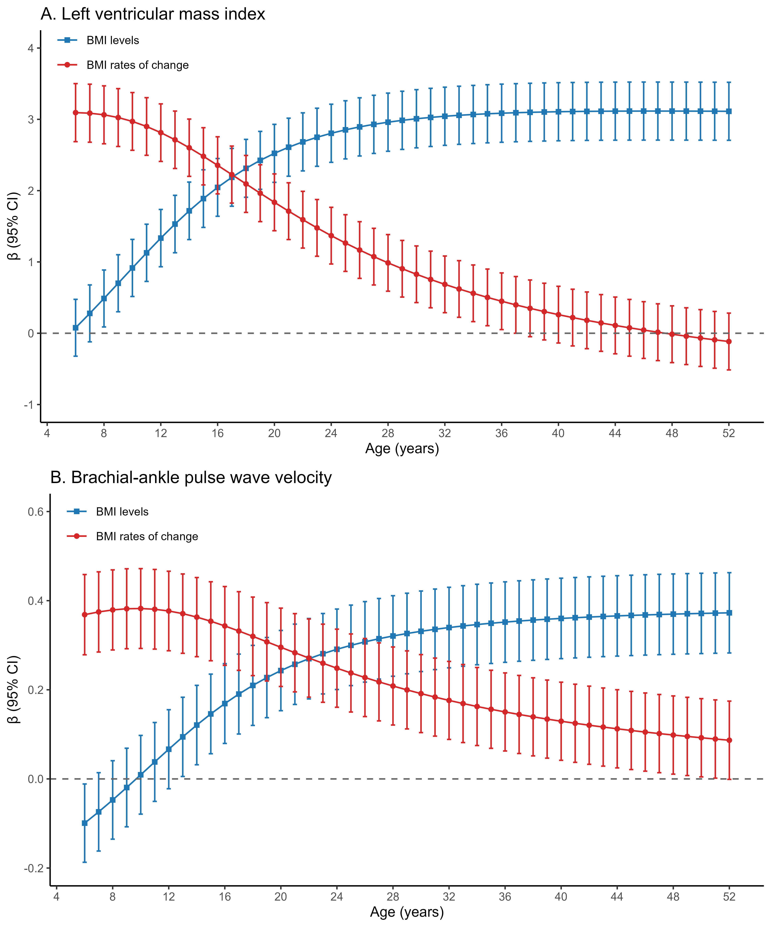
Figure S11. Sensitivity analyses of associations of age-specific model-estimated BMI levels and level-adjusted change rates from childhood to adulthood with mid-adulthood subclinical cardiovascular measures (excluding the 2005 follow-up data): (A) Left ventricular mass index; (B) Brachial-ankle pulse wave velocity
Note: Data are presented as β coefficients with 95% CIs. β coefficients represent the change in outcome measures per 1-SD change in BMI.
Abbreviation: BMI, body mass index; CI, confidence interval.

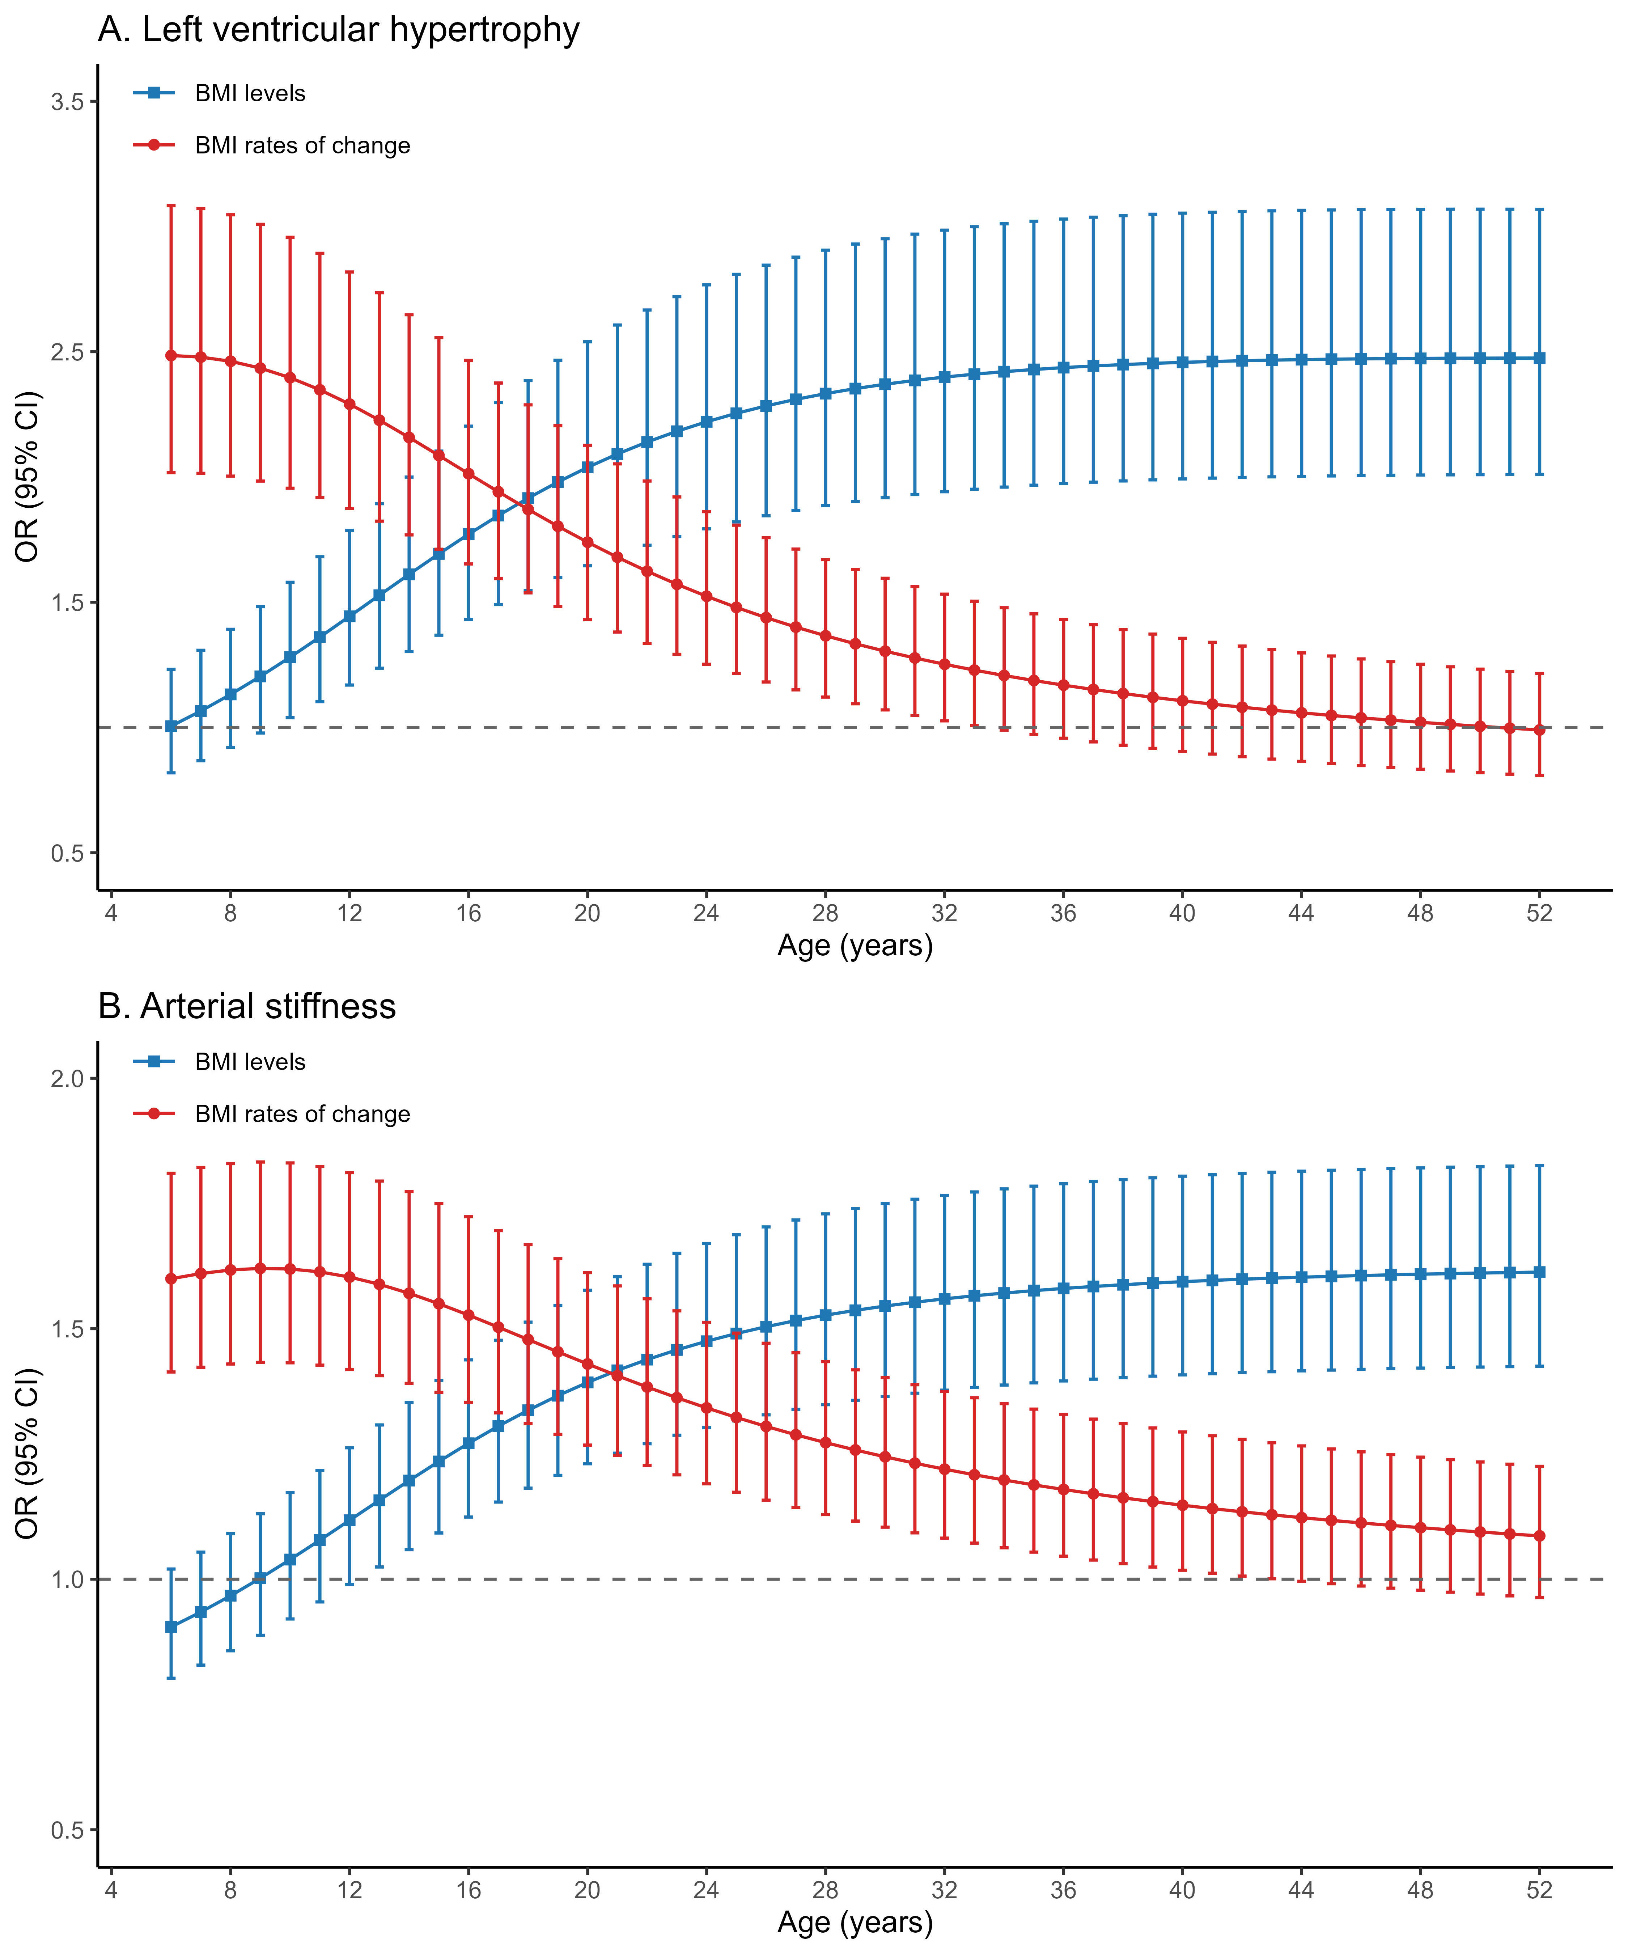
Figure S12. Sensitivity analyses of associations of age-specific model-estimated BMI levels and level-adjusted change rates from childhood to adulthood with mid-adulthood subclinical cardiovascular outcomes (excluding the 2005 follow-up data): (A) Left ventricular hypertrophy; (B) Arterial stiffness
Note: Data are presented as ORs with 95% CIs.
Abbreviation: BMI, body mass index CI, confidence interval; OR, odds ratio.
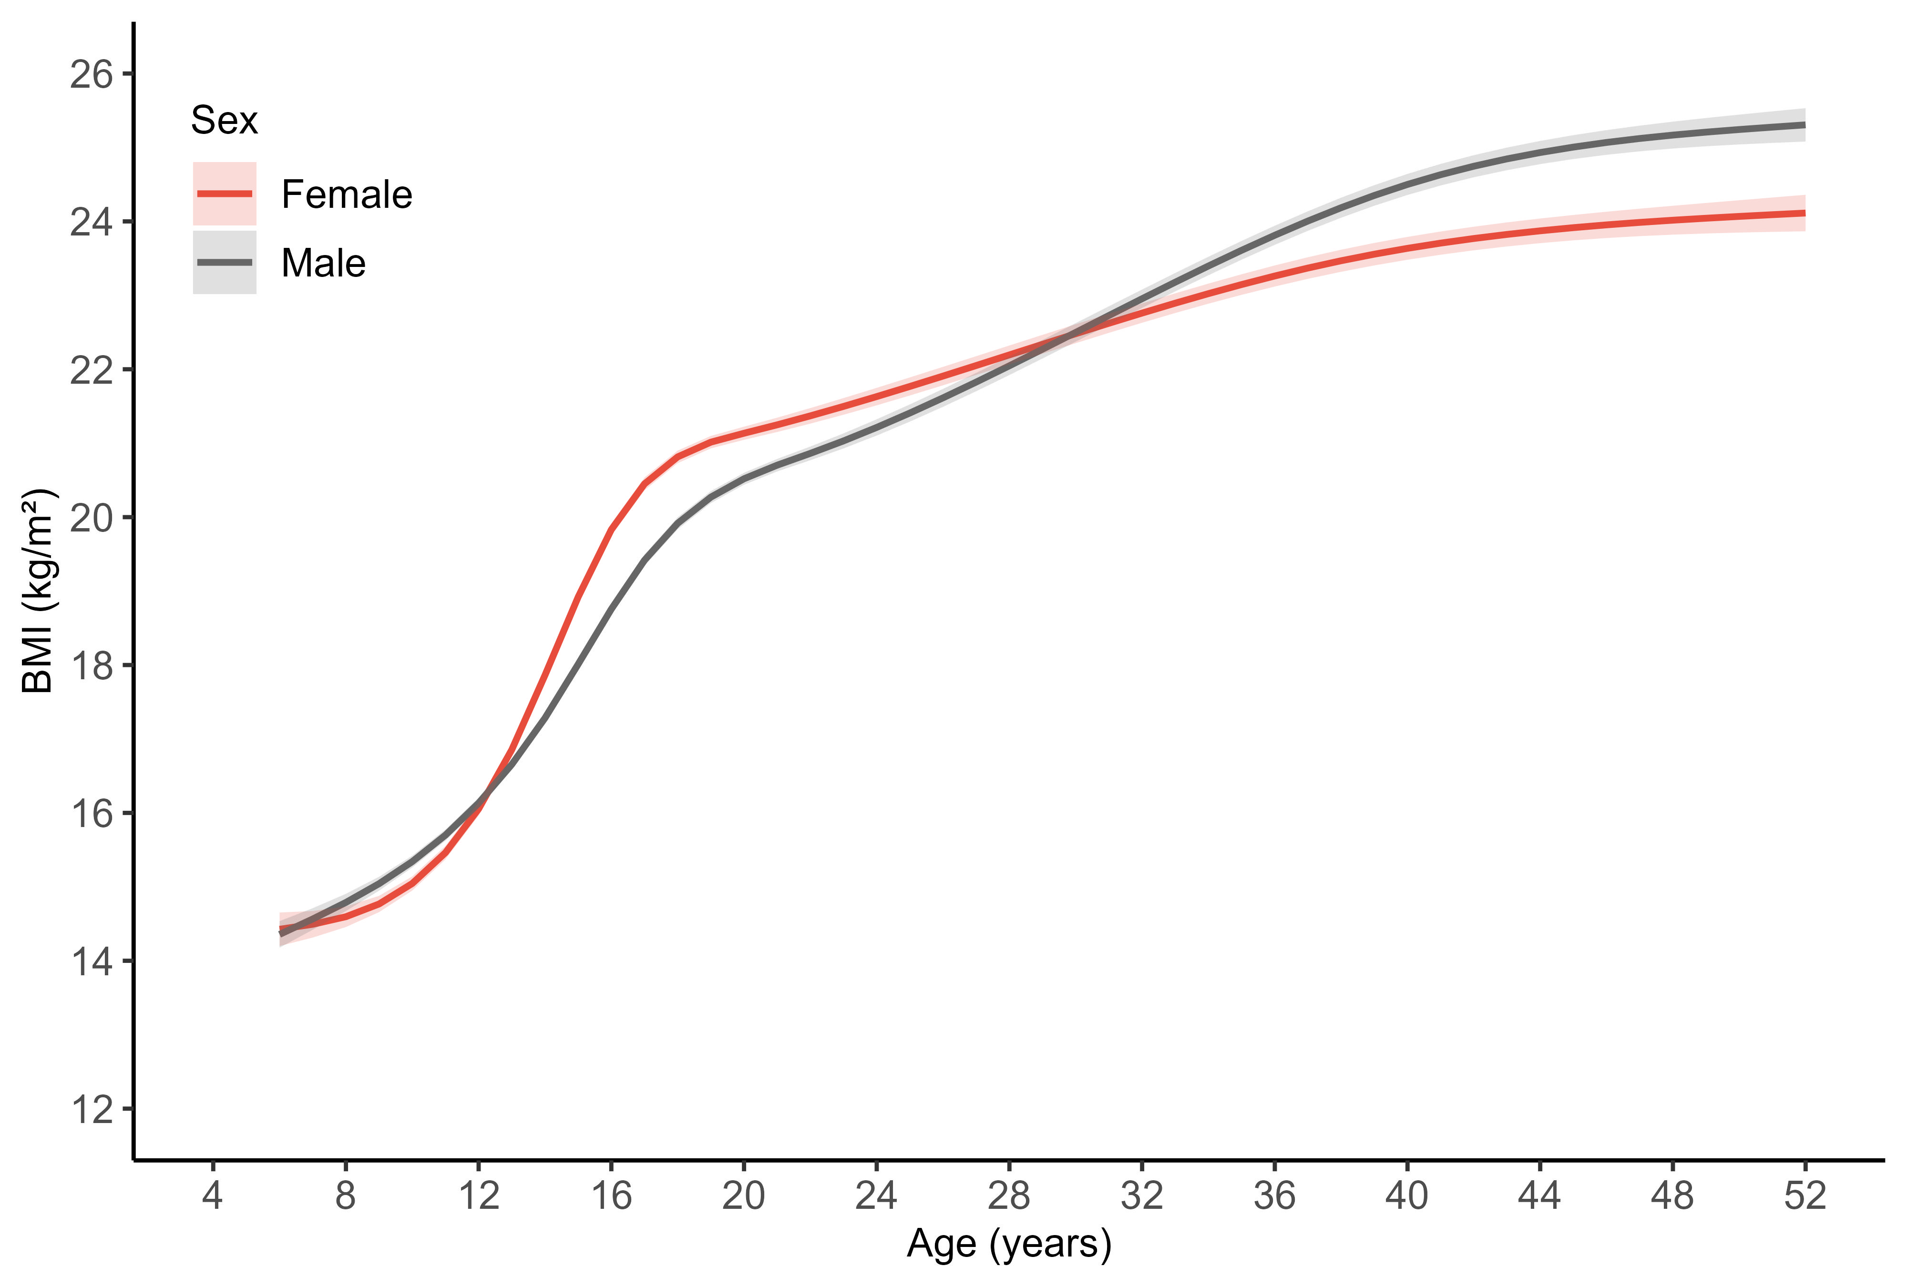
Figure S13. Sex-specific model-predicted mean BMI trajectories from childhood to adulthood (ages 6-52 years): a sensitivity analysis including participants with ≥1 BMI measurements
Note: Curves show population-average (fixed-effects only) estimates derived from sex-stratified mixed-effects models with restricted cubic splines for age. The shaded bands represent 95% confidence intervals for the mean trajectory, computed from the fixed-effects covariance matrix.
Abbreviation: BMI, body mass index.

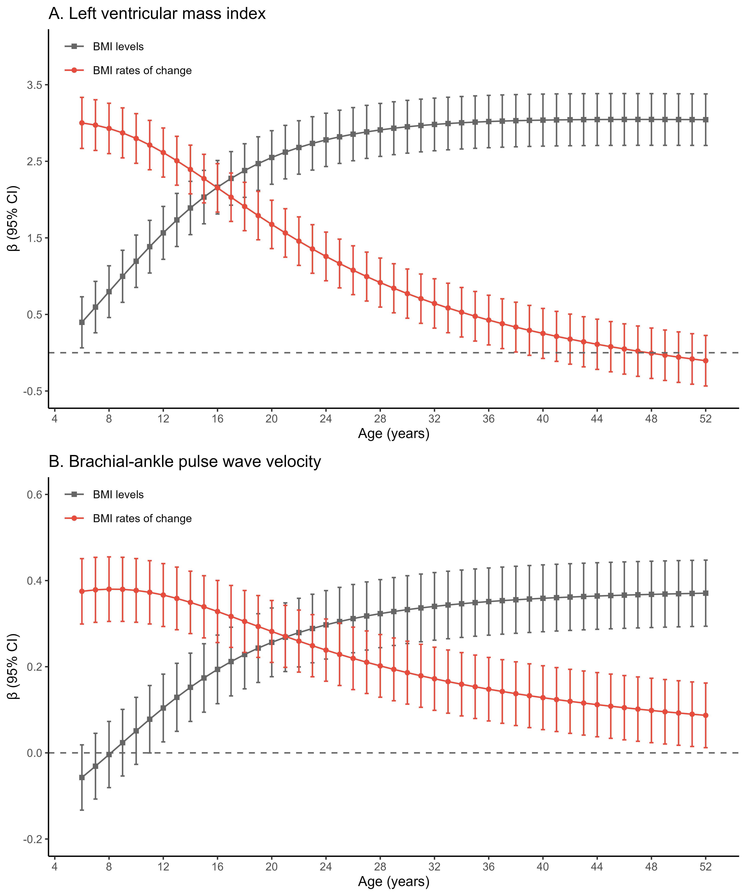
Figure S14. Sensitivity analyses of associations of age-specific model-estimated BMI levels and level-adjusted change rates from childhood to adulthood with mid-adulthood subclinical cardiovascular measures (including participants with ≥1 BMI measurement): (A) Left ventricular mass index; (B) Brachial-ankle pulse wave velocity
Note: Data are presented as β coefficients with 95% CIs. β coefficients represent the change in outcome measures per 1-SD change in BMI.
Abbreviation: BMI, body mass index; CI, confidence interval.

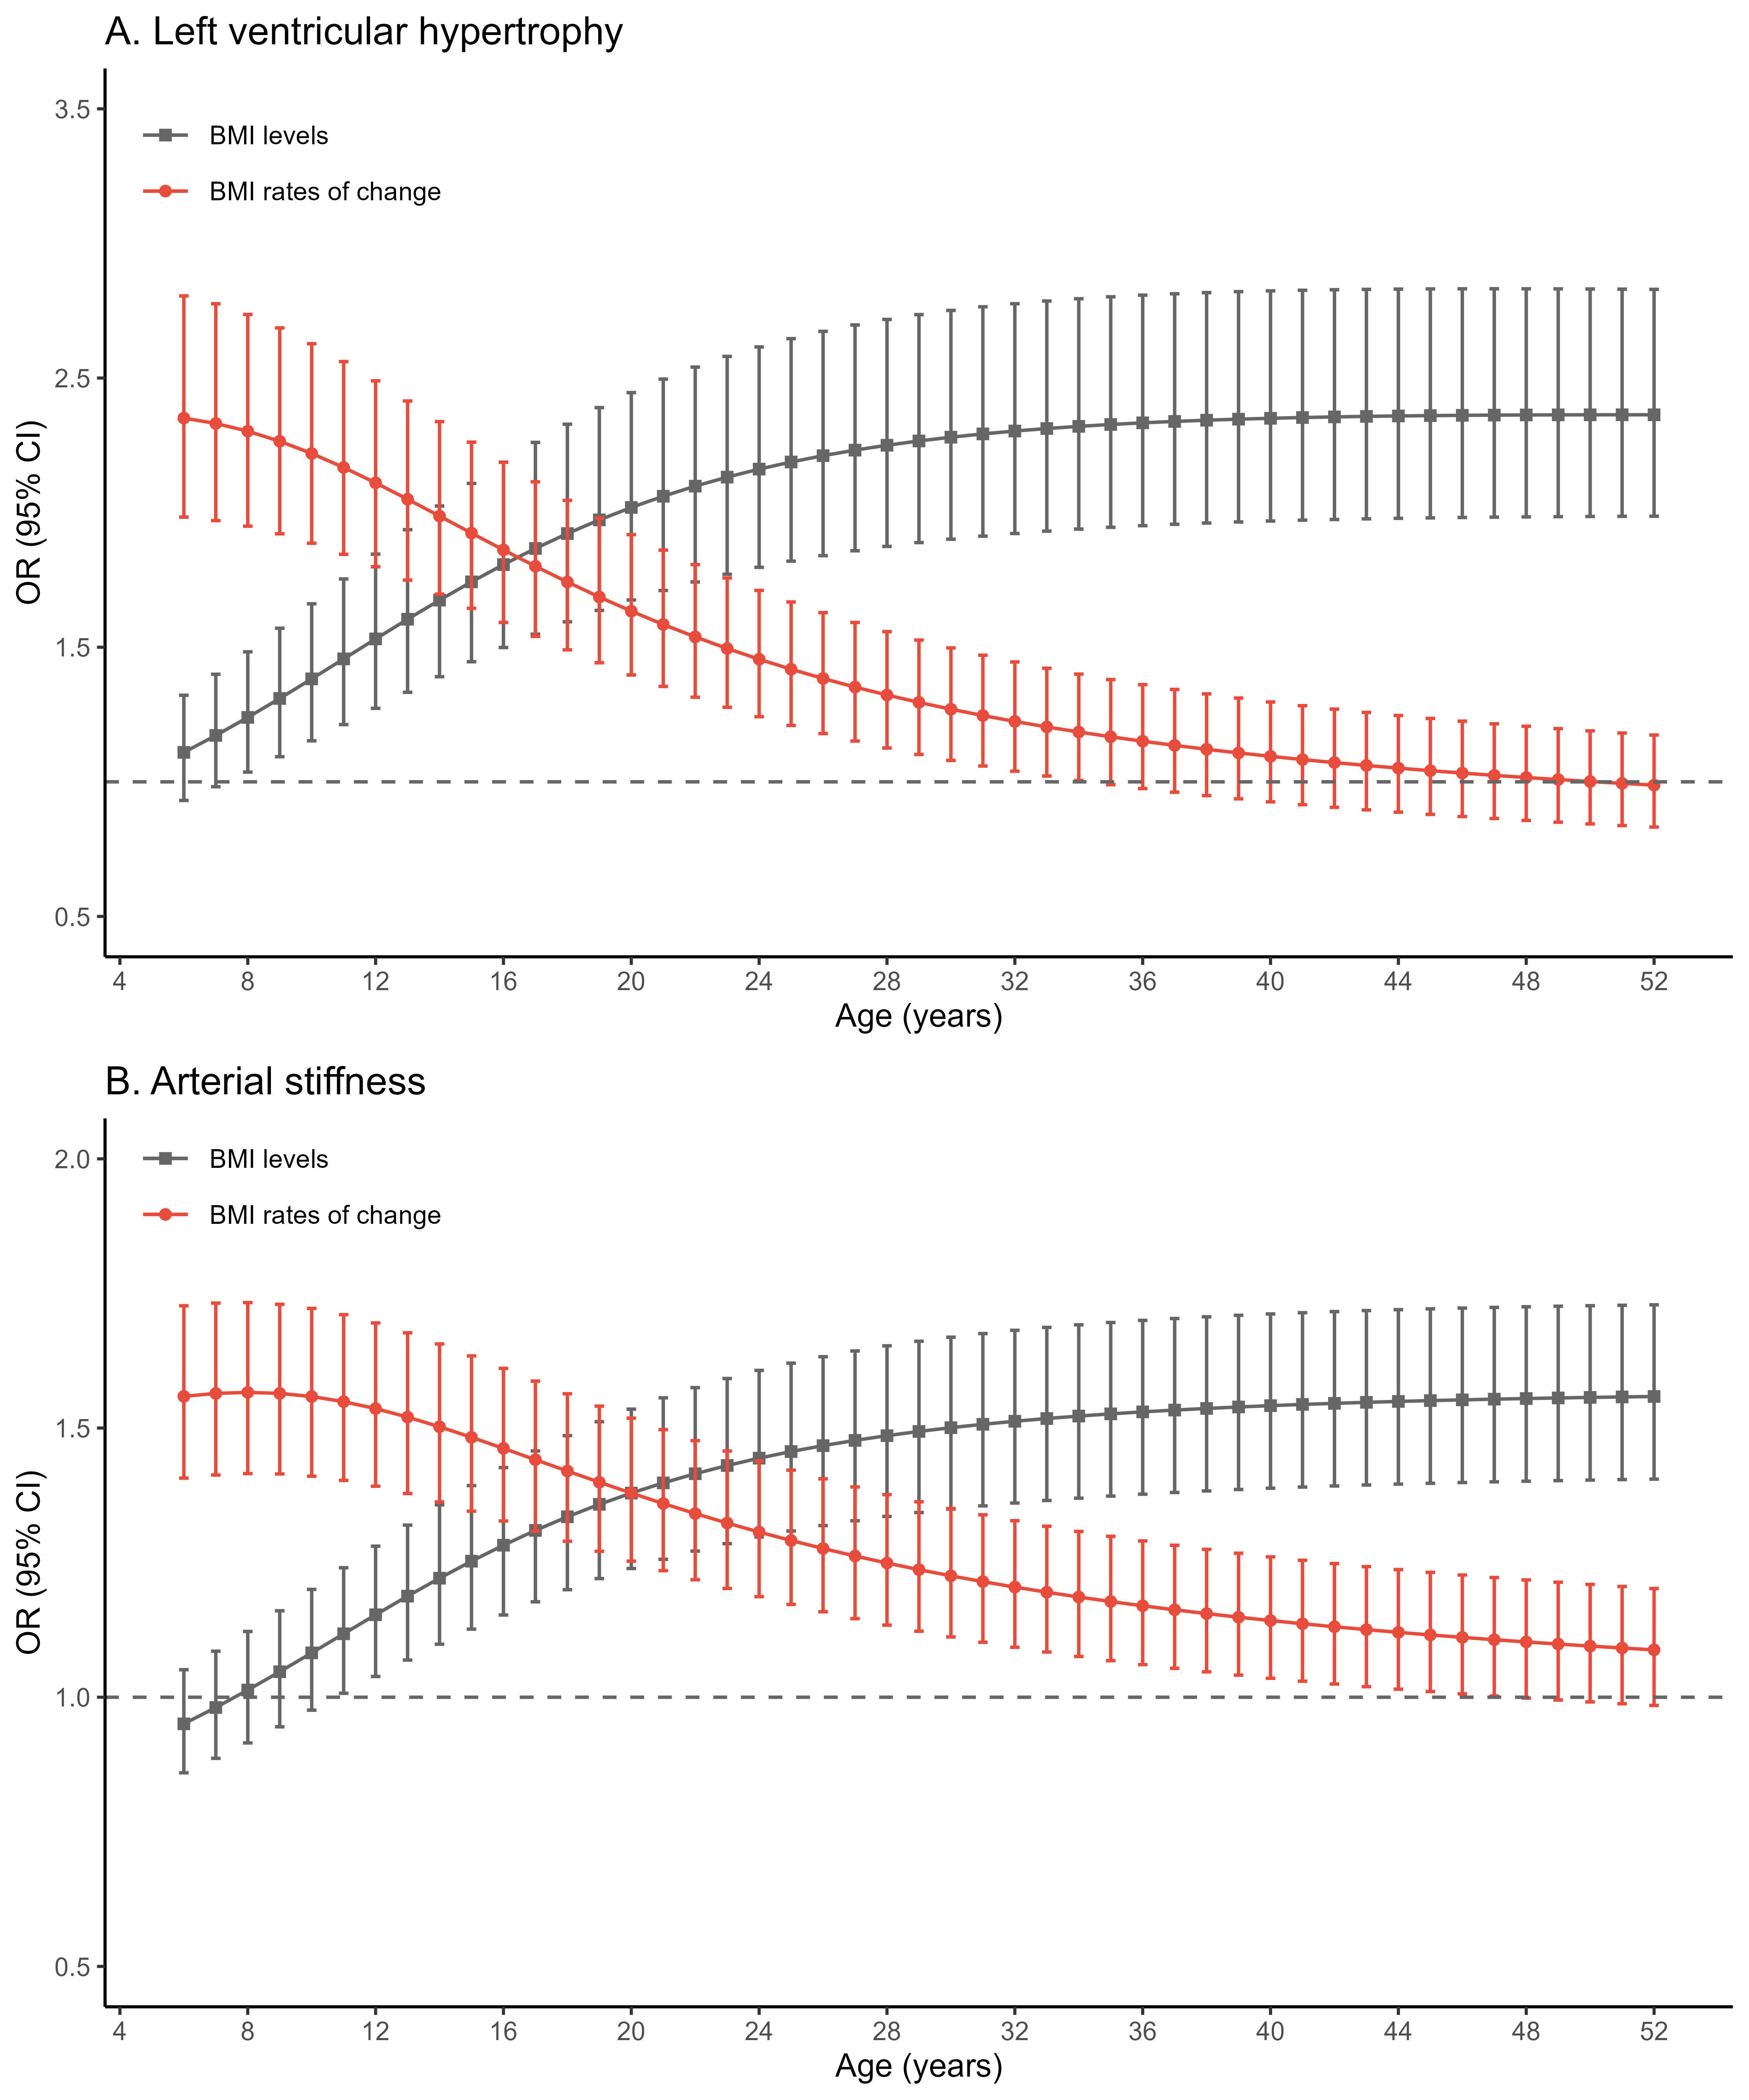
Figure S15. Sensitivity analyses of associations of age-specific model-estimated BMI levels and level-adjusted change rates from childhood to adulthood with mid-adulthood subclinical cardiovascular outcomes (including participants with ≥1 BMI measurement): (A) Left ventricular hypertrophy; (B) Arterial stiffness
Note: Data are presented as ORs with 95% CIs.
Abbreviation: BMI, body mass index CI, confidence interval; OR, odds ratio.

