Anticholinergic Drug Burden and Incident Cardiovascular Events: A Population-based Study

Supplementary Materials
Table S1. List of drugs included in the Anticholinergic Cognitive Burden scale 2
Table S2. List of ICD-10 codes used to identify cardiovascular events 5
Table S3. List of ICD-10 codes and ATC codes used to define covariates 6
Table S4. Association between baseline anticholinergic burden (annual DDDs) and incident cardiovascular events, using conventional multivariable Cox models 8
Table S5. Competing risk analysis of baseline anticholinergic burden (annual DDDs) and incident cardiovascular events 9
Table S6. Characteristics according to the total ACB score at baseline 10
Table S7. Association between anticholinergic burden (ACB score) and incident cardiovascular events 13
Table S8. Association between time-varying anticholinergic burden (annual DDDs) and incident cardiovascular events, stratified by sex 14
Table S9. Association between time-varying anticholinergic burden (annual DDDs) and incident cardiovascular events, stratified by age groups at baseline 15
Figure S1. Graphical depiction of the study design 16
Figure S2. Alluvial plots illustrating the changes in drug exposure categories over time 17
Figure S3. Distribution of population total DDDs of anticholinergic drugs by ATC groups 18
Figure S4. Distribution of baseline inverse probability weights 19
Figure S5. Covariate balance before and after baseline inverse probability weighting 20
Figure S6. Distribution of time-varying inverse probability weights 21
Figure S7. Associations between time-varying anticholinergic burden (ACB score) and specific cardiovascular events 22

Table S1. List of drugs included in the Anticholinergic Cognitive Burden scale
Generic name | Score | ATC codes
Alimemazine | 1 | R06AD01
Alprazolam | 1 | N05BA12
Alverine | 1 | A03AX08, A03AX58
Aripiprazole | 1 | N05AX12
Asenapine | 1 | N05AH05
Atenolol | 1 | C07AB03, C07AB11, C07BB03, C07CB03, C07CB53, C07DB01, C07FB03
Bupropion | 1 | N06AX12, A08AA62
Captopril | 1 | C09AA01, C09BA01
Cetirizine | 1 | R06AE07
Chlortalidone | 1 | C03BA04, C03BB04, C03EA06
Cimetidine | 1 | A02BA01, A02BA51
Clidinium | 1 | A03CA02
Clorazepate | 1 | N05BA05
Codeine | 1 | R05DA04, R05DA12, N02AA08, N02AA58, N02AA59, N02AA79, N02AJ01, N02AJ02, N02AJ03, N02AJ06, N02AJ07, N02AJ08, N02AJ09
Colchicine | 1 | M04AC01, L01CC
Desloratadine | 1 | R06AX27
Diazepam | 1 | N05BA01, N05BA17
Digoxin | 1 | C01AA05, C01AA02, C01AA08, C01AA52
Dipyridamole | 1 | B01AC07
Disopyramide | 1 | C01BA03
Fentanyl | 1 | N01AH01, N01AH51, N02AB03
Fluvoxamine | 1 | N06AB08
Furosemide | 1 | C03CA01, C03CB01, C03EB01
Haloperidol | 1 | N05AD01
Hydralazine | 1 | C02DB02, C02DB01, C02LG01, C02LG02, C02LG51
Hydrocortisone | 1 | H02AB09, A07EA02
Iloperidone | 1 | N05AX14
Isosorbide | 1 | C01DA08, C01DA14, C01DA58, C05AE02
Levocetirizine | 1 | R06AE09
Loperamide | 1 | A07DA03, A07DA05, A07DA53
Loratadine | 1 | R06AX13
Metoprolol | 1 | C07AB02, C07BB02, C07BB52, C07CB02, C07FB02, C07FB13, C07FX03, C07FX05
Morphine | 1 | N02AA01, N02AA04, N02AA51, N02AG01, R05DA01, R05DA05, A07DA52
Nifedipine | 1 | C08CA05, C08CA55, C08GA01
Paliperidone | 1 | N05AX13
Prednisone | 1 | H02AB07, H02AB15, A07EA03
Quinidine | 1 | C01BA01, C01BA13, C01BA51, C01BA71
Ranitidine | 1 | A02BA02, A02BA07
Risperidone | 1 | N05AX08
Theophylline | 1 | R03DA04, R03DA54, R03DA74, R03DB04
Trazodone | 1 | N06AX05
Triamterene | 1 | C03DB02
Venlafaxine | 1 | N06AX16
Warfarin | 1 | B01AA03
Amantadine | 2 | N04BB01
Belladonna | 2 | A03BA04, A03CB02, A06AB30
Carbamazepine | 2 | N03AF01
Cyclobenzaprine | 2 | M03BX08
Cyproheptadine | 2 | R06AX02
Levomepromazine | 2 | N05AA02
Loxapine | 2 | N05AH01
Molindone | 2 | N05AE02
Nefopam | 2 | N02BG06
Oxcarbazepine | 2 | N03AF02
Pethidine | 2 | N02AB02, N02AB52, N02AB72, N02AG03
Pimozide | 2 | N05AG02
Amitriptyline | 3 | N06AA09, N06CA01
Amoxapine | 3 | N06AA17
Atropine | 3 | A03BA01, A03CB03, A03BB02, A03BB06, A03CB04
Benzatropine | 3 | N04AC01, N04AC30
Brompheniramine | 3 | R06AB01, R06AB51, R06AB06, R06AB56
Carbinoxamine | 3 | R06AA08
Chlorphenamine | 3 | R06AB04, R06AB54, R06AB02, R06AB52
Chlorpromazine | 3 | N05AA01
Clemastine | 3 | R06AA04, R06AA54
Clomipramine | 3 | N06AA04
Clozapine | 3 | N05AH02
Darifenacin | 3 | G04BD10
Desipramine | 3 | N06AA01
Dicycloverine | 3 | A03AA07
Dimenhydrinate | 3 | R06AA11, R06AA61
Diphenhydramine | 3 | R06AA02, R06AA52
Doxepin | 3 | N06AA12
Doxylamine | 3 | R06AA09, R06AA59
Fesoterodine | 3 | G04BD11, G04BD13
Flavoxate | 3 | G04BD02
Hydroxyzine | 3 | N05BB01, N05BB51
Hyoscyamine | 3 | A03BA03, A03CB31
Imipramine | 3 | N06AA02, N06AA03
Meclozine | 3 | R06AE05, R06AE55
Methocarbamol | 3 | M03BA03, M03BA53, M03BA73
Nortriptyline | 3 | N06AA10
Olanzapine | 3 | N05AH03, N05AH53
Orphenadrine | 3 | M03BC01, M03BC51, N04AB02
Oxybutynin | 3 | G04BD04
Paroxetine | 3 | N06AB05
Perphenazine | 3 | N05AB03
Promethazine | 3 | R06AD02, R06AD52, V03AB05, R06AD05, R06AD55
Propantheline | 3 | A03AB05, A03CA34
Propiverine | 3 | G04BD06
Quetiapine | 3 | N05AH04
Scopolamine | 3 | A04AD01, A04AD51, N05CM05, A03BB01, A03BB03, A03CB01, A03DB04
Solifenacin | 3 | G04BD08, G04CA53
Thioridazine | 3 | N05AC02
Tolterodine | 3 | G04BD07
Trifluoperazine | 3 | N05AB06
Trihexyphenidyl | 3 | N04AA01
Trimipramine | 3 | N06AA06
Trospium | 3 | G04BD09, A03DA06
Abbreviation: ATC, Anatomical Therapeutic Chemical.

Table S2. List of ICD-10 codes used to identify cardiovascular events
 | ICD-10 codes
Any cardiovascular event | I00-I09, I11.0, I13.0, I13.2, I20-I89
Myocardial infarction | I21, I22, I25.2
Arrhythmias | I44.1, I44.2, I46, I47.0-I47.2, I48, I49.0, I49.5, I49.8
Heart failure | I09.9, I11.0, I13.0, I13.2, I25.5, I42.0, I42.6-I42.9, I43, I50
Cerebrovascular disease | I60-I69
Arterial disease | I70-I74
Venous thromboembolism | I26, I80-I82
Abbreviation: ICD-10, International Classification of Diseases 10th Revision.

Table S3. List of ICD-10 codes and ATC codes used to define covariates
 | ICD-10 codes | ATC codes
Surrogates for lifestyles
Tobacco-related disorders | F17, T65.2, Z71.6, Z72.0
Alcohol-related disorders | E24.4, F10, G31.2, G62.1, G72.1, I42.6, K29.2, K70, K86.0, O35.4, P04.3, Q86.0, T51.0, Y90, Y91, Z50.2, Z71.4, Z72.1
Obesity | E65-E66
Physical conditions
Hypertension | I10-I15 | C03, C07, C08, C09
Diabetes mellitus | E10-E14 | A10A, A10B
Dyslipidemia | E78
Any cancer (excl. non-melanoma skin cancer) | C00‐C97, excl. C44
Rheumatic disease | M05, M06, M12.3, M07.0-M07.3, M08, M13, M30, M31.3-M31.6, M32-M34, M35.0, M35.1, M35.3, M45, M46
Osteoarthritis | M15-M19
Liver disease | B15-B19, K70-K77, R18, I85.0, I85.9, I98.2, I98.3
Lung disease | J41-J47, J60-J70
Kidney disease | N03.2-N03.7, N05.2-N05.7, N11, N18, N19, N25.0, I12.0, I13.1, Q61.1-Q61.4, Z49, Z94.0, Z99.2
Urinary incontinence | N39.3, N39.4, R32
Gastro-esophageal reflux disease/Esophagitis | K20, K21
Peptic ulcer disease | K25-K28
Inflammatory bowel disease | K50, K51, K52.3
Irritable bowel syndrome | K58
Vestibular disorders | H81
Back pain | M54
Chronic pain | F45.4, E10.4, E11.4, E12.4, E13.4, E14.4, B02.2, G50.0, G50.1, G53.0, M25.5, M50.1, M51.1, M54.1, M79.1, M79.2, M79.7, G63.1, G63.2, R52.1, R52.2
Neurological/psychiatric conditions
Parkinson’s disease | G20
Epilepsy | G40
Migraine/Headache | G43, G44, R51
Transient ischemic attack | G45
Substance use disorder | F10-F19
Psychotic disorders/Bipolar disorder | F20-F29, F30, F31
Depression | F32, F33
Anxiety disorders | F40, F41
Stress-related disorders | F43
Sleep disorders | F51, G47
Medications
Renin-angiotensin system inhibitors |  | C09
Beta-blockers |  | C07
Calcium channel blockers |  | C08
Diuretics |  | C03
Statins |  | C10AA, C10B
Proton-pump inhibitors |  | A02BC
Antiplatelet drugs |  | B01AC
Nonsteroidal anti-inflammatory drugs |  | M01A
Opioids |  | N02A
Antiepileptics |  | N03A
Anti-Parkinson drugs |  | N04
Antipsychotics |  | N05A
Anxiolytics, hypnotics, and sedatives |  | N05B, N05C
Antidepressants |  | N06A
Anti-addiction drugs |  | N07B
Abbreviations: ATC, Anatomical Therapeutic Chemical; ICD-10, International Classification of Diseases 10th Revision.

Table S4. Association between baseline anticholinergic burden (annual DDDs) and incident cardiovascular events, using conventional multivariable Cox models
Baseline exposure  (DDDs) | No. of events | Person-year | Incidence rate per 1000 person-years | Weighted HR (95% CI) | Conventional multivariable Cox models
 |  |  |  |  | Model 1 | Model 2 | Model 3
0 | 76,004 | 4,211,926 | 18.0 | 1.00 | 1.00 | 1.00 | 1.00
1-89 | 12,686 | 565,755 | 22.4 | 1.05 (1.02, 1.08) | 1.22 (1.19, 1.24) | 1.06 (1.04, 1.08) | 1.05 (1.03, 1.07)
90-364 | 19,576 | 660,411 | 29.6 | 1.05 (1.01, 1.09) | 1.36 (1.34, 1.38) | 1.10 (1.08, 1.12) | 1.06 (1.04, 1.09)
≥365 | 10,000 | 256,643 | 39.0 | 1.17 (1.08, 1.27) | 1.80 (1.76, 1.84) | 1.31 (1.28, 1.34) | 1.20 (1.16, 1.24)
Abbreviations: CI, confidence interval; DDD, defined daily dose; HR, hazard ratio.
Model 1 was adjusted for age and sex.
Model 2 was additionally adjusted for socioeconomic status, healthcare utilization in the previous year, history of medical conditions, and use of medications other than anticholinergics at baseline.
Model 3 was additionally adjusted for past exposure to anticholinergic drugs.

Table S5. Competing risk analysis of baseline anticholinergic burden (annual DDDs) and incident cardiovascular events
Baseline exposure  (DDDs) | No. of events | Person-year | Incidence rate per 1000 person-years | Cause-specific HR (95% CI)^{a,b} | Subdistribution HR (95% CI)^{a,c}
Incident CVD
0 | 76,004 | 4,211,926 | 18.0 | 1.00 | 1.00
1-89 | 12,686 | 565,755 | 22.4 | 1.05 (1.02, 1.08) | 1.03 (1.01, 1.06)
90-364 | 19,576 | 660,411 | 29.6 | 1.05 (1.01, 1.09) | 1.03 (0.99, 1.07)
≥365 | 10,000 | 256,643 | 39.0 | 1.17 (1.08, 1.27) | 1.12 (1.04, 1.21)
Non-CVD mortality
0 | 45,045 | 4,557,795 | 9.9 | 1.00 | –
1-89 | 8,561 | 623,301 | 13.7 | 1.04 (1.00, 1.08) | –
90-364 | 12,765 | 744,608 | 17.1 | 1.05 (1.00, 1.10) | –
≥365 | 7,215 | 296,900 | 24.3 | 1.29 (1.18, 1.41) | –
Abbreviations: CI, confidence interval; CVD, cardiovascular disease; DDD, defined daily dose; HR, hazard ratio.
ª Model was weighted for baseline variables (age, sex, socioeconomic status, healthcare utilization in the previous year, history of medical conditions, use of medications other than anticholinergics), and pre-baseline exposure to anticholinergic drugs.
^{b} An inverse probability weighted Cox model was used.
^{c} An inverse probability weighted Fine-Gray model was used.

Table S6. Characteristics according to the total ACB score at baseline
Characteristics | Overall  N = 508,273 | 0  N = 365,398 | 1  N = 81,611 | 2–3  N = 39,179 | ≥4  N = 22,085
Age, years, median (IQR) | 58.9 (51.6–66.6) | 58.0 (50.9–65.4) | 61.5 (53.9–69.8) | 61.5 (53.6–70.9) | 60.4 (52.7–69.6)
Female | 270,441 (53.2) | 182,777 (50.0) | 47,447 (58.1) | 25,118 (64.1) | 15,099 (68.4)
Disposable income, ×100 SEK, median (IQR)ª | 2,080 (1,369–2,934) | 2,192 (1,452–3,049) | 1,933 (1,316–2,758) | 1,695 (1,235–2,497) | 1,509 (1,179–2,226)
Educational attainmentª
Compulsory education | 104,848 (21.0) | 69,755 (19.4) | 19,439 (24.2) | 9,934 (25.9) | 5,720 (26.5)
Upper secondary education | 206,333 (41.3) | 147,140 (41.0) | 33,831 (42.1) | 16,067 (41.9) | 9,295 (43.0)
University/college | 187,964 (37.7) | 141,921 (39.6) | 27,105 (33.7) | 12,361 (32.2) | 6,577 (30.5)
Marital statusª
Single | 199,270 (39.4) | 143,122 (39.4) | 29,593 (36.3) | 15,964 (40.8) | 10,591 (48.0)
Married | 268,191 (53.0) | 197,068 (54.2) | 43,412 (53.2) | 18,666 (47.7) | 9,045 (41.0)
Widowed | 38,717 (7.6) | 23,213 (6.4) | 8,540 (10.5) | 4,526 (11.6) | 2,438 (11.0)
Any outpatient specialist visits in the past year | 176,969 (34.8) | 103,646 (28.4) | 37,042 (45.4) | 21,531 (55.0) | 14,750 (66.8)
Any hospitalization in the past year | 35,643 (7.0) | 16,752 (4.6) | 8,543 (10.5) | 5,523 (14.1) | 4,825 (21.8)
Tobacco-related disorders | 4,961 (1.0) | 2,656 (0.7) | 1,105 (1.4) | 717 (1.8) | 483 (2.2)
Alcohol-related disorders | 12,564 (2.5) | 6,352 (1.7) | 2,167 (2.7) | 1,968 (5.0) | 2,077 (9.4)
Obesity diagnosis | 12,933 (2.5) | 6,229 (1.7) | 3,430 (4.2) | 1,940 (5.0) | 1,334 (6.0)
Physical conditions
Hypertension | 138,366 (27.2) | 59,896 (16.4) | 48,056 (58.9) | 19,237 (49.1) | 11,177 (50.6)
Chronic pain | 84,731 (16.7) | 52,211 (14.3) | 16,746 (20.5) | 9,448 (24.1) | 6,326 (28.6)
Back pain | 66,932 (13.2) | 40,274 (11.0) | 13,524 (16.6) | 7,746 (19.8) | 5,388 (24.4)
Osteoarthritis | 49,327 (9.7) | 29,481 (8.1) | 10,875 (13.3) | 5,523 (14.1) | 3,448 (15.6)
Cancer | 34,681 (6.8) | 20,902 (5.7) | 7,331 (9.0) | 4,004 (10.2) | 2,444 (11.1)
Diabetes mellitus | 33,878 (6.7) | 17,732 (4.9) | 8,904 (10.9) | 4,593 (11.7) | 2,649 (12.0)
Lung disease | 30,655 (6.0) | 16,651 (4.6) | 7,173 (8.8) | 4,064 (10.4) | 2,767 (12.5)
Dyslipidemia | 29,516 (5.8) | 16,060 (4.4) | 8,136 (10.0) | 3,491 (8.9) | 1,829 (8.3)
Kidney disease | 24,972 (4.9) | 10,954 (3.0) | 7,228 (8.9) | 4,347 (11.1) | 2,443 (11.1)
Rheumatic disease | 17,907 (3.5) | 10,629 (2.9) | 3,823 (4.7) | 2,132 (5.4) | 1,323 (6.0)
Gastroesophageal reflux disease | 14,326 (2.8) | 8,009 (2.2) | 3,138 (3.8) | 1,802 (4.6) | 1,377 (6.2)
Urinary incontinence | 11,983 (2.4) | 5,928 (1.6) | 2,067 (2.5) | 2,094 (5.3) | 1,894 (8.6)
Vestibular disorder | 11,329 (2.2) | 7,072 (1.9) | 2,191 (2.7) | 1,295 (3.3) | 771 (3.5)
Irritable bowel syndrome | 8,559 (1.7) | 4,621 (1.3) | 1,694 (2.1) | 1,257 (3.2) | 987 (4.5)
Liver disease | 7,431 (1.5) | 4,272 (1.2) | 1,379 (1.7) | 971 (2.5) | 809 (3.7)
Peptic ulcer disease | 5,089 (1.0) | 2,821 (0.8) | 1,095 (1.3) | 653 (1.7) | 520 (2.4)
Inflammatory bowel disease | 4,810 (0.9) | 2,940 (0.8) | 1,023 (1.3) | 491 (1.3) | 356 (1.6)
Neurological/psychiatric conditions
Depression | 29,792 (5.9) | 13,871 (3.8) | 5,803 (7.1) | 5,222 (13.3) | 4,896 (22.2)
Migraine/headache | 29,395 (5.8) | 16,946 (4.6) | 6,003 (7.4) | 3,641 (9.3) | 2,805 (12.7)
Sleep disorders | 22,578 (4.4) | 12,005 (3.3) | 4,655 (5.7) | 3,412 (8.7) | 2,506 (11.3)
Stress-related disorders | 20,637 (4.1) | 11,891 (3.3) | 3,795 (4.7) | 2,794 (7.1) | 2,157 (9.8)
Substance use disorder | 17,780 (3.5) | 8,950 (2.4) | 3,235 (4.0) | 2,763 (7.1) | 2,832 (12.8)
Anxiety disorders | 16,668 (3.3) | 6,527 (1.8) | 3,230 (4.0) | 3,351 (8.6) | 3,560 (16.1)
Psychotic disorders | 6,973 (1.4) | 1,840 (0.5) | 1,023 (1.3) | 1,691 (4.3) | 2,419 (11.0)
Transient ischemic attack | 4,213 (0.8) | 2,254 (0.6) | 1,107 (1.4) | 528 (1.3) | 324 (1.5)
Epilepsy | 3,908 (0.8) | 1,510 (0.4) | 490 (0.6) | 1,299 (3.3) | 609 (2.8)
Parkinson’s disease | 1,431 (0.3) | 726 (0.2) | 233 (0.3) | 273 (0.7) | 199 (0.9)
Medications^{b}
Number of distinct drugs, median (IQR) | 2 (1–5) | 2 (0–4) | 4 (2–7) | 6 (3–10) | 8 (5–13)
Nonsteroidal anti-inflammatory drugs | 100,992 (19.9) | 58,430 (16.0) | 22,477 (27.5) | 11,991 (30.6) | 8,094 (36.6)
Anxiolytics, hypnotics, and sedatives | 72,655 (14.3) | 31,194 (8.5) | 16,721 (20.5) | 13,187 (33.7) | 11,553 (52.3)
Renin-angiotensin system inhibitors | 68,793 (13.5) | 34,925 (9.6) | 20,408 (25.0) | 8,968 (22.9) | 4,492 (20.3)
Statins | 54,349 (10.7) | 27,414 (7.5) | 15,903 (19.5) | 7,233 (18.5) | 3,799 (17.2)
Proton-pump inhibitors | 45,767 (9.0) | 21,105 (5.8) | 11,230 (13.8) | 7,510 (19.2) | 5,922 (26.8)
Antidepressants | 37,880 (7.5) | 16,435 (4.5) | 8,066 (9.9) | 6,981 (17.8) | 6,398 (29.0)
Diuretics | 37,165 (7.3) | 16,626 (4.6) | 12,786 (15.7) | 4,910 (12.5) | 2,843 (12.9)
Calcium channel blockers | 35,143 (6.9) | 13,799 (3.8) | 13,350 (16.4) | 5,321 (13.6) | 2,673 (12.1)
Opioids | 30,946 (6.1) | 14,007 (3.8) | 7,221 (8.8) | 5,280 (13.5) | 4,438 (20.1)
Antiplatelet drugs | 30,053 (5.9) | 12,889 (3.5) | 9,853 (12.1) | 4,813 (12.3) | 2,498 (11.3)
Beta-blockers | 11,728 (2.3) | 6,361 (1.7) | 2,498 (3.1) | 1,596 (4.1) | 1,273 (5.8)
Antiepileptics | 7,692 (1.5) | 2,295 (0.6) | 1,334 (1.6) | 1,831 (4.7) | 2,232 (10.1)
Anti-addiction drugs | 7,413 (1.5) | 3,528 (1.0) | 1,475 (1.8) | 1,172 (3.0) | 1,238 (5.6)
Anti-Parkinson drugs | 4,782 (0.9) | 1,865 (0.5) | 928 (1.1) | 915 (2.3) | 1,074 (4.9)
Antipsychotics | 4,650 (0.9) | 1,351 (0.4) | 686 (0.8) | 1,068 (2.7) | 1,545 (7.0)
Abbreviations: ACB, Anticholinergic Cognitive Burden; IQR, interquartile range.
Frequency with percentage was reported unless otherwise specified.
ª Disposable income and marital status were missing for 2,095 (0.4%) individuals; educational attainment was missing for 9,128 (1.8%) individuals.
^{b} Drugs listed in the Anticholinergic Cognitive Burden scale were excluded from the covariate definition.

Table S7. Association between anticholinergic burden (ACB score) and incident cardiovascular events
 | No. of events | Person-year | Incidence rate per 1000 person-years | Weighted HR (95% CI)ª
Baseline exposure (score)
0 | 76,004 | 4,211,926 | 18.0 | 1.00
1 | 23,534 | 865,353 | 27.2 | 1.03 (1.01, 1.06)
2-3 | 11,961 | 397,930 | 30.1 | 1.03 (0.99, 1.07)
≥4 | 6,767 | 219,526 | 30.8 | 1.18 (1.11, 1.25)
Time-varying exposure (score)
0 | 62,942 | 3,927,587 | 16.0 | 1.00
1 | 28,159 | 1,000,228 | 28.2 | 1.29 (1.22, 1.36)
2-3 | 17,860 | 492,207 | 36.3 | 1.33 (1.25, 1.42)
≥4 | 9,305 | 274,713 | 33.9 | 1.37 (1.25, 1.50)
Abbreviations: ACB, Anticholinergic Cognitive Burden; CI, confidence interval; HR, hazard ratio.
ª Model was weighted for age, sex, socioeconomic status, healthcare utilization, medical conditions, use of medications other than anticholinergics, and pre-baseline exposure to anticholinergic drugs.

Table S8. Association between time-varying anticholinergic burden (annual DDDs) and incident cardiovascular events, stratified by sex
Annual DDDs | No. of events | Person-year | Incidence rate per 1000 person-years | Weighted HR (95% CI)ª
Women
0 | 25,645 | 2,003,383 | 12.8 | 1.00
1-89 | 7,821 | 381,724 | 20.5 | 1.18 (1.13, 1.23)
90-364 | 13,545 | 497,400 | 27.2 | 1.34 (1.30, 1.38)
≥365 | 8,254 | 205,516 | 40.2 | 1.78 (1.72, 1.85)
Men
0 | 37,297 | 1,924,204 | 19.4 | 1.00
1-89 | 7,345 | 240,612 | 30.5 | 1.15 (1.10, 1.20)
90-364 | 11,890 | 313,592 | 37.9 | 1.28 (1.24, 1.32)
≥365 | 6,469 | 128,305 | 50.4 | 1.64 (1.58, 1.70)
Abbreviations: CI, confidence interval; DDD, defined daily dose; HR, hazard ratio.
P for interaction <0.001.
ª Model was weighted for age, sex, socioeconomic status, healthcare utilization, medical conditions, use of medications other than anticholinergics, and pre-baseline exposure to anticholinergic drugs.

Table S9. Association between time-varying anticholinergic burden (annual DDDs) and incident cardiovascular events, stratified by age groups at baseline
Annual DDDs | No. of events | Person-year | Incidence rate per 1000 person-years | Weighted HR (95% CI)ª
<55 years
0 | 12,791 | 1,738,806 | 7.4 | 1.00
1-89 | 2,622 | 250,561 | 10.5 | 1.16 (1.08, 1.24)
90-364 | 3,219 | 260,111 | 12.4 | 1.28 (1.21, 1.36)
≥365 | 1,935 | 108,696 | 17.8 | 1.72 (1.61, 1.85)
55–64 years
0 | 20,126 | 1,381,425 | 14.6 | 1.00
1-89 | 4,422 | 212,997 | 20.8 | 1.17 (1.11, 1.23)
90-364 | 6,915 | 294,376 | 23.5 | 1.31 (1.26, 1.37)
≥365 | 3,945 | 117,508 | 33.6 | 1.73 (1.65, 1.82)
≥65 years
0 | 30,025 | 807,356 | 37.2 | 1.00
1-89 | 8,122 | 158,779 | 51.2 | 1.16 (1.11, 1.21)
90-364 | 15,301 | 256,505 | 59.7 | 1.31 (1.27, 1.35)
≥365 | 8,843 | 107,616 | 82.2 | 1.70 (1.65, 1.76)
Abbreviations: CI, confidence interval; DDD, defined daily dose; HR, hazard ratio.
P for interaction <0.001.
ª Model was weighted for age, sex, socioeconomic status, healthcare utilization, medical conditions, use of medications other than anticholinergics, and pre-baseline exposure to anticholinergic drugs.

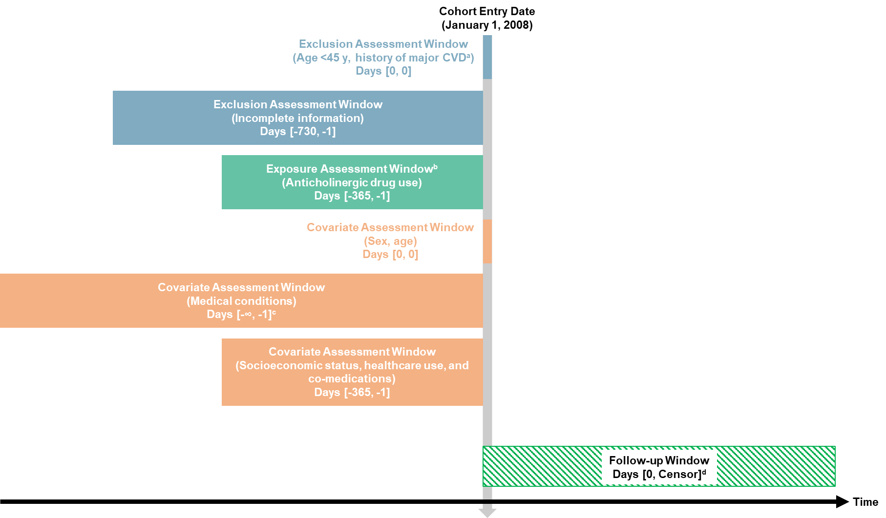

Figure S1. Graphical depiction of the study design
ª Individuals with hypertension but without hypertensive heart failure or any other cardiovascular diseases were eligible for inclusion.
^{b} Anticholinergic burden was updated using one-year sliding windows when analyzing time-varying exposure.
^{c} Healthcare data from 1997 onward were available to ascertain history of medical conditions.
^{d} Follow-up was censored at the earliest of outcome, death, emigration out of the region, or end of study period.
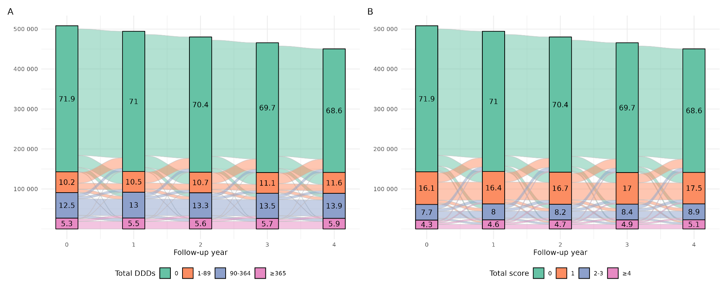

Figure S2. Alluvial plots illustrating the changes in drug exposure categories over time
Abbreviation: DDD, defined daily dose.
The overall height of each bar represents the number of individuals under follow-up in each year. Values within the bars indicate the proportion of exposure categories among individuals under follow-up.
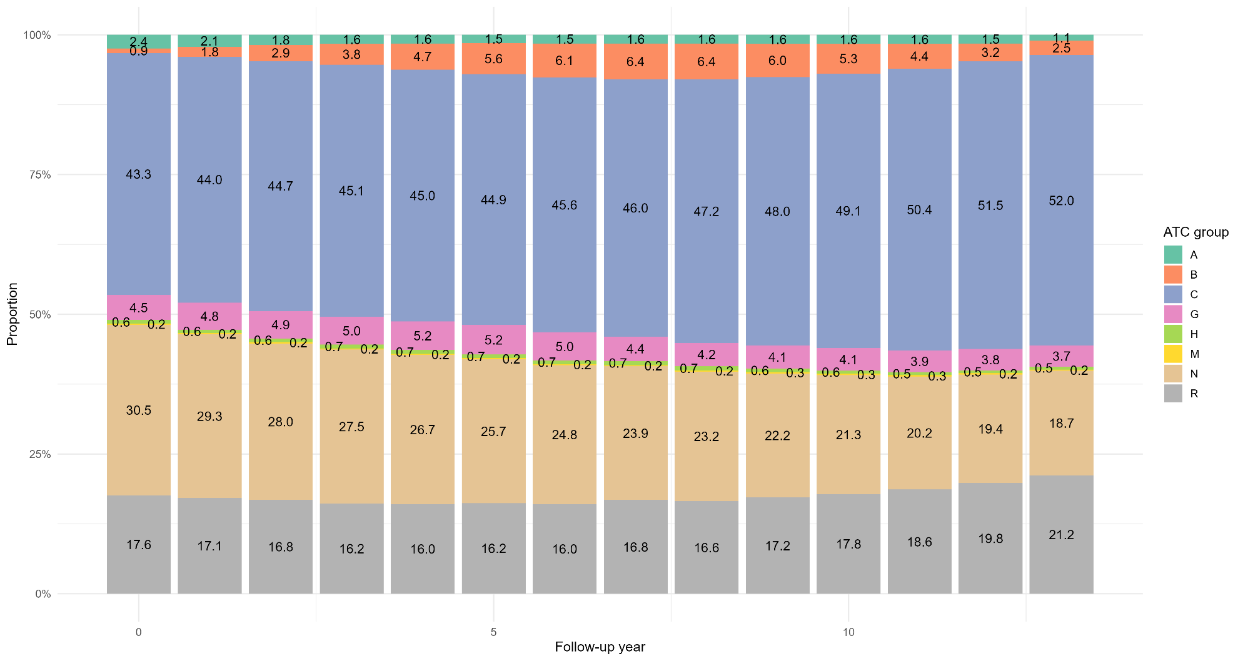

Figure S3. Distribution of population total DDDs of anticholinergic drugs by ATC groups
Abbreviations: ATC, Anatomical Therapeutic Chemical; DDD, defined daily dose.
ATC groups: A, Alimentary tract and metabolism; B, Blood and blood forming organs; C, Cardiovascular system; G, Genito urinary system and sex hormones; H, Systemic hormonal preparations, excl. sex hormones and insulins; M, Musculo-skeletal system; N, Nervous system; R, Respiratory system.
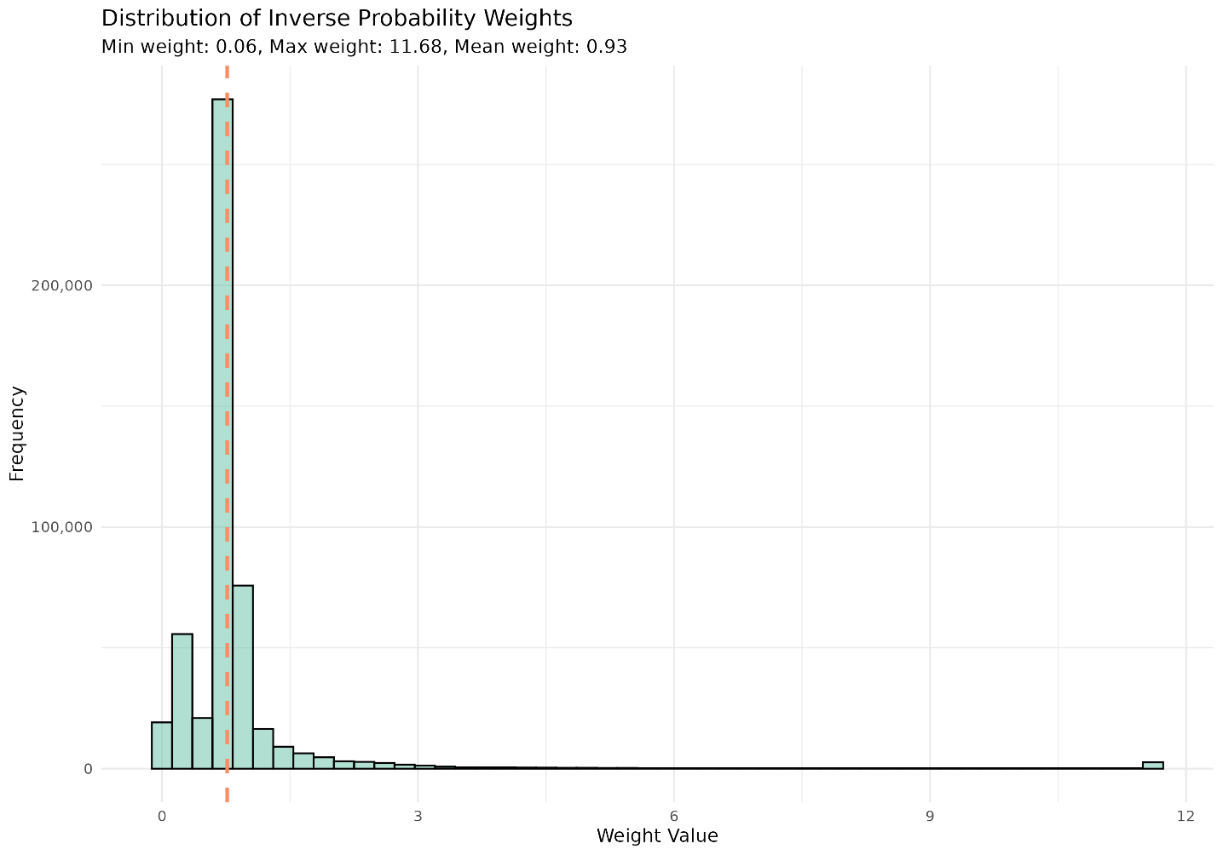

Figure S4. Distribution of baseline inverse probability weights
Stabilized inverse probability weights are truncated at the 0.5th and 99.5th percentiles. The dotted line represents the mean value.
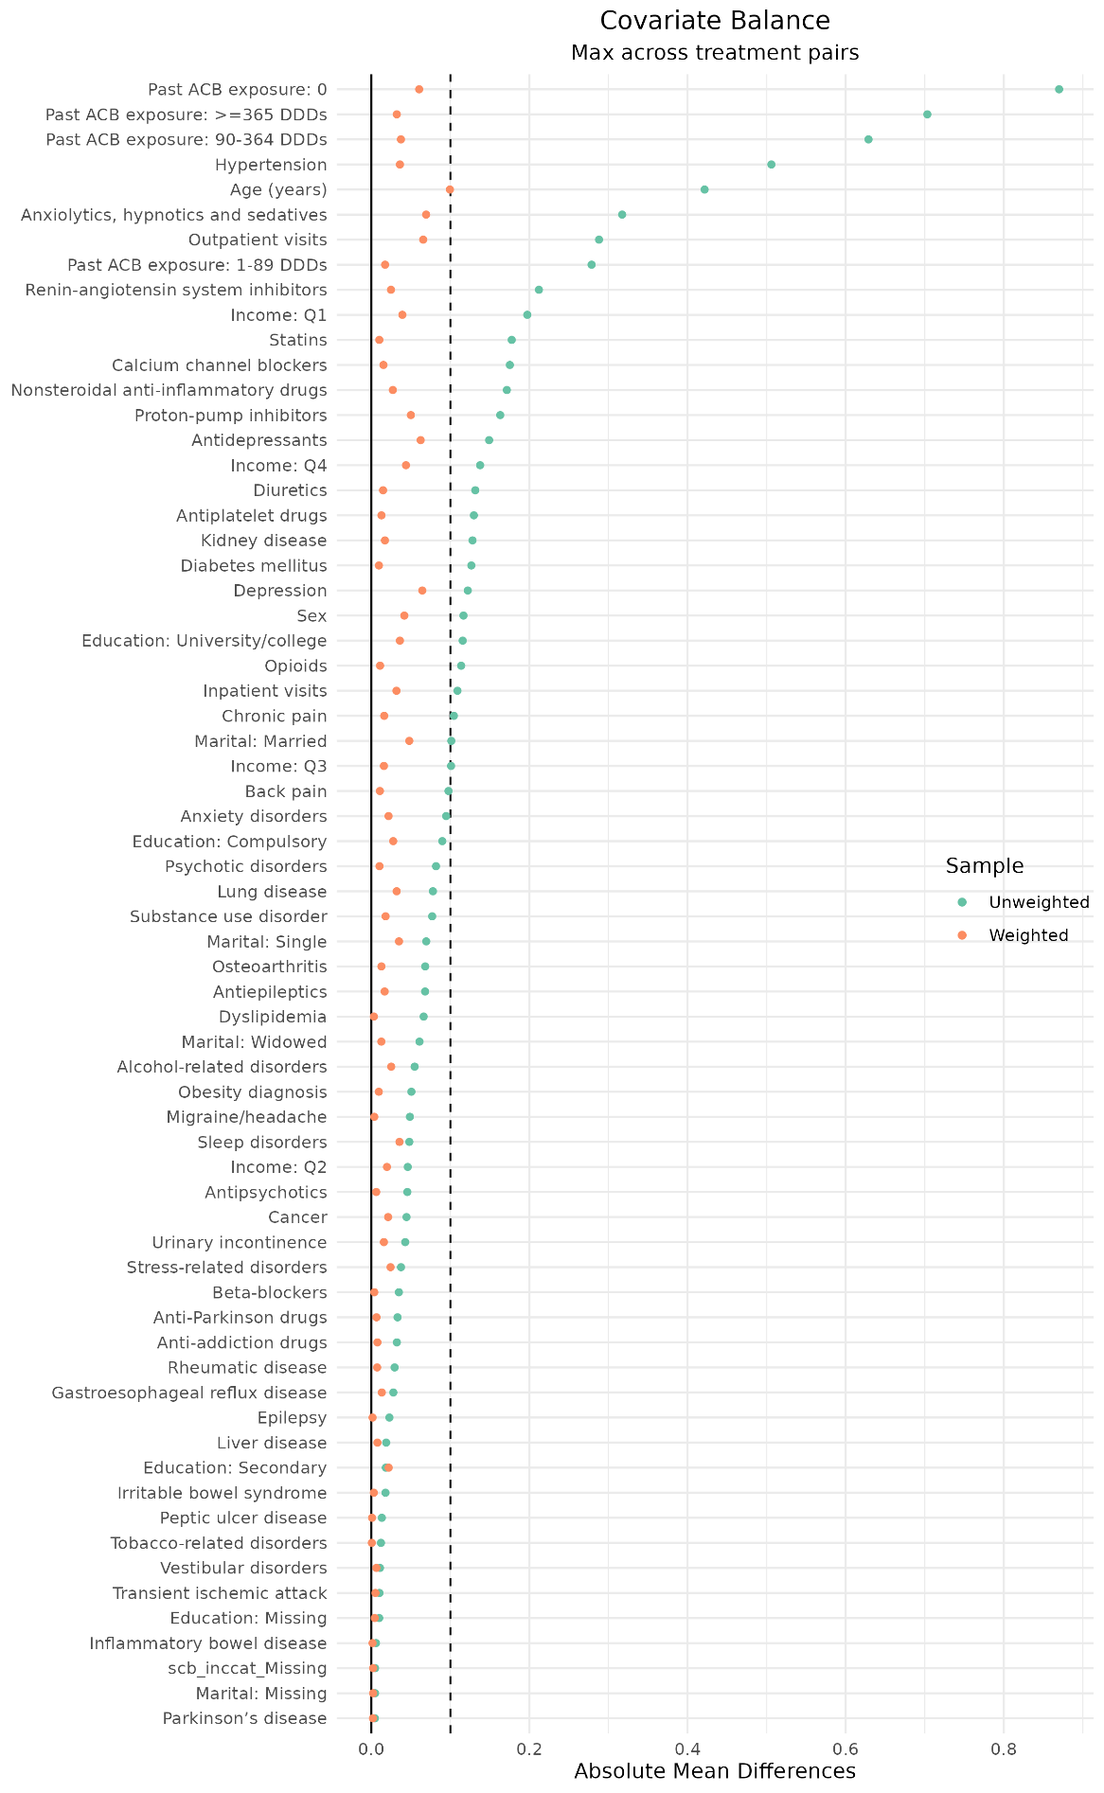

Figure S5. Covariate balance before and after baseline inverse probability weighting
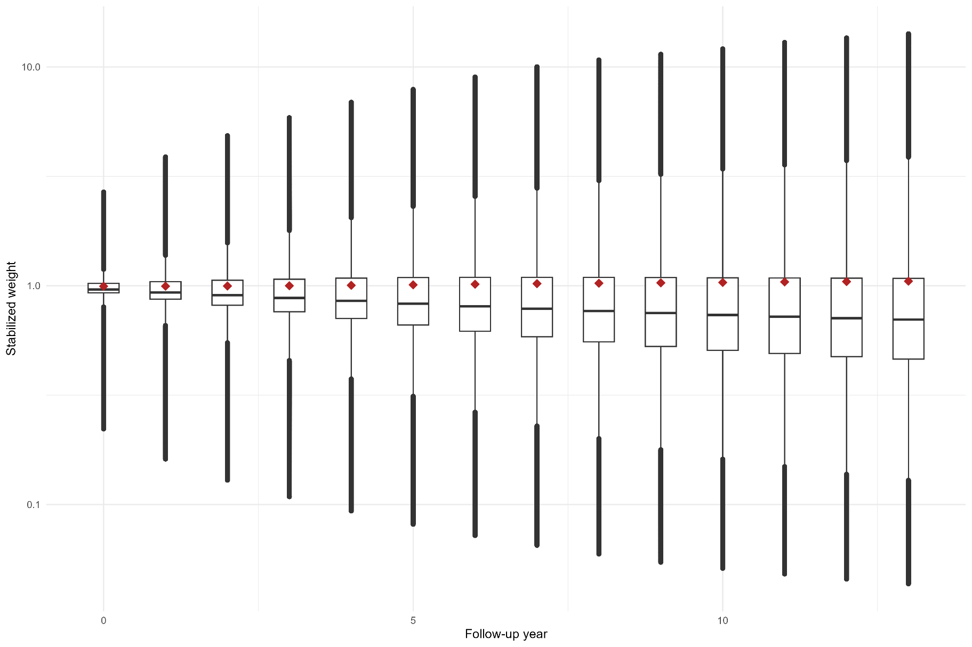

Figure S6. Distribution of time-varying inverse probability weights
Dark red points indicate the mean stabilized inverse probability weights by each year.
 | 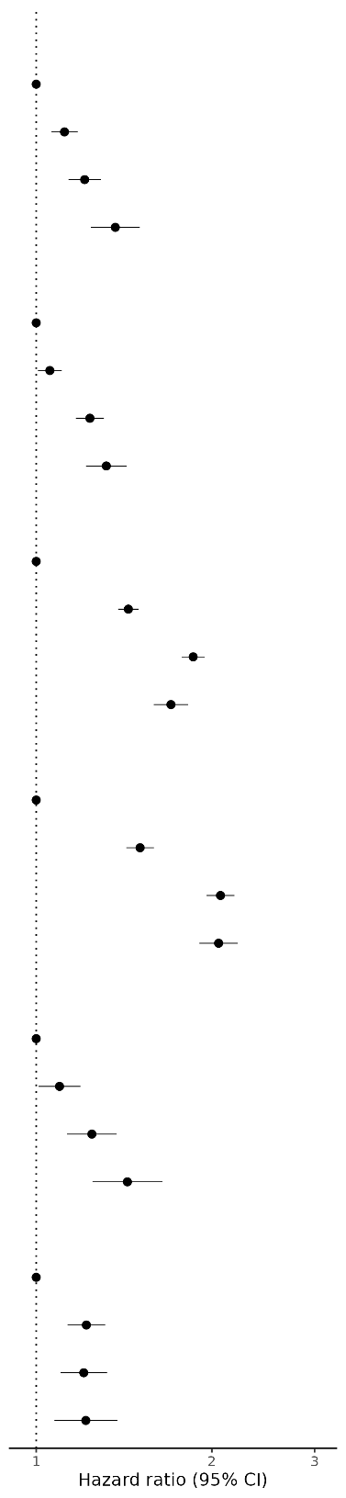
   | No. of events | Person-year | Incidence rate per 1000 person-years | Weighted HR (95% CI)ª
  Myocardial infarction
  0 | 12,412 | 4,070,706 | 3.0 | 1.00
  1 | 5,338 | 1,126,501 | 4.7 | 1.12 (1.06, 1.18)
  2-3 | 3,563 | 599,855 | 5.9 | 1.21 (1.14, 1.29)
  ≥4 | 1,848 | 321,882 | 5.7 | 1.37 (1.24, 1.50)
  Cerebrovascular disease
  0 | 16,002 | 4,040,372 | 4.0 | 1.00
  1 | 7,236 | 1,134,789 | 6.4 | 1.06 (1.01, 1.11)
  2-3 | 5,158 | 598,342 | 8.6 | 1.24 (1.17, 1.31)
  ≥4 | 2,665 | 318,469 | 8.4 | 1.32 (1.22, 1.43)
  Arrhythmias
  0 | 17,868 | 4,051,341 | 4.4 | 1.00
  1 | 10,713 | 1,119,672 | 9.6 | 1.44 (1.38, 1.50)
  2-3 | 8,065 | 568,175 | 14.2 | 1.86 (1.78, 1.94)
  ≥4 | 3,496 | 309,983 | 11.3 | 1.70 (1.59, 1.82)
  Heart failure
  0 | 9,810 | 4,080,153 | 2.4 | 1.00
  1 | 6,869 | 1,149,721 | 6.0 | 1.51 (1.43, 1.59)
  2-3 | 6,667 | 594,936 | 11.2 | 2.07 (1.96, 2.19)
  ≥4 | 3,223 | 319,048 | 10.1 | 2.05 (1.90, 2.22)
  Artery disease
  0 | 4,623 | 4,078,612 | 1.1 | 1.00
  1 | 2,622 | 1,160,264 | 2.3 | 1.10 (1.01, 1.19)
  2-3 | 1,907 | 618,575 | 3.1 | 1.25 (1.13, 1.37)
  ≥4 | 995 | 328,826 | 3.0 | 1.43 (1.25, 1.64)
  Venous thromboembolism
  0 | 6,879 | 4,073,201 | 1.7 | 1.00
  1 | 3,215 | 1,157,107 | 2.8 | 1.22 (1.13, 1.31)
  2-3 | 2,083 | 616,243 | 3.4 | 1.21 (1.10, 1.32)
  ≥4 | 1,250 | 326,958 | 3.8 | 1.22 (1.07, 1.38)

Figure S7. Associations between time-varying anticholinergic burden (ACB score) and specific cardiovascular events
Abbreviations: ACB, Anticholinergic Cognitive Burden; CI, confidence interval; HR, hazard ratio.
ª Models were weighted for age, sex, socioeconomic status, healthcare utilization, medical conditions, use of medications other than anticholinergics, and pre-baseline exposure to anticholinergic drugs.

