Additional file 3: Figure S1 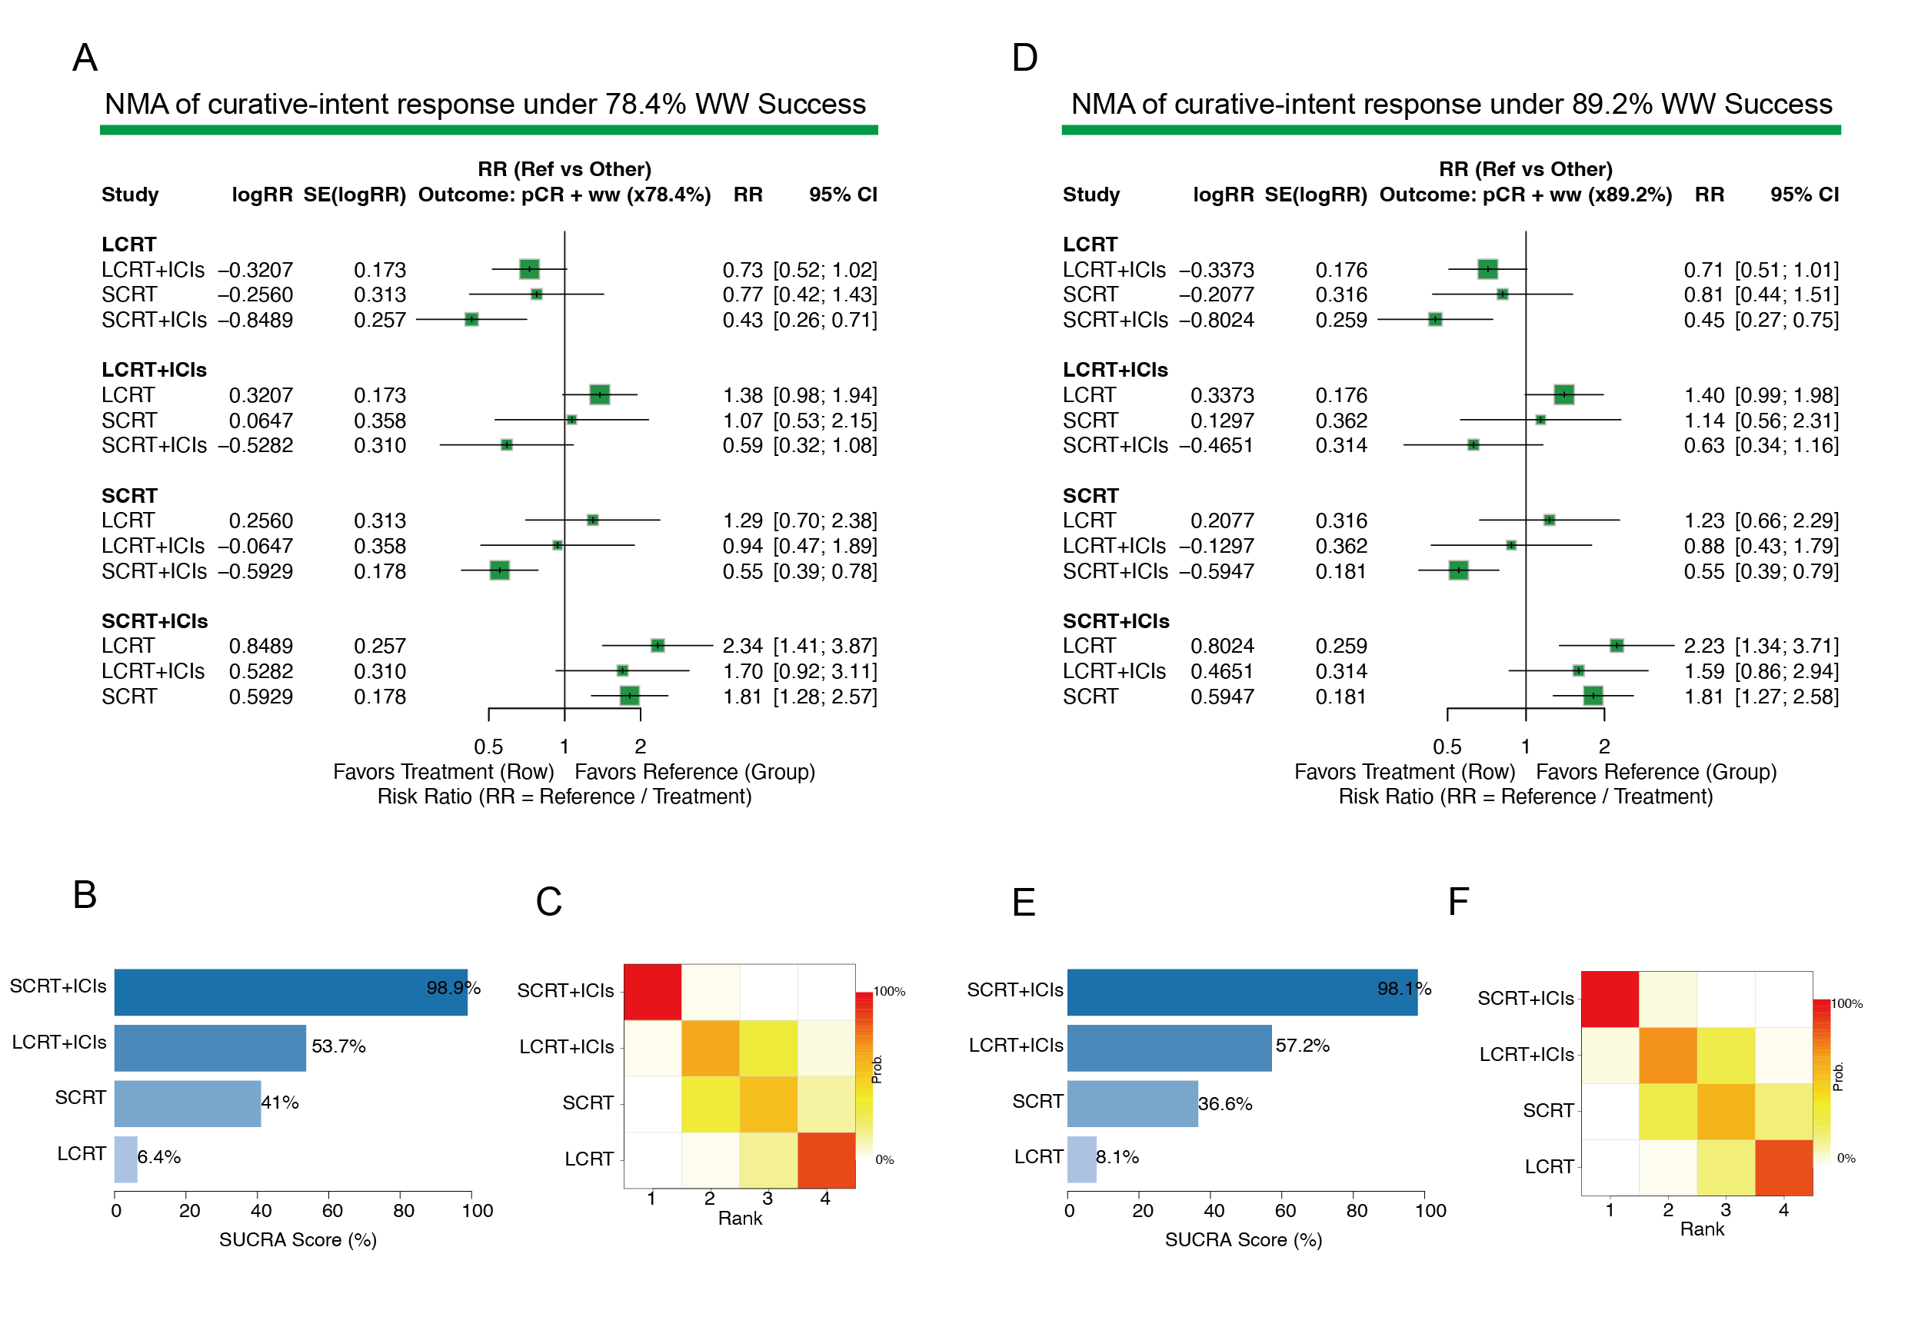
Figure S1. Sensitivity Analyses of the Curative-Intent Response Rate Under Conservative (78.4%) and Optimistic (89.2%) Watch-and-Wait Success Scenarios.
(A–C) Conservative scenario (78.4% WW success rate).
(A) League table of all pairwise comparisons from the network meta-analysis.
(B) Ranking of treatments based on SUCRA probabilities. Higher SUCRA values indicate a higher probability of being the most effective treatment.
(C) Rankogram showing the cumulative ranking probabilities for each treatment.
(D–F) Optimistic scenario (89.2% WW success rate).
(D) League table of all pairwise comparisons (RR with 95% CI).
(E) Ranking of treatments based on SUCRA probabilities. Higher SUCRA values indicate a higher probability of being the most effective treatment.
(F) Rankogram showing the cumulative ranking probabilities for each treatment.

