Additional file 4: Figure S2
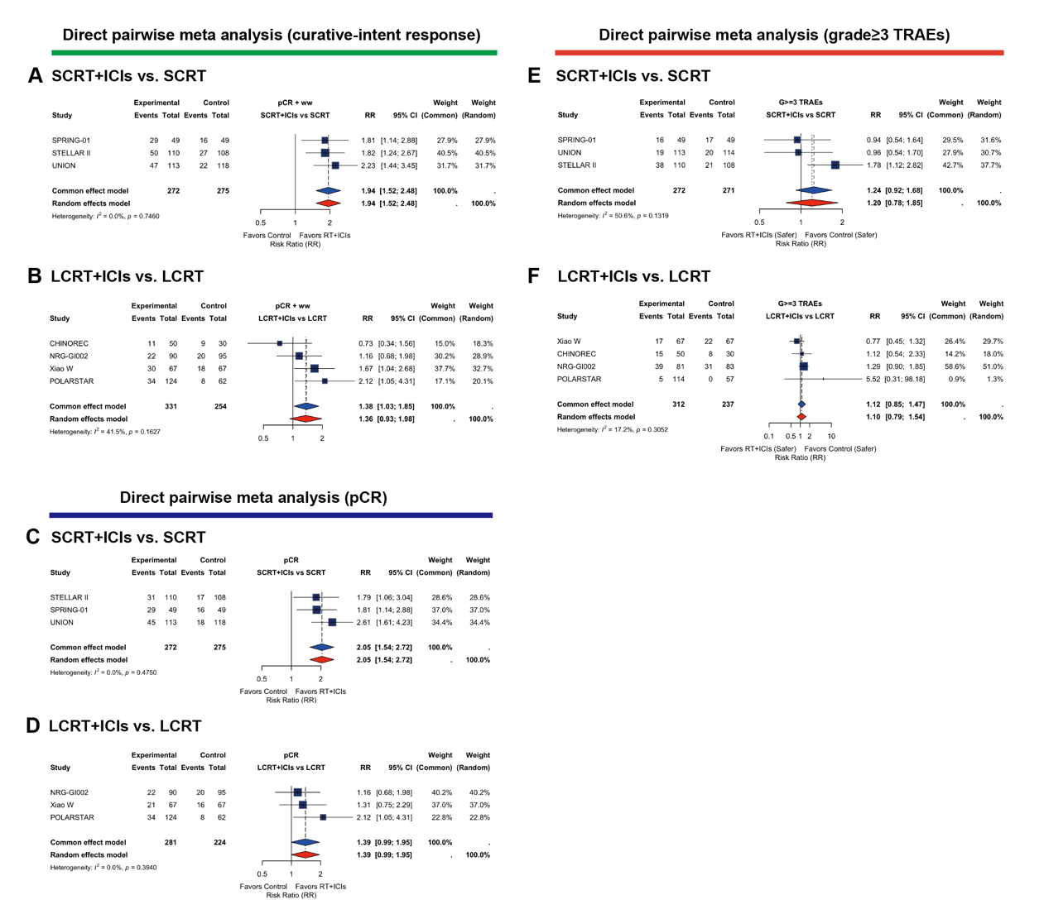
Figure S2. Forest Plots of Direct Pairwise Meta-Analyses for RCTs.
- Curative-intent response rate: SCRT+ICIs vs. SCRT alone.
- Curative-intent response rate: LCRT+ICIs vs. LCRT alone.
- pCR: SCRT+ICIs vs. SCRT alone.
- pCR: LCRT+ICIs vs. LCRT alone.
- grade≥3 TRAEs: SCRT+ICIs vs. SCRT alone.
- grade≥3 TRAEs: LCRT+ICIs vs. LCRT alone.

