Additional file 5: Figure S3
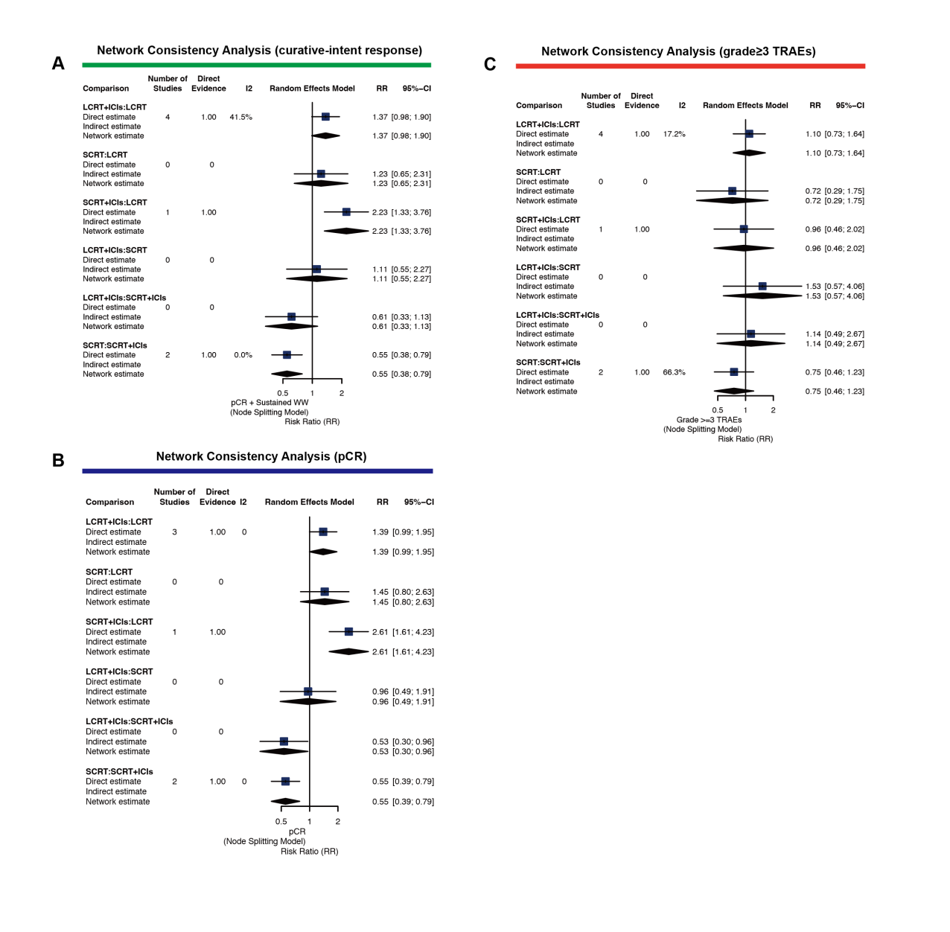
Figure S3. Node-splitting Analysis of Inconsistency Between Direct and Indirect evidence.
- Curative-intent response rate.
- pCR.
- Grade >3 TRAEs.

