Additional file 7: Figure S4
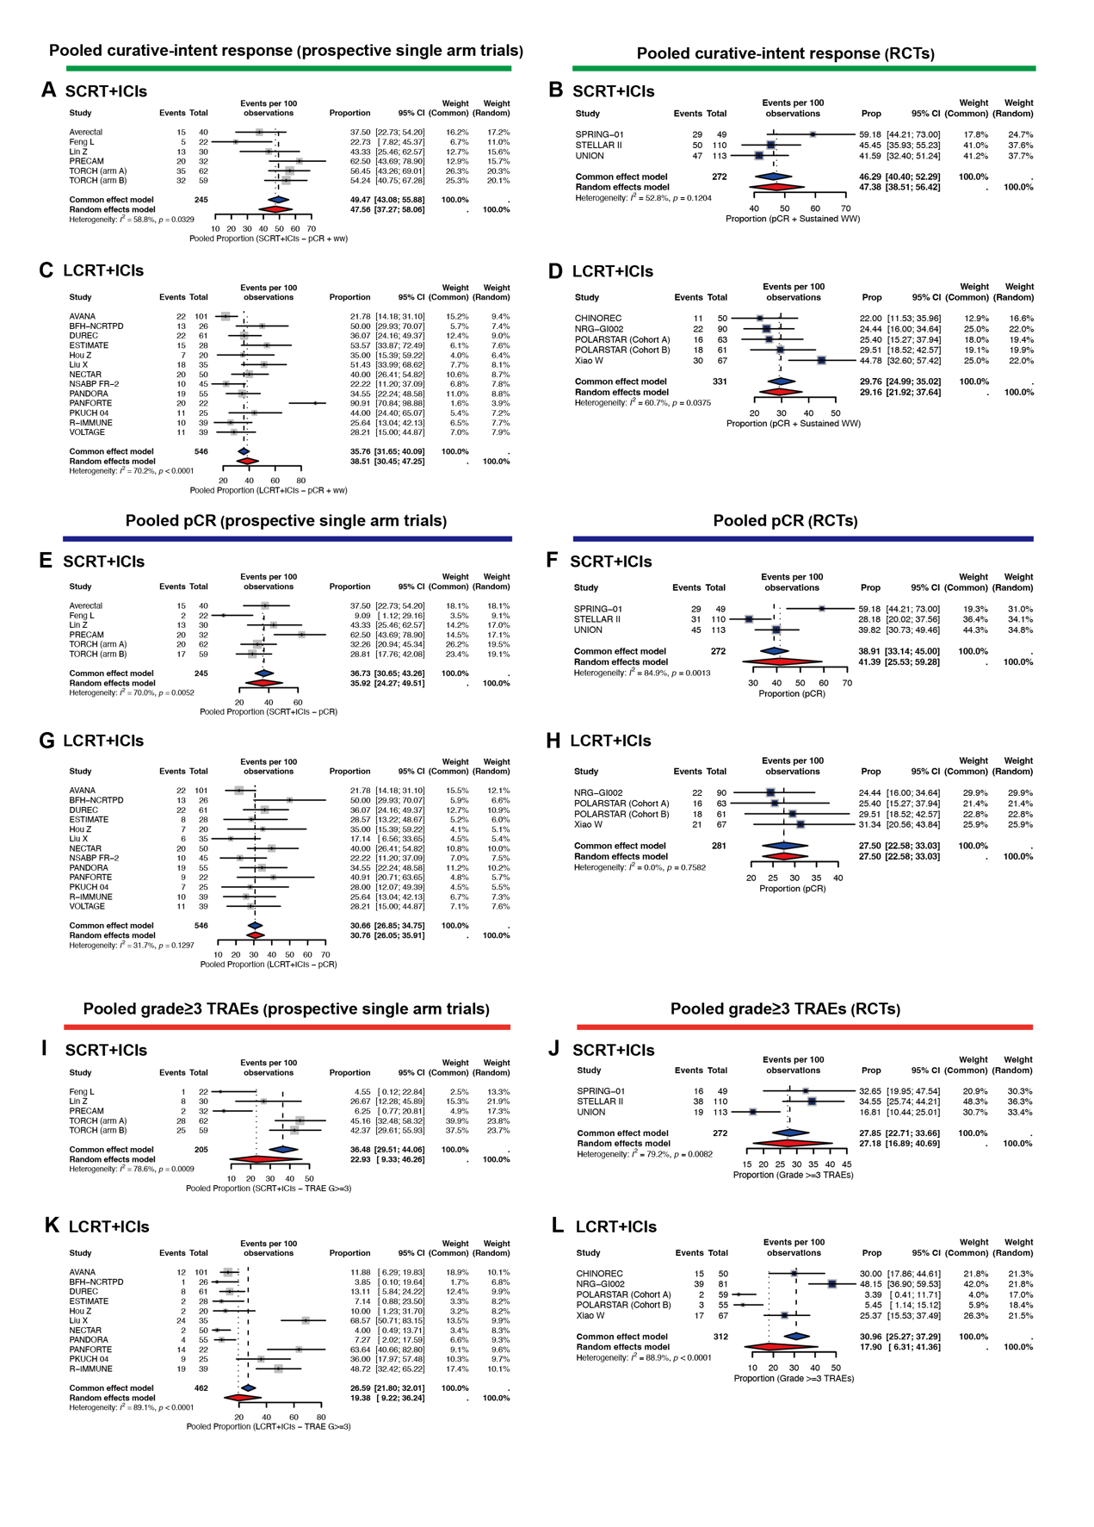
Figure S4. Pooled Efficacy and Toxicity Estimates from Both RCTs and Single-Arm Studies for the SCRT+ICIs and LCRT+ICIs Regimens
(A) Pooled curative-intent response rate for SCRT+ICIs (single-arm studies).
(B) Pooled curative-intent response rate for SCRT+ICIs (RCTs from direct comparisons).
(C) Pooled curative-intent response rate for LCRT+ICIs (single-arm studies).
(D) Pooled curative-intent response rate for LCRT+ICIs (RCTs from direct comparisons).
(E) Pooled pCR rate for SCRT+ICIs (single-arm studies).
(F) Pooled pCR rate for SCRT+ICIs (RCTs from direct comparisons).
(G) Pooled pCR rate for LCRT+ICIs (single-arm studies).
(H) Pooled pCR rate for LCRT+ICIs (RCTs from direct comparisons).
(I) Pooled grade≥3 TRAEs for SCRT+ICIs (single-arm studies).
(J) Pooled grade≥3 TRAEs for SCRT+ICIs (RCTs from direct comparisons).
(K) Pooled grade≥3 TRAEs for LCRT+ICIs (single-arm studies).
(L) Pooled grade≥3 TRAEs for LCRT+ICIs (RCTs from direct comparisons).

